

**BỘ GIÁO DỤC & ĐÀO TẠO**

**TRƯỜNG ĐẠI HỌC SƯ PHẠM KỸ THUẬT TP.HCM**

**KHOA CÔNG NGHÊ THÔNG TIN**

----❧❧❧❧----



**COURSE TOPIC**

**WEB PROGRAMMING**

**TOPIC: CAR RENTAL MANAGEMENT SYSTEM**

**LECTURER: Nguyễn Đức Khoan**

**STUDENT:   
 Nguyễn Đình Khang 17110039**

**Thành phố Hồ Chí Minh**

**Năm 2019**

1. Description
   1. Main function

1.2 In the world where there are more and more transportation vehicles today, car rental services have been built to meet the increasing needs of people. Therefore, the management of vehicles to limit the risks that may be encountered is essential for the houses responsible for car rental. Grasping the wishes of the users, I have been trying to create a management application to meet the basic needs of customers as well as the most simple approach to the users.

* 1. Database
* Database:
* Table user(id, name, username và password).

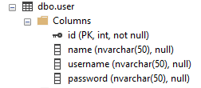

* Table cars(id,carNumber,make,model and available)

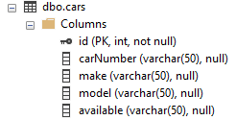

* Table customers(id,customerName,address and mobile)

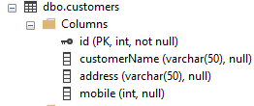

* Table rent(id,carid,customerid,fee,sdate,edate)

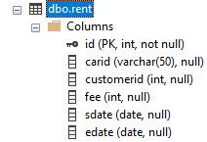

* Table returncar(id,carno,custid,date,elsp,fine)

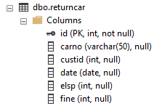

* 1. Purpose, feature
     1. Purpose
* As we mentioned at the beginning, our main purpose when creating this software is to solve the problem of managing events as efficiently as possible. We aim to the simplest, most effective for users both in interface and hand operation.
* Users: they can register to become a member of the organization and have full access to the software. They can also view all the current events to choose the event that best suits their close friends so they can arrange time and money in a reasonable way so that they are not interrupted or not participating of the user.
  + 1. Interface
* Sign in interface

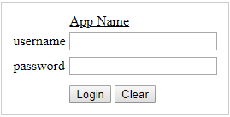

* Home interface

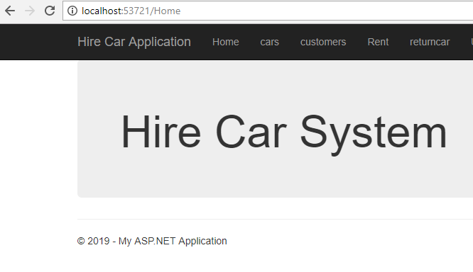

* Cars interface

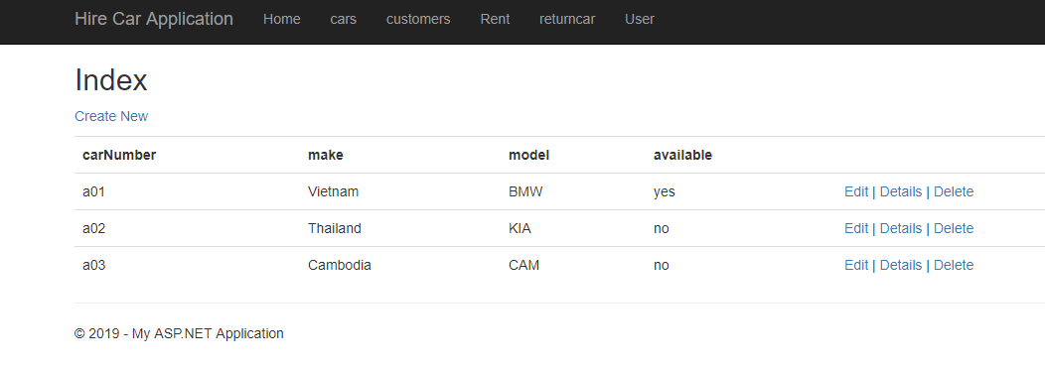

* Customers interface

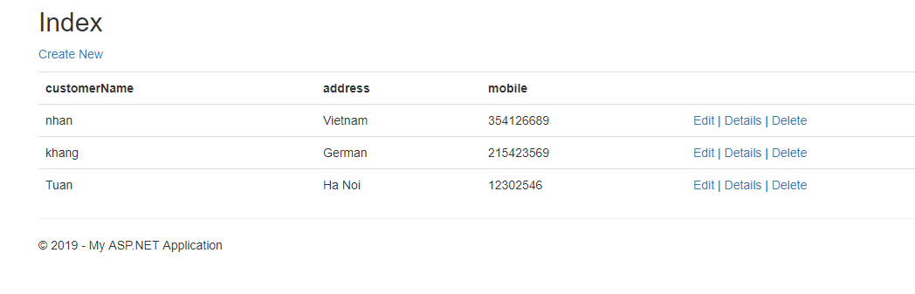

* Rent interface

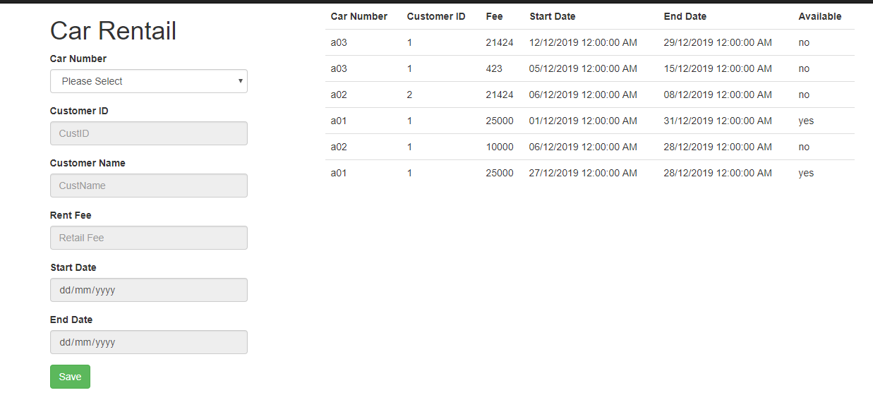

* Returncar interface

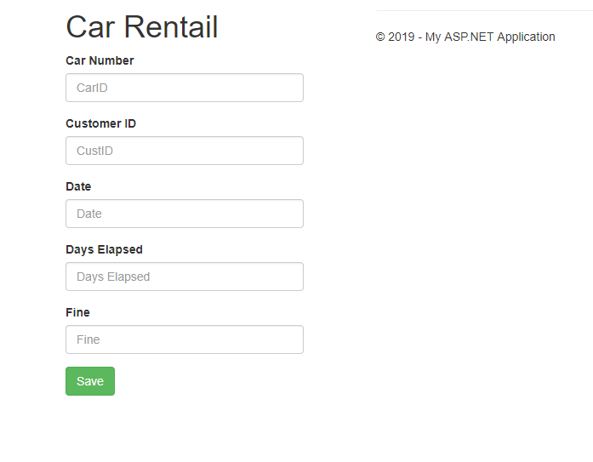

1. Work assignment

|  |  |  |  |
| --- | --- | --- | --- |
| TT | Name | Description | Attribution |
| 1 | Nguyễn Đình Khang | Code | 100 |
| 2 | Nguyễn Đình Khang | Interface | 100 |

1. Design
   1. Controller

|  |  |  |  |
| --- | --- | --- | --- |
| TT | Tên | Mô tả |  |
| 1 |  |  |  |
| 2 |  | Sign in |  |
| 3 |  | Car’s information |  |
| 4 |  | Customer’s information |  |
| 5 |  | Hire cars |  |
| 6 |  | Return the cars |  |
|  |  |  |  |

* 1. Class

|  |  |  |
| --- | --- | --- |
| TT | Name | Description |
| 1 |  | Available or not |
| 2 |  |  |
| 3 |  |  |

* 1. Diagram

