**User guide for using Phone Selling Webpage System**

1. To use the Phone Selling Webpage System, user have to access to the Internet with Browser such as Chrome, Edge, Mozilla Firefox, …
2. 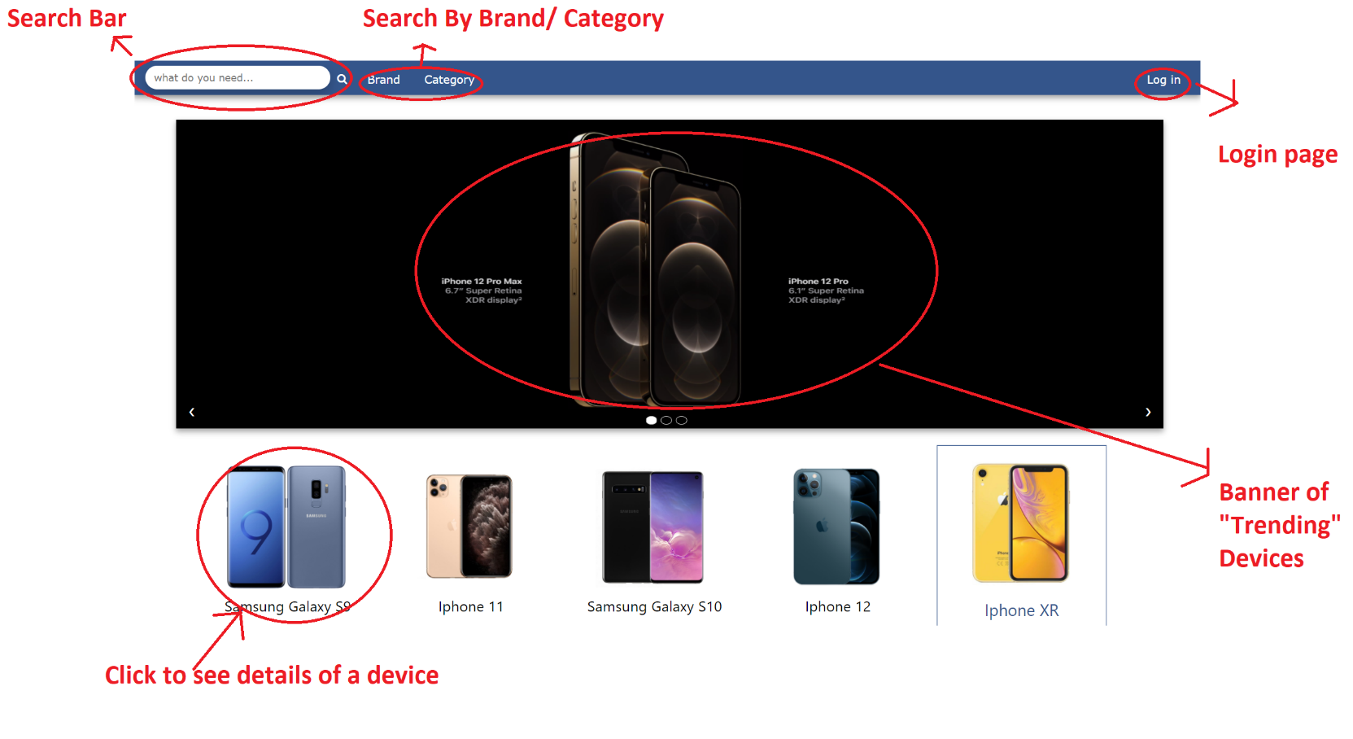At Main Page (All Users)
3. 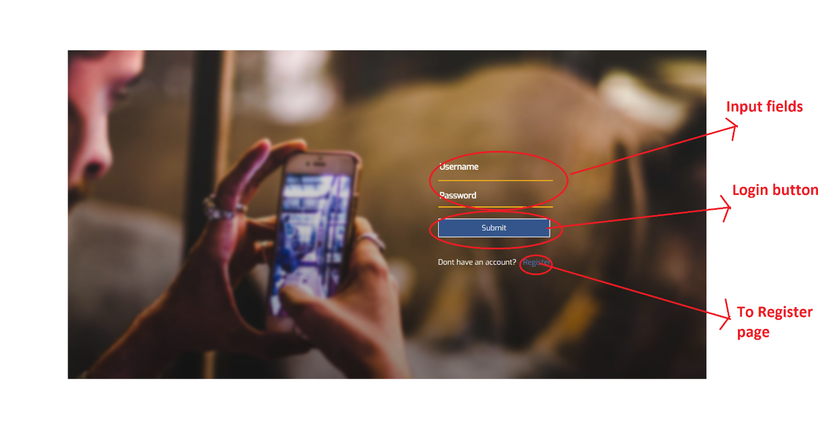Login Page (All Users)
4. Sign up Page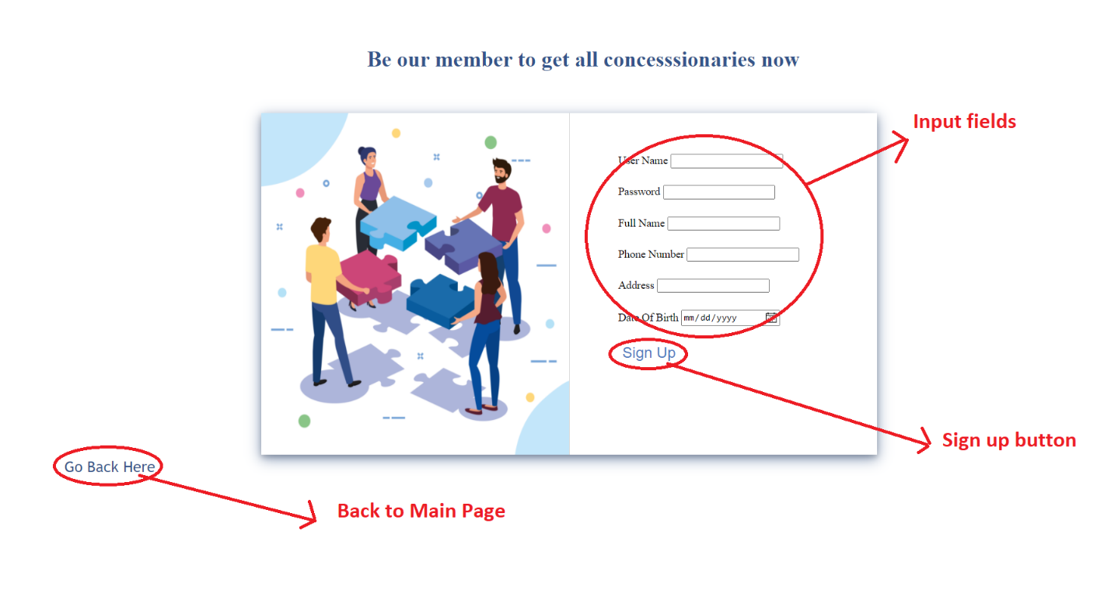 (Guest)
5. Detail Page (Guest & Customer)
   1. 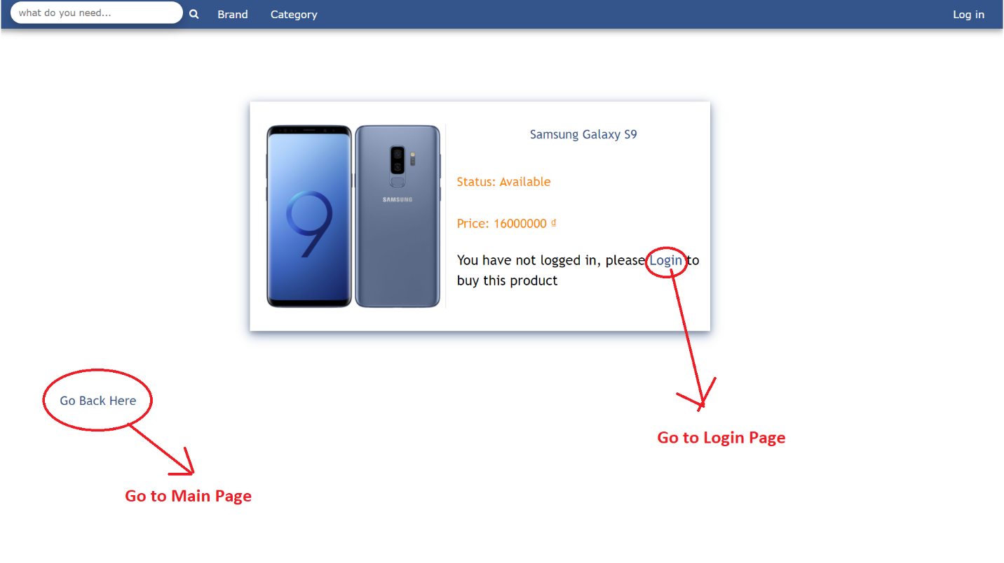Before Logging in (Guest)
   2. After Logging in as a Customer
   3. 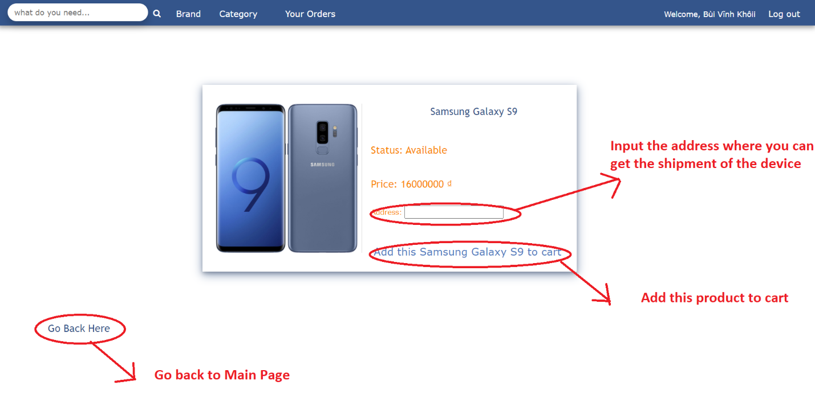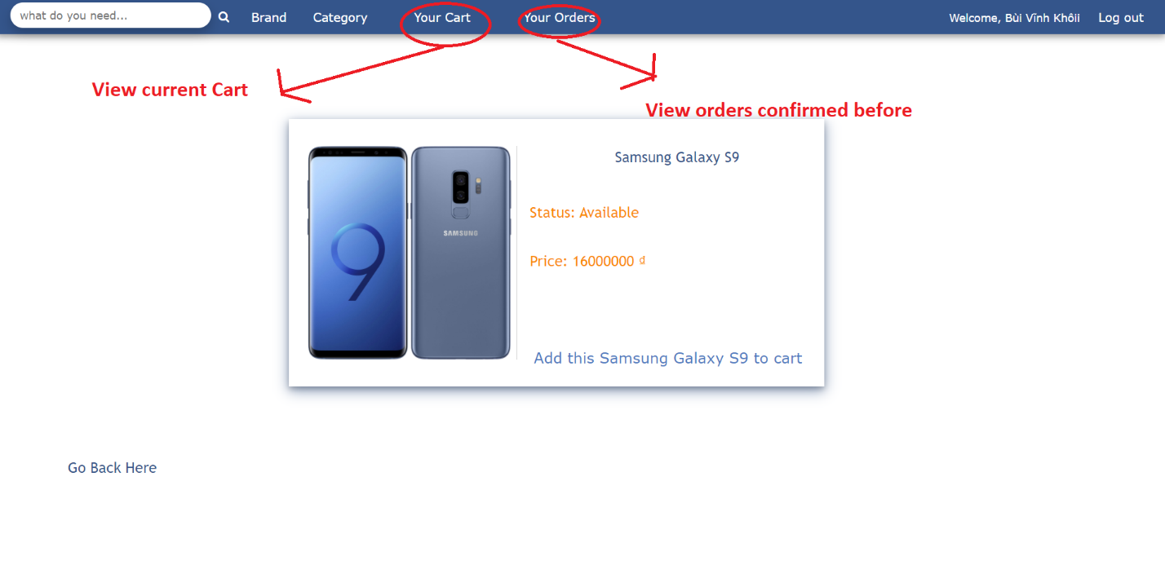After Add to Cart for the first time (Logged in as Customer)
6. View Cart (Customer)
7. 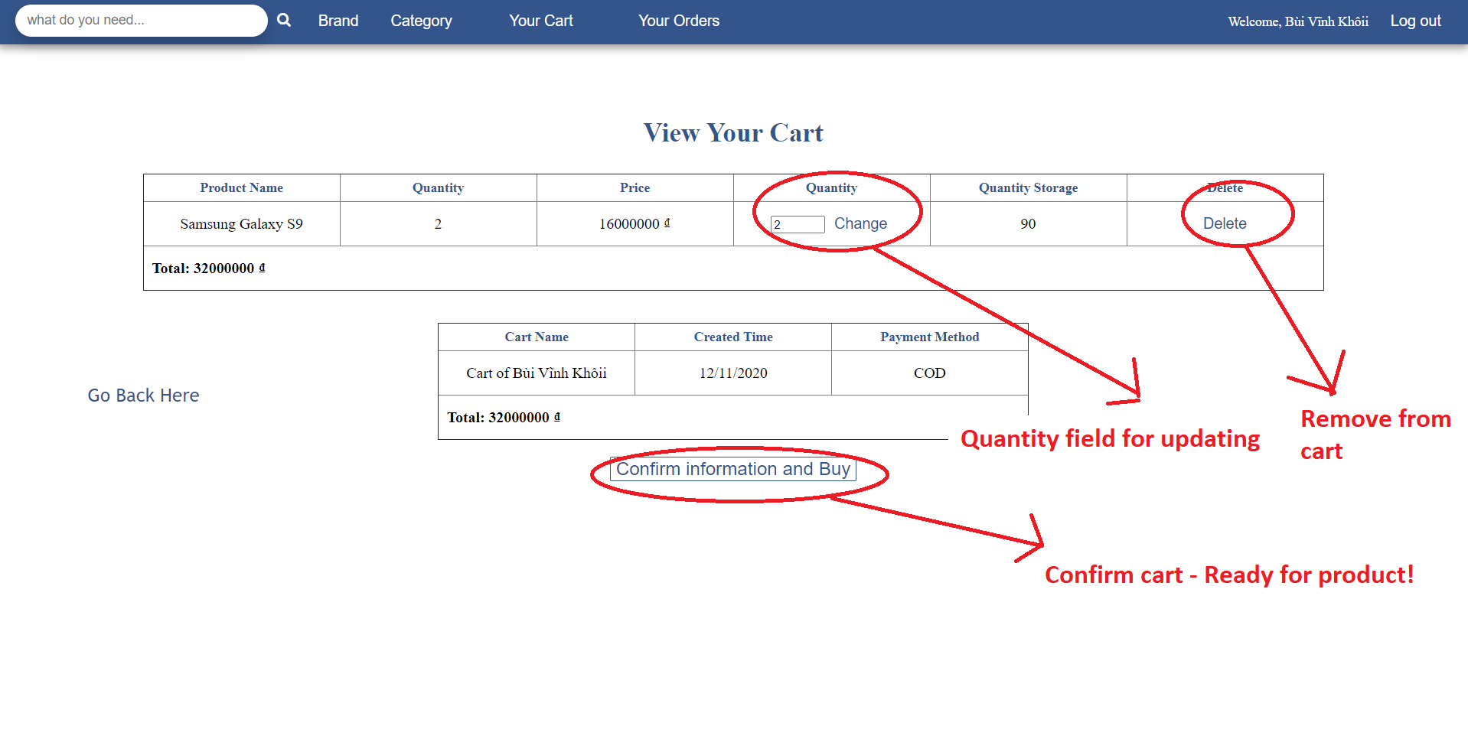View Order history (Customer)

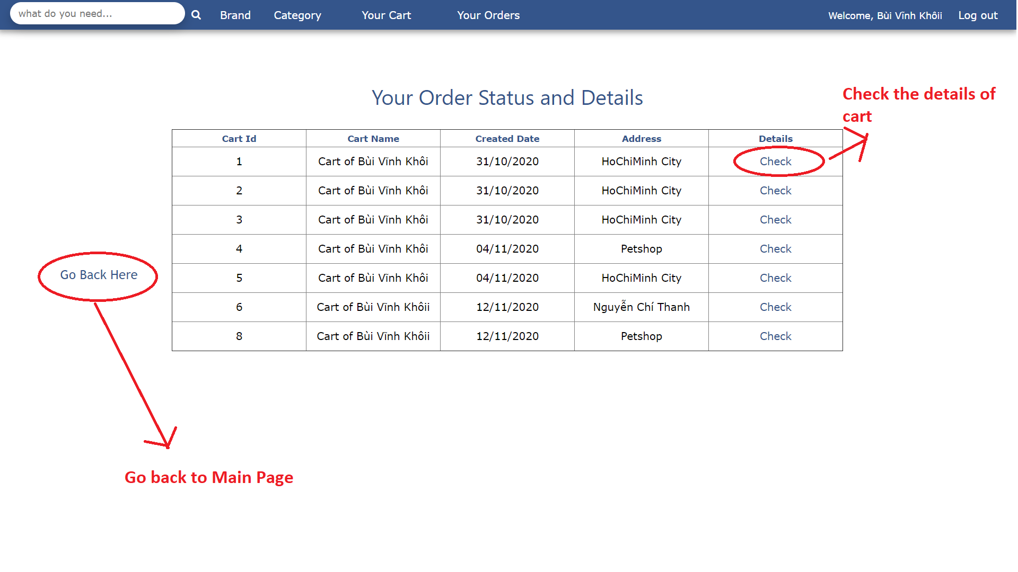

1. 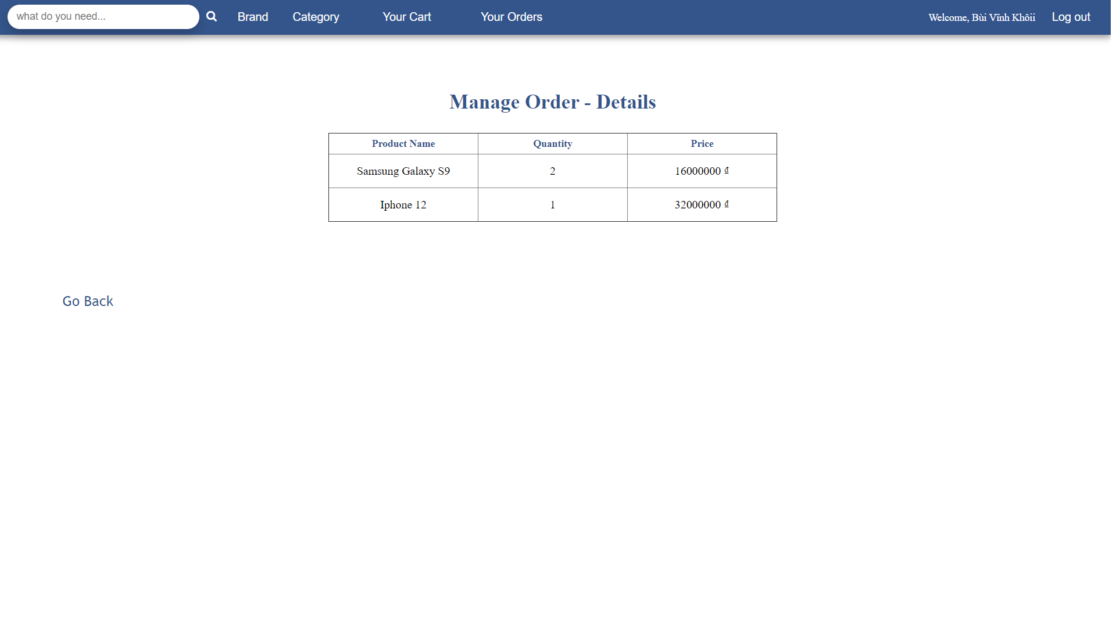Order Detail in history (Customer & Admin)
2. 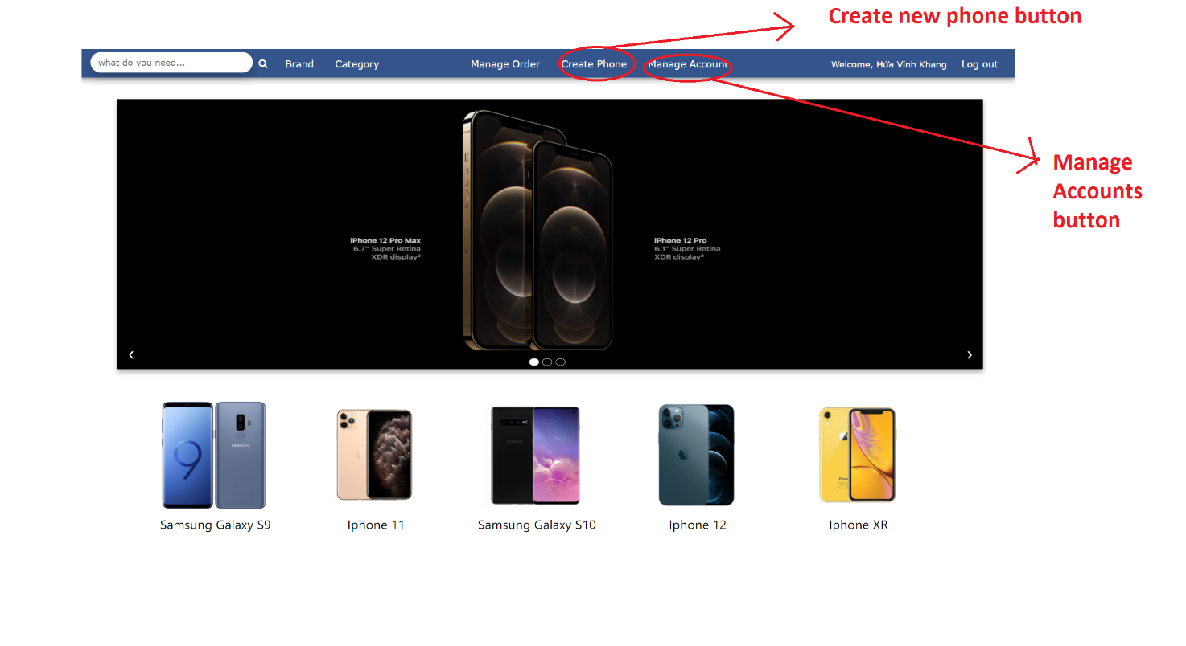For Admin
3. 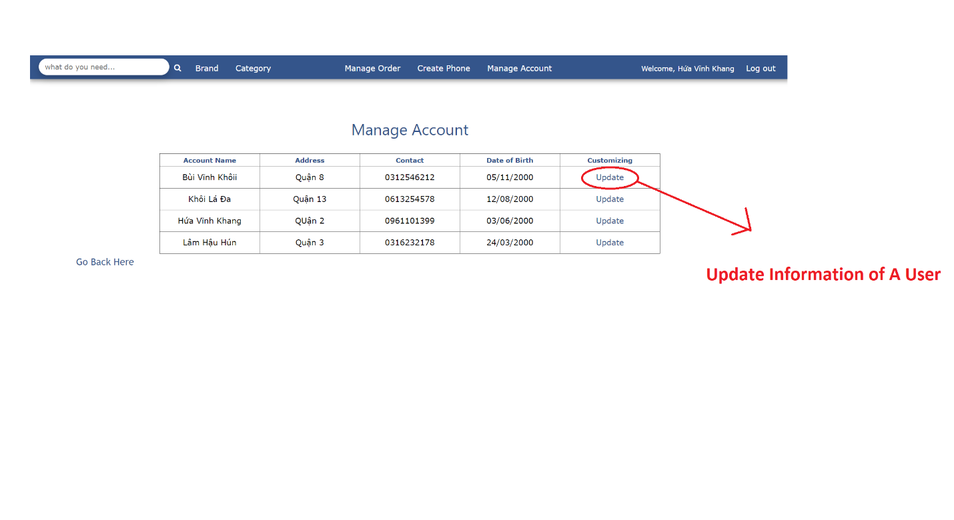Manage Accounts (Admin)
4. 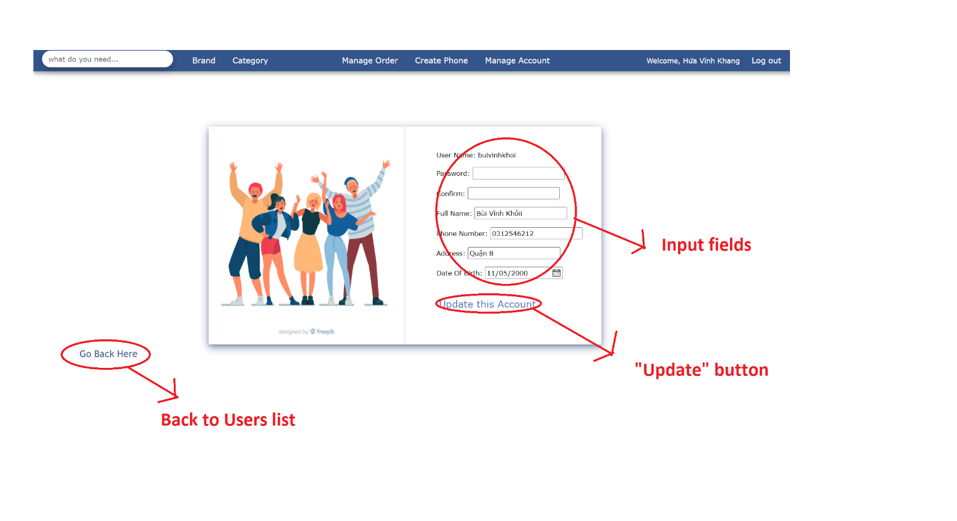Update One Account (Admin)
5. 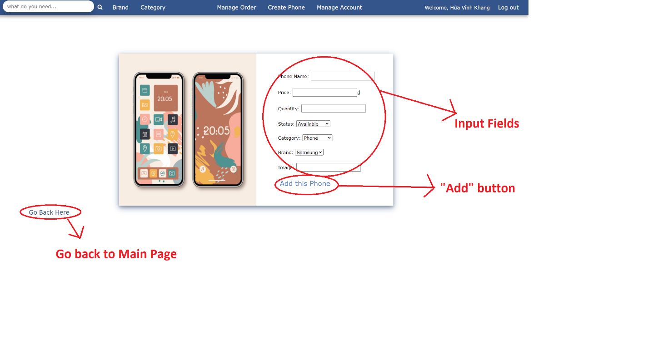Create a Product (Admin)
6. 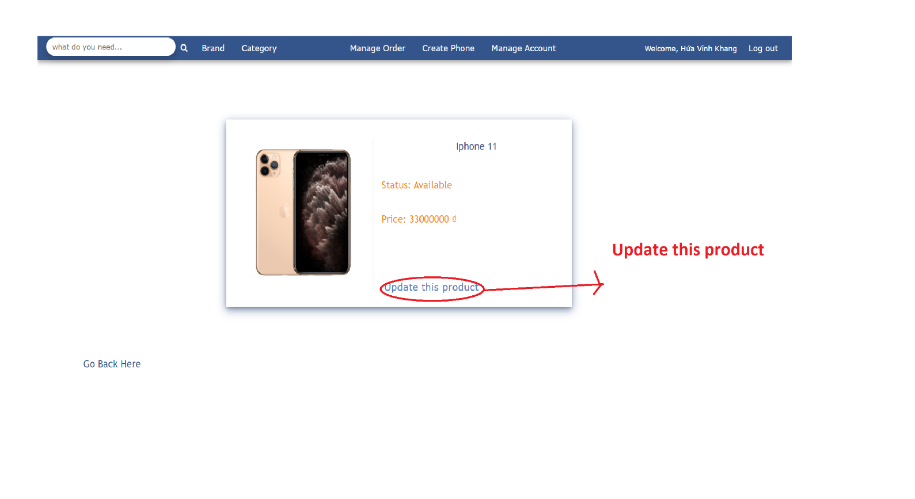Detail of a Product (Admin)
7. 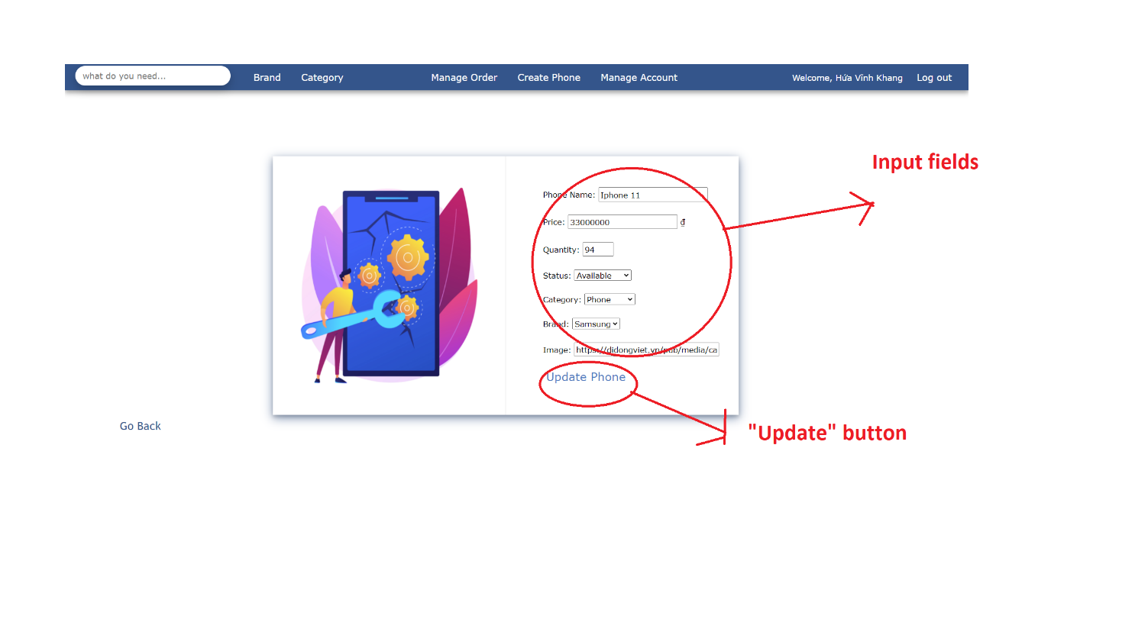Update a Product (Admin)
8. 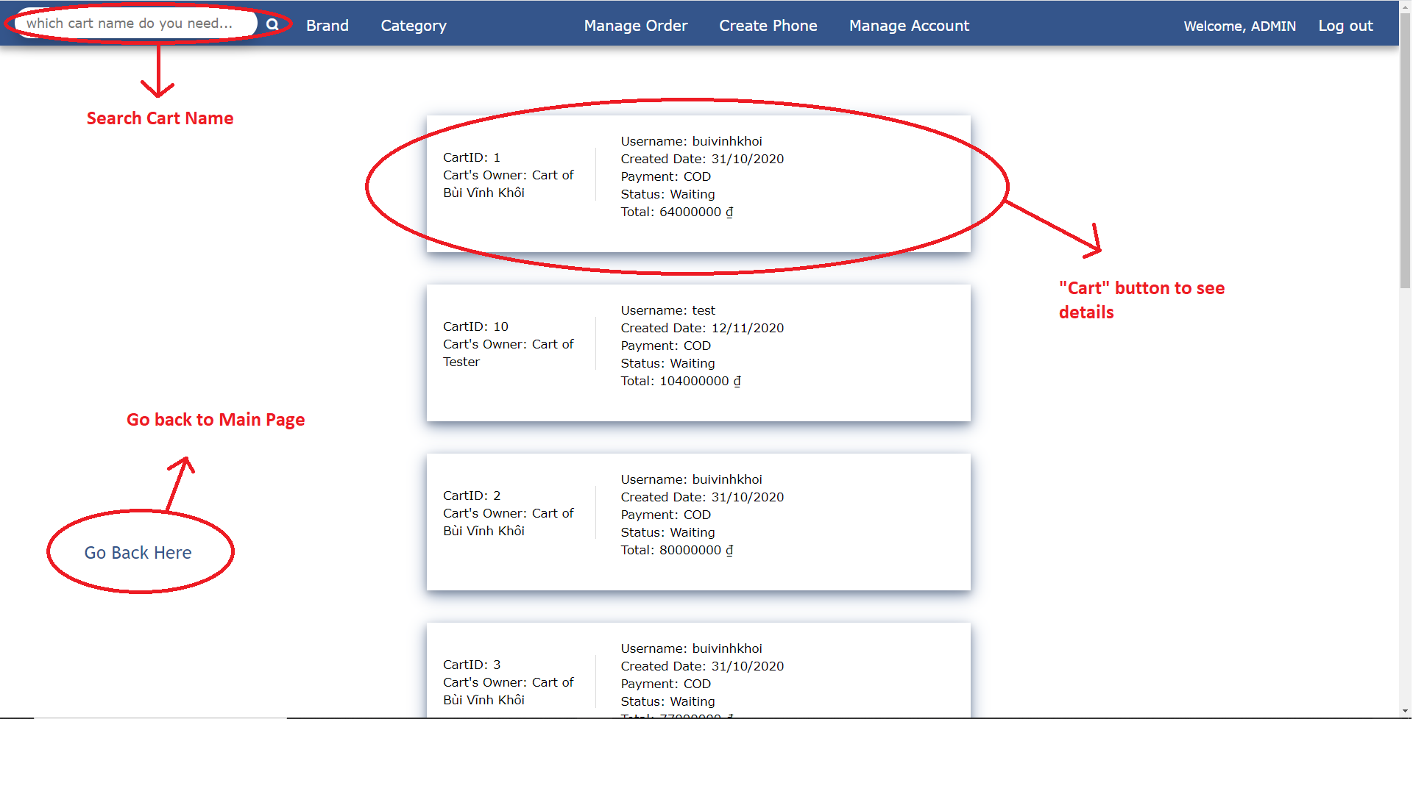Track Orders (Admin)
9. System Requirement:

* **For Users**
  + **Hardware**
    - CPU: Pentium IV 2.0 GHz or higher
    - RAM: 512 MB or higher
  + **Software**
    - OS: Windows 7/8/10/XP Professional…
    - Browser: Internet Explorer 8.0 or higher, Google Chrome, Firefox, Edge, …
* **For Software Developers**
  + **Hardware**
    - CPU: Pentium IV 2.0 GHz or higher
    - RAM: 512 MB or higher
  + **Software**
    - OS: Windows 10
    - Environment: Microsoft .NET Framework 4.7.2.
    - Database Management System: Microsoft SQL Server 2014
    - IDE: Microsoft Visual Studio 2019
    - Web Server: Internet Information Services (IIS) JSP