Software Requirements Specification

for

Cosmetic Management System, Release 1.0

Version 1.0 approved

Prepared by Lâm Bảo Khang, Đinh Nguyễn Trâm Anh

Process Impact

February, 15th 2021

Table of Contents

Revision History ii

1. Introduction 1

1.1 Purpose 1

1.2 Document Conventions 1

1.3 Project Scope and Product Features 1

1.4 References 1

2. Overall Description 1

2.1 Product Perspective 1

2.2 User Classes and Characteristics 2

2.3 Operating Environment 3

2.4 Design and Implementation Constraints 3

2.5 Assumptions and Dependencies 3

3. System Features 3

3.1 Usecase Diagram………………………………………………………………………………..4

3.2 Usecase List……………………………………………………………………………………..4

4. Data Requirements 6

4.1 Logical Data Model 6

4.2 Data Dictionary 6

4.3 Reports 9

4.4 Data Integrity, Retention, and Disposal 9

5. External Interface Requirements 8

5.1 User Interfaces 8

5.2 Software Interfaces 8

5.3 Hardware Interfaces 8

5.4 Communications Interfaces 8

6. Quality Attributes 8

6.1 Usability Requirements 8

6.2 Performance Requirements 8

6.3 Security Requirements 8

6.4 Safety Requirements 9

6.5 Availability Requirements 9

6.6 Robustness Requirements 9

**7. Diagram………………………………………………………………………………………9**

Revision History

|  |  |  |  |
| --- | --- | --- | --- |
| **Name** | **Date** | **Reason For Changes** | **Version** |
| Bảo Khang | 1/28/21 | initial draft | 1.0 draft 1 |
| Khang, Anh | 2/15/21 | baseline following changes after inspection | 1.0 approved |

# Introduction

## Background

Vendors nowadays find it hard to present the cosmetic products at their shops to the people around, especially new arrivals. For the customers, not everyone has time to wanders around go shopping. Before, when customers want to buy something, they have to go to the shops or call the shop owners. But the customers not always get the items they want to buy because sometimes that item is sold out or not available yet. Shop vendors have to arrange the items in shop, it takes a lot of time, and saving the information of every items and customers is also more difficult.

## Business Opportunity

Many customers have request an application that they could use to look for the items they want to buy online so that they don’t have to go out, and then those items would be delivered right to their houses. Besides, customers could see the information of items whether it is available or not, so it would increase the chance of their getting the items they want. For the shop owners, it would reduce a lot of time to arrange their shops to put every cosmetic items on real shelves, now the online web is a comfortable place to present them all. It would also help reduce the time to answers question form customers or phone calls for orders because everything is now automatically done by the application.

## Business Objective

Choice for customers who want to buy goods without spending effort, time and cost of refueling, customers just need to sit at home surfing the web for hours and order through devices. electronic equipment connected to the network. This website is also profitable for the shop owner with the monthly revenue generated from the customer.

## Vision Statement

Customers want to order at home or the company through the store will not have to go directly to the store to choose and buy products. Instead, they simply go to the store's website choose and order. The web order system uses internet, so customers can use on their mobile phones or computers. After order, the system will receive and process payment for the customer's order. and move on to the preparation process. Customers only need to fill in the information and the receiving address, the store will prepare the goods and deliver the goods to the place, customers will not have to waste time and effort to run to the store

# Overall Description

## Product Perspective

The Cosmetic Management System is a new software system that replaces the current manual and telephone processes for ordering and picking up items from the shops. The context diagram in Figure 1 illustrates the external entities and system interfaces for release 1.0. The system is expected to evolve over several releases, ultimately connecting to the Internet ordering services for several local shops and to credit and debit card authorization services.

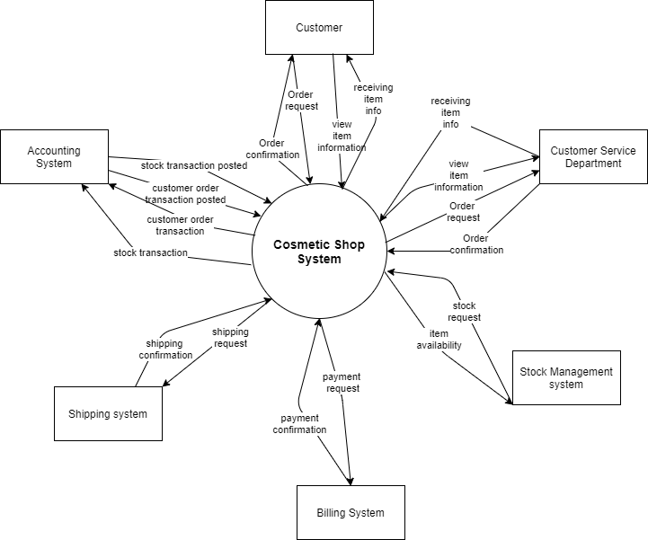Figure 1. Context diagram for release 1.0 of the Cosmetic Management System.

## Major Features

FE-1: Look up and view details of items

FE-2: Order and pay for items from the available list.

FE-3: Provides view, add, remove items in the cart before subscribe for deliver.

FE-4: Shop owner can add, delete, update information of items in shop.

FE-5: View information of customers and details of orders.

FE-6: View sales revenue, know the best-selling items.

FE-7: Provide system access through corporate intranet, smartphone, tablet, etc.

## Scope of Initial Release

|  |  |  |  |
| --- | --- | --- | --- |
| Feature | Release 1 | Release 2 | Release 3 |
| FE-1: Look up and view details of items | Search to find items | Click to see more details of the item | Not implemented |
| FE-2: Order and pay for items from the available list | Order from the list only | Accept credit card and cash | Delivery to address |
| FE-3: Provides view, add, remove items in the cart before subscribe for deliver | Create shopping cart and view items | Delete, add items | Submit to order |
| FE-4: Shop owner can add, delete, update information of items in shop | Can edit the items in the list of the web | Update, remove items | Submit the complete list |
| FE-5: View information of customers and details of orders | Click into the order to see full information of customer and items they order |  |  |
| FE-6: View sales revenue, know the best-selling items | See the sale off items | Choose the sale off item |  |
| FE-7: Provide system access through corporate intranet, smartphone, tablet,… | Connect with internet in the phone or computer |  |  |

## Design and Implementation Constraints

## Design and Implementation Constraints

## Assumptions and Dependencies

AS-1: Systems with appropriate user interfaces will be available for shop owner to process the expected volume of items ordered.

AS-2: The items in confirmed orders shall be prepared and delivered between 2 days.

AS-3: The system must response to database system in short times (1-3s).

AS-4: System shall have User Guide to help users using the system comfortably.

DE-1: If a shop has its own on-line ordering system, the Cosmetic Management System must be able to communicate with it bi-directionally.

# System Features

## E:\Spring2021\SWR302\Assignment_CosmeticManagement\Diagram\UsecaseDiagram.pngUsecase Diagram

## Usecase List

|  |  |  |  |
| --- | --- | --- | --- |
| UC ID and Name: | Update item information | | |
| Created By: | Khang | Date Created: | 19/1/2021 |
| Primary Actor: | Shop owner | Secondary Actors: | Account Database, Item Database |
| Trigger: | Shop owner has chosen to update item information. | | |
| Description: | Shop owner wants to manage items information, quantity, etc. | | |
| Preconditions: | Logged in as Shop owner. | | |
| Postconditions: | Pop-up message shows item has been updated. | | |
| Normal Flow: | 1. Shop owner chooses to view item information. 2. System shows item managing options. 3. Shop owner chooses update item information. 4. System displays form to manage with existing item information. 5. Shop owner fills in or change the fields in the form and submit. 6. System displays message that item is updated. | | |
| Alternative Flows: | None | | |
| Exceptions: | 1. Inputted information is in wrong format or null 🡪 System warns Shop owner and shows errors in the update form. 2. The Internet connection is interrupted when Shop owner clicks “Submit”🡪 System still caches the inputted information at server and shows message “Please wait a moment and click submit again later.”. | | |
| Priority: | High | | |
| Frequency of Use: | Approximately 200 times a month, when shop owner has to update the items in shop, mostly at weekends. | | |
| Business Rules: | 1. Information should be updated instantly after 30s. 2. Only one item is allowed to updated at a time. 3. Cannot update information when this item is in any order. | | |
| Other Information: | 1. Shop owner should be able to cancel updating items before click submit. 2. Shop owner can view the history of the updated items sort by date between 1 year. | | |
| Assumptions: | None | | |

|  |  |  |  |
| --- | --- | --- | --- |
| UC ID and Name: | View cart | | |
| Created By: | Trâm Anh | Date Created: | 19/01/2021 |
| Primary Actor: | Guest register/login | Secondary Actors: | Customer Database |
| Trigger: | View cart | | |
| Description: | For users to review products they have added to the shopping cart | | |
| Preconditions: | User has register or login as customer | | |
| Postconditions: | User has add the products to the shopping cart | | |
| Normal Flow: | 1. System ask users to register or login 2. User has register/login 3. System return register/login success or failed 4. User search the product 5. System filter out the products that customers search in the search category and return the product that customers search 6. User choose the product they want 7. User add the product into the shopping cart 8. System will add the product customer choose into the shopping cart 9. So that users can see the view of the product they choose in view cart | | |
| Alternative Flows: | none | | |
| Exceptions: | 1. System will output the error if users add the product but didn’t login-->system out println(“You must register/login”) | | |
| Priority: | Low | | |
| Frequency of Use: | Average a customer will use up to 12 times a day, depending on the need of the customer | | |
| Business Rules: | none | | |
| Other Information: | none | | |
| Assumptions: | none | | |

# Data Requirements

## Logical Data Model (ERD)

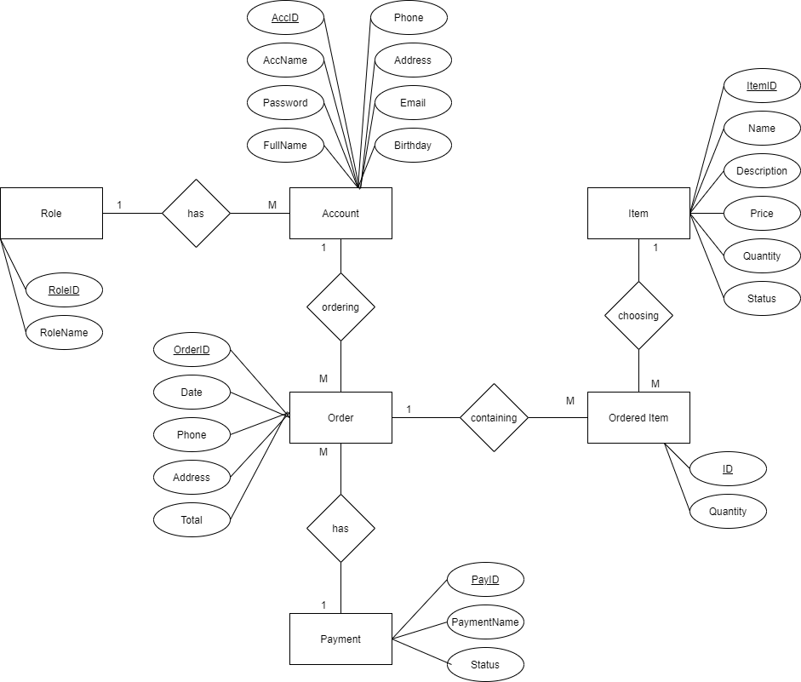

Figure . Partial data model for release 1.0 of the Cosmetic Management System.

## Data Dictionary

|  |  |  |  |  |
| --- | --- | --- | --- | --- |
| Data Element | Description | Composition or Data Type | Length | Values |
| AccountID | User ID number of the person using the app, order items. | Alphanumeric | 10 |  |
| AccName | Name of the account of the user for using the app | Alphanumeric | 30 |  |
| Fullname | Sav the full name of the user registered the account | Alphabetic | 50 |  |
| Password | Password of the account of the user | Alphanumeric | 20 |  |
| Birthday | Date of birth of the customer using the app | date, MM/DD/YYYY | 10 |  |
| Address | Address of the customer for the shipping orders | Alphanumeric | 100 | Hyphens and commas permitted |
| Email | Email address of the customer ordering items | Alphanumeric | 50 |  |
| Phone | Phone number of the customer ordering items | AAA-EEE-NNNN xXXXX for area code | 18 |  |
| Order ID | The system will check orders when the button of order have click to start order | +order name  +order date  +order local | 50 |  |
| Date | The date of the order will build when customer order | Date, MM/dd/yyyy | 10 | default = current date if the current time is before the order cut off time, else the next day; cannot be prior to current date |
| Phone | The phone number in the personal information board | integer | 10 |  |
| Email | Customer email who order the items | String | 20 | Start with aphabet and number, must have @gmail.com(.vn,ect) |
| Address | The place customer want to receive the item | String | 30 |  |
| Total | System will calculate and output invoice quantity and total the price in the online bill | String | 50 |  |

## Reports

## Data Integrity, Retention, and Disposal

DI-1: The CMS shall retain Individual customer orders for 6 months following the order’s delivery date.

# External Interface Requirements

## User Interfaces

## Software Interfaces

## Hardware Interfaces

## Communications Interfaces

# Quality Attributes

## Usability Requirements

USE-1: The CMS shall allow a shop owner to retrieve the previous ordered with a single interaction.

USE-2: 90% of new users shall be able to successfully order items without errors on their first try.

## Performance Requirements

PER-1: The system shall accommodate a total of 500 users and a maximum of 100 concurrent users during the peak usage time window of 9:00 A.M. to 2:00 P.M. local time, with an estimated average session duration of 8 minutes.

PER-2: 95% of webpages generated by the CMS shall download completely within 4 seconds from the time the user requests the page over a 20Mbps or faster Internet connection.

PER-3: The system shall display confirmation messages to users within an average of 3 seconds and a maximum of 6 seconds after the user submits information to the system.

## Security Requirements

SEC-1: All network transactions that involve financial information or personally identifiable information shall be encrypted by 256-bit encryption.

SEC-2: Shop owner shall be required to log on to the CMS for all operations except making an order.

SEC-3: The system shall permit customers to view only orders that they made.

## Safety Requirements

SAF-1: The user shall be able to see a list of all ingredients in any items.

## Availability Requirements

AVL-1: The CMS shall be available at least 70% of the time between 5:30 A.M. and midnight local time and at least 80% of the time between midnight and 5:30 A.M. local time, excluding scheduled maintenance windows.

## Robustness Requirements

ROB-1: If the connection between the user and the CMS is broken prior to a new order being either confirmed or terminated, the CMS shall enable the user to recover an incomplete order and continue working on it.

# Diagram:

## E:\Spring2021\SWR302\Assignment_CosmeticManagement\Diagram\CosmeticShop-UpdateItem_Sequence.jpgSequence Diagram

*Sequence Diagram – Update Item*

*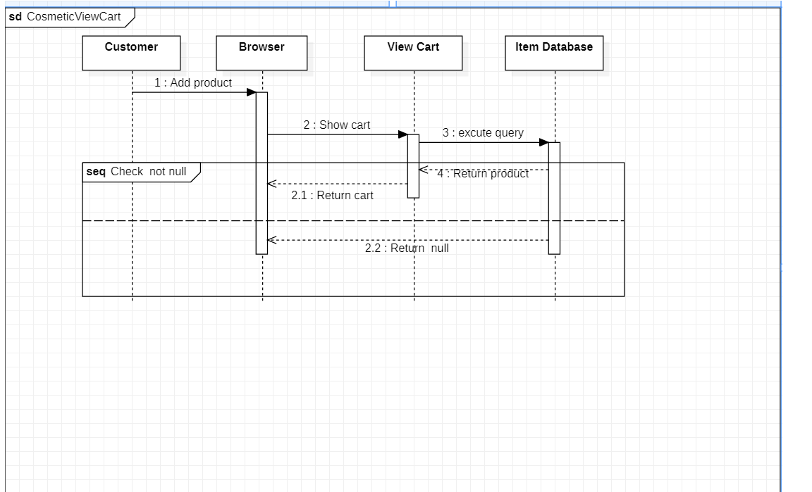Sequence Diagram – View Cart*

## State Machine:

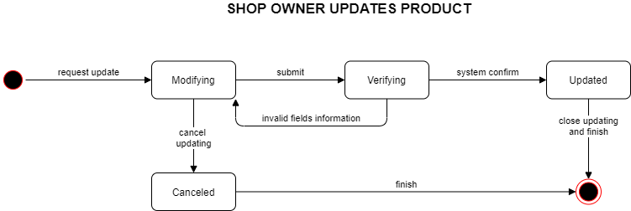

*State Machine – Update Item*

# *E:\Spring2021\SWR302\Assignment_CosmeticManagement\Diagram\Edit Diagram-StateMachine.pngState Machine – Cart*

## E:\Spring2021\SWR302\Assignment_CosmeticManagement\Diagram\CosmeticShop-ClassDiagram-UpdateProduct.pngClass Diagram:

*Class Diagram – Update Item*

*Class Diagram – Order Items