Software Requirements Specification

for

Food Management System, Release 1.0

Version 1.0 approved

Prepared by Lâm Bảo Khang, Lê Thị Thúy Bắc, Phạm Ngọc Khải, Hoàng Ngọc Tùng Lâm

Process Impact

February, 15th 2021

Table of Contents

Revision History ii

1. Introduction 1

1.1 Purpose 1

1.2 Document Conventions 1

1.3 Project Scope and Product Features 1

1.4 References 1

2. Overall Description 1

2.1 Product Perspective 1

2.2 User Classes and Characteristics 2

2.3 Operating Environment 3

2.4 Design and Implementation Constraints 3

2.5 Assumptions and Dependencies 3

3. System Features 3

3.1 Usecase Diagram………………………………………………………………………………..4

3.2 Usecase List……………………………………………………………………………………..4

4. Data Requirements 6

4.1 Logical Data Model 6

4.2 Data Dictionary 6

4.3 Reports 9

4.4 Data Integrity, Retention, and Disposal 9

5. External Interface Requirements 8

5.1 User Interfaces 8

5.2 Software Interfaces 8

5.3 Hardware Interfaces 8

5.4 Communications Interfaces 8

6. Quality Attributes 8

6.1 Usability Requirements 8

6.2 Performance Requirements 8

6.3 Security Requirements 8

6.4 Safety Requirements 9

6.5 Availability Requirements 9

6.6 Robustness Requirements 9

**7. Diagram………………………………………………………………………………………9**

Revision History

|  |  |  |  |
| --- | --- | --- | --- |
| **Name** | **Date** | **Reason For Changes** | **Version** |
| Bảo Khang | 2/28/21 | initial draft | 1.0 draft 1 |
| Khang | 3/1/21 | baseline following changes after inspection | 1.0 approved |

# Introduction

## Background

Vendors nowadays find it hard to selling food at their store in a managing way. Especially at the time where many people go into the store to buy food for their meals. The staff at the shop will also be exhausted if there are too much orders at a time, which leads to having some mistakes in the accounting phrase. The owner of the store has to check the stock and the bills every day the store closed, wasting a lot of time and effort.

## Business Opportunity

Many food store owners have requested an application that they and their staffs could use easily to manage the in and out amount of products sold every day. Besides, the staffs who use the application would know if the items on the list is out of stock or not to tell the customers at the store immediately. For the store owners, the application would also help them doing the accounting job, which reduces a lot of time for the application users.

## Business Objective

Choice for store owners who want to manage their store in a more comfortable and easy way without spending a lot of effort, time and cost of refueling. The users, the staffs, just need to stand at the checkout counter and using this application to making orders for customers. This application is also profitable for the shop owner with the monthly revenue generated from the customers.

## Vision Statement

# Overall Description

## Product Perspective

The Food Management System is a new software system that replaces the current manual and telephone processes for ordering and picking up items from the shops. The context diagram in Figure 1 illustrates the external entities and system interfaces for release 1.0. The system is expected to evolve over several releases, ultimately connecting to the Internet ordering services for several local shops and to credit and debit card authorization services.

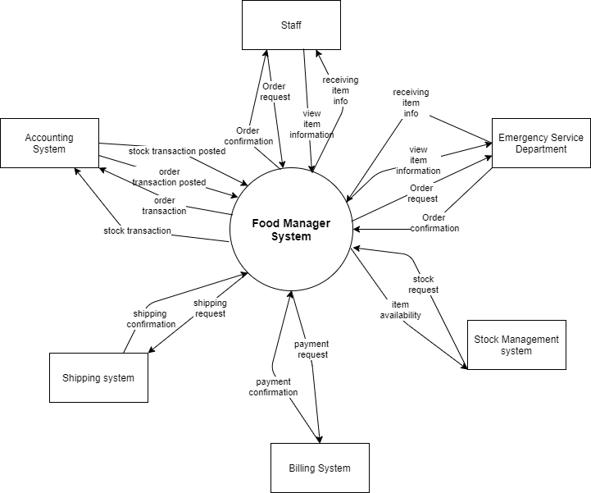

Figure 1. Context diagram for release 1.0 of the Food Management System.

## Major Features

FE-1: Look up and view details of items

FE-2: Order and pay for items from the available list.

FE-3: Provides view, add, remove items in the cart before subscribe for deliver.

FE-4: Shop owner can add, delete, update information of items in shop.

FE-5: View information of customers and details of orders.

FE-6: View sales revenue, know the best-selling items.

## Scope of Initial Release

|  |  |  |  |
| --- | --- | --- | --- |
| Feature | Release 1 | Release 2 | Release 3 |
| FE-1: Look up and view details of items | Search to find items | Click to see more details of the item | Not implemented |
| FE-2: Order and pay for items from the available list | Order from the list only | Accept credit card and cash | Delivery to address |
| FE-3: Provides view, add, remove items in the cart before subscribe for deliver | Create shopping cart and view items | Delete, add items | Submit to order |
| FE-4: Shop owner can add, delete, update information of items in shop | Can edit the items in the list of the web | Update, remove items | Submit the complete list |
| FE-5: View information of customers and details of orders | Click into the order to see full information of customer and items they order |  |  |
| FE-6: View sales revenue, know the best-selling items | See the sale off items | Choose the sale off item |  |

## Design and Implementation Constraints

## Design and Implementation Constraints

## Assumptions and Dependencies

AS-1: Systems with appropriate user interfaces will be available for shop owner to process the expected volume of items ordered.

AS-2: The items in confirmed orders shall be prepared and delivered between 15 minutes locally.

AS-3: The system must response to database system in short times (1-3s).

AS-4: System shall have User Guide to help users using the system comfortably.

DE-1: If a shop has its own on-line ordering system, the Cosmetic Management System must be able to communicate with it bi-directionally.

# System Features

## Usecase Diagram

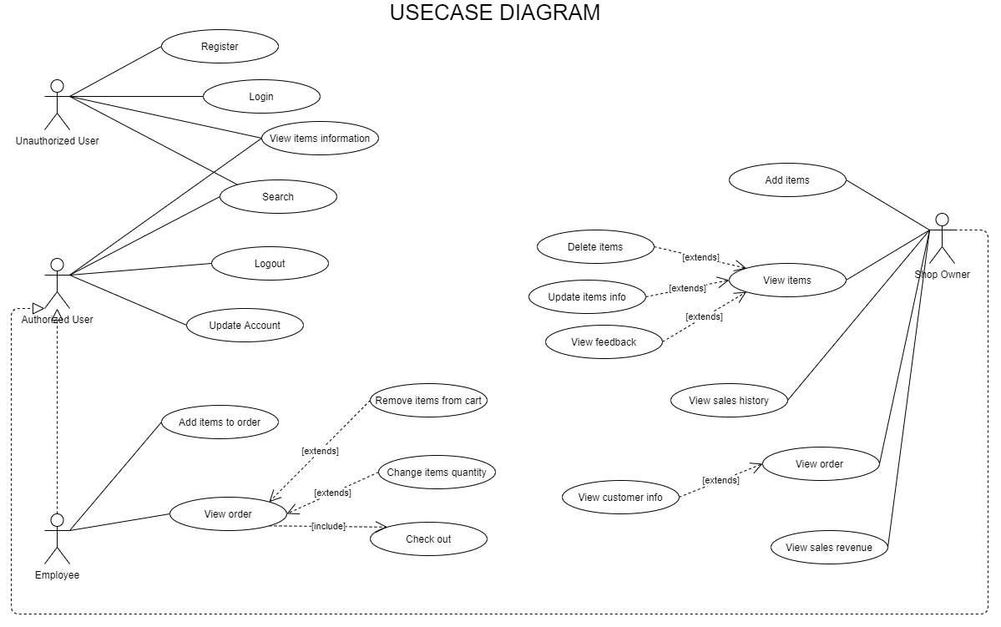

## Usecase List

|  |  |  |  |
| --- | --- | --- | --- |
| UC ID and Name: | UC01 Login | | |
| Created By: | Khang | Date Created: | 18/3/2021 |
| Primary Actor: | User | Secondary Actors: | Account Database |
| Trigger: | User clicks “Login” button | | |
| Description: | When user wants to using this application, they must login | | |
| Preconditions: | The application is opened | | |
| Postconditions: | System displays user view page based on user role | | |
| Normal Flow: | 1. Application started, system displays login page. 2. User inputs Username and Password to login 3. System validates Username and Password fields 4. System displays view page based on user role. | | |
| Alternative Flows: |  | | |
| Exceptions: | 1. Wrong or null password, username 🡪 System warns shop owner and display error in the confirmation form. 2. The Internet connection is interrupted when user clicks “Login”🡪 System still caches the inputted information at server and shows message “Please wait a moment and click login again later.”. | | |
| Priority: | High | | |
| Frequency of Use: | Approximately 50 times a day. When staffs or store owners want to manage food in the stores | | |
| Business Rules: | Systems shall display user view page between 3s | | |
| Other Information: | User could cancel login action | | |
| Assumptions: | none | | |

|  |  |  |  |
| --- | --- | --- | --- |
| UC ID and Name: | UC02 Register | | |
| Created By: | Khang | Date Created: | 19/3/2021 |
| Primary Actor: | User | Secondary Actors: | Account Database |
| Trigger: | User clicks “Register” button | | |
| Description: | When user wants to using this application, they must have an account | | |
| Preconditions: | The application is opened. User click “Register” button | | |
| Postconditions: | System displays login page after register successfully | | |
| Normal Flow: | 1. System display register form 2. User fill in the required fields on the form to register 3. System validates information in the fields and warns user if there is any error. 4. User clicks “Submit” button (see 1.1) 5. System send message about register action, then displays login page. | | |
| Alternative Flows: | 1.1 User clicks “Cancel” button  1.2 Systems returns to login page. | | |
| Exceptions: | 1. Wrong or null inputted fields 🡪 System warns user and displays error in the confirmation form. 2. The Internet connection is interrupted when user clicks “Submit”🡪 System still caches the inputted information at server and shows message “Please wait a moment and click login again later.”. | | |
| Priority: | High | | |
| Frequency of Use: | Approximately 5 times a month. When there is new account to register. | | |
| Business Rules: | Systems shall display register form between 3s | | |
| Other Information: | User could cancel register action | | |
| Assumptions: | none | | |

|  |  |  |  |
| --- | --- | --- | --- |
| UC ID and Name: | UC03 Delete item information | | |
| Created By: | Lam | Date Created: | 19/1/2021 |
| Primary Actor: | Shop owner | Secondary Actors: | Account Database, Item Database |
| Trigger: | Shop owner has chosen to delete item information. | | |
| Description: | Shop owner wants to delete items information, | | |
| Preconditions: | Logged in as Shop owner. | | |
| Postconditions: | Pop-up message shows item has been delete. | | |
| Normal Flow: | 1. System shows item managing options. 2. Shop owner chooses item to delete or input ID in txtID. 3. Shop owner chooses delete. 4. System displays form YES/NO “Are you sure want to delete ?”. 5. Shop owner click YES to delete. 6. System displays message that item is delete. | | |
| Alternative Flows: | None | | |
| Exceptions: |  | | |
| Priority: | High | | |
| Frequency of Use: | Approximately 10 times a month, when shop owner has to update the items in shop, mostly at weekends. | | |
| Business Rules: | 1. Only one item is allowed to delete at a time. 2. Cannot delete item when this item is in any order. | | |
| Other Information: | None | | |
| Assumptions: | None | | |

|  |  |  |  |
| --- | --- | --- | --- |
| UC ID and Name: | UC04 Check out shopping cart | | |
| Created By: | Lam | Date Created: | 19/01/2021 |
| Primary Actor: | Employee | Secondary Actors: | Food database  Order detail database  Order database |
| Trigger: | Employee checkout and output order for customer | | |
| Description: | For employee to review products they have added to the shopping cart | | |
| Preconditions: | User has register or login as employee | | |
| Postconditions: | User has add the products to the shopping cart | | |
| Normal Flow: | 1. User search the product 2. System filter out the products that employee search in the search category and return the product that customers search 3. User choose the product they want and quantity 4. User add the product into the shopping cart 5. System will add the product customer choose into the shopping cart 6. So that users can see the view of the product they choose in view cart 7. System will show the total price | | |
| Alternative Flows: | none | | |
| Exceptions: |  | | |
| Priority: | Low | | |
| Frequency of Use: | Average a customer will use up to 12 times a day, depending on the need of the customer | | |
| Business Rules: | none | | |
| Other Information: | none | | |
| Assumptions: | none | | |

|  |  |  |  |
| --- | --- | --- | --- |
| UC ID and Name: | UC05 Update Account | | |
| Created By: | Bac | Date Created: | 19/1/2021 |
| Primary Actor: | Admin | Secondary Actors: | Account Database |
| Trigger: | Admin has chosen to update Account information. | | |
| Description: | Admin wants to update Account information. | | |
| Preconditions: | Logged in as Admin. | | |
| Postconditions: | Pop-up message shows item has been update. | | |
| Normal Flow: | 1. System shows all Account information. 2. Admin chooses account to update. 3. Update information. 4. Admin chooses update. 5. System displays form YES/NO “Are you sure want to Update ?”. 6. Shop owner click YES to Update. 7. System displays message that account is updated. | | |
| Alternative Flows: | None | | |
| Exceptions: |  | | |
| Priority: | High | | |
| Frequency of Use: |  | | |
| Business Rules: | 1. Only one item is allowed to update at a time. | | |
| Other Information: | None | | |
| Assumptions: | None | | |

|  |  |  |  |
| --- | --- | --- | --- |
| UC ID and Name: | UC06 Search Account | | |
| Created By: | Bac | Date Created: | 19/1/2021 |
| Primary Actor: | Admin | Secondary Actors: | Account Database |
| Trigger: | Admin has chosen to search Account information. | | |
| Description: | Admin wants to search Account information. | | |
| Preconditions: | Logged in as Admin. | | |
| Postconditions: |  | | |
| Normal Flow: | 1. System shows all Account information. 2. Admin fill name of account in txtSearch . 3. Admin chooses Search. 4. System display List result. | | |
| Alternative Flows: | None | | |
| Exceptions: |  | | |
| Priority: | High | | |
| Frequency of Use: |  | | |
| Business Rules: |  | | |
| Other Information: | None | | |
| Assumptions: | None | | |

|  |  |  |  |
| --- | --- | --- | --- |
| UC ID and Name: | UC07 Add to cart | | |
| Created By: | Ngoc Khai | Date Created: | 22/03/2021 |
| Primary Actor: | Employee | Secondary Actors: | Cart Database |
| Trigger: | Add to cart | | |
| Description: | For employee to add product to the shopping cart for order of customer | | |
| Preconditions: | Employee has register or login as shop owner | | |
| Postconditions: | Employee has add the products to the shopping cart | | |
| Normal Flow: | 1. System ask employee to register or login 2. Employee has register/login 3. System return register/login success or failed 4. Employee search the product 5. System filter out the products that employee search in the search category and return the product that employee search 6. Employee choose the product customer wants 7. Employee add the product into the shopping cart 8. System will add the product employee choose into the shopping cart | | |
| Alternative Flows: | none | | |
| Exceptions: | 1. System will output the error if employee add the product but didn’t login --> System out println(“You must register/login first”) 2. System will output the error if the employee choose product with quantity is 0 and status is 0 --> System out println(“The product is out of stock”) | | |
| Priority: | Low | | |
| Frequency of Use: | Average a shop owner will use up to 12 times a day, depending on the need of the customer | | |
| Business Rules: | none | | |
| Other Information: | none | | |
| Assumptions: | none | | |

|  |  |  |  |
| --- | --- | --- | --- |
| UC ID and Name: | UC08 View cart | | |
| Created By: | Ngoc Khai | Date Created: | 22/03/2021 |
| Primary Actor: | Employee | Secondary Actors: | Cart Database |
| Trigger: | View cart | | |
| Description: | For employee to review products they have added to the shopping cart for order of customer | | |
| Preconditions: | Employee has register or login as shop owner | | |
| Postconditions: | Employee can view product in cart | | |
| Normal Flow: | 1. System ask employee to register or login 2. Employee has register/login 3. System return register/login success or failed 4. Employee press the button “View Cart” 5. The system will show the cart to employee 6. Employee will check the cart, delete or change the quantity of each product in cart 7. After check the cart, employee can check out to save the cart to database 8. Shop owner will check the cart and ship product to customer | | |
| Alternative Flows: | none | | |
| Exceptions: | 1. System will output the error if employee add the product but didn’t login 🡪 System out println(“You must register/login first”) 2. System will output the error if the cart is empty 🡪 System out println(“Shopping cart is empty !!”) | | |
| Priority: | Low | | |
| Frequency of Use: | Average a shop owner will use up to 12 times a day, depending on the need of the customer | | |
| Business Rules: | none | | |
| Other Information: | none | | |
| Assumptions: | none | | |

# Data Requirements

## Logical Data Model (ERD)

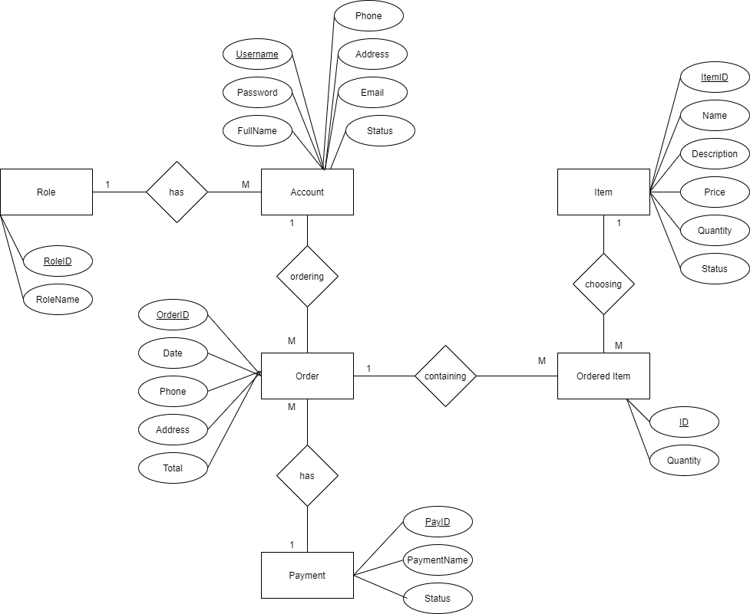

Figure . Partial data model for release 1.0 of the Cosmetic Management System.

## Data Dictionary

|  |  |  |  |  |
| --- | --- | --- | --- | --- |
| Data Element | Description | Composition or Data Type | Length | Values |
| Username | User ID number of the person using the app, order items. | Alphanumeric | 10 |  |
| Fullname | Sav the full name of the user registered the account | Alphabetic | 50 |  |
| Password | Password of the account of the user | Alphanumeric | 20 |  |
| Birthday | Date of birth of the customer using the app | date, MM/DD/YYYY | 10 |  |
| Address | Address of the customer for the shipping orders | Alphanumeric | 100 | Hyphens and commas permitted |
| Email | Email address of the customer ordering items | Alphanumeric | 50 |  |
| Phone | Phone number of the customer ordering items | AAA-EEE-NNNN xXXXX for area code | 18 |  |
| Order ID | String specify order | Alphanumeric | 50 |  |
| DayOfCreate | The date of the order will build when employee order | Date, MM/dd/yyyy | 10 |  |
| Status | Status order | integer | 10 |  |
| TotalPrice | Total price of the order | float | 20 |  |
| FoodID | String specify food | String | 30 |  |
| FoodName | Food name | String | 50 |  |
| Description | Food Description | String | 100 |  |
| Price | Food price | float | 20 |  |
| StatusFood | Food status | True/false |  |  |
| CategoryID | String specify Category | String | 10 |  |
| CategoryName | Categoty Name | String | 50 |  |
| Order detail id | String specify detail | String | 10 |  |
| Quantity | Quantity of food | int | 100 |  |
| PriceDetail | Total detailed price | floatư |  |  |

## Reports

## Data Integrity, Retention, and Disposal

DI-1: The CMS shall retain Individual customer orders for 6 months following the order’s delivery date.

# External Interface Requirements

## User Interfaces

## Software Interfaces

## Hardware Interfaces

## Communications Interfaces

# Quality Attributes

## Usability Requirements

USE-1: The CMS shall allow a shop owner to retrieve the previous ordered with a single interaction.

USE-2: 90% of new users shall be able to successfully order items without errors on their first try.

## Performance Requirements

PER-1: The system shall accommodate a total of 500 users and a maximum of 100 concurrent users during the peak usage time window of 9:00 A.M. to 2:00 P.M. local time, with an estimated average session duration of 8 minutes.

PER-2: 95% of webpages generated by the CMS shall download completely within 4 seconds from the time the user requests the page over a 20Mbps or faster Internet connection.

PER-3: The system shall display confirmation messages to users within an average of 3 seconds and a maximum of 6 seconds after the user submits information to the system.

## Security Requirements

SEC-1: All network transactions that involve financial information or personally identifiable information shall be encrypted by 256-bit encryption.

SEC-2: Shop owner shall be required to log on to the CMS for all operations except making an order.

SEC-3: The system shall permit customers to view only orders that they made.

## Safety Requirements

SAF-1: The user shall be able to see a list of all ingredients in any items.

## Availability Requirements

AVL-1: The CMS shall be available at least 70% of the time between 5:30 A.M. and midnight local time and at least 80% of the time between midnight and 5:30 A.M. local time, excluding scheduled maintenance windows.

## Robustness Requirements

ROB-1: If the connection between the user and the CMS is broken prior to a new order being either confirmed or terminated, the CMS shall enable the user to recover an incomplete order and continue working on it.

# Diagram:

## E:\Spring2021\PRN292\Assignment\diagram\FoodManager-Login_Sequence.pngSequence Diagram

*Login*

*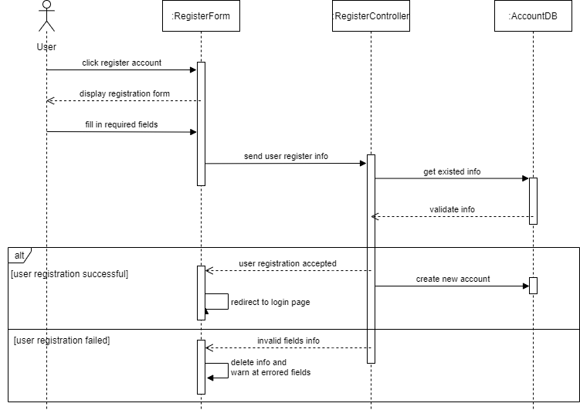Register*

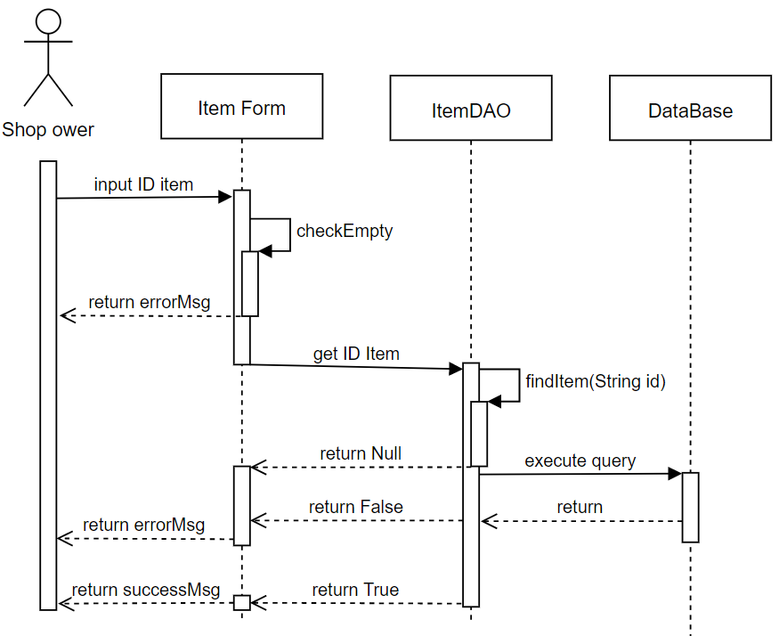

*Delete Food*

*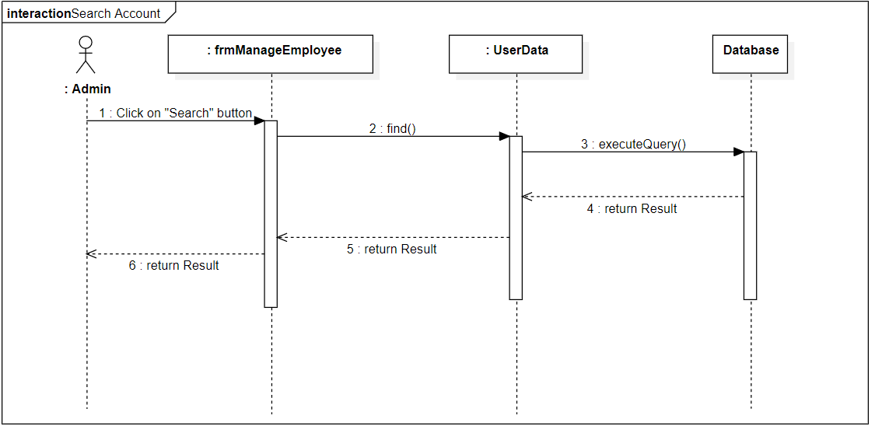*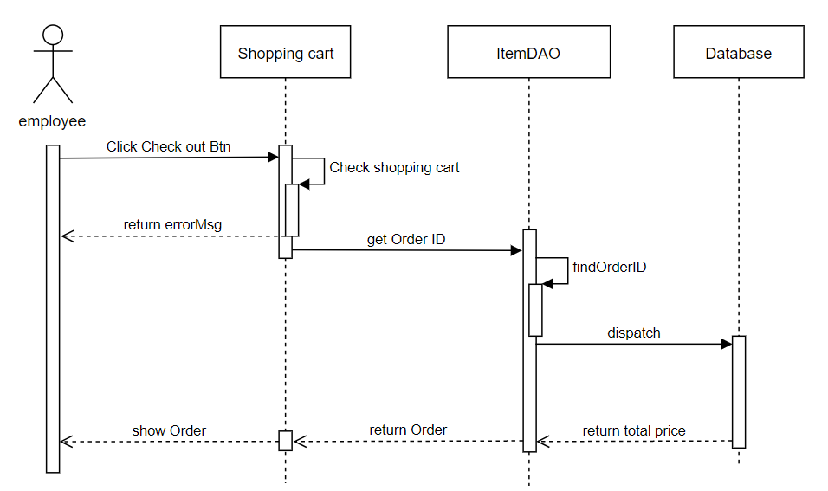*Checkout*

*Search Account*

*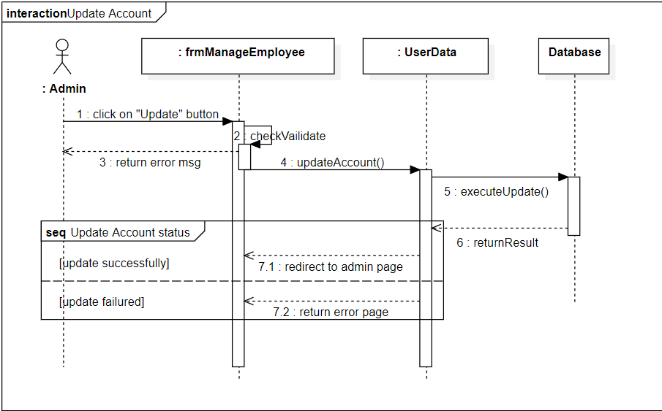*

*Update Account*

## State Machine:

Login

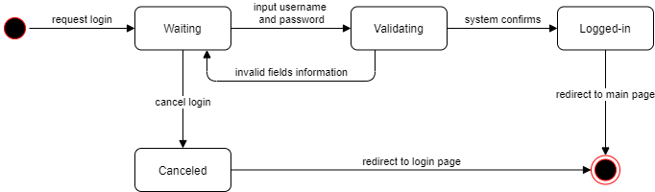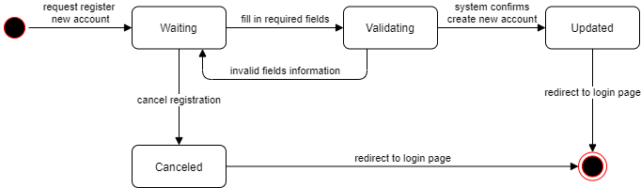Register

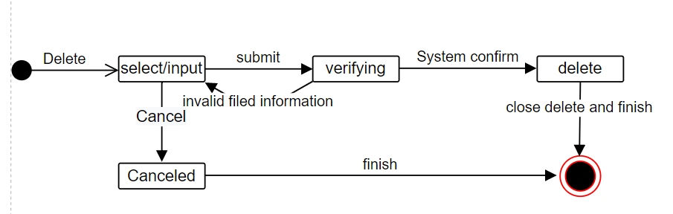

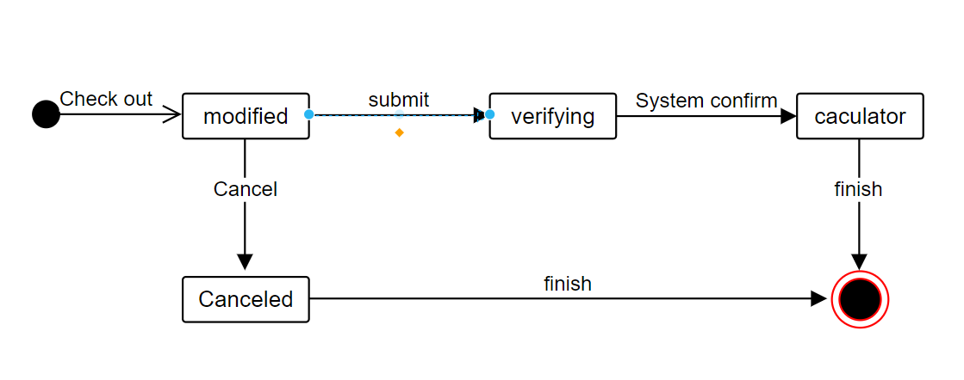Checkout

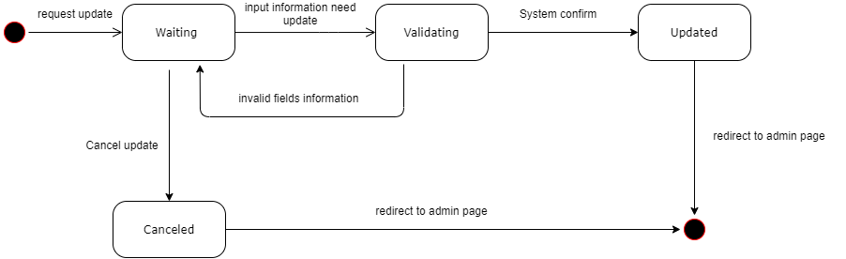Update Account

## Class Diagram:

