Recommender Systems - Course Project Report
Cumulative report template - Parts 1, 2, and 3
Team | 12
Members | Chi Nguyen, Khang Le
For Part 3 track: select one | A / B / C
GitHub repository link | https://github.com/khangle2004/MovieLens-rec-sys

How to use this template
- This is one cumulative report. Extend and revise the same document at each project stage.
- Maximum length: 4 pages at Part 1, 8 pages at Part 2, and 12 pages for the final report, excluding references.
- Keep the section headings below. You may add subsections where useful.
- All explanations and justifications requested in the project specification belong in this report.
- The Results Sheet contains the complete standardized numerical record. In the report, include only the tables and figures needed to support your analysis.
- Delete all italic instructional text before the final submission.

1. Part 1 - Data, Protocol and Baselines

1.1 Data characterization
MovieLens 1M contains 1 000 209 ratings provided by 6 040 users for 3 706 movies (out of 3 883 available movies). Considering only movies with observed interactions, the user-item matrix has a density of approximately 4.47% and a sparsity of 95.53%, indicating that the majority of user-movie interactions are unobserved.
The average user contributes 165.60 ratings, with a standard deviation of 192.75 ratings. The large standard deviation relative to the mean suggests substantial variability in user activity. While the median user provides only 96 ratings, the most active user contributes 2 314 ratings, indicating that a small proportion of highly active users account for a large share of the interactions.

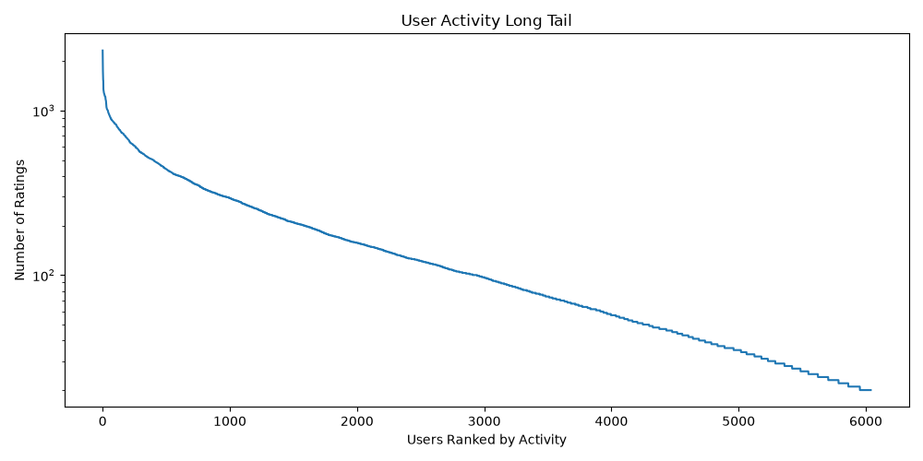
Figure 1: User rating distribution
On the other hand, a movie receives an average of 269.89 ratings. However, the median movie receives only 123.50 ratings. The substantial difference between the mean and median, together with the large standard deviation of 384.05 ratings, indicates a highly skewed distribution of movie popularity. The most popular movie accumulates 3 428 ratings. Furthermore, 25% of movies receive no more than 33 ratings, whereas 25% receive more than 350 ratings.
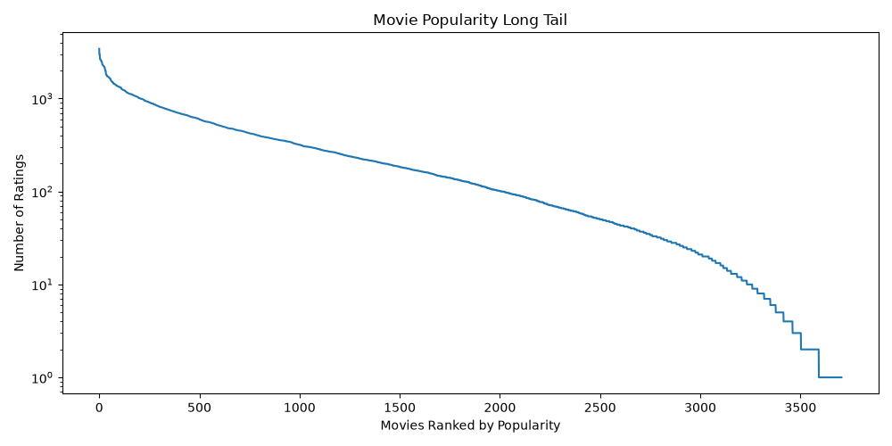
Figure 2: Movie rating distribution
Daily rating activities were collected from 25.04.2000 to 28.02.2003. From Figure 3, rating activity is highly concentrated in a short period from the beginning to early 2001. There are extreme spikes in this period, especially the largest one in around November, 2000. From 2001 onward, activity becomes very sparse and remains low until 2003.
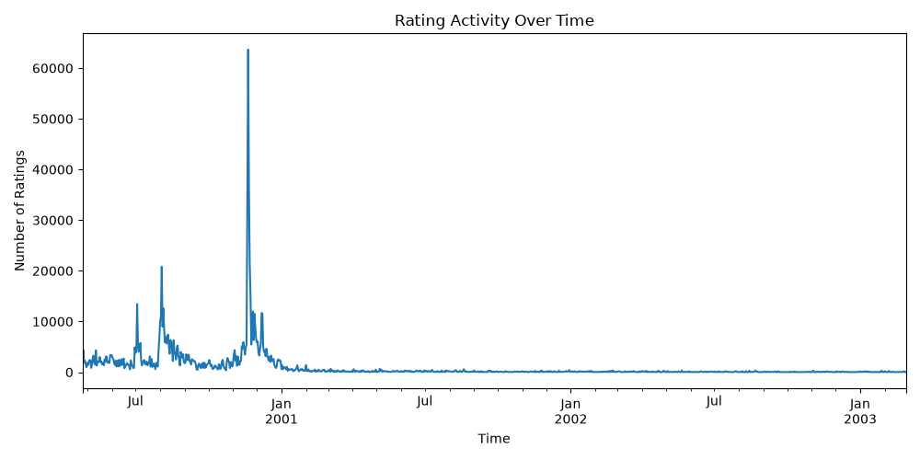
Figure 3: Rating activity over time
In addition, the rating distribution is positively skewed toward higher ratings. Ratings of 4 account for the largest proportion of interactions (34.89%), followed by ratings of 3 (26.11%) and 5 (22.63%). In contrast, ratings of 1 and 2 represent only 5.62% and 10.75% of all ratings, respectively. Overall, approximately 57.5% of ratings are either 4 or 5, indicating that users tend to provide favorable evaluations more frequently than negative ones.
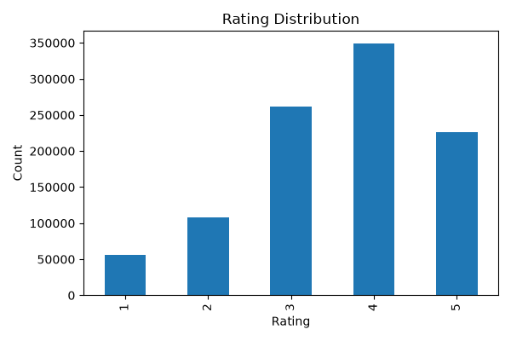
Figure 4: Rating distribution

1.2 Preprocessing and feedback treatment
By inspecting the dataset, no duplicate or invalid rows were found in the ratings, user, or movie data. Therefore, no records were removed during preprocessing. The only change made was the addition of the date of the rating converted from the given timestamps.

1.3 Train/validation/test split
The rating activity is highly concentrated during late 2000, with substantially lower activity in subsequent years. Therefore, a temporal split based on the chronological order of interactions. The earliest 80% of interactions were assigned to the training set, the following 10% to the validation set, and the final 10% to the test set. Noticing from Figure 5 that most of the sparse activity occurs after the major rating peaks, this low-activity period was intentionally reserved for testing. This provides a more challenging and realistic evaluation scenario, as the model is trained on periods with abundant interactions and evaluated on future data where user activity is considerably lower.
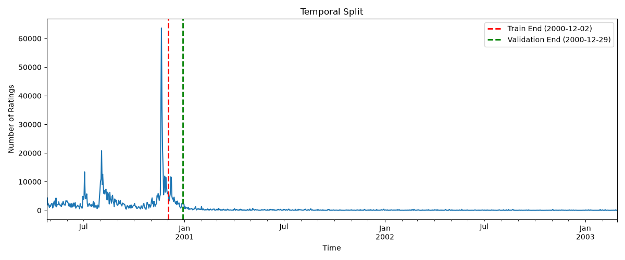
Figure 5: Daily rating activity with temporal split boundaries

1.4 Evaluation protocol
For evaluation, we use the following metrics:
- Precision@10: Measures the proportion of relevant movies among the top 10 recommended items
- Recall@10: Measures the proportion of all relevant movies that are successfully retrieved within the top 10 recommendations
- NDCG@10: Evaluates both the relevance and the ranking position of recommended items. Relevant items appearing near the top of the recommendation list contribute more to the score than those appearing lower in the ranking.
- Catalogue Coverage: Measures the proportion of movies that appear at least once across all recommendation lists
The neighborhood size k and similarity measure for Item-kNN were selected using the validation set. NDCG@10 was used as the primary model-selection metric because it considers both recommendation accuracy and ranking quality. The configuration with the highest validation NDCG@10 was chosen for final testing.

1.5 Baseline methods and settings

1.5.1 Most Popular
The Most Popular baseline recommends movies according to their popularity in the training data. Two variants were evaluated:
- All ratings: Movies are ranked by the total number of ratings received in the training set.
- Positive Ratings: Movies are ranked by the number of positive ratings (ratings ≥ 4) received in the training set.
Information about the datasets can be seen in the below table:
Table 1: Datasets' information
Dataset | Split ratio (%) | Size | Positive ratings (≥ 4) | Retained (%)
Training | 80 | 800 164 | 463 017 | 57.87
Validation | 10 | 100 024 | 57 812 | 57.80
Test | 10 | 100 021 | 54 452 | 54.44

1.5.2 Item-based kNN
Item-based kNN recommends movies based on their similarity to items previously rated positively by a user. We consider the following metrics for the model:
- Cosine similarity
- Adjusted Cosine similarity
- Jaccard similarity
We set the k range as {1,10,20,50,100,200,500}. The variants will be evaluated with only positive ratings as threshold.

1.6 Results and analysis
With the specified settings, we achieve the following results for the models, using the validation set that can be observed in Table 2 as follows
Table 2: Experimential results on validation dataset
Model | Precision@10 | Recall@10 | NDCG@10 | Catalogue coverage
Most popular (all ratings) | 0.23 | 0.06 | 0.25 | 0.04
Most popular (positive ratings) | 0.24 | 0.06 | 0.26 | 0.03
kNN – Cosine similarity (optimal k=500) | 0.11 | 0.05 | 0.12 | 0.05
kNN – Adjusted Cosine similarity (optimal k=20) | 0.08 | 0.04 | 0.09 | 0.07
kNN – Jaccard similarity  (optimal k=500) | 0.10 | 0.04 | 0.11 | 0.06

From the results, the Most Popular baselines achieved the highest recommendation accuracy. The positive-ratings variant obtained the best overall performance, achieving the highest Precision@10 (0.24) and NDCG@10 (0.26), while matching the highest Recall@10 (0.06).
Compared to the Most Popular methods, the Item-based kNN models with their optimal k values achieved lower Precision@10, Recall@10, and NDCG@10 scores. Among the kNN variants, Cosine similarity performed best, obtaining a Precision@10 of 0.11 and an NDCG@10 of 0.12. Jaccard similarity produced slightly lower recommendation accuracy.
However, the kNN approaches provided greater recommendation diversity. Adjusted Cosine achieved the highest catalogue coverage (0.07), followed by Jaccard similarity (0.06) and Cosine similarity (0.05). In contrast, the Most Popular baselines exhibited very low coverage (0.03-0.04)

2. Part 2 - Models and Honest Comparison

2.1 Models
Describe the additional models and paradigms. Clearly identify the self-implemented algorithm and explain its implementation.

2.2 Hyperparameter tuning and variability
Describe the validation-only tuning procedure, search spaces/budgets, random seeds, and confidence intervals or statistical testing.

2.3 Overall results
Present and discuss the main comparison. Explain important differences and avoid unsupported claims.

2.4 Disaggregated analysis
Report and interpret results broken down by at least two of the required dimensions: items with few vs. many training interactions, low- vs. high-activity users, popular vs. long-tail items, and early vs. late test period. Define any thresholds used and focus on findings that change or qualify the overall conclusions.

2.5 Sparsity ablation
Report and discuss the 100%, 50%, and 20% training-interaction experiments, including changes in the ranking between models.

3. Part 3 - Beyond Accuracy

3.1 Selected track and motivation
State Track A, B, or C and briefly motivate the selected intervention/extension.

3.2 Method
Describe only your selected track. The Track A/B/C guidance below is provided as instructions; delete the guidance for the two tracks you did not select before submission.

If Track A - Diversity and popularity bias
State the base recommender, selected re-ranking method, genre-vector item representation, trade-off parameter, and exact item-distance measure. Describe how the parameter was swept.

If Track B - Fairness
Define the release-decade provider proxy, report and justify the final decade boundaries and group sizes, state and justify the adopted fairness notion, describe the consumer groups based on MovieLens user attributes, and identify the stage and form of the mitigation.

If Track C - Group recommendations
State the selected synthetic group type and justify the chosen group size (3-5). Describe the three aggregation strategies. Identify which strategy was extended to the sequential scenario and explain how satisfaction is carried forward between recommendation rounds.

3.3 Results and trade-offs
Present the required track-specific results. Track A: report intra-list diversity, catalogue coverage, Gini and calibration error across the parameter sweep, and discuss the accuracy-diversity frontier. Track B: report position-weighted exposure against catalogue share, per-group consumer-side accuracy, and the fairness-performance frontier. Track C: compare group satisfaction, disagreement and minimum member satisfaction across the three aggregation strategies, then analyse how member and group satisfaction develop in the sequential scenario.

3.4 Cost and interpretation
State what is gained, what is lost, and who bears the cost where applicable. Explain what operating choice or strategy you would select and why.

3.5 "One number we cannot explain"
Identify one result you do not fully understand and describe how you would investigate it.

4. Discussion and Conclusions
Summarize the main findings across the project. Discuss limitations, failed approaches where relevant, and what the experiments support.

5. Contribution Statement
Chi Nguyen: helped with coding, proposing ideas, and documenting the report.
Khang Le: helped with inspecting the data, setting up the team’s repository, coding and documenting the report.
Both members share the same work amount and contributed equally to the first section.

6. Use of AI Assistants
The team has used Copilot to support writing idea and project understanding. We also implemented some functions with the help of the agent.

References
List references used in the report. References do not count toward the page limit.

