CYT 145 - Ethical and Legal Issues

Project option A - Network Design and Configuration Infrastructure

Instructor
Professor Lisa Li

Student (Individual work)
Khang Le 119039253

Introduction
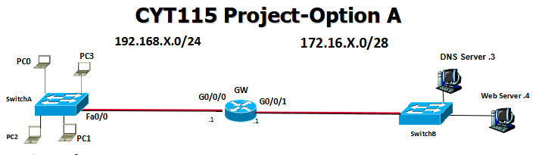
This project involves designing and configuring a dual-LAN network in Cisco Packet Tracer using a Cisco 2911 router, 2960 switches, Cisco PCs, and two Server-PT devices for DNS and web hosting. The network uses static IP addressing, provides DNS and HTTP/HTTPS services, and implements port security and ACLs to control access between the user LAN and server LAN. The project demonstrates essential skills in routing, switching, service configuration, and basic network security.

Project Objectives

- Design a dual-LAN network topology using a Cisco 2911 router, Cisco 2960 switches, PCs, and server devices.
- Assign static IPv4 addressing to all network devices for consistent and reliable connectivity.
- Configure essential network services, including DNS and a web server hosting HTTP/HTTPS.
- Implement router configuration to enable communication between the user LAN and server LAN.
- Apply switch port security to restrict unauthorized device connections on access ports.
- Deploy Access Control Lists (ACLs) to control traffic flow, limit access to server resources, and secure remote management.
- Verify network functionality through testing of connectivity, DNS resolution, web access, and ACL enforcement.

Devices List
- 1 Router: Cisco 2911 router.
- 2 Switches, Switch A (left) and Switch B (right): 2960 switches.
- 4 Pcs: Cisco PCs.
- 1 DNS Server: Cisco Server-PT.
- 1 Web Server: Cisco Server-PT.

Connections
Copper straight-through cables will be used across all connections for connecting different kinds of network devices. The setup includes left network of client side with 4 client PCs connected to a switch under 192.168.10.0/24 network and right network under 172.16.20.0/28 network consists of DNS and webserver connect to a switch.
Left side network (192.168.10.0/24):
PC should be connected to switch through fast internet port since switch supports 100 Mbps Fast Ethernet ports.
PC (FastEthernet0) → Switch (FastEthernet0/1-4)
Enterprise switches reserve the highest numbered port for uplinks to routers.
FastEthernet0/24 → GigabitEthernet0/0
Right side network (172.16.20.0/28):
Connected through straight-through cable with Ethernet.
Server (FastEthernet0) → Switch (FastEthernet0/1-2)
Enterprise switches reserve the highest numbered port for uplinks to routers.
FastEthernet0/24 → GigabitEthernet0/1

Assigned IP Table
IP addresses are assigned through device’s Desktop tab:
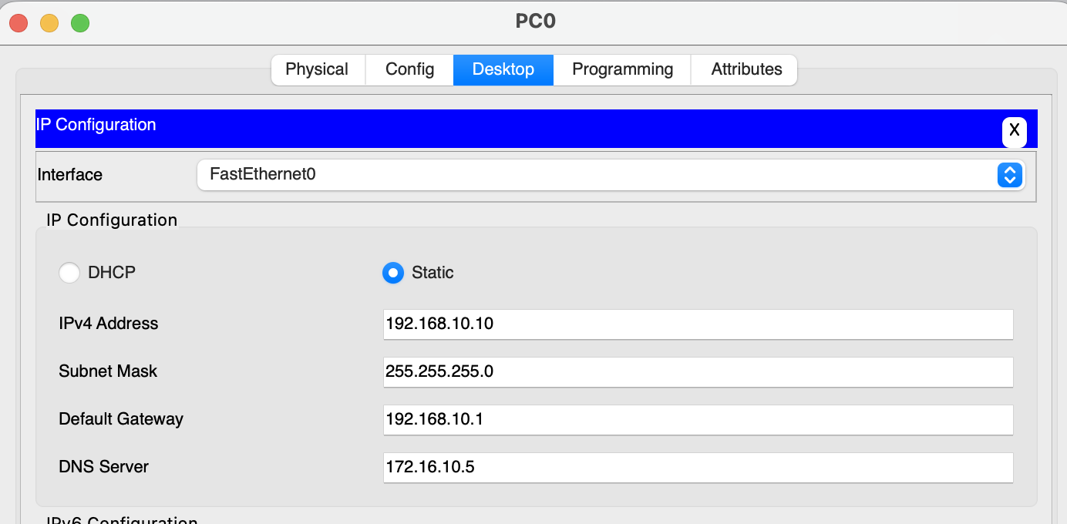
IPv4, subnet mask and gateway of each device are configured as following table:
Devices | IPv4 Address | Subnet Mask | Gateway
PC0 | 192.168.10.10 | 255.255.255.0 | 192.168.10.1
PC1 | 192.168.10.11 | 255.255.255.0 | 192.168.10.1
PC0 | 192.168.10.10 | 255.255.255.0 | 192.168.10.1
PC0 | 192.168.10.10 | 255.255.255.0 | 192.168.10.1
 | 192.168.10.1 | 255.255.255.0 | 192.168.10.1
  Router G0/0
 | 172.16.20.1 | 255.255.255.240 | 172.16.10.1
  Router G0/1
DNS server | 172.16.20.5 | 255.255.255.240 | 172.16.10.1
Web Server | 172.16.20.6 | 255.255.255.240 | 172.16.10.1

Configure the Router
sets up two router interfaces with IP addresses, enables them, and saves the configuration. left interface (192.168.10.1/24), and the right interface (172.16.20.1/28). The router can be configured through following commands:
Appendix A: Router Configuration
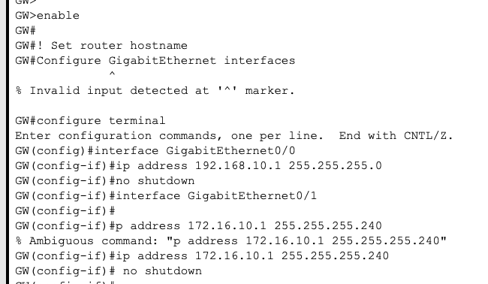
The desired setting after configuring:
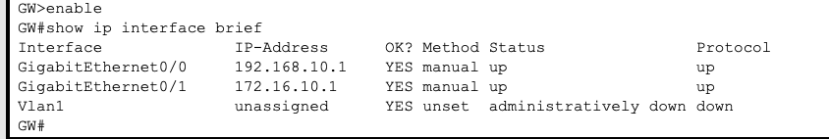
And set cyt115.local as a domain-name:
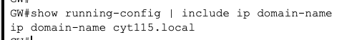
Configure router to allow SSH with encrypted password:
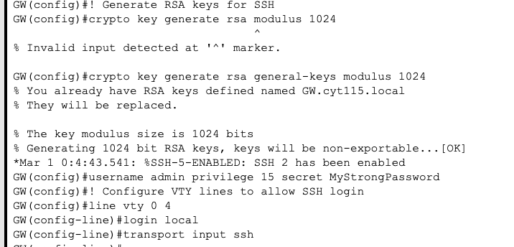
The result account uses for ssh:
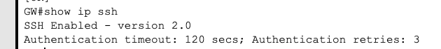
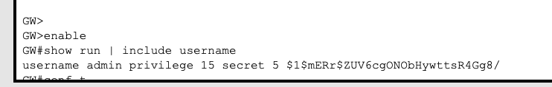

Configure DNS SERVER
DNS server serves as address translation, allows to lookup devices by defined name rather than IPv4. It should have A records for itself and for the web server.
I can be configured through the services tab:
Appendix B: DNS server Configuration
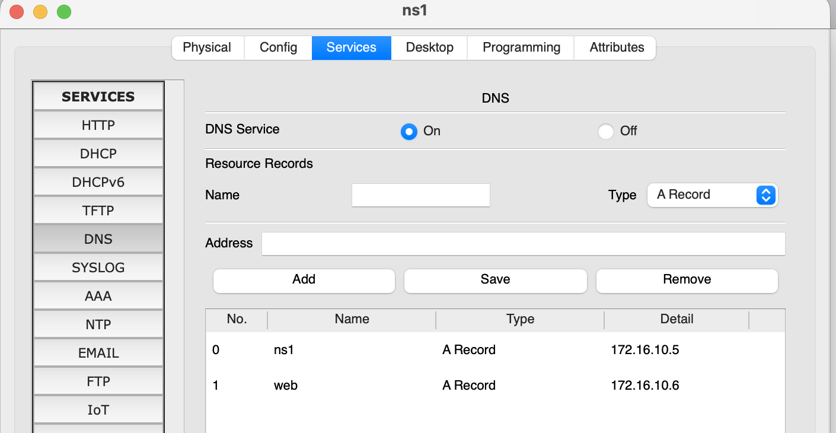

Configure WEB SERVER
Web server allows device to lookup web page through typing IPv4 address in web browser. It can be configured through HTTP tab under device services, for this setting, only HTTPS connection is allowed for its security capacity.
Appendix C: Web server Configuration

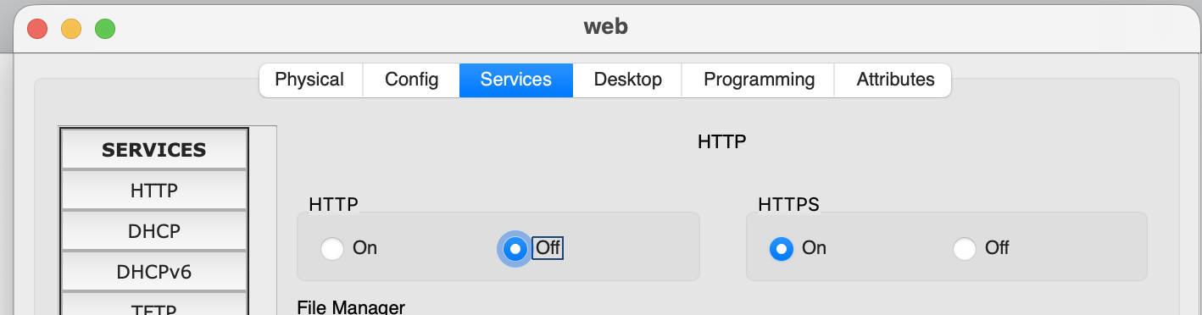

Configuring Switch Port Security
I configured switch ports fa0/1 to fa0/4 as access ports with port security, allowing only one device per port and using sticky MAC addresses to remember connected devices; this ensures that unauthorized devices are blocked while legitimate devices maintain network access. Switch on the right side should follow similar setting.
Appendix D: Switch Configuration
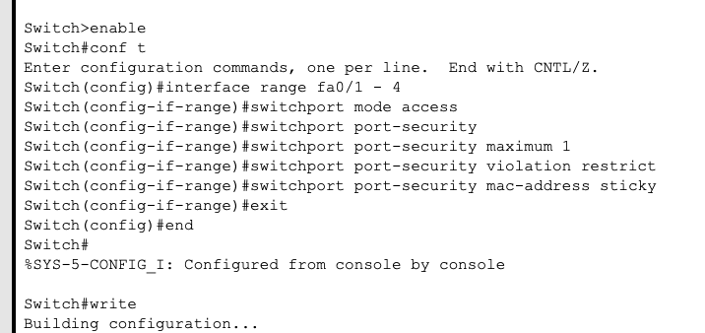

Configure the ACL
ACL is lists of rules that control incoming and exiting traffic through the network, for this project, ACL allows all PCs to have access to DNS and web server, while only PC0 can ping DNS and webserver. Furthermore, PC1/2 can SSH login to GW router, and all rest type of IP packet from left network to right network should be blocked. It can be configured through the router through these commands:

Router> enable
Router# configure terminal
! Define ACL
Router(config)# access-list 10 permit 192.168.10.1
! Apply to an interface (inbound traffic)
Router(config)# interface GigabitEthernet0/0
Router(config-if)# permit udp 192.168.10.0 0.0.0.255 host 172.16.10.3 eq 53
The ACL after configuring is as follow:
Appendix E: ACL Configuration

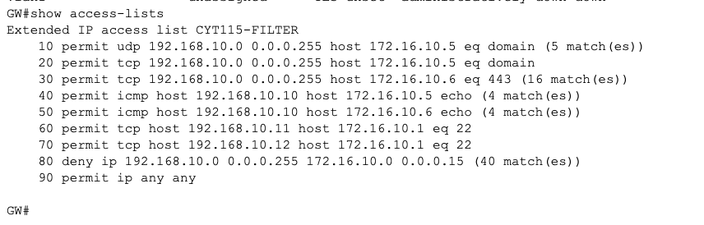

Connectivity check
Connect to web server all PC should be all to access the web server through HTTPS and connect through HTTP is not allowed since its less secure
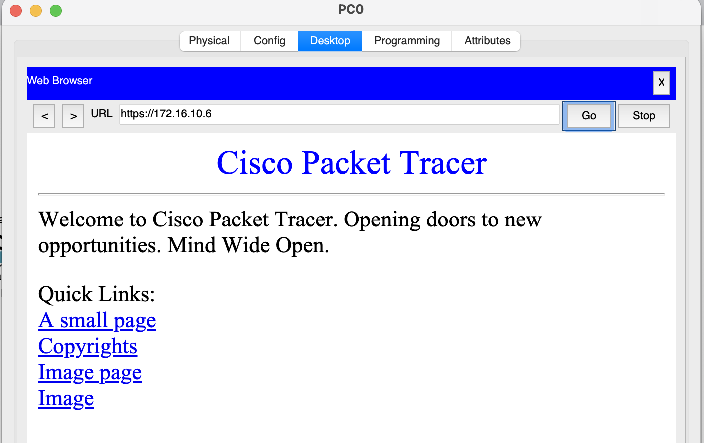
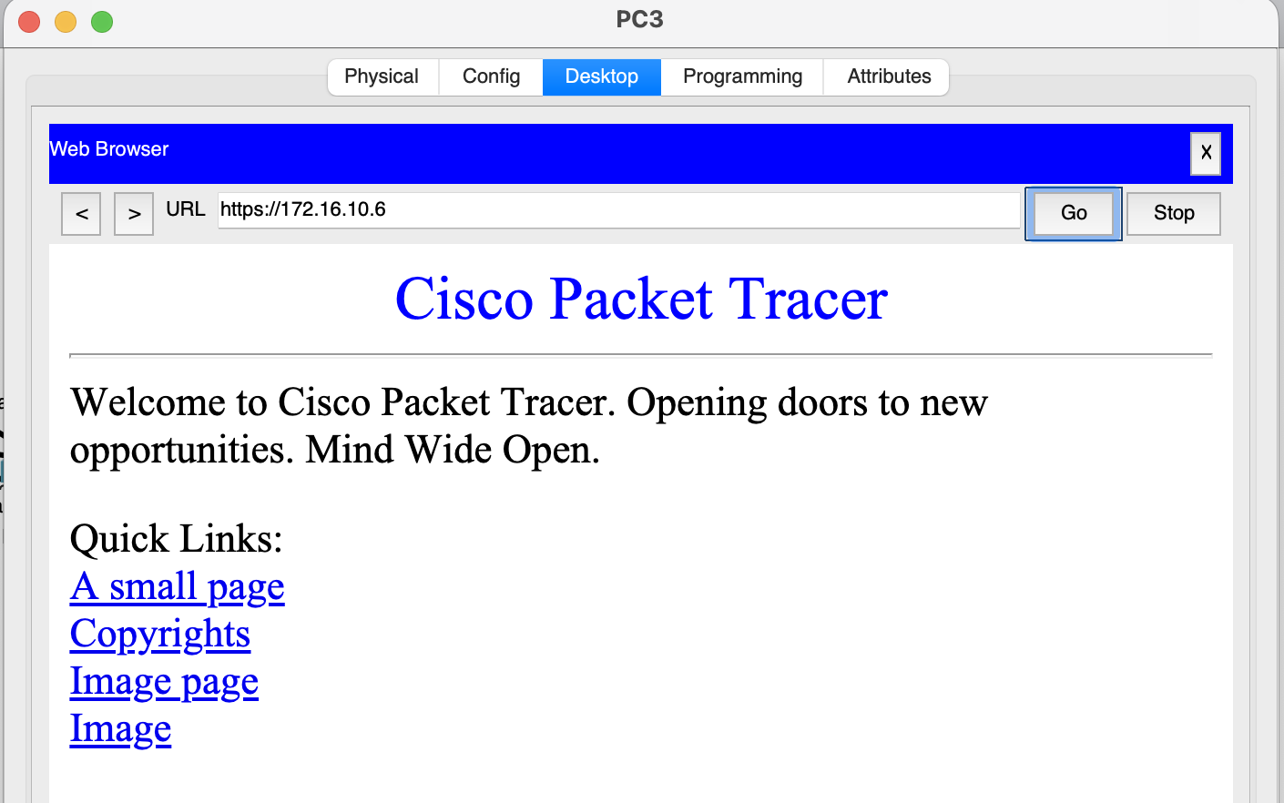
PC0 can ping web server and web server:
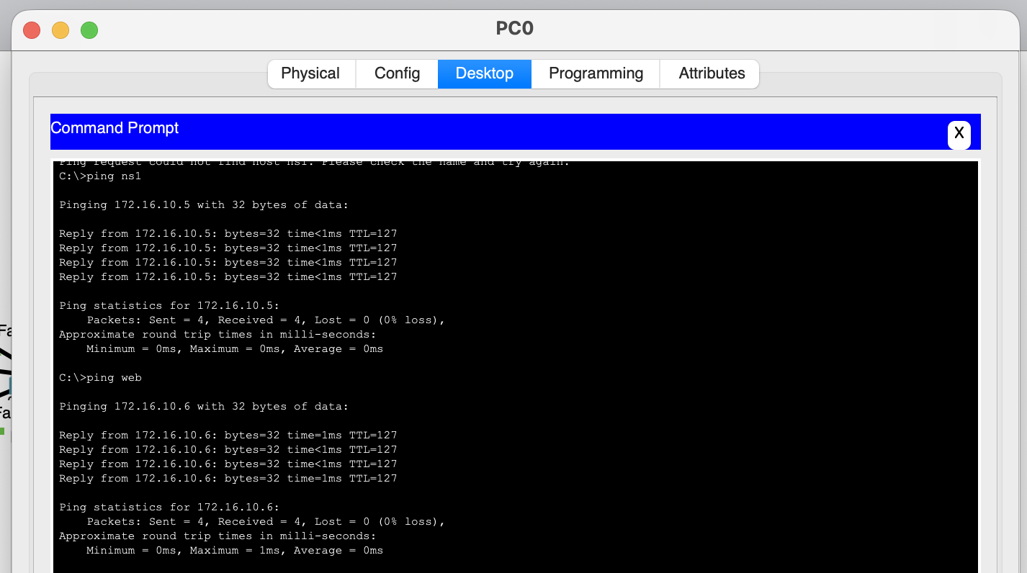

Pc1/2 can ssh into router securely with encrypted password, the ssh connection is established for the router with the following credential:

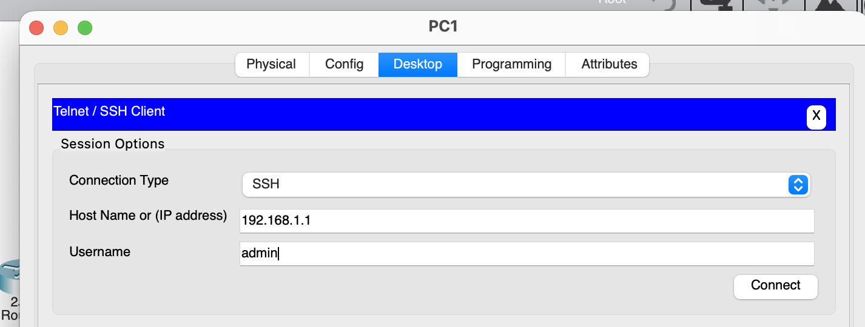
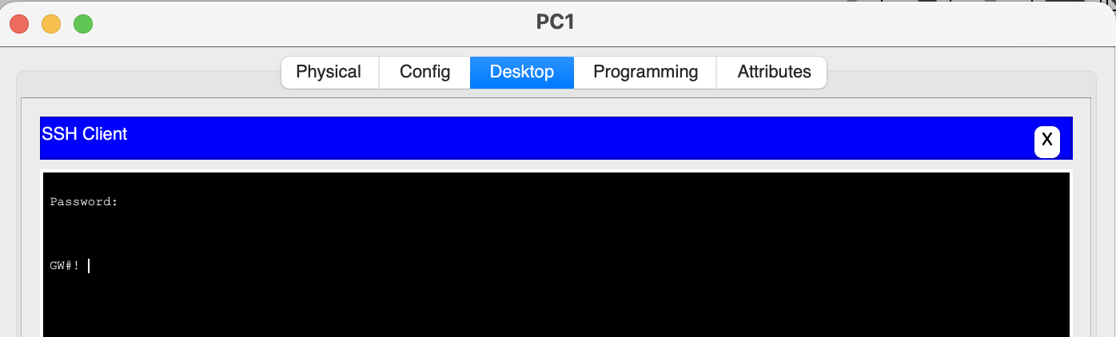
Connection that are not permitted on the ACL should be blocked:
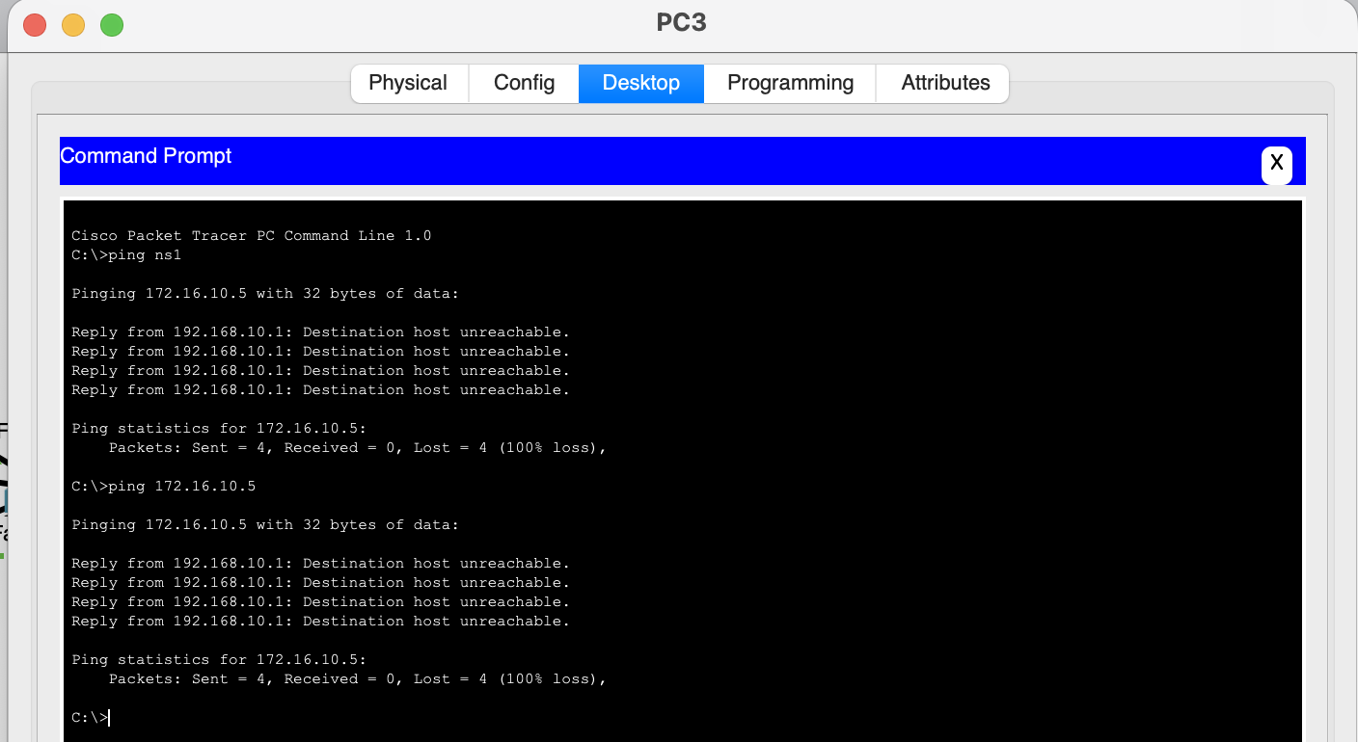
Physical layout of the final project:
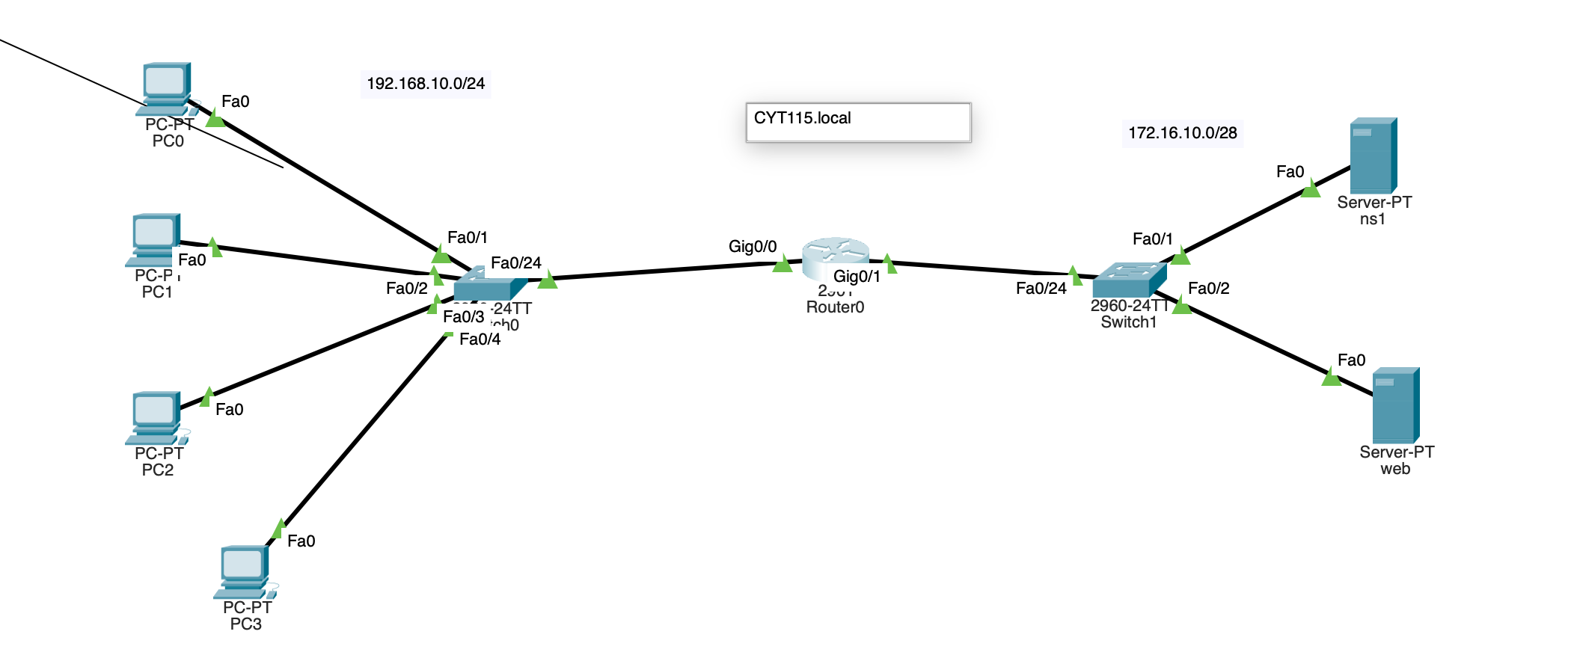

Summary:
The CYT 115 Project focused on designing and securing a small network infrastructure using Cisco Packet Tracer. Key tasks included configuring router interfaces, setting up SSH with encrypted passwords, and implementing ACLs to control traffic and restrict access to critical resources. Switch port security was applied to harden access to servers, ensuring only authorized devices could connect. The project emphasized practical skills in network configuration, security enforcement, and traffic management, providing hands-on experience with industry-standard networking practices.

Appendix:
Appendix A: Router Configuration
Appendix B: DNS server Configuration
Appendix C: Web server Configuration
Appendix D: Switch Configuration
Appendix E: ACL Configuration

References

Seneca College – CYT115 Course Materials
Seneca College. (2025). CYT115 Lab 10,11,12: VLANs and Inter-VLAN Routing. School of Information Technology Administration & Security.
Seneca College. (2025). CYT115 Lecture 11: Firewalls.pdf. School of Information Technology Administration & Security.

