CYT180 – Final Project

Instructor
Prof. Hessam Zakerzadeh

Student name and id
Khang Le 119039253

0-screen picture showing works were done on personal device
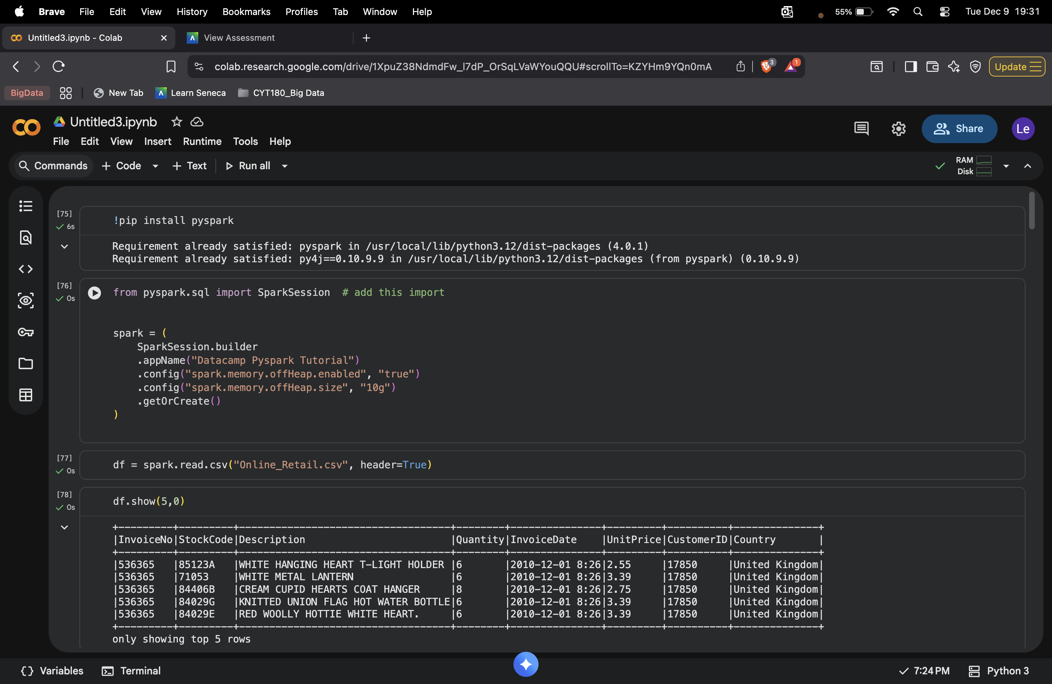

Step 1: Creating a SparkSession
This initializes a SparkSession, which is the main entry point for running PySpark operations.
Off-heap memory is enabled to allow Spark to use native memory outside the JVM heap.
The session is created with a custom app name and returns an existing one if already active.

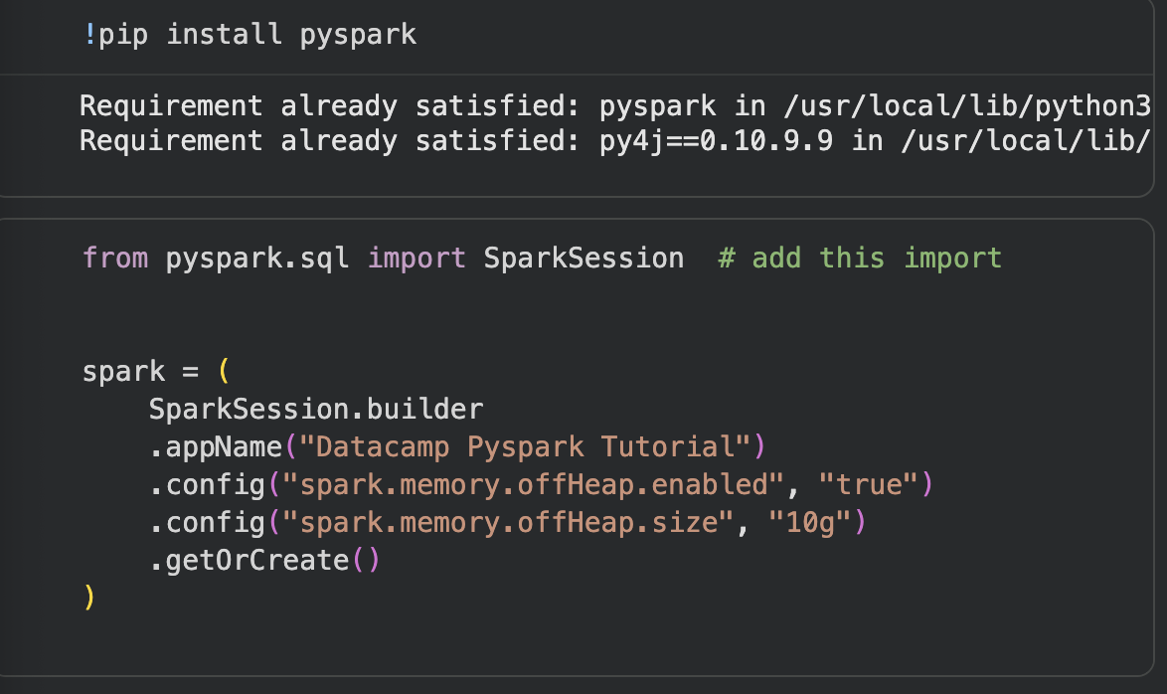

Step 2: Creating the DataFrame

The dataset is loaded from a CSV file and displayed to confirm its structure and content.

A count of all rows is performed to understand the dataset size.

The code groups transactions by country and calculates the number of unique customers in each one.
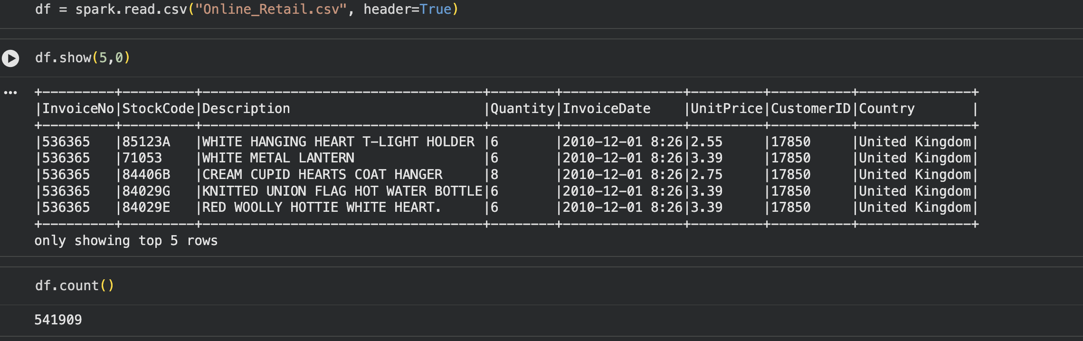

Step 3: Exploratory data analysis
This code groups the data by country and calculates the number of unique customers in each group. It helps identify how many distinct buyers come from each country.
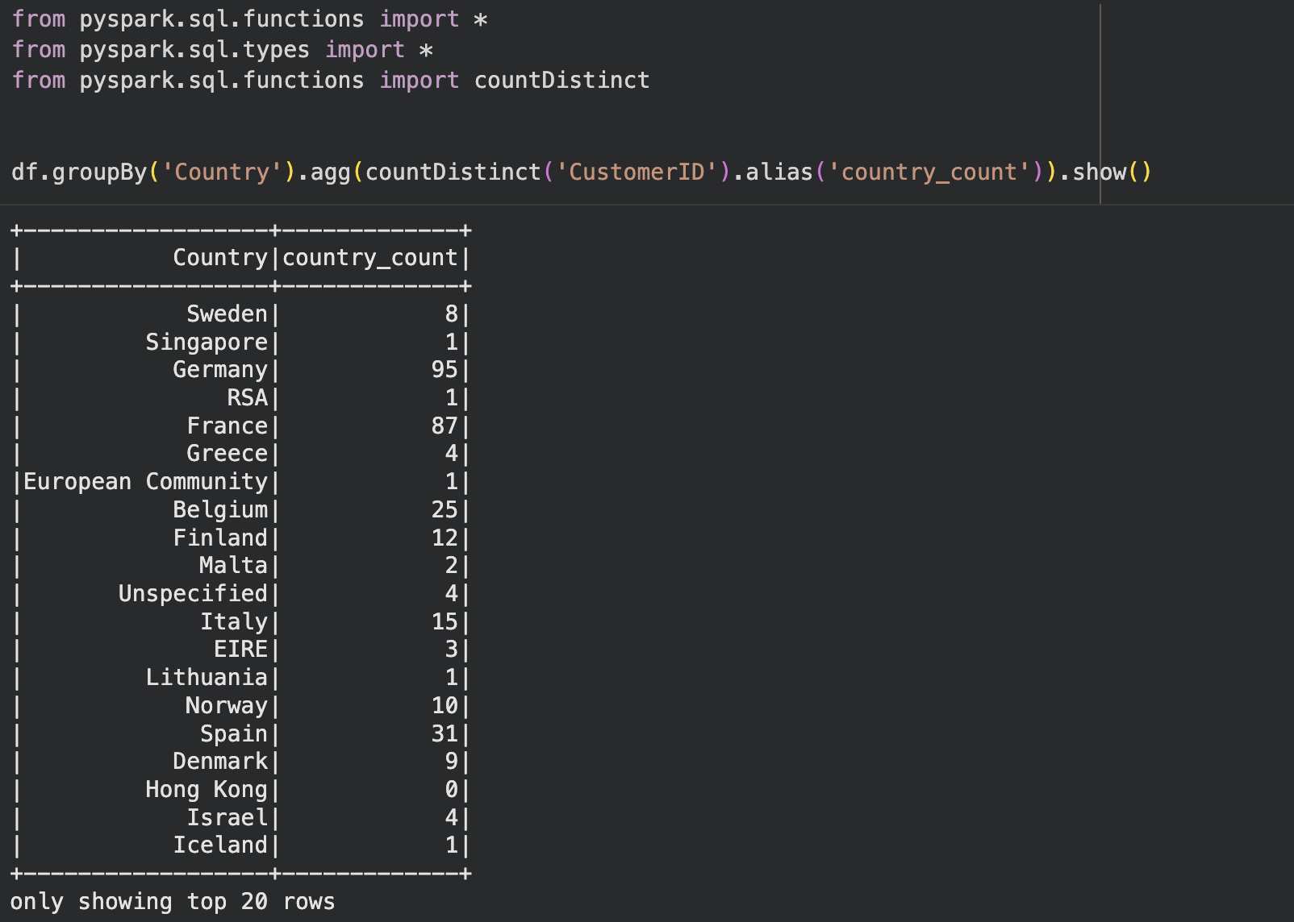

This code groups the dataset by country and calculates how many unique customers each country has. It then sorts the results in descending order so the countries with the highest customer counts appear first.
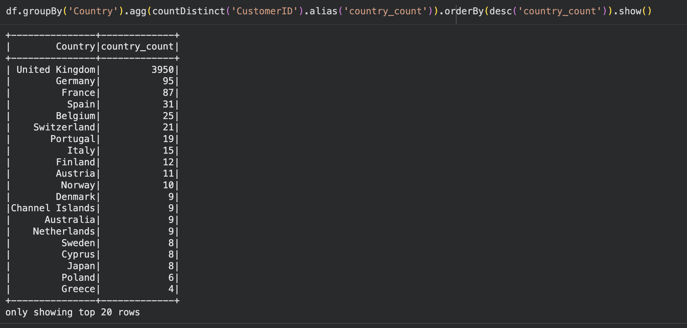

This code creates a new column by trying multiple timestamp formats until Spark successfully parses the InvoiceDate value. It then retrieves the earliest and latest dates in the dataset to confirm the full date range.
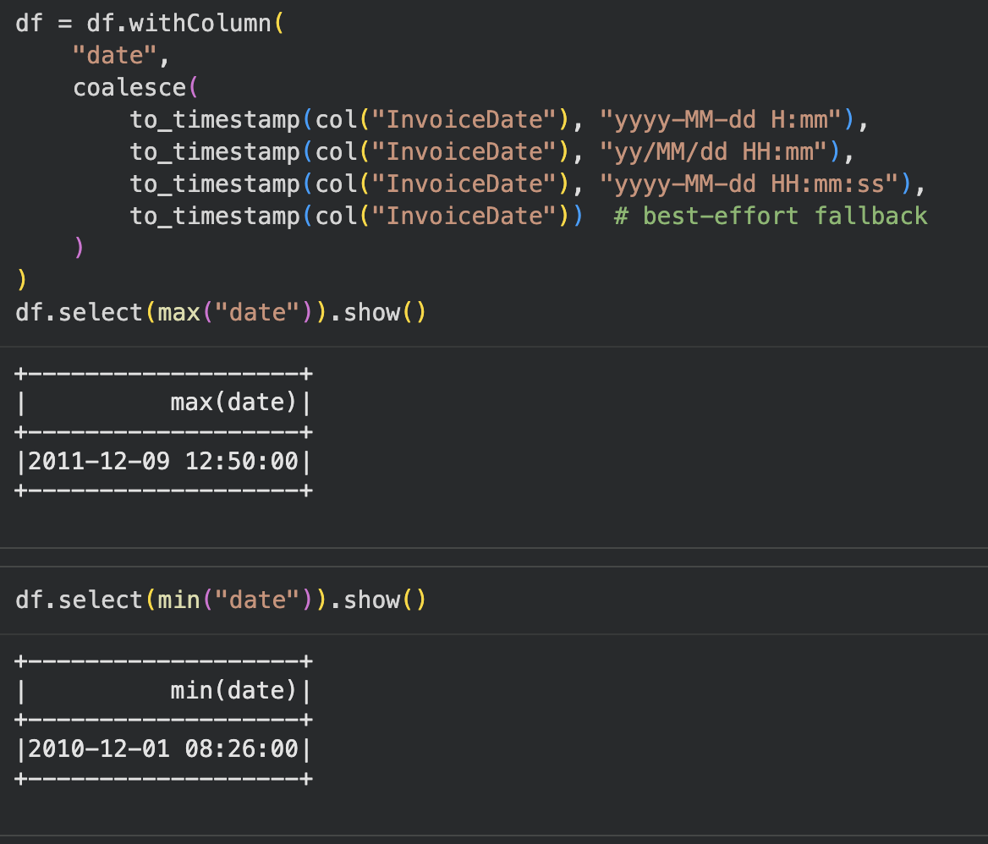

Step 4: Data pre-processing
The new date column has been successfully added and now shows properly parsed timestamps. The first five rows confirm that the transformation worked and the dates are consistent across the sample records.
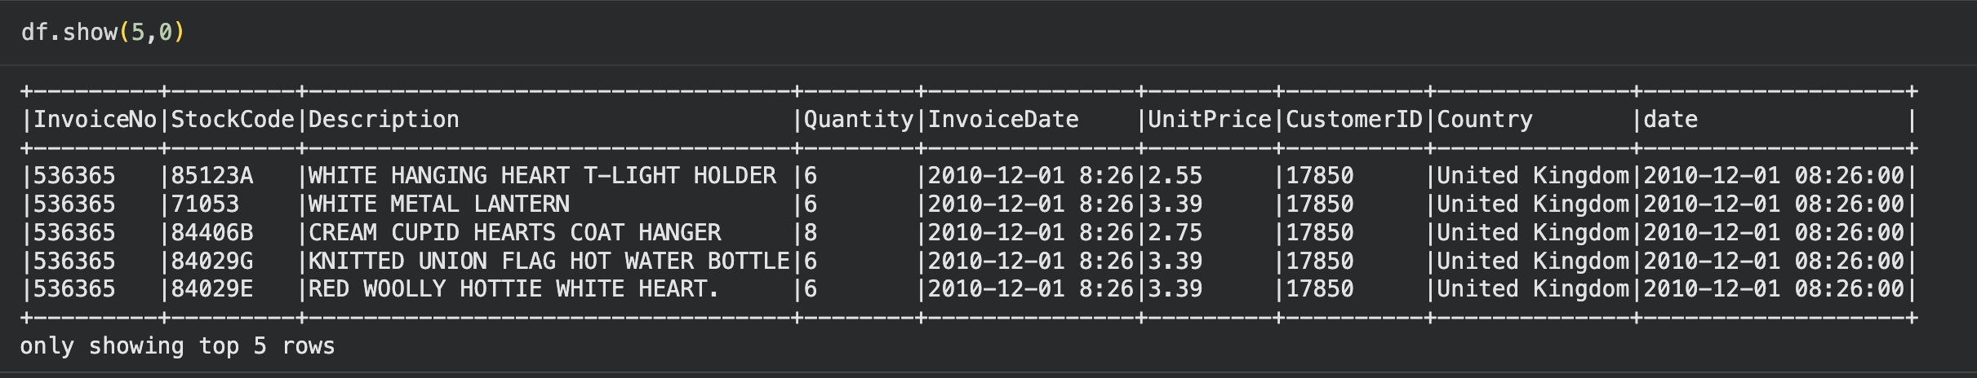

This code calculates customer recency by subtracting a fixed reference date from each transaction date. It then uses a window function to keep only the most recent record per customer and joins the results to produce a final recency table.
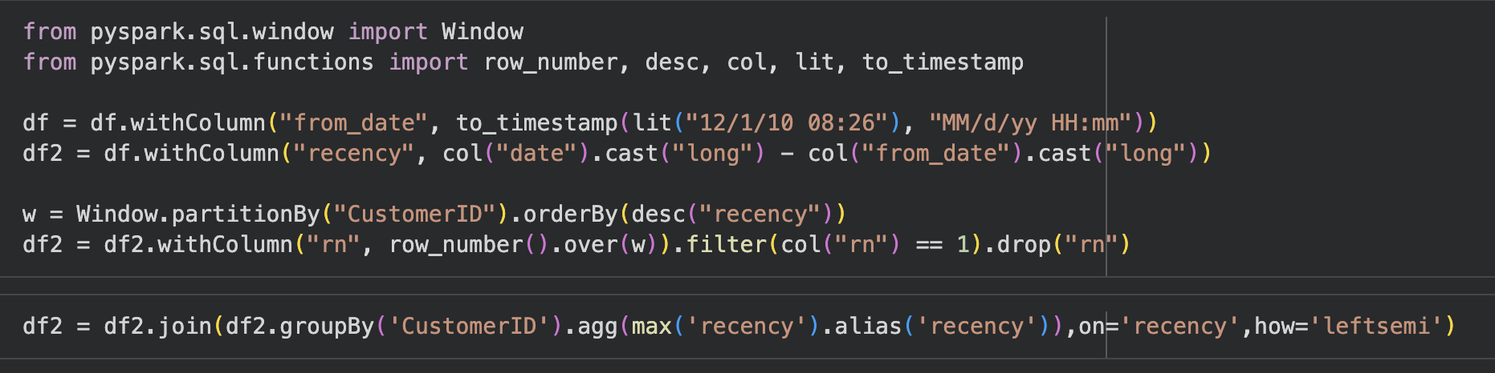
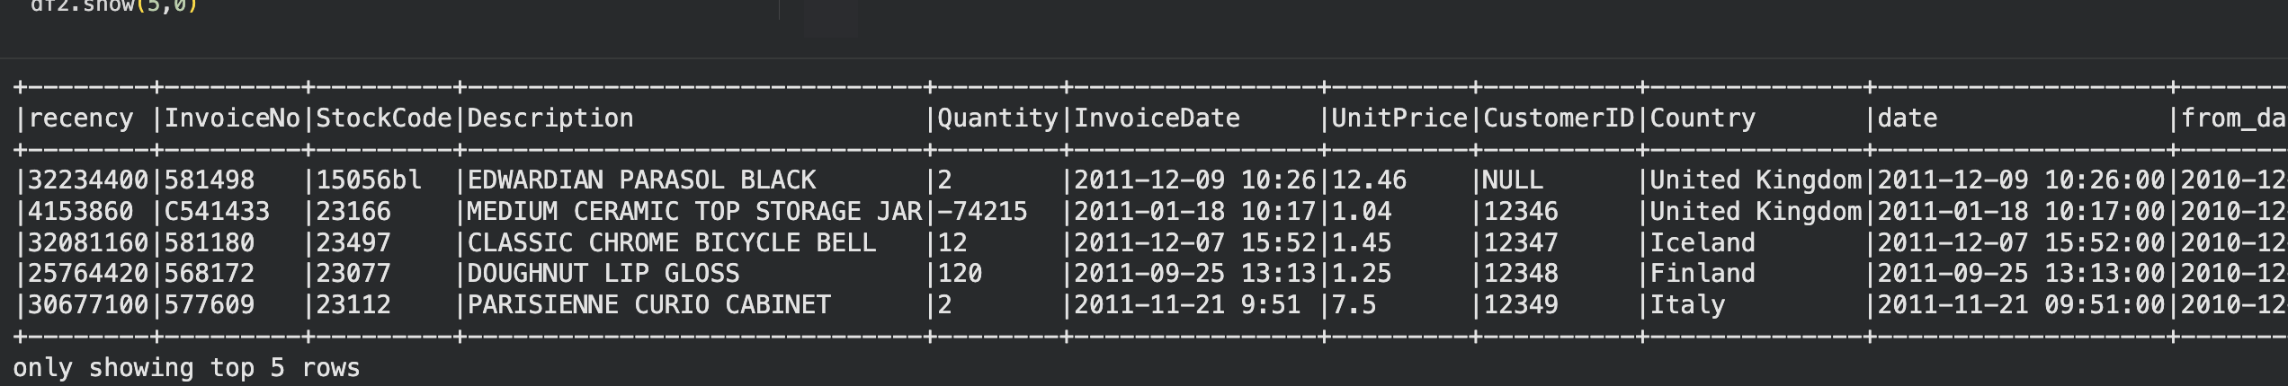
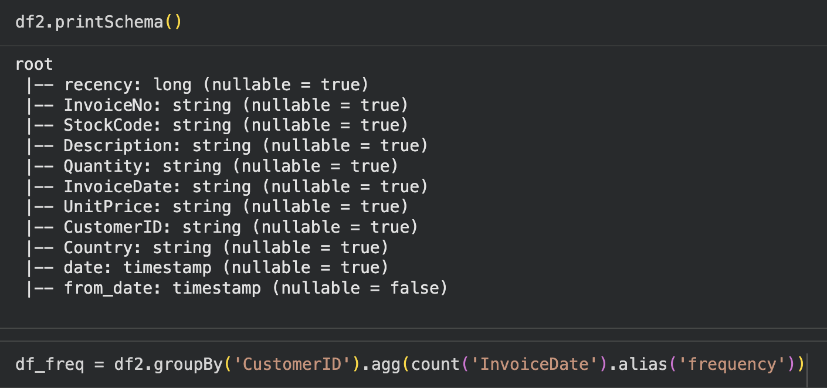

A frequency table is created to count how many transactions each customer has made. The main dataset is then joined with this frequency table, resulting in a combined schema that includes recency, transaction details, and the frequency metric for each customer.
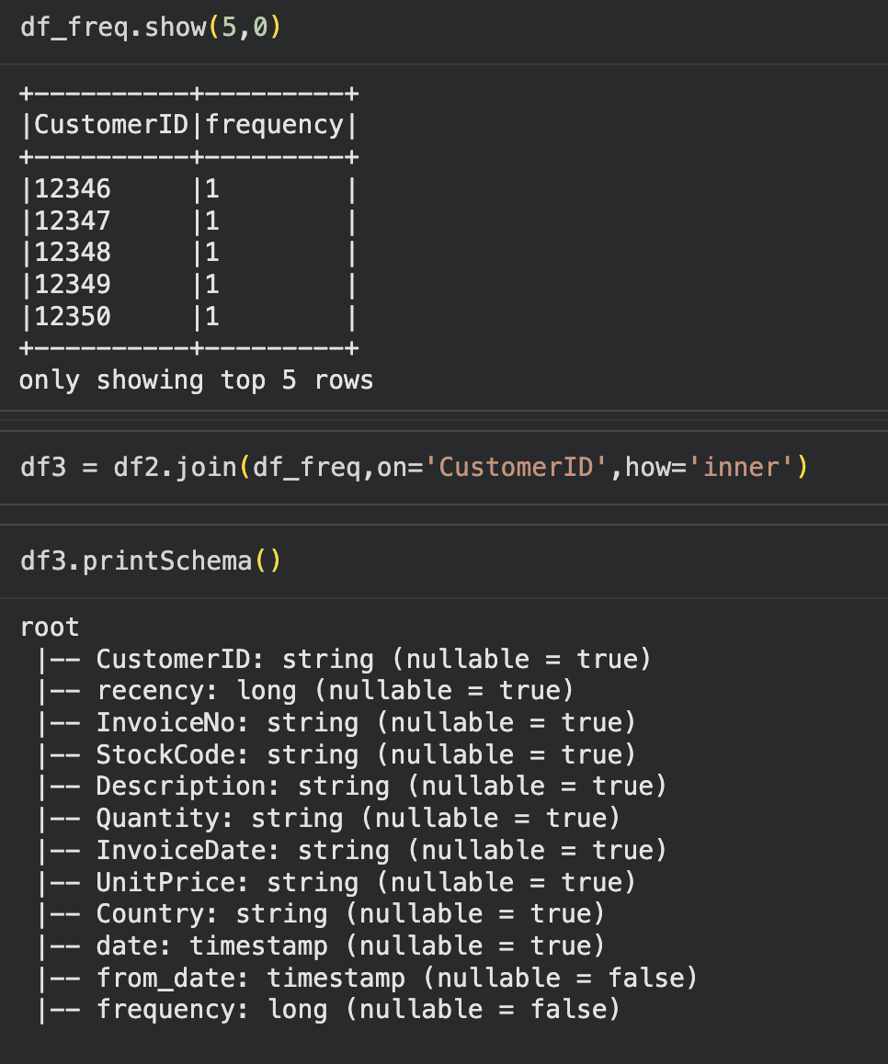

A new column is created to calculate the total amount spent per transaction by multiplying quantity and unit price. The data is then grouped by customer to compute each customer's total monetary value, which is joined back into the final RFM dataset.
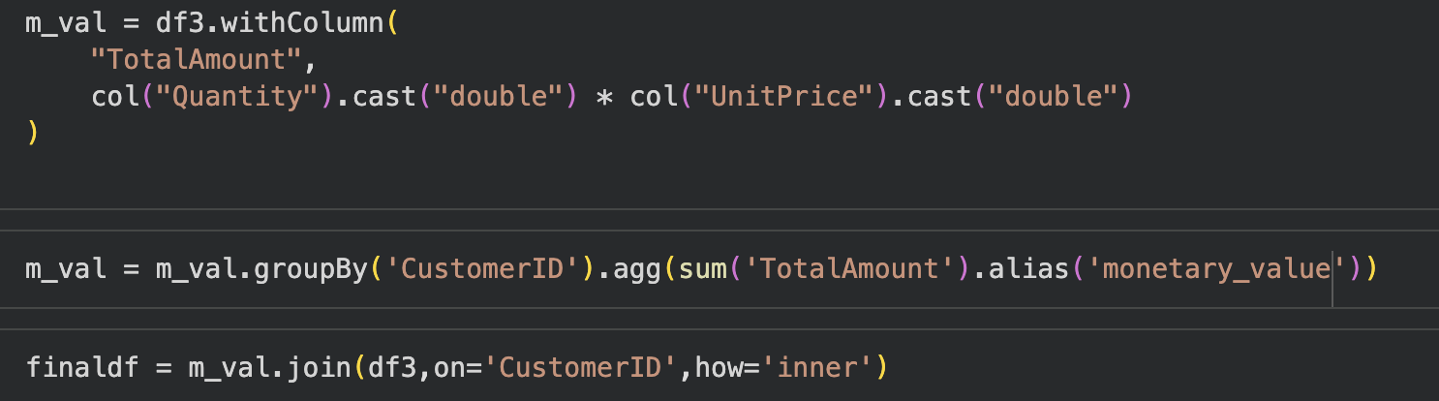
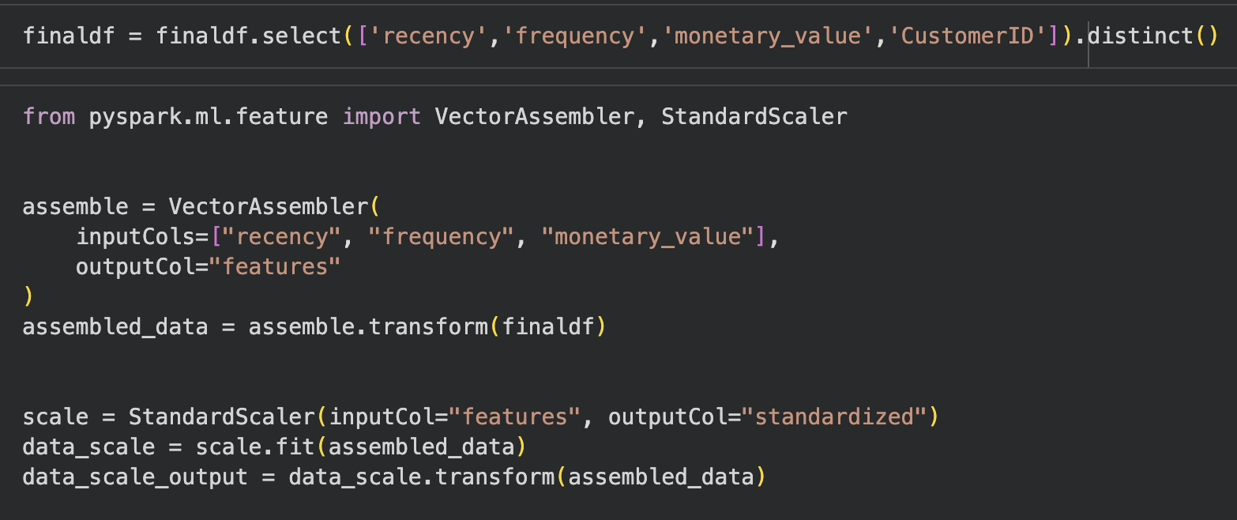

The scaled output shows the standardized RFM values, where each feature has been transformed to have comparable ranges. Displaying the first two rows confirms that the standardization process produced numeric vectors suitable for clustering.
