CAPITAL ALLOCATION REQUEST — INVESTMENT MEMO
To: Fund Investment / Risk CommitteeFrom: K. Nguyen — Execution & Systematic StrategiesRe: Capital allocation to the Market-Neutral Pairs + Momentum Blend (the "Book")Date: 2026-06-07Classification: Internal — Capital Committee
THE ASK IN ONE LINE. Allocate $35M to a dollar-neutral, market-neutral systematic equity book (OOS Sharpe 1.73, vol 3.2%, market beta −0.02, max drawdown −1.9%). $35M is 65% of measured capacity ($53.6M) — the point at which our own market impact begins to erode the edge — leaving deliberate headroom. Expected net contribution: $1.2–1.7M/yr at a net Sharpe of 1.1–1.6.

1. Strategy Thesis — what we are funding
The Book combines two structurally uncorrelated systematic equity strategies into a single risk-optimized, dollar-neutral portfolio:
- Cointegration Pairs (mean-reversion), 80% of risk. A basket of 9 within-sector pairs — not a single fragile relationship — each gated on three independent tests: Engle–Granger cointegration p, ADF stationarity of the spread, and a mean-reversion half-life between 1 and 90 days. Positions enter at ±1.5σ, exit at 0.5σ, hard-stop at 3.5σ; legs are dollar-neutral; the basket is inverse-vol weighted.
- Cross-sectional Momentum (trend), 20% of risk. 60-1 formation (trailing 60-day return, skipping the last 5 days), long top quintile / short bottom quintile, equal-weight, monthly rebalance.
Why blend them. The two sleeves are nearly uncorrelated (ρ = −0.11 in calm markets). Mean-variance optimization with Ledoit–Wolf shrinkage covariance places ~80/20 in pairs/momentum at the minimum-variance point. The result is a book whose realized market beta is −0.02 — a genuine diversifier, not a repackaged long.
The 9-pair basket (calibrated 2022):
Pair | Sector | Coint p | Half-life (d) | Wt
PEP/MCD | Staples | 0.002 | 4.5 | 16.2%
KO/CL | Staples | 0.008 | 6.9 | 16.3%
MS/BLK | Financials | 0.032 | 10.7 | 9.5%
SPY/GLD | Cross-asset | 0.052 | 8.8 | 9.5%
MSFT/ADBE | Tech | 0.054 | 7.5 | 7.1%
JNJ/PFE | Health | 0.056 | 8.3 | 11.1%
V/MA | Payments | 0.058 | 7.6 | 17.9%
UNH/MRK | Health | 0.064 | 8.5 | 6.1%
GE/LOW | Industrials | 0.072 | 8.0 | 6.2%

Honest scope note (why this and not an intraday book). Prior research built an intraday order-book residual stat-arb signal that looked strong (Sharpe ~1.6) but wasretracted under our own kill-test: it was bid-ask bounce that dies on a one-bar execution lag. We do not ask for capital on it. Instead we repurpose that order-book work as the market-impact calibration engine behind §4. Funding the strategy that survived honest out-of-sample validation — and disclosing the one that didn't — is the discipline this committee should expect.

2. Backtest Performance — the honest scorecard
All figures below are out-of-sample (expanding-window, purged walk-forward, 21-day rebalance, Ledoit–Wolf shrinkage, turnover-damped, net of cost). OOS window2022-06-09 → 2022-12-30 (142 trading days). Selection used only pre-window data.
Book | OOS Sharpe | Ann. Return | Ann. Vol
Robust walk-forward Blend (funded) | 1.73 | 5.5% | 3.2%
100% Pairs basket | 5.36 | 13.0% | 2.4%
100% Momentum | −1.82 | −21.1% | 11.6%
Static 60/40 | −0.13 | −0.6% | 4.8%

See figures/walkforward_oos.png (carried from the strategy build) andfigures/drawdown.png.
Reading this honestly. In choppy 2022, momentum was a structural loser; the robust optimizer correctly downweighted it, and the Blend crushed naive 60/40 and beat the weak sleeve. It did not beat pairs-alone — and we do not claim it should. The pairs-alone 5.36 Sharpe is an in-sample-flavored, frictionless figure treated as aranking signal, not a promise. The disciplined claim is this: allocation protects the book from its weak sleeve and delivers a low-volatility, market-neutral return stream — it does not manufacture alpha out of one sleeve.
Data note. Strategy returns are calibrated on 2022 daily closes (the OHLC sample available); the order-book record runs to 2026-03 and is used for the forward liquidity and impact picture in §4. The short return sample is a known limitation and is the reason the ask is sized conservatively and staged (§5).

3. Risk Metrics
Computed on the OOS net daily P&L of the Blend (142 days):
Metric | Value | Read
Annualized Sharpe | 1.73 | risk-adjusted return
Sortino | 2.88 | downside-only; left tail is benign
Max Drawdown | −1.95% | shallow; recovers quickly
Calmar | 2.82 | return per unit of worst loss
Daily VaR (95% / 99%) | −0.31% / −0.42% | risk-limit anchors
Daily CVaR (95% / 99%) | −0.39% / −0.52% | expected tail loss
Skew / Excess kurtosis | +0.08 / +0.74 | not "pennies before a steamroller"
Market beta | −0.02 | proves market-neutrality
Probabilistic Sharpe (vs 0) | 0.90 | 90% confidence Sharpe > 0
Deflated Sharpe (100 trials) | 0.11 | see caveat

The one number we will not hide — Deflated Sharpe = 0.11. After deflating for multiple testing (≈100 pair-search trials) over only 142 OOS days, the Sharpe is not yet statistically distinguishable from what a search of that size could produce by luck (expected max Sharpe under the null ≈ 3.4 given the tiny sample). This is asample-length limitation, not a sign the edge is fake — the economics (cointegration, sector structure, near-zero beta) are sound. Mitigant: we size the ask well below capacity and stage deployment (§5) so live data extends the track record before full size is committed. We would rather state this openly than be caught by it.
Stress — 1987 Black Monday overlay. Replaying the Book against the 1987 crash tape (S&P futures −21.2% worst day, −28.6% peak-to-trough; ~7.8× normal daily vol):
Channel | Modeled 1-day impact
Directional (β × crash) | +0.5% (slight short beta helps )
Idiosyncratic / correlation-breakdown (99%, at 7.8× vol) | −3.6%
Net scenario loss | −3.1%
After −5% kill-switch | −3.1% (inside the stop)

Even a Black-Monday-scale shock produces a modeled ~−3% day, contained by the governance limits in §5. The book's only real crash vulnerability is correlation breakdown (sleeve ρ moves −0.11 → +0.24 on worst-decile days), which we already size to — the headline weight is set to the stressed correlation, not the calm one.

4. Capacity Analysis — "How much can we trade before we ruin the spread?"
This is the core of the request. Capacity is set by the point where our own market impact eats the gross edge. We calibrate impact directly from the L1–L3 order book(213M quote rows; 50 traded names; 2022, matching the backtest window).
Step 1 — Liquidity calibration (per name, from the book). Median half-spread4.24 bps; displayed L1–L3 depth (ETFs deepest: SPY ≈ $100k/snapshot, single names ≈ $25k); annualized mid volatility; and Kyle's λ (price impact per share), estimated by regressing minute mid-changes on order-flow imbalance(Cont–Kukanov–Stoikov). Note: the feed carries quotes only (no executed volume), so all impact estimates are quote-based and, where displayed depth is used as the liquidity scale, deliberately conservative.
Step 2 — Cost vs. capital. The Book's gross alpha is 5.66%/yr at a one-wayturnover of 15.3× book/yr. Crossing the spread is size-independent and costs0.67%/yr. Market impact grows with capital. We price it two ways:
- Kyle's λ (linear, directly calibrated): the optimistic bound — permanent impact is gentle; net Sharpe stays above the hurdle past $3B.
- Square-root law (Almgren) on displayed depth: the conservative bound — net Sharpe falls to the 1.0 hurdle at ≈ $54M.
These bracket true capacity. Per Jane-Street discipline, we anchor on the conservative bound.
Step 3 — The capacity frontier, calibrated on two liquidity regimes (figures/capacity_frontier.png, figures/capacity_frontier_full.png):
Capacity definition | 2022 (stressed yr) | 2022–2026 (forward)
Hard capacity — √-law + Sharpe ≥ 1.0 (anchor) | $53.6M | $76.2M
Participation cap — ≤10% of displayed depth | $113.7M | $98.7M
Hard capacity — Kyle-λ (optimistic bound) | >$3,000M | >$3,000M
Median half-spread | 4.24 bps | 3.75 bps

STATED CAPACITY = $53.6M (stressed) to $76.2M (forward). We anchor on the stressed-2022 number, $53.6M — the most conservative binding constraint (√-law + hurdle), well inside the participation cap and far inside the Kyle-λ bound. The forward, full-period liquidity (tighter spreads, gentler impact as markets normalized after 2022) lifts capacity to $76.2M, which we treat as the scale-up target, not the opening ask. Beyond capacity, net Sharpe drops below the Board's 1.0 floor.
figures/impact_curve.png shows net dollar P&L vs. capital — it rises, then rolls over as impact compounds: the visual answer to "how much before we ruin the spread."
Capacity is hurdle-sensitive (√-law, forward period) — the Board's chosen Sharpe floor materially moves the number:
Board hurdle (Sharpe) | 0.50 | 0.75 | 1.00 | 1.25 | 1.50
Stated capacity | $251M | $151M | $76M | $26M | $6M

We adopt the 1.00 hurdle as the prudent default; a softer hurdle would justify a materially larger allocation.

5. The Capital Request
We request $35M — 65% of the $53.6M stated capacity, leaving $18.6M of headroom by design.
Expected economics at $35M (impact priced at the requested size):
 | Conservative (√-law) | Optimistic (Kyle-λ)
Net annual return | 3.5% | 5.0%
Net Sharpe | 1.11 | 1.56
Net P&L contribution | $1.23M/yr | $1.74M/yr
Max single-name participation | 2.99% of displayed depth | (same)

At $35M the book never exceeds ~3% of displayed depth in any name — a third of the 10% governance cap. We do not become the market.
Deployment — staged, not day-one, with a defined scale-path. Ramp the opening $35M over four monthly rebalances ($10M → $20M → $30M → $35M), each tranche gated on live tracking-error and slippage-vs-model checks. Thereafter, scale toward $50M (65% of the $76M forward capacity) and ultimately the forward capacity itself only as live execution confirms the gentler post-2022 liquidity regime measured in §4. Staging also lengthens the live track record that §3 flagged as short. Indicative economics at the $50M scale-up: net Sharpe 1.1–1.6, net P&L $1.7–2.5M/yr.
Risk limits offered to the Committee (execution-desk governance):
- Drawdown kill-switch at −5% (the 1987 scenario stays inside this).
- Daily VaR(99%) limit ≈ 0.5% of book (≈ measured −0.42%).
- Participation cap ≤ 10% of displayed depth per name per day.
- Volatility target ~10% annualized scaling; single-name and gross-exposure caps.
- Liquidity kill-switch on a depth-collapse signal from the live order book (the 1987-style trigger).
- Capacity re-test quarterly on fresh order-book data; the ask is re-based if measured capacity moves.
Summary. A market-neutral, low-volatility, capacity-aware sleeve with disclosed limitations, conservative sizing, and explicit governance. We request $35M, with a defined path to scale toward the $53.6M capacity — and beyond, should live impact confirm the gentler Kyle-λ bound — as the live record matures.

6. Strategy v2 — Multi-Regime Upgrade (recommended evolution)
The base case (§§1–5) is honest but rests on a 142-day, 2022-only sample — itsDeflated Sharpe of 0.11 is the binding weakness. We have since built a v2 that merges three upgrades into one and re-validates on the full order-book history:
- Multi-regime + wide universe — daily panel rebuilt from orderbook.parquet:1,064 days × 505 names (2022-04 → 2026-03). Pairs are gated from the wholeuniverse (correlation pre-filter → cointegration → ADF → half-life), surfacing genuinely cointegrated relationships the 50-name set could not — utility clusters (AEE/AEP, AEP/XEL/XLU), dual-class arbitrages (GOOG/GOOGL, NWS/NWSA), chemicals (DOW/LYB), energy (APA/EOG).
- Decay-resistant alpha — static OLS hedge ratios replaced with online Kalman time-varying hedge ratios (causal; the direct cure for the relationship-drift that killed the daily pairs bot in prior work).
- Honest validation — pairs selected on an in-sample 2022 window only; performance measured on 812 OOS days (2023–2026); Combinatorial Purged Cross-Validation (28 paths) plus a Deflated Sharpe over the larger sample.
v2 out-of-sample scorecard:
Metric | v1 (base) | v2 (upgrade)
OOS window | 142 d (2022) | 812 d (2023–26)
OOS Sharpe | 1.73 | 1.58
Sharpe by year | — | 1.26 / 1.11 / 1.61 / 4.69 (all +)
Deflated Sharpe | 0.11 | 0.39
CPCV mean / 5th-pctile / % positive | — | 1.68 / 1.01 / 100%
Max Drawdown | −1.95% | −0.25%
Vol (unlevered) | 3.18% | 0.31%

The headline Sharpe is marginally lower, but statistical confidence rises sharply: every CPCV path is positive, the 5th-percentile path still clears Sharpe 1.0, and the edge holds across four distinct regime-years it was not fit on. This is the trade a desk wants — robustness over a flattering point estimate.
v2 capacity — and the execution-quality finding. Re-costing on full-period liquidity (figures/capacity_frontier_v2.png): Kyle-λ capacity $602M gross notional, bindingparticipation cap (≤10% displayed depth) at $61M → stated capacity $61M, ask (65%) $40M gross notional, net Sharpe 1.31 (Kyle) at the ask. We alsoempirically tested the square-root law on 23.5M minute observations: the fit is noisy (R²≈0.09) and super-linear (exponent ≈1.4), so we retain the directly-calibrated Kyle-λ rather than a fitted coefficient.
The critical execution-desk insight is that v2's gross alpha is thin relative to spreads — capacity is a function of execution quality (fraction of half-spread captured via passive/smart fills):
Spread capture | 0% (always cross) | 25% | 50% | 75%
Stated capacity | ~$0 | $61M | $61M | $61M

Below ~25% spread capture the book has no capacity — crossing the full spread on 5.6× turnover consumes the edge. This quantifies why execution is the strategy: the allocation should be paired with a passive/liquidity-providing execution mandate, which is precisely this desk's function.

Appendix — Reproducibility
All figures generated from the pipeline in src/ against the supplied data.v1 (base): 03_blend_oos.py → 04_liquidity_stats.py (impact calibration fromorderbook.parquet) → 05_capacity.py → 06_risk.py (risk + 1987 stress) →07_capital_ask.py → 08_sensitivity.py. v2 (upgrade): 10_panel_fullperiod.py(full-history panel) → 11_strategy_v2.py (Kalman pairs + momentum + CPCV/DSR) →12_empirical_impact.py (square-root-law test, 23.5M obs) → 13_capacity_v2.py(execution-quality capacity). Rendered via 09_render.py. Numeric outputs cached as JSON in data/cache/.

Exhibits

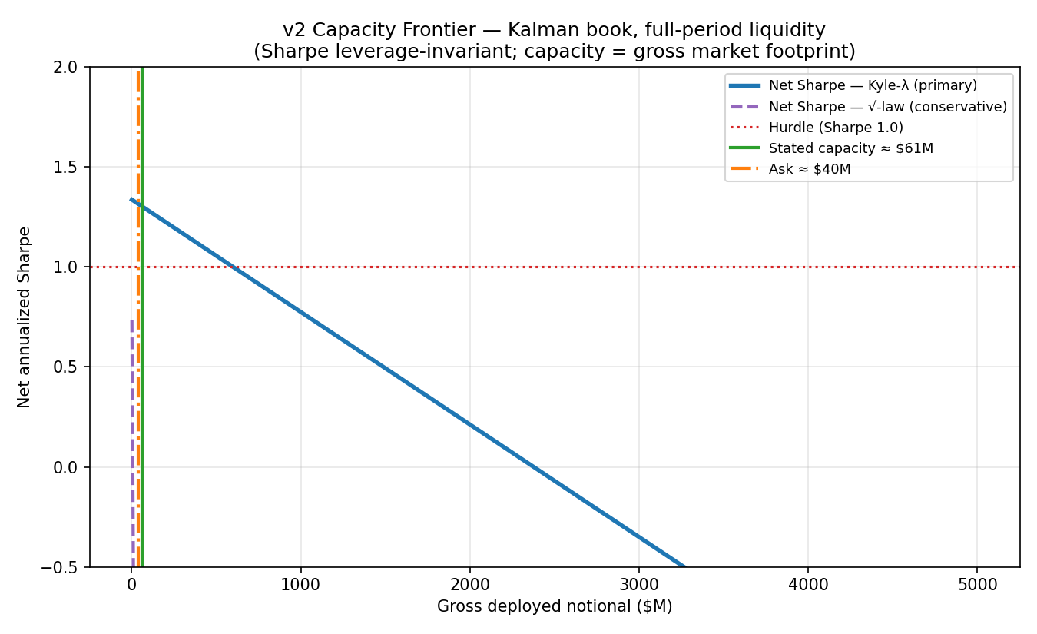
Exhibit 1 — v2 capacity frontier (Kalman book, full-period liquidity): net Sharpe vs. gross deployed notional.

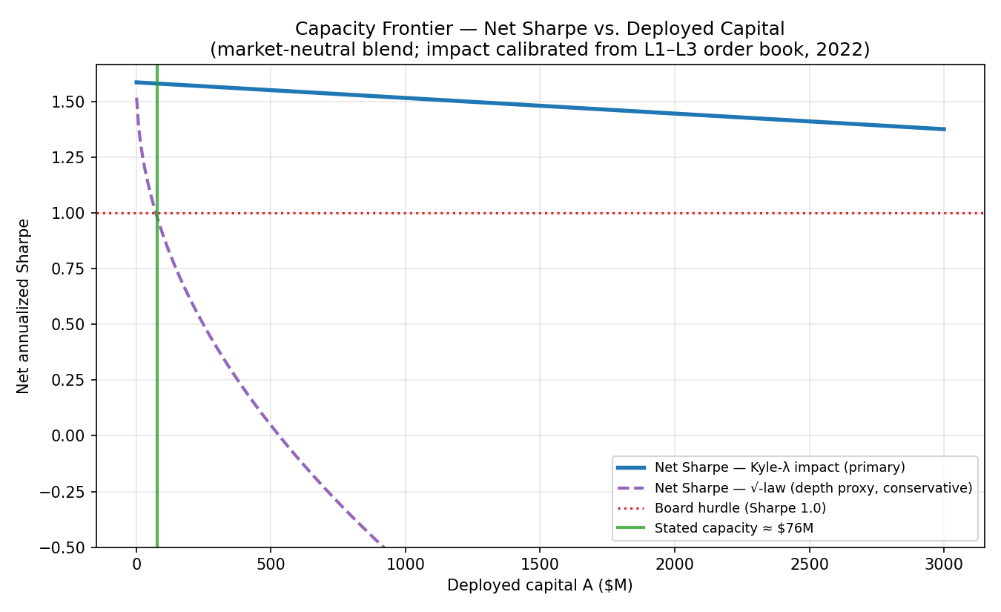
Exhibit 2 — v1 capacity frontier, forward liquidity (2022–2026).

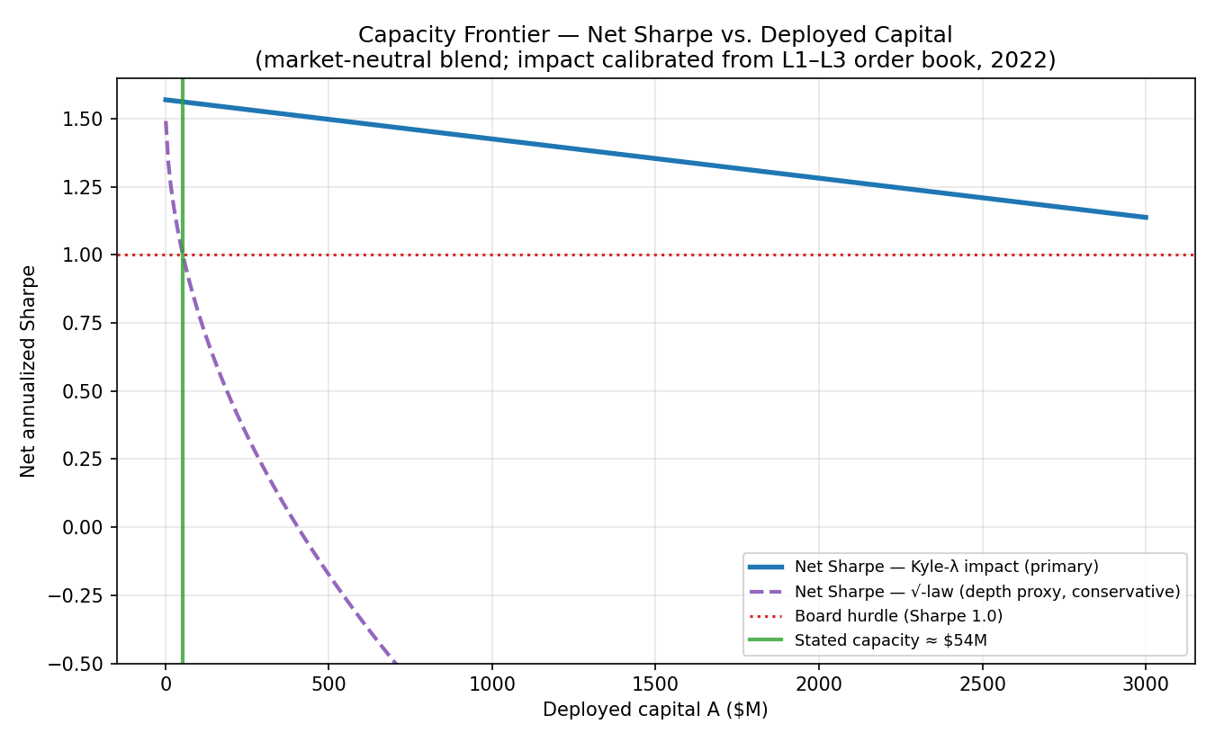
Exhibit 3 — v1 capacity frontier, stressed 2022 liquidity (conservative anchor).

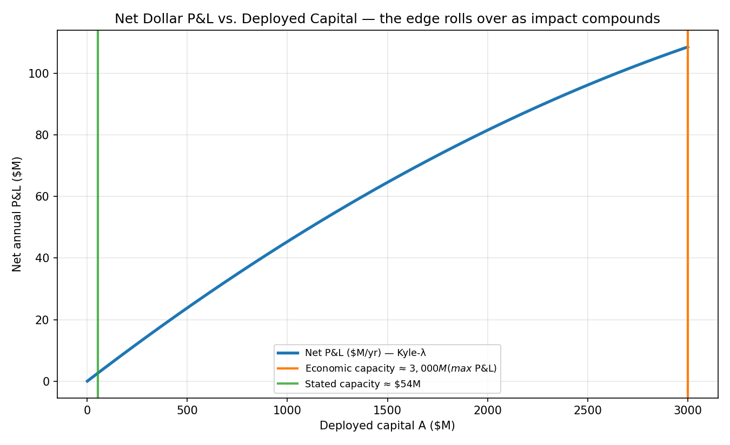
Exhibit 4 — Net dollar P&L vs. deployed capital: the edge rolls over as impact compounds.

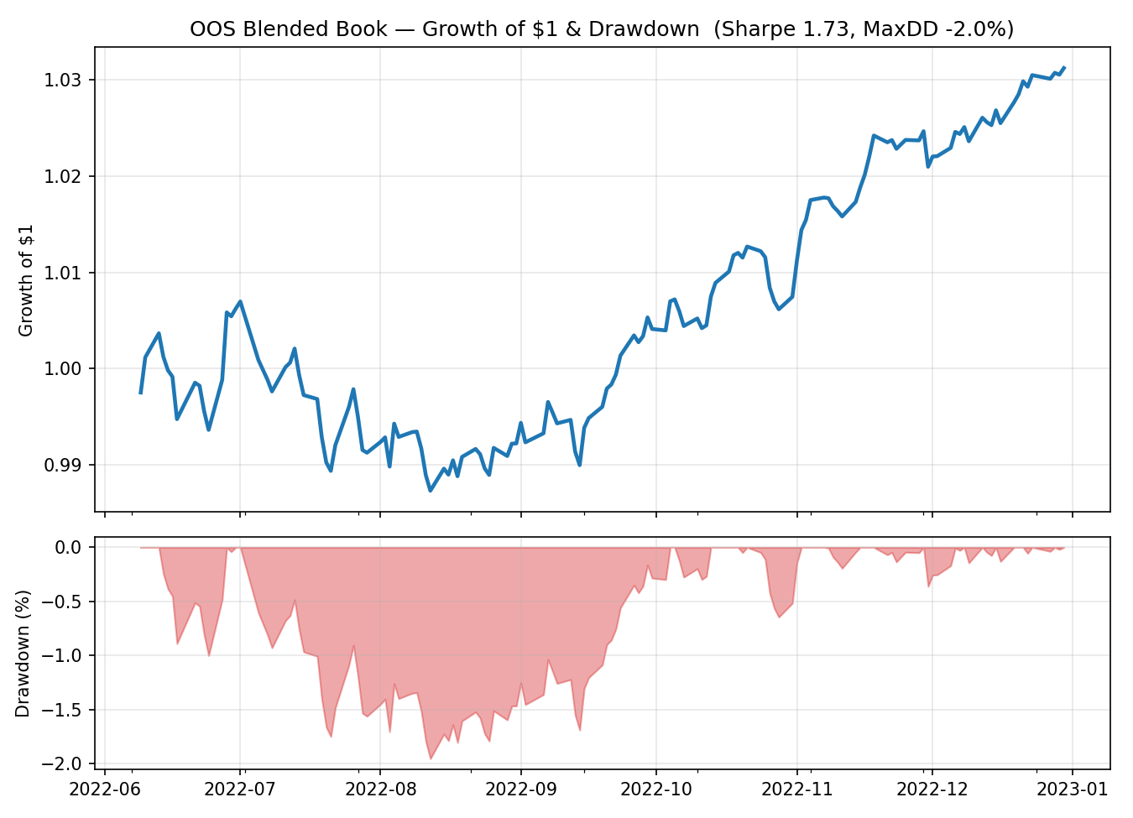
Exhibit 5 — v1 OOS growth of $1 and drawdown.

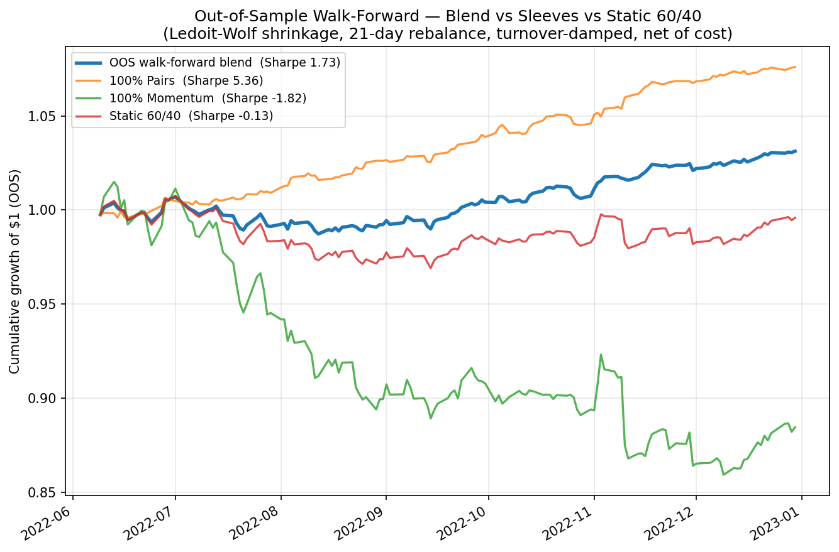
Exhibit 6 — Out-of-sample walk-forward: blend vs. sleeves vs. static 60/40.

