

ASSIGNMENT 2 FRONT SHEET

|  |  |  |  |
| --- | --- | --- | --- |
| **Qualification** | **BTEC Level 5 HND Diploma in Computing** | | |
| **Unit number and title** | Unit 30: Application Development | | |
| **Submission date** |  | **Date Received 1st submission** |  |
| **Re-submission Date** |  | **Date Received 2nd submission** |  |
| **Student Name** | Tran Duc Luong | **Student ID** | BH00108 |
| **Class** | IT0502 | **Assessor name** | Nguyen Thanh Trieu |
| **Student declaration**  I certify that the assignment submission is entirely my own work and I fully understand the consequences of plagiarism. I understand that making a false declaration is a form of malpractice. | | | |
|  | | **Student’s signature** | Luong |

**Grading grid**

|  |  |  |  |  |  |  |  |
| --- | --- | --- | --- | --- | --- | --- | --- |
| P4 | P5 | P6 | M3 | M4 | M5 | D2 | D3 |
|  |  |  |  |  |  |  |  |

|  |  |  |
| --- | --- | --- |
| * **Summative Feedback:**  **Resubmission Feedback:** | | |
| **Grade:** | **Assessor Signature:** | **Date:** |
| **Lecturer Signature:** | | |

# Nô^̣ i dung

1. Introduction 5
2. P4 Create a formal questionnaire that effectively reviews your business application, problem definition statement, proposed solution and development strategy. Use this questionnaire as part of a peer-review and document any feedback given 5
   1. Formal questionnaire 5
   2. The result of survey 9
   3. Feedback Review 12
3. P5 Develop a functional business application based on a specified business problem 13
   1. Administrator’s Role 13
      1. Login by Administrator’s account 13
      2. User account management 14
   2. Training staff’s role 15
   3. User category management 16
   4. User Course management 17
   5. User Topic management 18
   6. Trainer Role 19
   7. Trainee 20
   8. Code 20
      1. Account 20
      2. Cateogory 23
      3. Course 26
      4. Topic 29

D.(P6)Review the performance of your business application against the Problem Definition Statement and initial requirements. 31

1. Function requirements 31
   1. Administrator 31
   2. Training staff 31
   3. Trainer 32
   4. Trainee 32
2. Test plan 32
3. Test case 37
4. Evaluation 42
5. Conclusion 43
6. Reference 43

Figure 1: Login 13

Figure 2 14

Figure 3 15

Figure 4 16

Figure 5 17

Figure 6 18

Figure 7 19

Figure 8 19

Figure 9 20

Figure 10 20

Figure 11 21

Figure 12 22

Figure 13 23

Figure 14 24

Figure 15 25

Figure 16 26

Figure 17 27

Figure 18 28

Figure 19 29

Figure 20 30

Figure 21 31

# Introduction

In the intricate endeavor of constructing a robust business application, our team meticulously undertook a comprehensive process that encompassed not merely conceptualization and design, but also rigorous evaluation and iterative refinements. This report comprehensively details our systematic approach, chronicling the evolution from initial design concepts, as presented earlier, to the development phase, meticulously capturing the effective utilization of selected technologies and methodologies.

Throughout this endeavor, we actively sought and incorporated feedback from our esteemed peers through a formal questionnaire. This valuable input enabled us to adapt reflectively, incorporating insights into our development process. Moreover, our report critically analyzes the application's performance against pre- established specifications, delving into the intricate factors that influence its efficacy.

The culmination of our efforts is a comprehensive presentation and a fully functional application for demonstration and evaluation. In the concluding chapter, we present a reflective analysis, profoundly acknowledging the application's strengths, identifying potential weaknesses, and envisioning opportunities for future enhancements. This report serves as a testament to our unwavering commitment to delivering high-caliber business applications that empower businesses to achieve their strategic objectives.

# P4 Create a formal questionnaire that effectively reviews your business application, problem definition statement, proposed solution and development strategy. Use this questionnaire as part of a peer-review and document any feedback given.

## Formal questionnaire

Formal Questionnaires for Data Collection and Analysis

A formal questionnaire is a structured method of gathering feedback or information. Its standardized format ensures consistency in data collection, facilitating analysis and the extraction of meaningful insights.

Benefits of Formal Questionnaires:

Organized Data Collection: A formal questionnaire organizes responses in a systematic manner, making it easier to quantify and analyze data.

Consistent Feedback: All respondents answer the same set of questions, allowing for fair comparisons and the identification of common themes or issues.

Improved Data Analysis: The structured format enables efficient data analysis, allowing researchers to identify trends, patterns, and areas for improvement.

Enhanced User Feedback: Formal questionnaires provide a platform for users to express their experiences and suggestions, helping organizations gather valuable feedback to enhance user satisfaction and engagement.

Application in FPT Training Web Application:

Creating a formal questionnaire for the FPT Training Web Application is a valuable tool for gathering feedback and identifying areas for improvement. By distributing the questionnaire using Google Forms, I can gather insights on the following:

User experience and satisfaction levels

Perceived strengths and weaknesses of the application Suggestions for enhancing functionality and user interface Best practices for implementing effective training programs

The collected data will be analyzed to inform decision-making processes and guide improvements to the FPT Training Web Application. The goal is to enhance user engagement, satisfaction, and the overall effectiveness of training programs delivered through the platform.

Link survey:

https://docs.google.com/forms/d/e/1FAIpQLSftn5EkW38eCNMaRFyMR2t8Xp8hk34q5dTuvzkNHgFSEwvfDw/ viewform?usp=sharing

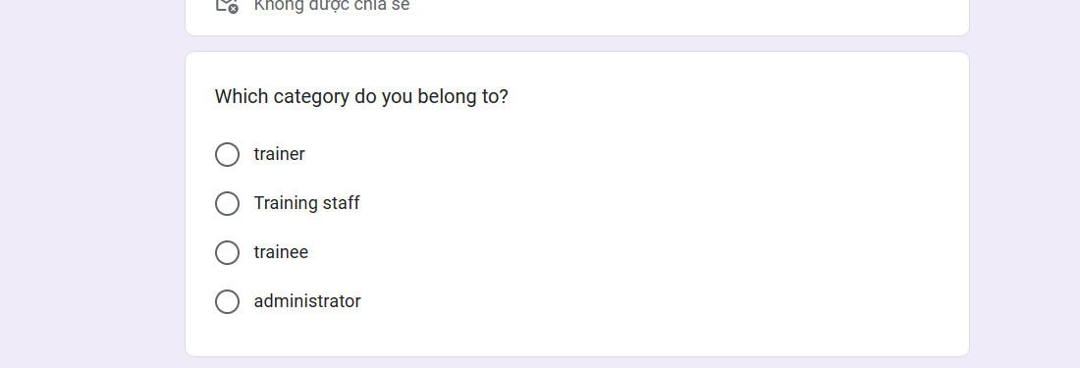

*Survey 1*

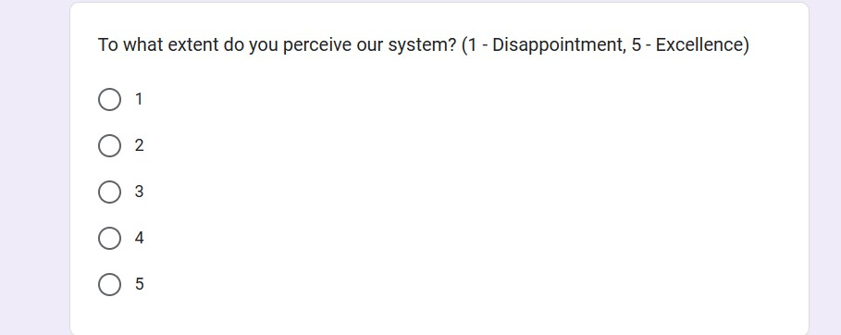

*Survey 2*

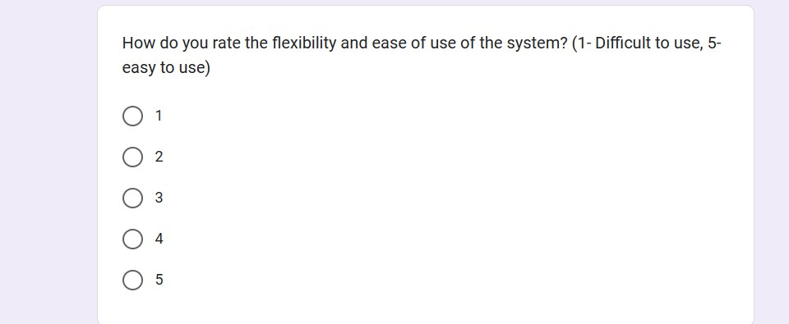

*Survey 3*

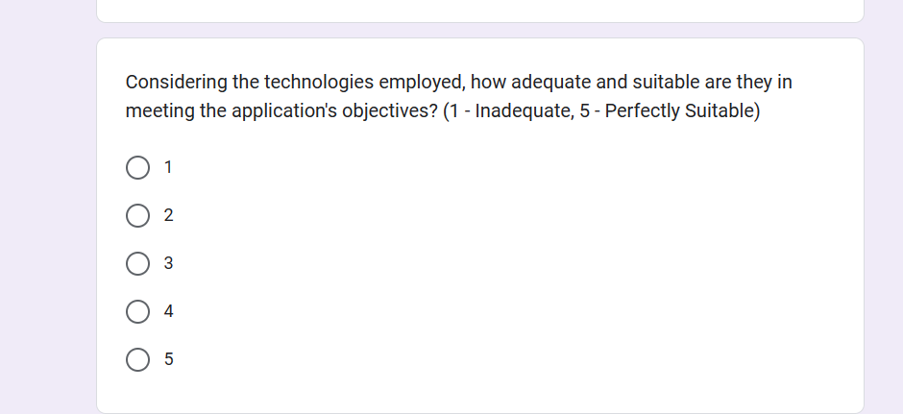

*Survey 4*

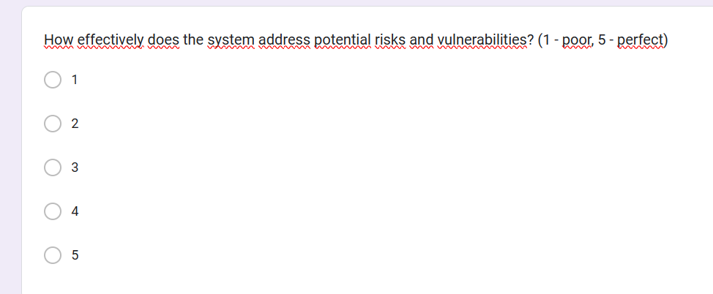

*Survey 5*

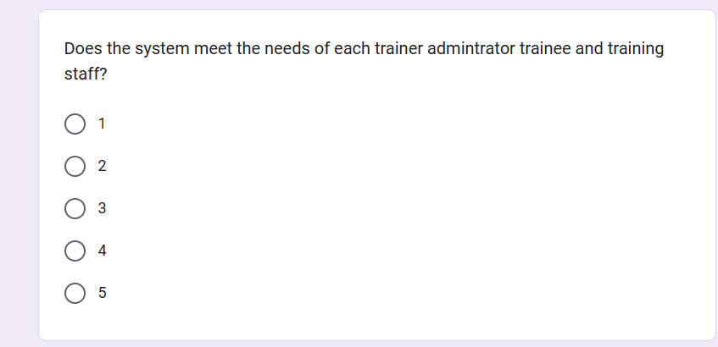

*Survey 6*

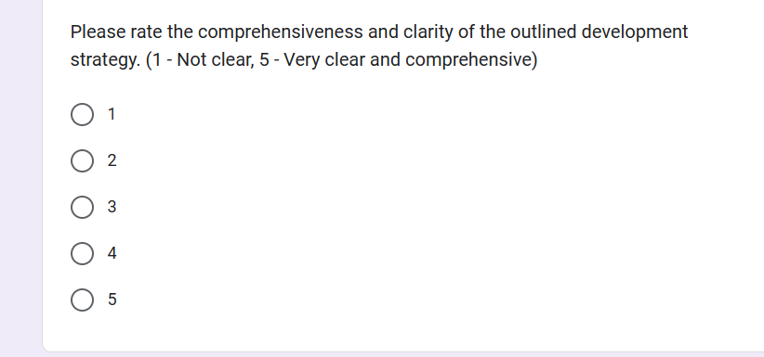

*Survey 7*

## Ảnh có chứa văn bản, ảnh chụp màn hình, Hệ điều hành, phần mềm Mô tả được tạo tự độngThe result of survey

*result 1*

According to the above survey results, the number of people who are administrators is very small. In fact, a system only has 1 to 2 administrators. The training staff is only 3 people, accounting for a small portion. The rest are mostly trainees and trainers participating in the interview. Because these two objects account for the majority of system usage.

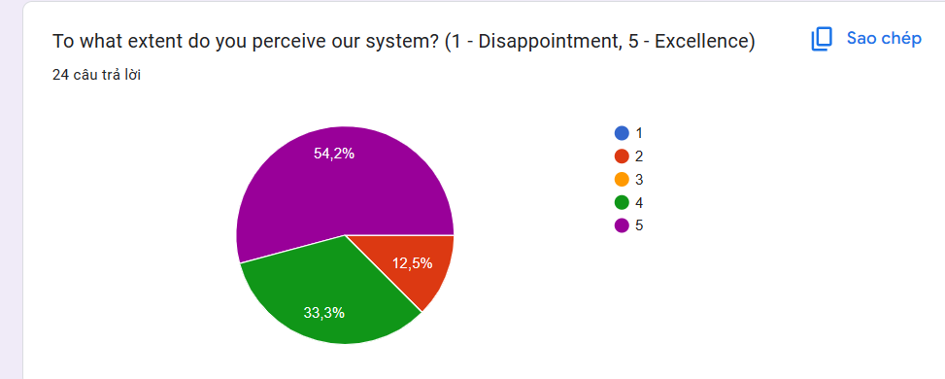

*result 2*

The system was rated excellent by many participants with up to 54.2%. On the contrary, only 12.5% rated the system as poor, the rest rated the system as being close to excellent. Maybe the system gets positive reviews.

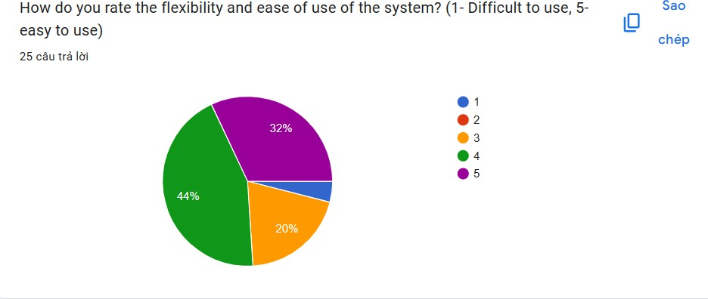

*result 3*

Through the assessment of the survey, from milestone 4 to 5 is a positive evaluation milestone, the system shows that many choose milestones 4 and 5. It can be seen that our system has developed with very high flexibility. 20% of participants rated the system as average. and a small portion of participants rated it at the most negative level.

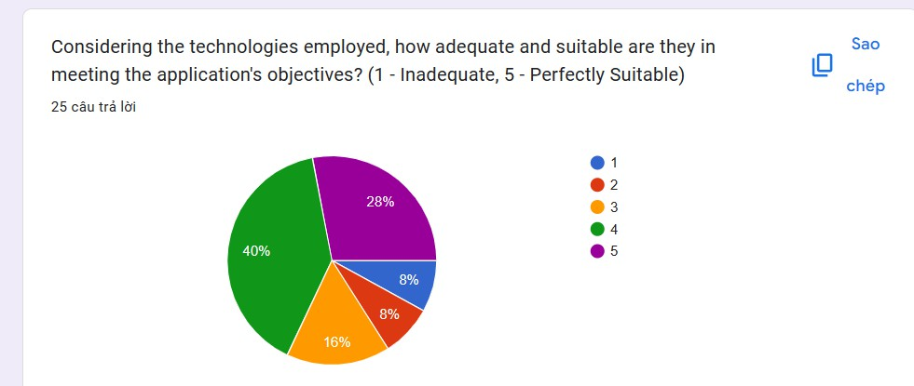

*result 4*

2 milestones 4 and 5 show that many people choose it, with a total of 68% of participants showing that the technologies are used at an appropriate level. The remaining milestones show a breakdown in their assessments. They seem to have little understanding of the technologies used in the system.

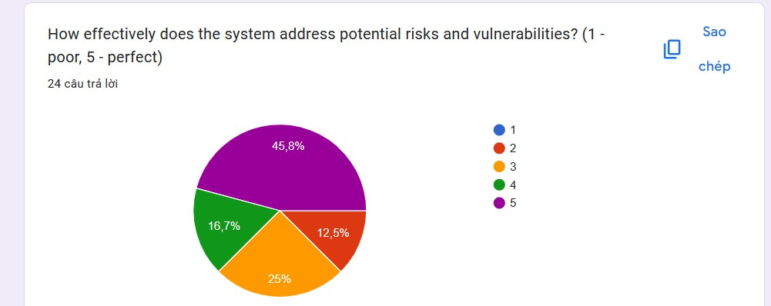

*result 5*

Up to 45.8% of participants felt that the system for addressing potential risks and vulnerabilities was perfect. Up to 25% of people also think that the system can only solve problems at a normal level. And a small number of participants found it less effective.

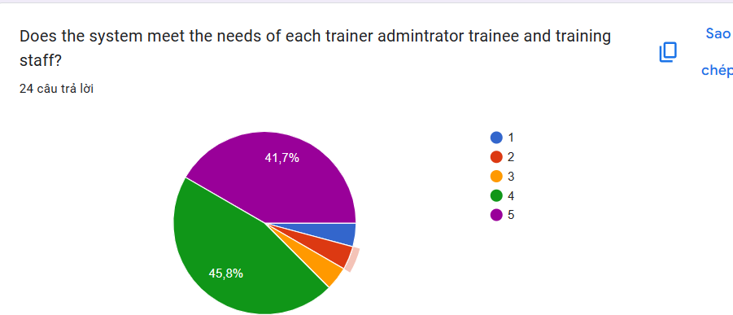

*result 6*

At milestones 4 and 5, many participants evaluate that the system is suitable and meets the needs of system objects. In both milestones, up to 87.5% of people accounted for the majority of participants.

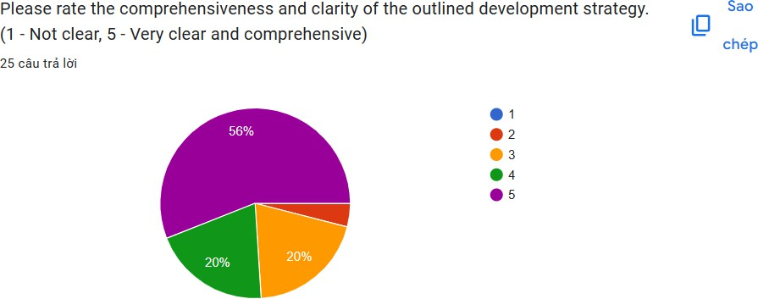

*result 7*

Up to 56% of participants showed that the comprehensive level of development strategy was clearly and completely outlined. 20% of participants agreed that the level was only clear and complete. The remaining 20% think it's just average. Only a few think it is unclear.

## Feedback Review

Based on the survey I conducted using the 7 comprehensive questions outlined earlier, overall feedback from users indicates moderate to high satisfaction, with most responding focuses on ratings from level 3 to level 5. These ratings, with level 3 being the lowest and level 5 being the highest, rarely include a level 2. It reflects generally positive sentiment on the aspects variety of business applications.

* I am pleased to note that the problem definition statement received moderate to high ratings, mostly hovering around level 4, indicating a clear presentation of the core challenges the application solves. decided. This indicates a positive reception of the application's suitability for the identified needs.
* Regarding the effectiveness of the proposed solution in solving the identified problem, responses tended to be at level 4, suggesting a moderate to high level of effectiveness. Although the application appears to provide solutions with a good reputation, further improvements may be needed to achieve the optimal solution level.
* Users expressed satisfaction, mainly at level 4, with the clarity and comprehensiveness of the development strategy, indicating a well-defined and well-communicated plan. However, there may be potential areas for improvement to raise it to a more exemplary level.
* Alignment between the app's design and functionality and user experience received mostly positive feedback, around a level of 4, demonstrating good alignment, although some aspects may require fine- tuning for optimal usability and experience.
* Although users found the interface to be quite intuitive and user-friendly (rated at 4 to 5), there is potential for further improvements to make the interface more user-centric and easier to navigate.
* Overall, survey responses expressed a generally positive view of the business application, acknowledging its strengths while highlighting areas for improvement. The ratings, aggregated between levels 3 and 5,

provide valuable insights that will guide me in refining and optimizing the app for a more robust and user- centric solution.

# P5 Develop a functional business application based on a specified business problem.

## Administratôr’s Rôle

* + 1. 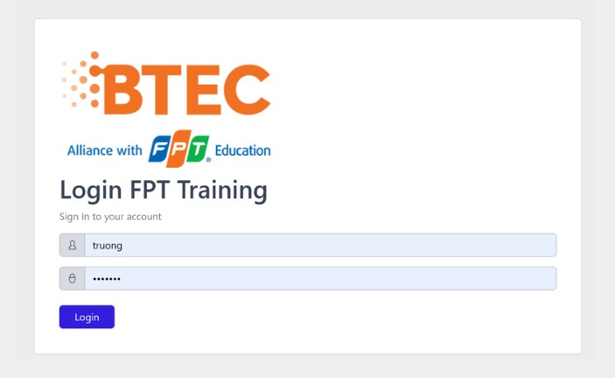Lôgin by Administratôr’s accôunt

*Figure 1: Login*

* + 1. User account management

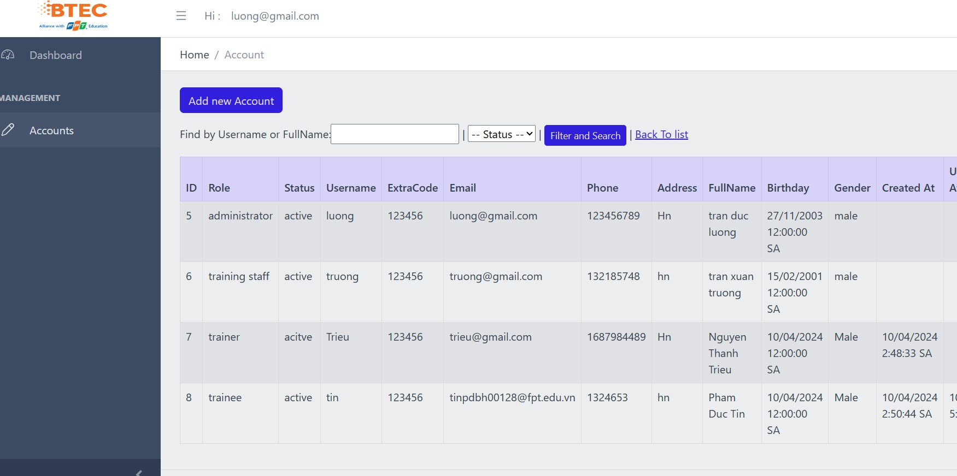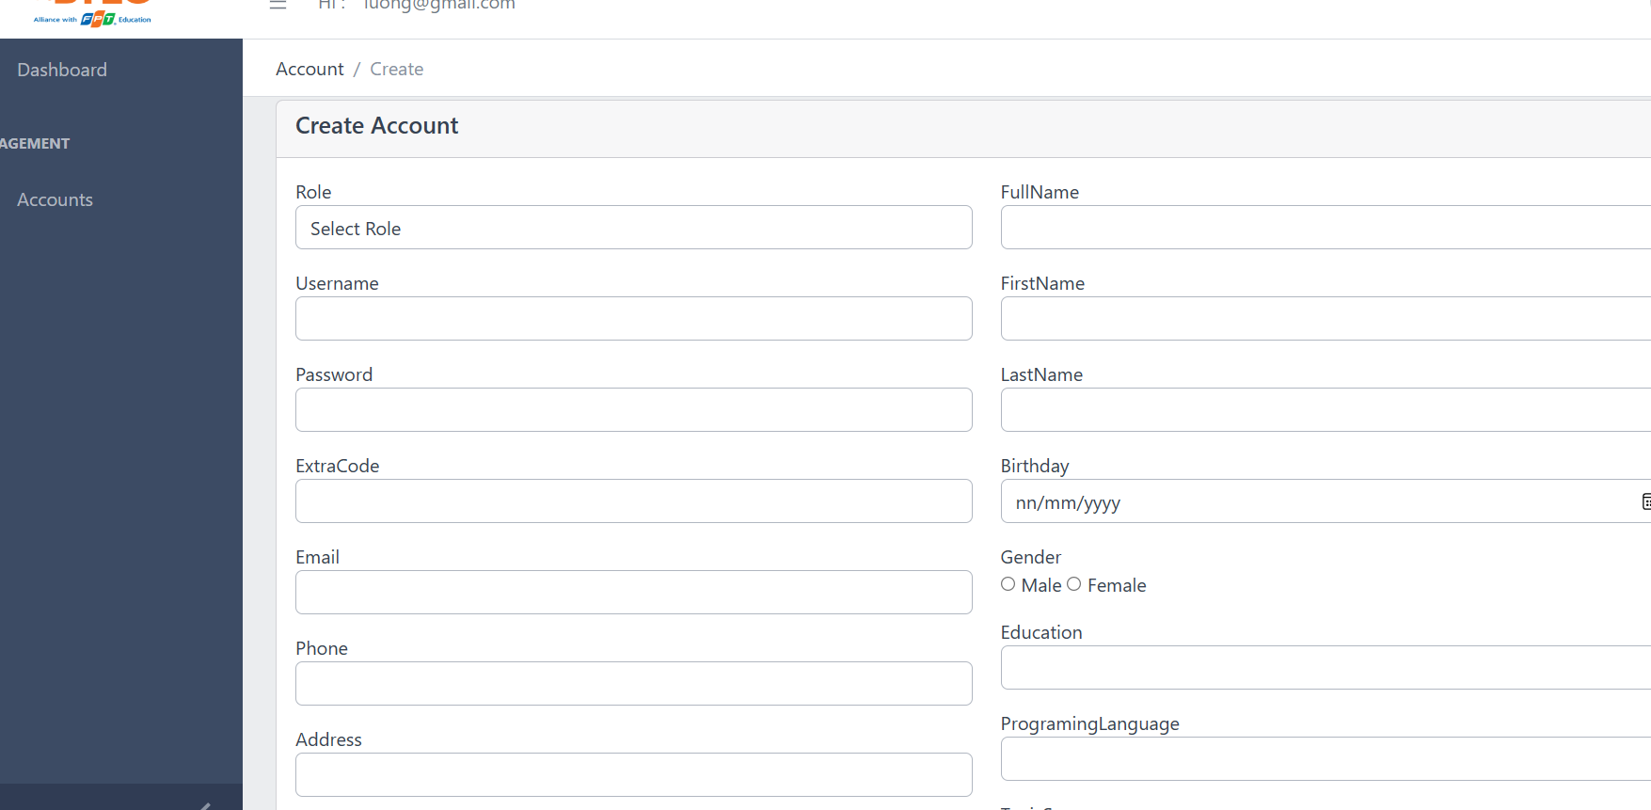

*Figure 2:*

We will log in to the admin, training staff and trainne accounts in this login interface. When logged in successfully, you will be redirected to the "Account" management page.

## Ảnh có chứa văn bản, ảnh chụp màn hình, Website, Trang web Mô tả được tạo tự độngTraining staff’s rôle

*Figure 3*

Log in to your account with the login name staff and when the information matches, you will be redirected to the Menu page including Category, Course, Topic,...

* 1. 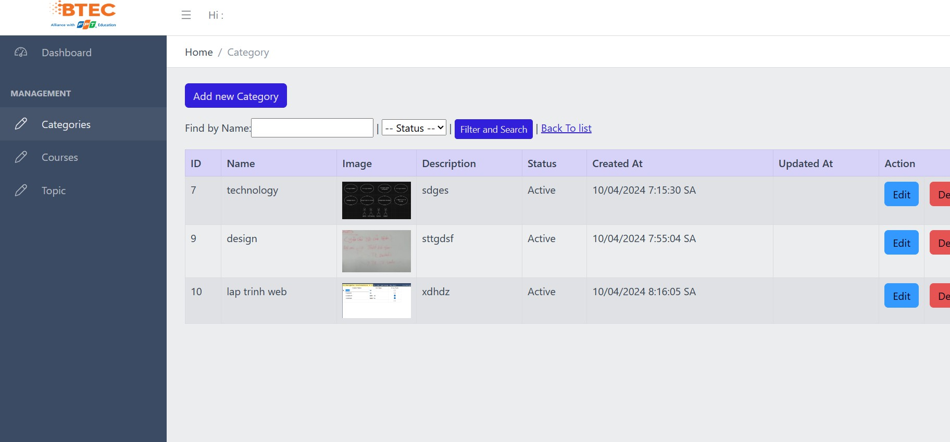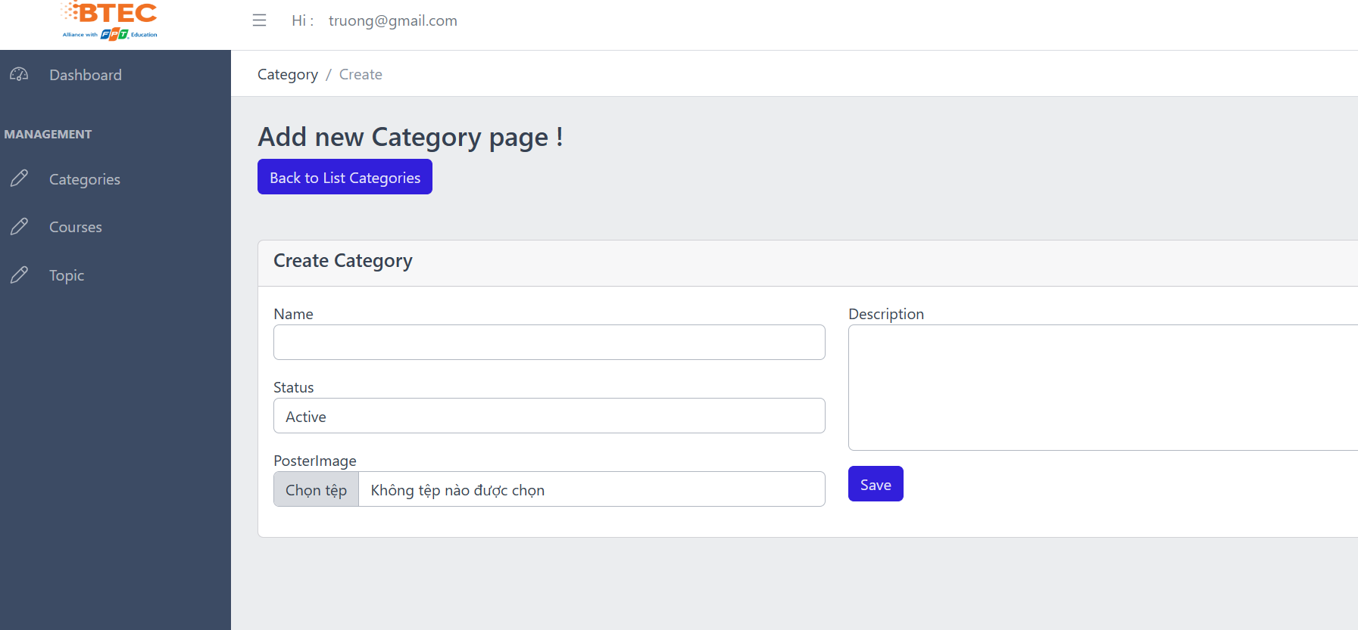User category management

*Figure 4*

Training staff can update and delete student accounts and can manage course categories such as searching, adding, updating and deleting course categories.

* 1. 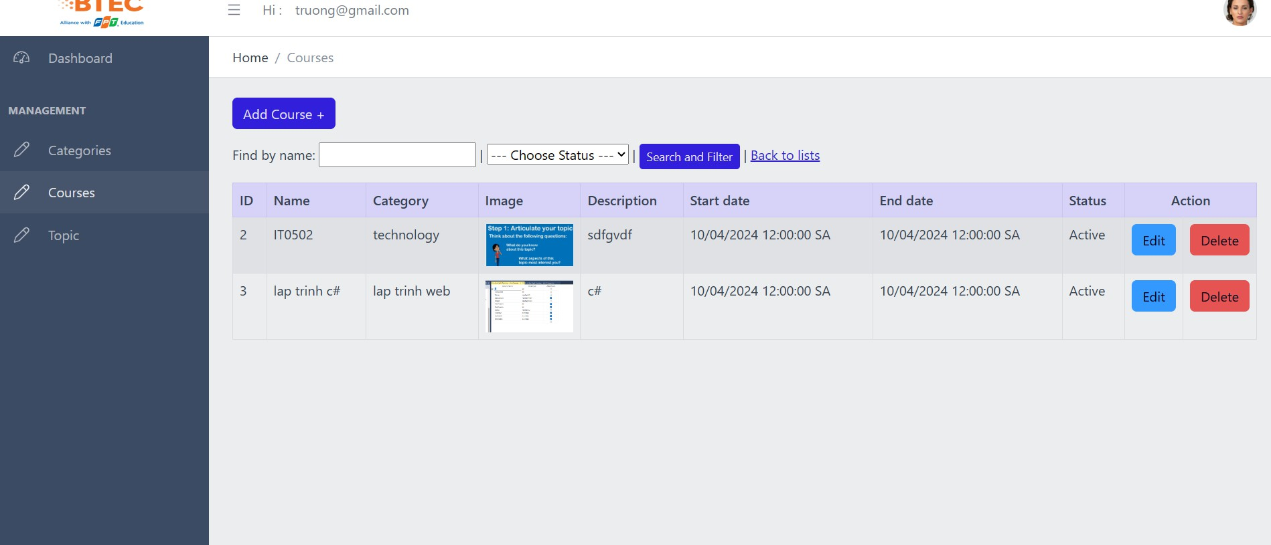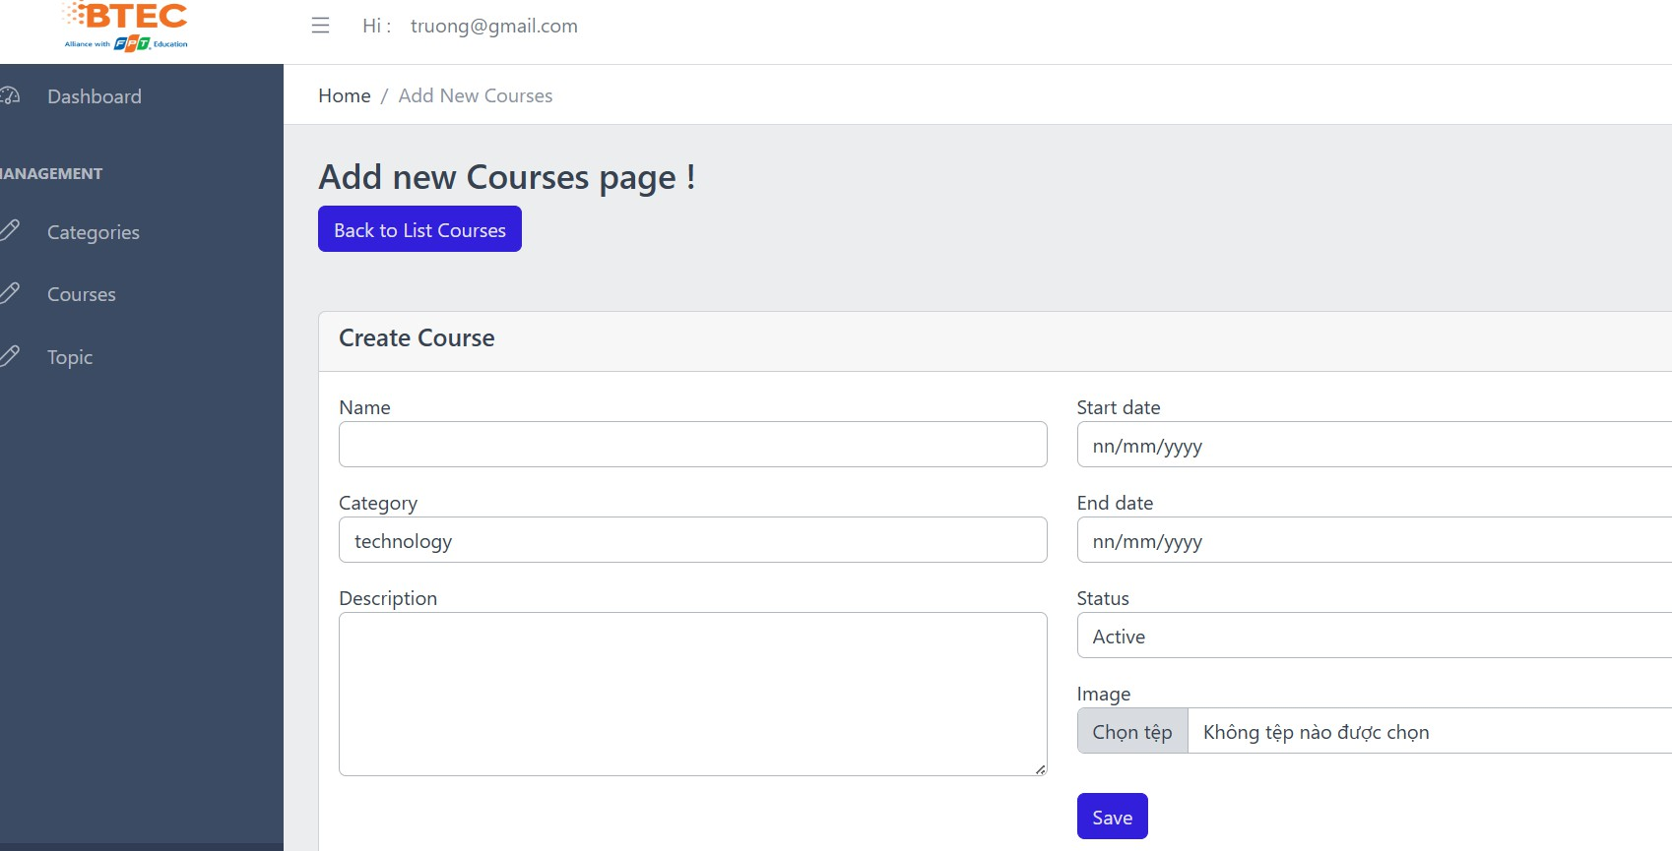User Course management

*Figure 5*

Training staff can manage courses such as searching, adding, updating and deleting courses. Course includes course name and description.

* 1. 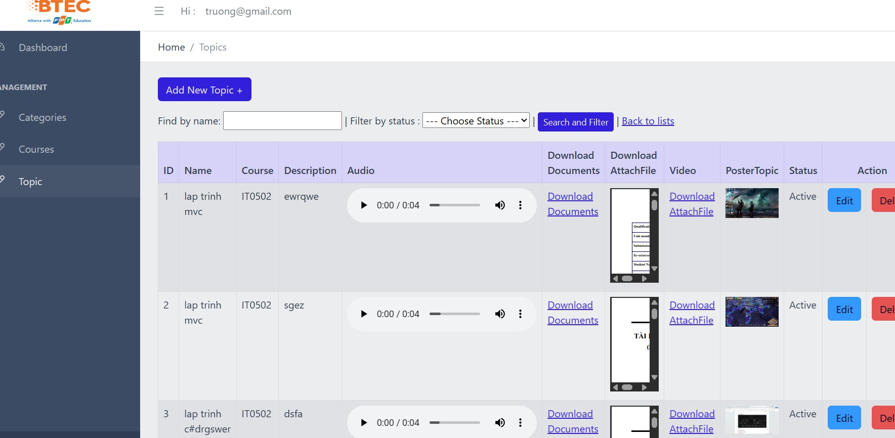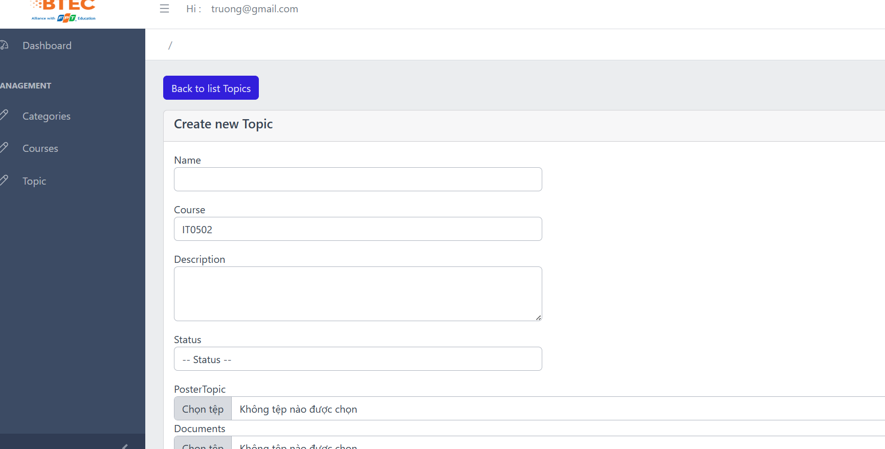User Topic management

*Figure 6*

Topics such as topic name and topic description can be added to a course, courses can be added to a category.

## Ảnh có chứa văn bản, ảnh chụp màn hình, phần mềm, Biểu tượng máy tính Mô tả được tạo tự độngTrainer Role

*Figure 7*

Trainers can view the courses they are assigned.

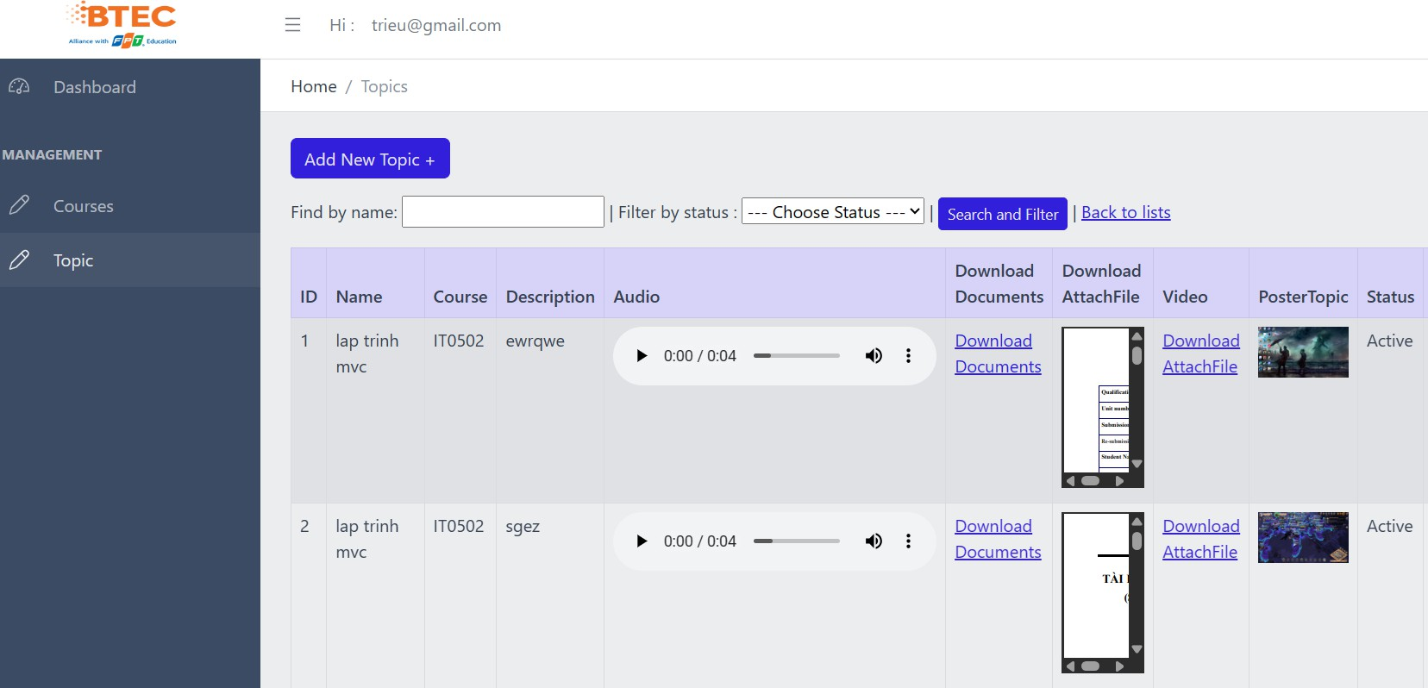

*Figure 8*

Trainers can view the topics they are assigned to.

## Ảnh có chứa văn bản, ảnh chụp màn hình, phần mềm, Biểu tượng máy tính Mô tả được tạo tự độngTrainee

*Figure 9*

Trainees can only view the courses they are assigned to.

## Code

* + 1. 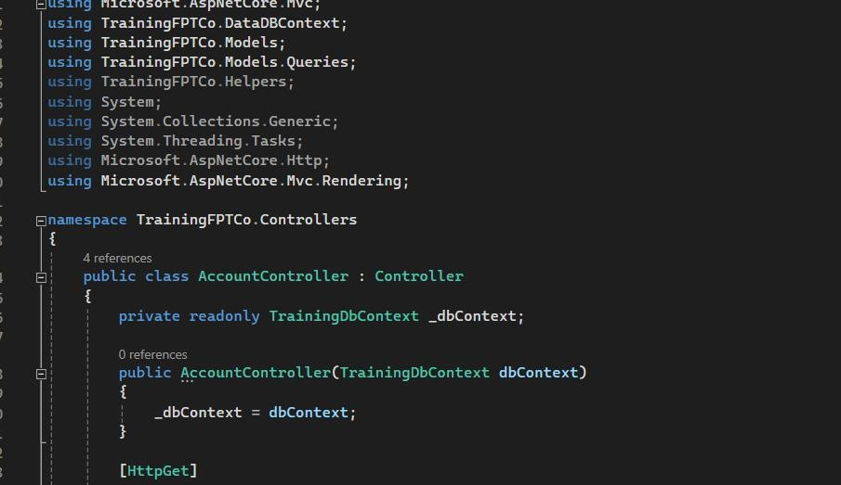Account

*Figure 10*

The "accountcontroller" class is often used to manage and control account-related behavior in software applications. It takes care of tasks like user authentication, account creation, and account deletion. The purpose of the "accountcontroller" class is to ensure that appropriate actions are taken when interacting with user accounts.

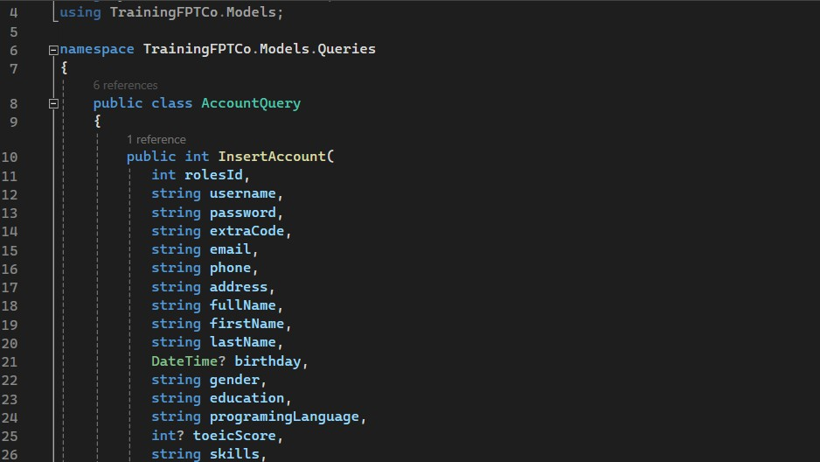

*Figure 11*

The "accountquery" class is often used to query and retrieve information about accounts. It helps perform tasks such as searching for accounts, retrieving account information, and performing account-related queries.

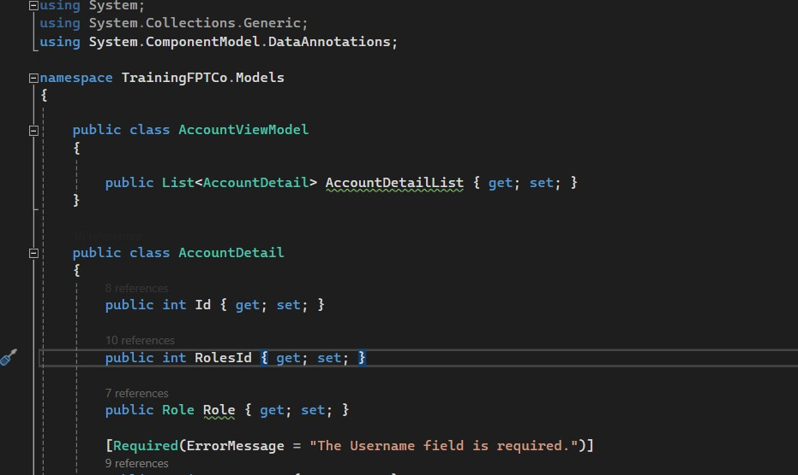

*Figure 12*

The "accountviewmodel" class is typically used to define the data model and business logic for account-related features in the application. It helps create a set of data and corresponding processing methods to display information and interact with accounts in the user interface.

* + 1. 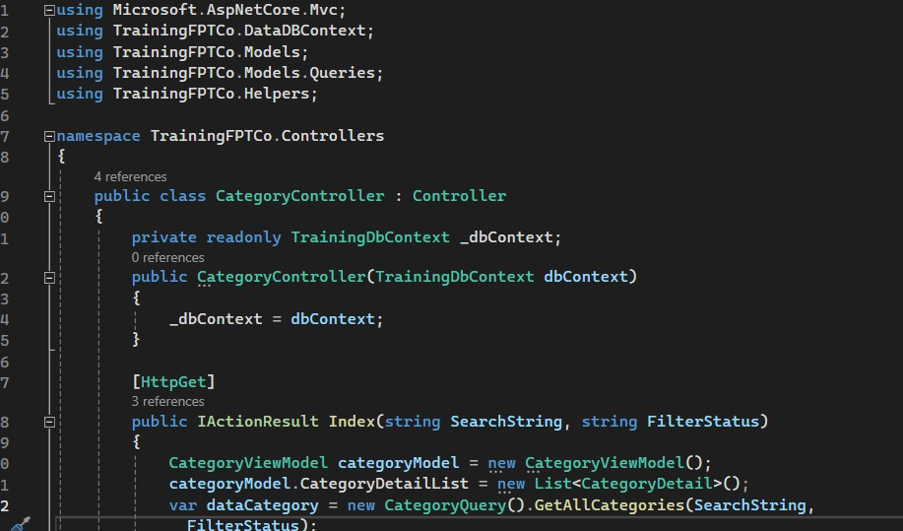Cateogory

*Figure 13*

The "CategoryController" class is often used to manage and control behavior related to categories in software applications. It takes care of tasks like creating, editing, and deleting categories. The purpose of the "CategoryController" class is to ensure that appropriate actions are taken when interacting with categories in the application.

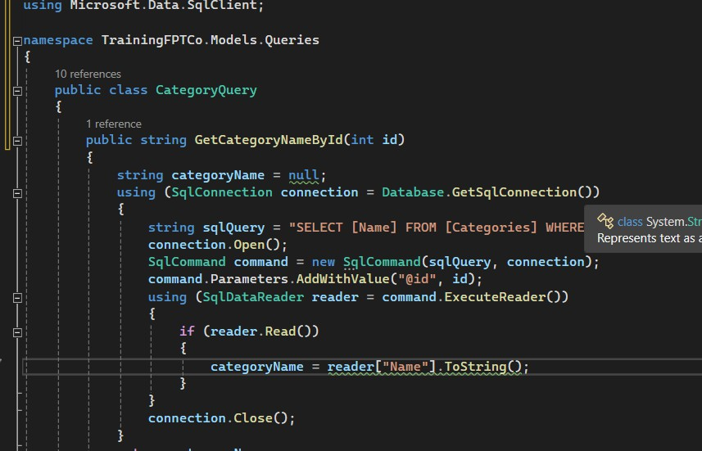

*Figure 14*

The "CategoryQuery" class is commonly used to query and retrieve information about categories. It helps perform tasks such as searching categories, retrieving category information, and performing category-related queries.

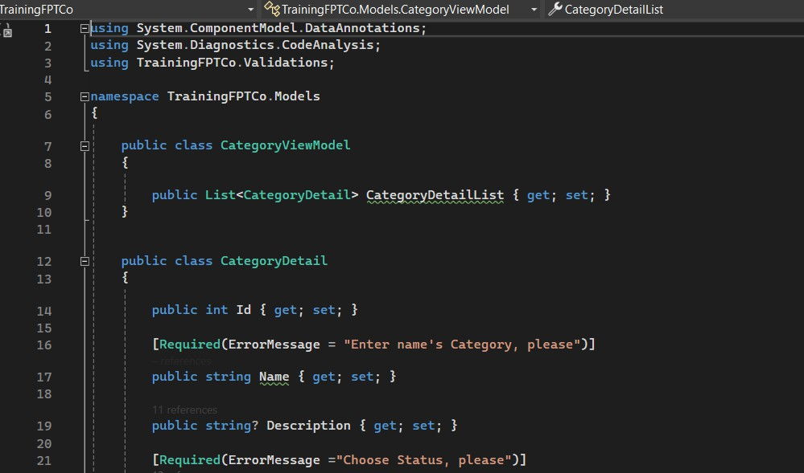

*Figure 15*

The "CategoryViewModel" class is typically used to define the data model and business logic for category-related features in the application. It helps create a set of data and corresponding processing methods to display information and interact with categories in the user interface.

* + 1. 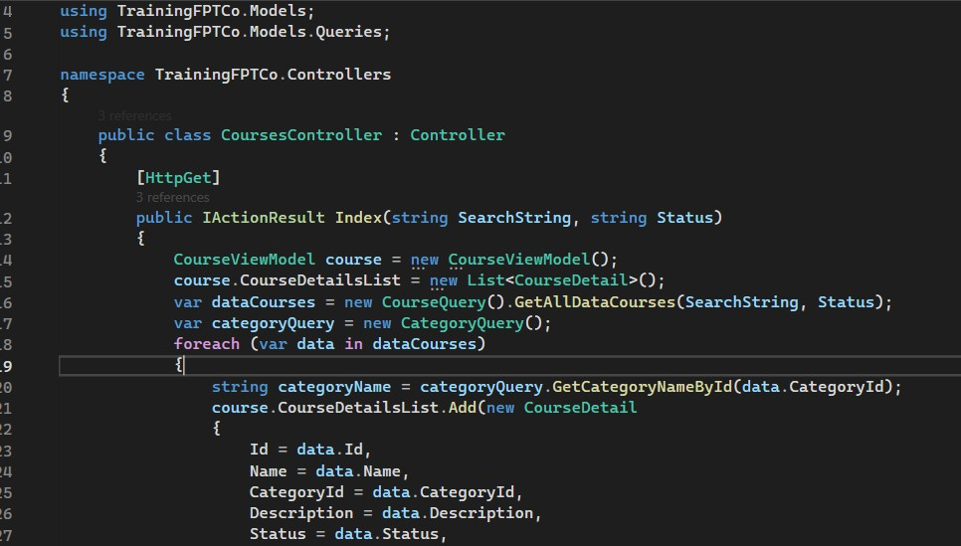Course

*Figure 16*

The "CoursesController" class is typically used to manage and control behavior related to course-related features in a software application. It takes care of tasks such as retrieving course data, updating course information, and deleting courses. The purpose of the "CoursesController" class is to ensure that appropriate actions are taken when interacting with courses in the application.

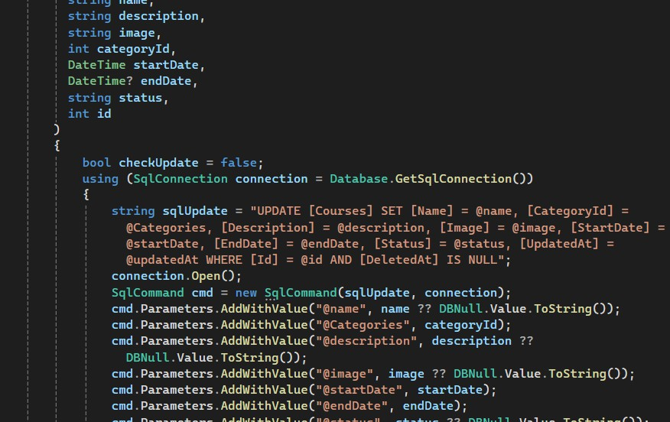

*Figure 17*

The "CourseQuery" class is commonly used to query and retrieve course information. It helps perform tasks such as searching for courses, retrieving course information, and performing course-related queries.

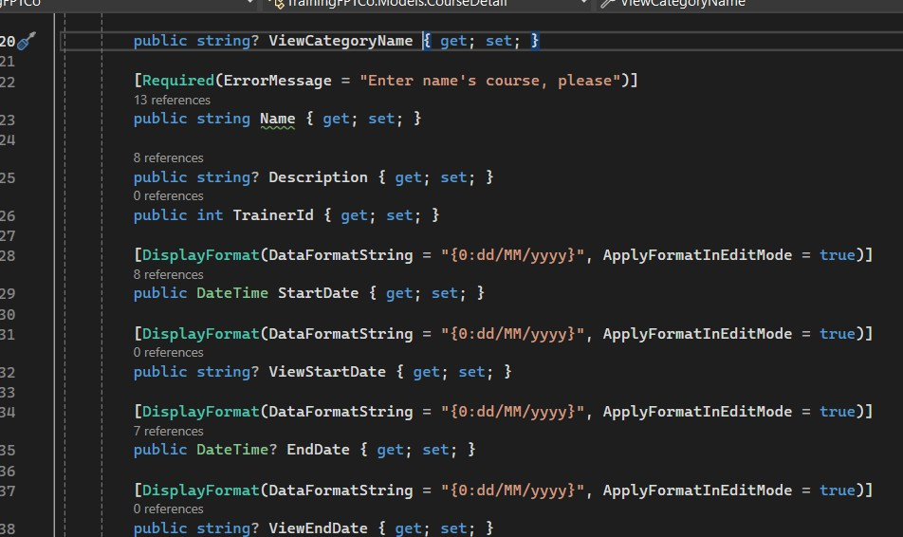

*Figure 18*

The "CourseViewModel" class is typically used to define the data model and business logic for course-related features in the application. It helps create a set of data and corresponding processing methods to display course information and interact with the course in the user interface.

* + 1. 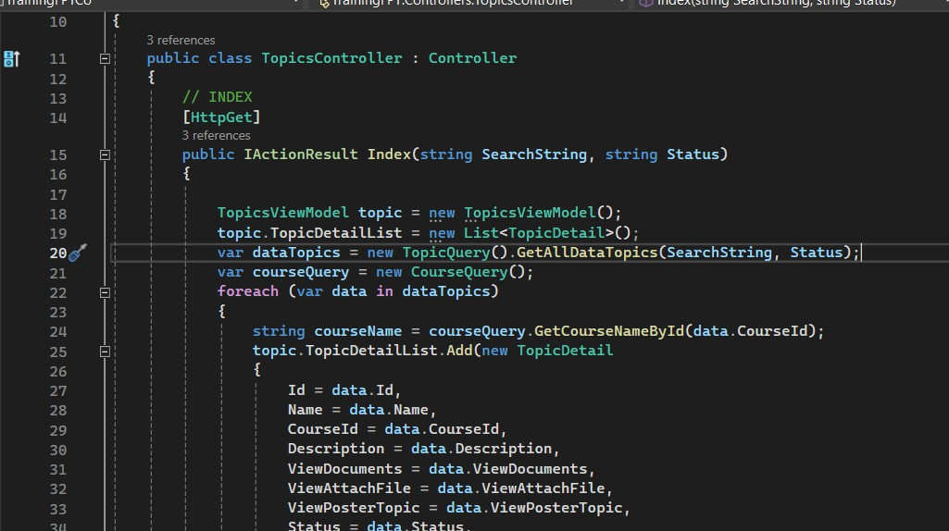Topic

*Figure 19*

The "TopicController" class is often used to manage and control topic-related behavior in software applications. It takes care of tasks like creating, editing, and deleting themes. The purpose of the "TopicController" class is to ensure that appropriate actions are taken when interacting with topics in the application.

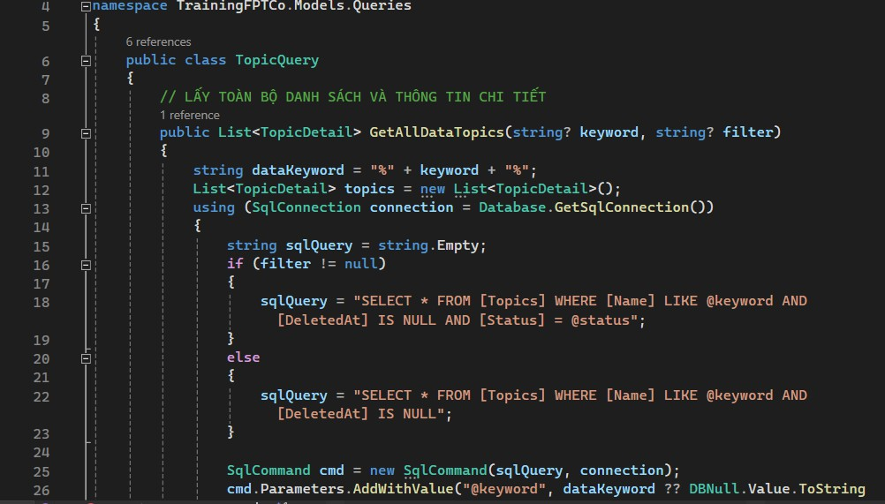

*Figure 20*

The "TopicQuery" class is commonly used to query and retrieve information about a topic. It helps perform tasks such as searching for topics, retrieving topic information, and performing queries related to the topic.

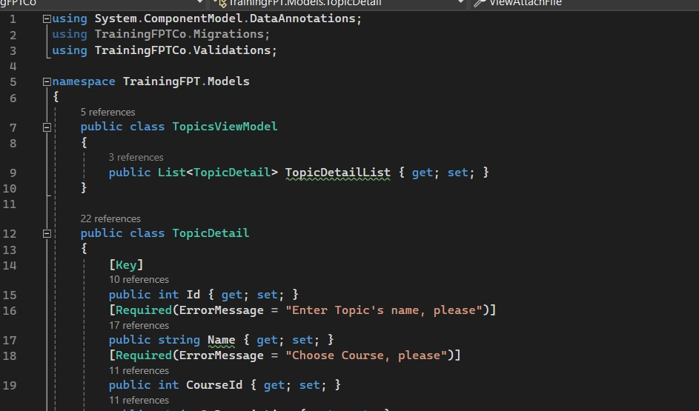

*Figure 21*

The "TopicViewModel" class is typically used to define the data model and business logic for theme-related features in the application. It helps create a set of data and corresponding processing methods to display information and interact with the subject in the user interface.

# D.(P6)Review the performance of your business application against the Problem Definition Statement and initial requirements.

## Function requirements

* 1. Administrator

Login

Management user account

* + - Create account
    - Edit account
    - Delete account Logout
  1. Training staff

Login

Management course

* + - Add course
    - Edit course
    - delete course Management categories
    - Add categories
    - Edit categories
    - Delete categories Management topic
    - Add topic
    - Edit topic
    - Delete topic Assign trainers to topic Assign trainee to course Logout
  1. Trainer

Login

View and update their profile View course with assign topics

* 1. Trainee

Login

View their profile View course

## Test plan

|  |  |  |  |
| --- | --- | --- | --- |
| **ID** | **Test case name** | **Description** | **Actor** |
| **TC1** | Login | Login successful | Administrator, training staff, trainer, trainee |

|  |  |  |  |
| --- | --- | --- | --- |
| **TC2** | Login | Login failed | Administrator, training staff, trainer, trainee |
| **TC3** | Account manager | Display list account | administrator |
| **TC4** | Account manager | Add account | administrator |
| **TC5** | Account manager | Edit account | administrator |

|  |  |  |  |
| --- | --- | --- | --- |
|  |  |  |  |
| **TC6** | Account manager | Delete account | administrator |
| **TC7** | Account manager | Search account | administrator |
| **TC8** | Category manager | Add category | Training staff |
| **TC9** | Category manager | Edit category | Training staff |
| **TC10** | Category manager | Delete category | Training staff |
| **TC11** | Category manager | Search category | Training staff |
| **TC12** | Course manager | Add course | Training staff |

|  |  |  |  |
| --- | --- | --- | --- |
| **TC13** | Course manager | Edit course | Training staff |
| **TC14** | Course manager | Delete course | Training staff |
| **TC15** | Course manager | Search course | Training staff |
| **TC16** | Topic manager | Add topic | Training staff |
| **TC17** | Topic manager | Edit topic | Training staff |
| **TC18** | Topic manager | Delete topic | Training staff |

|  |  |  |  |
| --- | --- | --- | --- |
| **TC19** | Topic manager | Search topic | Training staff |
| **TC20** | Assign trainer manager | Add assign trainer | Training staff |
| **TC21** | Assign trainer manager | Edit assign trainer | Training staff |
| **TC22** | Assign trainer manager | Delete assign trainer | Training staff |
| **TC23** | Assign trainee manager | Add assign trainee | Training staff |
| **TC24** | Assign trainee manager | Edit assign trainee | Training staff |
| **TC25** | Assign trainee manager | Delete assign trainee | Training staff |

|  |  |  |  |
| --- | --- | --- | --- |
| **TC26** | Logged in | User has session | Administrator, training staff, trainer, trainee |
| **TC27** | Logout | User has log out | Administrator, training staff, trainer, trainee |

## Test case

|  |  |  |  |  |  |  |
| --- | --- | --- | --- | --- | --- | --- |
| **ID** | **Test case name** | **Description** | **Test data** | **Expected** | **Actual** | **Remarks** |
| **TC1** | Login | Login successful | Username: admin, Password: admin | Login successful | Login successful | Pass |
| **TC2** | Login | Login failed | Username: admin, Password: 5 | Login failed | Login failed | Pass |
| **TC3** | Account manager | Display list account |  | Display all data in database | Display all data in database | Pass |
| **TC4** | Account manager | Add account | Role: admin, extra_code: test,  username: test, password: 1, email: test@test,  Phone: 123,  gender: female, Fullname: test | Add successful | Add successful | Pass |

|  |  |  |  |  |  |  |
| --- | --- | --- | --- | --- | --- | --- |
| **TC5** | Account manager | Edit account | Role: training staff, extra_code: test2, username: test, password: 1, email: test@test, | Edit successful | Edit successful | Pass |

|  |  |  |  |  |  |  |
| --- | --- | --- | --- | --- | --- | --- |
|  |  |  | Phone: 123,  gender: male, Fullname: test |  |  |  |
| **TC6** | Account manager | Delete account | Id = 12 | Delete successful | Delete successful | Pass |
| **TC7** | Account manager | Search account | Trainner | Display data of user has  name: Admin | Display data of user has  name: Admin | Pass |
| **TC8** | Category manager | Add category | Name: category5, Status: active | Add successful | Add successful | Pass |
| **TC9** | Category manager | Edit category | Name: category2, Status: active | Edit successful | Edit successful | Pass |
| **TC10** | Category manager | Delete category | Id = 5 | Delete successful | Delete successful | Pass |
| **TC11** | Category manager | Search category | Cate8 | Display data of  category has name: Cate2 | Display data of  category has name: Cate2 | Pass |
| **TC12** | Course manager | Add course | Name: course4, Category: cate003, startDate: 10/09/2023,  Status: active | Add successful | Add successful | Pass |

|  |  |  |  |  |  |  |
| --- | --- | --- | --- | --- | --- | --- |
| **TC13** | Course manager | Edit course | Name: course2, Category: cate3, startDate: 10/09/2023,  Status: active | Edit successful | Edit successful | Pass |
| **TC14** | Course manager | Delete course | Id = 20 | Delete successful | Delete successful | Pass |
| **TC15** | Course manager | Search course | Course10 | Display data of course has name:  Course1 | Display data of course has name:  Course1 | Pass |
| **TC16** | Topic manager | Add topic | Name: topic1,  Course: course2, Document: document.doc Status: active | Add successful | Add successful | Pass |
| **TC17** | Topic manager | Edit topic | Name: topic2,  Course: course2, Document: document2.doc Status: active | Edit successful | Edit successful | Pass |
| **TC18** | Topic manager | Delete topic | Id = 4 | Delete successful | Delete successful | Pass |

|  |  |  |  |  |  |  |
| --- | --- | --- | --- | --- | --- | --- |
| **TC19** | Topic manager | Search topic | Topic3 | Display data of topic has name: Topic1 | Display data of topic has name: Topic1 | Pass |
| **TC20** | Assign trainer manager | Add assign trainer | Trainer: 2,  Course: 2, Status: active | Add successful | Add successful | Pass |
| **TC21** | Assign trainer manager | Edit assign trainer | Trainer: 2,  Course: 1, Status: active | Edit successful | Edit successful | Pass |
| **TC22** | Assign trainer manager | Delete assign trainer | Id = 8 | Delete successful | Delete successful | Pass |
| **TC23** | Assign trainee manager | Add assign trainee | Trainee: 4,  Topic: 2, Status: active | Add successful | Add successful | Pass |
| **TC24** | Assign trainee manager | Edit assign trainee | Trainee: 6,  Topic: 5, Status: active | Edit successful | Edit successful | Pass |
| **TC25** | Assign trainee manager | Delete assign trainee | Id = 4 | Delete successful | Delete successful | Pass |

|  |  |  |  |  |  |  |
| --- | --- | --- | --- | --- | --- | --- |
| **TC26** | Logged in | User has session |  | Still login until logout | Logged out  after few minute | Fail |
| **TC27** | Logout | User has log out |  | Logout successful | Logout successful | Pass |

## Evaluation

Strength:

Clarity in Problem Definition: The project completes it with a clear problem statement and scores a 4 out of 5. This lays a solid foundation for addressing the need.

Solutions on point: Feedback shows solutions are on point, with most ratings falling in the "effective to highly effective" range. While there are still gaps, it's clear the solutions are resonating.

Clear development plan: The comprehensive development strategy scored a commendable 4, showing a clearly communicated detailed plan for implementation. This solid foundation bodes well for successful project implementation.

Appropriate design and functionality: The app's design and functionality are appropriate for the intended purpose and user experience, mainly received at level 4. While this is a solid foundation, there is still work to be done. improvements to optimize usability and overall experience.

Weaknesses:

GUI Maze: The interface could use some navigation tweaks and a more user-focused design. Ratings range from 3-4, indicating areas that need improvement. A better GUI will increase satisfaction and engagement.

Opportunities for improvement:

Refine the solution: Dive into user feedback to refine the proposed solution and improve its effectiveness. An iterative approach that incorporates user insights will tailor the app to meet their needs.

Optimize your growth strategy: Your growth strategy is solid, but you should review it closely to find areas that need improvement. Continuous improvement in development methods can improve efficiency and inspire innovation.

Enhanced interface: Prioritize interface improvements focused on intuitive navigation and user-centered design. This will take the user experience to the next level and increase overall satisfaction.

Feedback-Driven Iteration: Create a robust feedback loop, combining iterative testing and integrating flexible feedback to continuously refine the application. This ensures continuous alignment with user expectations and evolving needs.

# Conclusion

In conclusion, this critical evaluation not only highlights the notable strengths of the project, it also acknowledges areas that could be improved. Leveraging these insights, I'm committed to adopting an iterative approach that refines the solution, optimizes development strategies, and prioritizes interface enhancements. This allows the project to further evolve in order to meet and exceed user expectations. Embracing user-centric iterations and robust testing throughout the development process ensures refined solutions with intuitive navigation features. This iterative approach includes regular feedback from users, which helps to ensure that the final product is user-friendly, effective, and highly satisfactory, always aligning with user expectations.

# Reference

**Survey:**

[**https://docs.google.com/forms/d/e/1FAIpQLSftn5EkW38eCNMaRFyMR2t8Xp8hk34q5dTuvzkNHgFSE**](https://docs.google.com/forms/d/e/1FAIpQLSftn5EkW38eCNMaRFyMR2t8Xp8hk34q5dTuvzkNHgFSEwvfDw/viewform?usp=sharing)[**wvfDw/viewform?usp=sharing**](https://docs.google.com/forms/d/e/1FAIpQLSftn5EkW38eCNMaRFyMR2t8Xp8hk34q5dTuvzkNHgFSEwvfDw/viewform?usp=sharing)

**Source Code: https://github.com/NEKOshirp/WEB-MVC**