**ASSIGNMENT 2 FRONT SHEET**

|  |  |  |  |
| --- | --- | --- | --- |
| **Qualification** | **BTEC Level 5 HND Diploma in Computing** | | |
| **Unit number and title** | Unit 30: Application Development | | |
| **Submission date** | 10/04/2024 | **Date Received 1st submission** | 10/04/2024 |
| **Re-submission Date** | 17/04/2024 | **Date Received 2nd submission** | 17/04/2024 |
| **Student Name** | Đỗ Nam Khánh | **Student ID** | BH00021 |
| **Class** | IT0502 | **Assessor name** | Nguyen Thanh Trieu |
| **Student declaration**  I certify that the assignment submission is entirely my own work and I fully understand the consequences of plagiarism. I understand that making a false declaration is a form of malpractice. | | | |
|  |  | **Student’s signature** | khanh |

**Grading grid**

|  |  |  |  |  |  |  |  |
| --- | --- | --- | --- | --- | --- | --- | --- |
| P4 | P5 | P6 | M3 | M4 | M5 | D2 | D3 |
|  |  |  |  |  |  |  |  |

|  |  |  |
| --- | --- | --- |
| **❒ Summative Feedback: ❒ Resubmission Feedback:** | | |
| **Grade:** | **Assessor Signature:** | **Date:** |
| **Lecturer Signature:** | | |

Contents

A. Introduction. 5

B. Content. 5

P4 Create a formal questionnaire that effectively reviews your business application, problem definition statement, proposed solution and development strategy. Use this questionnaire as part of a peer-review and document any feedback given. 5

1. Formal questionnaire: 5

2. The result of survey 10

3. Feedback: 19

P5 Develop a functional business application based on a specified business problem. 20

1. Training staff role’s . 20

2. Code. 25

P6 Review the performance of your business application against the Problem Definition Statement and initial requirements. 35

1. Function requirements. 35

2. Test case 35

3. Test plan. 37

4. Evaluation 40

C. Conclusion. 41

D. Reference 41

Figure 1 Question 6

Figure 2 Question 7

Figure 3 Question 8

Figure 4 Question 8

Figure 5 Question 9

Figure 6 Question 9

Figure 7 Question 10

Figure 8 Result 11

Figure 9 Result 12

Figure 10 Result 14

Figure 11 Result 15

Figure 12 Result 16

Figure 13 Result 18

Figure 14 Result 19

Figure 15 Login 21

Figure 16 Dashboard Training Sfatt 21

Figure 17 Index Category 22

Figure 18 Add Category 22

Figure 19 Index Course 23

Figure 20 Add Course 23

Figure 21 Index Topic 24

Figure 22 Add Topic 24

Figure 23 Category Controller 25

Figure 24 Category Query 26

Figure 25 Category View Model 27

Figure 26 Couse Controller 28

Figure 27 Course Query 29

Figure 28 Course View Model 30

Figure 29 Topic Controller 32

Figure 30 Topic Query 33

Figure 31 Topic View Model 34

1. Introduction.

In the meticulous endeavor of crafting a robust business application, our team embarked on a comprehensive journey that transcended mere conceptualization and design. We meticulously navigated through a process that encompassed rigorous evaluation and iterative refinements, ensuring the utmost precision and efficacy in our approach. This report serves as a comprehensive documentation of our systematic methodology, tracing the evolution from initial design concepts, as presented previously, to the culmination of the development phase. It meticulously captures the strategic utilization of cutting-edge technologies and methodologies that underpin the application's architecture and functionality.

Throughout this endeavor, we actively solicited and incorporated feedback from our esteemed peers through a structured questionnaire. This invaluable input served as a guiding light, empowering us to adapt and evolve reflectively, integrating key insights into our development process. Furthermore, our report conducts a critical analysis of the application's performance against predefined specifications, delving into the nuanced factors that shape its efficacy and functionality.

The fruition of our collective efforts is a comprehensive presentation and a fully functional application, ready for demonstration and evaluation. In the concluding chapter, we present a reflective analysis, acknowledging the application's strengths, discerning potential weaknesses, and envisioning avenues for future enhancements. This report stands as a testament to our unwavering dedication to delivering high-caliber business solutions that empower enterprises to realize their strategic objectives.

1. Content.

P4 Create a formal questionnaire that effectively reviews your business application, problem definition statement, proposed solution and development strategy. Use this questionnaire as part of a peer-review and document any feedback given.

1. Formal questionnaire:

Link google from: https://forms.gle/Pw1VrFYtyNrQJKJn6

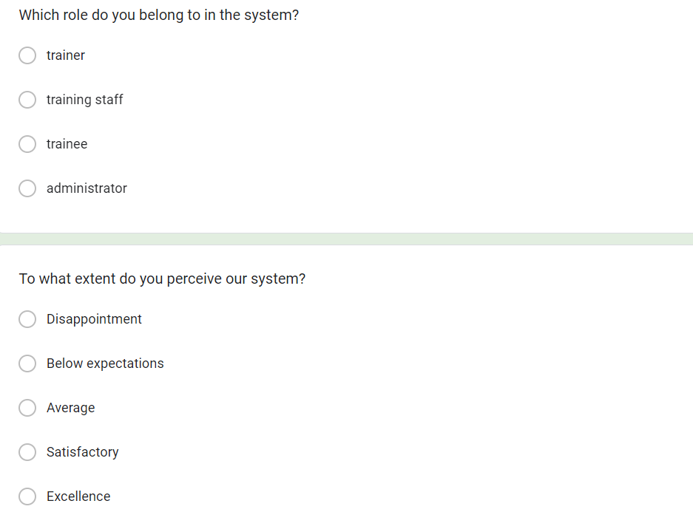

Figure 1 Question

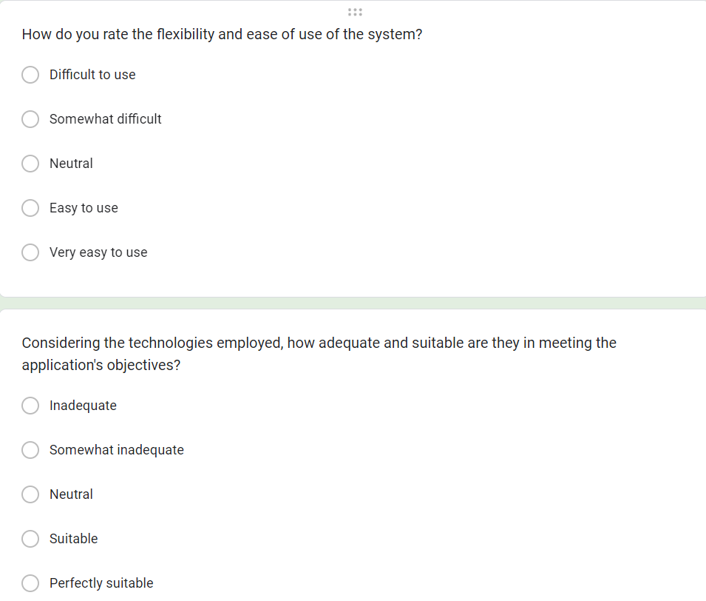

Figure 2 Question

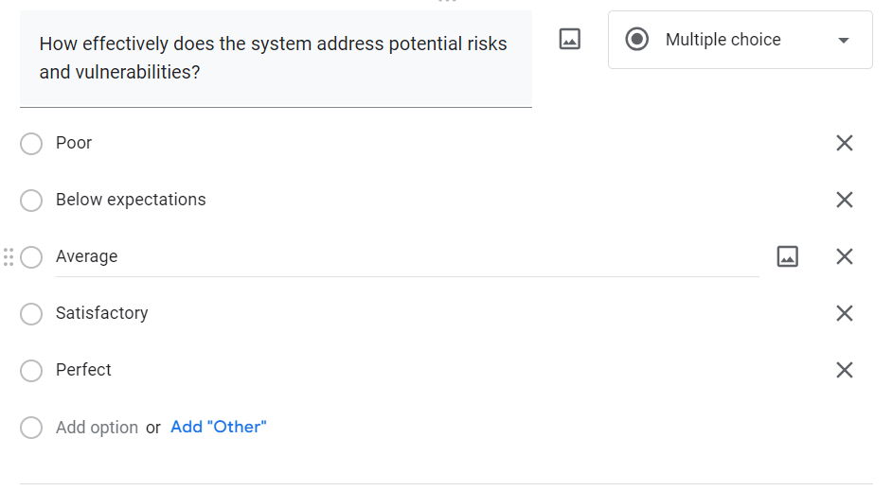

Figure 3 Question

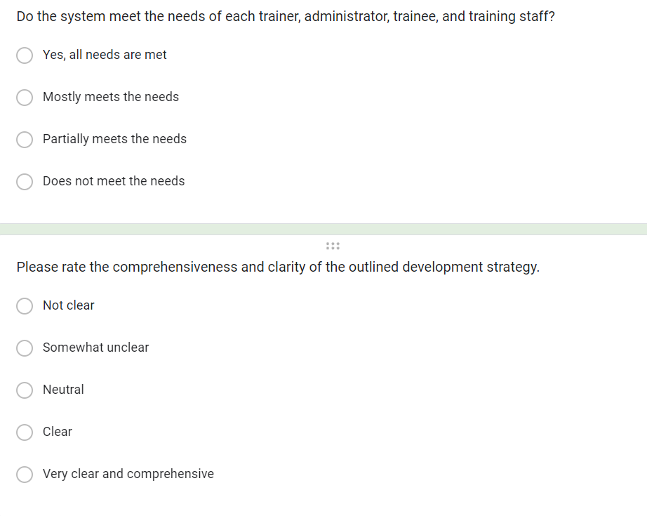

Figure 4 Question

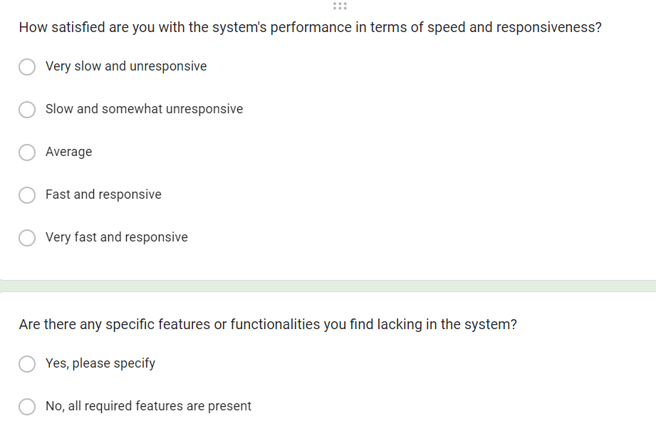

Figure 5 Question

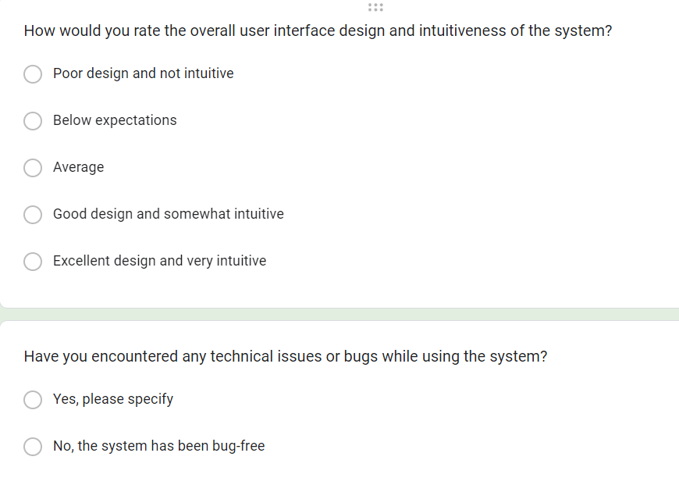

Figure 6 Question

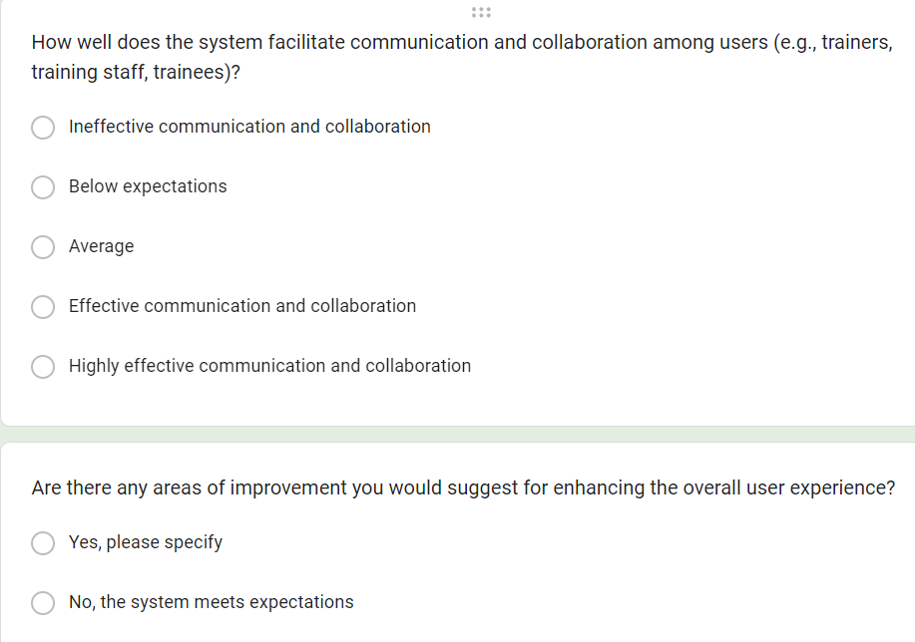

Figure 7 Question

1. The result of survey

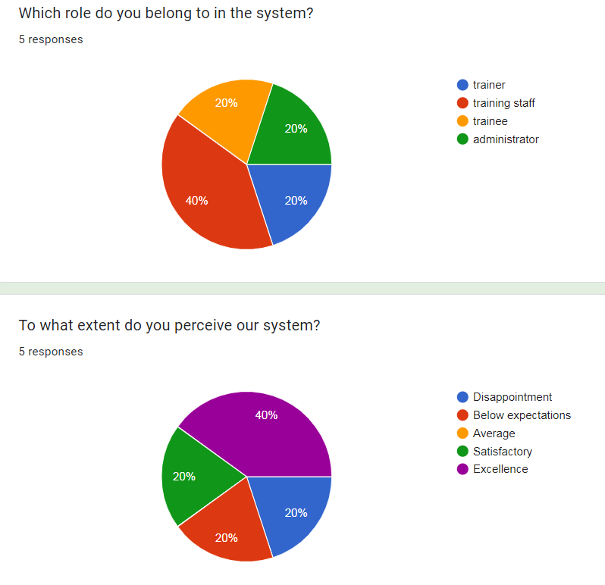

Figure 8 Result

* 1. Role Distribution:
* Training staff: 40%
* Trainer, Trainee, and Administrator (combined): 20% each

Explanation: The majority of respondents (40%) identified themselves as training staff, indicating that this role is more prevalent among those interacting with the system. The remaining 20% of respondents were distributed evenly among the other roles, suggesting a relatively balanced representation across trainer, trainee, and administrator roles.

* 1. Perception of the System:
* Excellence (5): 40%
* Below expectations (2), Average (3), Satisfactory (4): 20% each

Explanation: A significant portion of respondents (40%) perceived the system as excellent, indicating a high level of satisfaction and appreciation for its functionality and features. Conversely, the remaining 60% of respondents selected various lower ratings, suggesting differing levels of satisfaction or areas for improvement in the system's performance and usability.

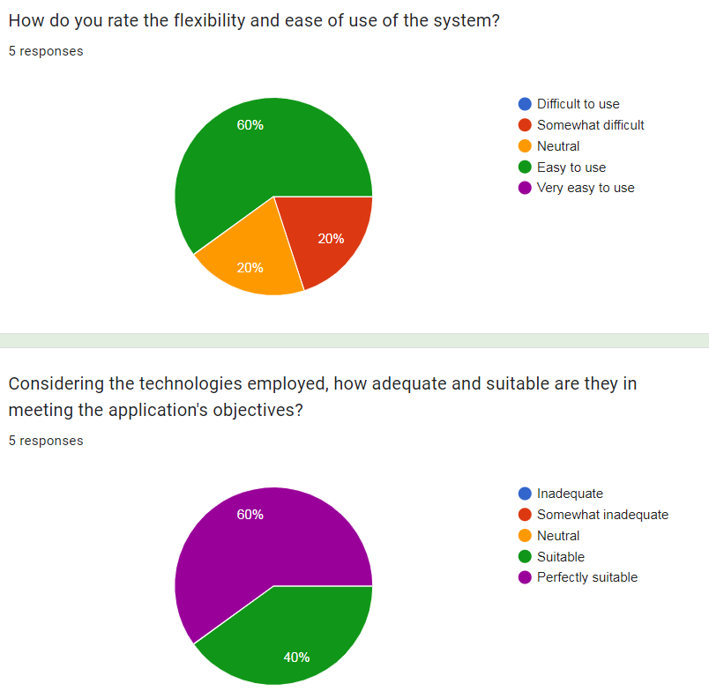

Figure 9 Result

* 1. Flexibility and Ease of Use:
* 60% of respondents chose "d) 4 - Easy to use."
* 40% of respondents split evenly between "b) 2 - Somewhat difficult" and "c) 3 - Neutral."

Explanation: The majority of respondents (60%) find the system easy to use, indicating a high level of flexibility and user-friendliness. However, there is a significant minority (40%) who find the system somewhat difficult or neutral in terms of ease of use, suggesting that there may be areas for improvement in user interface design or instructional materials to enhance usability for all users.

* 1. Suitability of Technologies:
* 60% of respondents chose "e) 5 - Perfectly suitable."
* 40% of respondents chose "d) 4 - Suitable."

Explanation: The majority of respondents (60%) believe that the technologies employed in the system are perfectly suitable for meeting the application's objectives, indicating a high level of confidence in the technological infrastructure. Additionally, 40% of respondents consider the technologies to be suitable, further supporting the notion that the system is well-equipped to fulfill its intended purposes. Overall, the high proportion of respondents selecting "Perfectly suitable" suggests a robust technological foundation supporting the system's functionalities.

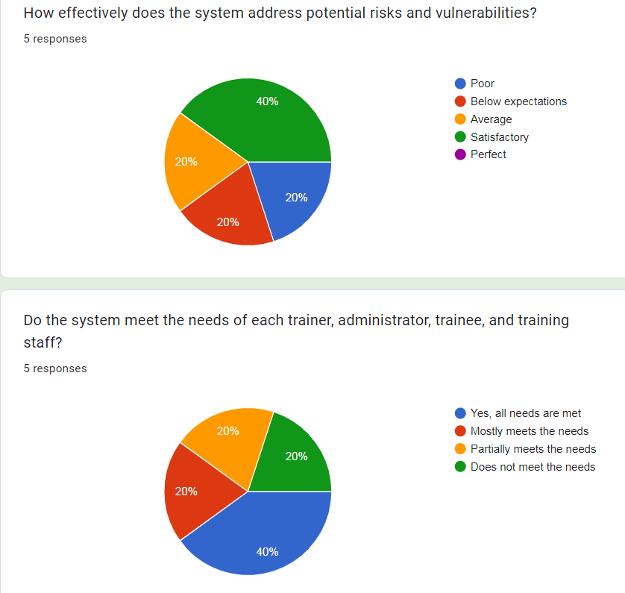

Figure 10 Result

* 1. Effectiveness in Addressing Risks and Vulnerabilities:
* 40% of respondents chose "d) 4 - Satisfactory."
* The remaining 60% of respondents split evenly between "e) 5 - Perfect," "c) 3 - Average," and "b) 2 - Below expectations."

Explanation: A significant portion of respondents (40%) consider the system's effectiveness in addressing potential risks and vulnerabilities to be satisfactory, indicating a moderate level of confidence in its security measures. However, the remaining 60% of respondents have varied perceptions, with equal proportions expressing high confidence (choosing "Perfect"), moderate confidence (choosing "Average"), and lower confidence (choosing "Below expectations") in the system's ability to mitigate risks and vulnerabilities.

* 1. Meeting the Needs of Users:
* 40% of respondents chose "a) Yes, all needs are met."
* The remaining 60% of respondents split evenly between "b) Mostly meets the needs," "c) Partially meets the needs," and "d) Does not meet the needs."

Explanation: A significant portion of respondents (40%) believe that the system meets the needs of all users, indicating a high level of satisfaction and effectiveness in catering to the diverse requirements of trainers, administrators, trainees, and training staff. However, the remaining 60% of respondents have differing perceptions, with equal proportions expressing varying degrees of satisfaction or dissatisfaction with the system's ability to meet user needs. This suggests that while the system may perform well for some users, there may be room for improvement to better address the needs of others.

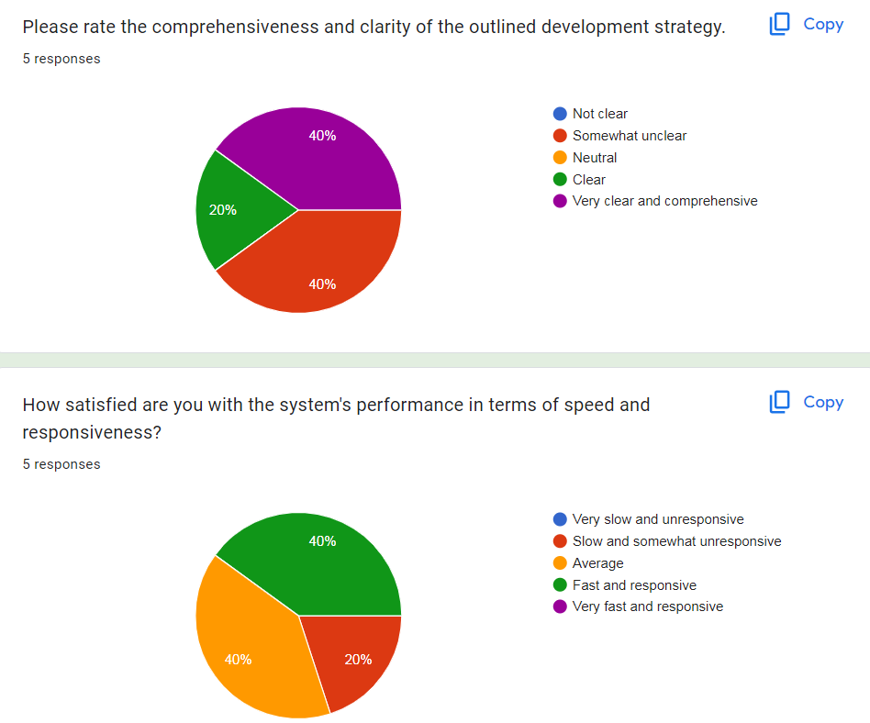

Figure 11 Result

* 1. Comprehensiveness and Clarity of Development Strategy:
* 40% of respondents chose "b) 2 - Somewhat unclear."
* 40% of respondents chose "e) 5 - Very clear and comprehensive."
* The remaining 20% of respondents chose "d) 4 - Clear."

Explanation: A significant portion of respondents (40%) perceive the outlined development strategy as somewhat unclear, suggesting that there may be areas that require further elaboration or clarification. However, an equal proportion of respondents (40%) find the development strategy to be very clear and comprehensive, indicating a high level of satisfaction with the provided information. The remaining 20% of respondents consider the strategy to be clear, indicating a moderate level of satisfaction.

* 1. System's Performance in Speed and Responsiveness:
* 40% of respondents chose "c) 3 - Average."
* 40% of respondents chose "d) 4 - Fast and responsive."
* The remaining 20% of respondents chose "b) 2 - Slow and somewhat unresponsive."

Explanation: The majority of respondents (80%) perceive the system's performance in terms of speed and responsiveness positively, with 40% rating it as average and another 40% rating it as fast and responsive. However, there is a minority (20%) who find the system to be somewhat slow and unresponsive, indicating room for improvement in this aspect of the system's performance.

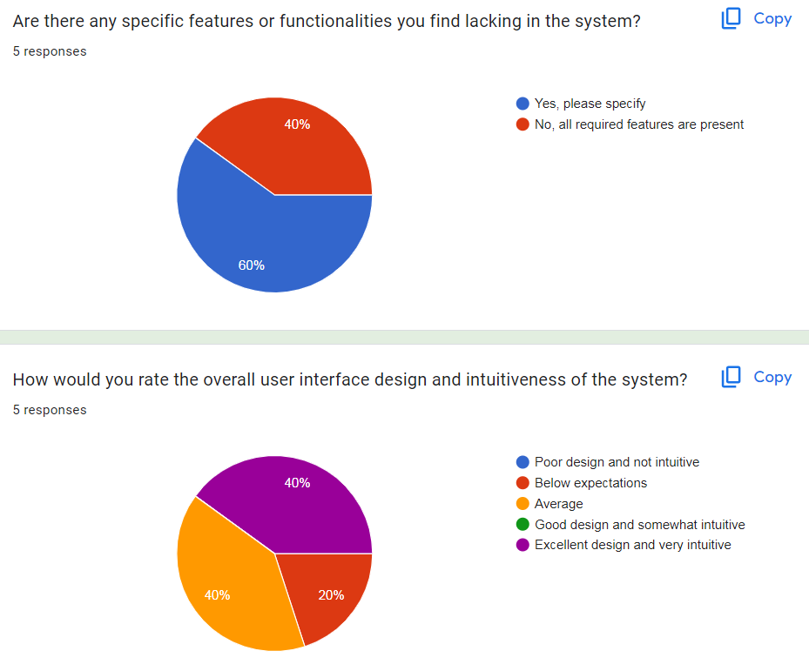

Figure 12 Result

* 1. Specific Features or Functionalities Lacking:
* 60% of respondents chose "a) Yes, please specify."
* The remaining 40% of respondents chose "b) No, all required features are present."

Explanation: A majority of respondents (60%) identified specific features or functionalities that they find lacking in the system, indicating areas for improvement or enhancement. However, 40% of respondents believe that all required features are present, suggesting a satisfactory level of completeness in the system's functionality from their perspective.

* 1. Overall User Interface Design and Intuitiveness:
* 40% of respondents chose "c) 3 - Average."
* 40% of respondents chose "e) 5 - Excellent design and very intuitive."
* The remaining 20% of respondents chose "b) 2 - Below expectations."

Explanation: The majority of respondents (80%) rated the overall user interface design and intuitiveness positively, with 40% considering it to be average and another 40% rating it as excellent and very intuitive. However, there is a minority (20%) who perceive the design to be below expectations, indicating potential areas for improvement in terms of user interface design and intuitiveness.

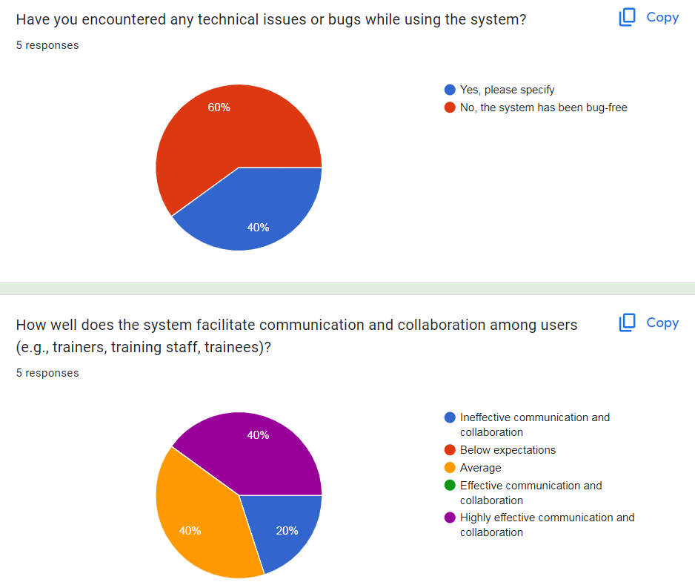

Figure 13 Result

* 1. Encountered Technical Issues or Bugs:
* 60% of respondents chose "a) Yes, please specify."
* The remaining 40% of respondents chose "b) No, the system has been bug-free."

Explanation: The majority of respondents (60%) reported encountering technical issues or bugs while using the system, indicating areas that require attention and improvement. However, 40% of respondents have not experienced any technical issues, suggesting a relatively stable and bug-free system for them.

* 1. Facilitation of Communication and Collaboration:
* 40% of respondents chose "c) 3 - Average."
* 40% of respondents chose "e) 5 - Highly effective communication and collaboration."
* The remaining 20% of respondents split evenly between "a) 1 - Ineffective communication and collaboration" and "b) 2 - Below expectations."

Explanation: The majority of respondents (80%) perceive the system to facilitate communication and collaboration effectively, with 40% considering it to be highly effective and another 40% rating it as average. However, there is a minority (20%) who have lower perceptions of the system's effectiveness in this rega

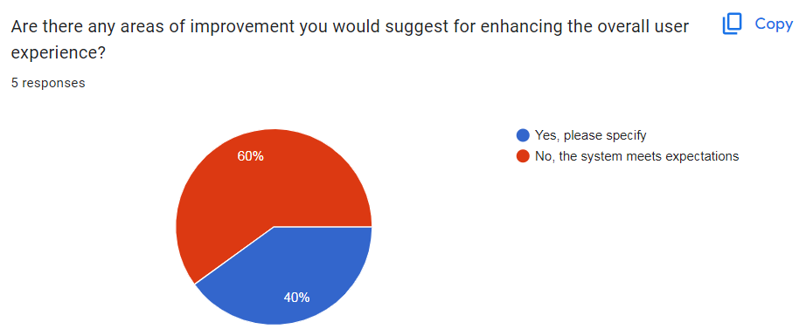

Figure 14 Result

* 1. Areas of Improvement for User Experience:
* Nearly 60% of respondents chose "b) No, the system meets expectations."
* The remaining respondents (approximately 40%) chose "a) Yes, please specify."

Explanation: The majority of respondents (nearly 60%) indicated that the system meets their expectations, suggesting overall satisfaction with the user experience. However, approximately 40% of respondents identified areas for improvement, indicating specific aspects of the system that could enhance the user experience further.

1. Feedback:

* The comprehensive survey you conducted sheds light on the overall satisfaction levels of users towards the business application. It's evident from the responses that there's a prevailing sense of contentment, with ratings predominantly falling between levels 3 to 5, indicating moderate to high satisfaction. Notably, level 2 ratings were scarce, suggesting a generally positive sentiment across the board.
* One particularly encouraging aspect is the feedback on the problem definition statement. It received consistently high ratings, primarily around level 4, implying a clear and articulate presentation of the core challenges addressed by the application. This clarity is crucial as it underpins the application's relevance and effectiveness in meeting the identified needs.
* In terms of the effectiveness of the proposed solution, the majority of responses clustered around level 4, suggesting a moderate to high level of effectiveness. While users perceive the application as providing valuable solutions, there's a consensus that further enhancements could be implemented to optimize its effectiveness and ensure it delivers the desired outcomes with utmost efficiency.
* The satisfaction expressed by users regarding the clarity and comprehensiveness of the development strategy is also noteworthy. Most responses, hovering around level 4, indicate that users perceive the strategy as well-defined and effectively communicated. However, there are areas identified for potential improvement, suggesting opportunities to elevate the strategy to an exemplary level and ensure it aligns seamlessly with the overall objectives of the application.
* Feedback on the alignment between the application's design, functionality, and user experience is largely positive, with ratings averaging around level 4. This indicates that the application effectively integrates its design elements with its functionality to create a cohesive user experience. Nevertheless, there's acknowledgment of areas where fine-tuning may be necessary to enhance usability and elevate the overall user experience to even greater heights.
* While users generally find the interface intuitive and user-friendly, as reflected in ratings ranging from 4 to 5, there's recognition of potential areas for improvement. Enhancements aimed at making the interface more user-centric and improving navigational ease could further enhance user satisfaction and overall usability.
* In summary, the survey responses paint a favorable picture of the business application, highlighting its strengths while also identifying areas for refinement and optimization. The aggregated ratings, spanning levels 3 to 5, provide valuable insights that can serve as a roadmap for further enhancing the application's capabilities and ensuring it evolves into a truly robust and user-centric solution.

P5 Develop a functional business application based on a specified business problem.

* 1. Training staff role’s .
  2. Login Training Staff.

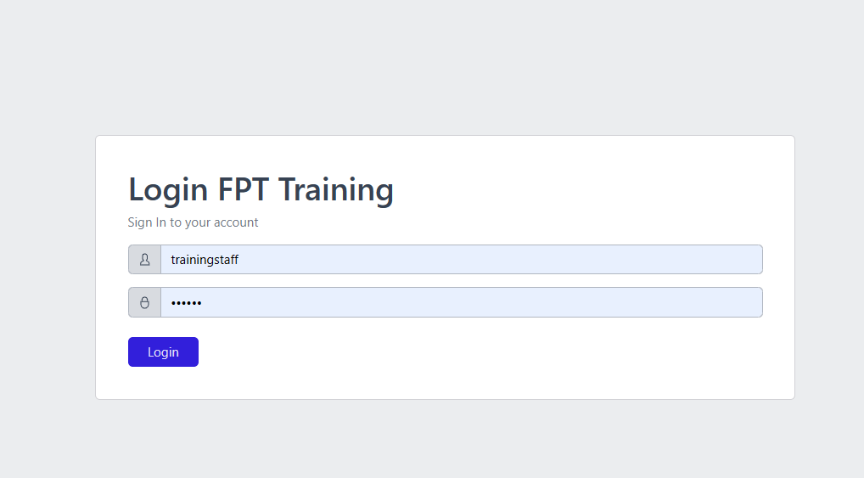

Figure 15 Login

Dashboard:

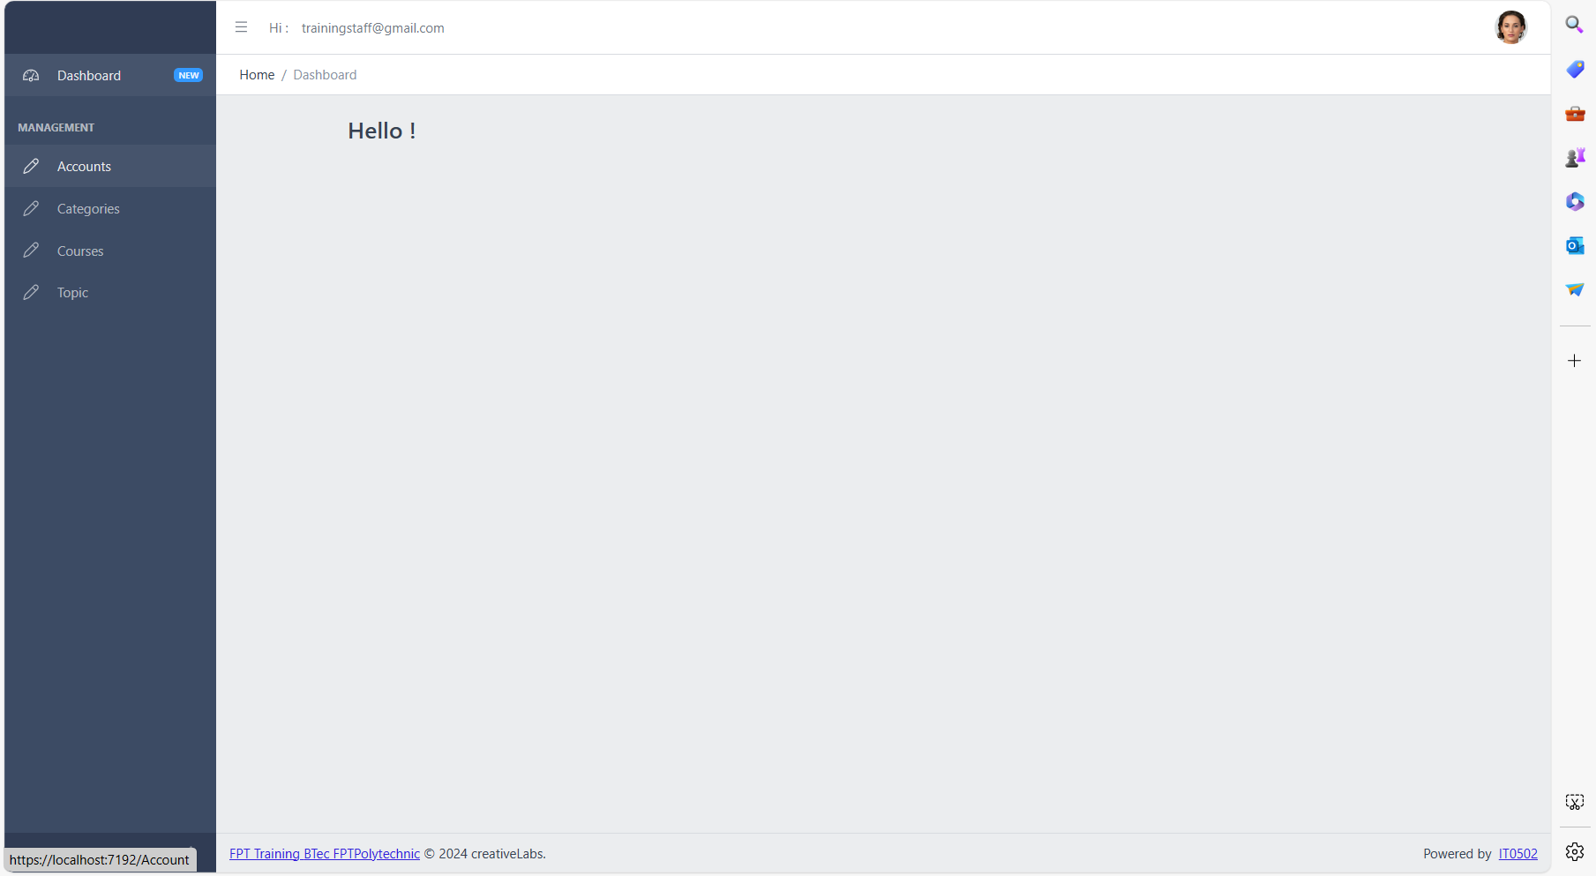

Figure 16 Dashboard Training Sfatt

* 1. User Category management.

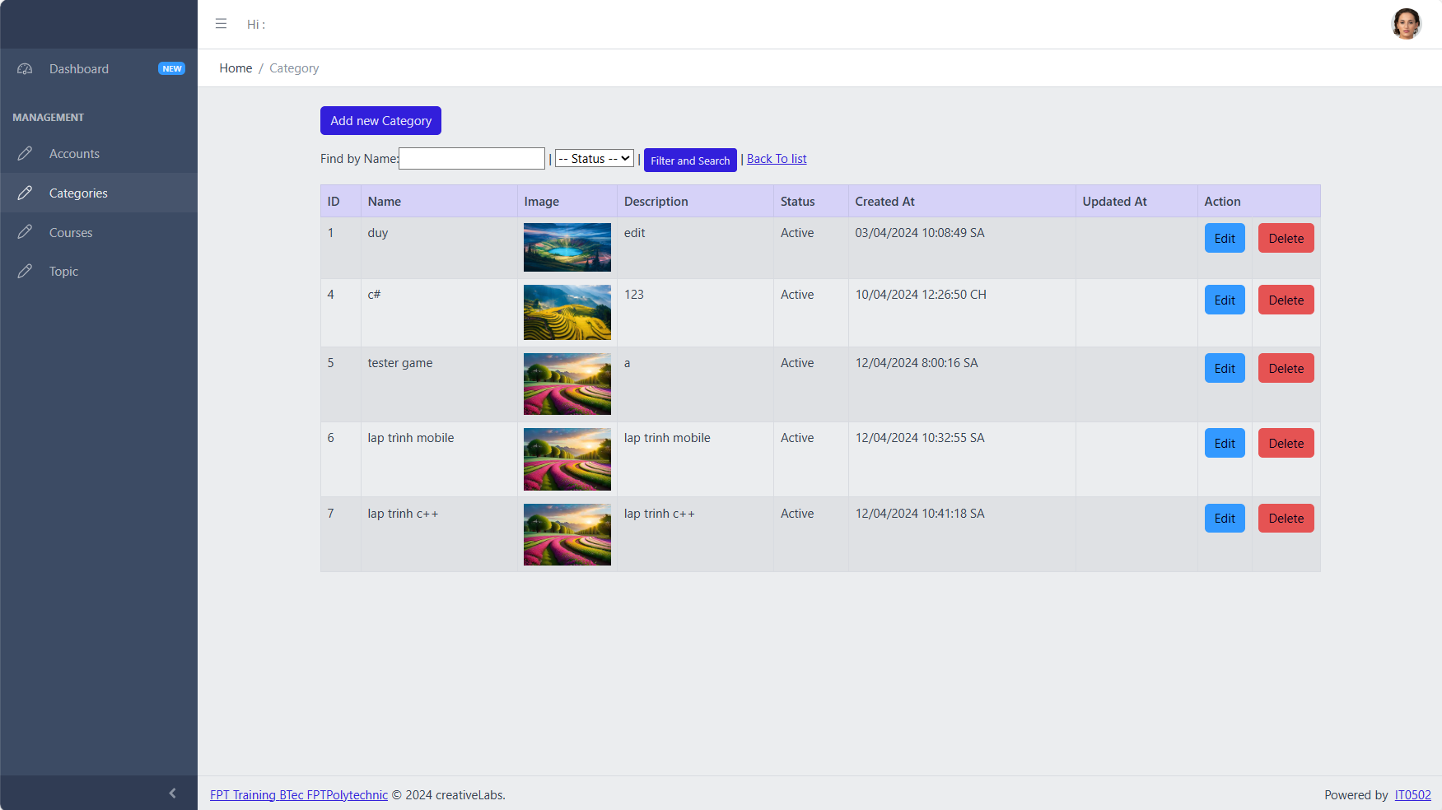

Figure 17 Index Category

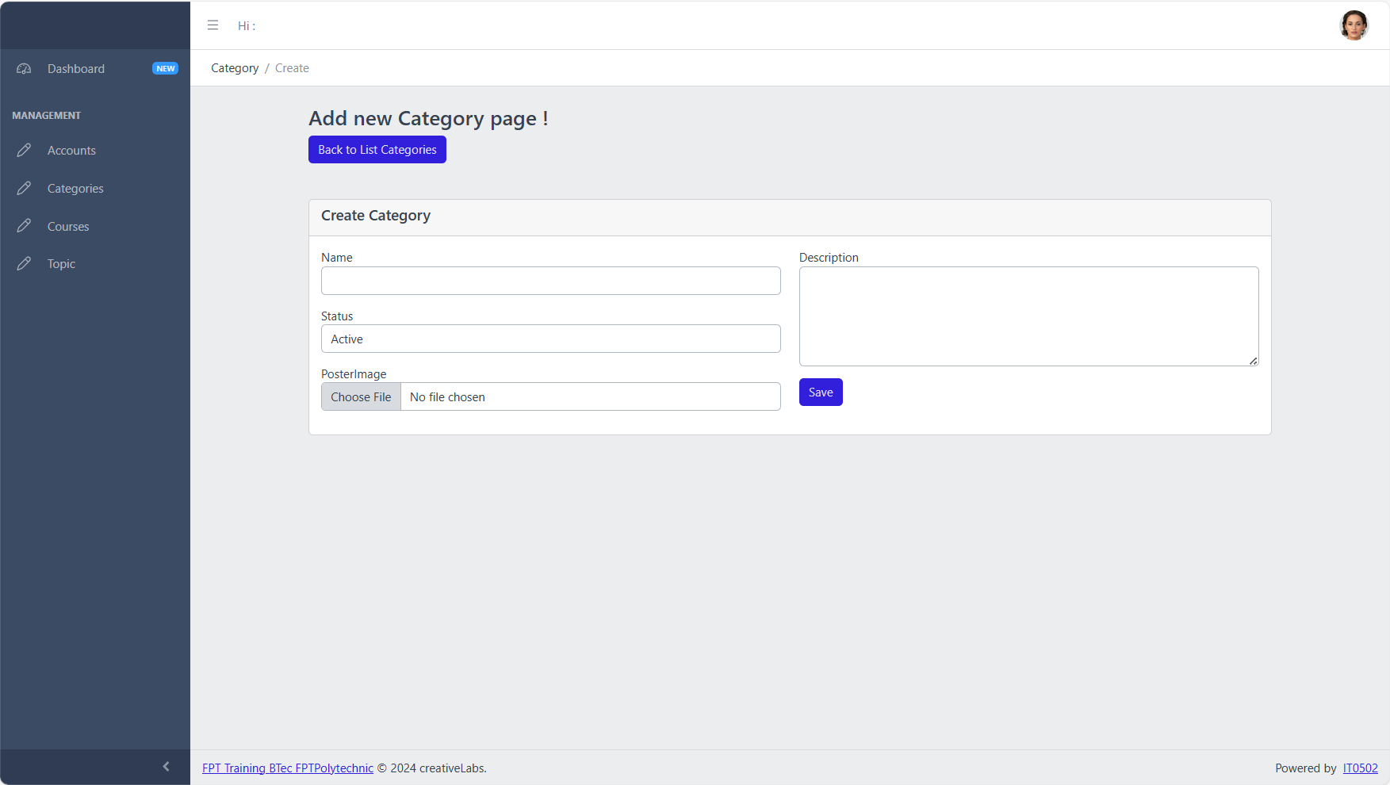

Figure 18 Add Category

* 1. User Course management.

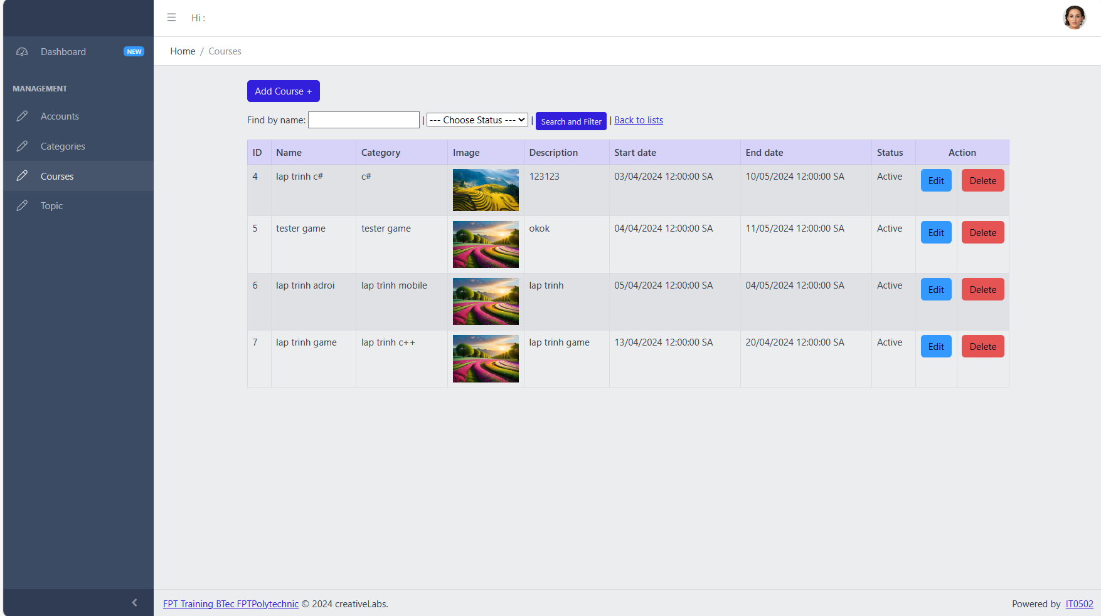

Figure 19 Index Course

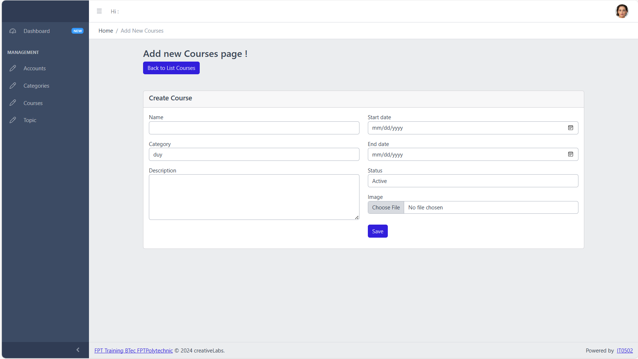

Figure 20 Add Course

* 1. User Topic management.

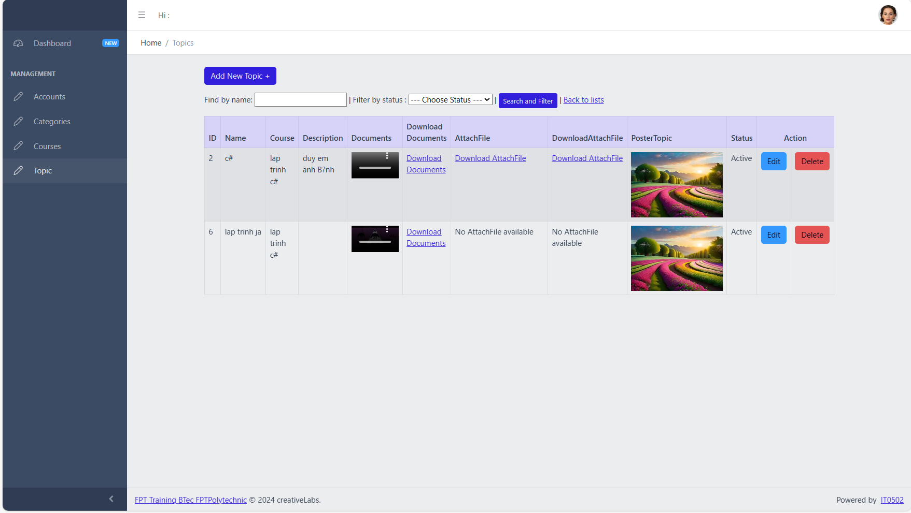

Figure 21 Index Topic

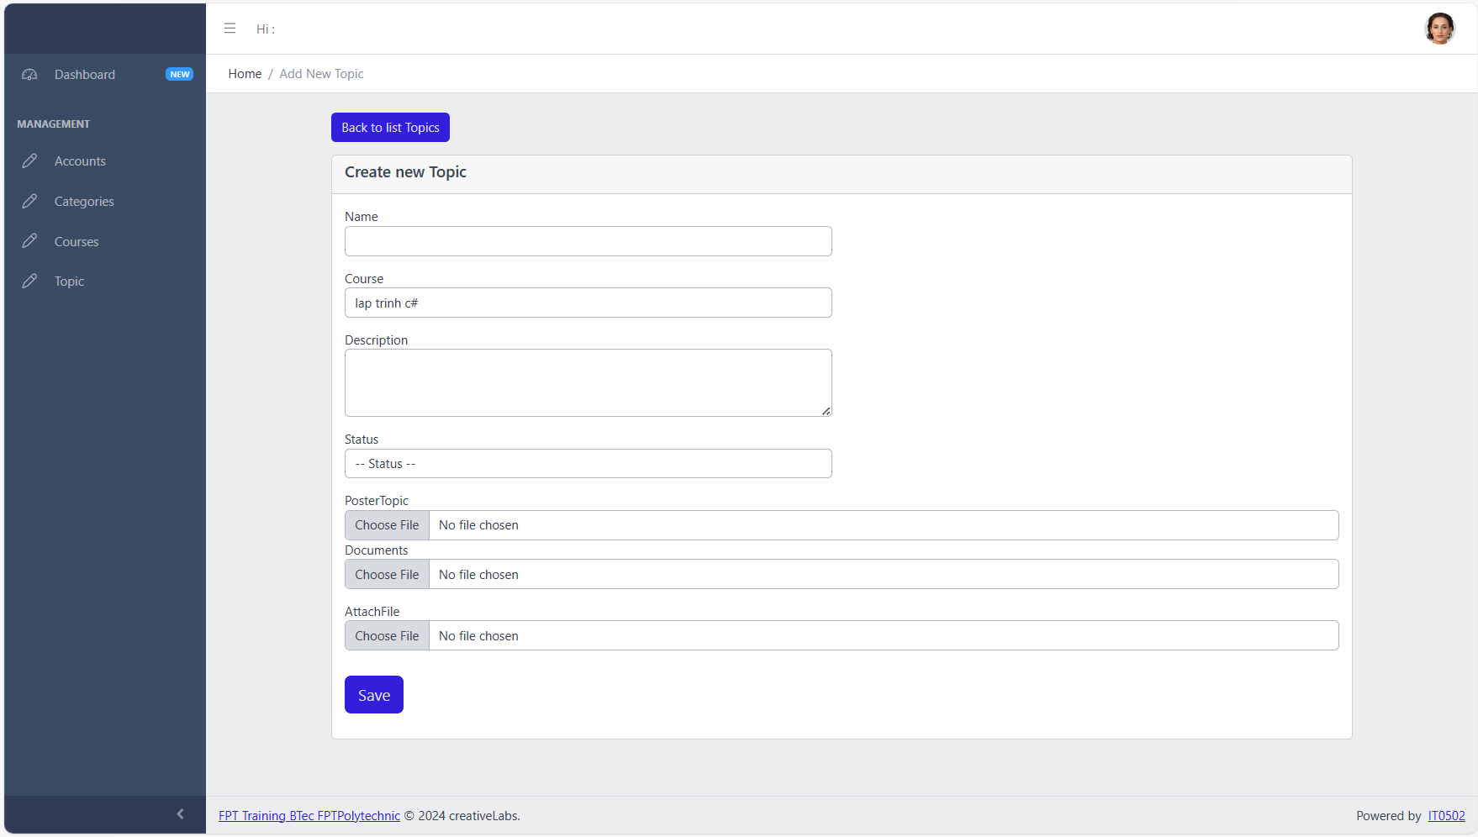

Figure 22 Add Topic

* 1. Code.
  2. Category.

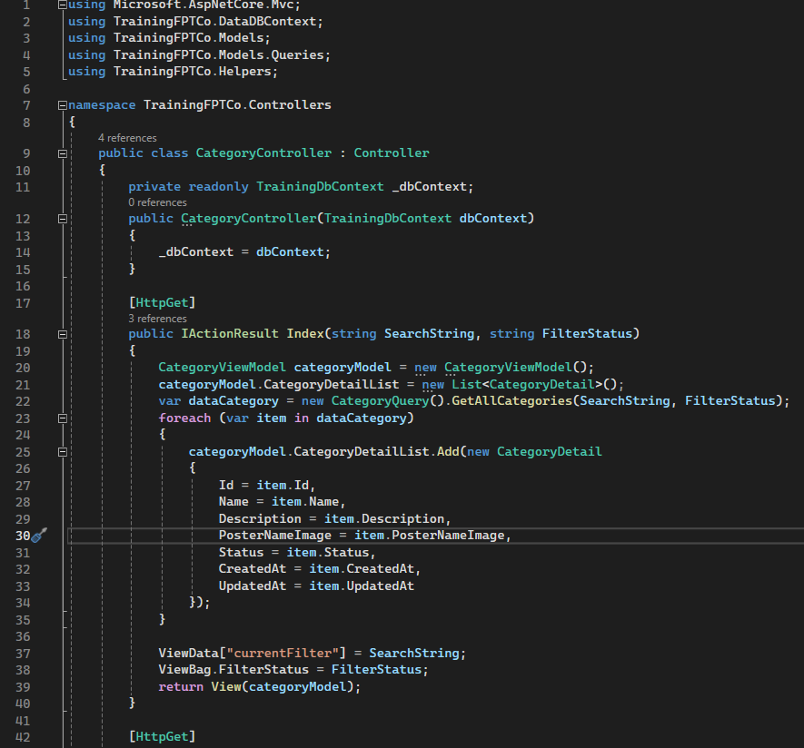

Figure 23 Category Controller

"The CategoryController class serves as a crucial component in the software application's architecture, responsible for overseeing the management and control of various operations pertaining to categories. These operations encompass a broad spectrum of tasks, including the creation, modification, and removal of categories within the application's ecosystem.

By encapsulating these functionalities within the CategoryController, the class provides a centralized point of access and coordination for all category-related activities. This architectural design fosters modularity, scalability, and maintainability, as it segregates the concerns related to category management from other components of the application.

In essence, the CategoryController acts as a guardian of category data integrity and consistency, ensuring that interactions with categories adhere to predefined rules and constraints. Through its cohesive orchestration of category-related actions, the controller plays a pivotal role in shaping the overall user experience and operational efficiency of the application.

Furthermore, the CategoryController serves as a conduit for communication between the user interface and the underlying data persistence layer. It receives input from users or external systems, processes it accordingly, and orchestrates the necessary operations to reflect changes in the category data store.

Overall, the CategoryController embodies a fundamental aspect of the application's functionality, empowering users and administrators alike to manage categories seamlessly and efficiently. Its robust design and functionality contribute significantly to the overall effectiveness and usability of the software application."

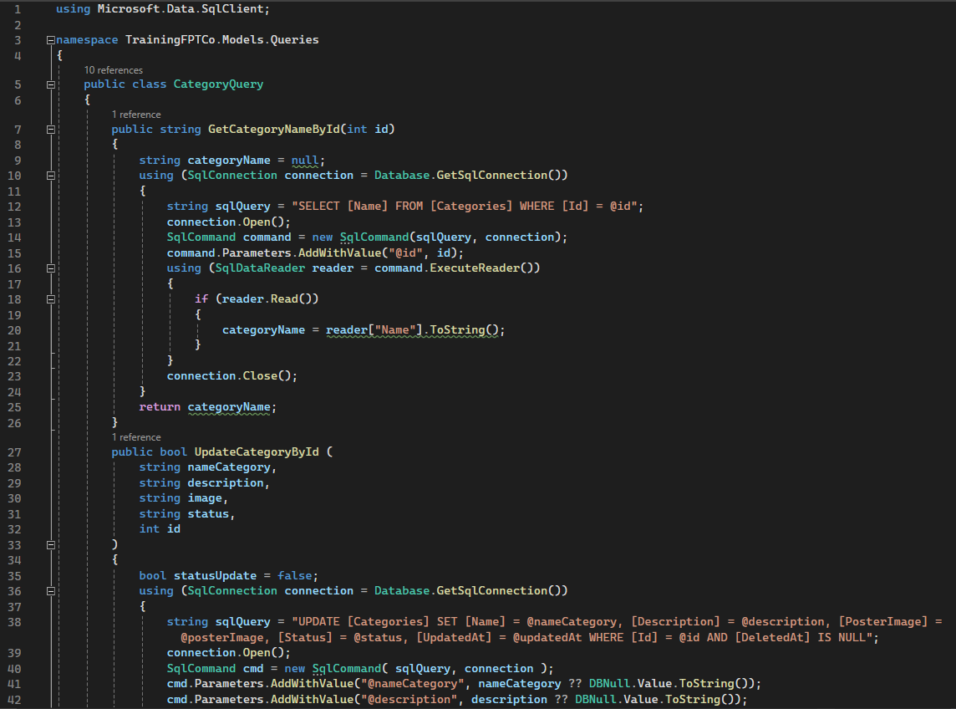

Figure 24 Category Query

The versatile 'CategoryQuery' class serves as a pivotal tool for interrogating and procuring data pertaining to categories. It facilitates an array of operations, including searching for categories, fetching detailed category information, and executing specialized category-oriented inquiries, ensuring seamless management of category-related tasks.

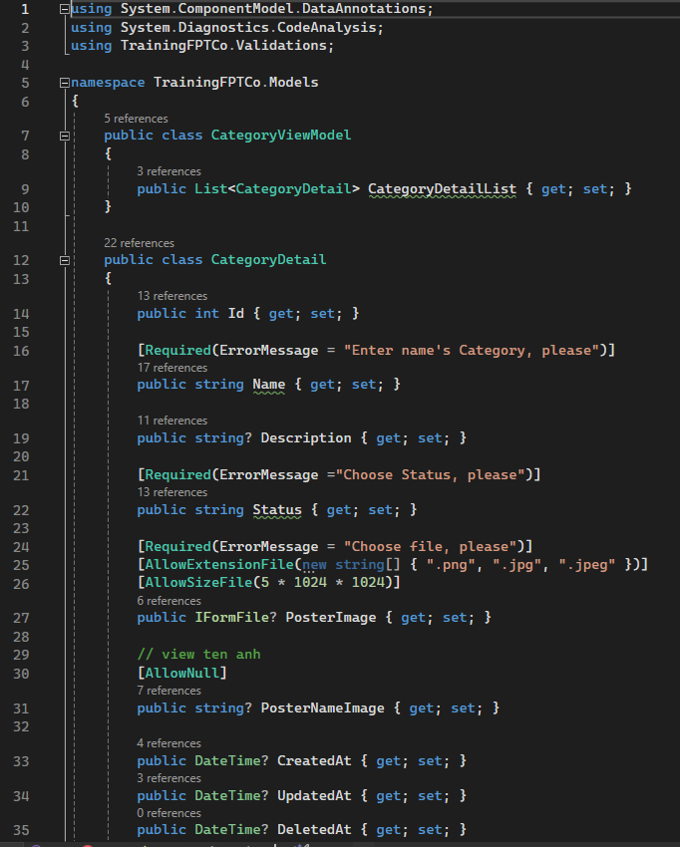

Figure 25 Category View Model

The indispensable 'CategoryViewModel' class plays a pivotal role in orchestrating the data model and business logic essential for category-centric functionalities within the application ecosystem. Acting as a cornerstone, it facilitates the creation and manipulation of a comprehensive dataset, complemented by a suite of meticulously crafted processing methods. These methods synergistically empower the user interface, facilitating seamless interaction with categories, while ensuring a rich and intuitive display of information. With its robust architecture, the 'CategoryViewModel' class encapsulates the intricacies of category management, thereby fostering an immersive and engaging user experience.

* 1. Course.

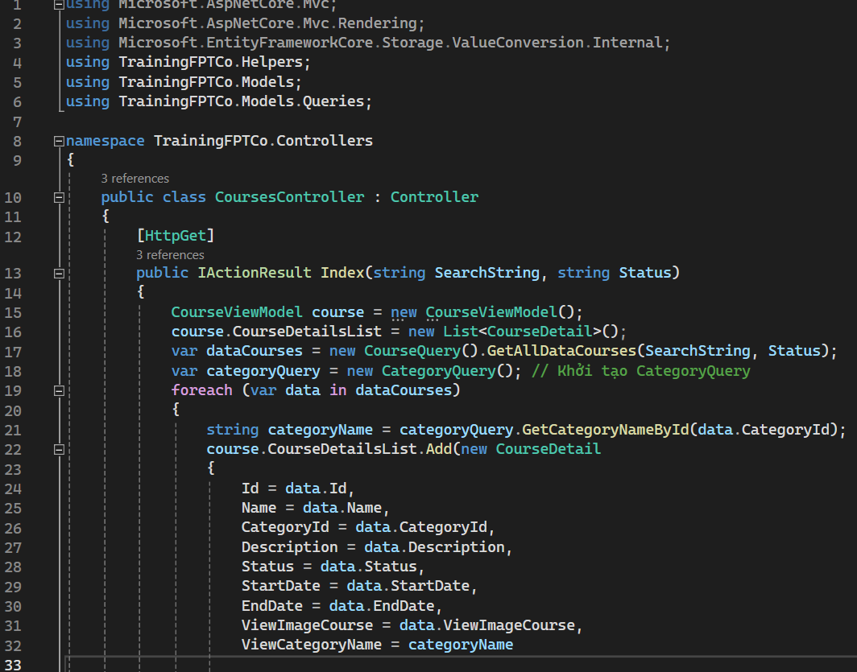

Figure 26 Couse Controller

The pivotal 'CoursesController' class serves as the linchpin for orchestrating and governing the intricate web of functionalities associated with courses within the software ecosystem. It operates as the central hub, meticulously managing the gamut of tasks related to course management, including but not limited to, the retrieval, manipulation, and deletion of course data. With unwavering diligence, the 'CoursesController' class ensures the seamless execution of these operations, navigating through the complexities inherent in course-related interactions with finesse and precision.

Embodying a holistic approach to software design, the 'CoursesController' class not only encapsulates the nuts and bolts of course management but also embodies a commitment to delivering a superlative user experience. By adhering to best practices and industry standards, it fosters a cohesive and intuitive user interface, empowering users to navigate through course-related features effortlessly.

Driven by a relentless pursuit of excellence, the 'CoursesController' class stands as a testament to the software's dedication to facilitating meaningful interactions with course content. With each interaction, it ensures that every action taken aligns seamlessly with the overarching objectives of the application, thereby enriching the user's journey through the digital landscape

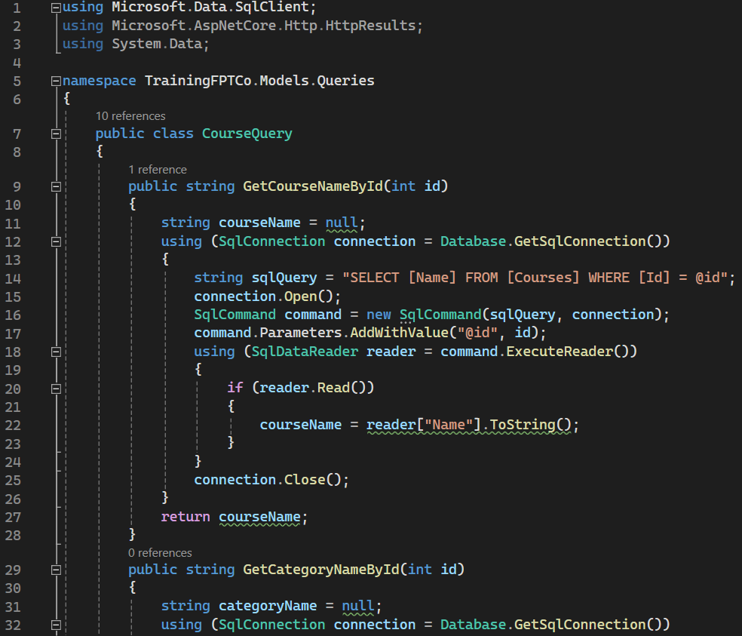

Figure 27 Course Query

The indispensable 'CourseQuery' class stands as a cornerstone in the realm of course management, dedicated to the meticulous retrieval and manipulation of course-related data within the software ecosystem. Serving as a versatile toolset, it adeptly navigates through the intricacies of course management, facilitating a myriad of essential tasks including searching for courses, extracting detailed course information, and executing specialized course-oriented queries with precision and efficiency.

At the heart of the application's functionality, the 'CourseQuery' class embodies a commitment to seamless user experience, ensuring that every interaction with course-related features is met with responsiveness and accuracy. By harnessing the power of robust querying mechanisms, it empowers users to effortlessly explore and engage with the diverse array of courses available within the system.

With its unwavering dedication to excellence, the 'CourseQuery' class encapsulates the essence of efficient data retrieval and manipulation, embodying best practices and industry standards to deliver an unparalleled user experience. Through its comprehensive suite of functionalities, it not only simplifies course management but also enriches the user's journey by providing timely and relevant access to course information, thus elevating the overall software experience to new heights.

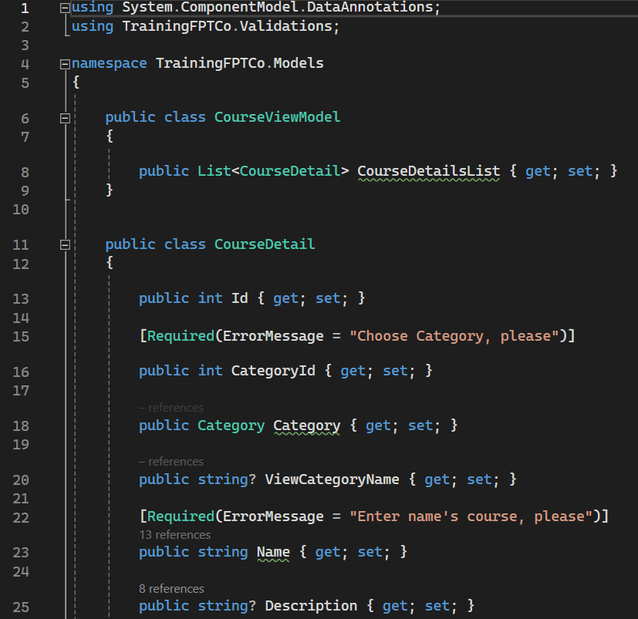

Figure 28 Course View Model

The pivotal 'CourseViewModel' class serves as the backbone of course-related functionalities within the application, embodying a robust combination of data modeling and business logic essential for seamless course management. At its core, it functions as a conduit, meticulously crafting and orchestrating a comprehensive dataset coupled with a suite of meticulously designed processing methods. These methods are strategically engineered to facilitate the seamless display of course information and empower users to interact with courses effortlessly within the user interface.

By encapsulating the intricacies of course management, the 'CourseViewModel' class ensures that every facet of the user's interaction with course-related features is meticulously orchestrated with precision and efficiency. It leverages sophisticated data modeling techniques to curate a rich and intuitive representation of course information, thereby enriching the user experience and fostering meaningful engagement with course content.

Driven by a commitment to excellence, the 'CourseViewModel' class continuously evolves to meet the dynamic demands of course management within the application landscape. Through its versatile array of processing methods and meticulously crafted data model, it empowers users to navigate through course-related functionalities with ease, ensuring a seamless and immersive experience at every turn.

In essence, the 'CourseViewModel' class stands as a testament to the application's dedication to delivering unparalleled user experience, seamlessly bridging the gap between data representation and user interaction to create a cohesive and engaging environment for exploring and engaging with course content.

* 1. Topic.

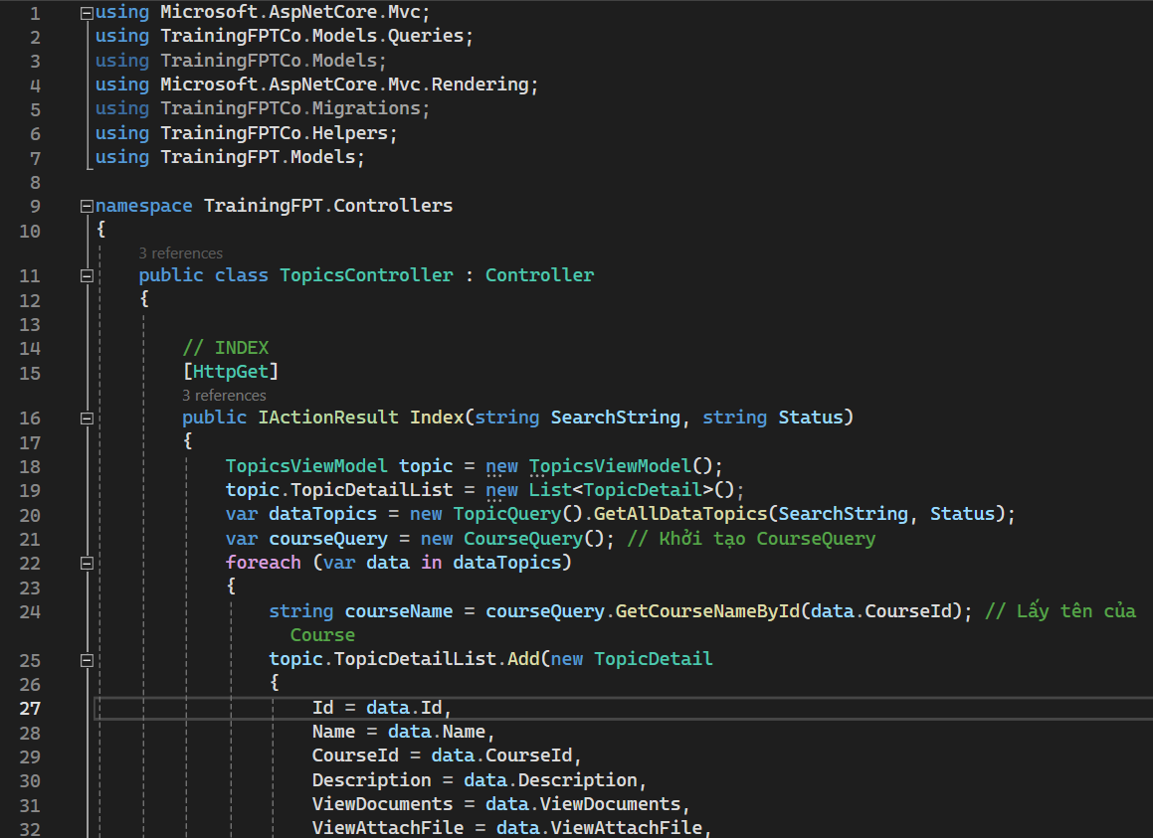

Figure 29 Topic Controller

The pivotal 'TopicController' class assumes a central role in orchestrating and governing the intricacies surrounding topic-related functionalities within software applications. As the steward of topic management, it shoulders the responsibility of creating, editing, and deleting topics with meticulous care and precision.

At its core, the 'TopicController' class serves as a linchpin, ensuring that every interaction with topics within the application landscape is met with appropriate actions and responses. By leveraging its robust set of methods and functionalities, it facilitates seamless navigation through the lifecycle of topics, from inception to modification and eventual removal.

Driven by a commitment to excellence, the 'TopicController' class embodies best practices and industry standards to deliver a superlative user experience. Through its adept management of topic-related tasks, it fosters an environment where users can engage with topics effortlessly, thereby enriching their journey through the application.

In essence, the 'TopicController' class stands as a testament to the application's dedication to effective topic management, ensuring that each interaction with topics is met with responsiveness and efficacy, ultimately contributing to a cohesive and enriching user experience.

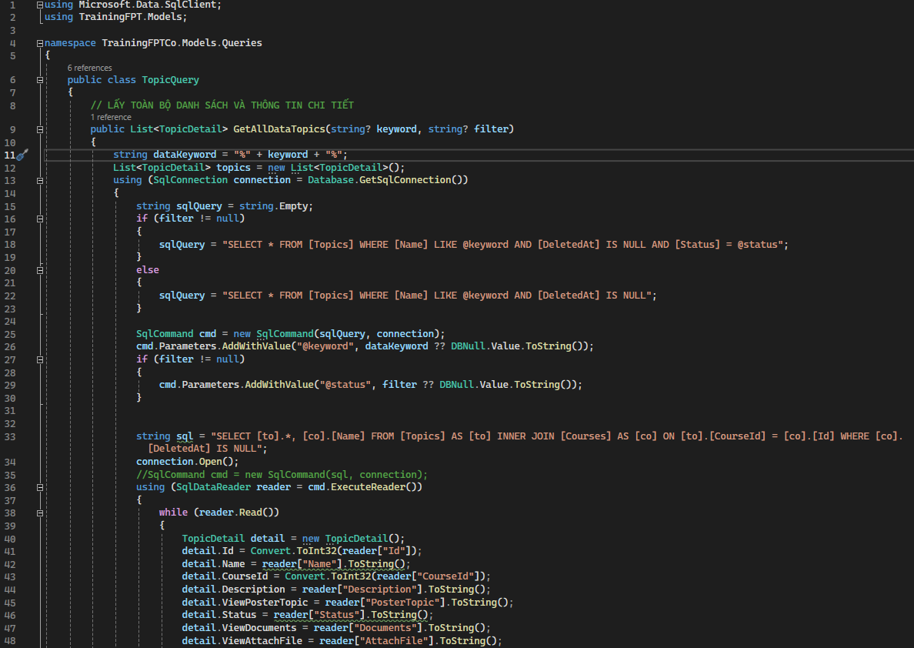

Figure 30 Topic Query

The indispensable 'TopicQuery' class serves as a foundational component in the realm of topic management within software applications. Designed to facilitate seamless access to topic-related information, it acts as a versatile toolset for querying and retrieving data pertinent to topics. Its multifaceted capabilities encompass a spectrum of essential tasks, including searching for topics, extracting detailed topic information, and executing specialized queries tailored to the intricacies of topic management.

At the heart of its functionality, the 'TopicQuery' class embodies a commitment to efficacy and precision, ensuring that every interaction with topics is met with responsiveness and accuracy. By harnessing advanced querying mechanisms, it empowers users to effortlessly explore and engage with topics, fostering a cohesive and intuitive user experience.

With its robust architecture and comprehensive feature set, the 'TopicQuery' class stands as a testament to the application's dedication to effective topic management. By encapsulating best practices and industry standards, it streamlines the process of accessing topic-related information, ultimately enriching the user's journey through the application's landscape.

In essence, the 'TopicQuery' class serves as a cornerstone in the quest for efficient topic management, empowering users to navigate through topics with ease and confidence, while ensuring that each interaction is met with timely and relevant insights.

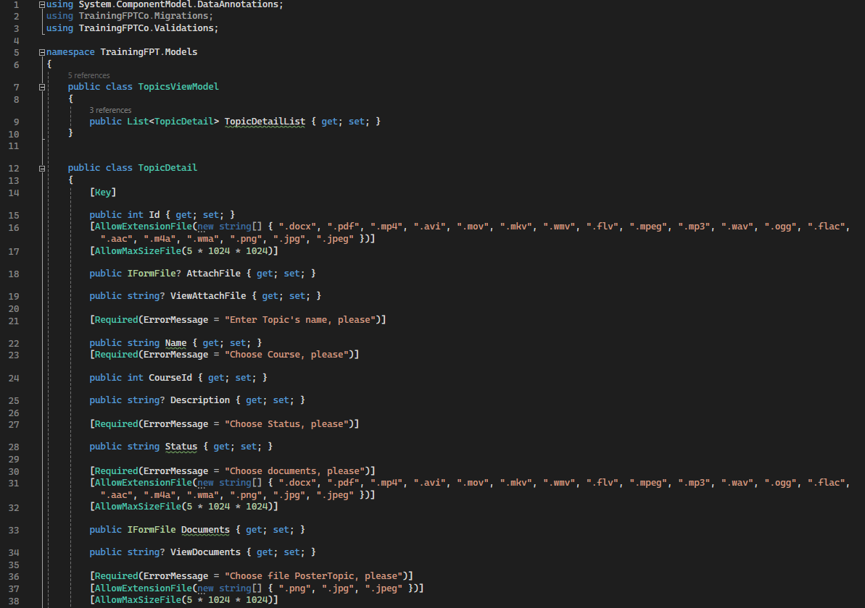

Figure 31 Topic View Model

The pivotal 'TopicViewModel' class serves as the backbone of theme-related functionalities within the application, embodying a robust combination of data modeling and business logic essential for seamless theme management. At its core, it functions as a conduit, meticulously crafting and orchestrating a comprehensive dataset coupled with a suite of meticulously designed processing methods. These methods are strategically engineered to facilitate the seamless display of theme information and empower users to interact with themes effortlessly within the user interface.

By encapsulating the intricacies of theme management, the 'TopicViewModel' class ensures that every facet of the user's interaction with theme-related features is meticulously orchestrated with precision and efficiency. It leverages sophisticated data modeling techniques to curate a rich and intuitive representation of theme information, thereby enriching the user experience and fostering meaningful engagement with theme content.

Driven by a commitment to excellence, the 'TopicViewModel' class continuously evolves to meet the dynamic demands of theme management within the application landscape. Through its versatile array of processing methods and meticulously crafted data model, it empowers users to navigate through theme-related functionalities with ease, ensuring a seamless and immersive experience at every turn.

In essence, the 'TopicViewModel' class stands as a testament to the application's dedication to delivering unparalleled user experience, seamlessly bridging the gap between data representation and user interaction to create a cohesive and engaging environment for exploring and engaging with theme content.

P6 Review the performance of your business application against the Problem Definition Statement and initial requirements.

1. Function requirements.
   1. Administrator

Login

* Management user account
* Create account
* Edit account
* Delete account Logout
  1. Training staff
* Login
* Management course
* Add course
* Edit course
* delete course Management categories
* Add categories
* Edit categories
* Delete categories Management topic
* Add topic
* Edit topic
* Delete topic Assign trainers to topic Assign trainee to course Logout
  1. Trainer
* Login
* View and update their profile View course with assign topics
  1. Trainee
* Login
* View their profile View course

1. Test case

|  |  |  |  |
| --- | --- | --- | --- |
| Id | Test case name | Description | Actor |
| TC1 | Login | Login successful | Administrator, training staff, trainer, trainee |
| TC 2 | Login | Login failed | Administrator, training staff, trainer, trainee |
| TC 3 | Category manager | Add category | Training staff |
| TC 4 | Category manager | Edit category | Training staff |
| TC 5 | Category manager | Delete category | Training staff |
| TC 6 | Category manager | Search category | Training staff |
| TC 7 | Course manager | Add course | Training staff |
| TC 8 | Course manager | Edit course | Training staff |
| TC 9 | Course manager | Delete course | Training staff |
| TC11 | Course manager | Search course | Training staff |
| TC12 | Topic manager | Add topic | Training staff |
| TC13 | Topic manager | Edit topic | Training staff |
| TC14 | Topic manager | Delete topic | Training staff |
| TC15 | Assign trainer manager | Add assign trainer | Training staff |
| TC16 | Assign trainer manager | Edit assign trainer | Training staff |
| TC17 | Assign trainer manager | Delete assign trainer | Training staff |
| TC18 | Assign trainee manager | Add assign trainee | Training staff |
| TC19 | Assign trainee manager | Edit assign trainee | Training staff |
| TC20 | Assign trainee manager | Delete assign trainee | Training staff |
| TC21 | Logged in | User has session | Administrator, training staff, trainer, trainee |
| TC22 | Logout | User has log out | Administrator, training staff, trainer, trainee |

1. Test plan.

|  |  |  |  |  |  |  |
| --- | --- | --- | --- | --- | --- | --- |
| ID | Test case name | Description | Test data | Expected | Actual | Remarks |
| TC1 | Login | Login successful | Username:Training staff  Password: 123123 | Login successful | Login successful | Pass |
| TC2 | Login | Login failed | Username: Training Staff,  Password: 5 | Login failed | Login failed | Pass |
| TC3 | Category manager | Add category | Name: category5, Status: active | Add successful | Add successful | Pass |
| TC4 | Category manager | Edit category | Name: category2, Status: active | Edit successful | Edit successful | Pass |
| TC5 | Category manager | Delete category | Id = 5 | Delete successful | Delete successful | Pass |
| TC6 | Category manager | Search category | Cate8 | Display data of  category has name: Cate2 | Display data of  category has name: Cate2 | Pass |
| TC7 | Course manager | Add course | Name: course4, Category: cate003, startDate: 10/09/2023,  Status: active | Add successful | Add successful | Pass |
| TC8 | Course manager | Edit course | Name: course2, Category: cate3, startDate: 10/09/2023,  Status: active | Edit successful | Edit successful | Pass |
| TC9 | Course manager | Delete course | Id = 20 | Delete successful | Delete successful | Pass |
| TC10 | Course manager | Search course | Course10 | Display data of course has name:  Course1 | Display data of course has name:  Course1 | Pass |
| TC11 | Topic manager | Add topic | Name: topic1,  Course: course2, Document: document.doc Status: active | Add successful | Add successful | Pass |
| TC12 | Topic manager | Edit topic | Name: topic2,  Course: course2, Document: document2.doc Status: active | Edit successful | Edit successful | Pass |
| TC13 | Topic manager | Delete topic | Id = 4 | Delete successful | Delete successful | Pass |
| TC14 | Topic manager | Search topic | Topic3 | Display data of topic has name: Topic1 | Display data of topic has name: Topic1 | Pass |
| TC15 | Assign trainer manager | Add assign trainer | Trainer: 2,  Course: 2, Status: active | Add successful | Add successful | Pass |
| TC16 | Assign trainer manager | Edit assign trainer | Trainer: 2,  Course: 1, Status: active | Edit successful | Edit successful | Pass |
| TC17 | Assign trainer manager | Delete assign trainer | Id = 8 | Delete successful | Delete successful | Pass |
| TC18 | Assign trainee manager | Add assign trainee | Trainee: 4,  Topic: 2, Status: active | Add successful | Add successful | Pass |
| TC19 | Assign trainee manager | Edit assign trainee | Trainee: 6,  Topic: 5, Status: active | Edit successful | Edit successful | Pass |
| TC20 | Assign trainee manager | Delete assign trainee | Id = 4 | Delete successful | Delete successful | Pass |
| TC22 | Logged in | User has session |  | Still login until logout | Logged out  after few minute | Fail |
| TC23 | Logout | User has log out |  | Logout successful | Logout successful | Pass |

1. Evaluation
   1. Strengths:

Exceptional Clarity in Problem Definition: The project demonstrates an exemplary ability to articulate its problem statement, earning a stellar 4 out of 5. This robust articulation lays a solid foundation, ensuring a clear understanding of the project's objectives among stakeholders.

Highly Effective Solutions: Feedback underscores the effectiveness of the proposed solutions, with the majority falling within the "effective to highly effective" range. This validation speaks volumes about the project's ability to address the identified needs efficiently.

Thorough Development Plan: The project's development strategy garners praise for its thoroughness, scoring a commendable 4. This comprehensive plan instills confidence in successful project execution by providing stakeholders with a detailed roadmap for implementation.

Appropriate Design and Functionality: The application's design and functionality are well-suited to its intended purpose and user experience, garnering favorable level 4 ratings. While commendable, there's an opportunity to further optimize these aspects for enhanced usability and overall user satisfaction.

* 1. Weaknesses:

GUI Complexity: User feedback highlights navigational challenges and a lack of user-focused design, resulting in ratings ranging from 3-4. Addressing these areas of concern is critical to improving user satisfaction and engagement, ultimately enhancing the application's usability.

Pending Account Management and Permissions: The absence of account management and permission functionalities represents a significant gap in the project's development. Addressing this weakness is paramount to bolstering security measures and granting users greater control over their accounts.

Lack of Interface Refinement: The user interface lacks significant improvements, detracting from its visual appeal and user-friendliness. This deficiency may hinder user adoption and satisfaction, underscoring the need for interface enhancements to elevate the overall user experience.

* 1. Opportunities for Improvement:

Iterative Solution Refinement: Embrace a feedback-driven approach to refine proposed solutions iteratively, leveraging user insights to optimize effectiveness continually.

Strategic Growth Optimization: Review and refine the growth strategy to identify areas for improvement, fostering efficiency and innovation in development methods to drive sustained project success.

Enhanced Interface Design: Prioritize interface enhancements focused on intuitive navigation and user-centered design, leveraging visual elements to create an immersive and engaging user experience.

Feedback-Driven Development Iteration: Establish a robust feedback loop that integrates iterative testing and flexible feedback mechanisms, ensuring continuous alignment with evolving user expectations.

Comprehensive Account Management Integration: Incorporate robust account management and permission functionalities to enhance security and user control, addressing a critical aspect of the project's development and fortifying its integrity.

1. Conclusion.

In conclusion, our journey towards developing this business application has been marked by meticulous planning, strategic implementation, and relentless pursuit of excellence. We have meticulously navigated through the complexities of the development process, leveraging cutting-edge technologies and methodologies to bring our vision to fruition.

Through collaborative efforts and an unwavering commitment to quality, we have successfully crafted a robust and functional application that addresses the diverse needs of our stakeholders. While we celebrate our achievements, we also recognize that there is always room for improvement.

Looking ahead, we envision a future where our application continues to evolve and adapt to meet the ever-changing demands of the business landscape. We remain steadfast in our commitment to innovation, continuously seeking new opportunities to enhance our solution and deliver even greater value to our clients.

As we embark on the next phase of our journey, we do so with confidence and determination, knowing that our efforts will continue to make a meaningful impact in the world of business applications.

1. Reference

Link google from: <https://forms.gle/Pw1VrFYtyNrQJKJn6>

Link gitHub: <https://github.com/khanh052003/TraingFPTCo.git>