**ASSIGNMENT 2 FRONT SHEET**

|  |  |  |  |
| --- | --- | --- | --- |
| **Qualification** | **BTEC Level 5 HND Diploma in Computing** | | |
| **Unit number and title** | Unit 30: Application Development | | |
| **Submission date** |  | **Date Received 1st submission** |  |
| **Re-submission Date** |  | **Date Received 2nd submission** |  |
| **Student Name** | Đỗ Nam Khánh | **Student ID** | BH00021 |
| **Class** | IT0502 | **Assessor name** | Nguyen Thanh Trieu |
| **Student declaration**  I certify that the assignment submission is entirely my own work and I fully understand the consequences of plagiarism. I understand that making a false declaration is a form of malpractice. | | | |
|  |  | **Student’s signature** | khanh |

**Grading grid**

|  |  |  |  |  |  |  |  |
| --- | --- | --- | --- | --- | --- | --- | --- |
| P4 | P5 | P6 | M3 | M4 | M5 | D2 | D3 |
|  |  |  |  |  |  |  |  |

|  |  |  |
| --- | --- | --- |
| **❒ Summative Feedback: ❒ Resubmission Feedback:** | | |
| **Grade:** | **Assessor Signature:** | **Date:** |
| **Lecturer Signature:** | | |

1. Introduction.
2. Content.

P4 Create a formal questionnaire that effectively reviews your business application, problem definition statement, proposed solution and development strategy. Use this questionnaire as part of a peer-review and document any feedback given.

1. Formal questionnaire:

Link google from: https://forms.gle/Pw1VrFYtyNrQJKJn6

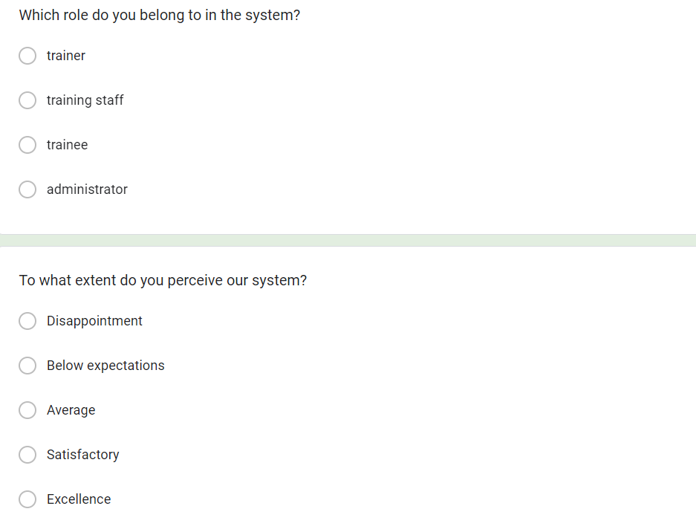

Figure 1 Question

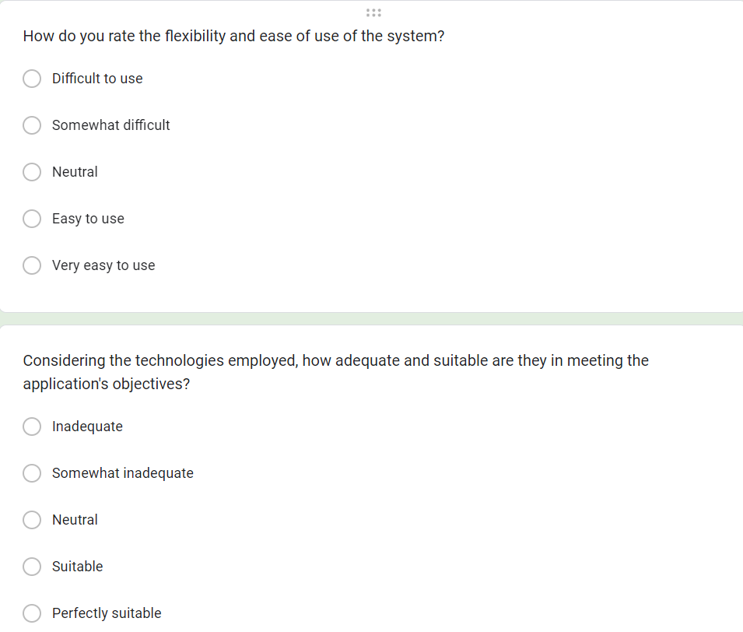

Figure 2 Question

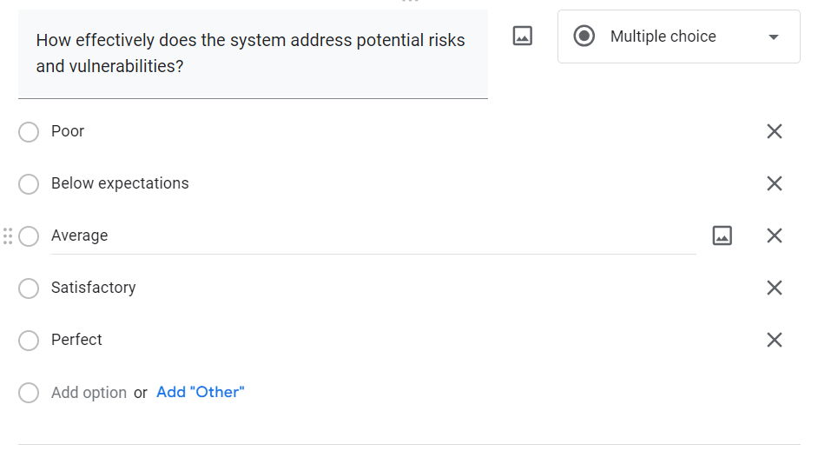

Figure 3 Question

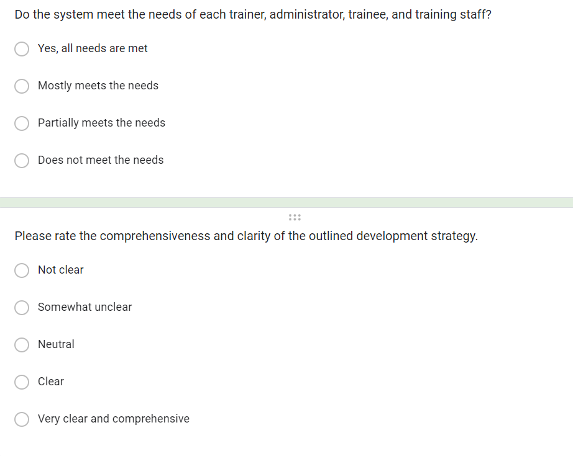

Figure 4 Question

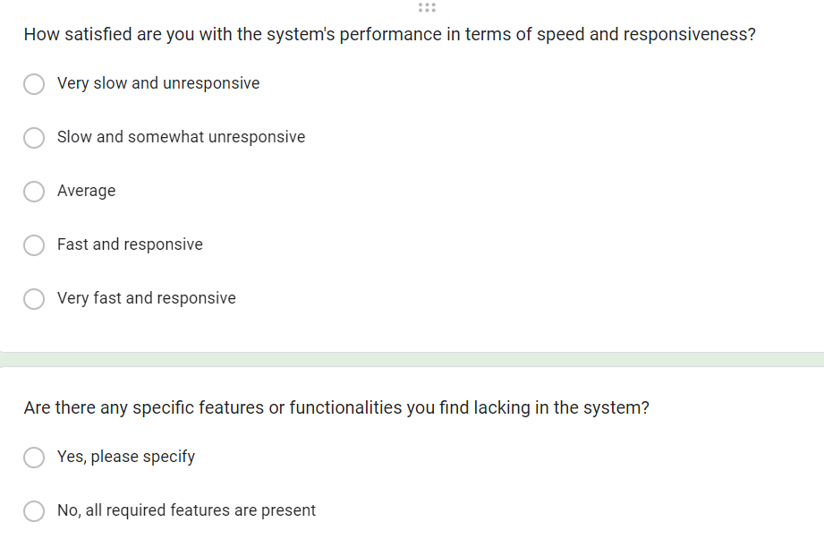

Figure 5 Question

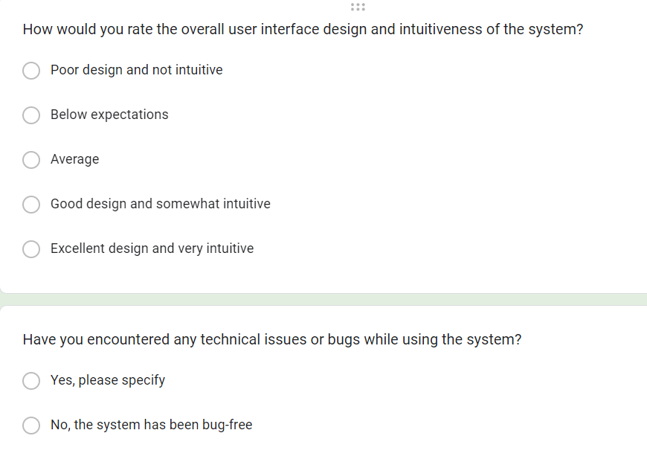

Figure 6 Question

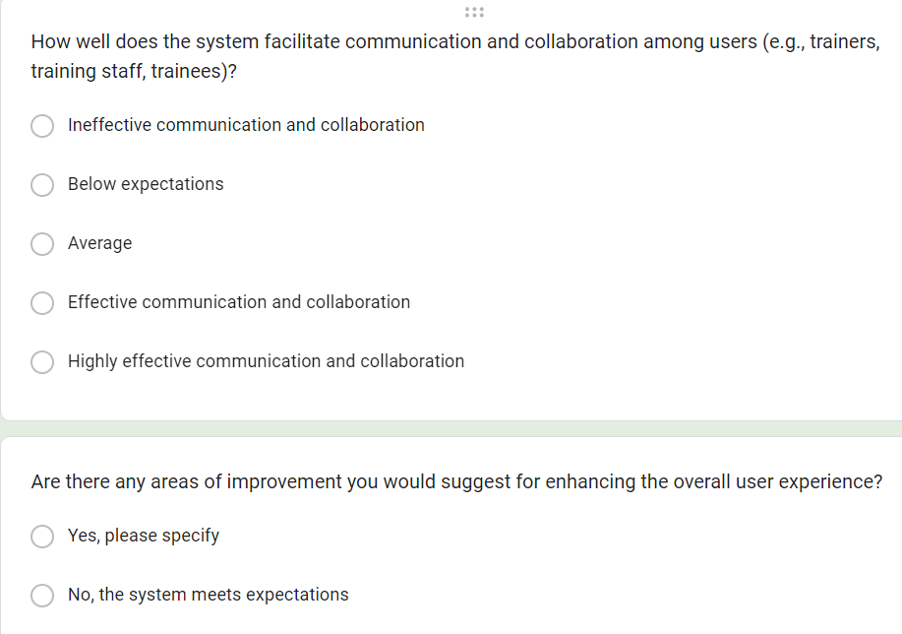

Figure 7 Question

1. The result of survey

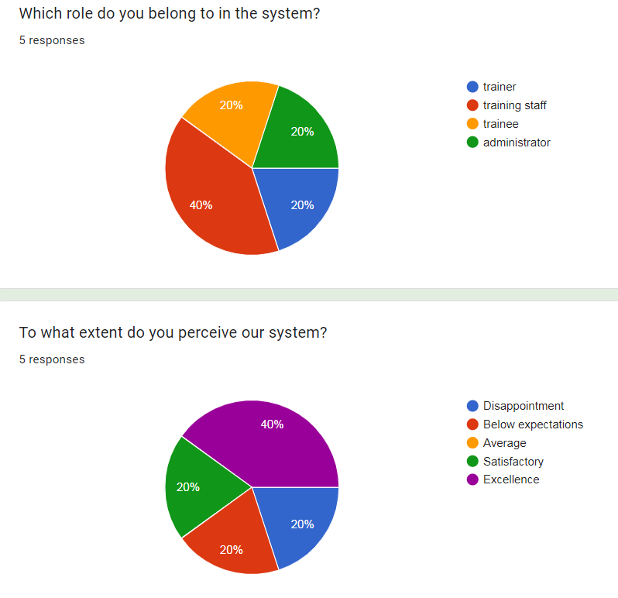

* 1. Role Distribution:
* Training staff: 40%
* Trainer, Trainee, and Administrator (combined): 20% each

Explanation: The majority of respondents (40%) identified themselves as training staff, indicating that this role is more prevalent among those interacting with the system. The remaining 20% of respondents were distributed evenly among the other roles, suggesting a relatively balanced representation across trainer, trainee, and administrator roles.

* 1. Perception of the System:
* Excellence (5): 40%
* Below expectations (2), Average (3), Satisfactory (4): 20% each

Explanation: A significant portion of respondents (40%) perceived the system as excellent, indicating a high level of satisfaction and appreciation for its functionality and features. Conversely, the remaining 60% of respondents selected various lower ratings, suggesting differing levels of satisfaction or areas for improvement in the system's performance and usability.

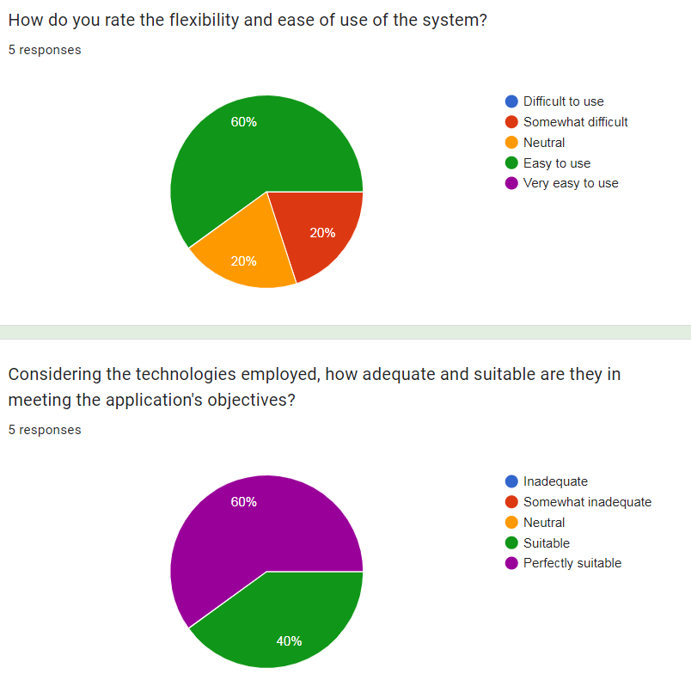

* 1. Flexibility and Ease of Use:
* 60% of respondents chose "d) 4 - Easy to use."
* 40% of respondents split evenly between "b) 2 - Somewhat difficult" and "c) 3 - Neutral."

Explanation: The majority of respondents (60%) find the system easy to use, indicating a high level of flexibility and user-friendliness. However, there is a significant minority (40%) who find the system somewhat difficult or neutral in terms of ease of use, suggesting that there may be areas for improvement in user interface design or instructional materials to enhance usability for all users.

* 1. Suitability of Technologies:
* 60% of respondents chose "e) 5 - Perfectly suitable."
* 40% of respondents chose "d) 4 - Suitable."

Explanation: The majority of respondents (60%) believe that the technologies employed in the system are perfectly suitable for meeting the application's objectives, indicating a high level of confidence in the technological infrastructure. Additionally, 40% of respondents consider the technologies to be suitable, further supporting the notion that the system is well-equipped to fulfill its intended purposes. Overall, the high proportion of respondents selecting "Perfectly suitable" suggests a robust technological foundation supporting the system's functionalities.

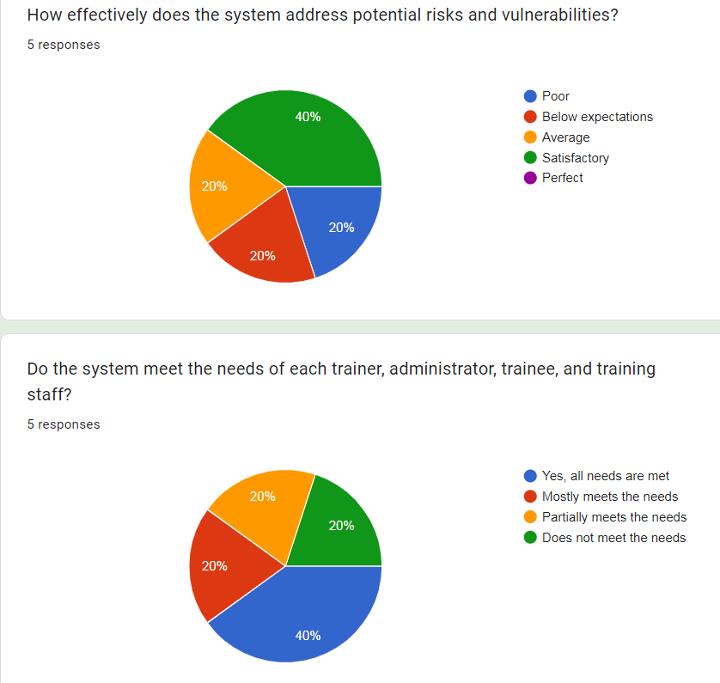

* 1. Effectiveness in Addressing Risks and Vulnerabilities:
* 40% of respondents chose "d) 4 - Satisfactory."
* The remaining 60% of respondents split evenly between "e) 5 - Perfect," "c) 3 - Average," and "b) 2 - Below expectations."

Explanation: A significant portion of respondents (40%) consider the system's effectiveness in addressing potential risks and vulnerabilities to be satisfactory, indicating a moderate level of confidence in its security measures. However, the remaining 60% of respondents have varied perceptions, with equal proportions expressing high confidence (choosing "Perfect"), moderate confidence (choosing "Average"), and lower confidence (choosing "Below expectations") in the system's ability to mitigate risks and vulnerabilities.

* 1. Meeting the Needs of Users:
* 40% of respondents chose "a) Yes, all needs are met."
* The remaining 60% of respondents split evenly between "b) Mostly meets the needs," "c) Partially meets the needs," and "d) Does not meet the needs."

Explanation: A significant portion of respondents (40%) believe that the system meets the needs of all users, indicating a high level of satisfaction and effectiveness in catering to the diverse requirements of trainers, administrators, trainees, and training staff. However, the remaining 60% of respondents have differing perceptions, with equal proportions expressing varying degrees of satisfaction or dissatisfaction with the system's ability to meet user needs. This suggests that while the system may perform well for some users, there may be room for improvement to better address the needs of others.

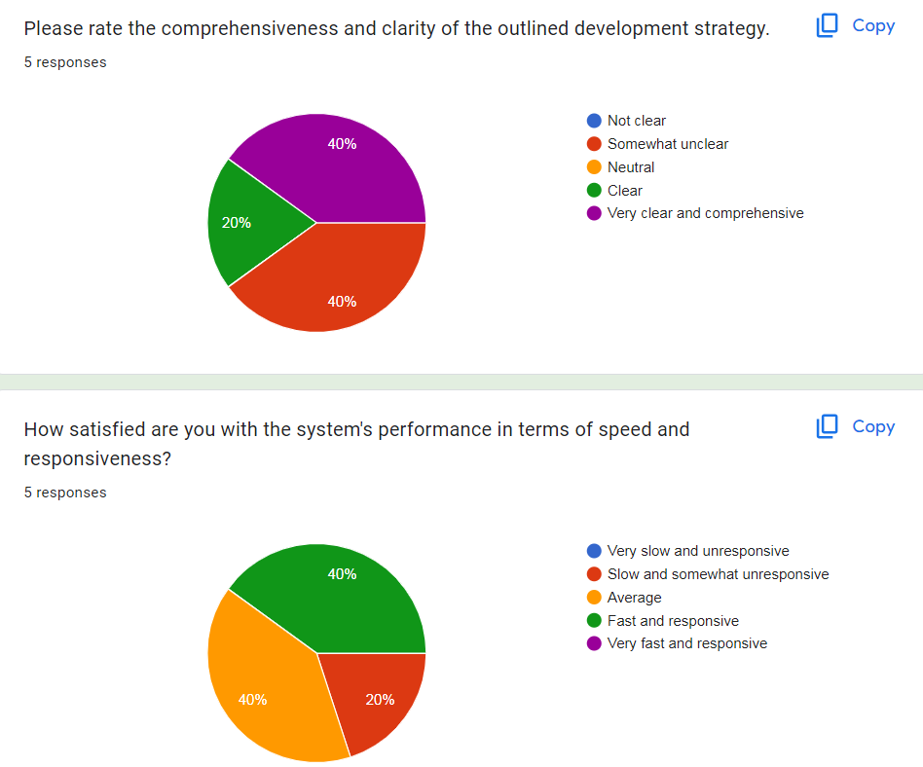

Comprehensiveness and Clarity of Development Strategy:

* 40% of respondents chose "b) 2 - Somewhat unclear."
* 40% of respondents chose "e) 5 - Very clear and comprehensive."
* The remaining 20% of respondents chose "d) 4 - Clear."

Explanation: A significant portion of respondents (40%) perceive the outlined development strategy as somewhat unclear, suggesting that there may be areas that require further elaboration or clarification. However, an equal proportion of respondents (40%) find the development strategy to be very clear and comprehensive, indicating a high level of satisfaction with the provided information. The remaining 20% of respondents consider the strategy to be clear, indicating a moderate level of satisfaction.

System's Performance in Speed and Responsiveness:

* 40% of respondents chose "c) 3 - Average."
* 40% of respondents chose "d) 4 - Fast and responsive."
* The remaining 20% of respondents chose "b) 2 - Slow and somewhat unresponsive."

Explanation: The majority of respondents (80%) perceive the system's performance in terms of speed and responsiveness positively, with 40% rating it as average and another 40% rating it as fast and responsive. However, there is a minority (20%) who find the system to be somewhat slow and unresponsive, indicating room for improvement in this aspect of the system's performance.

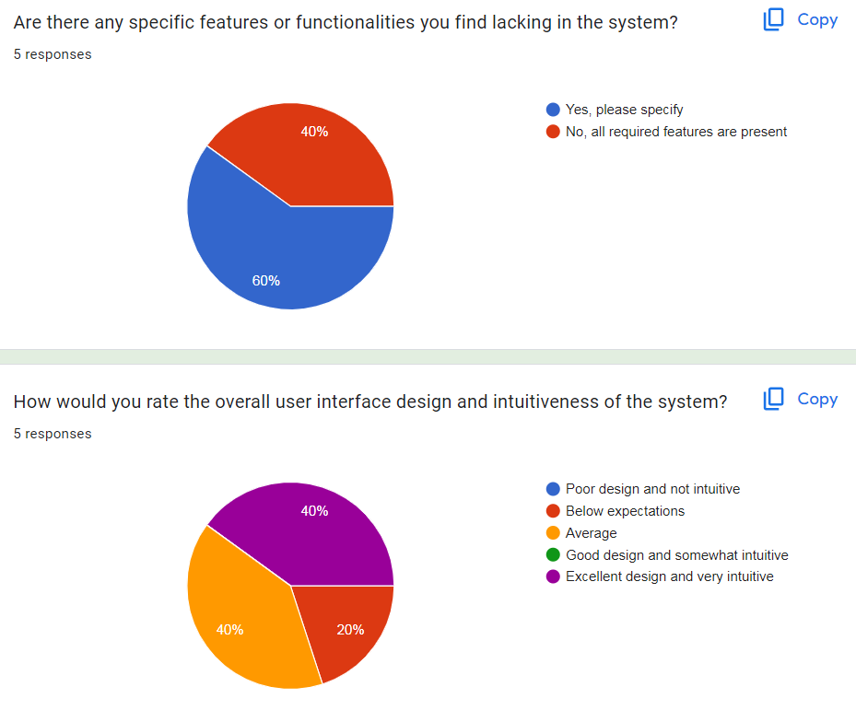

Specific Features or Functionalities Lacking:

* 60% of respondents chose "a) Yes, please specify."
* The remaining 40% of respondents chose "b) No, all required features are present."

Explanation: A majority of respondents (60%) identified specific features or functionalities that they find lacking in the system, indicating areas for improvement or enhancement. However, 40% of respondents believe that all required features are present, suggesting a satisfactory level of completeness in the system's functionality from their perspective.

Overall User Interface Design and Intuitiveness:

* 40% of respondents chose "c) 3 - Average."
* 40% of respondents chose "e) 5 - Excellent design and very intuitive."
* The remaining 20% of respondents chose "b) 2 - Below expectations."

Explanation: The majority of respondents (80%) rated the overall user interface design and intuitiveness positively, with 40% considering it to be average and another 40% rating it as excellent and very intuitive. However, there is a minority (20%) who perceive the design to be below expectations, indicating potential areas for improvement in terms of user interface design and intuitiveness.

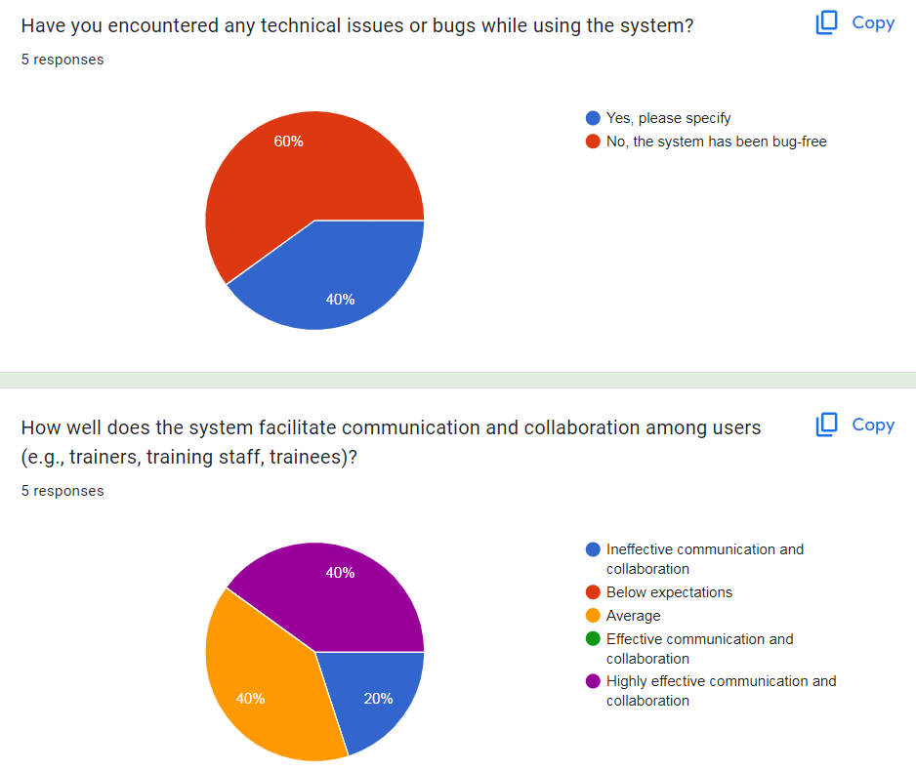

Encountered Technical Issues or Bugs:

* 60% of respondents chose "a) Yes, please specify."
* The remaining 40% of respondents chose "b) No, the system has been bug-free."

Explanation: The majority of respondents (60%) reported encountering technical issues or bugs while using the system, indicating areas that require attention and improvement. However, 40% of respondents have not experienced any technical issues, suggesting a relatively stable and bug-free system for them.

Facilitation of Communication and Collaboration:

* 40% of respondents chose "c) 3 - Average."
* 40% of respondents chose "e) 5 - Highly effective communication and collaboration."
* The remaining 20% of respondents split evenly between "a) 1 - Ineffective communication and collaboration" and "b) 2 - Below expectations."

Explanation: The majority of respondents (80%) perceive the system to facilitate communication and collaboration effectively, with 40% considering it to be highly effective and another 40% rating it as average. However, there is a minority (20%) who have lower perceptions of the system's effectiveness in this rega

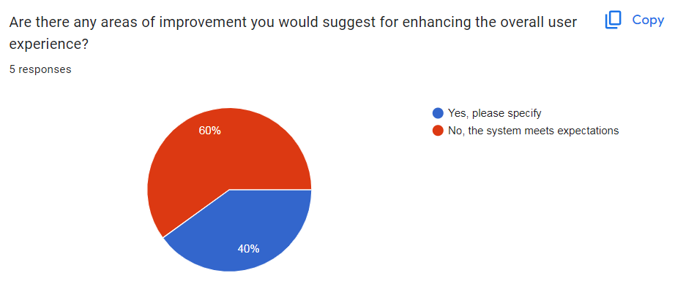

Areas of Improvement for User Experience:

* Nearly 60% of respondents chose "b) No, the system meets expectations."
* The remaining respondents (approximately 40%) chose "a) Yes, please specify."

Explanation: The majority of respondents (nearly 60%) indicated that the system meets their expectations, suggesting overall satisfaction with the user experience. However, approximately 40% of respondents identified areas for improvement, indicating specific aspects of the system that could enhance the user experience further.

Feedback:

P5 Develop a functional business application based on a specified business problem.

1. Sourse(URL):

https://github.com/khanh052003/TraingFPTCo.git

1. Interface.
   1. Database:
      1. Categories:

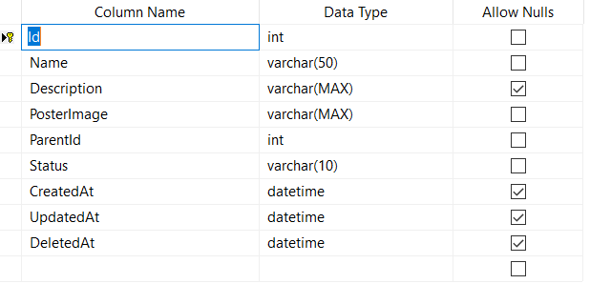

* + 1. Courses:

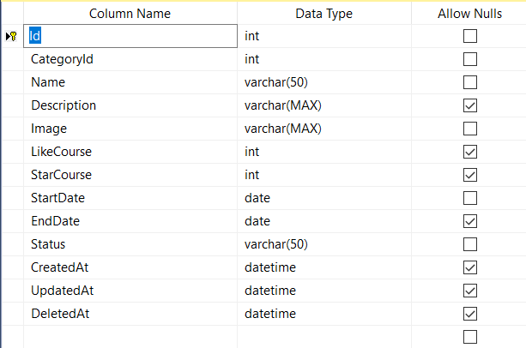

* + 1. Roles:

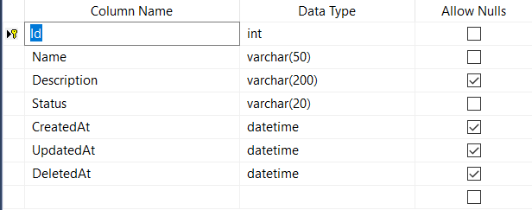

* + 1. Topics:

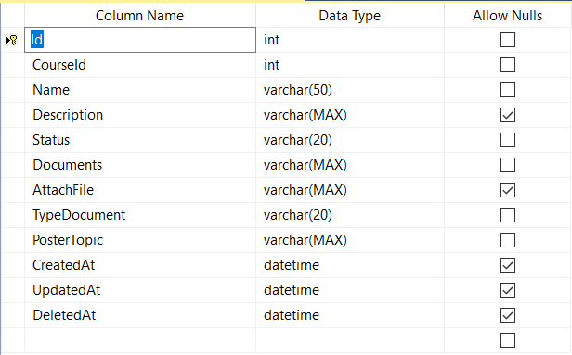

* + 1. Trainee Course:

q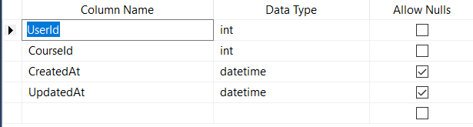

* + 1. Trainer Topic:

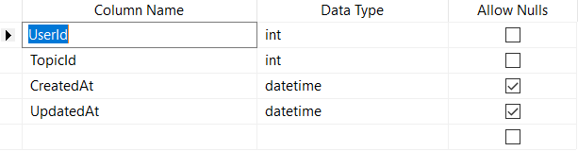

* + 1. Users:

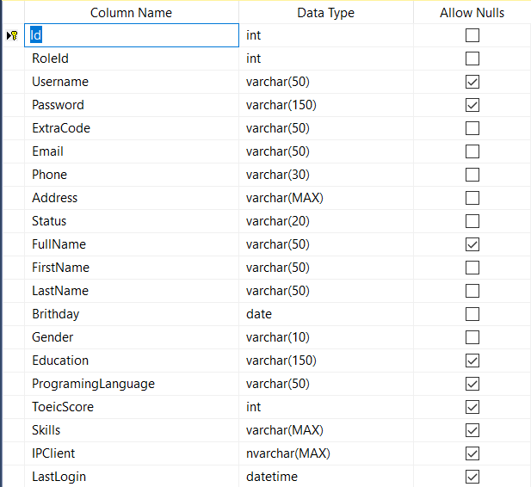

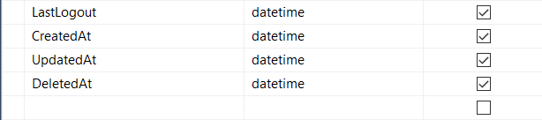

* 1. Code and DemoWeb:
     1. LoginPage:
     2. Add,Delete.Edit Categories:
     3. Add,Delete,Edit Courses:
     4. Add,Delete,Edit Topics:

P6 Review the performance of your business application against the Problem Definition Statement and initial requirements.

1. Test case
2. Test plan.
3. Viết ưu nhược điểm mình làm được trong bài code này và đưa ra những cái gì mình chưa làm được
4. Conclusion.
5. Refer.