**ASSIGNMENT 2 FRONT SHEET**

|  |  |  |  |
| --- | --- | --- | --- |
| **Qualification** | **BTEC Level 5 HND Diploma in Computing** | | |
| **Unit number and title** | Unit 9: Software Development Life Cycle | | |
| **Submission date** | 08/04/2023 | **Date Received 1st submission** | 08/04/2023 |
| **Re-submission Date** |  | **Date Received 2nd submission** |  |
| **Student Name** | Pham Duc Tin | **Student ID** | BH00128 |
| **Class** |  | **Assessor name** | Ngo Thi Mai Loan |
| **Student declaration**  I certify that the assignment submission is entirely my own work and I fully understand the consequences of plagiarism. I understand that making a false declaration is a form of malpractice. | | | |
|  |  | **Student’s signature** | Tín |

**Grading grid**

|  |  |  |  |  |  |  |  |  |
| --- | --- | --- | --- | --- | --- | --- | --- | --- |
| P5 | P6 | P7 | M3 | M4 | M5 | M6 | D3 | D4 |
|  |  |  |  |  |  |  |  |  |

|  |  |  |
| --- | --- | --- |
| **❒ Summative Feedback: ❒ Resubmission Feedback:** | | |
| **Grade:** | **Assessor Signature:** | **Date:** |
| **Internal Verifier’s Comments:** | | |
| **Signature & Date:** | | |

Table Of Contents

**A.** **INTRODUCTION** 6

**B.** **BODY OF REPORT** 6

**I.** **(P5) Undertake a software investigation to meet a business need.** 6

**1.** **Business need analysis** 6

**2.** **Stakeholders and their roles in Tune Source Project** 7

**3.** **Functional and non-functional requirements in the Tune Source project.** 8

**4.** **Techniques used for requirement analysis** 11

**5.** **Techniques used to gather requirements** 13

**II.** **(P6) Use appropriate software analysis tools/techniques to carry out a software investigation and create supporting documentation.** 16

**1.** **Activity diagram** 16

**2.** **Use case diagram** 19

**3.** **Use case description** 22

**4.** **Data Flow Diagram** 26

**5.** **ERD Chart** 29

**III.** **(P7) Explain how user and software requirements have been addressed.** 29

**1.** **Using wireframe to design website** 29

**2.** **Website** 33

**3.** **Database Design** 40

**C.** **CONCLUSION** 41

**D.** **REFERENCES** 41

List Of Figures

Figure 1: Business Process Improvement (BPI) 12

Figure 2: Activity diagram for Admin Side 17

Figure 3: Activity diagram for User Side 18

Figure 4: Use case diagram 20

Figure 5: Data Flow Diagram 1 26

Figure 6: Data Flow Diagram Admin 27

Figure 7: Data Flow Diagram User 28

Figure 8: ERD Chart 29

Figure 9: Wireframe homepage 30

Figure 10 : Wireframe Login 31

Figure 11 : Wireframe Register 32

Figure 12 : Web homepage 33

Figure 13 : Login User 34

Figure 14 : Register 35

Figure 15 : Admin Login 36

Figure 16 : Search Product 36

Figure 17 : User Management 37

Figure 18 : Category Management 38

Figure 19 : Product Management 39

Figure 20 : Database Design 40

1. **INTRODUCTION**

This report aims to provide a comprehensive understanding of request collection techniques, specifically focusing on five techniques including interview, questionnaire, JAD, document analysis, and observation. The definitions and factors associated with each technique have been thoroughly explained. Moreover, the report highlights the application of the interview technique in the development of Tune Source project. Furthermore, the report presents several diagrams for the system design of Tune Source, such as the use case diagram, activity diagram, data flow diagram, and entity relationship diagram. The entity relationship diagram has been used to create a relational database that includes all the information and data required by Tune Source's system. Additionally, a report has been created that outlines the functions of the website, including the wireframe and main system functions. Throughout this report, a software investigation has been conducted to ensure that the system meets the necessary requirements.

1. **BODY OF REPORT**
2. **(P5) Undertake a software investigation to meet a business need.**
3. **Business need analysis**

**Business Need**: The purpose of this project is to increase sales for Tune Source by creating the capability to sell digital music downloads through their stores and website. This will enable customers to purchase specific digital music tracks through kiosks located in stores and the internet using the website.

**Business Value**: The project is expected to increase sales by attracting existing and new customers interested in Tune Source's unique archive of rare and hard-to-find music. The company anticipates gaining a new revenue stream from customer subscriptions to their download services. In addition, the project is expected to increase cross-selling by encouraging customers who have downloaded a track or two of a CD to purchase the entire CD through the website or store. The company also expects to generate new revenue streams from the sale of music download gift cards.

**Analysis**: The project aims to provide a robust and user-friendly digital music download system to facilitate the sale of digital music tracks. By offering this service, Tune Source can expand its customer base and increase sales through customer subscriptions to download services and the sale of music download gift cards. Furthermore, the project will encourage cross-selling of physical CDs, generating additional revenue streams. The successful implementation of this project will enable Tune Source to meet the needs of their customers and achieve their business goals.

1. **Stakeholders and their roles in Tune Source Project**

|  |  |  |
| --- | --- | --- |
| **Stakeholder** | **Role** | **Interests** |
| Customers | End-users of Tune Source's music products and services | Quality of music, availability of desired music, pricing, ease of access |
| Employees | Staff members of Tune Source | Job security, fair compensation, pleasant work environment, opportunities for growth and advancement |
| Management | Senior executives and decision-makers of Tune Source | Profitability, growth and expansion of the business, market share, customer satisfaction |
| Shareholders | Owners of Tune Source's stocks | Dividends, stock price appreciation, financial stability of the company |
| Suppliers | Providers of goods and services to Tune Source | Stable business relationships, timely payments, clear communication, sustainable practices |
| Partners | Collaborators and affiliates of Tune Source | Mutual benefits and growth opportunities, effective communication and coordination, shared goals and values |
| Regulators | Government agencies and industry watchdogs | Compliance with laws and regulations, adherence to industry standards, ethical and responsible business practices |
| Community | Residents and organizations in Tune Source's local and global communities | Corporate social responsibility, environmental sustainability, community engagement and support |

1. **Functional and non-functional requirements in the Tune Source project.**
2. **Discuss the relationships between the FRs and NFRs.**

* FRs (Functional Requirements) and NFRs (Non-Functional Requirements) are two types of requirements that are essential for defining a system or product's characteristics. The relationship between the two is that FRs describe what a system or product should do, while NFRs describe how well it should do it. In other words, FRs are concerned with the system's behavior and functionality, while NFRs are concerned with the system's qualities or attributes.
* FRs specify what the system or product is expected to do, in terms of its functionality, performance, and features. For example, an FR for a web application might be that it should allow users to create and save a profile. Another FR might be that the application should have a search function that returns results based on user input. These requirements are essential to ensuring that the system meets the needs of its users and performs its intended functions.
* NFRs are concerned with how well the system should perform. NFRs describe system characteristics such as usability, reliability, scalability, performance, and security. For example, an NFR might specify that the web application should load in under two seconds, or that it should be available 99.9% of the time. These requirements are essential to ensuring that the system is usable, reliable, and secure.

1. **FRs and NFRs of Tune Source Project**

* **Function requirement**

A functional requirement is defined as the description of the functionality or service of the software or system.

|  |  |
| --- | --- |
| **Admin** | **Users** |
| * Admin login. * User management: Decentralize user accounts, Add/Edit/Delete and search for users. * Order management: Confirm/Cancel orders, create new orders. * Category management : Add/Edit/Delete and search categories. * Product management: Add/Edit/Delete and search for products. * Personal account management: change password, delete account. * Log out of your account. | * View home page demo, Product page demo * User login * Register an account * Search Product * Add Product to cart * Remove Product from cart * Product payment * Listen to product demos * View reports * Change password * Delete the account * Log out account |

* **Non-function requirement**

Non-functional requirements include all requirements that functional requirements do not contain. They specify criteria by which to evaluate the performance of the system rather than the behavior.

**Non-functional requirements of the system :**

* The system shall be available 24/7 with a minimum uptime of 99%.
* The system shall support up to 10,000 concurrent users.
* High security system to ensure all information about customers and online transactions.
* Cross-platform compatibility to support customers using goods on different devices.
* The access rights management system is designed so that different customer access rights can be managed.
* A reliable online payment system that helps customers make payments easily and securely.
* Customer support provides information through communication channels such as email, phone or online chat.
* Professional customer service helps customers answer questions and resolve issues quickly and efficiently.
* Ability to integrate with other services like other online sales websites to increase sales.
* **Relationship**

The functional requirements (FRs) and non-functional requirements (NFRs) of the Tune Source project are interdependent and have a direct relationship. The FRs specify what the software system should do, while the NFRs specify how the software system should perform those functions.

For example, a functional requirement of Tune Source could be to allow customers to purchase and download digital music tracks. However, the non-functional requirement would specify the response time of the system, which means that the download time should be less than 30 seconds.

Another example is that an FR for Tune Source could be to allow customers to search for specific songs. An NFR would specify the accuracy of the search results, which means that the search results should be accurate and relevant.

Therefore, the NFRs are necessary to ensure that the functional requirements are met effectively and efficiently. The FRs and NFRs are closely related and must be considered together during the development of the Tune Source project to ensure that both types of requirements are satisfied.

1. **Techniques used for requirement analysis**
2. **Techniques used (BPI, BPA, BPR)**

In analyzing software requirements to meet business needs, there are various techniques to choose from. Among them, three techniques, BPI (Business Process Improvement), BPA (Business Process Analysis), and BPR (Business Process Reengineering), are widely used in practice.

* BPA is a technique for analyzing software requirements based on researching current business processes to understand requirements, conduct evaluations, identify issues, and seek improvements for these processes. BPA is often used when an organization wants to improve existing business processes without completely changing them.
* BPI is a technique for analyzing software requirements that focuses on improving existing business processes. It focuses on optimizing current processes by seeking and eliminating barriers, optimizing processes, and enhancing efficiency. BPI is used when an organization wants to improve existing business processes and seeks solutions to enhance performance.
* BPR is a technique for analyzing software requirements that focuses on completely renewing existing business processes by removing unnecessary activities, optimizing processes, and creating a new process model. BPR is used when an organization wants to completely change its way of operation, seek new solutions, and comprehensively improve business processes.

1. **Reasons and technical choices in the Tune Source project**

To meet the business need of Tune Source, which is to create the capability of selling digital music downloads to customers through kiosks in their stores and over the internet using their website, the appropriate technique for requirement analysis would be Business Process Improvement (BPI). BPI is a systematic approach to improving an organization's workflow, processes, and procedures to achieve better efficiency, effectiveness, and adaptability to changing business needs.

Figure : Business Process Improvement (BPI)

The BPI technique involves identifying existing business processes and analyzing them to identify areas for improvement. This technique is suitable for Tune Source as it can help identify the current sales processes, bottlenecks, and inefficiencies that need to be improved to achieve the business goal. By implementing BPI, Tune Source can improve their existing processes, optimize the workflow, and reduce the time and resources required for selling digital music downloads.

1. **Techniques used to gather requirements**
2. **Describle software investigation technique**

To gather requirements, several techniques can be used, including interviews, Joint Application Design (JAD) sessions, questionnaires, documentation analysis, and observation. For Tune Source, a combination of these techniques can be used, but the most appropriate technique would be interviews with key stakeholders, including sales staff, customers, and IT professionals. This technique will help to understand the current sales processes, identify gaps and issues, and gather feedback on the proposed digital music download system.

To undertake the software investigation, the following steps can be taken:

* **Step 1** : Identify the stakeholders who will be involved in the requirement gathering process, including sales staff, customers, and IT professionals.
* **Step 2**: Schedule interviews with the stakeholders to gather information about the existing sales processes, bottlenecks, and inefficiencies.
* **Step 3** : Analyze the information gathered from the interviews to identify areas for improvement and define the requirements for the digital music download system.
* **Step 4** : Develop a prototype of the digital music download system based on the requirements identified.
* **Step 5** : Test the prototype with stakeholders to get feedback and refine the system based on the feedback received.
* **Step 6** : Implement the final version of the digital music download system, ensuring that it meets the business need of increasing sales and is user-friendly for customers and staff.

1. **Undertake the investigation**

Step 1: Choose people to be interviewed

|  |  |  |
| --- | --- | --- |
| **Name** | **Job Title** | **Department** |
| Truong | Sales Manager | Sales |
| Luong | Customer Rep | Customer Service |
| Pham | IT Manager | IT |
| Duc | Marketing Head | Marketing |
| Tran | Store Manager | Operations |

Step 2: Design interview questions

|  |
| --- |
| **Questions** |
| How do you handle customer complaints? |
| What are some of the biggest challenges you face in your role? |
| What are some common issues with our current sales process? |
| How do you manage the inventory for digital music downloads? |
| Can you walk me through the process of selling digital music downloads in the store? |

Step 3: Interview

|  |  |  |  |
| --- | --- | --- | --- |
| **Name** | **Job Title** | **Department** | **Answers to Interview Questions** |
| Truong | Sales Manager | Sales | Handles customer complaints by offering refunds or replacements |
| Luong | Customer Rep | Customer Service | Common challenges include long wait times and language barriers |
| Pham | IT Manager | IT | Common issue is slow download speeds and server downtime |
| Duc | Marketing Head | Marketing | Manages inventory using a digital tracking system |
| Tran | Store Manager | Operations | Process involves selecting desired tracks, payment, and download link sent to customer email |

Step 4: Create interview reports

|  |  |  |  |
| --- | --- | --- | --- |
| **Name** | **Job Title** | **Department** | **Interview Report** |
| Truong | Sales Manager | Sales | Truong highlighted that customer complaints are usually resolved by offering refunds or replacements. He also mentioned that sales representatives often struggle with reaching sales targets due to competition from online platforms. He suggested offering promotions to customers who purchase digital music downloads in-store to increase sales. |
| Luong | Customer Rep | Customer Service | Luong mentioned that common challenges she faces in her role include long wait times and language barriers when dealing with customers. She suggested implementing a call-back system for customers waiting on hold for extended periods and providing language training for employees. |
| Pham | IT Manager | IT | Pham stated that the most common issue with the current sales process is slow download speeds and server downtime. He suggested upgrading the system and implementing a backup server to minimize downtime. |
| Duc | Marketing Head | Marketing | David highlighted that the digital tracking system currently in use is effective in managing inventory for digital music downloads. He suggested promoting the availability of rare and hard-to-find tracks to attract more customers. |
| Tran | Store Manager | Operations | Tran provided a detailed overview of the sales process for digital music downloads in the store. She mentioned that the process involves selecting desired tracks, payment, and download link sent to customer email. She suggested offering music download gift cards to customers as a promotional item. |

1. **(P6) Use appropriate software analysis tools/techniques to carry out a software investigation and create supporting documentation.**
2. **Activity diagram**

Figure : Activity diagram for Admin Side

Figure : Activity diagram for User Side

1. **Use case diagram**
2. **Definition**

A use case diagram is a dynamic or behavior diagram in UML. Use case diagrams model the functionality of a system using actors and use cases. Use cases are a set of actions, services, and functions that the system needs to perform. In this context, a "system" is something being developed or operated, such as a web site. The "actors" are people or entities operating under defined roles with in the system.

* Purpose of Use Case Diagrams:

The purpose of use case diagram is to capture the dynamic aspect of a system. However, this definition is too generic to describe the purpose, as other four diagrams (activity, sequence, collaboration, and Statechart) also have the same purpose. We will look into some specific purpose, which will distinguish it from other four diagrams.

Use case diagrams are used to gather the requirements of a system including internal and external influences. These requirements are mostly design requirements. Hence, when a system is analyzed to gather its functionalities, use cases are prepared and actors are identified.

When the initial task is complete, use case diagrams are modelled to present the outside view.

* In brief, the purposes of use case diagrams can be said to be as follows :
* Used to gather the requirements of a system.
* Used to get an outside view of a system.
* Identify the external and internal factors influencing the system.
* Show the interaction among the requirements are actors.

1. **Draw a use case diagram**

Figure : Use case diagram

|  |  |  |  |
| --- | --- | --- | --- |
| **Number** | **Code** | **Name** | **Brief description** |
| **1** | **UC01** | Login | Allow actors who have an account to access the system. |
| **2** | **UC02** | Register | Actor provides information to create an account to access the system |
| **3** | **UC03** | Logout | Actor stops accessing the system. |
| **4** | **UC04** | Add user | Add a new user with their personal information provided |
| **5** | **UC05** | Add music | Add new music with their information |
| **6** | **UC06** | Search music | Search music by their name |
| **7** | **UC07** | Edit music | Edit the music’s information |
| **8** | **UC08** | Make favorite list | Create a favorite list with the music that users love |
| **9** | **UC09** | Edit user | Actor changes information about their account. |
| **10** | **UC010** | Listen to the music | Allow customers to listen to the music sample they chose |
| **11** | **UC011** | Download music | Download the product they bought |
| **12** | **UC012** | Buy music | actor can buy music copyright |
| **13** | **UC013** | Delete music | admin can delete the music account on the system |
| **14** | **UC014** | Delete user | admin can delete the user on the system |

1. **Use case description**
2. **UC01**

|  |  |  |  |
| --- | --- | --- | --- |
| Name | Login | Code | UC01 |
| Description | Allow actor login to the system | | |
| Actor | User / admin | Trigger | Actor click button [Log in] on the main page |
| Pre−condition | The actor has an account | | |
| Post condition | Go to the homepage with the corresponding role | | |

|  |  |
| --- | --- |
| Actor | System |
| Main Flow: **login successfully** | |
| From any screen, the actor selects Login |  |
|  | Load page Login |
| Enter the required information. |  |
|  | Validation input information |
| Edit (if a wrong password or username). |  |
|  | Load the main page |

1. **UC02**

|  |  |  |  |
| --- | --- | --- | --- |
| Name | Register | Code | UC02 |
| Description | Actor provides information to create an account to access the system | | |
| Actor | User / admin | Trigger | Actor click button [Register] on the main page |
| Pre−condition | The actor has an account | | |
| Post condition | Register successfully! | | |

|  |  |
| --- | --- |
| Actor | System |
| Main Flow: **add new ussr successfully** | |
| From any screen, the actor selects Register |  |
|  | Load page Register |
| Enter the required information. |  |
|  | Validation input information |
| Edit (if a wrong password or username). |  |
|  | Load the main page |

1. **UC03**

|  |  |  |  |
| --- | --- | --- | --- |
| Name | Logout | Code | UC03 |
| Description | Actor stops accessing the system. | | |
| Actor | User/admin | Trigger | Actor click button [log out] on the main page |
| Pre-condition | User has logged in account | | |
| Post condition | Logout successfully! | | |

|  |  |
| --- | --- |
| Actor | System |
| Main Flow: **login successfully** | |
| From any screen, the actor selects Logout |  |
|  | Load the main page |

1. **Data Flow Diagram**
2. **Definition**

A data flow diagram (DFD) maps out the flow of information for any process or system. It uses defined symbols like rectangles, circles and arrows, plus short text labels, to show data inputs, outputs, storage points and the routes between each destination. Data flowcharts can range from simple, even hand-drawn process overviews, to in-depth, multi-level DFDs that dig progressively deeper into how the data is handled. They can be used to analyze an existing system or model a new one. Like all the best diagrams and charts, a DFD can often visually "say" things that would be hard to explain in words, and they work for both technical and nontechnical audiences, from developer to CEO. That’s why DFDs remain so popular after all these years. While they work well for data flow software and systems, they are less applicable nowadays to visualizing interactive, real-time or database-oriented software or systems.

1. **Draw a Data Flow Diagram**

Figure : Data Flow Diagram 1

Figure : Data Flow Diagram Admin

Figure : Data Flow Diagram User

1. **ERD Chart**

Figure : ERD Chart

1. **(P7) Explain how user and software requirements have been addressed.**
2. **Using wireframe to design website**

Figure : Wireframe homepage

Figure : Wireframe Login

Figure : Wireframe Register

1. **Website**

Figure : Web homepage

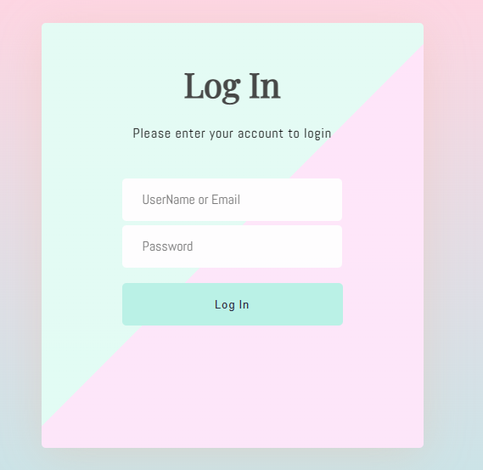

Figure : Login User

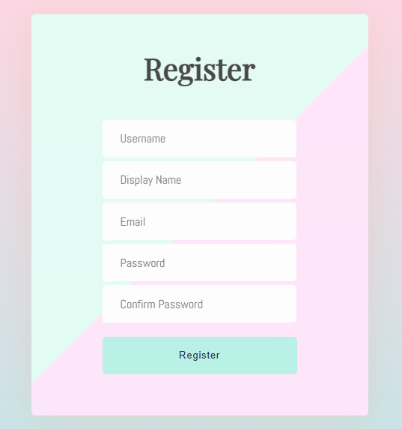

Figure : Register

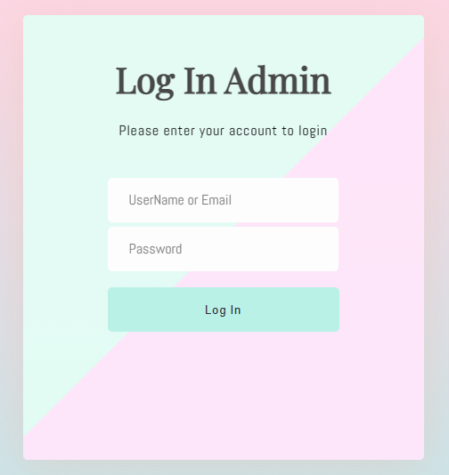

Figure : Admin Login



Figure : Search Product

Figure : User Management

Figure : Category Management

Figure : Product Management

1. **Database Design**

Figure : Database Design

1. **CONCLUSION**

Throughout this assignment, I have thoroughly examined the functional and non-functional requirements of the Tune Source system, providing a clear understanding of what is necessary for its success. By creating various diagrams, including use case, activity, data flow, and entity relationship diagrams, I have presented a comprehensive overview of the system's design. Furthermore, by utilizing the entity relationship diagram, I have constructed a relational database that contains all the essential information and data required for Tune Source's system to operate effectively. Finally, I have created a detailed report on the website's functionality, highlighting the framework and key system functions. This assignment serves as a vital step towards the successful development and implementation of the Tune Source system.

1. **REFERENCES**

Smartdraw.com. 2021. Use Case Diagrams - Use Case Diagrams Online, Examples, and Tools. [online] Available at: <https://www.smartdraw.com/use-case-diagram/>

[Accessed 8 April, 2023].

Tutorialspoint.com. 2021. UKL - Use Case Diagrams. [online] Available at:

<https://www.tutorialspoint.com/uml/uml_use_case_diagram>

[Accessed 8 April, 2023].

Lucidchart.com. 2021. Data Flow Diagram Symbols, Types, and Tips | Lucidchart. [online] Available at:

<https://www.lucidchart.com/pages/templates/data-flow-diagram-logical>

[Accessed 8 April, 2023].

Lucidchart. 2021. What is an Entity Relationship Diagram (ERD)?. [online] Available at:

<https://www.lucidchart.com/pages/er-diagrams>

[Accessed 8 April, 2023].

Igi-global.com. 2021. What is Requirement | IGI Global. [online] Available at:

<https://www.igi-global.com/dictionary/identifying-requirements-healthcare-information-systems/25141>

[Accessed 8 April, 2023].

GeeksforGeeks. 2021. Functional vs Non Functional Requirements - GeeksforGeeks. [online] Available at:

<https://www.geeksforgeeks.org/functional-vs-non-functional-requirements/>

[Accessed 8 April, 2023].