In Sprint #2, we focus on working with the architecture of the system as shown below:

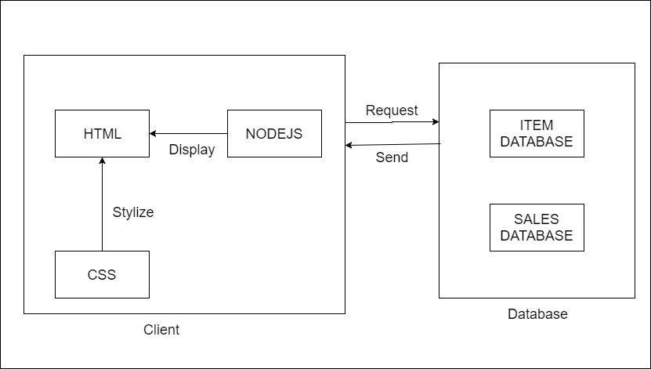

The client components are stored in user’s local machine which responsible for displaying the user interface so that users can perform the tasks.

The client’s files are kept separately with the database which is located on a remote server. The client will need to send requests to the database and wait to retrieve the responds. Hence, the database is secured and unique so that any client cannot manipulate it without permission.

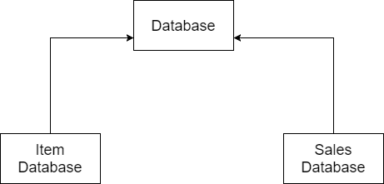

The database is divided into two smaller separate databases, one for the items, the other is for sales records.

The purpose of doing this is to avoid messing up those two databases which would could slow down data query time or maintaining process.

We also strictly apply MVC model to keep the modules sperately.

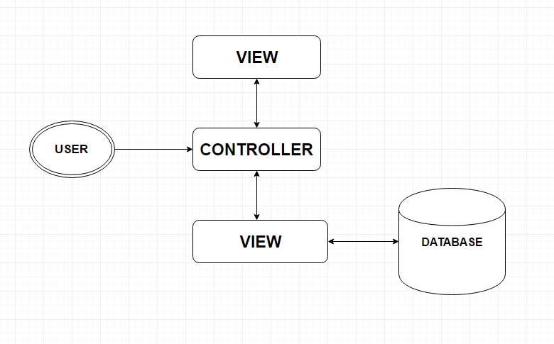

This help the system have a good architecture and achieve best interactions among modules. The maintenance process in future would be much easier since the code are kept clean and structural.

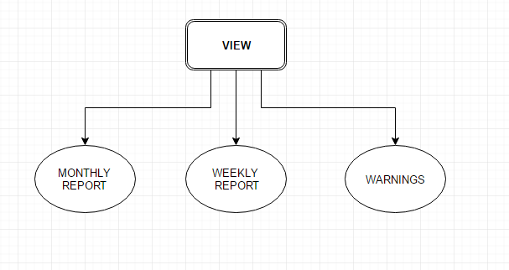

In the VIEW component, it is divided into many smaller modules which are Display Monthly reports, Weekly reports and show warnings messages.

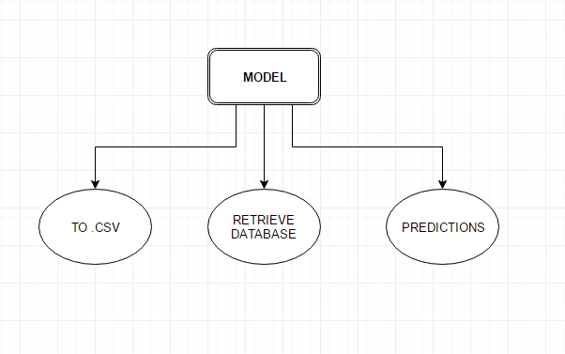

The MODEL component holds responsibility for retrieving database, export reports to .CSV files and run algorithms for sales prediction.

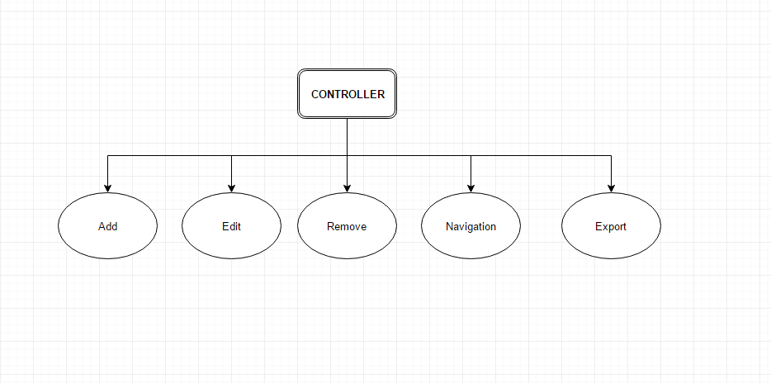

The CONTROLLER is also kept separately to help user control the system behaviours without knowing what happens inside. It controls the interactive buttons on the web page such as Add, Edit, Remove buttons as well as the Navigation buttons Forward/ Backward.