**Group Pass Task 5.2**

**Setup the plan for Sprint**

After choosing the backlog items for Sprint #1, our team started to setup basic tools for the project, including:

* Trello: We use this web-based tool to keep track of our backlog items and to-do tasks. We divide them into categories: To-do, Doing, Testing and To be confirmed.

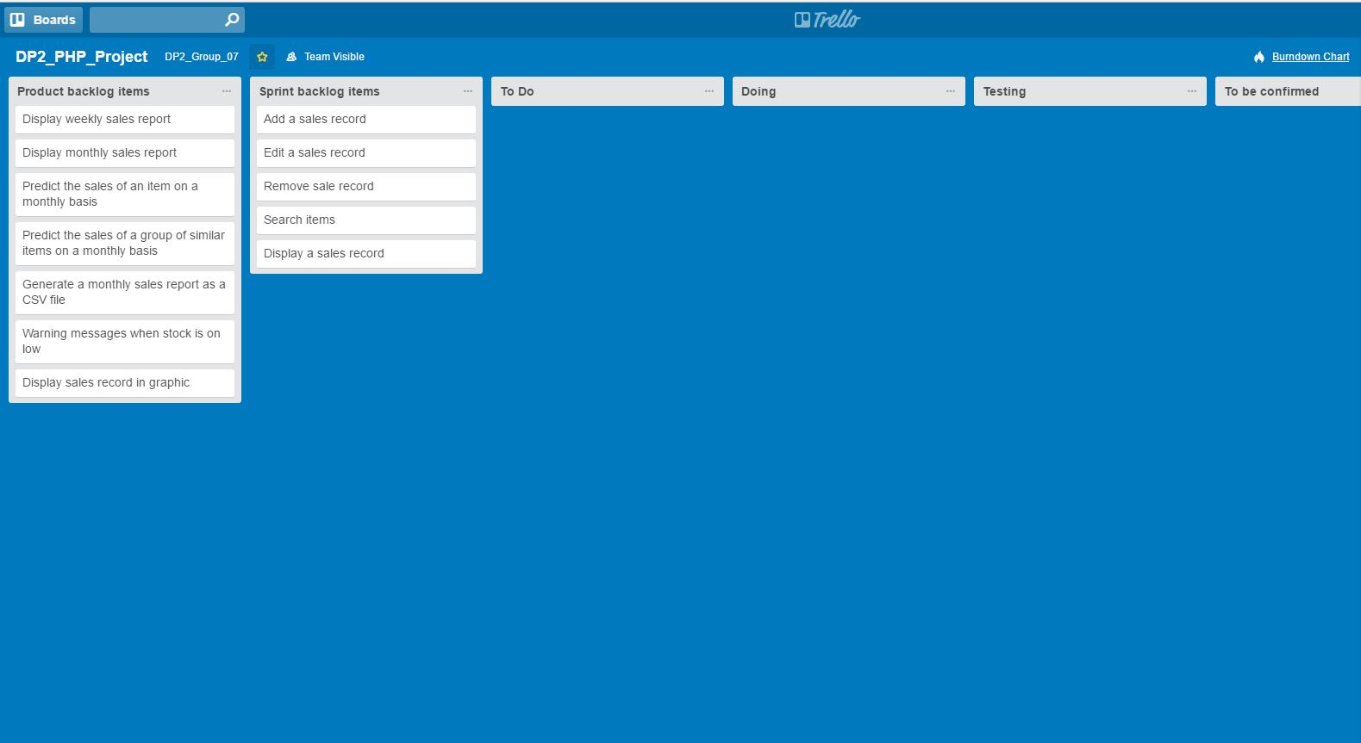

Next, we created a burndown chart for Trello on <https://www.burndownfortrello.com> to keep track of our working progress throughout the whole project period.

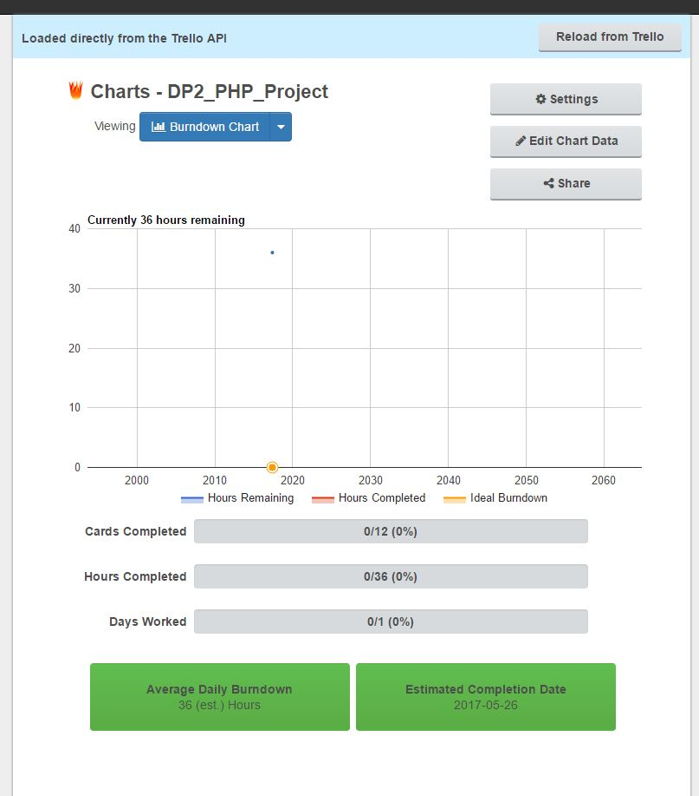

Finally, we created a new repository on Github to help manage our code so that every team member can edit it at any time.

