In Sprint #1, we focus on working with the basic architecture of the system as shown below:

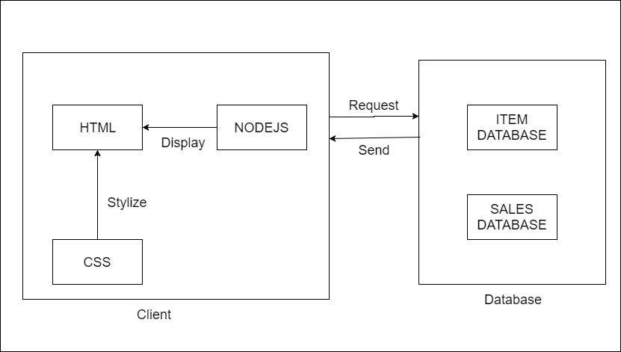

The client components are stored in user’s local machine which responsible for displaying the user interface so that users can perform the tasks.

The client’s files are kept separately with the database which is located on a remote server. The client will need to send requests to the database and wait to retrieve the responds. Hence, the database is secured and unique so that any client cannot manipulate it without permission.

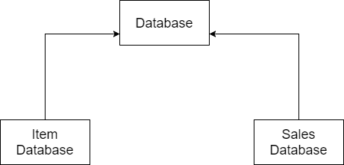

The database is divided into two smaller separate databases, one for the items, the other is for sales records.

The purpose of doing this is to avoid messing up those two databases which would could slow down data query time or maintaining process.

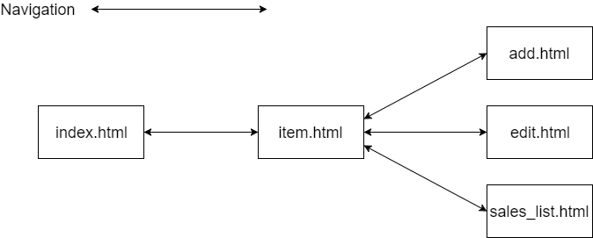

On client’s local machine, each web pages are also kept separately in type of .html files.

Instead of combining all things together, we need to have independent web pages which perform their own functions. However, each one should be able to quickly navigate to another page by using provided buttons or Web browser’s Forward/Backward buttons.

