SWE30010 – Development Project 2: Design, Planning and Management

Learning Summary Report

NHAN NGUYEN (100654070)

**Portfolio Submission Due**

Pass / Credit: Week 13 (starting 29 May 2017), Mon, 9:00am

Distinction / High Distinction: Week 14 (starting 5 June 2017), Mon, 9:00am

**Portfolio Interview Dates**

Distinction / High Distinction: Week 14 (starting 5 June 2017), Wed – Fri, (1 hr per student)

**[Optional, but Strongly Recommended] Tutor’s Feedback on LSR**

Timing of the Feedback process and submissions

|  |  |  |
| --- | --- | --- |
| **Grade**  **Description** | **Pass / Credit** | **Distinction / High Distinction** |
| LSR only [10.1] | Week 13, Mon (29 May), 09:00 | Week 13, Tue (30 May), 09:00 |
| Tutor’s feedback | Week 13, Wed (31 May), 17:00 | Week 13, Thu (1 June), 17:00 |
| Final Portfolio | Week 14, Mon (5 June), 09:00 | Week 14, Tue (6 Jun), 09:00 |

Self-Assessment Details

The following checklists provide an overview of my self-assessment for this unit.

|  |  |  |  |  |
| --- | --- | --- | --- | --- |
|  | Pass (D) | Credit (C) | Distinction (B) | High Distinction (A) |
| Self-Assessment (please tick) |  | X |  |  |

*Self-assessment Statement*

|  |  |
| --- | --- |
|  | Included (please tick) |
| Learning Summary Report | X |
| **All** Pass Tasks are Compete in Doubtfire | X |

*Minimum Pass Checklist*

|  |  |
| --- | --- |
|  | Included (please tick) |
| All Credit Tasks are Complete on Doubtfire | X |

*Minimum Credit Checklist, in addition to Pass Checklist*

|  |  |
| --- | --- |
|  | Included (please tick) |
| Interview booked |  |
| All Distinction Tasks are Complete on Doubtfire |  |
| Other pieces (please specify) |  |

*Minimum Distinction Checklist, in addition to Credit Checklist*

|  |  |
| --- | --- |
|  | Included (please tick) |
| Software Project Document [Plan, Design, QA] meet HD criteria and standards |  |
| Research Article / Essay meets HD criteria and standards |  |
| Other pieces (please specify) |  |

*Minimum High Distinction Checklist, in addition to Distinction Checklist*

# Declaration

I declare that this portfolio is my individual work. I have not copied from any other student’s work or from any other source except where due acknowledgment is made explicitly in the text, nor has any part of this submission been written for me by another person.

Signature:

# Portfolio Overview

This portfolio includes work that demonstrates that I have achieve all Unit Learning Outcomes for SWE30010 Development Project 2 to a **Credit** level.

1. Pass task 2.1: Scope and Product Backlog  
 - Develop the product backlog of a software project  
2. Pass task 3.1: Design  
 - Develop a solution direction of a software project  
 3. Pass task 4.1: Quality  
 - Develop the quality requirements of a software project  
4. Pass task 5.1 and 8.1: Sprint planning meeting  
 - Analyse selection criteria  
 - Prioritise product backlog items  
5. Pass task 5.2 and 8.2: Setup plan for Sprint  
 - Setup a project essential tools (Github, Burndown chart, Trello, etc.)  
6. Pass task 6.1, 7.1 and 9.1, 10.1: Development during Sprint  
 - Focus on developing and debugging the software project.  
7. Pass task 7.2,7.3 and 10.2, 10.3: End of Sprint meeting  
 - Review and reflect team’s work during the sprints   
8. Pass task 7.4 and 10.4: Software design  
 - Document the design of the software components  
9. Credit task 2.3: Significant contribution to the team in Sprint 1  
 - Instruct new team member to setup and use Github as a development tool  
10. Credit task 5.3: Significant contribution to the team in Sprint 2  
 - Help the team to learn and use Web development framework as well as OOP principles.

# Reflection

## The most important things I learnt:

* Scrum process
* Project management
* Project estimation
* Teamwork
* Development tools and practises

## The things that helped me most were:

* Apply Scrum process into a real software project that requires lots of planning, meeting, estimation and reports.
* Work effectively as a scrum team.

## I found the following topics particularly challenging:

Planning a whole project from scratch, in other words, starting a new project from every aspect is hard to choose best ways to follow.

## I found the following topics particularly interesting:

The team could choose our own way develop the software as well as it satisfies the stakeholders. Therefore, we could improve our own skills in programming and learn new things during the development process.

## I feel I learnt these topics, concepts, and/or tools really well:

I think I did well on developing the backlog items for the project which helped the team successfully finish our product.

## I still need to work on the following areas:

The team was confused with the project estimation for the backlog deadlines and project finish date.

## My progress in this unit was …:

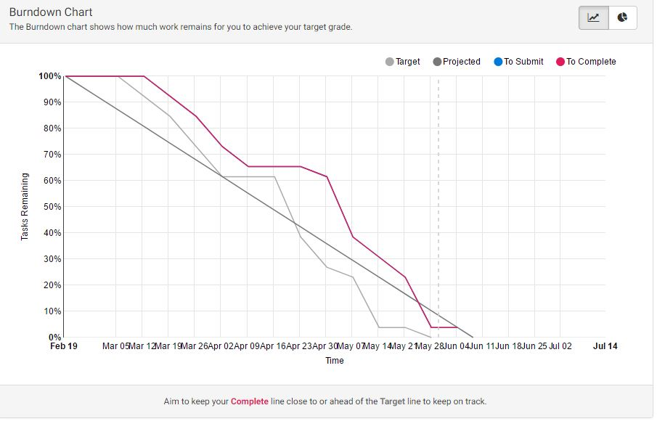

## This unit will help me in the future:

I have obtained a better understanding of software design solution direction and

high-level design. Therefore, I have been familiar with the Scrum process with currently the most common development process.

## If I did this unit again I would do the following things differently:

The deadline for the tasks was short, sometimes it took 4 to 5 days to work on the sprints and then submit the reports which made my submission date was very close to the deadline.