HỌ TÊN: NGUYỄN BÁ KHÁNH

Proc trong sql

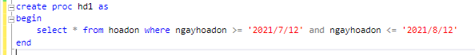

Event trong form CrvHoadon

|  |
| --- |
| using System;  using System.Collections.Generic;  using System.ComponentModel;  using System.Data;  using System.Drawing;  using System.Linq;  using System.Text;  using System.Threading.Tasks;  using System.Windows.Forms;  namespace WindowsFormsApp8.GUI  {  public partial class formBaocaoHoaDon2 : Form  {  public formBaocaoHoaDon2()  {  InitializeComponent();  }  private void crvHoadon1_Load(object sender, EventArgs e)  {  BUS.clsBaocaoHoaDon1 report = new BUS.clsBaocaoHoaDon1();  report.BaocaoKhachhang(crvHoadon1, @"C:\Users\Nhung\Desktop\repos\WindowsFormsApp8\WindowsFormsApp8\BUS\crvHoadon2.rpt");  }  }  } |

Event trong form Hóa đơn

|  |
| --- |
| private void menuHoadon1_Click(object sender, EventArgs e)  {  GUI.formBaocaoHoaDon2 hoaDon1 = new GUI.formBaocaoHoaDon2();  hoaDon1.ShowDialog();  } |

Design Bảng Hóa đơn

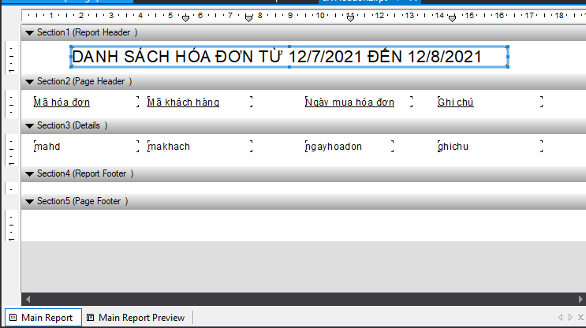

Chạy ứng dụng

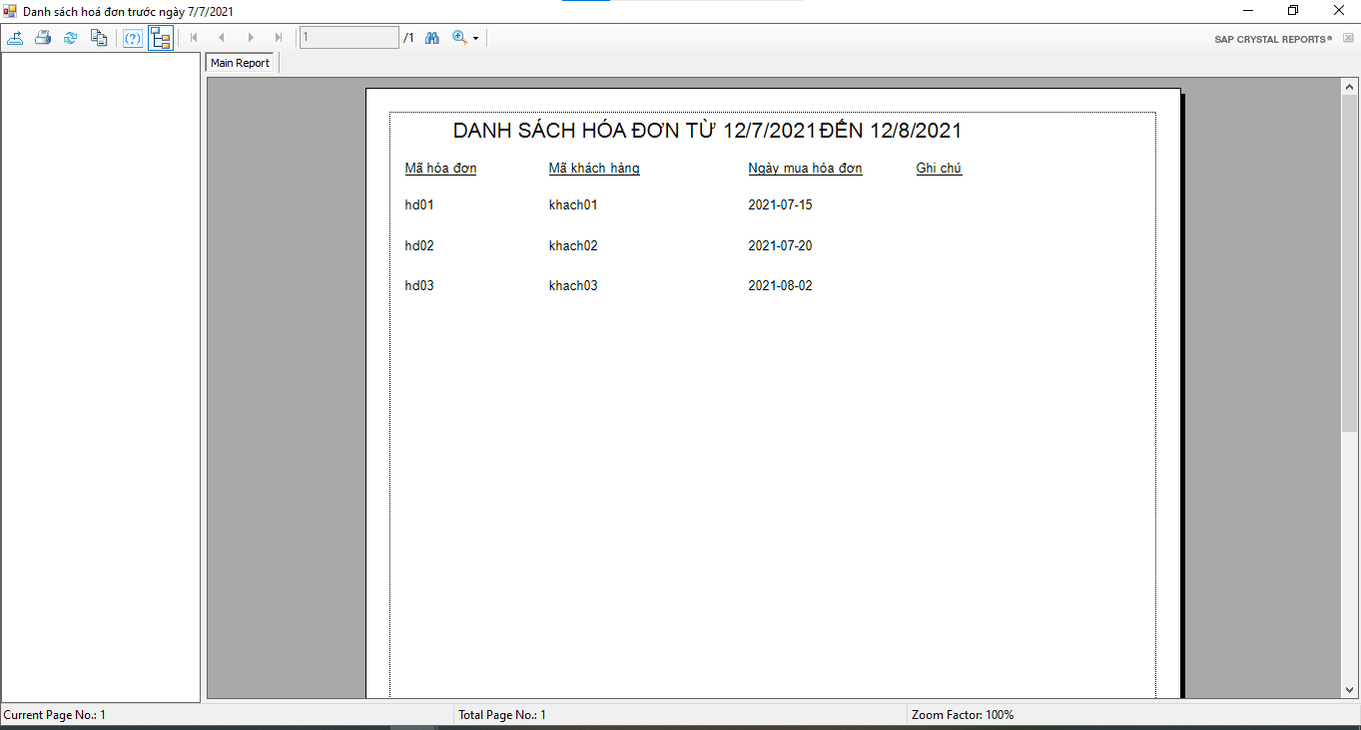

Proc trong sql

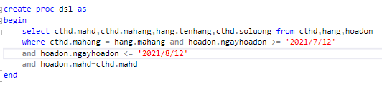

Event trong form CrvCthd

|  |
| --- |
| using System;  using System.Collections.Generic;  using System.ComponentModel;  using System.Data;  using System.Drawing;  using System.Linq;  using System.Text;  using System.Threading.Tasks;  using System.Windows.Forms;  namespace WindowsFormsApp8.GUI  {  public partial class formBaocaoCthd1 : Form  {  public formBaocaoCthd1()  {  InitializeComponent();  }  private void crvCTHD_Load(object sender, EventArgs e)  {  BUS.clsBaocaoHoaDon1 report = new BUS.clsBaocaoHoaDon1();  report.BaocaoKhachhang(crvCTHD, @"C:\Users\Nhung\Desktop\repos\WindowsFormsApp8\WindowsFormsApp8\BUS\crvCthd2.rpt");  }  }  } |

Event trong form CTHD

|  |
| --- |
| private void menuBaocao_Click(object sender, EventArgs e)  {  GUI.formBaocaoCthd1 cthd1 = new GUI.formBaocaoCthd1();  cthd1.ShowDialog();  } |

Design bảng CTHD

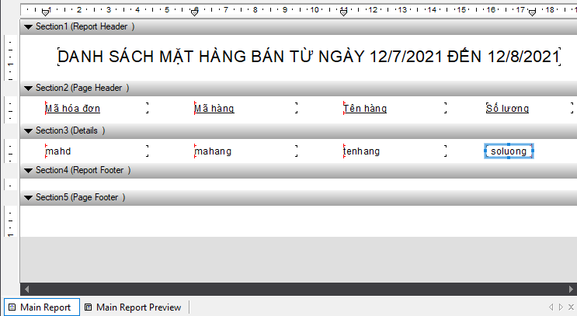

Chạy ứng dụng

