**NGUYỄN BÁ KHÁNH**

**Bài 1**

|  |
| --- |
| using System;  using System.Collections.Generic;  using System.ComponentModel;  using System.Data;  using System.Drawing;  using System.Linq;  using System.Text;  using System.Threading.Tasks;  using System.Windows.Forms;  namespace WindowsFormsApp2  {  public partial class Form1 : Form  {  public Form1()  {  InitializeComponent();  }  private void myButton_Click(object sender, EventArgs e)  {  string s = "Hello " + textBox1.Text;  MessageBox.Show(s);  }  }    } |

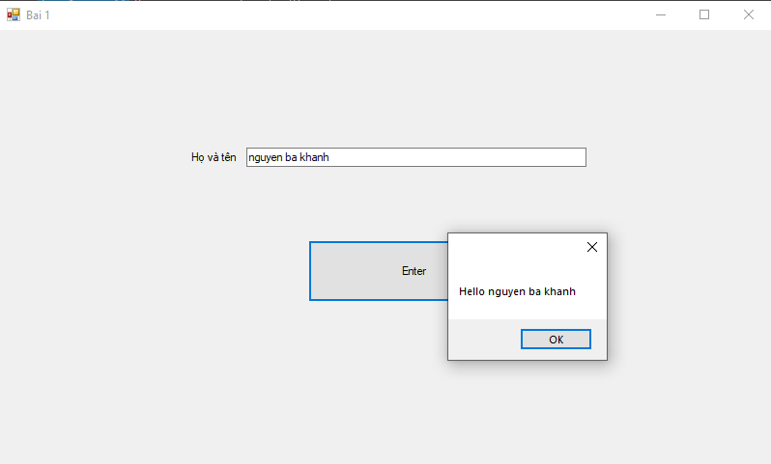

**Bài 2:**

|  |
| --- |
| using System;  using System.Collections.Generic;  using System.ComponentModel;  using System.Data;  using System.Drawing;  using System.Linq;  using System.Text;  using System.Threading.Tasks;  using System.Windows.Forms;  namespace WindowsFormsApp3  {  public partial class Form1 : Form  {  public Form1()  {  InitializeComponent();  }  private void textBox1_KeyPress(object sender, KeyPressEventArgs e)  {  if (!char.IsControl(e.KeyChar) && !char.IsDigit(e.KeyChar) &&  (e.KeyChar != '.'))  {  e.Handled = true;  }  // only allow one decimal point  if ((e.KeyChar == '.') && ((sender as TextBox).Text.IndexOf('.') > -1))  {  e.Handled = true;  }  }  private void button1_Click(object sender, EventArgs e)  {  float number1 = float.Parse(textBox1.Text);  float number2 = float.Parse(textBox2.Text);  var s = comboBox1.GetItemText(this.comboBox1.SelectedItem);  float sum;  switch (s)  {  case "+":  {  sum = number1 + number2;  string sum2 = sum.ToString();  MessageBox.Show(sum2);  break;  }  case "-":  {  sum = number1 - number2;  string sum2 = sum.ToString();  MessageBox.Show(sum2);  break;  }  case "x":  {  sum = number1 * number2;  string sum2 = sum.ToString();  MessageBox.Show(sum2);  break;  }  case "/":  {  sum = number1 / number2;  string sum2 = sum.ToString();  MessageBox.Show(sum2);  break;  }  }  }  private void comboBox1_SelectedIndexChanged(object sender, EventArgs e)  {  }  }  } |

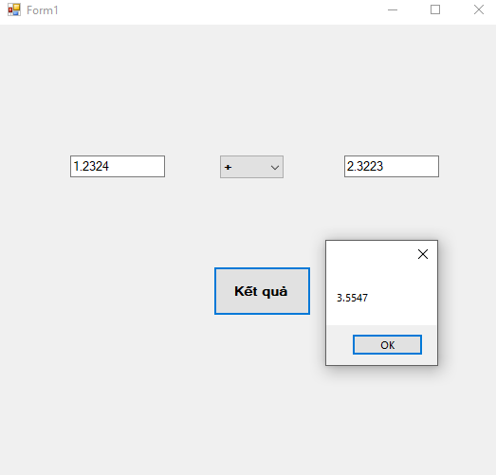

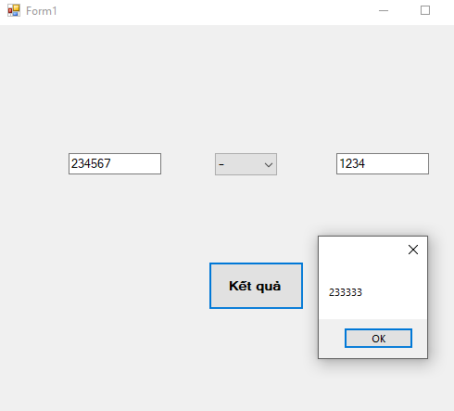

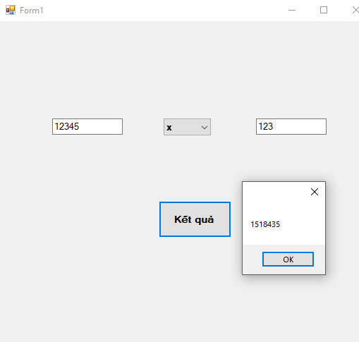

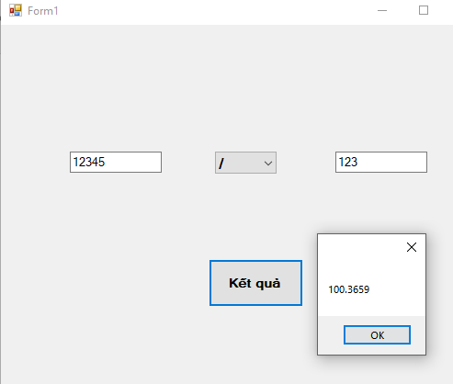

**Bài 3**

|  |
| --- |
| using System;  using System.Collections.Generic;  using System.ComponentModel;  using System.Data;  using System.Drawing;  using System.Linq;  using System.Text;  using System.Threading.Tasks;  using System.Windows.Forms;  namespace WindowsFormsApp4  {  public partial class Form1 : Form  {  public Form1()  {  InitializeComponent();  }  private void button1_Click(object sender, EventArgs e)  {  textBox1.Text += 1;  }  private void button2_Click(object sender, EventArgs e)  {  textBox1.Text += 2;  }  private void button3_Click(object sender, EventArgs e)  {  textBox1.Text += 3;  }  private void button4_Click(object sender, EventArgs e)  {  textBox1.Text += 4;  }  private void button5_Click(object sender, EventArgs e)  {  textBox1.Text += 5;  }  private void button6_Click(object sender, EventArgs e)  {  textBox1.Text += 6;  }  private void button7_Click(object sender, EventArgs e)  {  textBox1.Text += 7;  }  private void button8_Click(object sender, EventArgs e)  {  textBox1.Text += 8;  }  private void button9_Click(object sender, EventArgs e)  {  textBox1.Text += 9;  }  private void button10_Click(object sender, EventArgs e)  {  textBox1.Text += 0;  }  private void button12_Click(object sender, EventArgs e)  {  textBox1.Text = "";  textBox2.Text = "";  }  private void button20_Click(object sender, EventArgs e)  {  string s = textBox1.Text;  int i, j;  float t;  var oper1 = "+-x/";  float[] str = new float[1000];  string[] opr = new string[1000];  float[] sinNum = new float[1000];  int d = 0, count = 0, oprCount;  int len = s.Length;  i = 0;  while (i < len)  {  if (s[i] == oper1[0] || s[i] == oper1[1] || s[i] == oper1[2] || s[i] == oper1[3])  {  str[d] = int.Parse(s.Substring(0, i));  opr[d] = s.Substring(i, 1);  s = s.Remove(0, i + 1);  len = s.Length;  d++;  i = -1;  }  for (j = 0; j < len; j++)  {  if (s[j] == oper1[0] || s[j] == oper1[1] || s[j] == oper1[2] || s[j] == oper1[3])  count++;  }  if (count == 0)  {  str[d] = int.Parse(s.Substring(0, len));  s = s.Remove(0, len);  len = 0;  d++;  }  i++;  count = 0;  }  oprCount = d - 1;  i = 0;  while (i < oprCount)  {  if (opr[i] == "x")  {  t = str[i] * str[i + 1];  str[i] = t;  opr[i] = opr[i + 1];  j = i + 1;  var k = i + 1;  while (j < d)  {  str[j] = str[j + 1];  j++;  }  d--;  while (k < oprCount)  {  opr[k] = opr[k + 1];  k++;  }  oprCount--;  i = -1;  }  else  {  if (opr[i] == "/")  {  t = str[i] / str[i + 1];  str[i] = t;  opr[i] = opr[i + 1];  j = i + 1;  var k = i + 1;  while (j < d)  {  str[j] = str[j + 1];  j++;  }  d--;  while (k < oprCount)  {  opr[k] = opr[k + 1];  k++;  }  oprCount--;  i = -1;  }  }  i++;  }  i = 0;  while (i < oprCount)  {  if (opr[i] == "+")  {  t = str[i] + str[i + 1];  str[i] = t;  opr[i] = opr[i + 1];  j = i + 1;  var k = i + 1;  while (j < d)  {  str[j] = str[j + 1];  j++;  }  d--;  while (k < oprCount)  {  opr[k] = opr[k + 1];  k++;  }  oprCount--;  i = -1;  }  else  {  if (opr[i] == "-")  {  t = str[i] - str[i + 1];  str[i] = t;  opr[i] = opr[i + 1];  j = i + 1;  var k = i + 1;  while (j < d)  {  str[j] = str[j + 1];  j++;  }  d--;  while (k < oprCount)  {  opr[k] = opr[k + 1];  k++;  }  oprCount--;  i = -1;  }  }  i++;  }  textBox2.Text = str[0].ToString();  }  private void button13_Click(object sender, EventArgs e)  {  string opr = "+-x/";  string s = textBox1.Text;  int len = s.Length;  if (len==0)  {  textBox1.Text += "";  }  else  {  if (s[len - 1] == opr[0] || s[len - 1] == opr[1] || s[len - 1] == opr[2] || s[len - 1] == opr[3]) s = s.Remove(len - 1, 1);  textBox1.Text = s;  textBox1.Text += "+";  }  }  private void button14_Click(object sender, EventArgs e)  {  string opr = "+-x/";  string s = textBox1.Text;  int len = s.Length;  if (len == 0)  {  textBox1.Text += "";  }  else  {  if (s[len - 1] == opr[0] || s[len - 1] == opr[1] || s[len - 1] == opr[2] || s[len - 1] == opr[3]) s = s.Remove(len - 1, 1);  textBox1.Text = s;  textBox1.Text += "-";  }  }  private void button15_Click(object sender, EventArgs e)  {  string opr = "+-x/";  string s = textBox1.Text;  int len = s.Length;  if (len == 0)  {  textBox1.Text += "";  }  else  {  if (s[len - 1] == opr[0] || s[len - 1] == opr[1] || s[len - 1] == opr[2] || s[len - 1] == opr[3]) s = s.Remove(len - 1, 1);  textBox1.Text = s;  textBox1.Text += "x";  }  }  private void button16_Click(object sender, EventArgs e)  {  string opr = "+-x/";  string s = textBox1.Text;  int len = s.Length;  if (len == 0)  {  textBox1.Text += "";  }  else  {  if (s[len - 1] == opr[0] || s[len - 1] == opr[1] || s[len - 1] == opr[2] || s[len - 1] == opr[3]) s = s.Remove(len - 1, 1);  textBox1.Text = s;  textBox1.Text += "/";  }  }  private void button11_Click(object sender, EventArgs e)  {  string s = textBox1.Text;  int len = s.Length;  s = s.Remove(len - 1, 1);  textBox1.Text = s;  }  }  } |

