NGUYỄN BÁ KHÁNH

|  |
| --- |
| using System;  using System.Collections.Generic;  using System.ComponentModel;  using System.Data;  using System.Drawing;  using System.Linq;  using System.Text;  using System.Threading.Tasks;  using System.Windows.Forms;  using System.Data.SqlClient;  namespace WindowsFormsApp8  {  public partial class Form1 : Form  {  public string strCon;  public Form1()  {  InitializeComponent();  }  private void menuConnect_Click(object sender, EventArgs e)  {  strCon = @"Data Source=laptop-bajmdj31;Initial Catalog=qlbh_kt;Integrated Security=True";  MessageBox.Show("Đã kết nối!");  }  private void btnRefresh_Click(object sender, EventArgs e)  {  SqlConnection conn = new SqlConnection();  conn.ConnectionString = strCon;  try  {  conn.Open();  SqlCommand command = new SqlCommand();  command.CommandText = "select * from hang_kt";  command.CommandType = CommandType.Text;  command.Connection = conn;  command.ExecuteNonQuery();  DataTable dt = new DataTable();  SqlDataAdapter da = new SqlDataAdapter(command);  da.Fill(dt);  dgvHang.DataSource = dt;  }  catch (Exception ex)  {  }  }  private void btnAdd_Click(object sender, EventArgs e)  {  DAL.clsMathang mathang = new DAL.clsMathang(  txbMahang.Text,  txbTenhang.Text,  float.Parse(txbDongia.Text),  txbGhichu.Text);  bool kt = mathang.add_hang(strCon);  if (kt)  {  MessageBox.Show("Thành công");  }  else  {  MessageBox.Show("Thất bại");  }  }  private void btnUpdate_Click(object sender, EventArgs e)  {  DAL.clsMathang mathang = new DAL.clsMathang(  txbMahang.Text,  txbTenhang.Text,  float.Parse(txbDongia.Text),  txbGhichu.Text);  bool kt = mathang.upd_hang(strCon);  if (kt)  {  MessageBox.Show("Thành công");  }  else  {  MessageBox.Show("Thất bại");  }  }  private void btnDelete_Click(object sender, EventArgs e)  {  DAL.clsMathang mathang = new DAL.clsMathang(  txbMahang.Text,  txbTenhang.Text,  float.Parse(txbDongia.Text),  txbGhichu.Text);  bool kt = mathang.del_hang(strCon);  if (kt)  {  MessageBox.Show("Thành công");  }  else  {  MessageBox.Show("Thất bại");  }  }  private void btnFind_Click(object sender, EventArgs e)  {  SqlConnection conn = new SqlConnection();  conn.ConnectionString = strCon;  try  {  conn.Open();  SqlCommand command = new SqlCommand();  command.CommandText = "select * from hang_kt where tenhang like " + "N'"+txbTimkiem.Text+"'";  command.CommandType = CommandType.Text;  command.Connection = conn;  command.ExecuteNonQuery();  DataTable dt = new DataTable();  SqlDataAdapter da = new SqlDataAdapter(command);  da.Fill(dt);  dgvHang.DataSource = dt;  }  catch (Exception ex)  {  }  }  }  } |

|  |
| --- |
| using System;  using System.Collections.Generic;  using System.Linq;  using System.Text;  using System.Threading.Tasks;  namespace WindowsFormsApp8.DAL  {  interface iMathang  {  string Mahang { get; set; }  string Tenhang { get; set; }  float Dongia { get; set; }  string Ghichu { get; set; }  bool add_hang(string strCon);  bool upd_hang(string strCon);  bool del_hang(string strCon);  }  } |

|  |
| --- |
| using System;  using System.Collections.Generic;  using System.Linq;  using System.Text;  using System.Threading.Tasks;  using System.Data;  using System.Data.SqlClient;  namespace WindowsFormsApp8.DAL  {  class clsMathang: iMathang  {  public string Mahang { get; set; }  public string Tenhang { get; set; }  public float Dongia { get; set; }  public string Ghichu { get; set; }  public clsMathang()  {  }  public clsMathang(string mahang,string tenhang,float dongia,string ghichu)  {  Mahang = mahang;  Tenhang = tenhang;  Dongia = dongia;  Ghichu = ghichu;  }  public bool add_hang(string strCon)  {  bool kt = false;  SqlConnection sqlConn = new SqlConnection(strCon);  try  {  sqlConn.Open();  SqlCommand sqlComm = new SqlCommand("proc_add_hang", sqlConn);  sqlComm.CommandType = CommandType.StoredProcedure;  //Truyen tham so vao cho thu tuc  sqlComm.Parameters.AddWithValue("@mahang", SqlDbType.Char).Value = Mahang;  sqlComm.Parameters.AddWithValue("@tenhang", SqlDbType.NVarChar).Value = Tenhang;  sqlComm.Parameters.AddWithValue("@dongia", SqlDbType.Float).Value = Dongia;  sqlComm.Parameters.AddWithValue("@ghichu", SqlDbType.NVarChar).Value = Ghichu;  //Thuc thi cau lenh  sqlComm.ExecuteNonQuery();  kt = true;  }  catch  { }  return kt;  }  public bool upd_hang(string strCon)  {  bool kt = false;  SqlConnection sqlConn = new SqlConnection(strCon);  try  {  sqlConn.Open();  SqlCommand sqlComm = new SqlCommand("proc_upd_hang", sqlConn);  sqlComm.CommandType = CommandType.StoredProcedure;  //Truyen tham so vao cho thu tuc  sqlComm.Parameters.AddWithValue("@mahang", SqlDbType.Char).Value = Mahang;  sqlComm.Parameters.AddWithValue("@tenhang", SqlDbType.NVarChar).Value = Tenhang;  sqlComm.Parameters.AddWithValue("@dongia", SqlDbType.Float).Value = Dongia;  sqlComm.Parameters.AddWithValue("@ghichu", SqlDbType.NVarChar).Value = Ghichu;  //Thuc thi cau lenh  sqlComm.ExecuteNonQuery();  kt = true;  }  catch  { }  return kt;  }  public bool del_hang(string strCon)  {  bool kt = false;  SqlConnection sqlConn = new SqlConnection(strCon);  try  {  sqlConn.Open();  SqlCommand sqlComm = new SqlCommand("proc_del_hang", sqlConn);  sqlComm.CommandType = CommandType.StoredProcedure;  //Truyen tham so vao cho thu tuc  sqlComm.Parameters.AddWithValue("@mahang", SqlDbType.Char).Value = Mahang;  //Thuc thi cau lenh  sqlComm.ExecuteNonQuery();  kt = true;  }  catch  { }  return kt;  }  }  } |

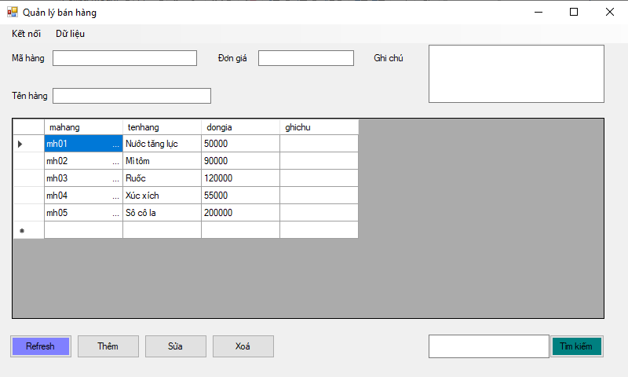

Thêm

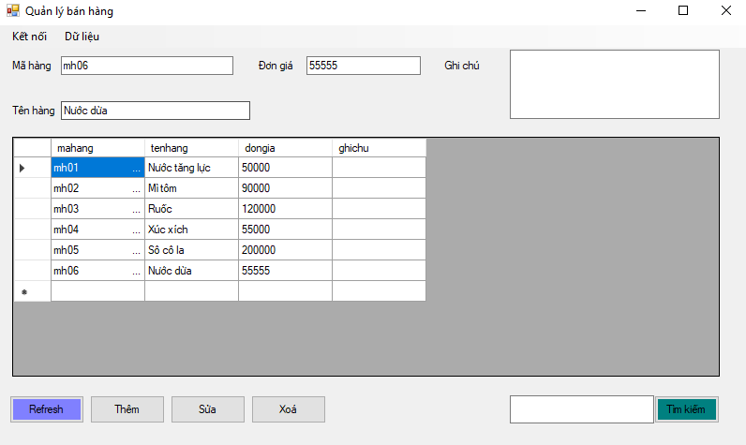

Sửa

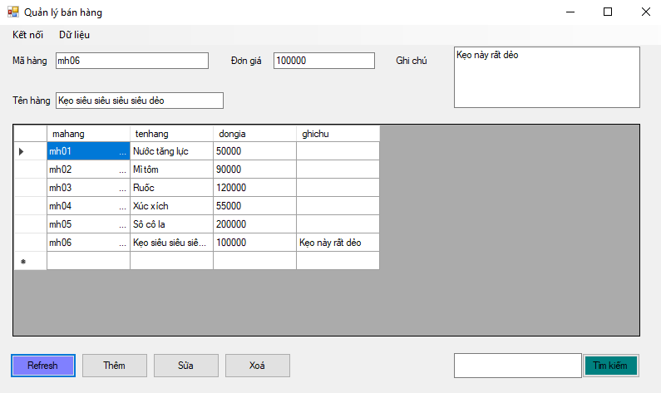

Xoá

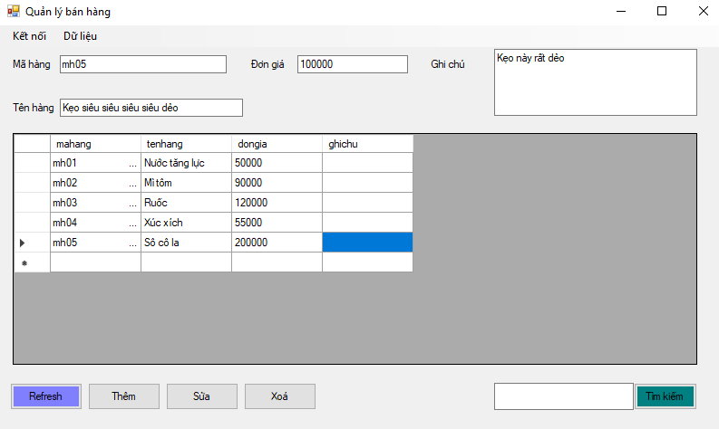

Tìm kiếm

