Họ tên:

|  |
| --- |
| using System;  using System.Collections.Generic;  using System.ComponentModel;  using System.Data;  using System.Drawing;  using System.Linq;  using System.Text;  using System.Threading.Tasks;  using System.Windows.Forms;  namespace Bai8.GUI  {  public partial class formBaocaoHoaDon1 : Form  {  public formBaocaoHoaDon1()  {  InitializeComponent();  }  private void crvHoadon1_Load(object sender, EventArgs e)  {  BUS.clsBaocaoHoaDon1 report = new BUS.clsBaocaoHoaDon1();  report.BaocaoKhachhang(crvHoadon1, @"C:\Users\LENOVO\source\repos\Bai8\Bai8\BUS\CrystalReportHoadon1.rpt");  }  }  } |

|  |
| --- |
| using System;  using System.Collections.Generic;  using System.ComponentModel;  using System.Data;  using System.Drawing;  using System.Linq;  using System.Text;  using System.Threading.Tasks;  using System.Windows.Forms;  namespace Bai8.GUI  {  public partial class formBaocaoKhachhang : Form  {  public formBaocaoKhachhang()  {  InitializeComponent();  }  private void crvKhachhang_Load(object sender, EventArgs e)  {  BUS.clsBaocaoKhachhang report = new BUS.clsBaocaoKhachhang();  report.BaocaoKhachhang(crvKhachhang, @"C:\Users\LENOVO\source\repos\Bai8\Bai8\BUS\CrystalReportKhachhang.rpt");  }  }  } |

|  |
| --- |
| using System;  using System.Collections.Generic;  using System.ComponentModel;  using System.Data;  using System.Drawing;  using System.Linq;  using System.Text;  using System.Threading.Tasks;  using System.Windows.Forms;  using System.Data.SqlClient;  namespace Bai8.GUI  {  public partial class formBaocaoMathang : Form  {  public string strCon;  public formBaocaoMathang()  {  InitializeComponent();  }  private void crvMathang_Load(object sender, EventArgs e)  {  BUS.clsBaocaoMathang report = new BUS.clsBaocaoMathang();  report.BaocaoMathang(crvMathang, @"C:\Users\LENOVO\source\repos\Bai8\Bai8\BUS\CrystalReportMathang.rpt");  }  }  } |

|  |
| --- |
| using CrystalDecisions.CrystalReports.Engine;  using CrystalDecisions.Windows.Forms;  using System;  using System.Collections.Generic;  using System.Linq;  using System.Text;  using System.Threading.Tasks;  namespace Bai8.BUS  {  class clsBaocaoHoaDon1  {  public void BaocaoKhachhang(CrystalReportViewer reportViewer, string CrystalFile)  {  ReportDocument rpt = new ReportDocument();  rpt.Load(CrystalFile);  reportViewer.ReportSource = rpt;  }  }  } |

|  |
| --- |
| using System;  using System.Collections.Generic;  using System.Linq;  using System.Text;  using System.Threading.Tasks;  using CrystalDecisions.CrystalReports.Engine;  using CrystalDecisions.Windows.Forms;  namespace Bai8.BUS  {  class clsBaocaoKhachhang  {  public void BaocaoKhachhang(CrystalReportViewer reportViewer, string CrystalFile)  {  ReportDocument rpt = new ReportDocument();  rpt.Load(CrystalFile);  reportViewer.ReportSource = rpt;  }  }  } |

|  |
| --- |
| using System;  using System.Collections.Generic;  using System.Linq;  using System.Text;  using System.Threading.Tasks;  using CrystalDecisions.CrystalReports.Engine;  using CrystalDecisions.Shared;  using System.Data;  using System.Data.SqlClient;  using CrystalDecisions.Windows.Forms;  namespace Bai8.BUS  {  class clsBaocaoMathang  {  public void BaocaoMathang(CrystalReportViewer reportViewer, string CrystalFile)  {  ReportDocument rpt = new ReportDocument();  rpt.Load(CrystalFile);  reportViewer.ReportSource = rpt;  }  }  } |

Hoá đơn mua trước 7/7

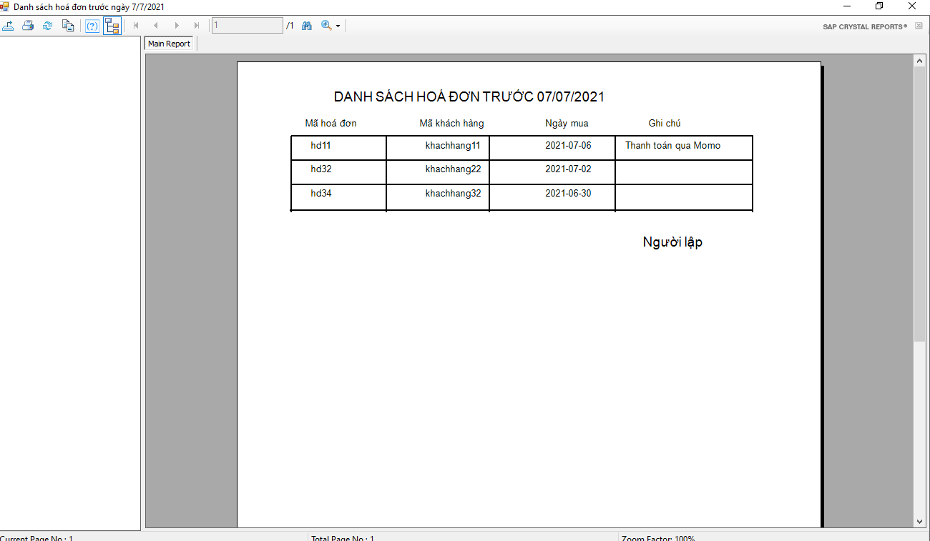

Danh sách khách hàng

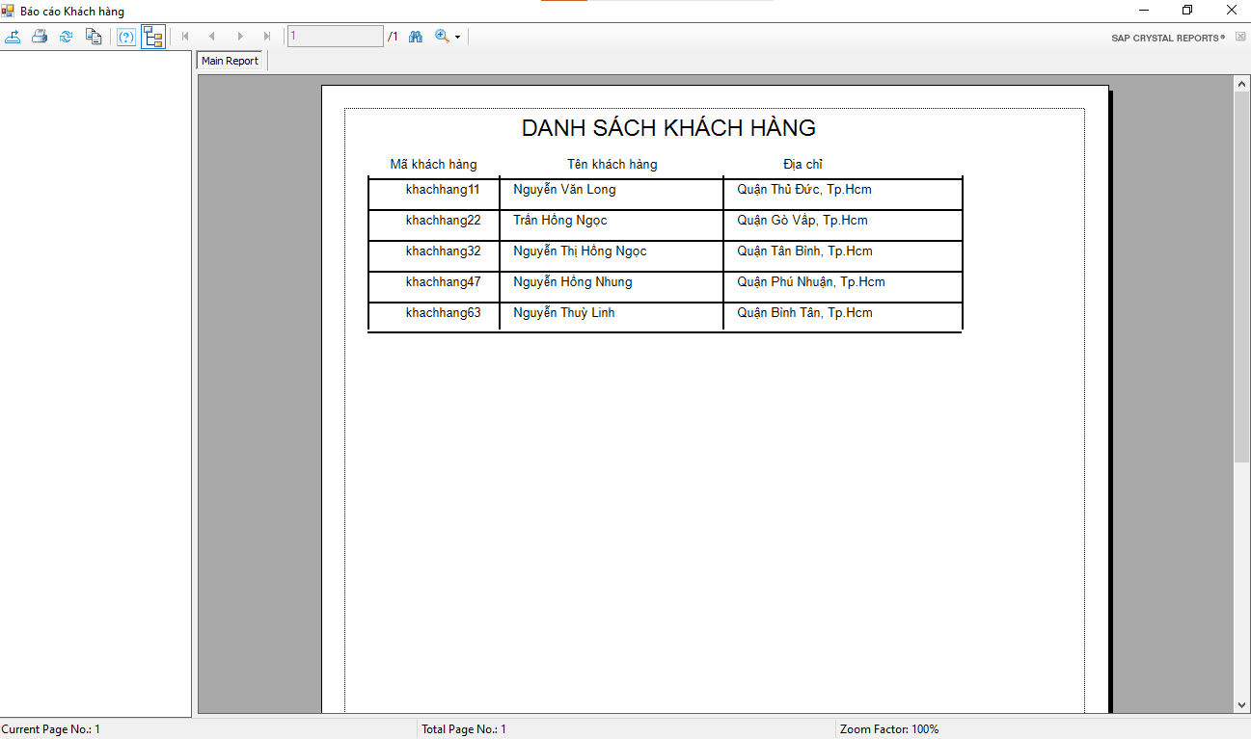

Danh sách mặt hàng

