Họ tên:

|  |
| --- |
| using System;  using System.Collections.Generic;  using System.ComponentModel;  using System.Data;  using System.Drawing;  using System.Linq;  using System.Text;  using System.Threading.Tasks;  using System.Windows.Forms;  using System.Data.SqlClient;  namespace WindowsFormsApp7.GUI  {  public partial class formSinhvien : Form  {  public string strSqlConnection = @"Data Source=laptop-bajmdj31;Initial Catalog=QLSV;Integrated Security=True";  public formSinhvien()  {  InitializeComponent();  }  private void btnRefresh_Click(object sender, EventArgs e)  {  SqlConnection conn = new SqlConnection();  conn.ConnectionString = @"Data Source=laptop-bajmdj31;Initial Catalog=QLSV;Integrated Security=True";  try  {  conn.Open();  SqlCommand command = new SqlCommand();  command.CommandText = "select * from sinhvien";  command.CommandType = CommandType.Text;  command.Connection = conn;  command.ExecuteNonQuery();  DataTable dt = new DataTable();  SqlDataAdapter da = new SqlDataAdapter(command);  da.Fill(dt);  dgvSinhvien.DataSource = dt;  }  catch (Exception ex)  {  }  }  private void btnAdd_Click(object sender, EventArgs e)  {  DAL.clsSinhvien sinhvien = new DAL.clsSinhvien(  int.Parse(txbMasv.Text),  txbHoten.Text,  txbSdt.Text,  txbDiachi.Text,  txbGhichu.Text);  bool kt = sinhvien.add_sv(strSqlConnection);  if (kt == false)  {  MessageBox.Show("Xảy ra lỗi");  }  }  private void btnUpdate_Click(object sender, EventArgs e)  {  DAL.clsSinhvien sinhvien = new DAL.clsSinhvien(  int.Parse(txbMasv.Text),  txbHoten.Text,  txbSdt.Text,  txbDiachi.Text,  txbGhichu.Text);  bool kt = sinhvien.upd_sv(strSqlConnection);  if (kt == false)  {  MessageBox.Show("Xảy ra lỗi");  }  }  private void btnDelete_Click(object sender, EventArgs e)  {  DAL.clsSinhvien sinhvien = new DAL.clsSinhvien(  int.Parse(txbMasv.Text),  txbHoten.Text,  txbSdt.Text,  txbDiachi.Text,  txbGhichu.Text);  bool kt = sinhvien.del_sv(strSqlConnection);  if (kt == false)  {  MessageBox.Show("Xảy ra lỗi");  }  }  private void btnChange_Click(object sender, EventArgs e)  {  GUI.formMonhoc monhoc = new GUI.formMonhoc();  this.Hide();  this.Close();  monhoc.ShowDialog();  }  }  } |

|  |
| --- |
| using System;  using System.Collections.Generic;  using System.Linq;  using System.Text;  using System.Threading.Tasks;  namespace WindowsFormsApp7.DAL  {  interface iSinhvien  {  int Masv { get; set; }  string Hoten { get; set; }  string Sdt { get; set; }  string Diachi { get; set; }  string Ghichu { get; set; }  bool add_sv(string strSqlConnection);  bool upd_sv(string strSqlConnection);  bool del_sv(string strSqlConnection);  }  } |

|  |
| --- |
| using System;  using System.Collections.Generic;  using System.Linq;  using System.Text;  using System.Threading.Tasks;  using System.Data.SqlClient;  using System.Data;  namespace WindowsFormsApp7.DAL  {  class clsSinhvien : iSinhvien  {  public int Masv { get; set; }  public string Hoten { get; set; }  public string Sdt { get; set; }  public string Diachi { get; set; }  public string Ghichu { get; set; }    public clsSinhvien(int masv, string hoten, string sdt,string diachi, string ghichu)  {  Masv = masv;  Hoten = hoten;  Sdt = sdt;  Diachi = diachi;  Ghichu = ghichu;  }  public bool add_sv(string strSqlConnection)  {  bool kt = false;  SqlConnection sqlConn = new SqlConnection(strSqlConnection);  try  {  sqlConn.Open();  SqlCommand sqlComm = new SqlCommand("proc_add_sv", sqlConn);  sqlComm.CommandType = CommandType.StoredProcedure;  //Truyen tham so vao cho thu tuc  sqlComm.Parameters.AddWithValue("@masv", SqlDbType.Int).Value = Masv;  sqlComm.Parameters.AddWithValue("@hoten", SqlDbType.NVarChar).Value = Hoten;  sqlComm.Parameters.AddWithValue("@sdt", SqlDbType.Char).Value = Sdt;  sqlComm.Parameters.AddWithValue("@diachi", SqlDbType.NVarChar).Value = Diachi;  sqlComm.Parameters.AddWithValue("@ghichu", SqlDbType.NVarChar).Value = Ghichu;  //Thuc thi cau lenh  sqlComm.ExecuteNonQuery();  kt = true;  }  catch  { }  return kt;  }  public bool upd_sv(string strSqlConnection)  {  bool kt = false;  SqlConnection sqlConn = new SqlConnection(strSqlConnection);  try  {  sqlConn.Open();  SqlCommand sqlComm = new SqlCommand("proc_upd_sv", sqlConn);  sqlComm.CommandType = CommandType.StoredProcedure;  //Truyen tham so vao cho thu tuc  sqlComm.Parameters.AddWithValue("@masv", SqlDbType.Int).Value = Masv;  sqlComm.Parameters.AddWithValue("@hoten", SqlDbType.NVarChar).Value = Hoten;  sqlComm.Parameters.AddWithValue("@sdt", SqlDbType.Char).Value = Sdt;  sqlComm.Parameters.AddWithValue("@diachi", SqlDbType.NVarChar).Value = Diachi;  sqlComm.Parameters.AddWithValue("@ghichu", SqlDbType.NVarChar).Value = Ghichu;  //Thuc thi cau lenh  sqlComm.ExecuteNonQuery();  kt = true;  }  catch  { }  return kt;    }  public bool del_sv(string strSqlConnection)  {  bool kt = false;  SqlConnection sqlConn = new SqlConnection(strSqlConnection);  try  {  sqlConn.Open();  SqlCommand sqlComm = new SqlCommand("proc_del_sv",sqlConn);  sqlComm.CommandType = CommandType.StoredProcedure;  //Truyen tham so vao cho thu tuc  sqlComm.Parameters.AddWithValue("@masv", SqlDbType.Int).Value = Masv;  //Thuc thi cau lenh  sqlComm.ExecuteNonQuery();  kt = true;  }  catch  { }  return kt;  }  }  } |

Bảng sinh viên

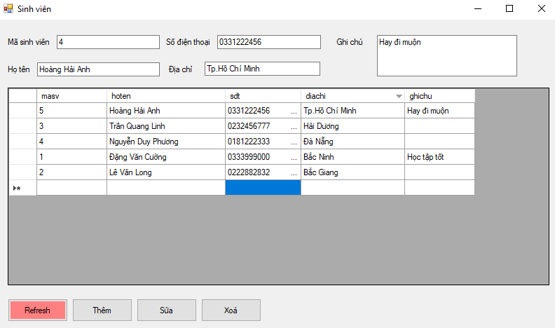

Thêm

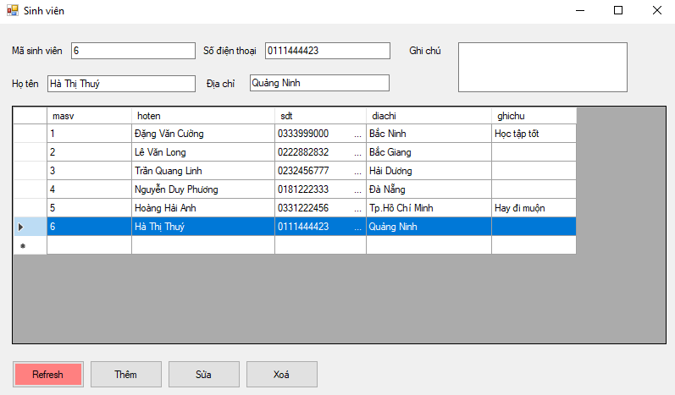

Sửa

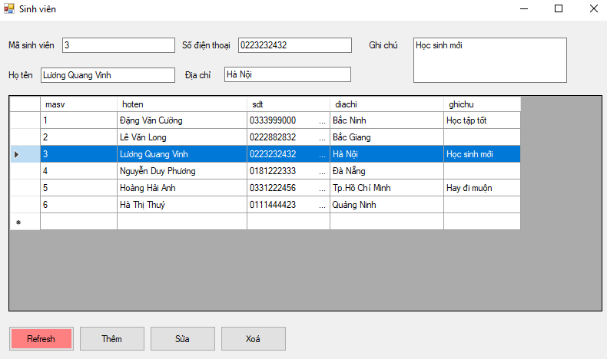

Xoá

