**MINISTRY OF EDUCATION AND TRAINING**

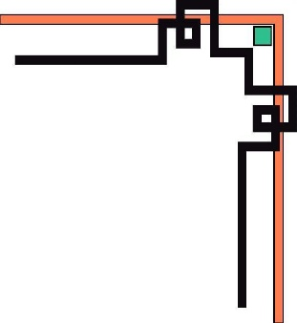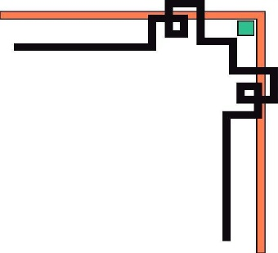

**HCMC UNIVERSITY OF TECHNOLOGY AND EDUCATION**

**FACULTY OF INFORMATION TECHNOLOGY**

----🙦🙦🕮🙤🙤----



**Instructor: Nguyen Duc Khoan Ph.D**

**FINAL PROJECT REPORT**

**“WEBSITE MARKETING”**

*Do Quoc Khanh - 17110041*

*Mai Phan Nguyet Ngan – 17110058*

*Tran Thuan Tuong Vy - 17110093*

*CLASS: 171100CLA*

**Ho Chi Minh City, December 2019**

**THANK YOU!**

*In the first words of this end-to-end "The Final Project" report, we would like to send our sincere thanks and gratitude to all those who have supported and provided us with knowledge and spirituality during project implementation.*

*We would like to express our faith to Mr. Khoan, lecturer at Ho Chi Minh City University of Technical and Education that helped us .*

*Due to limited time, knowledge is still limited so the project implementation certainly not avoid certain shortcomings. We would like to receive feedback from you so that we could have more experience to implement to complete our project better.*

*Best regards!*

*Ho Chi Minh city, December 20th, 2019*

**Group 4**

***Instructor’s comments***

*……………, Date ……… Month ……… Year …………*

**Instructor**

**CONTENT**

Thanks

*Content*

**1. INTRODUCTION** 6

***1.1.*** ***Requirement:*** 6

**2. USECASE MODEL** 7

***2.1. Use-Case Diagram:*** 7

***2.2. List of Actor:*** 8

***2.3. Description Use-Case:*** 8

**2.3.1. Use-Case “Log in”** 8

**2.3.2. Use-Case “Log out”** 9

**2.4.3. Use-Case “Sign up account”** 9

**2.4.4. Use-Case “Add/Delete - Categories”** 10

**2.4.5. Use-Case “Add/Delete - Products”** 11

**2.4.6. Use-Case “Delete user”** 11

**3. CLASS DIAGRAM** 12

**4. DATABASE DESIGN** 13

***4.1. ERD (Entity Relational Diagram)*** 13

***4.2. Database Diagram:*** 14

**5.** **INTERFACE DESIGN** 15

***5.1. Home page:*** 15

***5.2. Admin login:*** 16

***5.3. Category Management:*** 16

***5.4. Add Category:*** 16

***5.5. Add Product:*** 17

***5.6. User Management:*** 18

***5.7. Sign up account:*** 19

***5.8. User Login:*** 19

***5.9. Information of product:*** 20

**5.9.1. View Comment:** 20

**5.9.2. View Rate:** 20

***5.10. Post Comment/Rate of User:*** 21

**6. WORK PLAN** 23

***6.1. Work Assignment:*** 23

Build web: Marketing 23

**7. CONCLUSION** 24

***7.1. Result:*** 24

**7.1.2. The results have not been achieved:** 24

- The website has some bug in function edit and search. 24

***7.2. Conclusion:*** 24

**REFERENCES** 25

**1. INTRODUCTION**

An online marketer now needs to find where people are congregating online and needs to engage them in a meaningful way. Be it in matching with what they are looking for ,watching how they interact and understand what they like or listening to their natural opinions on your company or market and reacting to that.

Along with the rapid development of computer hardware, the website has become more diverse, abundant, more complete and effective support for human consumption. The current software supports users with convenient use, fast processing time, and some highly automated operations.

Thus, the website development not only requires precision, handling a lot of practical work but also must meet other requirements such as speed, compatibility, user-friendly interface, familiar, paradigm reality to the computer to the user ease of use and high security ... software saves a huge amount of time, energy of users, increasing accuracy and efficiency.

***1.1. Requirement:***

- Framework: Jquery, Bootstrap

- Language: C#, HTML, CSS

- Flatform: ASP.NET

**2. USECASE MODEL**

***2.1. Use-Case Diagram:***

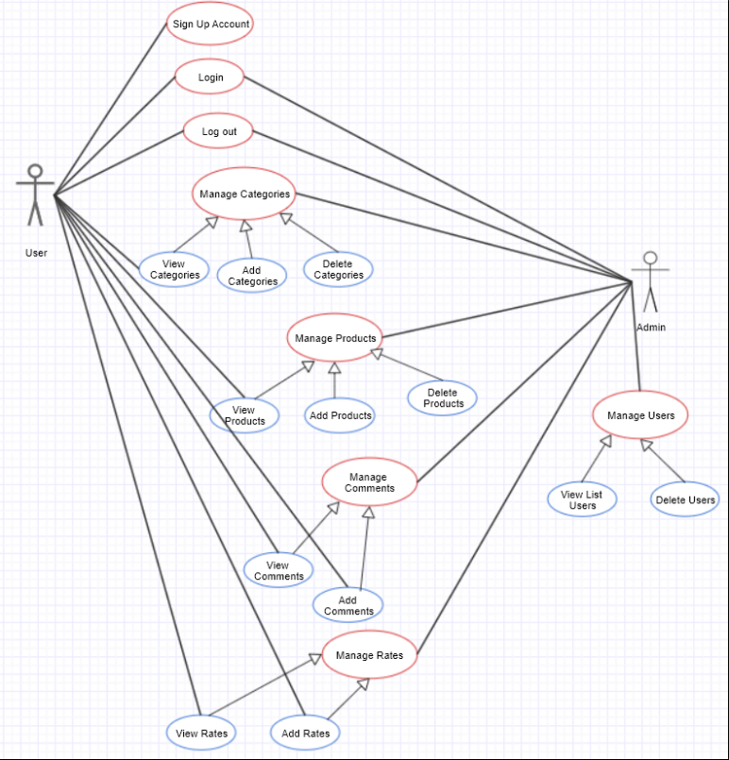

***2.2. List of Actor:***

|  |  |  |
| --- | --- | --- |
| **Order** | **Actor Name** | **Description** |
| 1 | Admins | Administrator of system, content management. |
| 2 | Users | Users login to the system to view the informations of the product. |

***2.3. Description Use-Case:***

**2.3.1. Use-Case “Log in”**

|  |  |
| --- | --- |
| **Brief** | Use-case is used to login to the system. Only after logging in to the system, users are allowed to use the system's functions, and admins are allowed to execute all content management. |
| **Actors** | Admins, Users |
| **Main events** | 1. Actors enters login account information, including login name and password.  2. The system checks the correct login information. |
| **Sub events** | The system checks the incorrect login information. |
| **Pre-condition** | - Status not logged in.  - The system has been successfully connected to the server. |
| **Post-condition** | - The system falls into one of two states:  + Already logged in: ready to work with logged-in users/admins.  + Not logged in: ready for users/admins to log in again.  - The system is ready for operations from users/admins. |

**2.3.2. Use-Case “Log out”**

|  |  |
| --- | --- |
| **Brief** | - Use-case is used to log out of the system. After logging out, the system will end the user’s/admin’s session, data and the user's/admins session will be deleted locally.  - Use-case starts when the system is in "Logged in" state and the user/admin wants to end the session and choose to log out of the system. |
| **Actors** | Admin, User |
| **Main eventss** | 1. The system closes the session with the user/admin, the system changes to the "Not logged in" state.  2. The system deletes all user/admin data in local (device in use).  3. The system returns to the login screen. |
| **Sub events** |  |
| **Pre-condition** | - The system is in the "Logged in" state. |
| **Post-condition** | - The system will be in the "Not logged in" state.  - The system is ready for operations from users/admins. |

**2.4.3. Use-Case “Sign up account”**

|  |  |
| --- | --- |
| **Brief** | - Use-case is used to create new system user information, register an account to use the system.  - Use-case starts when the system is in "Not logged in" state and the user chooses to create a system account. |
| **Actors** | User |
| **Main events** | 1. User enters registration information: required personal information, login account information.  2. The system checks the validity of registration information of users.  3. The system determines the valid registration information.  4. The system registers user information, and grants rights to newly registered users.  5. The user notification system has been successfully registered for users.  6. The system displays the login page. |
| **Sub events** | The system identifies invalid registration information: duplicate, incorrect, etc. |
| **Pre-condition** | - The system is in the "Not logged in" state.  - The system has been successfully connected to the server. |
| **Post-condition** | - The system will be in the "Not logged in" state.  - The system is ready for operations from users. |

**2.4.4. Use-Case “Add/Delete - Categories”**

|  |  |
| --- | --- |
| **Brief** | - Use-case is used to add/delete information of a category to the system.  - Use-case starts when in "logged in" state and admin chooses the function of adding/deleting categories. |
| **Actors** | Admin |
| **Main events** | 1. Admin choose information of categories to add/delete into the system.  2. Information validity checking system.  3. Verify the information.  4. The system adds/deletes category information to the database. |
| **Sub events** |  |
| **Pre-condition** | - The system is in the "Logged in" state.  - The system has been successfully connected to the server. |
| **Post-condition** | - The system is ready for operations from admins. |

**2.4.5. Use-Case “Add/Delete - Products”**

|  |  |
| --- | --- |
| **Brief** | - Use-case is used to add/delete information of product to the system.  - Use-case starts when in "logged in" state and the admin chooses the function of adding/deleting product. |
| **Actors** | Admin |
| **Main events** | 1. Admin choose information of product to add/delete into the system  2. Information validity checking system  3. Verify the information is valid  4. The system adds/deletes product information to the database. |
| **Sub events** |  |
| **Pre-condition** | - The system is in the "Logged in" state.  - The system has been successfully connected to the server. |
| **Post-condition** | - The system is ready for operations from admins. |

**2.4.6. Use-Case “Delete user”**

|  |  |
| --- | --- |
| **Brief** | - Use-case is used to delete information of user from the system.  - Use-case starts when in "logged in" state and admin chooses the function of manage user. |
| **Actors** | Admin |
| **Main events** | 1. Admin click “manage user” to view list user and click “delete” the user .  2. Information validity checking system  3. Verify the information is valid  4. The system deletes user information to the database. |
| **Sub events** |  |
| **Pre-condition** | - The system is in the “Logged in” state.  - The system has been successfully connected to the server. |
| **Post-condition** | - The system is ready for operations from admins. |

**3. CLASS DIAGRAM**

Image 15: Analytical Grade Diagram

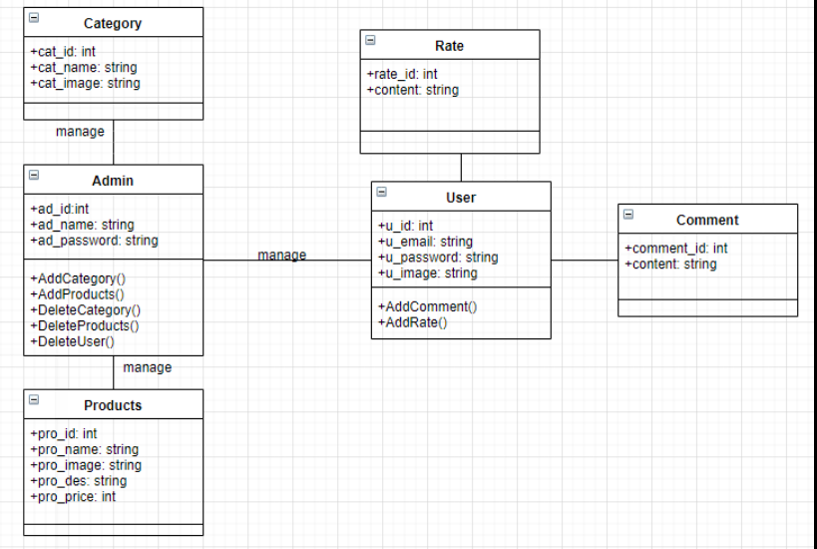

**4. DATABASE DESIGN**

***4.1. ERD (Entity Relational Diagram)***

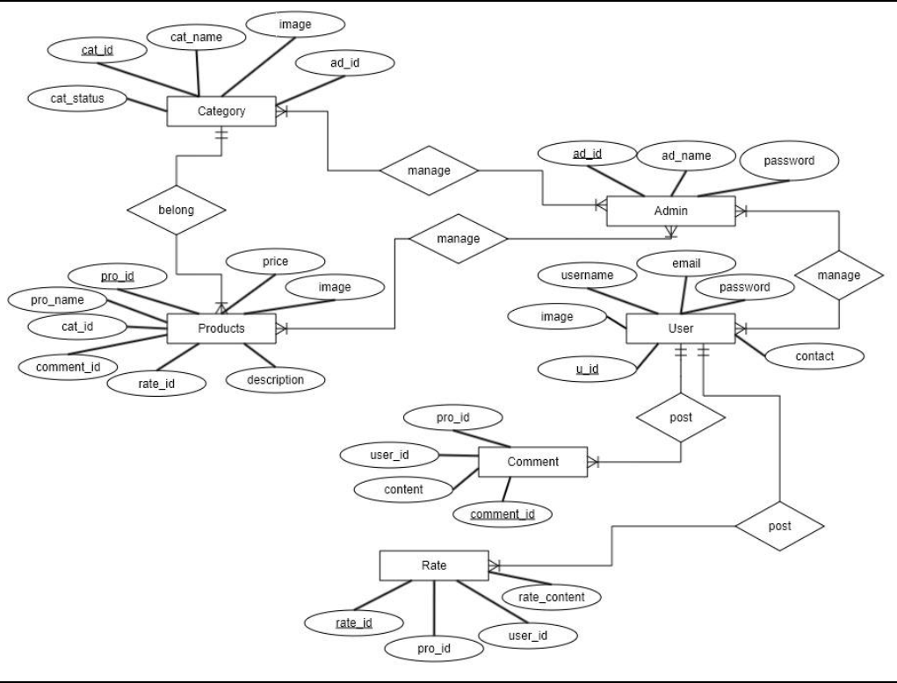

***4.2. Database Diagram:***

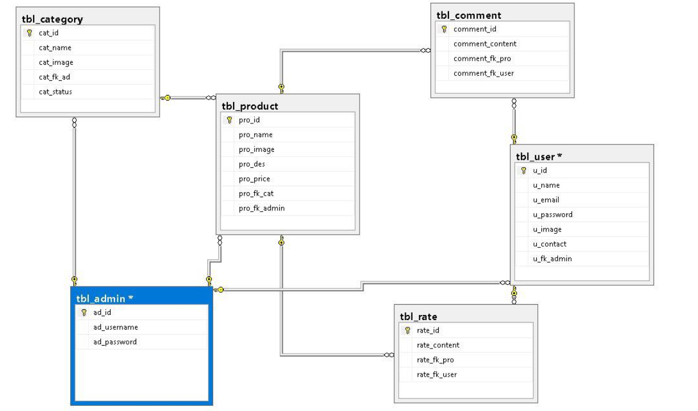

**5. INTERFACE DESIGN**

***5.1. Home page:***

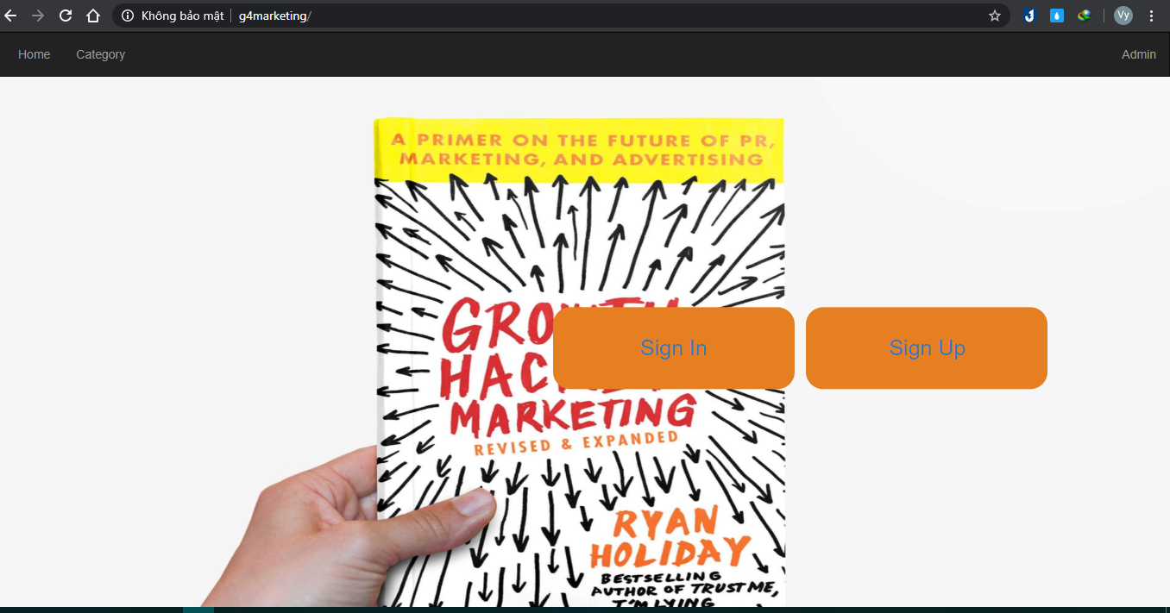

***5.2. Admin login:***

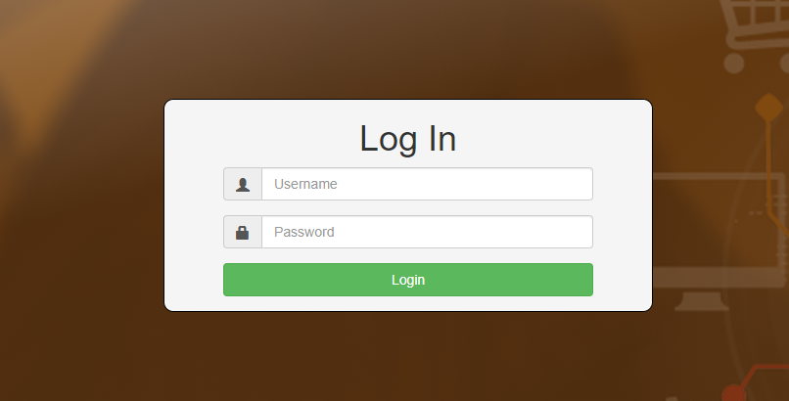

This is the admin login page . Admin need to type the correct username and password to access the website.

***5.3. Category Management:***

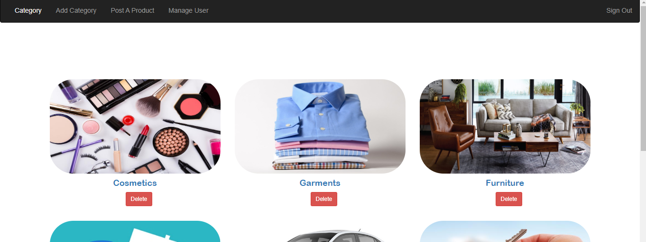

The category management page hows all the category and in this page admin can delete category.

***5.4. Add Category:***

Image 6: Permission Form

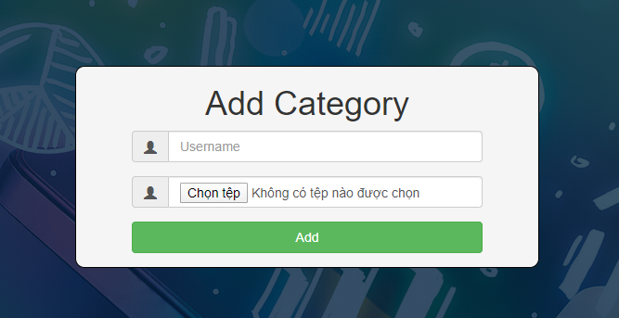

This page allow admin create new category.

***5.5. Add Product:***

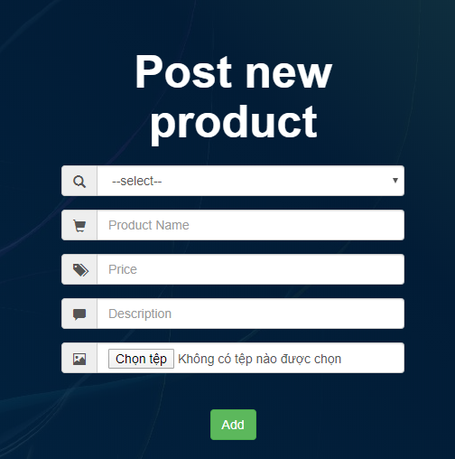

This page allow admin create new product.

***5.6. User Management:***

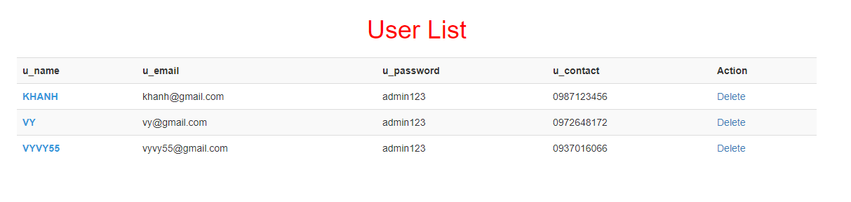

This page shows all the user’s information and admin also can delete user.

***5.7. Sign up account:***

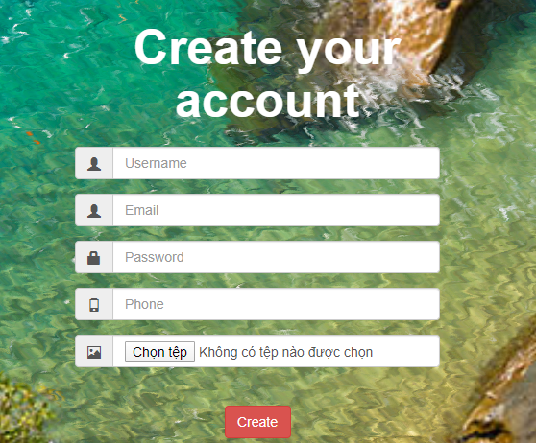

The page allows user create new account to login a website and can be comment or rate for product.

***5.8. User Login:***

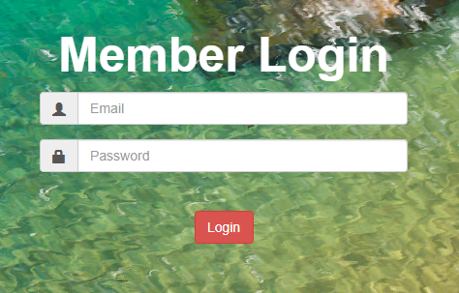

***5.9. Information of product:***

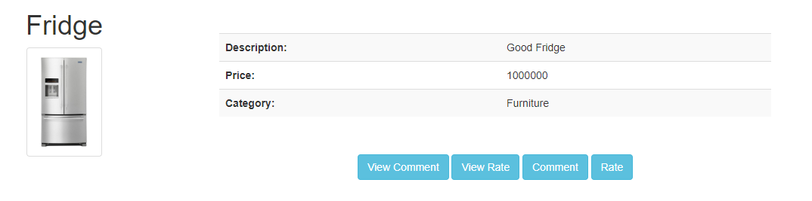

**5.9.1. View Comment:**

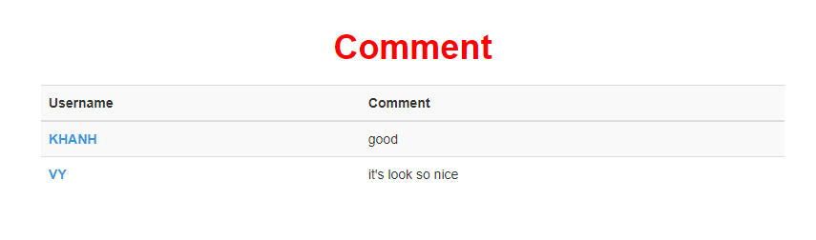

**5.9.2. View Rate:**

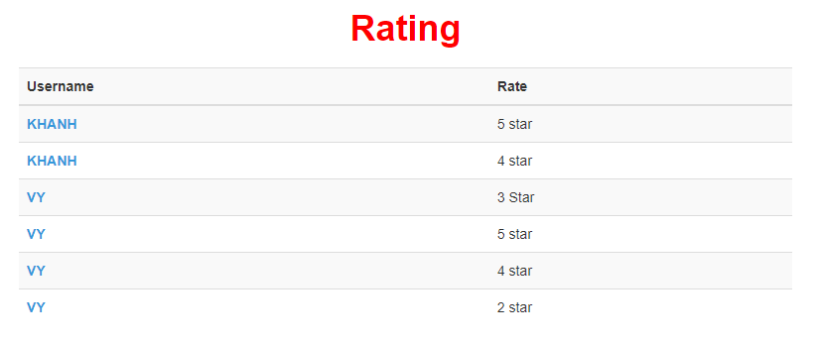

***5.10. Post Comment/Rate of User:***

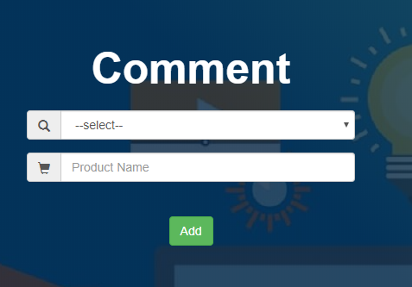 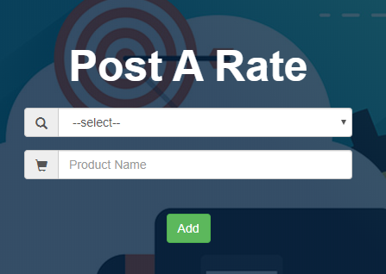

User choose a product after that add a comment for that product

**6. WORK PLAN**

***6.1. Work Assignment:***

|  |  |  |  |  |  |  |  |  |
| --- | --- | --- | --- | --- | --- | --- | --- | --- |
| Build web: Marketing | | | | | | | | |
| No. | Goal | Schedule | | | | Khanh | Ngan | Vy |
| 1 | Understand requirement. | o | o |  |  | 🗸 | 🗸 | 🗸 |
| 2 | Describe the requirements of the project. | o | o |  |  | 🗸 | 🗸 | 🗸 |
| 3 | Use case diagram |  | o | o |  | 🗸 | 🗸 | 🗸 |
| 4 | Make a database | o | o |  |  | 🗸 | 🗸 | 🗸 |
| 5 | User interface design |  | o | o |  | 🗸 |  |  |
| 6 | Class diagram design |  | o | o |  | 🗸 | 🗸 | 🗸 |
| 7 | Program implementation |  | o | o |  | 🗸 | 🗸 | 🗸 |
| 8 | Write function of Admin |  | o | o |  | 🗸 |  | 🗸 |
| 9 | Write function of User |  | o | o |  | 🗸 | 🗸 |  |
| 10 | Pages: Login, Add Category, Add Product |  | o | o |  | 🗸 |  |  |
| 11 | Pages: Manage user, Create new account, View comment and rate |  | o |  | o |  |  | 🗸 |
| 12 | Pages: Add comment, Add rate, View information of product |  | o | o |  |  | 🗸 |  |
| 13 | Testing |  |  |  | o | 🗸 | 🗸 | 🗸 |
| 14 | Report |  |  | o | o | 🗸 | 🗸 | 🗸 |
| Day | | 22/11/2019 | 29/11/2019 | 13/12/2019 | 20/12/2019 |  |  |  |
| Week | | 1 | 2 | 3 | 4 |  |  |  |
| Note | | o – Begin  o - Complete | | | |  |  |  |

**7. CONCLUSION**

***7.1. Result:***

Successfully built the functions we expected, the information updates function.

**7.1.2. The results have not been achieved:**

* The website has some bug in function edit and search.

***7.2. Conclusion:***

Due to limited time to complete the project and not deep professional experience, it is difficult for our topic to avoid professional shortcomings. We look forward to receiving your comments so that our project will be more complete and practical.

We sincerely thank you!

**REFERENCES**

<https://www.youtube.com/>

<https://www.w3schools.com/>

<https://stackoverflow.com/>