HO CHI MINH UNIVERSITY OF TECHNOLOGY

**HO CHI MINH UNIVERSITY OF TECHNOLOGY**

Faculty of Computer Science and Engineering

------------------------



Computer Networks

Report for lab 1

Lecture: Nguyễn Mạnh Thìn

Student name: Đặng Trần Khánh-1852037

**Computer Networks**

**Network Devices**

Student Name: Đặng Trần Khánh

Student No: 1852037

**I. Objectives:**

* Get to know basic network devices
* Understand functions of network devices
* Able to connect different network devices together to form a simple network

**II. Content**

**1. Get to know network devices:**

* Network Interface Card (NIC)
* Cables
* Hub
* Switches
* Routers
* Access Points
* Modems

**2. Understanding functions of network devices**

**a. Network Interface Card (NIC)**

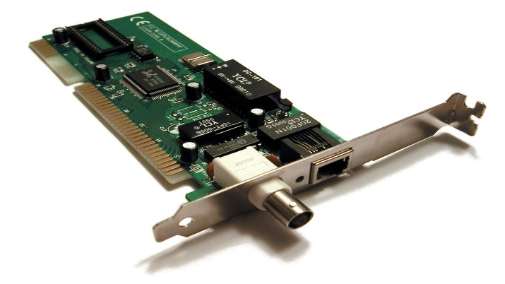

***NIC functions:***

NIC acts as a middle man between the computer and the data network. It takes signals from a network and converts to signals that computer can understand. For instance, when we access a web site, our computer diverts site information to NIC, and from there NIC passes signals to Web server of the site we request. Then the server returns the files, data necessary back to our computer, which the NIC interprets and turns those signals into data to display the result

***Code of NIC processors:***

***Check NIC of a computer, what is its MAC address?***

MAC Address stands for Media Access Control Address. This unique hardware address defines how the NIC is identified to ensure that the data gets to the correct system. Every NIC has a preassigned MAC address associated with it. MAC address (6 bytes) of a computer:

D4-AE-52-C1-6B-BF

***Cable to connect NIC to a network:***

RJ45

***Type:***

Ethernet, Wireless Network

***Standard:***

IEEE 802, which is a family of IEEE standards dealing with local area networks, personal area networks, and metropolitan area networks.

**b. Hubs**

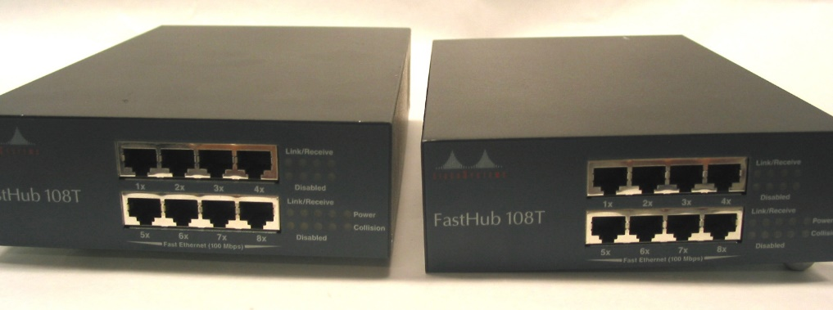

***Roles of hub in a network:***

It acts as a connection point for devices in a network. It is usually implemented in a LAN network. When a data frame arrives at a port, it is broadcast to every other port, without considering whether it is destined for a particular destination or not. Hub can have from 4 up to 64 or more ports, which allows connection to many devices.

***Main characteristics:***

Data that comes from one port are broadcasted across the network to all ports. A hub operates on the physical layer.

***Weaknesses of hub:***

As hub can’t differentiate between devices on the network. If one computer is trying to reach another on a hub-based network, the computer will send the message to every other computer on the network, consuming bandwidth for each transfer. It can place huge traffic on the network and lead to bottleneck issue. Devices in the network are prone to collisions.

Hub are unable to support large networks because hubs send all traffic to all devices on the network. The network is slower if more devices are added.

***Hub ports:*** mainly RJ45, some still comes with Attachment Unit Interface (AUI)

**c. Switches**

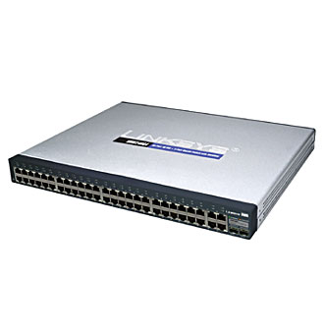 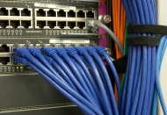

***Roles of switches in a network:***

It connects various devices together on a computer network by using packet switching to receive and forward data to the destination device.

***Main characteristics of switches:***

Switch stores the MAC address of all the devices in the network. When switch receives information from one port, it can specifically navigate to the destination port. Therefore, the response time and traffic of the network can be optimized.

***Differences between hubs and switches:***

Switch is much more efficient than hub in terms of performance. A switch can join multiple computers within one LAN, and a hub just connects multiple Ethernet devices together as a single segment. Unlike hub which can not locate the destination of the port, switch can determine the target of the forwarding data. Collison is prone to occur in hub whereas a full-duplex switch can avoid this issue. Hub operates on the physical layer while switch operates on the data link layer.

***Weakness of switches:***

- They are more expensive compare to network bridges.

- Network connectivity issues are difficult to be traced through the network switch.

- Broadcast traffic may be troublesome.

- If switches are in promiscuous mode, they are vulnerable to security attacks e.g. spoofing IP address or capturing of ethernet frames.

- Proper design and configuration are needed in order to handle multicast packets.

- While limiting broadcasts, they are not as good as routers.

***Switch ports:*** RJ45

**d. Routers**

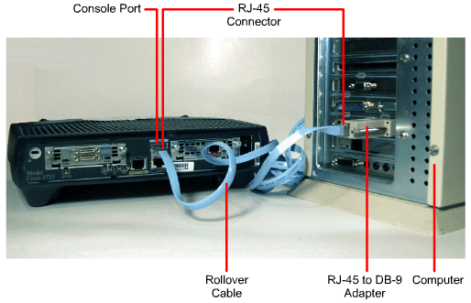

***Roles of routers in a network:***

It is a networking device that is used for receiving, analyzing, and forwarding data packets among the connected computer networks. When a data packet arrives, the router inspects the destination address, consults its routing tables to decide the optimal route and then transfers the packet along this route.

***Main characteristics of routers:***

They forward packets based upon a routing table to many other networks. When doing so, they also provide traffic segmentation, multiple broadcast domains, and define network layer addressing subnets and networks. Those networks are defined by router network adapters or ports to which IP addresses are assigned. Those IP addresses are typically the default gateway to PCs and servers or other networking devices.

***Differences between routers and switches:***

- Router store IP address in the routing table whereas switch store MAC address in a lookup table. Router uses IP address for their operation while switch works with MAC address.

- Routers can work within both wired and wireless network situations. Switch can only work with wired networks.

- In a LAN environment, a switch is faster than Router. By contrast, in network environments (MAN/ WAN), the router works faster.

- Router will offer NAT, NetFlow, and QoS Services while Switch will offer none of these services.

- Routers operate at Layer 3 (Network) of the OSI model whereas Network switches operate at layer two (Data Link Layer) of the OSI model.

***Router ports:***

WAN port: WAN stands for Wide Area Network and this is the network that connects router to the service provider.

LAN port: LAN stands for Local Area Network and is connected to other computers, switches, and routers using an Ethernet cable.

**e. Access Points**

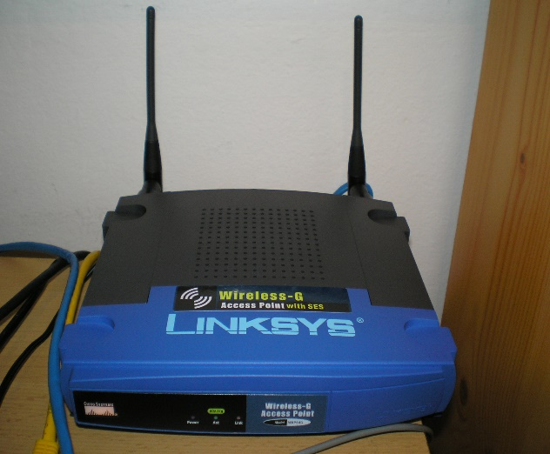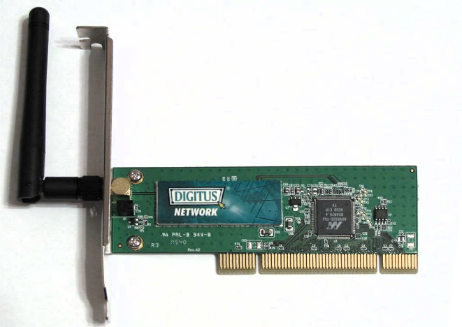

***Roles of access points***:

create a wireless local area network, or WLAN, usually in an office or large building. An access point connects to a wired router, switch, or hub via an Ethernet cable, and broadcasts a Wi-Fi signal to a certain area.

***Main characteristics of access points:***

It can project Wifi signal and handle up to hundreds of device connections at the same time.

***Access point’s interfaces:***

Access points provide wireless connection to existing LAN network. It does not route traffic between different networks, rather provides wireless access to an already existing local wired network.

***Compare access point and other networking devices mentioned above:***

Unlike other networking devices, access point is a sub-device within the local area network that is used for extending the wireless coverage of an existing network and for increasing the number of users that can connect to it. While other networking devices set up LAN network and manage the devices in it.

**f. Modem**

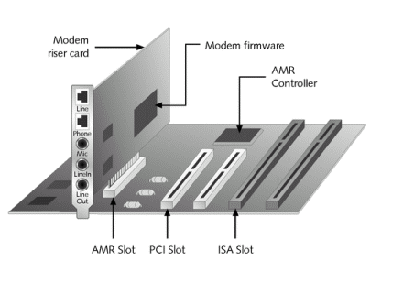 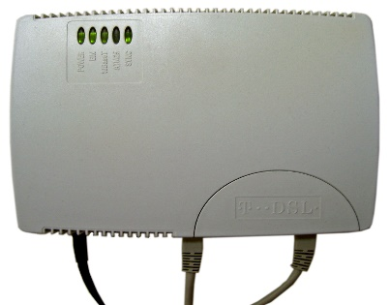 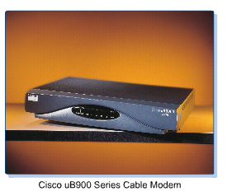

Differentiate:

* Dial-up modem: The dial-up internet connection is an old technology that uses phone line along with a modem. Modem makes a phone call to your ISP. Compared to ADSL and cable, Dial-up is much cheaper but also much slower in speed, thus being suitable only for light-weight works.
* ADSL Modem: This technology works by splitting telephone line into two, such that we can use the phone and the internet at the same time. It is much faster than dial-up connection by providing greater speeds and larger data transfers.
* Cable Modem: Cable internet runs through an underground coaxial cable network. It’s usually faster than DSL and a better option overall.

For each type of modem describe its roles and characteristics:

+ Dial-up modem:

- It is a device that is used to connect computers to the Internet. It connects to the Internet Provider by dialing a telephone number on a conventional telephone line.

- Characteristics: To make the dial-up connection, the modem must connect to an active phone line that is not in use. When connecting, the modem picks up the phone and dials a number that's attached to another computer. The connection usually takes about ten seconds and is accompanied by several beeping sounds.

+ ADSL Modem:

-Asymmetric digital subscriber line (ADSL) is a type of digital subscriber line (DSL), which is used to connect a computer or router to a telephone line which provides the digital subscriber line service for connection to the Internet.

-Characteristic: In ADSL, bandwidth and bit rate are said to be asymmetric, meaning greater toward the customer premises (downstream) than the reverse (upstream). ADSL allows users to download data faster than upload.

+ Cable modem:

- A cable modem is a hardware device that allows computer to communicate with an Internet service provider over a landline connection.

- Characteristics: cable modem dramatically increased the bandwidth between the user's computer and the Internet. It works by connecting to a coaxial cable.

**3. Connecting network devices:**

**Identify the type of network cable can be used for below network connections:**

a) Computer and hub: straight-through cable

b) Computer and switch: straight-through cable

c) Computer and router: straight-through cable

d) Computer hub and hub: cross-over cable

e) Hub and switch: cross-over cable

f) Hub and router: straight-through cable

g) Switch and switch: cross-over cable

h) Switch and router: straight-through cable

k) Router and router: cross-over cable