HO CHI MINH UNIVERSITY OF TECHNOLOGY

**HO CHI MINH UNIVERSITY OF TECHNOLOGY**

Faculty of Computer Science and Engineering

------------------------



Report for lab 1 Wireshark

Lecture: Nguyễn Mạnh Thìn

Student name: Đặng Trần Khánh-1852037

Computer Network

**Question 1.**

Three other packages that appear in the protocol column in the unfiltered packet-listing window in step 7: TCP, MDNS, ARP…

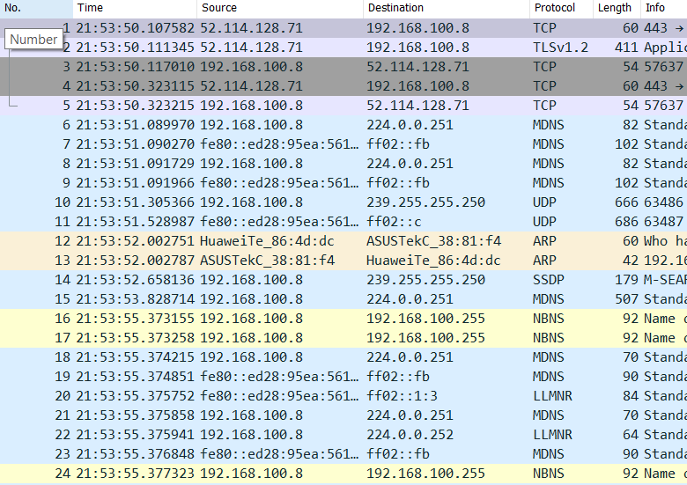

**Question 2.**

After requesting the link http://gaia.cs.umass.edu/wireshark-labs/INTRO-wireshark-file1.html, Wireshark will capture the package HTTP and display it as below:

The second column depicts the time when the GET message is requested until the OK message is received. The time (the unit was time of day) taken was 0.231273 second.

**Question 3.**

The Internet address of the gaia.cs.umass.edu is ***128.119.245.12***

The Internet address of my computer is ***192.168.100.8***

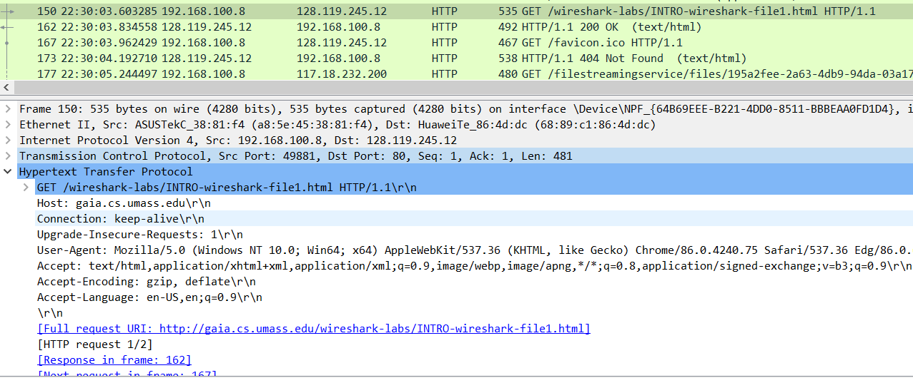We can verify that in the package details windows line number 3:

**Question 4.**

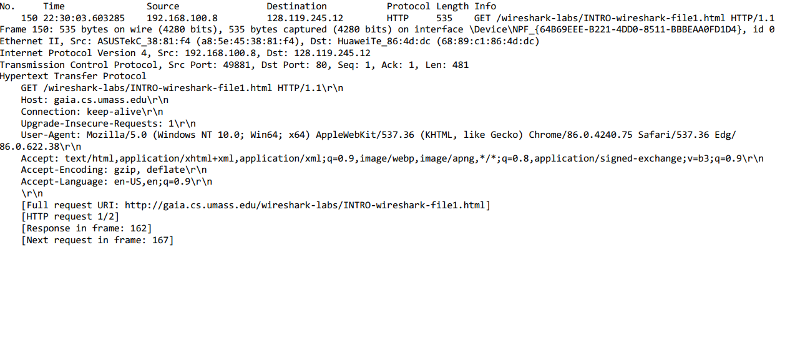The message from the GET:

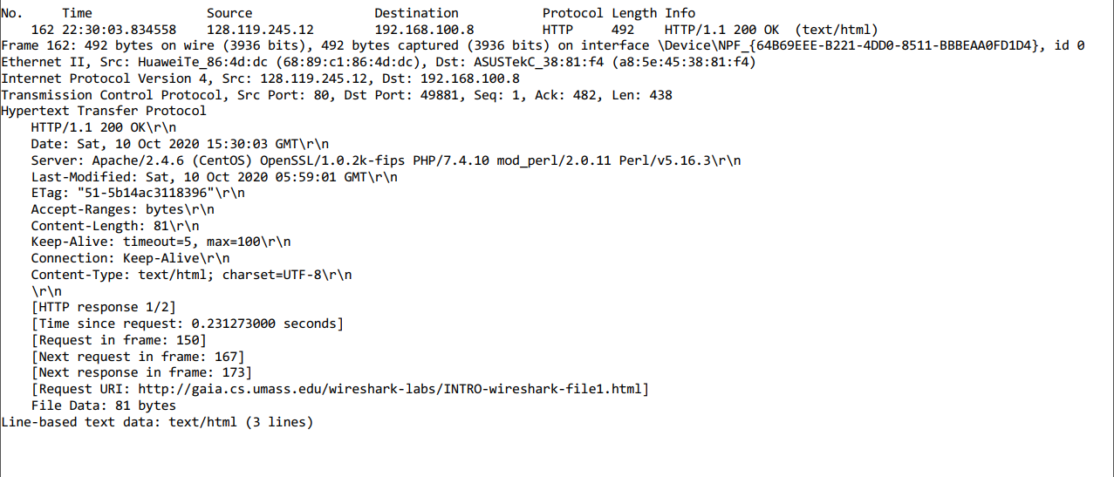The message from the OK: