HO CHI MINH UNIVERSITY OF TECHNOLOGY

**HO CHI MINH UNIVERSITY OF TECHNOLOGY**

Faculty of Computer Science and Engineering

------------------------



Computer Networks

Report for lab 3a

Lecture: Nguyễn Mạnh Thìn

Student name: Đặng Trần Khánh-1852037

**I. A first look at the captured trace**

***1. Select one UDP packet from your trace. From this packet, determine how many fields there are in the UDP header. Name these fields***

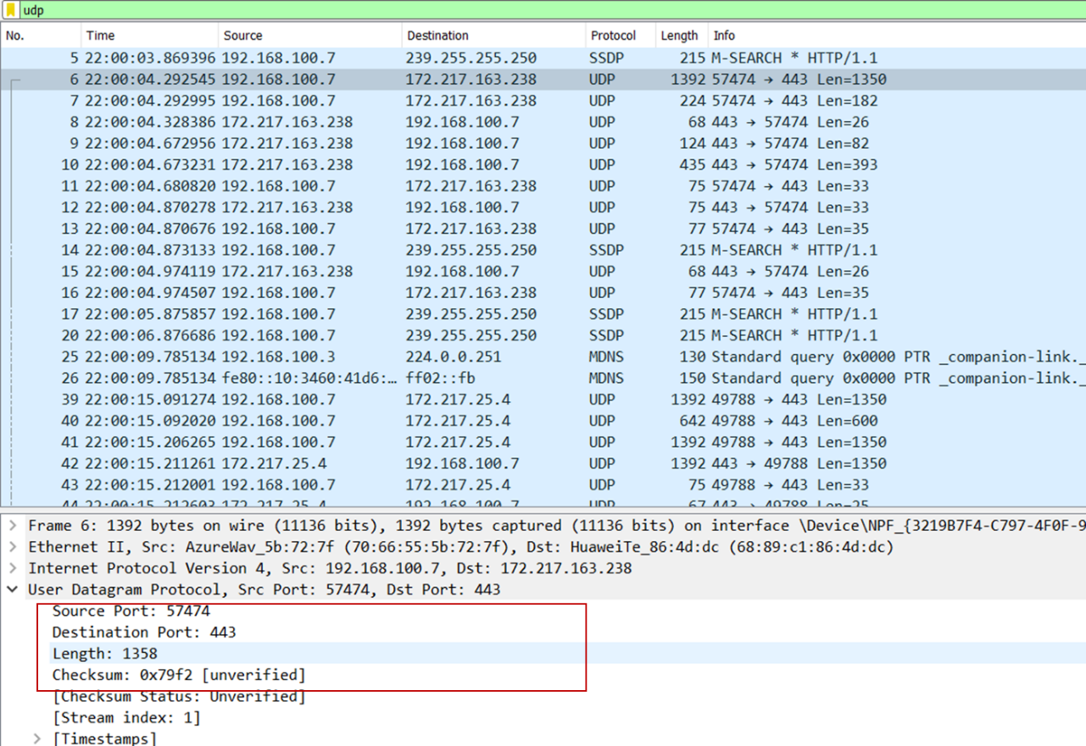Answer: There are 4 fields in the UDP header: Source port, Destination port, Length, Checksum.

***2. By consulting the displayed information in Wireshark’s packet content field for this packet, determine the length (in bytes) of each of the UDP header fields.***

Answer: The length of the UDP packet is 8 bytes (shown in the picture below). The length for each UDP header field is 2 bytes.

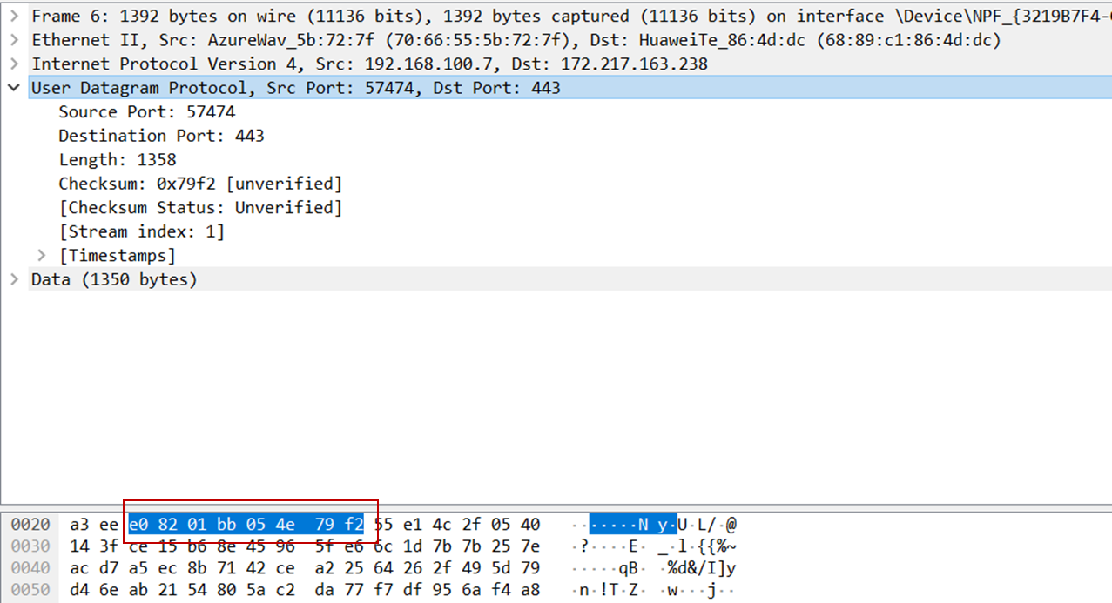

***3. The value in the Length field is the length of what? Verify your claim with your captured UDP packet.***

Answer: The length field specifies the number of bytes in the UDP segment (header plus data). An explicit length value is needed since the size of the data field may differ from one UDP segment to the next. In the example below, the length field value is 34 which consists of 8 bytes of header and 26 bytes of data.

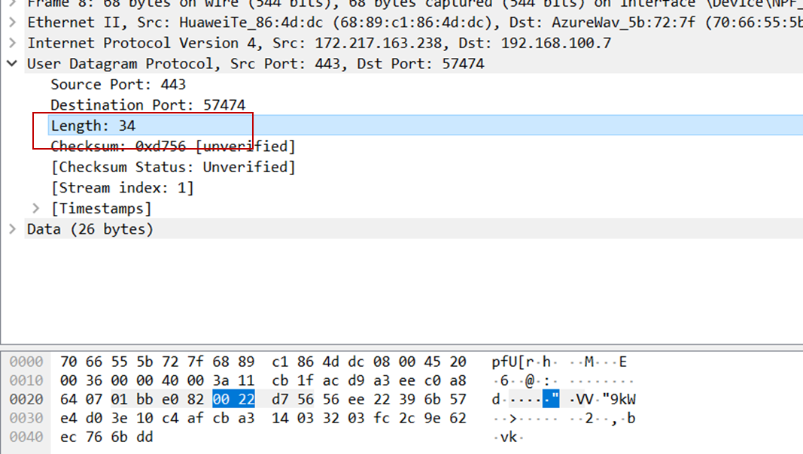

***4. What is*** ***the maximum number of bytes that can be included in a UDP payload?***

Answer: Since the length field is only capable of holding 16 bits (2 bytes). The total maximum bytes of the UDP packet can hold is 216 – 1 = 66535 bytes (minus 1 because bit starts at 0). After that, 8 bytes that counts for the header length are removed to achieve the maximum number of bytes that can be included in a UDP payload: 65535 – 8 = 65527 bytes.

***5. What is the largest possible source port number?***

Answer: Similar to question 4, the Source port can hold up to 16 bits (2 bytes), the largest possible number is 216 – 1 = 66535

***6. What is the protocol number for UDP?***

Answer: The protocol number for UDP is 17, which 11 in hexadecimal (in packet content field)

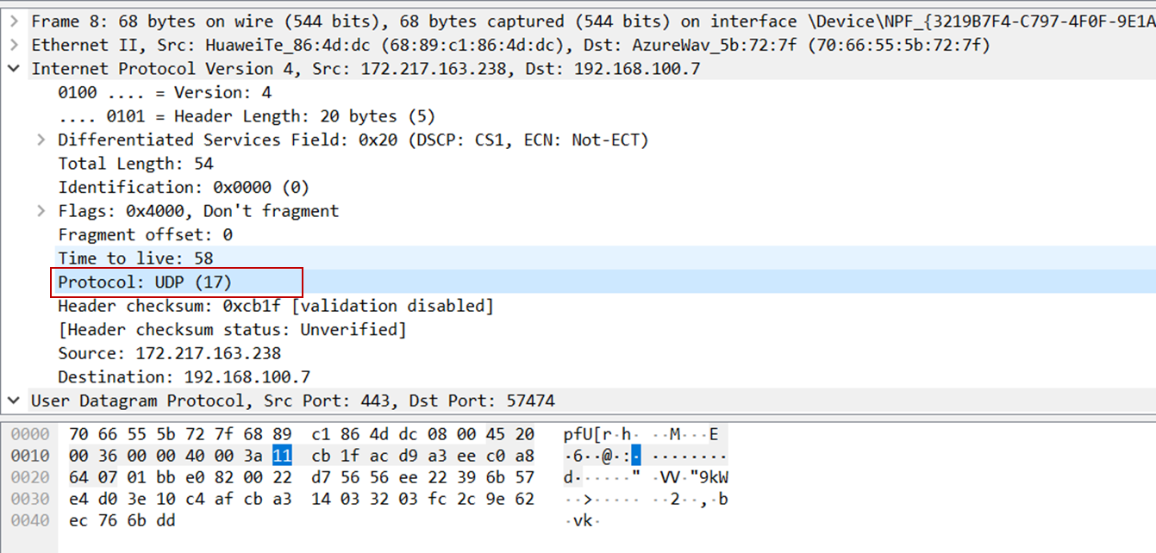

***7. Examine a pair of UDP packets in which your host sends the first UDP packet and the second UDP packet is a reply to this first UDP packet. Describe the relationship between the port numbers in the two packets.***

Answer:

The UDP packet sent by host (image below) shows the source port is 57474, the destination port is 443.

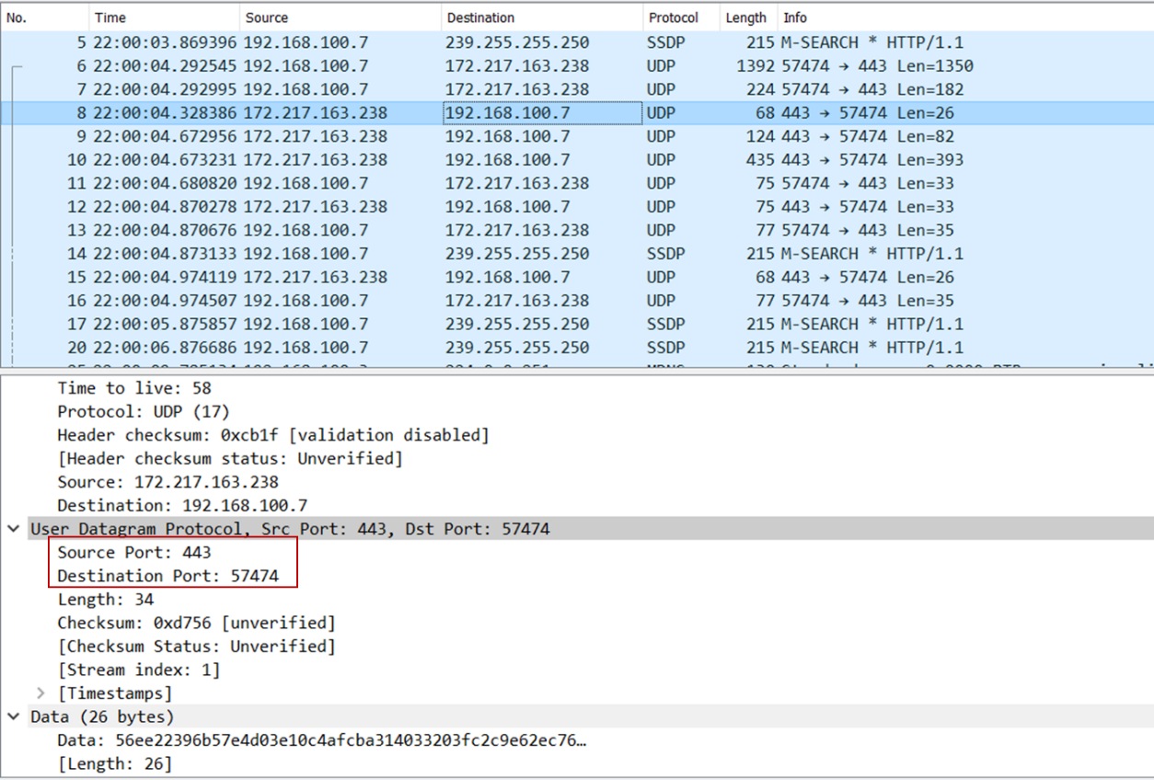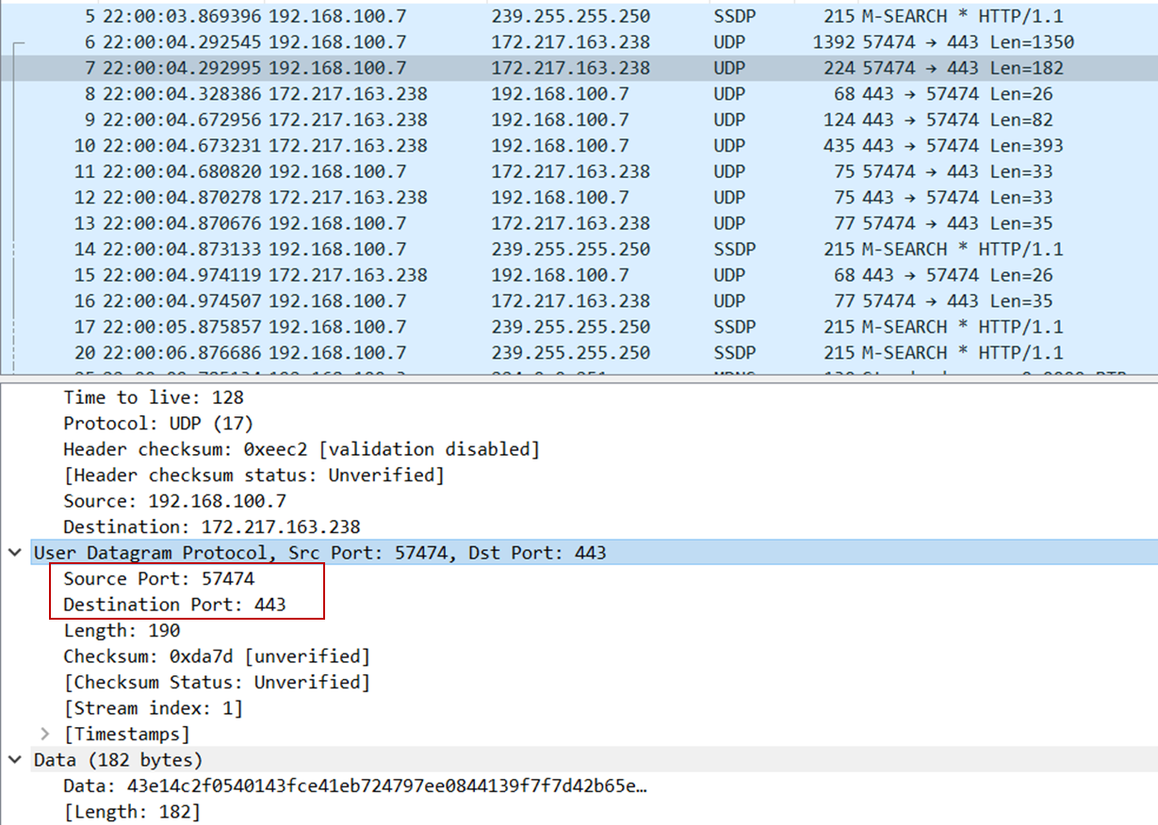The UDP packet received by host (image below) shows the source port is 443, the destination port is 57474. It is clear that the source port of the UDP packet sent by the host is the same as the destination port of the reply packet. Similarly, the destination port of the UDP packet sent by host is the source port for the received packet.