HO CHI MINH UNIVERSITY OF TECHNOLOGY

**HO CHI MINH UNIVERSITY OF TECHNOLOGY**

Faculty of Computer Science and Engineering

------------------------



Computer Networks

Report for lab 8

Lecturer: Nguyễn Mạnh Thìn

Student name: Đặng Trần Khánh-1852037

***1/ For each of the first 8 Ethernet frames, specify the source of the frame (client or***

***server), determine the number of SSL records that are included in the frame, and***

***list the SSL record types that are included in the frame. Draw a timing diagram***

***between client and server, with one arrow for each SSL record?***

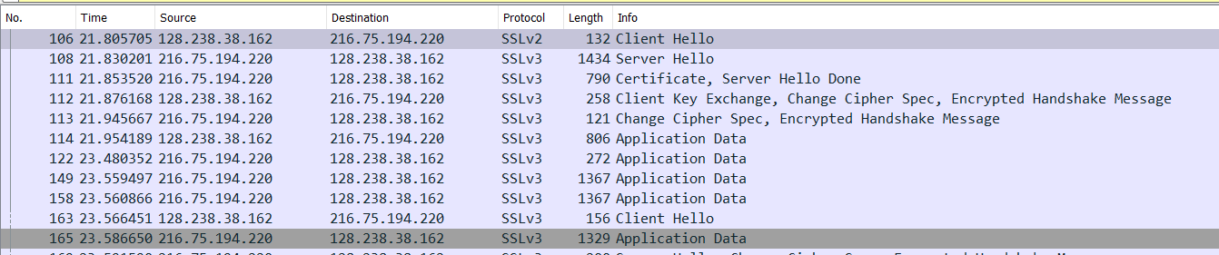Answer:

|  |  |  |  |  |  |
| --- | --- | --- | --- | --- | --- |
| No | Frame | Source | Destination | SSL count | SSL Type |
| 1 | 106 | 128.238.38.162 | 216.75.194.220 | 1 | Client Hello |
| 2 | 108 | 216.75.194.220 | 128.238.38.162 | 1 | Server Hello |
| 3 | 111 | 216.75.194.220 | 128.238.38.162 | 2 | Server Hello Done |
| 4 | 112 | 128.238.38.162 | 216.75.194.220 | 3 | Client Key Exchange |
| 5 | 113 | 216.75.194.220 | 128.238.38.162 | 2 | Change Cipher Spec |
| 6 | 114 | 128.238.38.162 | 216.75.194.220 | 1 | Application Data |
| 7 | 122 | 216.75.194.220 | 128.238.38.162 | 1 | Application Data |
| 8 | 149 | 216.75.194.220 | 128.238.38.162 | 1 | Application Data |

Timing diagram:

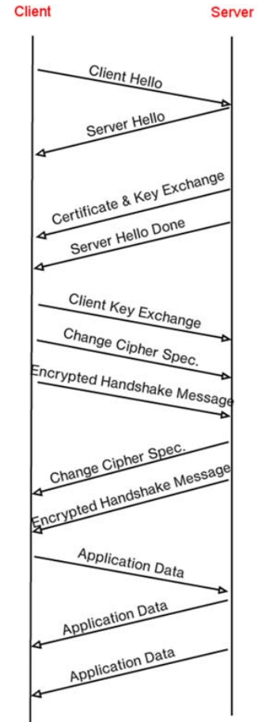

***2/Each of the SSL records begins with the same three fields (with possibly different***

***values). One of these fields is “content type” and has length of one byte. List all***

***three fields and their lengths.***

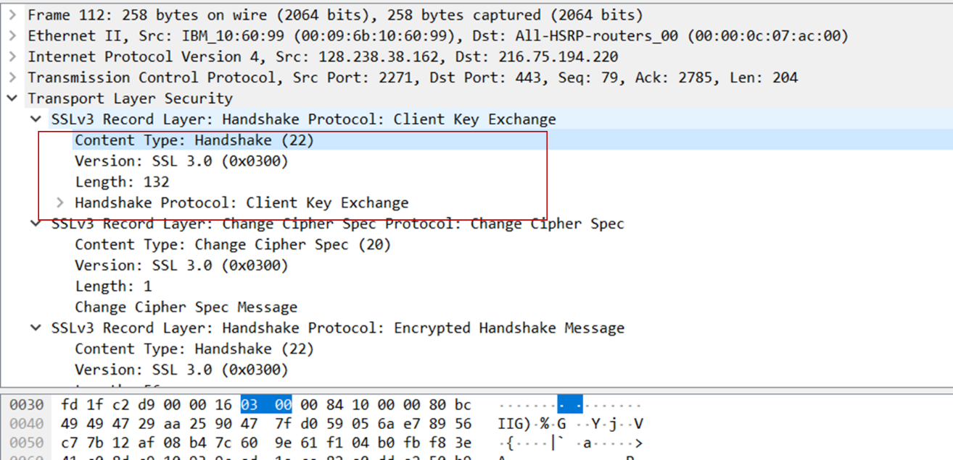Answer: Content Type = 1 byte

Version = 2 bytes

Length = 2 bytes

***3/Expand the ClientHello record. (If your trace contains multiple ClientHello records, expand the frame that contains the first one.) What is the value of the content type?***

Answer:

The content type is 22, for Handshake message type of 01, Client Hello.

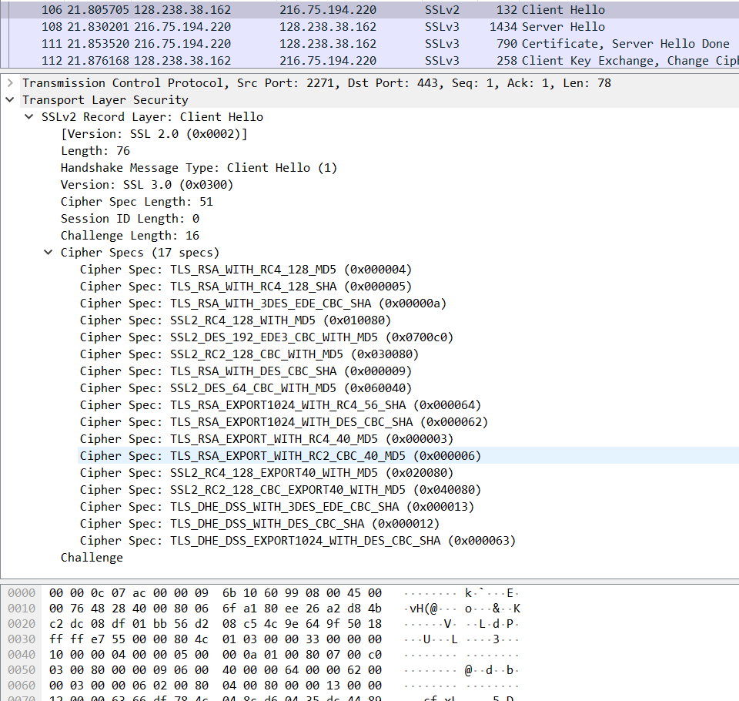

***4/Does the ClientHello record contain a nonce (also known as a “challenge”)? If so, what is the value of the challenge in hexadecimal notation?***

Answer: 66 df 78 4c 04 8c d6 04 35 dc 44 89 89 46 99 09

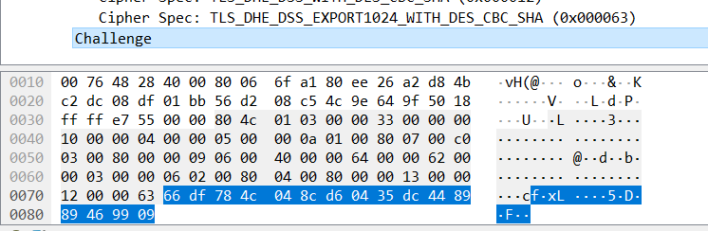

***5/ Does the ClientHello record advertise the cyber suites it supports? If so, in the first listed suite, what are the public-key algorithm, the symmetric-key algorithm, and the hash algorithm?***

Answer:

Public key algorithm: RSA

Symmetric‐key algorithm: RC4

Hash algorithm: MD5

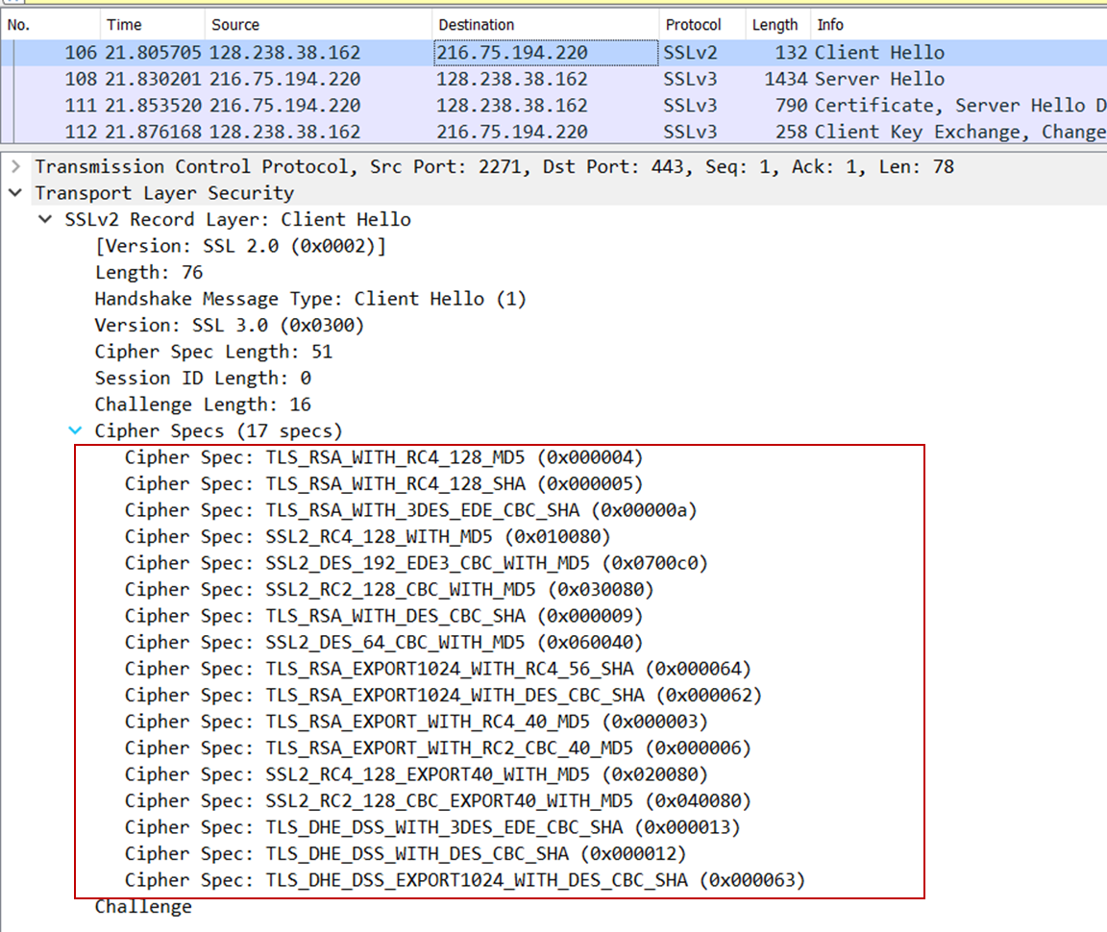

***6/Locate the ServerHello SSL record. Does this record specify a chosen cipher suite? What are the algorithms in the chosen cipher suite?***

Answer:

Public key algorithm: RSA

Symmetric‐key algorithm: RC4

Hash algorithm: MD5

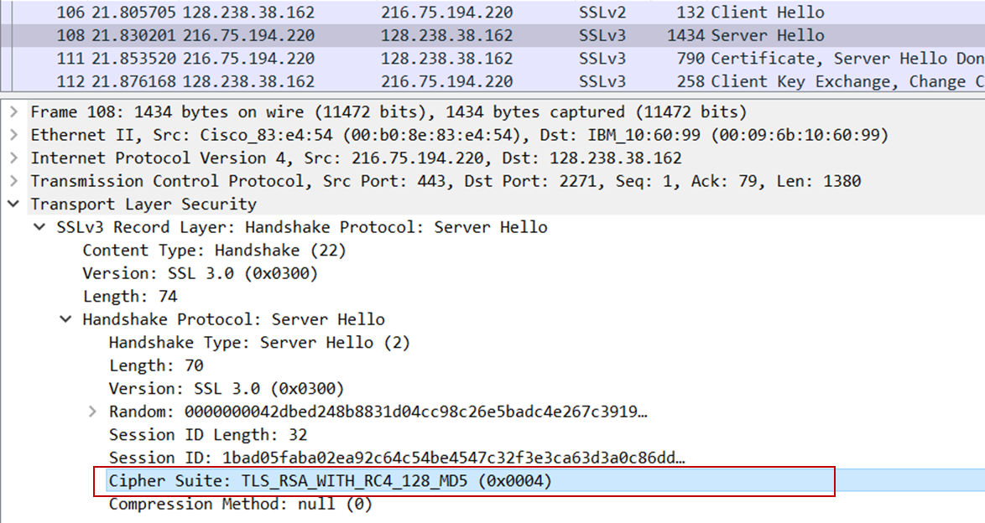

***7/ Does this record include a nonce? If so, how long is it? What is the purpose of the client and server nonces in SSL?***

Answer: Yes, this package does include a nonce under Random field. It is 32 bits long (28bits data + 4 bits time), it is used for attack preventing.

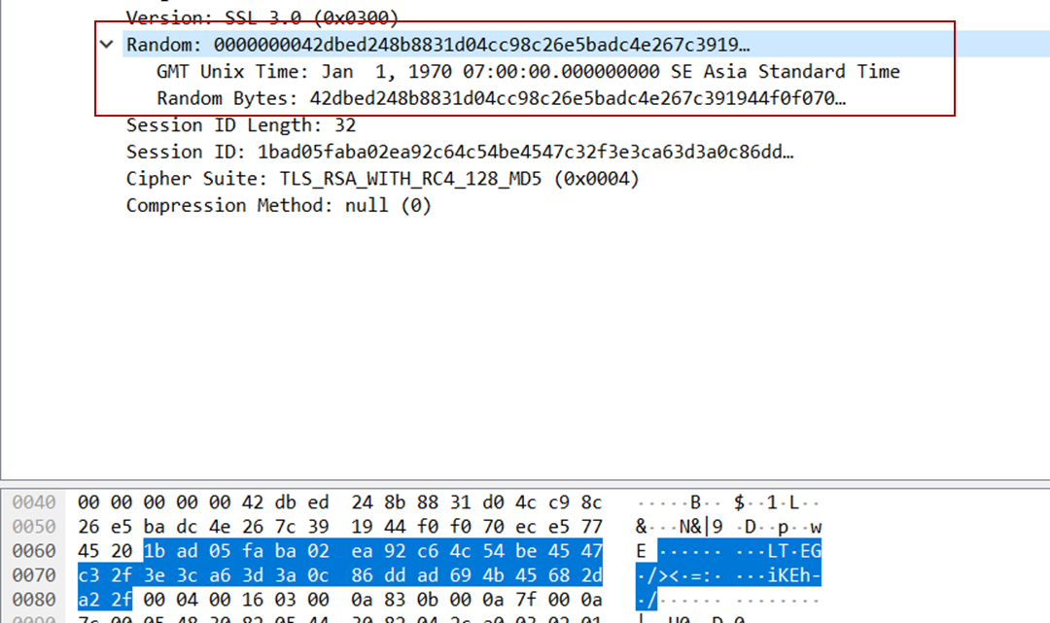

***8/ Does this record include a session ID? What is the purpose of the session ID?***

Answer: This record does include a session ID as described in the picture below. This session is for resume the same session later by using the server provided session ID when it sends the ClientHello.

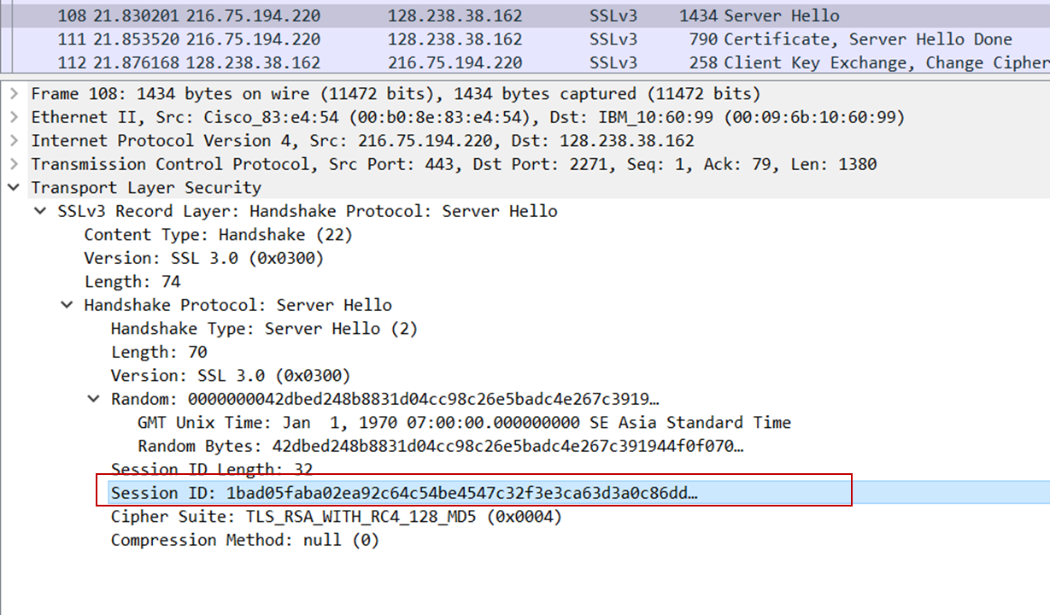

***9/ Does this record contain a certificate, or is the certificate included in a separate***

***record. Does the certificate fit into a single Ethernet frame?***

Answer: No, there is no certificate in this record. The certificate is in the separate record.

The certificate does fit into a single Ethernet frame.

***10/ Locate the client key exchange record. Does this record contain a pre-master secret? What is this secret used for? Is the secret encrypted? If so, how? How long is the encrypted secret?***

Answer: Yes, it does contain a premaster secret. It is used by both the server and client to make a master secret, which is used to generate session keys for MAC and encryption. The secret gets encrypted using the server’s public key, which the client extracted from the certificate sent by the server. The secret is 128 bytes long.

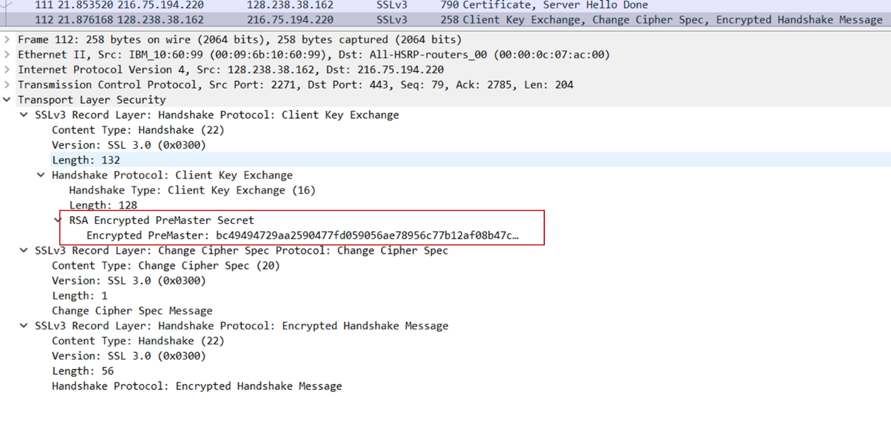

***11/ What is the purpose of the Change Cipher Spec record? How many bytes is the record in your trace?***

Answer: The purpose of the Change Cipher Spec record is to indicate that the contents of the following SSL records sent by the client (data, not header) will be encrypted. This record is 6 bytes long: 5 for the header and 1 for the message segment.

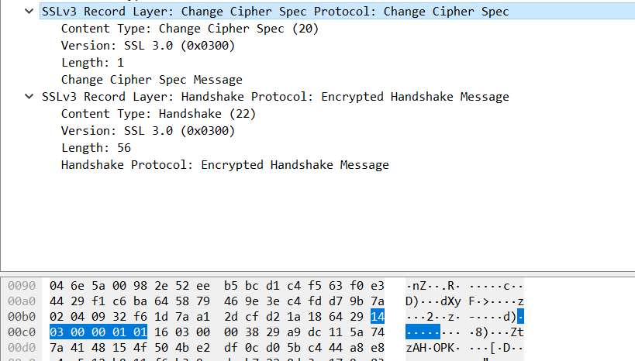

***12/ In the encrypted handshake record, what is being encrypted? How?***

Answer: In the encrypted handshake record, handshake messages and MAC addresses are concatenated and encrypted. They are sent to the server.

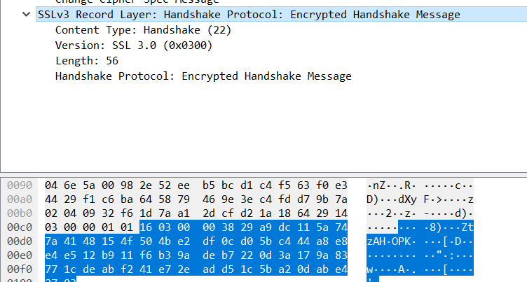

***13/ Does the server also send a change cipher record and an encrypted handshake***

***record to the client? How are those records different from those sent by?***

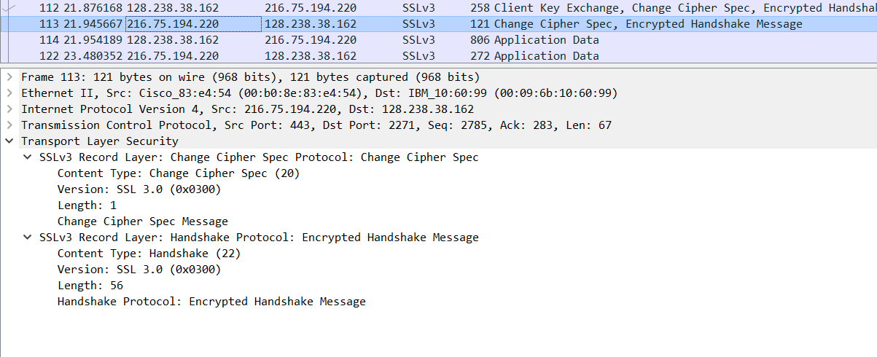Answer: Yes, the server’s encrypted handshake contains all the handshake messages sent from the server. Other contains messages sent from client.

***14/ How is the application data being encrypted? Do the records containing application data include a MAC? Does Wireshark distinguish between the encrypted application data and the MAC***?

Answer: The symmetric encryption algorithm is used to encrypt the application data. Yes, the records containing application data include a MAC.

Wireshark did not distinguish between the encrypted application data and the MAC.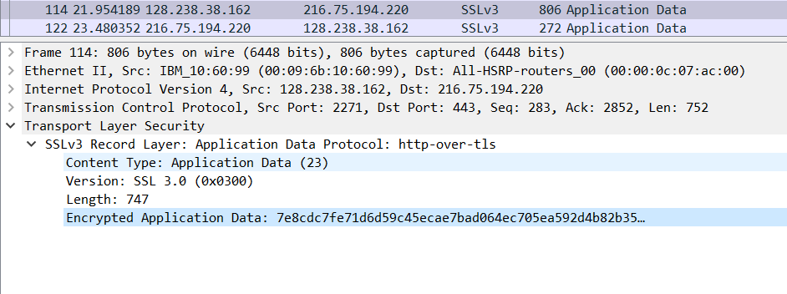

***15/ Comment on and explain anything else that you found interesting in the trace.***

Answer: The version of SSL used changes from SSLv2 in the initial ClientHello message to SSLv3 in all following message exchanges.