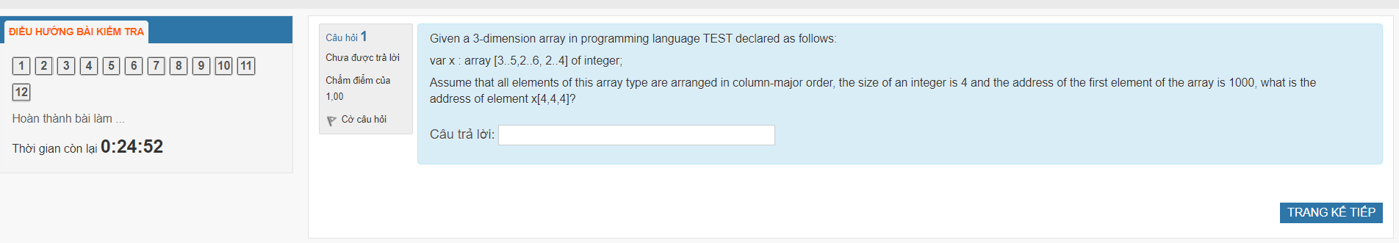

3D array:

width from 3 to 5 (starts at 3) (x-axis) => sizeX = 3, offsetX = 4 – 3 = 1

depth from 2 to 6 (starts at 2) (y-axis) => sizeY = 5, offsetY = 4 – 2 = 2

height from 2 to 4 (starts at 2) (z-axis) => sizeZ = 3, offsetZ = 4 – 2 = 2

addr(x[4,4,4]) = 1000 + 4 * (offsetZ * sizeX * sizeY + offsetY * sizeX + offsetX)

= 1000 + 4 * (2 * 5 * 3 + 2 * 3 + 1) = 1148.

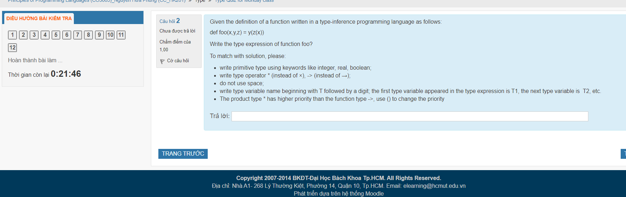

(T1*T2*T3)->(T1->T3)->T2

Which type has mutual exclusive components?

* Record
* Union → correct answer
* Array
* Enum

Floating point number of IEEE-754 but different size of area: 4 for exponent area, 6 for fraction area, Number bit of sign area is 1 if negative and 0 if positive. Write the bit presentation of 5.7?

5 is 101.

0.7 is 101100 (…).

number is approximately 101.101100 in binary.

To scientific notation = 1.01101100*2^2

=> Exponent = 2.

There are four digits in the exponent part, so the offset should be 0111, or 7. Therefore, the bias+exponent sum is 9, or 1001.

Mantissa = 01101100 (take 6 digits).

Sign bit = 0.

=> number is 01001011011

#define MERCURY 0

#define VENUS 1

#define EARTH 2

#define MERCURY 0

Which type should we use ?

* Union
* Set
* Enumerate ← this
* Int

Assume a function prototype in PASCAL:

function foo(x:integer;y:real):char;

what is the type expression?

**(integer*real)->char**

Given a struct in C:

Struct x{

Int a;

Float b ;

Char c;

Float d;

Size of int, float, char are 2,4,1; types: 2,4,1 bytes aligned. Size of above struct ?

**Answer:**

Int a before float b => pad 2.

Char c before float d => pad 3.

Size of fields including in-between padding is 2+2+4+1+3+4=16, which is a multiple of 4 (the size of float, the largest type) => No additional padding needed.

Therefore, the size of the above struct is 16 bytes.

Assume that all integer var of a program language is stored in 1 byte memory. Value of -87?

**Assuming 2’s complement:**

Unsigned 87 in 8 bits: 0101 0111.

Flipped: 1010 1000.

Incremented: 1010 1001 ← Value of -87 in 1-byte memory with 2’s complement.

A set of type stored in bit-chain following with a declaration of 4 set var include integer numbers from 6 to 45 as follows:

Var x = set of 6..45

What is the size of x?

* 3
* 5 ← this in bytes?
* Others
* 40 ← this in bits?

45-6+1 = 40 flag bits or 5 bytes.

Pascal:

Var a,b: string(7)

A:= “toi”

B:= “di an gio” ← f l a g

Write(a+b)

Assume string type implementing as: string length and operator + append 2 string. What is the result of write(a+b)?

**toidi an gio**