Step 1: Create table:
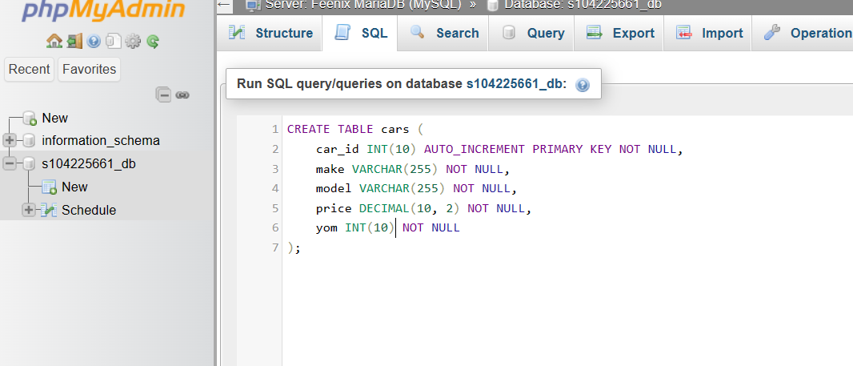
Insert query syntax
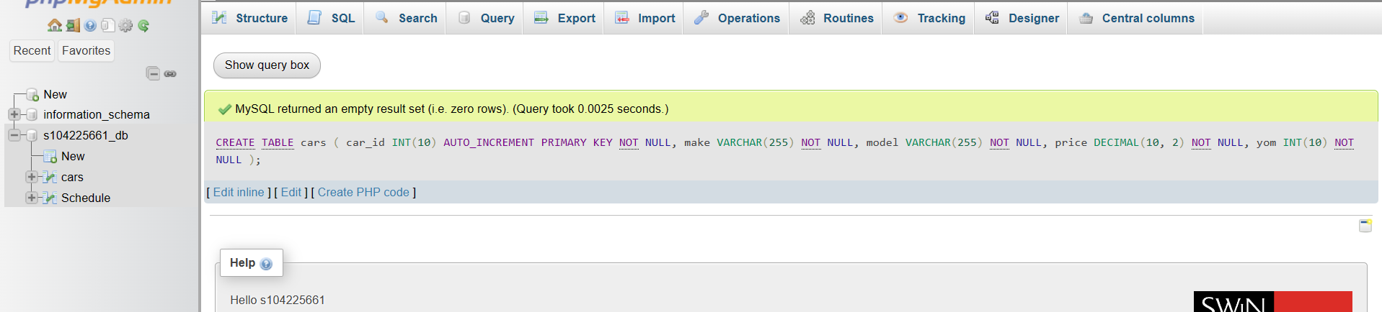
Successfully create table

Step 2: Insert data into table:
INSERT INTO `cars` (`make`, `model`, `price`, `yom`) VALUES
('Holden', 'Astra', 14000.00, 2005),
('BMW', 'X3', 35000.00, 2004),
('Ford', 'Falcon', 39000.00, 2011),
('Toyota', 'Corolla', 20000.00, 2012),
('Holden', 'Commodore', 13500.00, 2005),
('Holden', 'Astra', 8000.00, 2001),
('Holden', 'Commodore', 28000.00, 2009),
('Ford', 'Falcon', 14000.00, 2007),
('Ford', 'Falcon', 7000.00, 2003),
('Ford', 'Laser', 10000.00, 2010),
('Mazda', 'RX-7', 26000.00, 2000),
('Toyota', 'Corolla', 12000.00, 2001),
('Mazda', '3', 14500.00, 2009);

Step 3: Query all records
SELECT * FROM cars
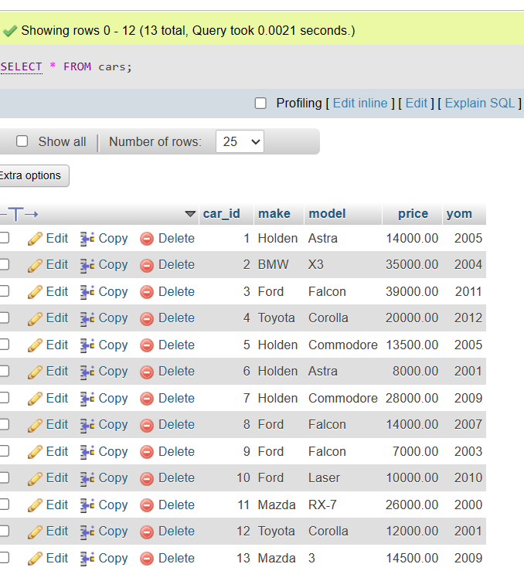
Successfully query

Step 4: Make, model, and price, sorted by make and model
SELECT make, model, price FROM cars ORDER BY make, model;

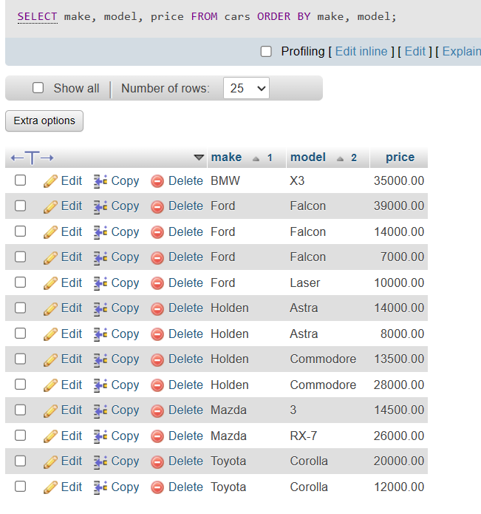
Result order by make, model

Step 5: The make and model of the cars which cost $20,000.00 or more
SELECT make, model FROM cars WHERE price >= 20000.00;
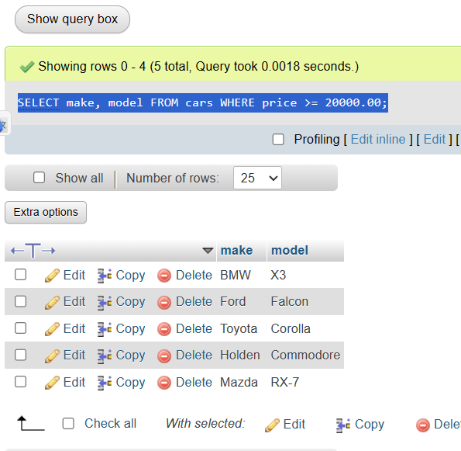
Make and model with price > 20000

Step 6: The make and model of the cars which cost below $15,000.00
SELECT make, model FROM cars WHERE price < 15000.00;
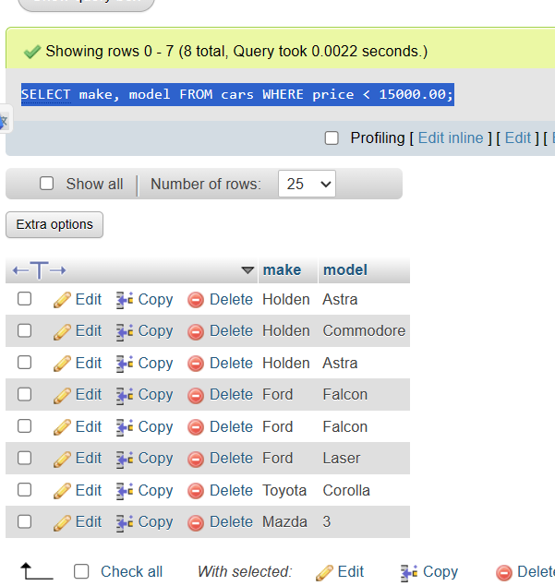

Make and model with price > 20000

Step 7: The average price of cars for similar make
SELECT make, AVG(price) FROM cars GROUP BY make;
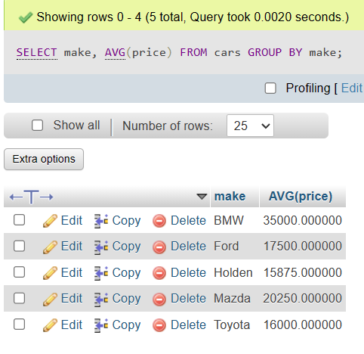
AVG of price

