MCP201 PROJECT REPORT
PROJECT TITLE: DESIGN AND IMPLEMENTATION OF A 4-WHEEL AUTONOMOUS OBSTACLE-AVOIDANCE ROBOT USING STM32 MICROCONTROLLER
Performed by:
Vũ Quang Anh - SE203210
Hoàng Minh Tuấn - SE203362
Phạm Quỳnh Khánh Đoan - SE205286
Nguyễn Anh Thư - SE211061

Class: MCP201

Instructor: Phạm Thế Vinh

Mục lục

CHAPTER 1. PROJECT OVERVIEW 4
1.1. Background and Practical Needs 4
1.2. Project Objectives 4
1.3. Scope and Limitations of the Project 5
CHAPTER 2. THEORETICAL BASIS 5
2.1. STM32 Microcontroller Architecture and HAL Library 5
2.2. Pulse Width Modulation (PWM) Technique and Motor Control 6
2.3. HC-SR04 Ultrasonic Sensor and DWT Counter Application 6
2.4. SG90 Servo Motor 7
2.5. Median Filter Algorithm 7
2.6. Finite State Machine (FSM) Model 7
CHAPTER 3. HARDWARE DESIGN 8
3.1. General System Block Diagram 8
3.2. Schematic Diagram and Peripheral Connections 8
3.3. Power System Design and Wiring Principles 9
CHAPTER 4. SOFTWARE DESIGN AND IMPLEMENTATION RESULTS 10
4.1. Algorithm Flowchart 10
4.2. Main Software Modules 10
4.3. Evaluation and Actual Execution Results 11
4.4. Detailed Source Code 12
4.4.1. Finite State Machine (FSM) Implementation 12
4.4.2. High-Precision Distance Measurement using DWT 13
4.4.3. PWM Motor Control Logic 14
4.4.4. Noise Filtering (Median Filter) 14
CHAPTER 5. CONCLUSION AND FUTURE DEVELOPMENT 15
5.1. Conclusion 15
5.2. Future Development of the Project 16
APPENDIX A: GLOSSARY OF TECHNICAL TERMS 16
A.1. Microcontroller and Programming Terms 16
A.2. Motor Control Terms 17
A.3. Sensor and Measurement Terms 18
A.4. Mechanical and Power System Terms 19
APPENDIX B: FUTURE DEVELOPMENT TERMS 20
REFERENCES 20

CHAPTER 1. PROJECT OVERVIEW

1.1. Background and Practical Needs
In the era of Industry 4.0, automation and mobile robots are playing an increasingly important role in improving productivity and liberating human labor. From Automated Guided Vehicles (AGVs) in smart factories and logistics warehouses to service robots and robotic vacuum cleaners in homes, the ability to move autonomously and perceive the environment is a core element. Among these, the most fundamental and critical problem for any autonomous robot system is the ability to detect and avoid obstacles automatically and safely.
To solve this problem, mastering knowledge about microcontrollers, sensors, and actuators is essential. The MCP201 course provides a solid foundation in STM32 microcontrollers. Aiming to apply the acquired knowledge to practice, our group decided to choose the topic "Design and Implementation of a 4-wheel Autonomous Obstacle-Avoidance Robot Using STM32 Microcontroller". This project not only reinforces theories on embedded programming and sensor signal processing but also trains skills in hardware design, solving electromagnetic interference issues, and optimizing real-time control algorithms.

1.2. Project Objectives
The project is carried out with the following specific objectives:
- - Hardware objectives:
+ Successfully assemble a 4-wheel car model with a sturdy chassis.
+ Integrate an STM32 microcontroller (Nucleo/Blue Pill) as the central brain.
+ Use an L298N motor driver module to drive 4 DC motors.
+ Equip an HC-SR04 ultrasonic sensor mounted on an SG90 servo to expand the obstacle scanning angle to 180 degrees.
+ Design a stable power supply system, isolating the power source and the control source to prevent interference.
- - Software and algorithmic objectives:
+ Program and configure STM32 peripherals (GPIO, Timer, PWM) using the HAL library.
+ Build an accurate distance measurement algorithm from the ultrasonic sensor using the DWT cycle counter, avoiding the use of system-blocking delay functions.
+ Apply a Median Filter algorithm to improve the reliability of sensor data.
+ Design the program according to the Finite State Machine (FSM) architecture so that the robot has multitasking capabilities and responds quickly to environmental changes.
+ Optimize the decision-making algorithm: Upon encountering an obstacle, the robot automatically stops, scans both sides to find the widest path, and executes a safe turn.

1.3. Scope and Limitations of the Project
Due to limitations in time, budget, as well as knowledge within the framework of a course, the project is limited to the following scopes:
- The robot mainly operates on flat surfaces, in indoor environments.
- The recognition capability is limited to static obstacles large enough to reflect ultrasonic waves.
- Complex trajectory control algorithms such as PID combined with Encoders for absolute straight movement have not been applied.
- Hardware issues with the DFPlayer Mini audio module prevented the integration of the warning sound function in the current version; the group focused entirely on the core movement and obstacle avoidance functions.

CHAPTER 2. THEORETICAL BASIS

2.1. STM32 Microcontroller Architecture and HAL Library
The STM32 microcontroller (specifically the F103 series like Blue Pill or Nucleo-F401RE/F411RE used in the course) belongs to the family of high-performance 32-bit microcontrollers based on the ARM Cortex-M core. The Cortex-M architecture provides powerful computing capabilities, energy efficiency, and supports an excellent Nested Vectored Interrupt Controller (NVIC), which is highly suitable for real-time applications such as robot control.
To accelerate development speed and code portability, the project utilizes the STM32Cube HAL (Hardware Abstraction Layer) library. Unlike bare-metal register-level programming, HAL provides high-level APIs (e.g., HAL_GPIO_WritePin, HAL_TIM_PWM_Start), enabling programmers to interact with hardware intuitively and facilitating easy maintenance[1], [2], [3].

2.2. Pulse Width Modulation (PWM) Technique and Motor Control
The DC motors on the robot cannot be speed-controlled simply by turning the DC power on/off. The most optimal method is using PWM (Pulse Width Modulation). By changing the ratio of time the signal is at a high voltage level (Duty Cycle) within a fixed period, we can change the average voltage supplied to the motor, thereby controlling its rotational speed.
In this project, PWM signals are generated from STM32 Timers (e.g., TIM1) and supplied to the L298N H-bridge circuit. The L298N acts as a power amplifier circuit, allowing a large current to pass through the motors based on a small control current signal from the microcontroller. Additionally, the L298N allows reversing the current direction (via pins IN1, IN2, IN3, IN4) to control the robot to move forward, backward, or turn.

2.3. HC-SR04 Ultrasonic Sensor and DWT Counter Application
The HC-SR04 is a popular distance measurement sensor that operates based on the principle of sound wave reflection. The measurement process is as follows:
1. The microcontroller supplies a HIGH pulse lasting a minimum of 10µs to the TRIG pin.
2. The sensor emits a series of 8 ultrasonic pulses at a frequency of 40kHz.
3. The ECHO pin of the sensor is pulled HIGH and holds this state until a reflected wave is received.
The time the ECHO pin remains HIGH is exactly the time the ultrasonic wave travels from the sensor to the obstacle and reflects back. The distance (d) is calculated using the formula: d = (v * t) / 2, where v is the speed of sound in the air (approximately 343 m/s or 0.0343 cm/µs).
A major challenge in distance measurement programming is measuring the ECHO pulse time (in microseconds) accurately. Using iterative delay functions (like HAL_Delay) is not only inaccurate but also wastes CPU resources. The group applied the technique of using the DWT (Data Watchpoint and Trace) counter built into the Cortex-M core. DWT_CYCCNT is a 32-bit register that automatically increments every system clock cycle, allowing execution time measurement with nanosecond resolution without needing to configure any additional peripheral Timers[4].

2.4. SG90 Servo Motor
The RC Servo SG90 motor is used as a rotating mount for the ultrasonic sensor, giving the robot the ability to "look" to both sides. The servo is controlled by a PWM signal with a fixed frequency of 50Hz (20ms period). The rotation angle of the Servo shaft (from 0 to 180 degrees) is determined by the width of the HIGH pulse (Duty cycle), usually ranging from 1ms (0 degrees) to 2ms (180 degrees).

2.5. Median Filter Algorithm
In real-world environments, data from ultrasonic sensors is often noisy due to multiple sound reflections, wave absorption, or non-perpendicular incidence angles. This leads to sudden erroneous measurement values (e.g., reading 30cm and suddenly jumping to 400cm or dropping to 0cm).
To overcome this, the group applies a median filter algorithm. Specifically, instead of trusting a single measurement value, the system will perform 3 consecutive measurements, store them in an array, sort that array, and take the value in the middle (the median). This method is extremely effective in eliminating sudden impulse noise, ensuring the robot moves stably without erroneous processing phases.

2.6. Finite State Machine (FSM) Model
To control the complex operational flow of the robot (running, measuring distance, and deciding direction simultaneously) without "hanging" the microcontroller, the program is structured according to the FSM model. Instead of executing code sequentially from top to bottom, FSM divides the robot's operations into discrete states (e.g., FORWARD, SCAN_LEFT, TURN_RIGHT...). The microcontroller will continuously check conditions (like distance < 25cm) to decide whether to remain in the current state or transition to a new state.

CHAPTER 3. HARDWARE DESIGN

3.1. General System Block Diagram
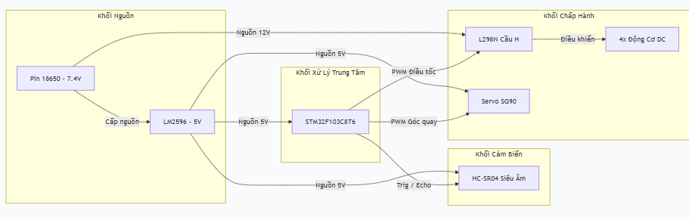

3.2. Schematic Diagram and Peripheral Connections
The tight and accurate connection between the microcontroller and peripherals is a decisive factor for hardware success. Below is the detailed pinout allocation table of the system:
Table 3.1: Detailed Signal Pin Connections
Functional Block | Communication Pin | STM32 Pin | STM32CubeMX Configuration
L298N Motor Driver | ENA (Left wheel speed PWM) | PA8 | TIM1_CH1 (PWM Generation)
L298N Motor Driver | ENB (Right wheel speed PWM) | PA9 | TIM1_CH2 (PWM Generation)
L298N Motor Driver | IN1, IN2 (Left wheel rotation direction) | PA4, PA5 | GPIO_Output
L298N Motor Driver | IN3, IN4 (Right wheel rotation direction) | PB0, PB1 | GPIO_Output
HC-SR04 Sensor | TRIG (Trigger pulse emission) | PB6 | GPIO_Output
HC-SR04 Sensor | ECHO (Read reflected pulse) | PB7 | GPIO_Input (No Pull)
SG90 Servo | PWM signal for rotation angle control | PA1 | TIM2_CH2 (PWM Generation, 50Hz)
DFPlayer Mini (Hardware error) | TX / RX | PA2 / PA3 | USART2 (Disabled in code)

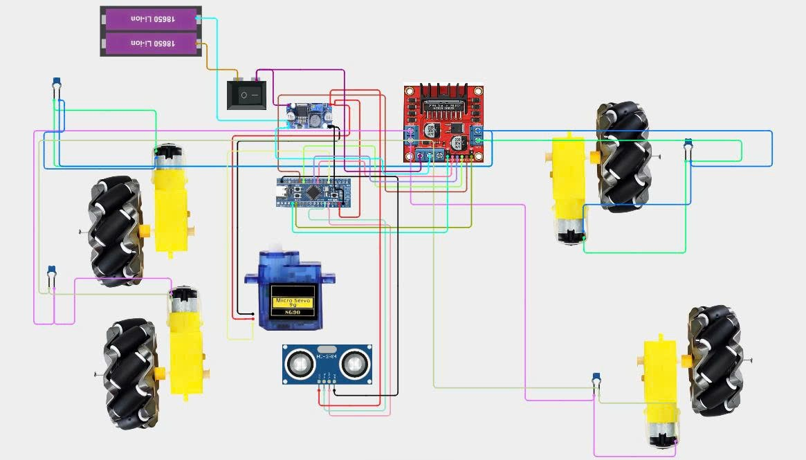[1], [3]

3.3. Power System Design and Wiring Principles
Power is the "heart" of the robot. Voltage drops during motor startup can cause noise, misalign sensors, or cause the microcontroller to reset continuously. To overcome this, the power system is designed in isolation:
1. Power Source (Power): 2 series-connected 18650 battery cells provide a nominal voltage of about 7.4V - 8.4V. This power is supplied directly to the 12V input of the L298N module to provide a large current for the 4 DC gear motors.
2. Control Source (Logic): In parallel with the L298N, power from the battery is passed through an LM2596 switching step-down module (Buck Converter). The LM2596 circuit is fine-tuned via a potentiometer to output an accurate 5.0V voltage. This 5V source is then supplied to the STM32 microcontroller (5V or VIN pin), ultrasonic sensor, and Servo motor.
3. Common Ground: A critically important principle in mixed hardware design. The GND pins of the L298N circuit, LM2596, sensor, Servo, and STM32 must be connected together. This ensures that all control signal levels (PWM, HIGH/LOW) refer to the same 0V voltage level, avoiding logic level drift that causes interference.
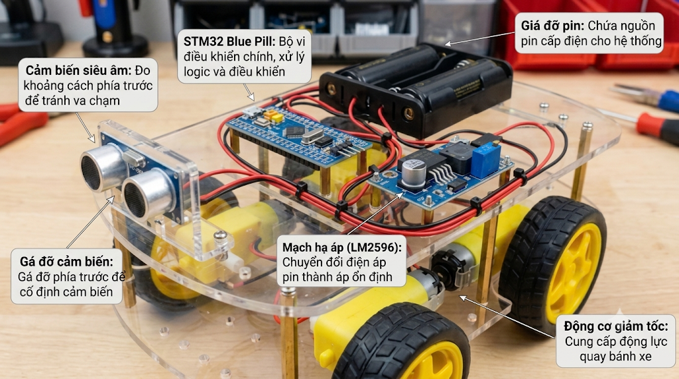[1], [3]

CHAPTER 4. SOFTWARE DESIGN AND IMPLEMENTATION RESULTS

4.1. Algorithm Flowchart
The control program is tightly designed according to the State Machine approach, ensuring continuity and fast response capabilities. The flowchart below describes the core operational logic of the `robot_loop()` loop:
[Requirement: INSERT FSM ALGORITHM FLOWCHART HERE. The flowchart must show the blocks: Start -> FORWARD state -> Check distance -> If < 25cm -> Switch to STOP state -> Switch to SCAN_LEFT -> SCAN_RIGHT -> Compare distance -> Decide TURN_LEFT/RIGHT -> Return to FORWARD]

4.2. Main Software Modules
The source code is structured into specialized functional modules:
- System Initialization (robot_hw_start & robot_init): Activates PWM channels of Timer 1 (L298N), Timer 2 (Servo), enables DWT counter. Moves Servo to the straight angle (90 degrees) and fills the distance buffer.
- Motor Control Module (setLeftMotor, setRightMotor): Receives speed values (from -255 to 255). Depending on the sign of the speed, it sets the IN1-IN4 pins (forward/backward) and loads the absolute value into the CCR register for PWM pulse width modulation.
- Ultrasonic and DWT Module (readDistanceCM): Executes the TRIG pulse triggering process and counts ECHO pulse time using `DWT->CYCCNT`. The function is protected by a timeout mechanism (5000µs wait and 12000µs read) to ensure the program doesn't get stuck in an infinite `while` loop if the sensor fails or the obstacle is too far.
- Noise Filtering Module (median3 & getDistanceNonBlocking): Collects 3 distance samples, calls the median filter function, and updates the result. The `getDistanceNonBlocking` function ensures sensor reading is only performed at a certain interval (MEASURE_INTERVAL = 50ms) to avoid overloading the CPU.
- State Machine Block (robot_loop): The heart of the program, continuously evaluating distances to switch back and forth between 8 states: ST_FORWARD, ST_OBSTACLE_SLOW, ST_STOPPED, ST_SCAN_LEFT, ST_SCAN_RIGHT, ST_DECIDE, ST_TURNING, ST_REVERSING[2], [4], [5].

4.3. Evaluation and Actual Execution Results
The system was tested under various environmental conditions. Below are the recorded results:
1. Sensor Accuracy: The distance data measured from the ultrasonic function (observed via the `dbg_dist` variable in STM32CubeIDE's Live Expressions mode) yielded highly stable results. The error margin at distances of 10cm - 100cm was only about ±1cm. The median filter worked effectively, eliminating sudden noise pulses when the robot moved over uneven surfaces.
2. Motor Control Response: PWM modulation at 1kHz frequency helped the motors run smoothly. The robot was able to decelerate smoothly when entering the warning zone (60cm) and completely stop quickly upon reaching the danger threshold (25cm) without drifting due to inertia.
3. Dead-end Handling: The algorithm for handling special situations (stuck in a narrow corner) worked well. When the `blockedCount` counter exceeded the threshold, the robot recognized a situation where normal turning was impossible and automatically activated the reversing process and a 180-degree turnaround.
4. Unexpected Issues: The DFPlayer Mini audio module suffered a hardware failure during integration. However, the flexible software architecture allowed disabling related function calls without breaking the overall system structure.
Table 4.2: Operational Scenario Testing Table
Test Scenario (Test Case) | Distance in front | Expected behavior | Actual result
Straight path, no obstacles | > 60 cm | Move straight at high speed | Passed
Obstacle appears in the distance | 25 cm - 60 cm | Gradually reduce speed (enter warning zone) | Passed
Obstacle right in front | < 25 cm | Stop immediately, switch to Servo scanning | Passed
Left is clear, right is blocked | Left > 25cm, Right < 25cm | Turn left, then continue straight | Passed
Blocked in all 3 directions (Narrow corner) | Front, Left, Right all < 25cm | Execute reversing motion and turnaround | Passed

4.4. Detailed Source Code

4.4.1. Finite State Machine (FSM) Implementation
Instead of using blocking delays (HAL_Delay), the robot operates using an FSM. The setState function acts as the central controller to transition between states, triggering specific motor and sensor actions.
/* Centralized State Transition */
static void setState(RobotState next) {
RobotState old = currentState;
if (next == old) return; // Prevent redundant state entry

currentState = next;
stateTimer = HAL_GetTick(); // Reset timer for the new state

switch (next) {
case ST_FORWARD:
obstacleAlertSent = false;
servoWrite(90); // Reset Servo to center
break;
case ST_STOPPED: stopMotors(); // Immediately stop to avoid collision
break;
case ST_SCAN_LEFT: stopMotors();
servoWrite(150); // Turn Servo left to measure
break; // ... (other states)
}
}

Analysis: This approach allows the CPU to remain responsive. When the robot enters the ST_STOPPED state, the motors stop immediately, but the CPU continues running the main loop to process the next state (e.g., ST_SCAN_LEFT) based on the elapsed time.

4.4.2. High-Precision Distance Measurement using DWT
Using standard hardware timers for microsecond delays can cause conflicts with PWM timers. Therefore, the Data Watchpoint and Trace (DWT) cycle counter is utilized to achieve nanosecond-level accuracy without consuming hardware peripherals.
/* Microsecond delay using DWT cycle counter */
static void delay_us(uint32_t us) {
uint32_t ticks = us * (SystemCoreClock / 1000000U);
uint32_t start = DWT->CYCCNT;
while ((DWT->CYCCNT - start) < ticks) { }
}

static float readDistanceCM(void) {
// ... (Trigger pulse generation)

// Measure ECHO pin HIGH duration with Timeout
uint32_t start = DWT->CYCCNT;
uint32_t timeout_cycles = (uint32_t)ECHO_TIMEOUT_US * (SystemCoreClock / 1000000U);
while (HAL_GPIO_ReadPin(ECHO_PORT, ECHO_PIN) == GPIO_PIN_SET) {
if ((DWT->CYCCNT - start) > timeout_cycles) {
return 999.0f; // Return max distance on timeout
}
}
uint32_t dur = (DWT->CYCCNT - start) / (SystemCoreClock / 1000000U);
return ((float)dur * 0.0343f) / 2.0f; // Convert to cm
}
Analysis: The timeout_cycles mechanism is a critical safety feature. If the ultrasonic wave is lost (e.g., hitting a soft obstacle), the while loop will not hang indefinitely, preventing the entire robot from freezing.

4.4.3. PWM Motor Control Logic
The L298N requires both direction control (IN1, IN2) and speed control (ENA). The setLeftMotor function handles both positive (forward) and negative (backward) speed values.
/* Motor Control with direction and PWM speed */
static void setLeftMotor(int speed) {
if (speed >= 0) { // Forward
HAL_GPIO_WritePin(IN1_PORT, IN1_PIN, GPIO_PIN_SET);
HAL_GPIO_WritePin(IN2_PORT, IN2_PIN, GPIO_PIN_RESET);
} else { // Backward
HAL_GPIO_WritePin(IN1_PORT, IN1_PIN, GPIO_PIN_RESET);
HAL_GPIO_WritePin(IN2_PORT, IN2_PIN, GPIO_PIN_SET);
speed = -speed; // Make speed absolute for PWM duty cycle
}
if (speed > 255) speed = 255; // Safety limit
__HAL_TIM_SET_COMPARE(&htim1, TIM_CHANNEL_1, speed); // Set PWM Duty Cycle
}
Analysis: Passing a negative speed value elegantly flips the H-Bridge logic while maintaining a positive PWM duty cycle (0-255). This abstraction makes the higher-level FSM code much cleaner (e.g., turnLeftCmd simply calls setLeftMotor(-180) and setRightMotor(180)).

4.4.4. Noise Filtering (Median Filter)
To eliminate impulse noise from the ultrasonic sensor, a 3-sample median filter is applied.
c
static float median3(float a, float b, float c) {
// Find the middle value among the three measurements
if ((a >= b && a <= c) || (a <= b && a >= c)) return a;
if ((b >= a && b <= c) || (b <= a && b >= c)) return b;
return c;
}
Analysis: In a real environment, if measurements are [25cm, 26cm, 400cm (noise)], the median is 26cm. If a simple average were used, the result would be 150.3cm, which could cause the robot to crash into an obstacle. The Median filter guarantees that only a true representation of the environment is passed to the decision-making logic[2], [4], [5].

CHAPTER 5. CONCLUSION AND FUTURE DEVELOPMENT

5.1. Conclusion
The project "Design and Implementation of a 4-wheel Autonomous Obstacle-Avoidance Robot Using STM32 Microcontroller" successfully accomplished the core design and technical objectives set forth in the MCP201 course. Through the implementation process, the student group has:
- Successfully built a complete hardware system, thoroughly solving issues related to power distribution and signal noise prevention.
- Mastered programming and configuring STM32 microcontroller peripherals (Timer, PWM, GPIO) via the HAL library.
- Successfully applied the DWT counter for high-precision time measurement, replacing traditional delay functions.
- Deployed an event-driven software architecture based on a Finite State Machine (FSM) and digital filtering, providing the system with smooth, multitasking operation and highly responsive reactions to the environment.
The obtained results prove that the system fully meets the requirements of a basic automatic navigation problem.

5.2. Future Development of the Project
Although positive results were achieved, the current system remains an academic model. To develop the project into a more highly applicable product, the group proposes the following upgrade directions:
1. Closed-loop control with PID algorithm: Currently, the car moves based on open-loop control (applying a fixed PWM pulse). Integrating speed sensors (Encoders) on the wheels and applying a PID control algorithm will help the car run absolutely straight on all surfaces and stabilize speed when battery voltage fluctuates.
2. Application of Real-Time Operating System (RTOS): Migrate the current FSM architecture to the FreeRTOS platform. Using independent Tasks for sensor scanning, algorithmic calculations, and motor control will fully utilize the power of the 32-bit Cortex-M chip series, helping the system easily expand with many more complex features.
3. Expand perception capabilities: Integrate additional infrared (IR) line-tracking sensors, accelerometer/gyroscope sensor modules (IMU MPU6050) so the car has the ability to map spaces and orient itself more accurately. Audio modules or wireless connections (ESP8266/Bluetooth) can be re-added for remote control and monitoring.

APPENDIX A: GLOSSARY OF TECHNICAL TERMS

A.1. Microcontroller and Programming Terms

1. STM32 (STMicroelectronics 32-bit Microcontroller)
STM32 is a family of 32-bit microcontrollers developed by STMicroelectronics. In this project, the STM32 acts as the main controller, processing sensor data and controlling the robot's motors and servo.

2. HAL (Hardware Abstraction Layer)
HAL is a software library provided by STMicroelectronics. It provides ready-to-use functions that allow programmers to configure and control STM32 peripherals without directly accessing hardware registers.

3. GPIO (General Purpose Input/Output)
GPIO refers to configurable pins on a microcontroller that can be used as digital inputs or outputs. In this project, GPIO pins are used to read sensor signals and control the L298N motor driver.

4. TIM (Timer)
A Timer is a hardware peripheral inside the STM32 microcontroller. It is used to generate time intervals, measure signal durations, and create PWM signals for motor and servo control.

5. CCR (Capture/Compare Register)
CCR is a register inside a Timer peripheral. It stores the comparison value used to determine the PWM pulse width and duty cycle.

A.2. Motor Control Terms

6. PWM (Pulse Width Modulation)
PWM is a technique used to control the average power supplied to an electrical device by changing the pulse width of a digital signal. In this project, PWM is used to control the rotational speed of the DC motors.

7. Duty Cycle
Duty Cycle is the percentage of time that a PWM signal remains at the HIGH level during one complete cycle. A higher duty cycle generally provides more power to the motor and increases its speed.

8. L298N Motor Driver
The L298N is a dual H-Bridge motor driver module used to control DC motors. It allows the microcontroller to control the direction and speed of the motors.

9. H-Bridge
An H-Bridge is an electronic circuit that allows current to flow through a motor in either direction. By changing the current direction, the motor can rotate forward or backward.

10. DC Motor (Direct Current Motor)
A DC motor is an electrical device that converts electrical energy into mechanical rotational motion. The four DC motors in this project provide movement for the robot.

A.3. Sensor and Measurement Terms

11. HC-SR04 Ultrasonic Sensor
The HC-SR04 is an ultrasonic distance-measuring sensor. It sends ultrasonic waves and measures the time required for the reflected waves to return. The measured time is used to calculate the distance to an obstacle.

12. TRIG (Trigger Pin)
TRIG is the trigger input pin of the HC-SR04 sensor. The microcontroller sends a HIGH pulse lasting at least 10 microseconds to activate the distance measurement process.

13. ECHO (Echo Pin)
ECHO is the output pin of the HC-SR04 sensor. It generates a HIGH signal whose duration corresponds to the time taken by the ultrasonic wave to travel to the obstacle and return.

14. DWT (Data Watchpoint and Trace)
DWT is a debugging and tracing component built into the ARM Cortex-M processor. In this project, it is used to measure time accurately by counting CPU clock cycles.

15. DWT_CYCCNT
DWT_CYCCNT is a 32-bit cycle counter register inside the DWT unit. It automatically increases with each CPU clock cycle and is used to measure short time intervals.

16. Timeout
Timeout is a maximum waiting period defined in a program. It prevents the microcontroller from waiting indefinitely when a sensor does not provide the expected signal.

17. Median Filter
A Median Filter is a digital filtering technique used to reduce noise in measurement data. In this project, three consecutive distance measurements are sorted, and the middle value is selected as the final result.

A.4. Mechanical and Power System Terms

18. SG90 Servo Motor
The SG90 is a small servo motor that can rotate to specific angles. In this project, it is used to rotate the ultrasonic sensor to scan the left and right sides of the robot.

19. Buck Converter
A Buck Converter is a DC-DC power converter that reduces a higher input voltage to a lower output voltage. The LM2596 module is used in this project to provide a stable 5V power supply.

20. Common Ground
Common Ground means connecting the GND terminals of different electronic modules together. This ensures that all components share the same voltage reference for reliable signal communication.

21. 18650 Battery
An 18650 is a rechargeable lithium-ion battery with a cylindrical shape. Two 18650 cells connected in series are used as the main power source for the robot.

A.5. Software Architecture Terms

22. FSM (Finite State Machine)
FSM is a software design model in which a system operates through a set of predefined states. In this project, the robot uses different states such as FORWARD, STOPPED, SCAN_LEFT, SCAN_RIGHT, and TURNING to control its movement.

23. Non-blocking Programming
Non-blocking programming is a programming approach that allows the main program to continue executing other tasks without waiting for a specific operation to finish. It helps the robot respond quickly to changes in its environment.

24. UART/USART (Universal Asynchronous Receiver/Transmitter)
UART/USART is a serial communication interface used to exchange data between electronic devices. It is commonly used for communication between microcontrollers and external modules.

APPENDIX B: FUTURE DEVELOPMENT TERMS

1. PID (Proportional-Integral-Derivative)
PID is a feedback control algorithm that calculates control outputs based on the difference between a desired value and the actual value. It can be used to improve the robot's movement accuracy and speed stability.

2. Encoder
An Encoder is a sensor that detects the rotation of a motor shaft. It provides information about motor speed and position, allowing the controller to monitor wheel movement.

3. RTOS (Real-Time Operating System)
An RTOS is an operating system designed to manage tasks within specific timing requirements. It can help embedded systems execute multiple tasks in an organized and predictable manner.

4. FreeRTOS
FreeRTOS is a real-time operating system designed for microcontrollers and embedded systems. It provides task scheduling and synchronization mechanisms.

5. IR Sensor (Infrared Sensor)
An IR sensor uses infrared light to detect objects or surfaces. It can be used in robots for obstacle detection or line-following applications.

6. IMU (Inertial Measurement Unit)
An IMU is a sensor module that measures motion and orientation using components such as accelerometers and gyroscopes.

7. MPU6050
The MPU6050 is a 6-axis motion sensor that integrates a 3-axis accelerometer and a 3-axis gyroscope. It can provide motion and orientation-related data for robotic applications.

REFERENCES

[1]. STMicroelectronics, STM32F103x8, STM32F103xB Datasheet, 2015.
[2]. STMicroelectronics, STM32F10xxx Reference Manual (RM0008).
[3]. ST Wiki, STM32CubeMX Tutorials. Accessed from: https://wiki.st.com/stm32mcu/wiki
[4]. Controllerstech, STM32 HAL Library Tutorials. Accessed from: https://controllerstech.com
[5]. DeepBlueEmbedded, STM32 Timer Input Capture & DWT Delay Guide. Accessed from: https://deepbluembedded.com

