Technical Document

# Game: Tetris 360

Khanh Tran Ngoc

Hà Nội, 21/11/2018

# Features List

# Game Engine.

* cocos2dx – C++ 11

# Analysis System.

## Use case

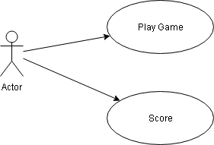

|  |  |
| --- | --- |
| Title | Content |
| Name | Play |
| Description | Player select play to play game. |
| Active Event | Select play button |
| Precondition | Entered game |
| post-condition |  |
| Main flow | 1. Player loads game 2. Player selects play button. 3. Player plays game. 4. Player loses 5. Display Popup score |
| Sub flow | * Flow 1:  1. Player exits game when is playing. 2. Game is paused. 3. Player enters again and play  * Flow 2:  1. Player enters sound option popup to modify sound/music. 2. Game is paused. 3. Player continues playing. |

## State Diagram

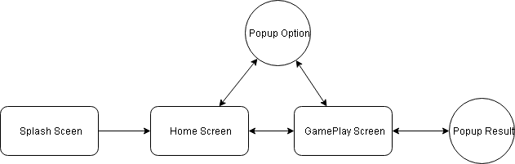

## Activity Diagram

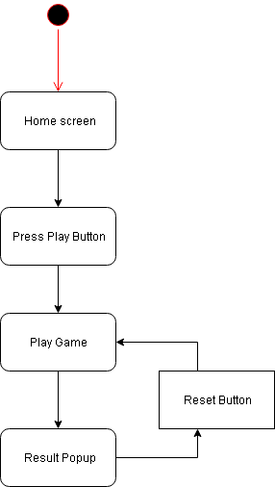

## Sequence Diagram

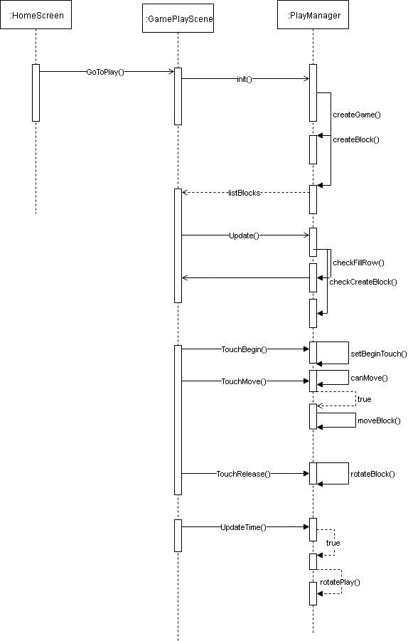

## Class Diagram

