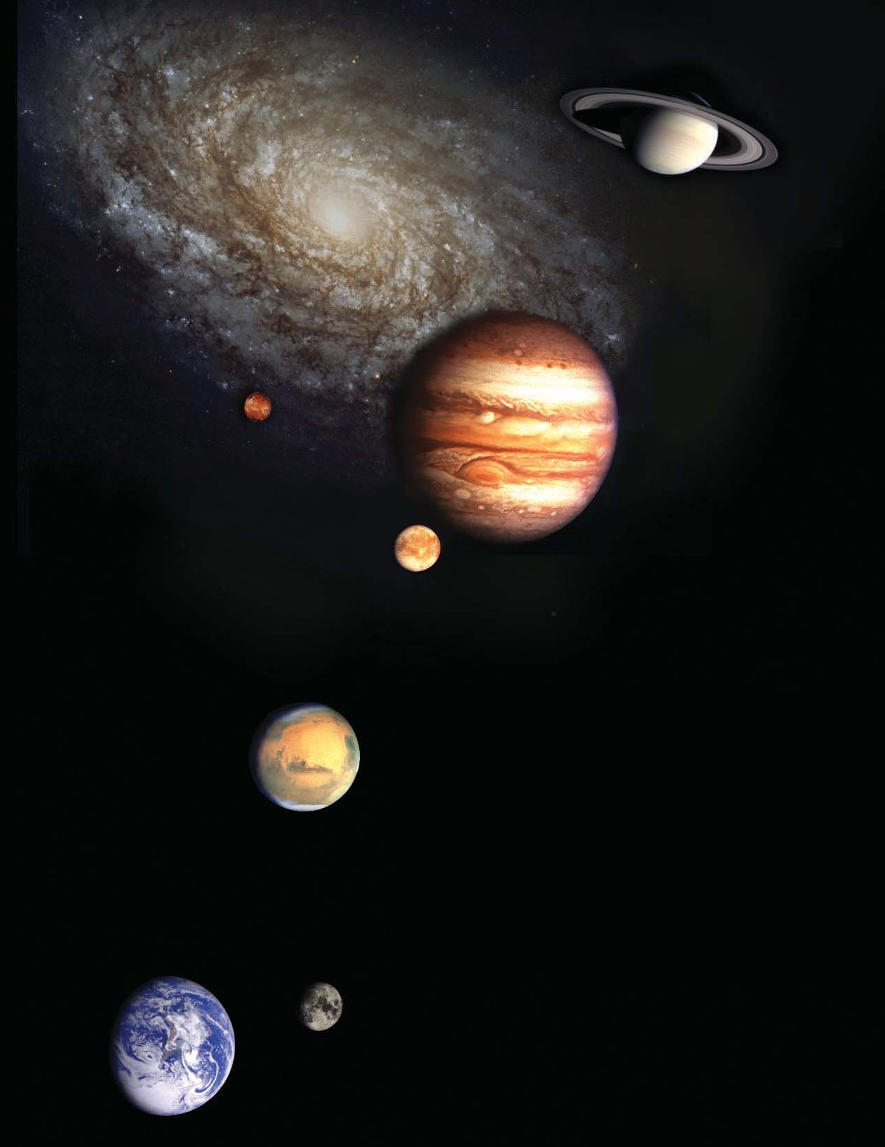

National Aeronautics and Space Administration

The Vision for Space Exploration
February 2004

“This cause of exploration and discovery is not an option we choose; it is a desire written in the human heart.”
President George W. Bush February 4, 2003

“We leave as we came, and God willing as we shall return, with peace and hope for all mankind.”
Eugene Cernan (Commander of last Apollo mission)
December 17, 1972

“. . . America will make those words come true.”
President George W. Bush January 14, 2004



Message from
the NASA Administrator
Dear Reader,

With last year’s budget, NASA released a new Strategic Plan outlining a new approach to space exploration using a “building block” strategy to explore scientifically valuable destinations across our solar system. At the same time that we released the Strategic Plan, our Nation and the NASA family also suffered the loss of the seven brave astronauts aboard the Space Shuttle Columbia. The report of the Columbia Accident Investigation Board emphasized the need for a clearer direction from which to drive NASA’s human exploration agenda. On January 14, 2004, the President articulated a new vision for space exploration.

You hold in your hands a new, bolder framework for exploring our solar system that builds upon the policy that was announced by the President after months of careful deliberations within the Administration. This plan does not undertake exploration merely for the sake of adventure, however exciting that may be, but seeks answers to profound scientific and philosophical questions, responds to recent discoveries, will put in place revolutionary technologies and capabilities for the future, and will genuinely inspire our Nation, the world, and the next generation.

Our aim is to explore in a sustainable, affordable, and flexible manner. We believe the principles and roadmap set down in this document will stand the test of time. Its details will be subject to revision and expansion as new discoveries are made, new technologies are applied, and new challenges are met and over- come. This plan is guided by the Administration’s new space exploration policy, “A Renewed Spirit of Discovery: The President’s Vision for U.S. Space Exploration,” a copy of which is provided on the follow- ing pages. NASA is releasing this plan simultaneously with NASA’s FY 2005 Budget Justification. This plan is fiscally responsible, consistent with the Administration’s goal of cutting the budget deficit in half within the next five years.

I cannot overstate how much NASA will change in the coming years as this plan is implemented. I also can- not overstate how profound the rewards will be on this new course. With the support of Congress, the sci- ence community, the NASA civil and contractor workforce, and most importantly, the American public, we will embark on this very exciting future.

When Christopher Columbus made his voyages across the Atlantic in the 15th and 16th centuries, his ships carried the inscription “Following the light of the sun, we left the Old World.” I look forward to joining you as we follow the light of the planets and the stars into the new worlds of the 21st century.


Sean O'Keefe Administrator

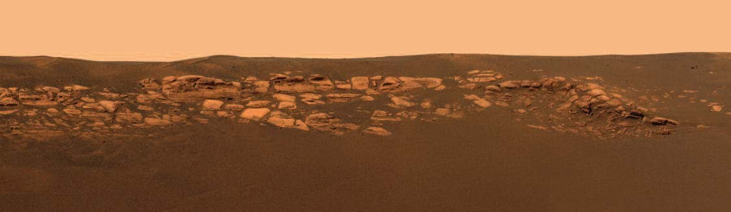

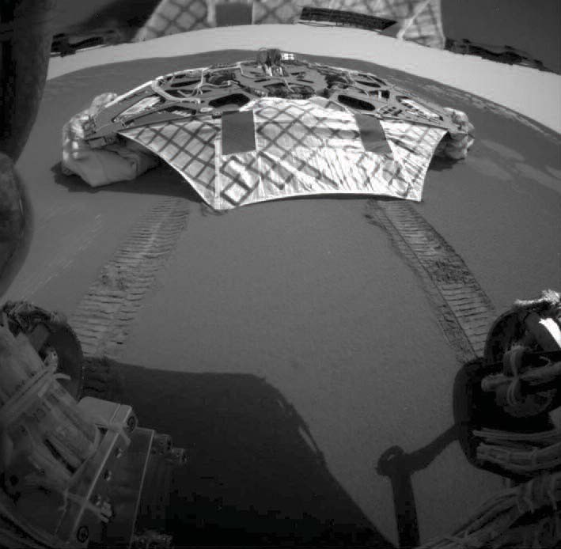

Top image: The Mars Exploration Rover Opportunity’s view of Mars’ Meridiani Planum, taken with the panoramic camera. Lower image: Opportunity looks back at its empty lander as it begins to explore Meridiani Planum.

A Renewed Spirit of Discovery:
The President’s Vision
for U.S. Space Exploration

Background
From the Apollo landings on the Moon, to robotic surveys of the Sun and the planets, to the compelling images captured by advanced space telescopes, U.S. achievements in space have revolutionized humanity’s view of the universe and have inspired Americans and people around the world. These achievements also have led to the development of technologies that have widespread applications to address problems on Earth. As the world enters the second century of powered flight, it is time to articulate a new vision that will define and guide U.S. space exploration activities for the next several decades.

Today, humanity has the potential to seek answers to the most fundamental questions posed about the exis- tence of life beyond Earth. Telescopes have found planets around other stars. Robotic probes have identified potential resources on the Moon, and evidence of water -- a key ingredient for life -- has been found on Mars and the moons of Jupiter.

Direct human experience in space has fundamentally altered our perspective of humanity and our place in the universe. Humans have the ability to respond to the unexpected developments inherent in space travel and possess unique skills that enhance discoveries. Just as Mercury, Gemini, and Apollo challenged a gen- eration of Americans, a renewed U.S. space exploration program with a significant human component can inspire us -- and our youth -- to greater achievements on Earth and in space.

The loss of Space Shuttles Challenger and Columbia and their crews are a stark reminder of the inherent risks of space flight and the severity of the challenges posed by space exploration. In preparation for future human exploration, we must advance our ability to live and work safely in space and, at the same time, develop the technologies to extend humanity’s reach to the Moon, Mars, and beyond. The new technologies required for further space exploration also will improve the Nation’s other space activities and may provide applications that could be used to address problems on Earth.

Like the explorers of the past and the pioneers of flight in the last century, we cannot today identify all that we will gain from space exploration; we are confident, nonetheless, that the eventual return will be great. Like their efforts, the success of future U.S. space exploration will unfold over generations.

Goal and Objectives
The fundamental goal of this vision is to advance U.S. scientific, security, and economic interests through a robust space exploration program. In support of this goal, the United States will:

- Implement a sustained and affordable human and robotic program to explore the solar system and beyond;

- Extend human presence across the solar system, starting with a human return to the Moon by the year 2020, in preparation for human exploration of Mars and other destinations;

- Develop the innovative technologies, knowledge, and infrastructures both to explore and to support decisions about the destinations for human exploration; and

- Promote international and commercial participation in exploration to further U.S. scientific, security, and economic interests.

Bringing the Vision to Reality
The Administrator of the National Aeronautics and Space Administration will be responsible for the plans, programs, and activities required to implement this vision, in coordination with other agencies, as deemed appropriate. The Administrator will plan and implement an integrated, long-term robotic and human explo- ration program structured with measurable milestones and executed on the basis of available resources, accu- mulated experience, and technology readiness.

To implement this vision, the Administrator will conduct the following activities and take other actions as required:

Exploration Activities in Low Earth Orbit Space Shuttle
  - Return the Space Shuttle to flight as soon as practical, based on the recommendations of the Columbia Accident Investigation Board;

  - Focus use of the Space Shuttle to complete assembly of the International Space Station; and

  - Retire the Space Shuttle as soon as assembly of the International Space Station is completed, planned for the end of this decade;

International Space Station

  - Complete assembly of the International Space Station, including the U.S. components that support
U.S. space exploration goals and those provided by foreign partners, planned for the end of this decade;

  - Focus U.S. research and use of the International Space Station on supporting space exploration goals, with emphasis on understanding how the space environment affects astronaut health and capabilities and developing countermeasures; and

  - Conduct International Space Station activities in a manner consistent with U.S. obligations contained in the agreements between the United States and other partners in the International Space Station.

Space Exploration Beyond Low Earth Orbit The Moon
  - Undertake lunar exploration activities to enable sustained human and robotic exploration of Mars and more distant destinations in the solar system;

  - Starting no later than 2008, initiate a series of robotic missions to the Moon to prepare for and support future human exploration activities;

  - Conduct the first extended human expedition to the lunar surface as early as 2015, but no later than the year 2020; and

  - Use lunar exploration activities to further science, and to develop and test new approaches, technologies, and systems, including use of lunar and other space resources, to support sustained human space exploration to Mars and other destinations.

Mars and Other Destinations

- Conduct robotic exploration of Mars to search for evidence of life, to understand the history of the solar system, and to prepare for future human exploration;

- Conduct robotic exploration across the solar system for scientific purposes and to support human exploration. In particular, explore Jupiter’s moons, asteroids and other bodies to search for evidence of life, to understand the history of the solar system, and to search for resources;

- Conduct advanced telescope searches for Earth-like planets and habitable environments around other stars;

- Develop and demonstrate power generation, propulsion, life support, and other key capabilities required to support more distant, more capable, and/or longer duration human and robotic exploration of Mars and other destinations; and

- Conduct human expeditions to Mars after acquiring adequate knowledge about the planet using robotic missions and after successfully demonstrating sustained human exploration missions to the Moon.

Space Transportation Capabilities Supporting Exploration

  - Develop a new crew exploration vehicle to provide crew transportation for missions beyond low Earth orbit;

« Conduct the initial test flight before the end of this decade in order to provide an operational capability to support human exploration missions no later than 2014;

  - Separate to the maximum practical extent crew from cargo transportation to the International Space Station and for launching exploration missions beyond low Earth orbit;

« Acquire cargo transportation as soon as practical and affordable to support missions to and from the International Space Station; and

« Acquire crew transportation to and from the International Space Station, as required, after the Space Shuttle is retired from service.

International and Commercial Participation

  - Pursue opportunities for international participation to support U.S. space exploration goals; and

  - Pursue commercial opportunities for providing transportation and other services supporting the International Space Station and exploration missions beyond low Earth orbit.

P R ESIDENT GEORGE W . BUSH JANUAR Y 14, 2004

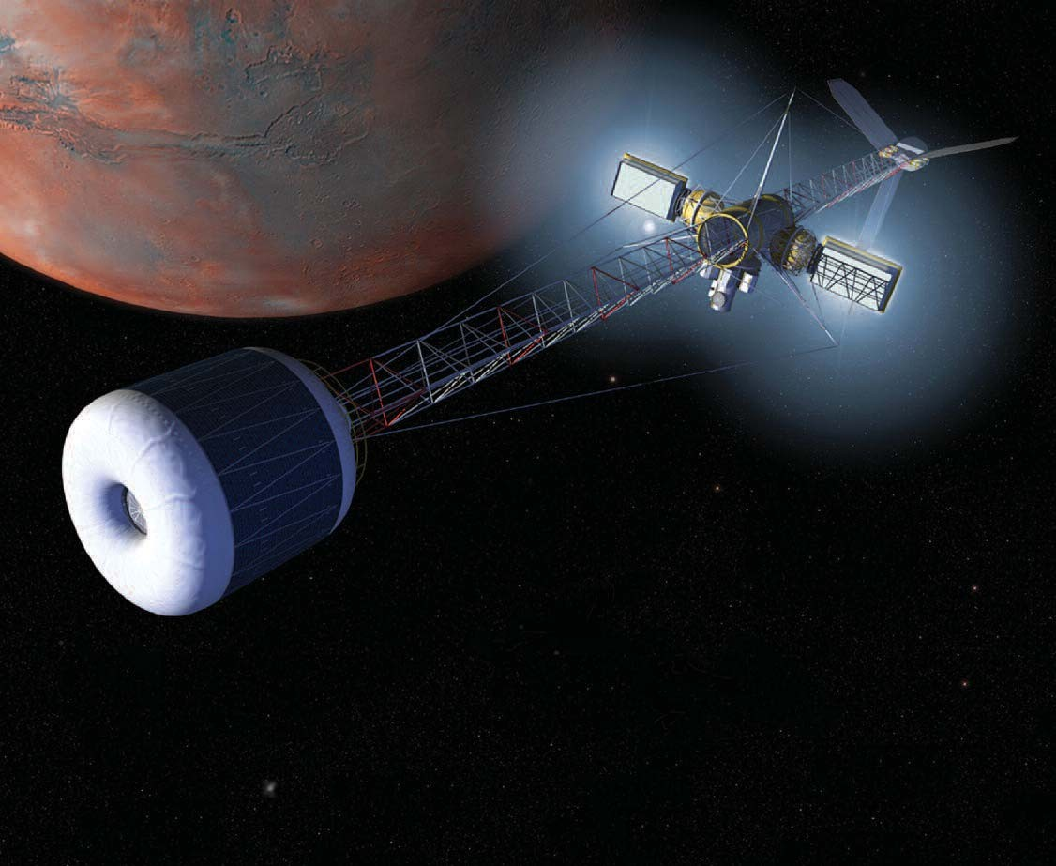

Table of Contents

Introduction 2
NASA Guiding Principles for Exploration 3
Solar System and Beyond—Exploration Roadmap 5
Lunar Testbeds and Missions 7
Mars Research, Testbeds, and Missions 9
Outer Moons Research and Missions 11
Extrasolar Planet Research and Observatories 13
Exploration Building Blocks 15
NASA Transformation 17
Resources 19
National Benefits 21

Left: An artist’s concept of a spacecraft, equipped with a centrifuge and nuclear–electric propulsion, traveling to Mars.

Introduction

“The American experience stirred mankind from discovery to exploration. From the cautious question of what they knew was out there . . . into an enthusiastic reaching to the unknown.”
Daniel J. Boorstin (1914– )

“Somewhere, something incredible is waiting to be known.”
Carl Sagan (1934–1996)

Understanding from the unknown. Comprehension from the cosmos. Insight from the infinite. The rela- tionship between discovery and exploration has driv- en human curiosity for all of recorded history. Since the time of the ancient philosophers, we have striven to comprehend our place in the universe and have looked to the heavens for answers to the questions: Where do we come from? Are we alone? Where are we going?

Exploration and discovery have been especially important to the American experience. New World pioneers and American frontiersmen showed our Nation the importance of the knowledge, technolo- gy, resources, and inspiration that flow from explo- ration. Like the ancients, America has also explored the heavens, and in the latter half of the 20th centu- ry, the Apollo Moon landings became the most dis- tant milestone in the continuing American explorato- ry tradition.

At the beginning of the 21st century, we stand at a unique time in our exploration of the heavens. The exploratory voyages of the next few decades have the potential—within our lifetimes—to answer age- old questions about how life begins, whether life exists elsewhere, and how we could live out there.

Our understanding of the universe and its habitabili- ty is being revolutionized by new discoveries. Scientists have found new forms of life in environ- ments once thought inhospitable. Spacecraft have identified potential new resources on the Moon. Robotic probes have found evidence of water, a key ingredient of life, on the planet Mars. A mission to Jupiter has revealed that oceans likely underlay the icy surfaces of that planet’s moons. Astronomers have discovered over 100 planets, and counting, cir- cling other stars. Together, these findings indicate that our universe may be more habitable than previ- ously known. Instead of a dry, lifeless universe, there may be many worlds that harbored life in the past and can support life today.
We also stand at a pivotal time in the history of human space flight, when important choices about investments in the Space Shuttle, the International Space Station, and follow-on programs are being made in the wake of the Space Shuttle Columbia tragedy. Just as decisions to begin the Space Station and Space Shuttle programs were made 20 and 30 years ago, the direction we set for our human space flight programs today will define space exploration for decades to come.

The President’s Vision for space exploration is bold and forward-thinking. It expands scientific discov- ery and the search for habitable environments and life by advancing human and robotic capabilities across multiple worlds. This plan provides the framework for fulfilling the President’s direction, guided by the principles on the facing page. It is responsive to recent science findings, the NASA Strategic Plan, the report of the Columbia Accident Investigation Board, and the new space exploration policy. It seeks to establish a sustainable and flexi- ble approach to exploration by pursuing compelling questions, developing breakthrough technologies, leveraging space resources, and making smart deci- sions about ongoing programs. It will help drive critical national technologies in power, computing, nanotechnology, biotechnology, communications, networking, robotics, and materials. It will start exciting new programs now to inspire the next gen- eration of explorers.

Our generation inherited great legacies from the exploratory voyages and discoveries of earlier cen- turies. Starting with an exploration roadmap (see page 4), this document outlines a plan for achieving great legacies that our century can leave to future generations.

NASA Guiding Principles for Exploration

Pursue Compelling Questions

Exploration of the solar system and beyond will be guided by compelling questions of scientific and socie- tal importance. NASA exploration programs will seek profound answers to questions about the origins of our solar system, whether life exists beyond Earth, and how we could live on other worlds.

Across Multiple Worlds

NASA will make progress across a broad front of destinations, starting with a return to the Moon to enable future human exploration of Mars and other worlds. Consistent with recent discoveries, NASA will focus on possible habitable environments on Mars, the moons of Jupiter, and in other solar systems. Where advan- tageous, NASA will also make use of destinations like the Moon and near-Earth asteroids to test and demon- strate new exploration capabilities.

Employ Human and Robotic Capabilities

NASA will send human and robotic explorers as partners, leveraging the capabilities of each where most use- ful. Robotic explorers will visit new worlds first, to obtain scientific data, assess risks to our astronauts, demonstrate breakthrough technologies, identify space resources, and send tantalizing imagery back to Earth. Human explorers will follow to conduct in-depth research, direct and upgrade advanced robotic explorers, prepare space resources, and demonstrate new exploration capabilities.

For Sustainable Exploration

NASA will pursue breakthrough technologies, investigate lunar and other space resources, and align ongo- ing programs to develop sustainable, affordable, and flexible solar system exploration strategies.

Use the Moon as a Testing Ground For Mars and Beyond

Under this new Vision, the first robotic missions will be sent to the Moon as early as 2008 and the first human missions as early as 2015 to test new approaches, systems and operations for sustainable human and robotic missions to Mars and beyond.

Starting Now

NASA will pursue this Vision as our highest priority. Consistent with the FY 2005 Budget, NASA will immediately begin to realign programs and organization, demonstrate new technical capabilities, and under- take new robotic precursor missions to the Moon and Mars before the end of the decade.

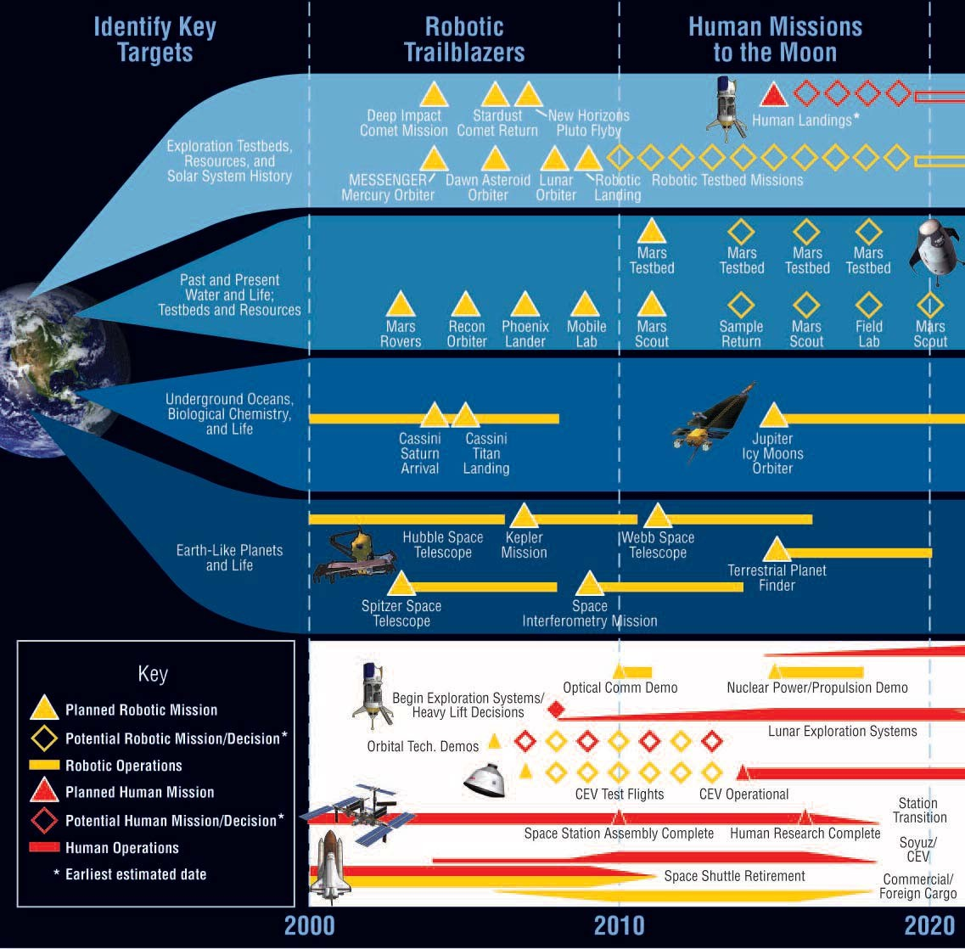

NOTE: All missions indicate launch dates.

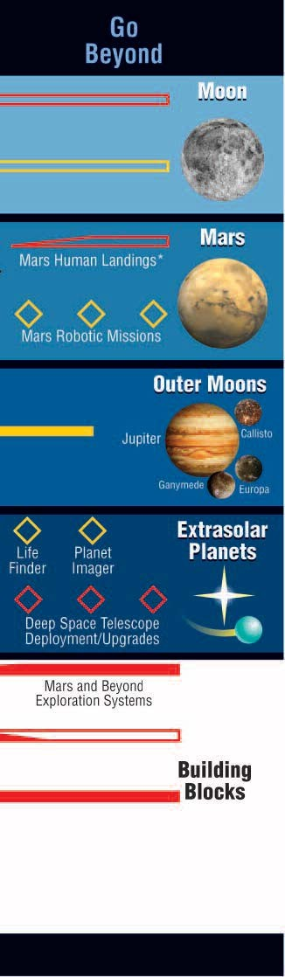
Solar System and Beyond— Exploration Roadmap
Over the next three decades, NASA will send robotic probes to explore our solar system, including our Earth’s Moon, the planet Mars, the moons of Jupiter and other outer planets, and will launch new space tel- escopes to search for planets beyond our solar system. These robotic explorers will pursue compelling scientific questions, demonstrate breakthrough technologies, identify space resources, and extend an advanced telepresence that will send stunning imagery back to Earth.

Starting at the Moon in 2008 and at Mars in 2011, NASA will launch dedicated robotic missions that will demonstrate new technologies and enhance our scientific knowledge of these destinations. These new technologies and discoveries will pave the way for more capable robot- ic missions and eventually human missions. The first human explorers will be sent to the Moon as early as 2015, as a stepping stone to demon- strate sustainable approaches to exploring Mars and other worlds.

To support these missions, a number of key building blocks are neces- sary. These include new capabilities in propulsion, power, communica- tions, crew transport, and launch, as well as the refocusing of ongoing programs like Space Station research. Major achievements, including the completion of Space Station assembly, test flights of new crew transport capabilities, and space technology demonstrations, are expect- ed before the end of this decade.

The activities in each of the sections in this roadmap, Moon, Mars, Outer Moons, Extrasolar Planets, and Exploration Building Blocks, are described in detail on the following pages. Sections describing changes in the NASA organization and resources to implement this plan are also included.

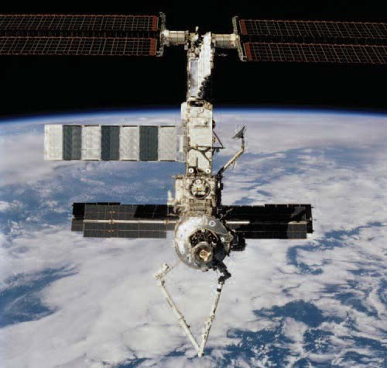
Right: The International Space Station as seen from the Shuttle Endeavour.

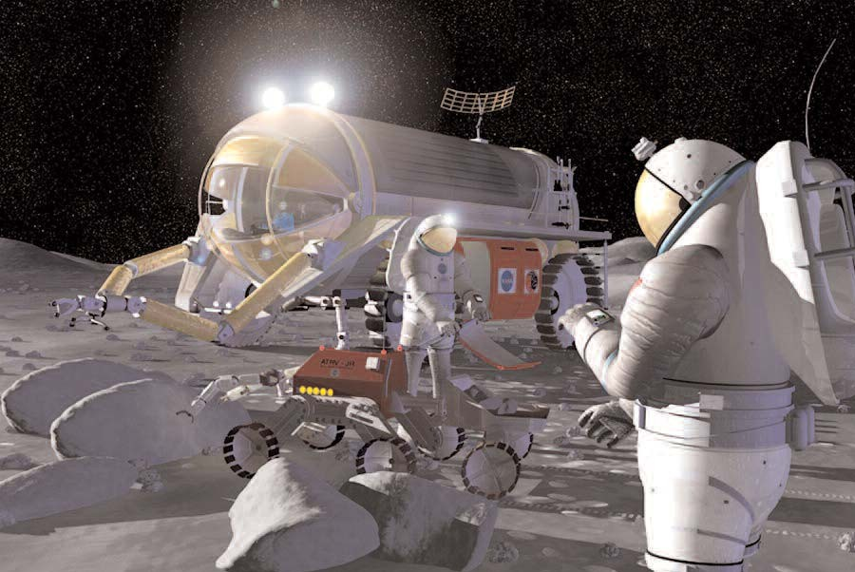

Facing page, left: Astronaut Nancy Currie, wearing an advanced, lightweight spacesuit, works with NASA’s Robonaut, a robotic assistant for space explo- ration. Facing page, right: A false-color mosaic taken by Galileo. Researchers use the different colors to determine the mineral composition of the lunar sur- face. Above: An artist’s concept of lunar exploration.

Lunar Testbeds and Missions

“The moon is a silver pin-head vast,
That holds the heaven’s tent-hangings fast.”
William R. Alger (1823–1905)
“The Use of the Moon,” Oriental Poetry
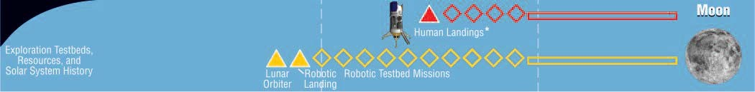

During the late 1960s and early 1970s, the Apollo program demonstrated American technical strength in a race against the Soviet Union to land humans on the Moon. Today, NASA’s plans for a return to the Moon are not driven by Cold War competition, but by the need to test new exploration technologies and skills on the path to Mars and beyond. Additionally, during the 1990s, robotic missions identified poten- tial evidence of water ice at the Moon’s poles, a resource that could make exploration further into the solar system easier to conduct.

NASA will begin its lunar testbed program with a series of robotic missions. The first, an orbiter to confirm and map lunar resources in detail, will launch in 2008. A robotic landing will follow in 2009 to begin demonstrating capabilities for sus- tainable exploration of the solar system. Additional missions, potentially up to one a year, are planned to demonstrate new capabilities such as robotic net- works, reusable planetary landing and launch sys- tems, pre-positioned propellants, and resource extraction.
A human mission to the Moon will follow these
robotic missions as early as 2015. The Moon will provide an operational environment where we can demonstrate human exploration capabilities within relatively safe reach of Earth. Human missions to the Moon will serve as precursors for human mis- sions to Mars and other destinations, testing new sustainable exploration approaches, such as space resource utilization, and human-scale exploration systems, such as surface power, habitation and life support, and planetary mobility. The scope and types of human lunar missions and systems will be determined by their support to furthering science, developing and testing new approaches, and their applicability to supporting sustained human space exploration to Mars and other destinations.

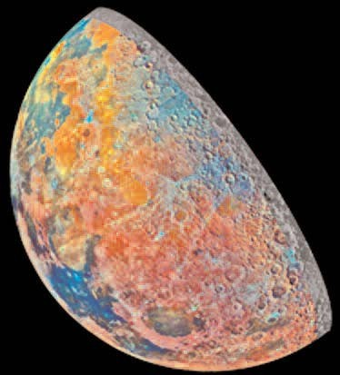
The major focus of these lunar activities will be on demonstrating capabilities to conduct sustained research on Mars and increasingly deep and more advanced exploration of our solar system. Additionally, these robotic and human missions will pursue scientific investigations on the Moon, such as uncovering geological records of our early solar system.

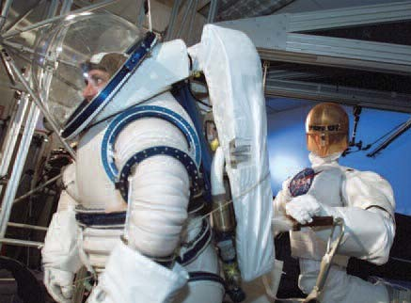

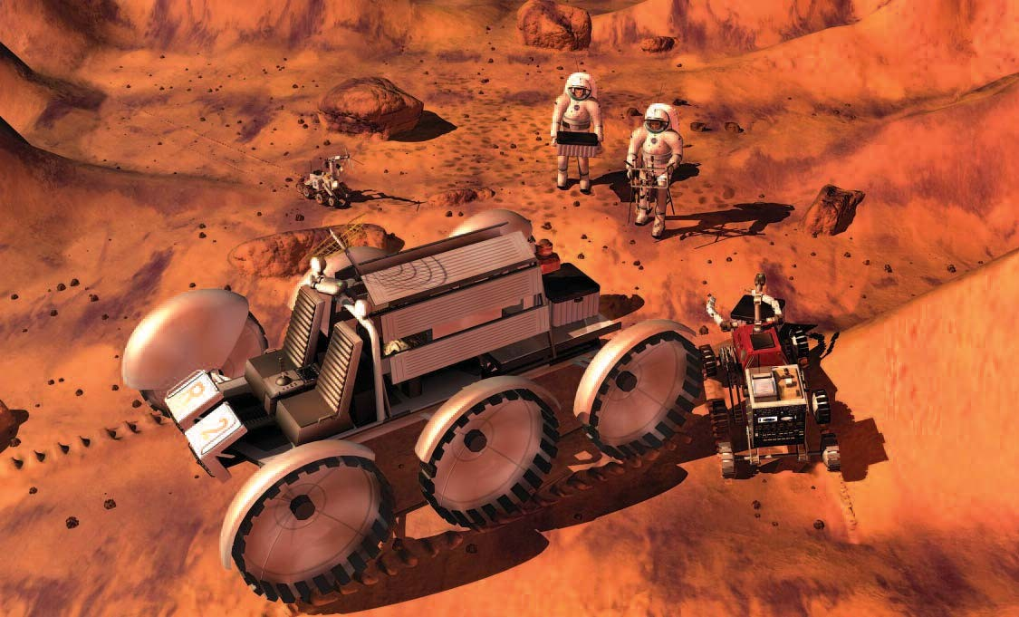

Facing page, left: Gullies on Mars, like this one in the Newton Basin, may have been formed by groundwater in geologically recent times. Facing page, right: The Mars Science Lander will land the roving Mars Science Laboratory on the surface of Mars. Above: A drawing of astronauts and robots exploring Mars.

Mars Research, Testbeds, and Missions

“We shall never cease from exploration And the end of all our exploring
Will be to arrive where we started And know the place for the first time.”
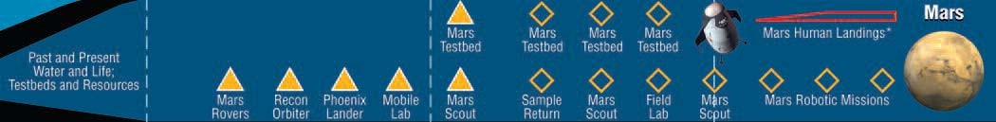
T.S. Eliot (1888–1965)

As early as the 19th century, telescope observations led some astronomers to speculate that Mars might harbor life. Subsequent robotic missions to Mars during the 1960s and 1970s showed that the surface of Mars is currently inhospitable. However, more recent missions have transformed our understanding of Mars. New data indicates that liquid water likely flowed across the surface of Mars in the distant past and may still exist in large reservoirs deep under- ground. This raises the prospect that simple forms of life may have developed early in Mars’ history and may persist beneath the surface of Mars to this day.

NASA is aggressively pursuing the search for water and life on Mars using robotic explorers. The Spirit and Opportunity rovers that landed on Mars in January 2004 are the latest in a series of research missions planned to explore Mars through 2010. By the end of this decade, three rovers, a lander, and two orbiters will have visited the planet. NASA will aug- ment this program and prepare for the next decade of Mars research missions by investing in key capabil- ities to enable advanced robotic missions, such as returning geological samples from Mars or drilling under the surface of Mars. This suite of technologies will enable NASA to rapidly respond to discoveries this decade and pursue the search for water and life at Mars wherever it may lead next decade.
Starting in 2011, NASA will also launch the first in a new series of human precursor missions to Mars.
These robotic testbeds will demonstrate technolo- gies—such as improved aerodynamic entry, Mars orbital rendezvous and docking, precision landing, resource extraction and utilization, and optical com- munications—that can greatly enhance future robot- ic capabilities and are key to enabling future human Mars missions. These missions will also obtain crit- ical data for future human missions on chemical haz- ards, resource locations, and research sites. They may prepare resources and sites in anticipation of human landings.

The first human mission beyond the Moon will be determined on the basis of available resources, accu- mulated experience, and technology readiness. Potential candidates that might be considered include circumnavigating Mars, visiting a near-Earth asteroid, or erecting or upgrading a deep space tele- scope. Such missions could test the human-scale power, propulsion, and other transit systems neces- sary to take trips to Mars before taking on the addi- tional risk of a landing on Mars.

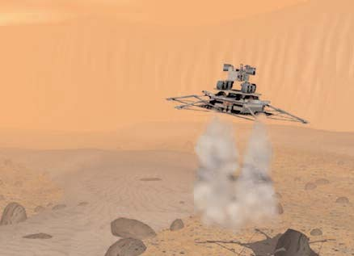
The timing of the first human research missions to Mars will depend on discoveries from robotic explorers, the development of techniques to mitigate Mars hazards, advances in capabilities for sustain- able exploration, and available resources.

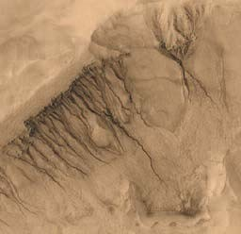

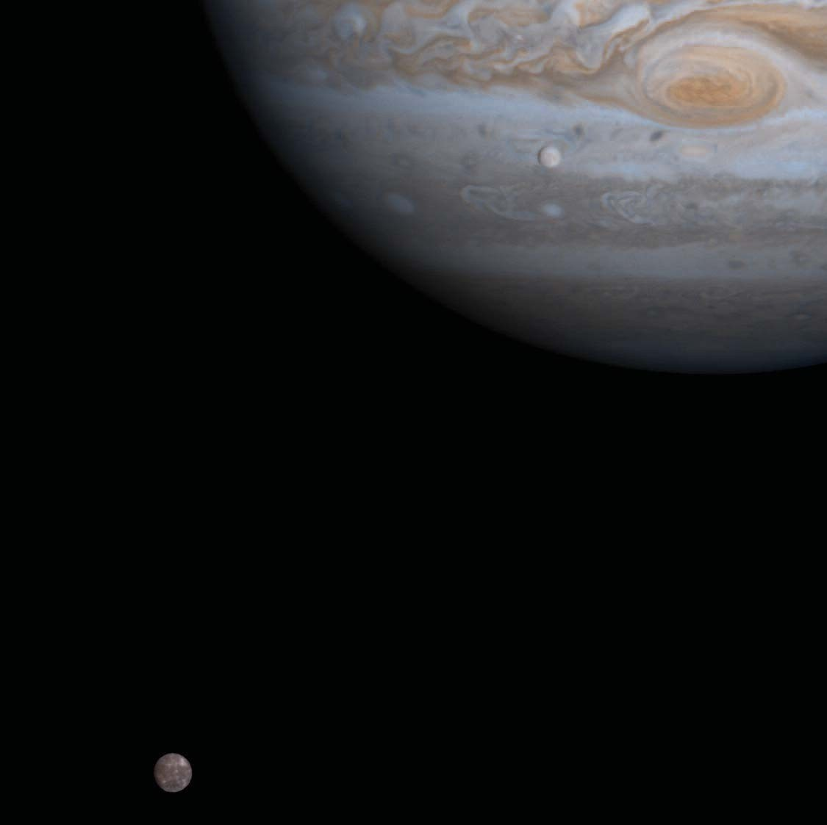

Facing page, left: An artist’s rendering of the Jupiter Icy Moons Orbiter. Facing page, right: An artist’s drawing of icy bodies in the Kuiper Belt. Above: Jupiter and its moons Europa (seen against Jupiter) and Callisto (lower left) as seen by the Cassini spacecraft in 2000.

Outer Moons Research and Missions

“Sometimes I think we're alone in the universe, and sometimes I think we're not. In either case the idea is quite staggering.”
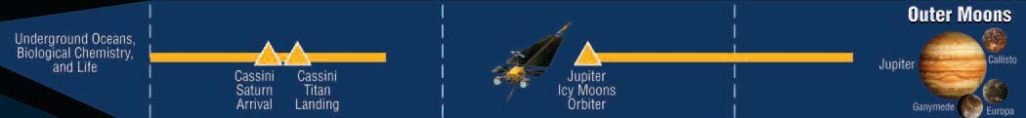
Arthur C. Clarke (1917– )

In 1610, the Italian astronomer Galileo Galilei discovered that four large moons circle the planet Jupiter. In the 1970s, NASA’s twin Voyager mis- sions flew by Jupiter and confirmed that three of these moons—Europa, Callisto, and Ganymede— are covered in water ice. Twenty years later, anoth- er NASA mission to Jupiter named after Galileo found evidence that enormous, planet-wide oceans likely lay underneath the icy surfaces of these moons. As on Mars, the presence of liquid water raises the prospect that life could have developed on one or more of these moons and may still swim in their oceans today.

NASA is in the early stages of planning a mission that will visit Europa, Callisto, and Ganymede dur- ing the next decade. Unlike the Voyager and Galileo missions, which could only briefly fly by Jupiter’s moons, the Jupiter Icy Moons Orbiter will be designed to circle each moon for up to a year, carry- ing revolutionary science instruments. This will allow the lengthy and detailed investigations neces- sary to confirm and map the underground oceans of these worlds in detail.

The Jupiter Icy Moons Orbiter is enabled by Project Prometheus, NASA’s program to develop space nuclear power and propulsion technology. The nuclear power and nuclear-electric propulsion tech- nologies that support this mission are also key to
enabling other advanced robotic missions and human missions beyond Earth’s orbit. In addition to mapping new oceans, the systems on the Jupiter Icy Moons Orbiter will be a forerunner of the systems needed to send humans to other worlds, to supply power for human expeditions on these worlds, and to pursue other challenging robotic science missions.

The moons of other planets in our outer solar system may also hold critical clues to the evolution of hab- itable environments and the development of life. NASA’s Cassini mission, currently on its way to Saturn, will encounter Saturn’s largest moon, Titan, next January. Titan is icy like Jupiter’s moons, but unlike Europa, Callisto, and Ganymede, Titan has an atmosphere that is about as dense as Earth’s, is com- posed of many of the same chemicals as Earth’s early atmosphere, and is believed to contain com- plex, pre-biotic chemistry. Titan may turn out to be a key laboratory for understanding how biology aris- es from chemistry.

Depending on the results from Cassini and the Jupiter Icy Moons Orbiter, NASA experts believe that advanced robotic missions to study the habitable environments of the outer moons in detail—such as submarines on Europa or balloons on Titan—are likely after 2020. Over the long term, a human research presence at some of these worlds may also become desirable.

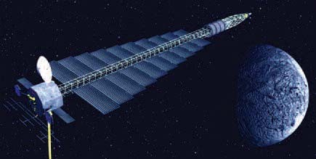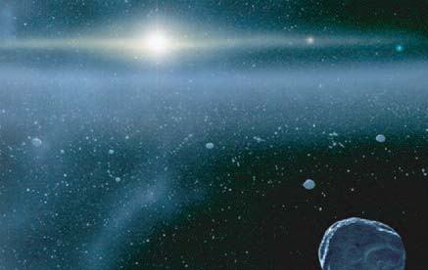

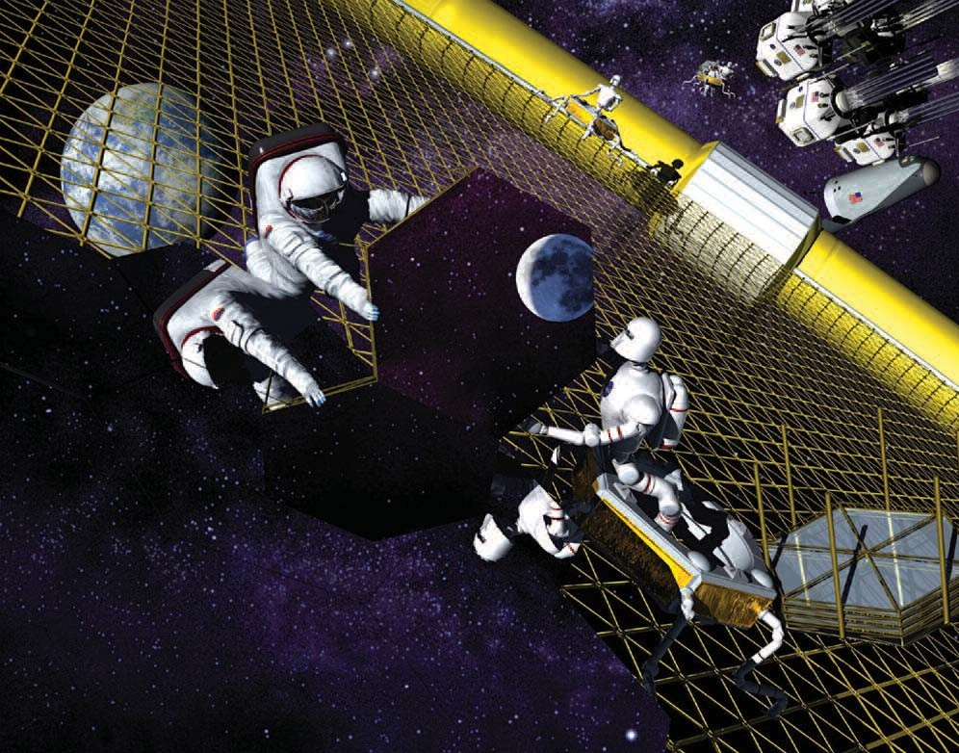

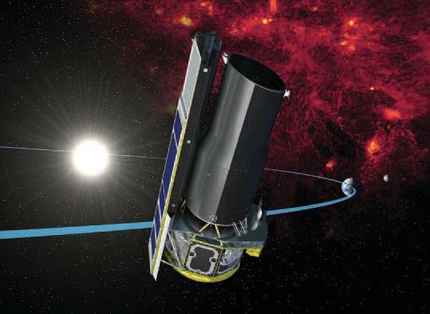
Facing page, right: An artist’s drawing of the Terrestrial Planet Finder. Above: A drawing of humans and advanced robotic assis- tants building a space telescope. Left: An artist’s concept of the Spitzer Space Telescope.

Extrasolar Planet Research and Observatories

“Do there exist many worlds, or is there but a single world? This is one of the most noble and exalted questions in the study of Nature.”
Albertus Magnus (1193–1280)

“We may object that we have been thinking of the stars as mere bodies . . . but should rather conceive them as enjoying life and action. On this view the facts cease to appear surprising.”
Aristotle (384–322 BC)
On the Heavens, Book II, Part 12



Our solar system is composed of nine planets, including Earth, that circle a central star, the Sun. Astronomers and philosophers have speculated for millennia about whether other stars harbor worlds like Earth and whether these worlds are inhabited. However, it is only in the last decade that telescopes have become powerful enough to detect whether planets of any type circle other stars. In 1995, astronomers discovered the first solar system besides our own. Since then, astronomers have found over 100 planets orbiting other stars—and the number continues to climb with new discoveries.

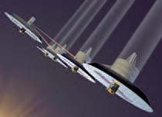
All of the extrasolar planets discovered to date are either very large planets or planets that circle very close to their parent stars. Some extrasolar planets are many times larger than the largest planet in our solar system, Jupiter, and orbit even closer to their parent star than the closest planet to our Sun, Mercury. Because of the obscuring effects of the Earth’s atmosphere, the detection and characteriza- tion of small planets with normal orbits like Earth is extremely challenging using ground-based tele- scopes.

NASA’s Astronomical Search for Origins program will use a variety of techniques this decade to great- ly expand the number and variety of known extraso- lar planets. New space telescopes like the Spitzer and James Webb Space Telescopes, the Kepler mis- sion, and the Space Interferometry mission, will search newly formed planets circling young stars, take planetary surveys of thousands of faraway stars, and detect planets only a few times larger than Earth around very nearby stars.
The results from these telescopes will be used in the design of an advanced space telescope, the Terrestrial Planet Finder, to be launched during the next decade. The Terrestrial Planet Finder will be capable of finding Earth-like planets and detecting the chemicals in their atmospheres. Just as plants and animals have changed Earth’s atmosphere over time, the detection of specific chemicals on other worlds would indicate that life has evolved on them, as well.

If the Terrestrial Planet Finder discovers extrasolar planets with evidence of life, NASA would pursue additional space telescopes after 2020 that can con- firm the existence of life on these worlds and image their features. Life Finder or Planet Imager tele- scopes would likely be very large and complex spacecraft located far from Earth. A human presence in deep space could be necessary to help erect and upgrade such future telescopes.

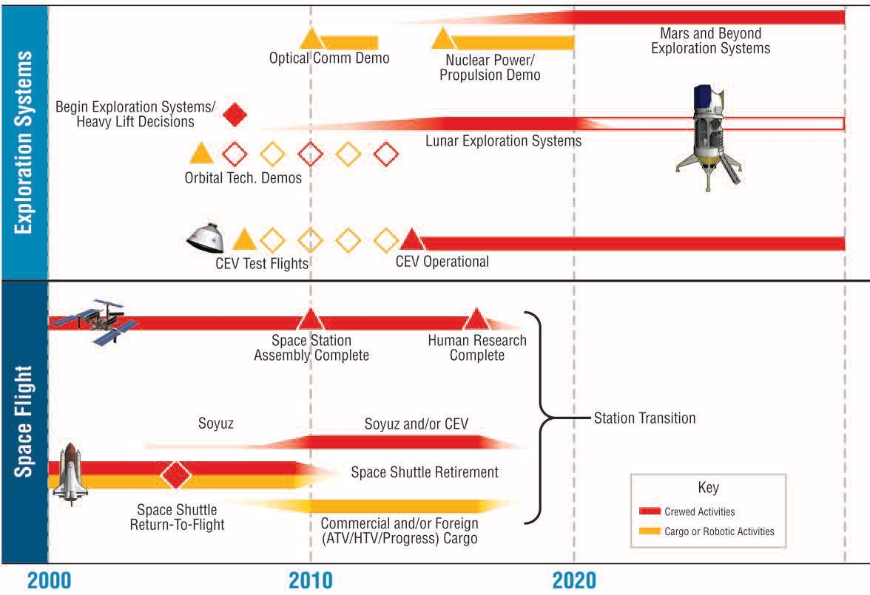

Above: Exploration building blocks will provide the capabilities necessary for exploration of the solar system and beyond.

Exploration Building Blocks

“As for the future, your task is not to see it, but to enable it.”
Antoine de-Saint Exupery (1900–1944)
The Wisdom of the Sands

“Man hath weaved out a net, and this net throwne upon the Heavens, and now they are his own.”
John Donne (1572–1631)

To conduct an effective and exciting program of exploration and discovery, we must overcome the limitations of space, time, and energy, as well as var- ious space hazards. Over the next two decades, NASA plans to develop a number of new capabilities that are critical to enabling the human and robotic missions described in this document.

For human explorers to undertake lengthy research trips on other worlds, they will have to maintain their health in environments that possess higher radiation and lower gravity than Earth and that are far from supplies and medical expertise. Research aboard the International Space Station and at various laborato- ries on Earth is critical to understanding the effects of space environments on the human body, develop- ing techniques for mitigating these hazards, mini- mizing the logistical burden of supporting humans far from Earth, and addressing remote medical emer- gencies. NASA plans to complete assembly of the Space Station, including international partner ele- ments, by the end of the decade. NASA will also augment its bioastronautics research program with the goal that Space Station research necessary to support human explorers on other worlds will be complete by 2016.
The Space Shuttle will be critical to completing assembly of the Space Station. With Space Station assembly complete at the end of this decade, NASA will retire the Space Shuttle and put crew and cargo on different launches, a safer approach to crew transport.

NASA will initiate Project Constellation to develop a new Crew Exploration Vehicle for future crew trans- port. This vehicle will be developed in stages, with the first automated test flight in 2008, more advanced test flights soon thereafter, and a fully operational capability no later than 2014. The design of the Crew Exploration Vehicle will be driv- en by the needs of the future human exploration
missions described in this document. The Crew Exploration Vehicle might also supplement interna- tional partner crew transport systems to the Space Station.

For cargo transport to the Space Station after 2010, NASA will rely on existing or new commercial cargo transport systems, as well as international part- ner cargo transport systems. NASA does not plan to develop new launch vehicle capabilities except where critical NASA needs—such as heavy lift—are not met by commercial or military systems. Depending on future human mission designs, NASA could decide to develop or acquire a heavy lift vehi- cle later this decade. Such a vehicle could be derived from elements of the Space Shuttle, existing commercial launch vehicles, or new designs.

In the days of the Apollo program, human explo- ration systems employed expendable, single-use vehicles requiring large ground crews and careful monitoring. For future, sustainable exploration pro- grams, NASA requires cost-effective vehicles that may be reused, have systems that could be applied to more than one destination, and are highly reliable and need only small ground crews. NASA plans to invest in a number of new approaches to explo- ration, such as robotic networks, modular systems, pre-positioned propellants, advanced power and propulsion, and in-space assembly, that could enable these kinds of vehicles. These technologies will be demonstrated on the ground, at the Space Station and other locations in Earth orbit, and on the Moon start- ing this decade and into the next. Other break- through technologies, such as nuclear power and propulsion, optical communications, and potential use of space resources, will be demonstrated as part of robotic exploration missions. The challenges of designing these systems will accelerate the develop- ment of fundamental technologies that are critical not only to NASA, but also to the Nation’s econom- ic and national security.

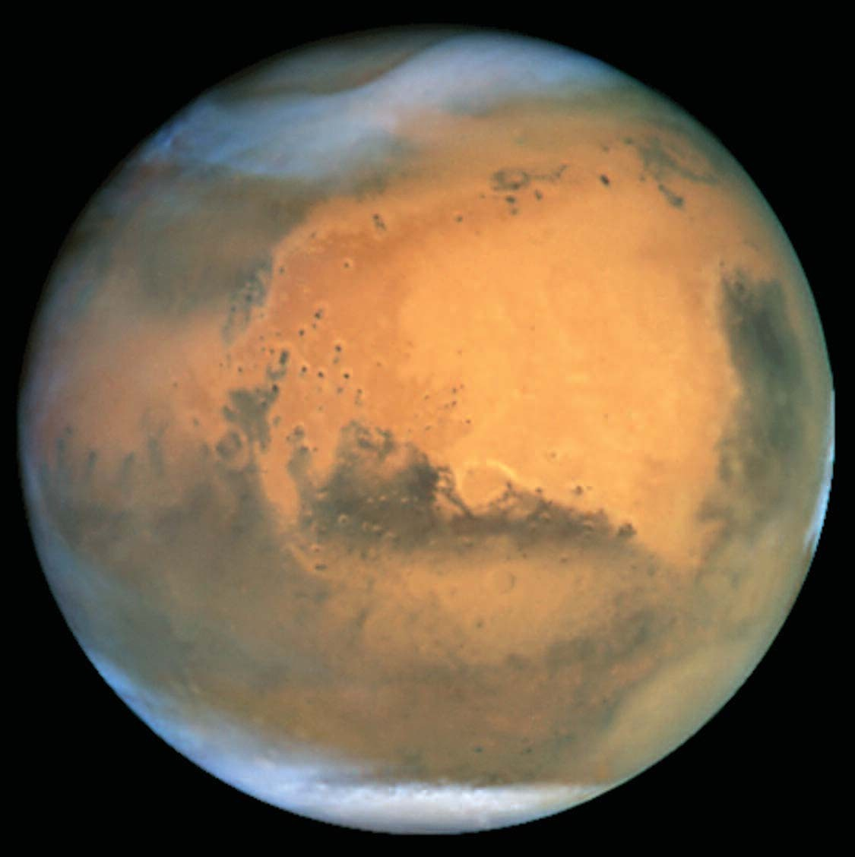

Above: Mars as seen by the Hubble Space Telescope.

NASA Transformation

“No one regards what is before his feet; we all gaze at the stars.”
Quintus Ennius (239–169 BC)

To successfully execute the President’s vision, NASA will refocus its organization, create new offices where necessary, realign ongoing programs and personnel, experiment with new ways of doing business, and tap the great innovative and creative talents of our Nation.

Prior to this plan, six Enterprises comprised NASA’s organization—Space Science, Earth Science, Biological and Physical Research, Aerospace Technology, Education, and Space Flight. To devel- op the exploration building blocks described in this document, NASA has created a new Exploration Systems Enterprise. Exploration Systems will be initially responsible for developing the solar system exploration vehicles and technologies described in this plan, including the Crew Exploration Vehicle, nuclear power and propulsion systems, and neces- sary supporting technologies. Relevant elements of the Aerospace Technology, Space Science, and Space Flight enterprises were transferred to the Exploration Systems Enterprise. The Aerospace Technology Enterprise was renamed the Aeronautics Enterprise.
In the past, NASA’s human space flight programs and robotic exploration programs have largely oper- ated independently of each other. As human explor- ers prepare to join their robotic counterparts, closer coordination and integration will be necessary. The Exploration Systems Enterprise will work closely with the Space Science Enterprise to use the Moon as a testing ground for solar system exploration vehi- cles and technologies.

NASA’s Space Science Enterprise will have respon- sibility for carrying out robotic testbeds on the Moon and Mars and will also demonstrate other key tech- nologies for human and robotic exploration in other missions to Mars and the outer moons. NASA’s Space Science Enterprise will eventually need to integrate human capabilities into Mars science plan- ning, and potentially deep space observatory or outer moon planning.

Many other elements of the NASA organization will be focused to support this new direction. NASA’s
Biological and Physical Research Enterprise will put much greater emphasis on bioastronautics research to enable human exploration of other worlds. Similarly, Space Station research will be prioritized to support human exploration.

NASA’s Office of the Space Architect will be responsible for coordinating and integrating the exploration activities of NASA’s different Enterprises and for maintaining exploration roadmaps and high-level requirements.

As we move outward into the solar system, NASA will rely more heavily on private sector space capa- bilities to support activities in Earth orbit and future exploration activities. In particular, NASA will seek to use existing or new commercial launch vehicles for cargo transport to the Space Station, and poten- tially to the Moon and other destinations.

Building on its long history and extensive and close ties with the space and research agencies of other nations, NASA will also actively seek international partners and work with the space agencies of these partners in executing future exploration activities.

Many of the technical challenges that NASA will face in the coming years will require innovative solutions. In addition to tapping creative thinking within the NASA organization, NASA will need to leverage the ideas and expertise resident in the Nation’s universities and industry. One way that NASA plans to do this is through a series of Centennial Challenges. As in the barnstorming days of early aviation, NASA plans to establish prizes for specific accomplishments that advance solar system exploration and other NASA goals.

NASA will also invigorate its workforce, focus its facilities, and revitalize its field centers. Congress is reviewing human capital legislation that will provide NASA with necessary workforce tools. NASA is also planning to phase out older, underutilized build- ings and facilities. As exploration activities get underway, NASA anticipates additional planning, reviews, and changes to align and improve its infra- structure.

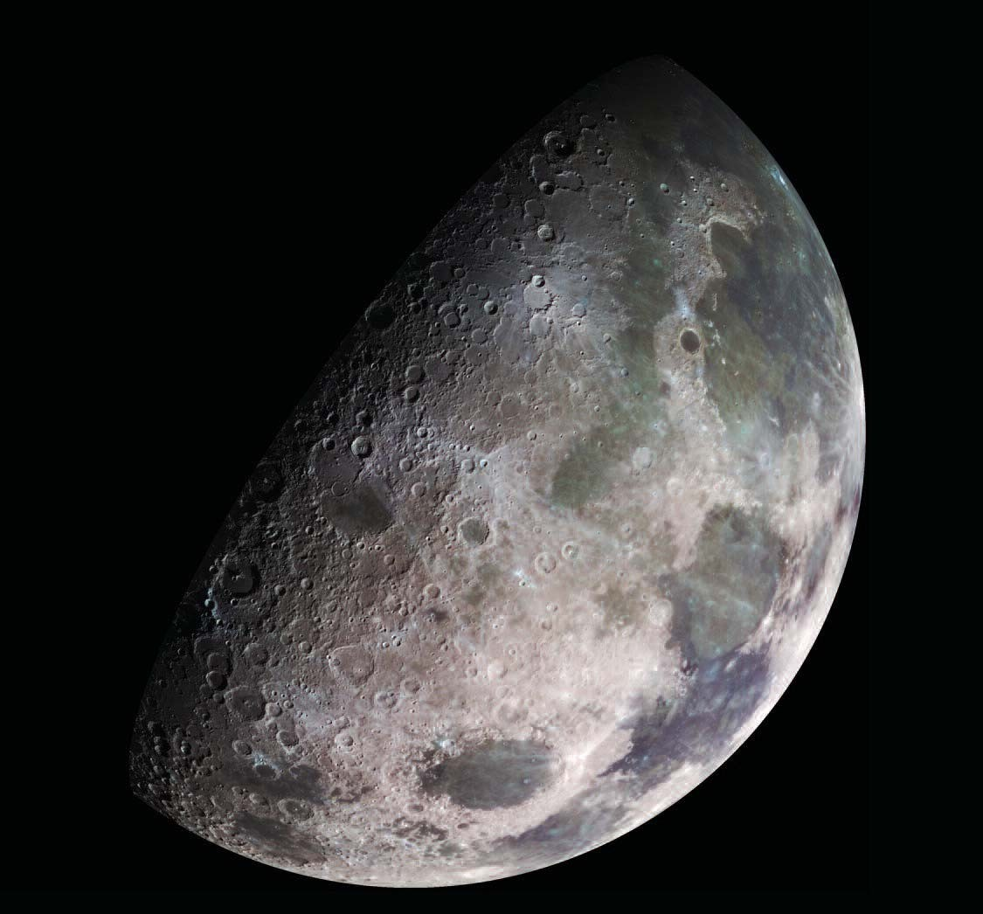

Above: The Moon as seen by the Galileo spacecraft.

Resources

To confine our attention to terrestrial matters would be to limit the human spirit.
Stephen Hawking (1942– )

Exploration Strategy Based on Long-Term Affordability

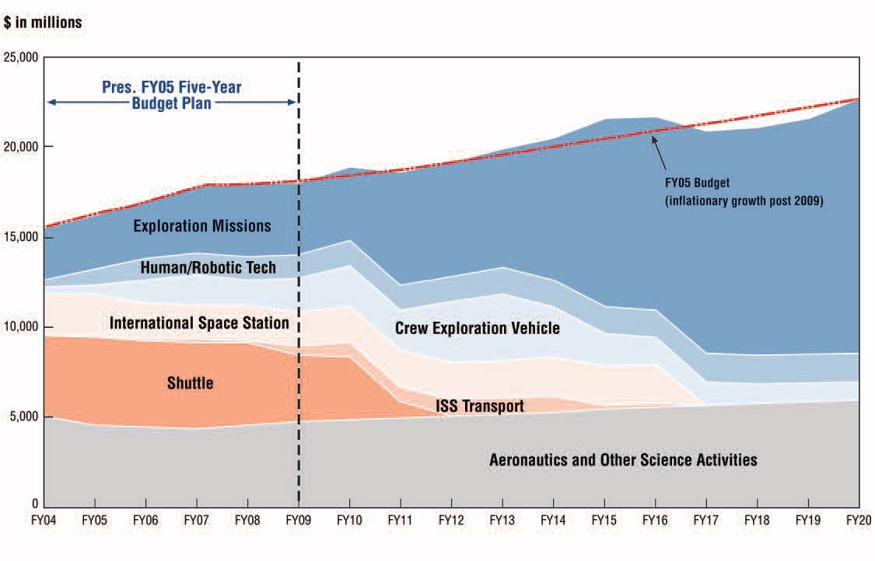

The President’s Vision for solar system exploration is affordable in both the short-term and the long- term. NASA’s budget will increase by five percent per year over the next three years and at about one percent for the following two years.

Although the budget increases are modest, NASA will be able to carry out a robust exploration pro- gram. NASA will free up resources in its budget in
three ways: holding down growth in existing pro- grams that do not support the vision; retiring the Space Shuttle to free up billions of dollars in the next decade; and focusing on innovations that reduce the cost of sustained space operations. The chart above reflects the shift in funding that will occur over time as the new vision for human and robotic exploration of the solar system and beyond is implemented.

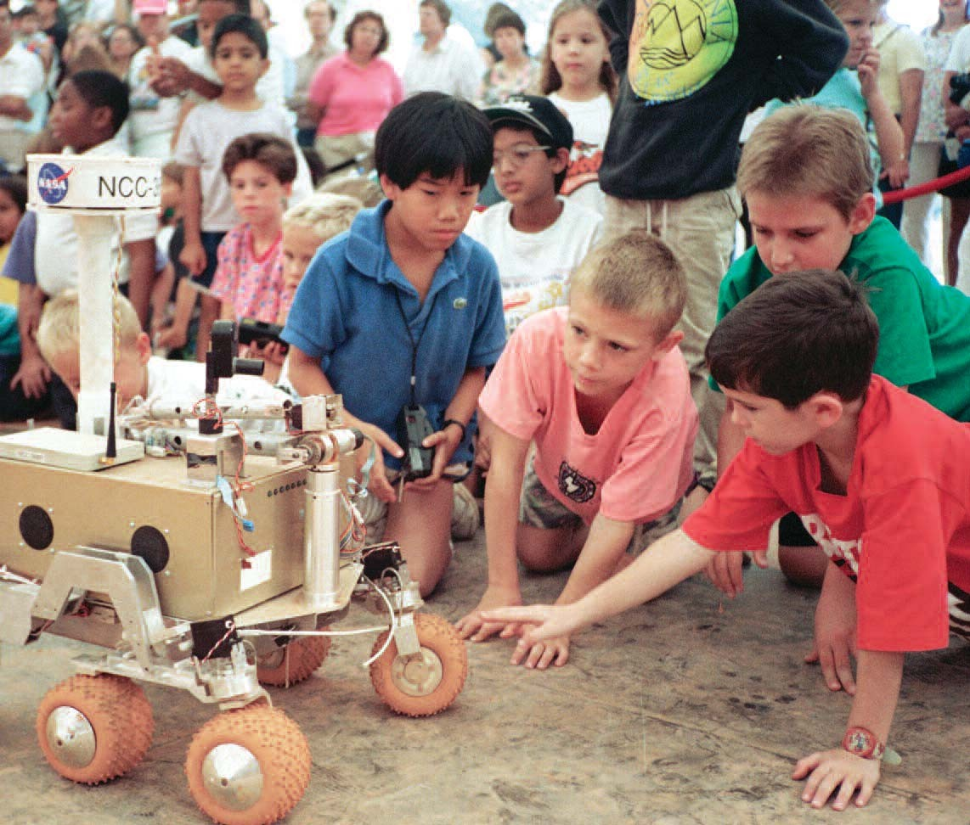

National Benefits

“Mankind is drawn to the heavens for the same reason we were once drawn into unknown lands and across the open sea. We choose to explore space because doing so improves our lives, and lifts our national spirit.”
President George W. Bush January 14, 2004

Just as Meriwether Lewis and William Clark could not have predicted the settlement of the American West within a hundred years of the start of their famous 19th century expedition, the total benefits of a single exploratory undertaking or discovery cannot be predicted in advance. Because the very purpose of exploratory voyages and research is to understand the unknown, exact benefits defy calculation. Nonetheless, we can define important categories of benefits to the Nation and society.

Preparing for exploration and research accelerates the development of technologies that are important to the economy and national security. The space missions in this plan require advanced systems and capabilities that will accelerate the development of many critical technologies, including power, com- puting, nanotechnology, biotechnology, communica- tions, networking, robotics, and materials. These technologies underpin and advance the U.S. econo- my and help ensure national security. NASA plans to work with other government agencies and the pri- vate sector to develop space systems that can address national and commercial needs.

Space exploration holds a special place in the human imagination. Youth are especially drawn to Mars rovers, astronauts, and telescopes. If engaged effec- tively and creatively, space inspires children to seek careers in math, science, and engineering, careers

NASA research stimulates and inspires young minds and provides critical technologies for the Nation.
that are critical to our future national economic com- petitiveness.

The accomplishments of U.S. space explorers are also a particularly potent symbol of American democracy, a reminder of what the human spirit can achieve in a free society. However, space explo- ration also encourages international cooperation, where spacecraft and explorers come to represent our world as well as our Nation.

When the unknown becomes known, it catalyzes change, stimulating human thought, creativity and imagination. The scientific questions that this plan pursues have the potential to revolutionize whole fields of research. For example, scientists are still working to understand how similarly sized planets, such as Mars and Earth, could have developed so differently and what that could mean for our planet. If life is found beyond Earth, biological processes on other worlds may be very different from those evolved on our world. Outside the sciences, the very knowledge that life exists elsewhere in the universe may hold revelations for fields in the humanities.

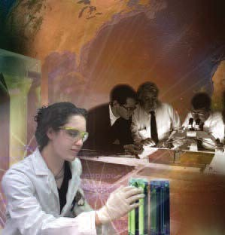
Exploration and discovery are key agents of growth in society—technologically, economically, socially, internationally, and intellectually. This plan sets in motion activities that will contribute to change and growth in the U.S. and the world over the next century.

Image Credits
Page vi An artist’s concept of a spacecraft, equipped with a centrifuge and nuclear–electric propulsion, traveling to Mars, John Frassanito and Associates.

Page 6 An artist’s concept of lunar exploration, John Frassanito and Associates.

Page 8 A drawing of astronauts and robots exploring Mars, John Frassanito and Associates.

Page 12 A drawing of astronauts and advanced robotic assistants building a space telescope, Pat Rawlings, SAIC. Below Analytical Mechanics Associates.
Editing, layout, and design by The Tauri Group, LLC, and Eileen Schramm visual communication.

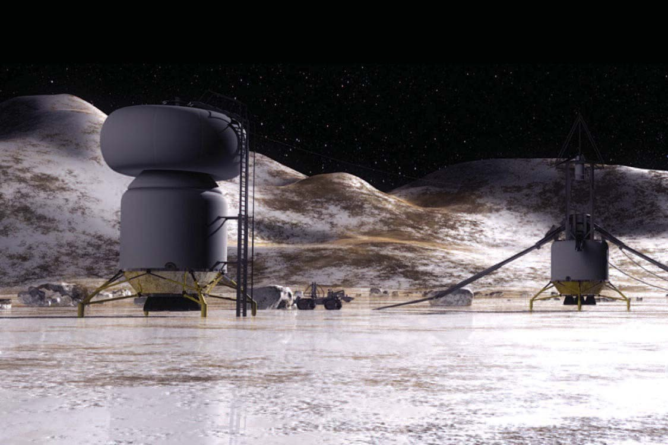

Above: An artist’s drawing of a human exploration base on Callisto, Jupiter’s second largest moon.

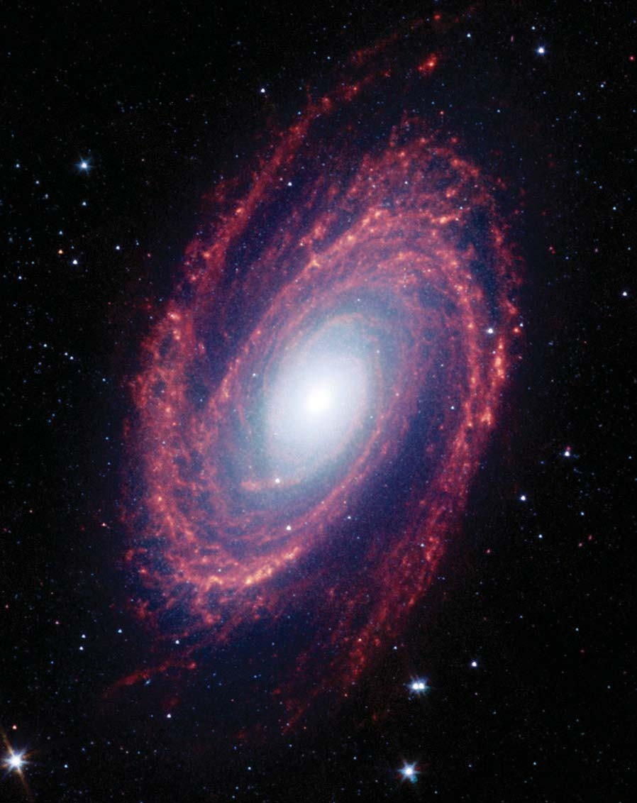

Above: Spiral galaxy M81, located approximately 12 million light-years from Earth, as seen by the Spitzer Space Telescope.

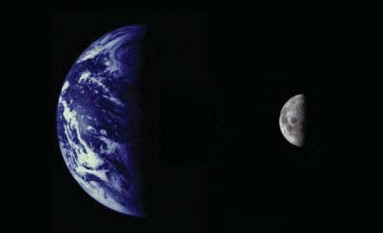

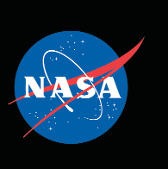

National Aeronautics and Space Administration

NASA Headquarters Washington, DC 20546 NP-2004-01-334-HQ

http://www.nasa.gov

