VIETNAMESE LABOR UNION

**TON DUC THANG UNIVERSITY**

**FACULTY OF INFORMATION TECHNOLOGY**



**LARGE FINAL GRADE OF MATH COMBINATION AND GRAPH**

**SHORTEST PATH**

*Instruction*: **Thầy Lê Đình Thận**

*Implementer*: **Lê Minh Hiếu - 51702016**

**Phạm Anh Duy – 51702088**

**Nguyễn Hữu Khánh - 51702122**

Class**: 17050201**

Course**: 21**

**HO CHI MINH CITY,2019**

THANK YOU

**GRAPHICS ARE COMPLETED AT TON DUC THANG UNIVERSITY**

I assure you this is my own project / product and is guided by Dr. Nguyen Van A; The research contents, results in this topic are honest and unpublished in any form before. The data in the tables for analysis, comment and evaluation are collected by the author from various sources in the reference section.

In addition, a number of comments and assessments as well as data from other authors and organizations have been used in the project.

If any fraud is detected, I will take full responsibility for the contents of my project. Ton Duc Thang University is not related to violations of copyright and copyright caused by me during the implementation process (if any).

Ho Chi Minh city, day and year

Author

(Signature and full name)

*Nguyen Huu Khanh*

*Le Minh Hieu*

*Pham Anh Duy*

PARTNER FOR ASSESSMENT AND EVALUATION OF TEACHERS

**Confirmation part of teacher instructung**

_______________________________________________________________________________________________________________________________________________________________________________________________________________________________________________________________________________________________________________________________________________________________________________________________________________

Ho Chi Minh city, day and year

(Signature and full name)

**The evaluation part of the teacher marking the lesson**

_______________________________________________________________________________________________________________________________________________________________________________________________________________________________________________________________________________________________________________________________________________________________________________________________________________

Ho Chi Minh city, day and year

(Signature and full name)

SUMMARY

CATEGORY

CHAPTER 1: INTRODUCTION………….………………….........7

CHAPTER 2: STATE OF THE WORKS/RETENRED WORKS ………………………………………………………….……………..7

CHAPTER 3: APPROACHES…………….………………………..7

CHAPTER 4: EXPERIENCES AND RESULTS....……………….7

CHAPTER 5: APPLICATIONS……………………………………7

CHAPTER 6: CONCLUSION...……...……………………………..7

**BRAND CATEGORIES AND ABBREVIATIONS**

LIST OF TABLES, DRAWINGS, GRAPHICS

CHAPTER 1 – INTRODUCTION

This project will show you how the shortest path can be found by Dijkstra’s algorithm. This algorithm will computes length of the shortest path from the source to each of the remaining vertices in the graph.

CHAPTER 2 – STATE OF THE ART/ RETERED WORKS

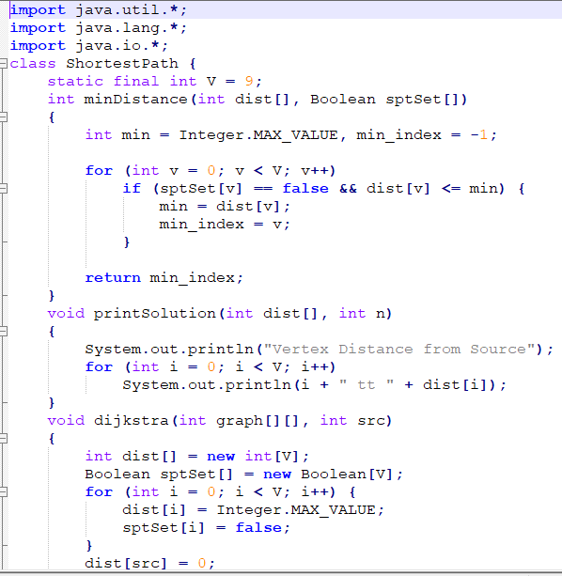

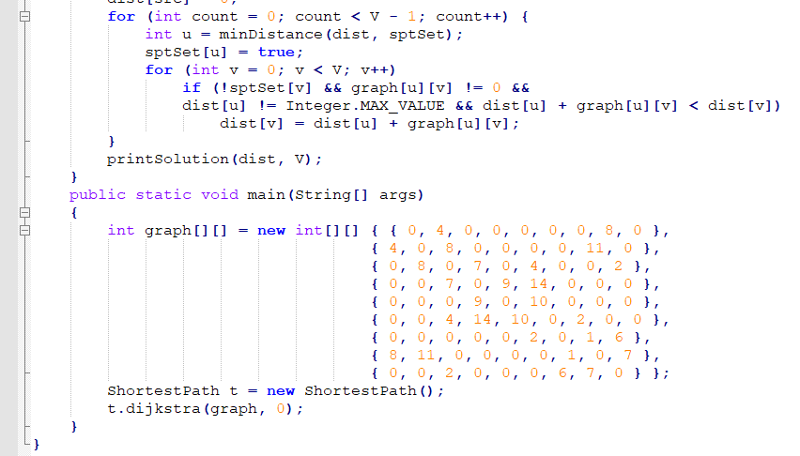

**CHAPTER 3 - APPROACHES**

CHAPTER 4 – EXPERIMENTS AND RESULTS

CHAPTER 5 – CONCLUSION

**REFERENCES**

**APPENDIX**