Solution - Practical Assignment Sheet 2:

Performance Measurements in Ad-Hoc Networks

Mobile Communication

## **Group 6**

Delcy Bonilla Oliva 362019

Duy Khanh Gian     362015​

M.Sc. Media Informatics

June 28, 2016

# Exercise 1

Using Java we have created a console application named pa2.jar that fetches the topology information and measurement data from the test network within the LBH building. The application was tested in Windows 7 and it can run with the command “Java –jar pa2.jar” using the command line.

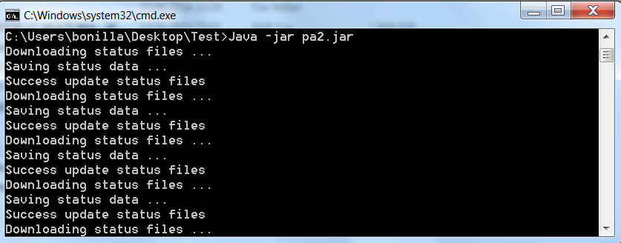

The following libraries were used in this application:

* dom4j.jar
* json-simple-1.1.1.jar
* openxml4j-1.0-beta.jar
* poi-3.9.jar
* poi-3.15-beta1.jar
* poi-ooxml-3.9.jar
* poi-ooxml-schemas-3.9.jar
* xmlbeans.jar

The application access each of the given status URLs every 30 seconds in a period of 2 hours, downloads the files and saves them in a new folder: “./dataPa2/jsonfiles”, each entry is parsed and the stored data is updated. The data is stored as Microsoft Excel Worksheets (.xlsx) in the following directory: “./dataPa2/excelfiles”.

Microsoft Excel Worksheet has been chosen to store the data for its simplicity to create and modify this file type in java and the application can run without any previous setup. Another advantage is its simplicity to work with R, which is the tool used for the second part of this assignment.

Eight files are created: http.xlsx containing the data from the HTTP throughput measurement, ping.xlsx containing the End-to-end delay and loss measurement and six other files, one for each router of the test network. These files contain the following information:

|  |  |  |
| --- | --- | --- |
| **File** | **Sheets** | **Columns** |
| http.xlsx | Sheet1 | Timestamp  Bytes  Time |
| ping.xlsx | Sheet1 | Timestamp  Packetloss  RTTmin  RTTavg  RTTmax |
| status-01.xlsx  status-02.xlsx  status-03.xlsx  status-04.xlsx  status-05.xlsx  status-06.xlsx | status | SystemTime  TimeSinceStartup |
| neighbors | SystemTime  ipAdress  symmetric  multiPointRelay  multiPointRelaySelector  willingness  twoHopNeighborCount |
| links | SystemTime  localIP  remoteIP  validityTime  linkQualit  neighborLinkQuality  linkCost |
| routes | SystemTime  destination  genmask,  gateway  metric  rtpMetricCost  networkInterface |
| topology | SystemTime  destinationIP  lastHopIP  linkQuality  neighborLinkQuality  tcEdgeCost  validityTime |

The data used in the second part of this assignment was collected for 2 hours on the 20th June, 2016 from 12:27 to 14:27.

# Exercise 2

## Task 1

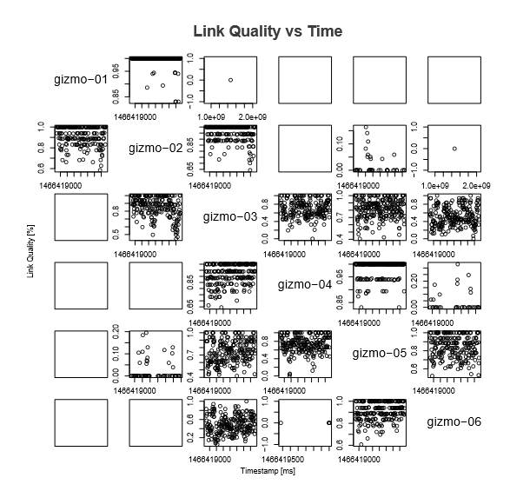

In the matrix plot the link quality of each node is shown through time. Each line of this matrix represents the source node and each column is the destination node. For example the first plot of the second line gives the link quality values of the link from gizmo-02 to gizmo-01. If no data is present at a certain moment in time means that there exist no connection between these two nodes in this moment thus this matrix also provides an idea on how the topology of the network might seem.

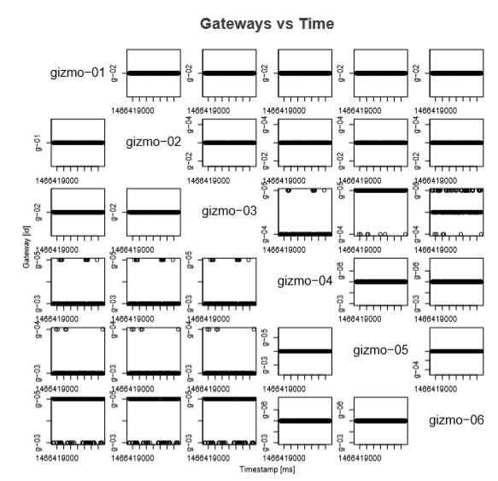

To show the routes of the topology the gateways that each router uses have been plotted in the previous graph. Each line on the matrix of plots represents the gateways that one router uses to reach all other routers, while each column represents the destination router. For example the third line displays the gateways gizmo-03 needs to communicate with the rest of the network, the second graph in this line presents the gateway used from gizmo-03 to gizmo-02 along time. Is important to note the abbreviation used in the y-axis of the plots, g-0X stands for gizmo-0X.

From this matrix the routes between each node can be approximated. To develop the routes that gizmo-01 uses to reach gizmo-06 we start by directing out attention to the plot in the first line and last column, gizmo-01 always uses gizmo-02 to reach gizmo-06; for the second step it can be appreciated that gizmo-02 always uses gizmo-03 to reach gizmo-06, however gizmo-03 uses three different routers to get to gizmo-06, it can communicate directly with gizmo-06, most of the time the connection is through gizmo-05 and few times was done via gizmo-04; finally gizmo-04 always connects to gizmo-06 through gizmo-05 and gizmo-05 reaches directly gizmo-06.

## Task 2

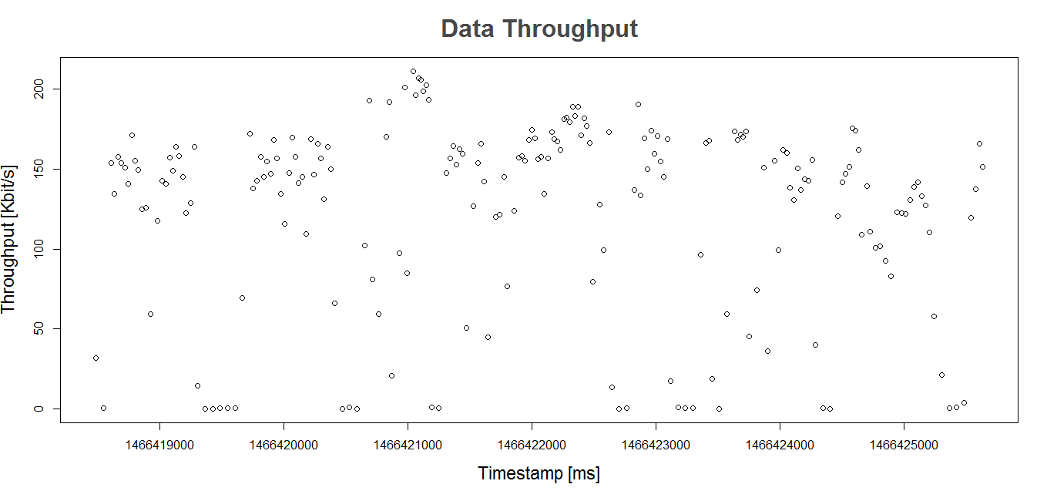

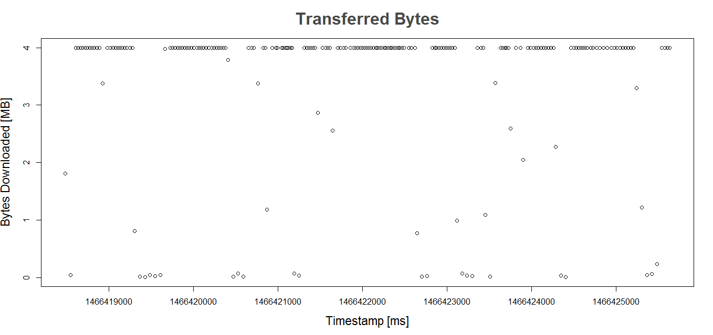

The variation of the data throughput can be easily appreciated in the first graph; when compared with the second graph we can see that, at moments with low transferred bytes we have low data throughput, however most the transferred bytes in our time frame are around 4MB, showing less variations. When compared with the topology analysis, we can see how the data throughput strongly depends on the topology of the network. The link quality shows fluctuation along the time thus the routes between router gizmo-01 and router gizmo-06 are constantly changing through time and producing a high packet loss rate; these changes of the topology are the cause of the variations in the data throughput.

## Task 3

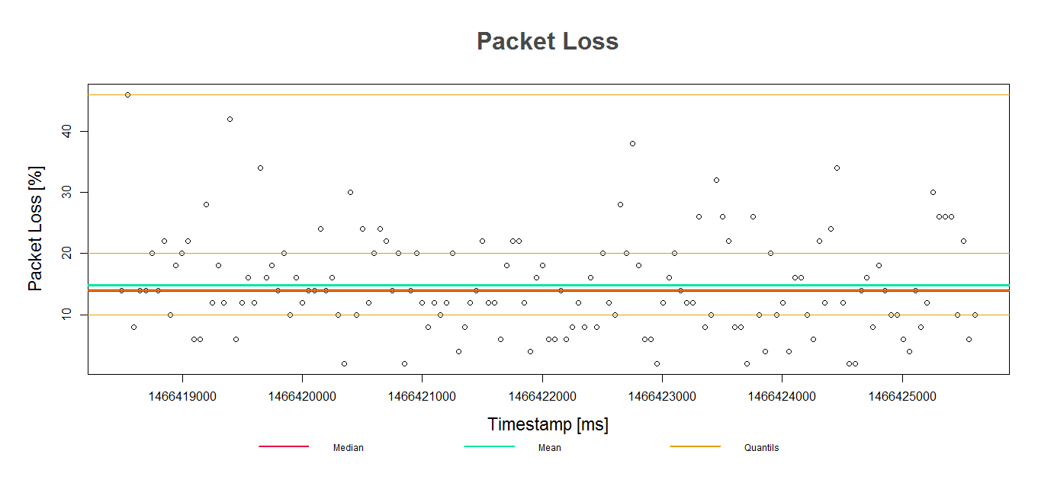

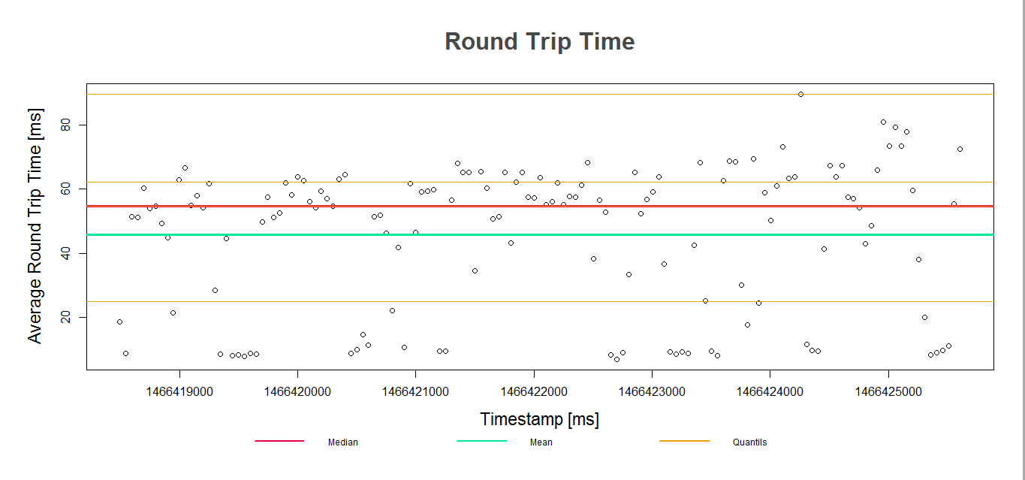

To analyze and evaluate the end-to-end packet loss and latency the median, mean and quantiles at 25, 50, 75, and 100 were added to the plots. As result we have that 75% of the packet loss values are less than 20% and the average is 15%. As for the latency we have a median of 54.65 milliseconds with a maximum value of 89.52 milliseconds. It has to be noted that this is the maximum value of the average round trip time.

### Multiplayer Computer Games

“The Effects of Loss and Latency on User Performance in Unreal Tournament 2003” (Beigbeder, et al., 2004) states that users rarely notice packet losses as high as 5% during the game while another study examining the perception of quality in video stream at 30 frames per second indicated that with losses less than 17%, the loss is imperceptible; between 17%-23%, it is tolerable; while above 23% it is unacceptable (Wijesekera, Srivastava, & Nerod, 1999). 25% of the packet loss values in our graph lay between 20% and 40% thus if not well handled the packet loss can be easily perceptible.

Many papers often quote 100 milliseconds as acceptable latency for multiplayer games. Raaen and Grønli in their paper “Latency Thresholds for Usability in Games: A Survey” conclude that 60 milliseconds, or even 45 milliseconds are better estimates at how much latency is acceptable in the most fast-paced games than the traditionally quoted 100 milliseconds value (Raaen & Grønli, 2014).

With more 25% of the round trip time values above 60 milliseconds and a high packet loss rate we conclude that the test network is not suited for multiplayer games.

### Voice-over-IP

In the case of latency ITU-T G.114 recommends delays less than 150 milliseconds one-way (ITU, 2016), the round trip times showed in the graph are below 90 milliseconds, while more than 50% of these values are below 55 milliseconds thus the network complies with this requirement.

75% of the packet loss values are below 20% however VoIP is not tolerant to packet loss, cisco’s Quality of Service for Voice over IP paper states: “The default G.729 codec requires packet loss far less than 1 percent to avoid audible errors. Ideally, there should be no packet loss for VoIP” (Cisco). A technique called Packet Loss Concealment is used to mask the effects of lost or discarded packets however this requires more bandwidth and provides reasonable quality up to 20% packet loss rates, that means that even using PLC algorithms our network is not suitable for Voice-over-IP.

### E-Mail

In the article “Outlook 2010 – network latency test results” (Trinder, 2016) the author tests the impact of network link latency on Outlook client performance. These test were performed in three different client connections, the best performance for Outlook 2010 Online Mode is between 0 milliseconds and 110 milliseconds, for Outlook 2010 Cached Mode is between 0 milliseconds and 200 milliseconds and for Outlook 2010 Outlook Anywhere (RPC/HTTPS) goes up to 320 milliseconds. Even though the high packet loss percentage will definitely affect the performance of this service, the network is suitable for E-Mail.

# References

Beigbeder, T., Coughlan, R., Lusher, C., Plunkett, J., Agu, E., & Claypool, M. (2004). *http://conferences.sigcomm.org/.* Retrieved from http://conferences.sigcomm.org/sigcomm/2004/workshop_papers/net505-claypool11.pdf

Cisco. (n.d.). *http://www.cisco.com/.* Retrieved from http://www.cisco.com/c/en/us/td/docs/ios/solutions_docs/qos_solutions/QoSVoIP/QoSVoIP.pdf

ITU. (2016, 06 21). *www.itu.int*. Retrieved from https://www.itu.int/rec/T-REC-G.114/en

Raaen, K., & Grønli, T.-M. (2014). *https://www.google.de/url?sa=t&rct=j&q=&esrc=s&source=web&cd=1&cad=rja&uact=8&ved=0ahUKEwj6p7TU_LjNAhWChywKHel3AtEQFggeMAA&url=http%3A%2F%2Fojs.bibsys.no%2Findex.php%2FNIK%2Farticle%2Fdownload%2F9%2F6&usg=AFQjCNG3FKsoYpYWztcPW59SrpRcFk_PQg&sig2=43Zskf6hky.* Retrieved from https://www.google.de/url?sa=t&rct=j&q=&esrc=s&source=web&cd=1&cad=rja&uact=8&ved=0ahUKEwj6p7TU_LjNAhWChywKHel3AtEQFggeMAA&url=http%3A%2F%2Fojs.bibsys.no%2Findex.php%2FNIK%2Farticle%2Fdownload%2F9%2F6&usg=AFQjCNG3FKsoYpYWztcPW59SrpRcFk_PQg&sig2=43Zskf6hky

Trinder, G. (2016). *blogs.technet.microsoft.com*. Retrieved from https://blogs.technet.microsoft.com/neiljohn/2011/06/15/outlook-2010-network-latency-test-results/

VoIP Troubleshooter.com. (2016, 06 21). *http://www.voiptroubleshooter.com/index.html*. Retrieved from http://www.voiptroubleshooter.com/index.html

Wijesekera, D., Srivastava, J., & Nerod, A. (1999). Retrieved from http://dmr.cs.umn.edu/Papers/P1999_12.pdf