-Describe time lapse

# Task 2

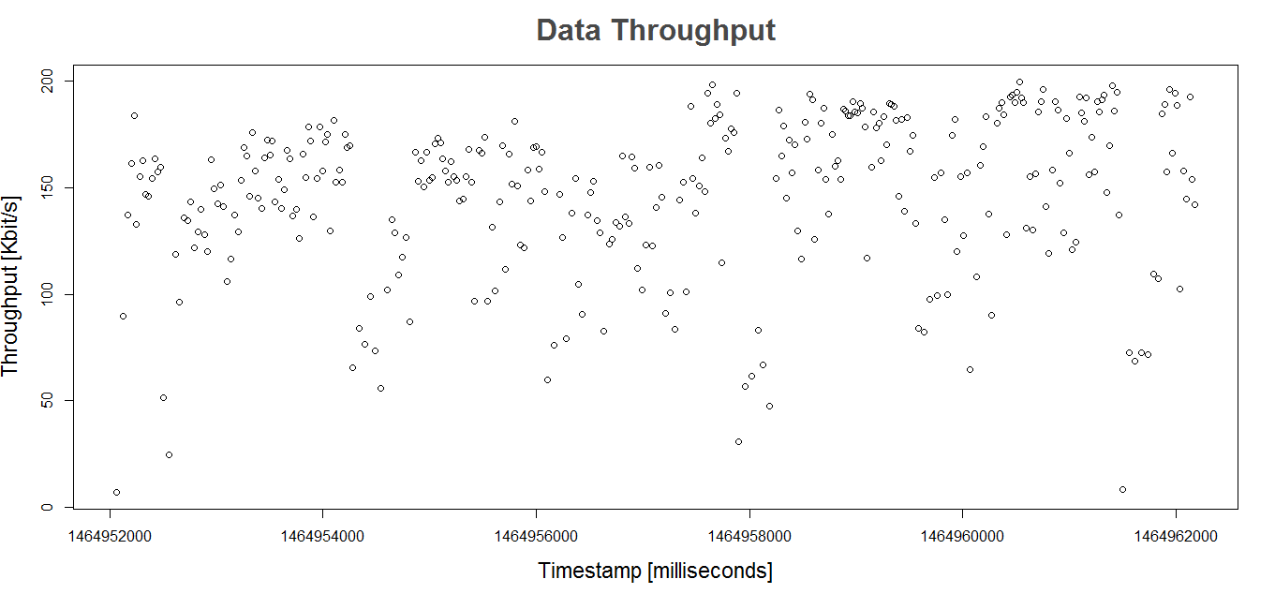

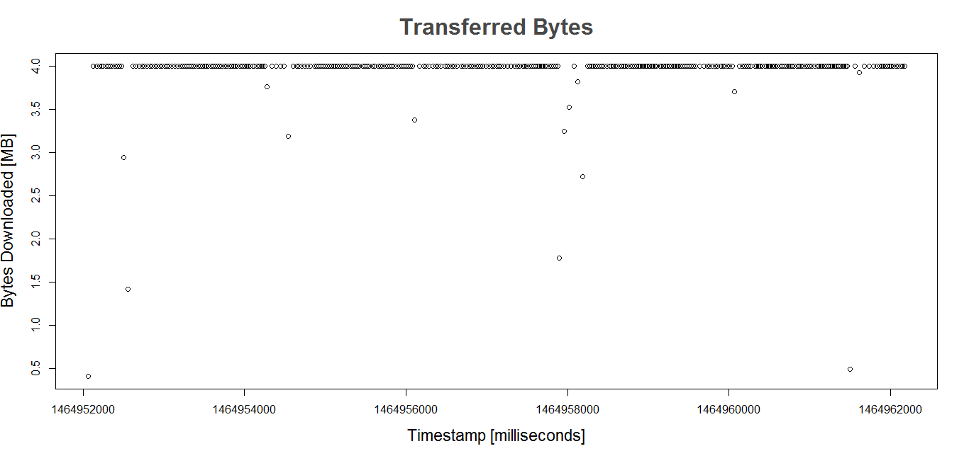

The variation of the data throughput can be easily appreciated in the first graph; when compared with the second graph we can see that, at moments with low transferred bytes we have low data throughput, however the transferred bytes are almost constant along our time frame, showing very few variations.

When compared with the topology analysis, we can see how the data throughput depends on…(link quality??) of the link between router gizmo-01 and router gizmo-06.