Assignment 5
Huy Khanh, Ha – 119465
Hung Thang, Nguyen – 119533

5.1

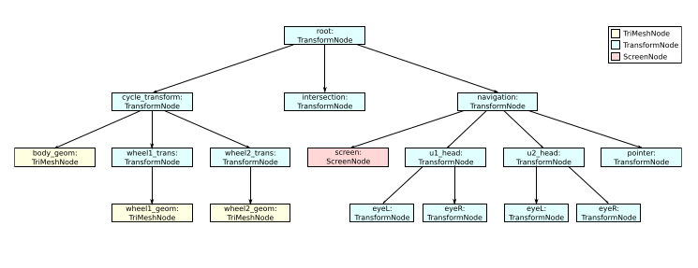
- You are given an arbitrary rotation matrix R and a rotation center defined
by the intersection node. Apply the rotation correctly to the navigation
node.
navigation.T = R * inv(intersection.T ) * navigation.T

- The pointer node defines the transformation of a tracked input device
controlling a straight-line pick ray. The intersection node represents the
intersection of the pick ray with the scene in world coordinates. Transform
the intersection node into a coordinate system, in which the -z-translation
component represents the distance of the pointer to the intersection.

T = intersection.T * inv(navigation.T) * inv(pointer.T)

- You are given pointer.T in the last frame and the current frame, denoted
by pointer_lf and pointer_cf, respectively. What is the delta matrix for
which pointer_lf · delta = pointer_cf holds?

pointer_lf.T * delta = pointer_cf.T
delta = inv(pointer_lf.T) * pointer_cf.T

- Perform a Model-View-Transformation of wheel1_geom.

inv(screen.T) * inv(navigation.T ) * cycle_transform.T * wheel1_trans.T * wheel1_geom.T
5.2.
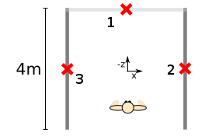

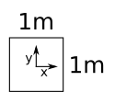

screen_1.T = translate(0, 0, -2) * scale(4,2,1) * screen_org.T
screen_2.T = translate(0,0, 2) * rot( 90, axis=(0,1,0)) * scale(4,2,1) * screen_org.T
screen_3.T = translate(0,0, 2) * rot(-90, axis=(0,1,0)) * scale(4,2,1) * screen_org.T

5.3
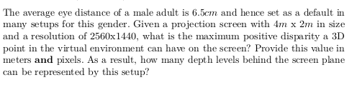

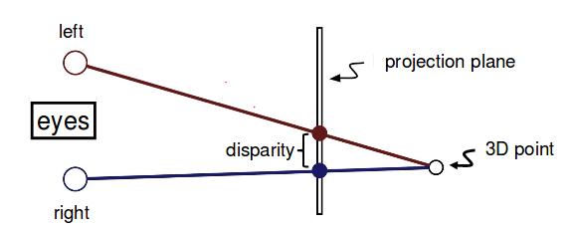

- when the 3d point approach infinity, the disparity values approach its maximum value, which is equal to the eye distance.
=> the maximum positive disparity in this case is 6.5 * 1e-2 meter.

- number of pixels per meter = 2560/4 = 640
=> the maximum positive disparity = 6.5*1e-2 * 640 = 41.6 pixels

- the maximum number of depth levels in this set up: 41, which is the number of red points on the below picture. In other words, we shoot 41 green rays from the left eyes and then the red points are found as the intersection points between these green rays and the projection direction of the right eye.
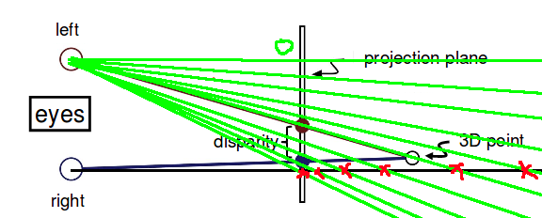

5.4
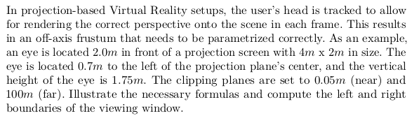
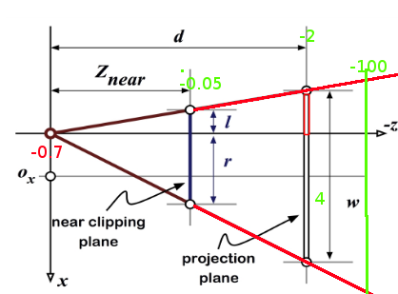

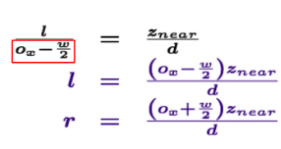

l = ((-0.7 - 4/2) * 0.05 ) / 2 = -0.0675
r = ((-0.7 + 4/2) * 0.05 ) / 2 = 0.0325

