**Carti Hotel Management System**

Use-Case Specification: Book Rooms

Version <1.0>

Revision History

|  |  |  |  |
| --- | --- | --- | --- |
| **Date** | **Version** | **Description** | **Author** |
| 20/11/2024 | 1.0 | Final Version | Nguyen Giang Minh |
|  |  |  |  |
|  |  |  |  |
|  |  |  |  |

**Table of Contents**

1. Book Rooms 4

1.1 Brief Description 4

2. Flow of Events 4

2.1 Basic Flow 4

2.2 Alternative Flows 4

3. Special Requirements 4

4. Preconditions 4

5. Postconditions 4

6. Extension Points 5

Use-Case Specification: Book Rooms

# Book Rooms

## Brief Description

This use case allows a customer to book rooms offered by the Carti hotel.

# Flow of Events

## Basic Flow

After the customer clicks the Book Now button, a window appears displaying options to initiate the booking process. On the left, a calendar allows the customer to select the Start Date and End Date, with the ability to navigate between months using arrow buttons. On the right, the customer can adjust the number of Rooms, Adults, and Children using the "+" or "-" buttons, with a note indicating that children are aged 0 to 17. Below these options, there is a field for entering a promo code if applicable. At the bottom, a dark blue Search Room button enables the customer to proceed to the next step.

After clicking this button, if the information is invalid , there is a pop up to notify error. If customer enter valid information ,the page reloads, and at the top, a progress indicator shows that the customer is now on the first step, Room Selection. The booking details from the previous page are displayed. The list of suitable rooms will display, the description will be displayed right in each room with number of people and total price .

By clicking the dark blue Select button on a room option, the page updates to display detailed booking information in a rectangular box, including the address, reception opening hours, check-in and check-out dates, spoken languages, and contact information, detailed room descriptions and prices, followed by a form to input personal details such as email, title, first name, last name, phone number. If the information customer enter are invalid, there is a rectangle pop-up notification, customer need enter valid information again.

At the bottom of this page is a dark blue Book&Proceed button to confirm the reservation. If all information is valid, the customer is redirected to a confirmation page that displays a successful booking message.

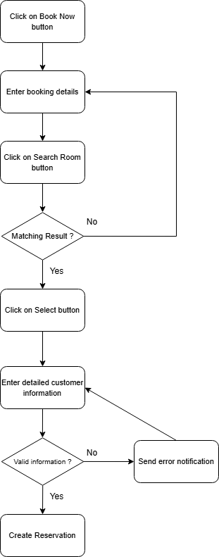

## Alternative Flows

None.

# Special Requirements

None.

# Preconditions

The user has successfully logged in the system in the role of customer

# Postconditions

The customer’s reservation history is updated, and the unavailable dates for the selected rooms are modified accordingly.

# Extension Points

NA.

# Prototype

1. After the customer clicks on the dark blue Book Now button, the customer sees a calendar with a form on the left side of it. In the form, the actor chooses the check-in date and check-out date. Input the number of people (adults and children) and the promo code on the right.

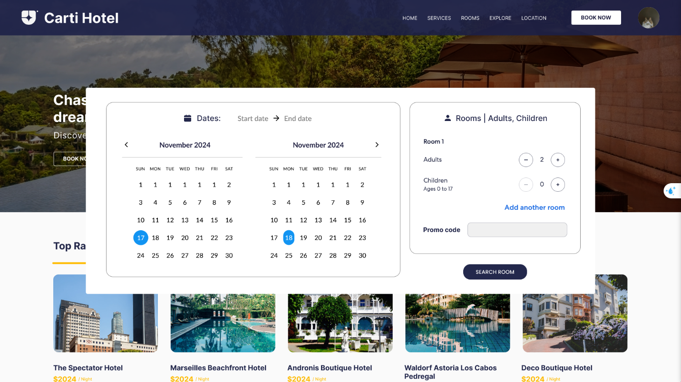

1. After that, the actor clicks on the dark blue Search Room button and the page is reloaded. The list of suitable rooms will display, the description will be displayed right in each room with number of people and total price. Customer can choose the room which he/she want by clicking the dark blue “Select” button.

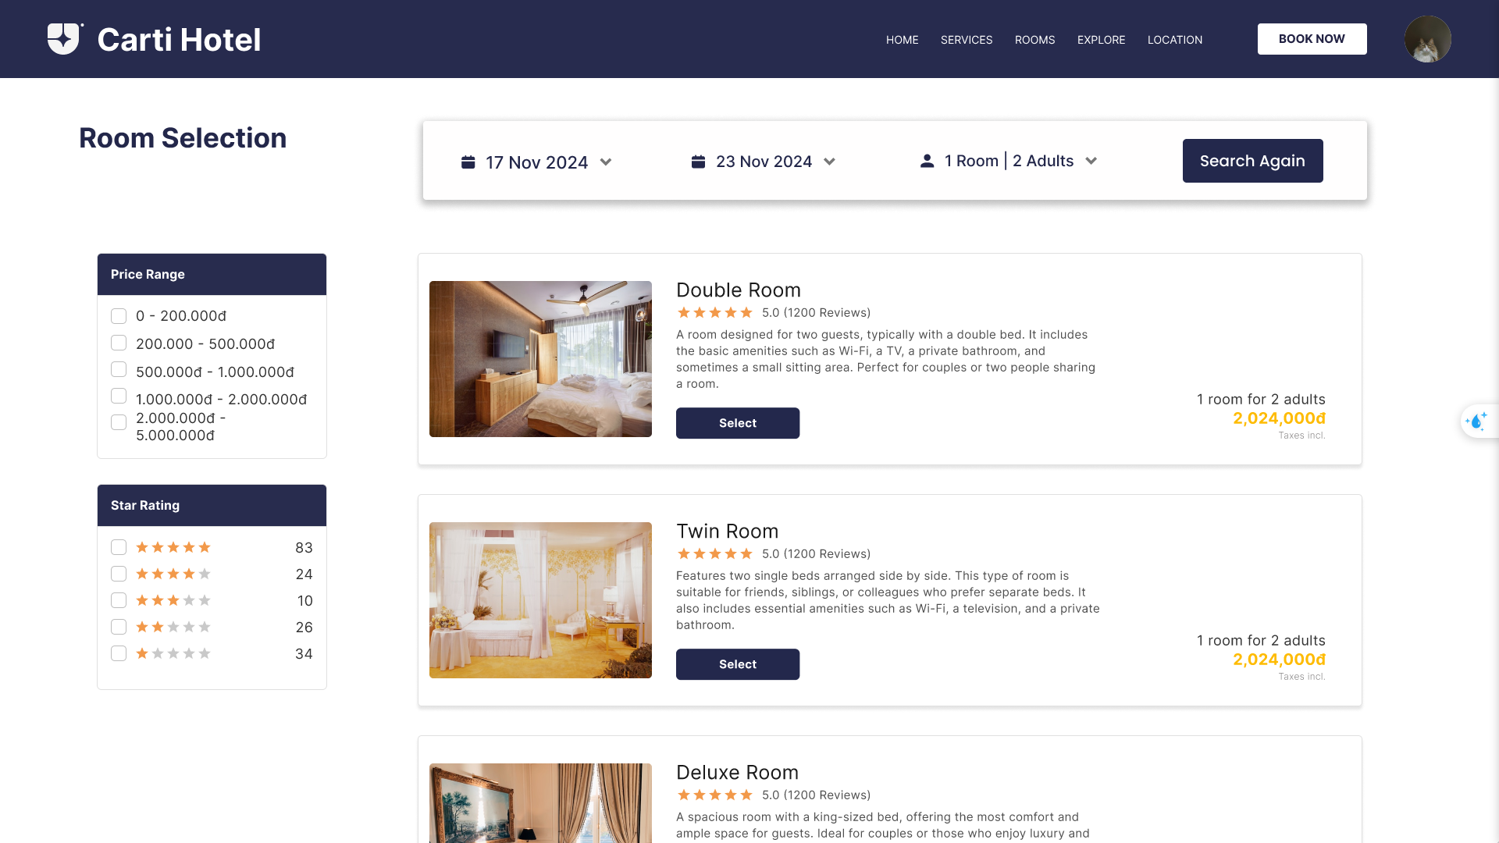

1. The page updates to display detailed booking information in a rectangular box, including the address, reception opening hours, check-in and check-out dates, spoken languages, and contact information, detailed room descriptions and prices, followed by a form to input personal details such as email, title, first name, last name, phone number.

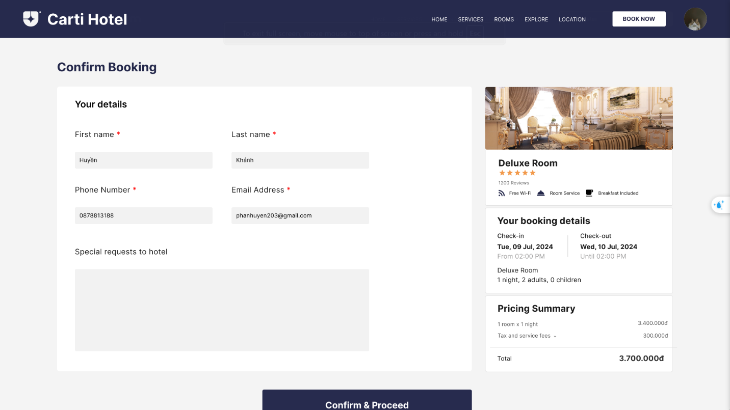

If the information customer enter are invalid, there is a rectangle pop-up notification, customer need enter valid information again.

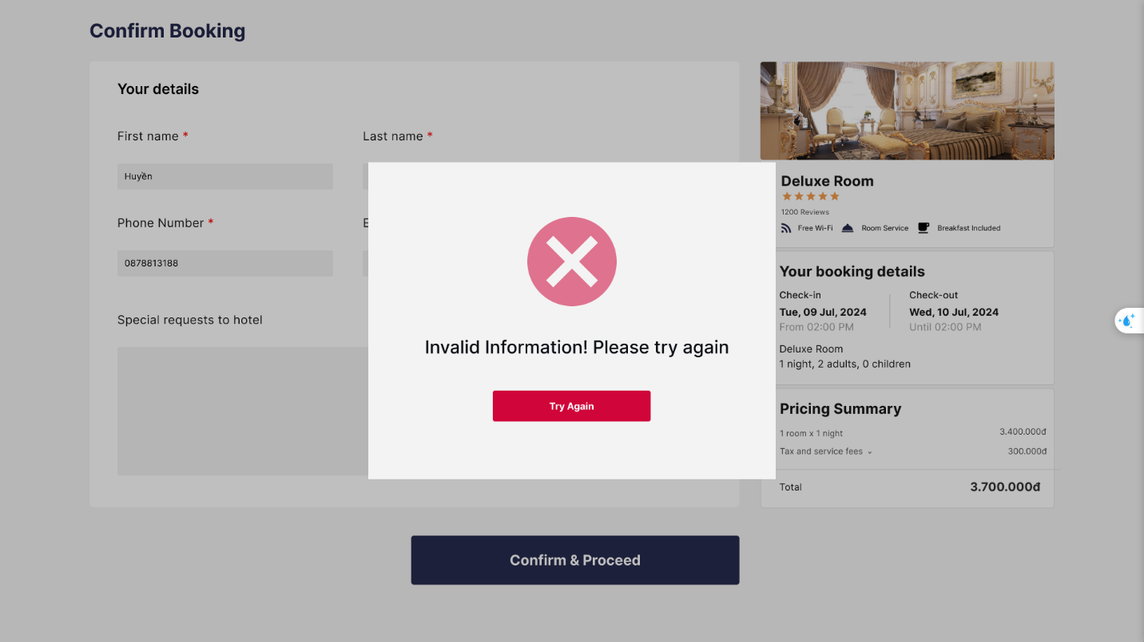

1. At the bottom of this page is a dark blue **Book&Proceed** button to confirm the reservation. If all information is valid, the customer is redirected to a confirmation page that displays a successful booking message with a reservation.

