**Carti Hotel Management System**

**Use-Case Specification: Check-in**

**Version <1.0>**

# Revision History

|  |  |  |  |
| --- | --- | --- | --- |
| **Date** | **Version** | **Description** | **Author** |
| 24th Nov 2024 | Version 1.0 | Final version | Tran Quang Huy |
|  |  |  |  |

**Table of Contents**

Revision History 2

Use-Case Specification: Manage Users 4

1. Manage users 4

1.1 Brief Description 4

1.2 Actor 4

2. Flow of Events 4

2.1 Basic Flow 4

2.2 Alternative Flows 5

3. Special Requirements 6

4. Preconditions 6

5. Postconditions 6

6. Extension Points 6

7. Prototype 6

# Use-Case Specification: Manage Users

## Manage users

### Brief Description

This use case outlines the process of customer check-in, particularly in cases where the customer has not made a reservation in advance but wishes to book a room directly at the reception. It allows the receptionist to complete the room booking and check-in process for the customer on the spot.

### Actor

Receptionist

## Flow of Events

### Basic Flow

On the Receptionist Page, the left side contains functional buttons such as Home Page, Check-in, Check-out, Rooms, Manage Services, Customer, and Cashier. The rest of the page displays the status of rooms in the hotel. A green status with the label "Vacant Ready" indicates a room is available for customers. A purple status means the room is being cleaned, while a red status means the room is currently occupied.

The receptionist begins by entering a customer's name in the search bar and clicking the search button. A list of matching customers will appear, and the receptionist selects the appropriate customer. The customer's reservation history is displayed, with each reservation shown in a separate block. Each reservation includes details such as the check-in and check-out dates, length of stay, room type, and total price.

If the customer has not made a reservation or has not booked a room for the current arrival, the receptionist clicks the "Check In Now" button. This redirects them to the Check-in Page, which includes a check-in form. Below the form, there is a Save button that matches the website’s main color. The receptionist then selects the required options for the customer, including the room number, check-in and check-out dates, and the number of guests, and clicks the Save button once the form is completed.

If the chosen room is available, a success message will appear. If the customer has already made a reservation, the receptionist does not need to proceed with the check-in process, and the process concludes at that point.

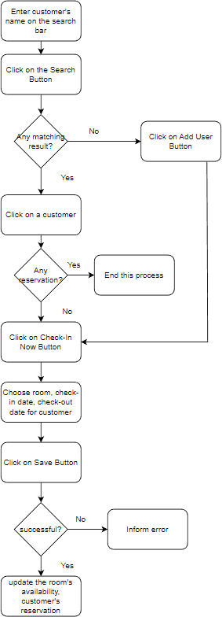

### Alternative Flows

When no matching customer results are found during the search, the receptionist must create a new user for the customer. To do so, the receptionist hovers over the "Customer" button on the Receptionist Home Page and clicks the "Add Customer" button. This action navigates them to the "Add User" form, where they enter the required customer information, including full name, phone number, sex, role, job, address, ID, nationality, passport details, and email. Once all information is provided, the receptionist clicks the "Save" button to complete the user creation process.

After creating the new user, the receptionist can proceed with the check-in process for the customer as described earlier.

## Special Requirements

None

## Preconditions

The user has successfully logged in with the role of receptionist.

## Postconditions

The customer’s reservation history is updated. The chosen rooms’ unavailable dates are updated.

## Extension Points

NA.

## Prototype

Firstly, the receptionist enters the customer’s name on the search bar and then clicks the Search Button. A list of matching customers will be shown:

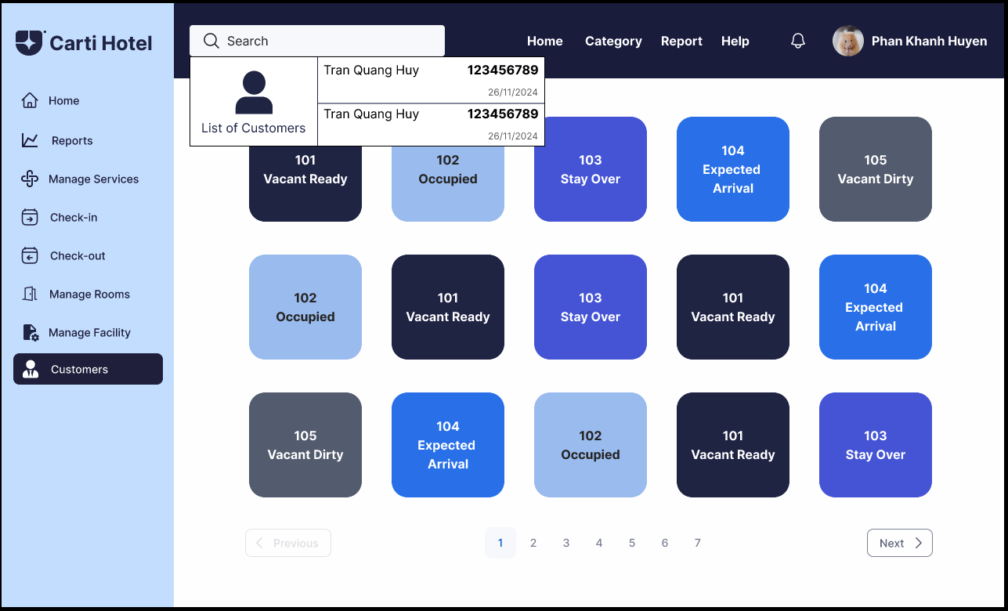

The receptionist clicks on a customer, then the reservation history of that customer will be shown up. Each block is a reservation including check-in, check-out date, total length of stay, the room type and total price. Below these blocks are two buttons: Check-in now to check-in for customers and Go back to come back.

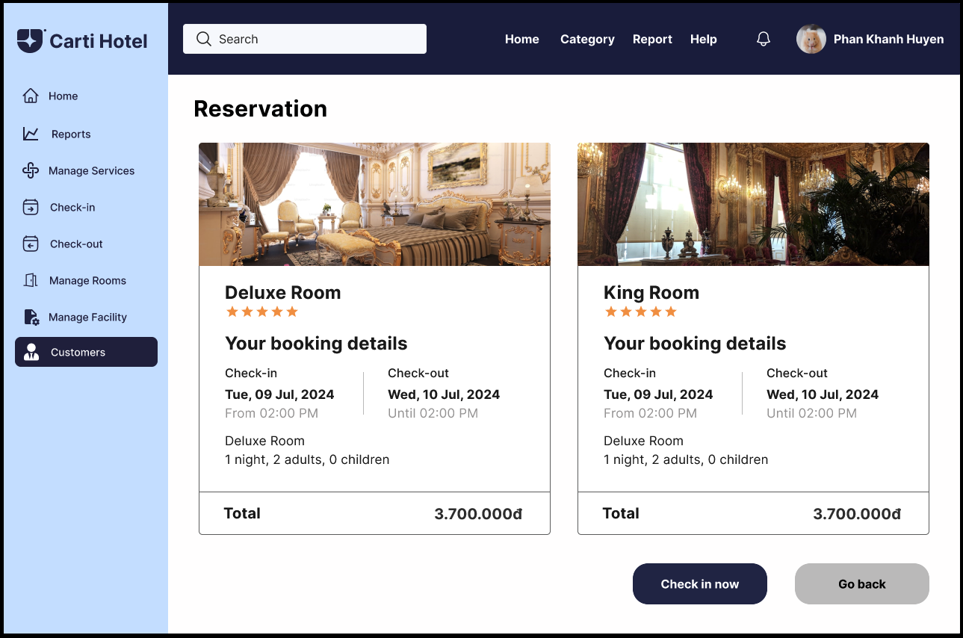

If the customer has booked any room in advance, the receptionist does not have to check-in for that customer anymore. Else, click on the Check In Now Button, which will navigate the receptionist to the Check-in Page. There, the receptionist chooses all the options that the customer requires. The chosen room will be blue.

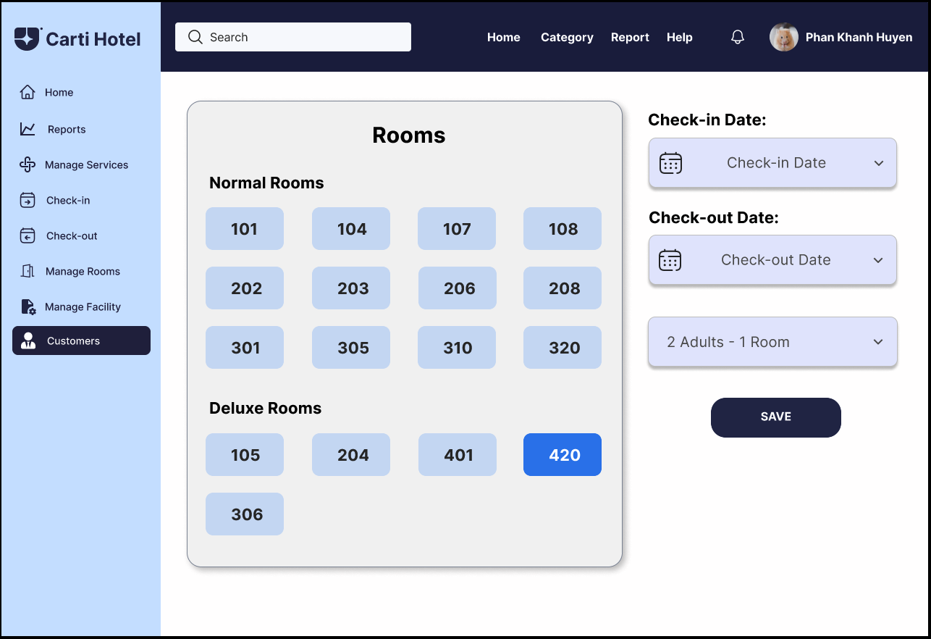

After choosing all the information to check-in for the customer, click the Save Button. A success message will show up if the rooms chosen are available:

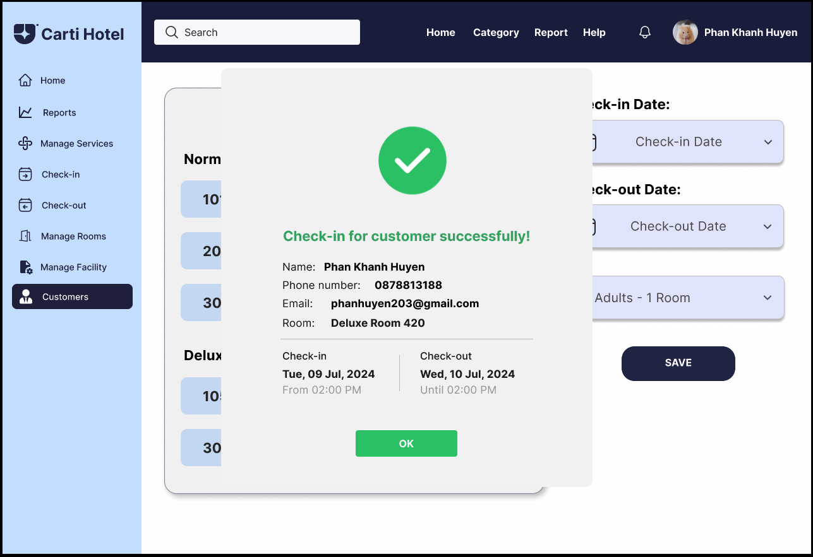

In the case that there are not any matching customers, or in other words, the customer has not created a booking account, the receptionist has to add a new customer account. On the receptionist page, hover on the Customer Button, and the Add Customer Button will show up.

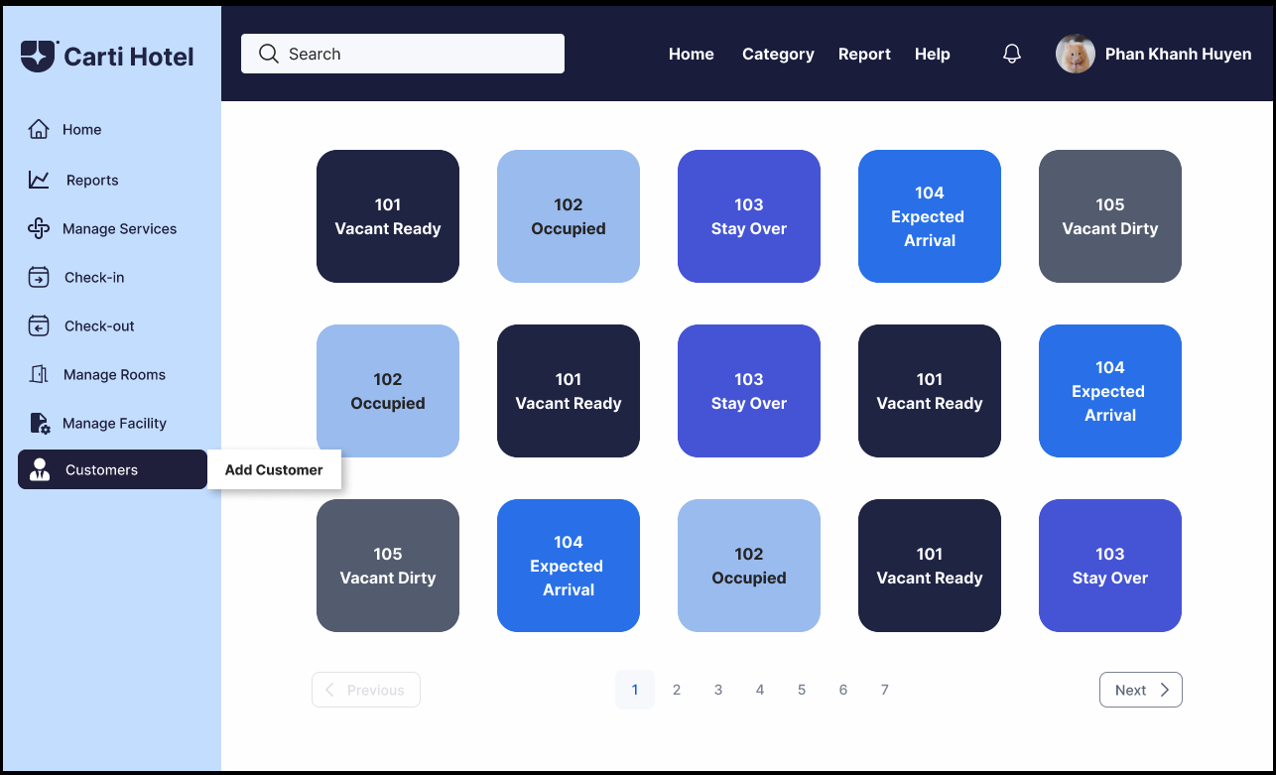

The receptionist clicks on the Add Customer button and will be directed to the Add Customer Page then. There, input all the required information to create a new Customer. If the input data is valid, at the end of each block will appear a green tick, otherwise, a red cross will appear. Beside the form is Save button with the same color as the main color of the website.

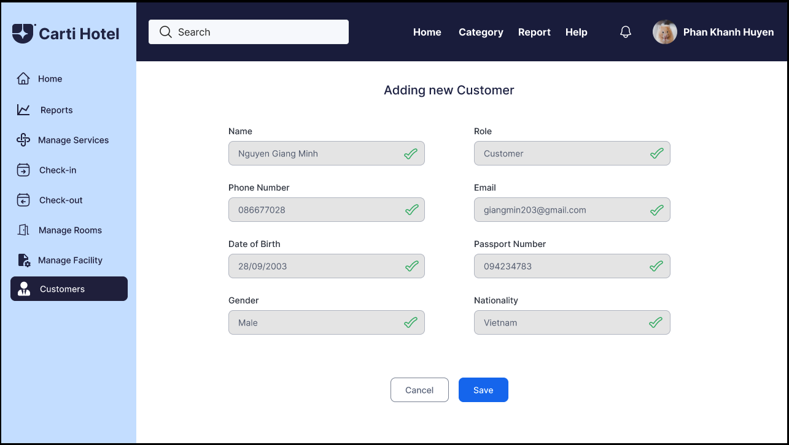

When finishing, click the Save Button, and a success message will be shown if nothing goes wrong. Along with the success message is the Check-in Now button. By clicking on this, the receptionist will be navigated to the Check-in page and start to check-in for Customer.

