**Carti Hotel Management System**

Use-Case Specification: Manage Services

Version <1.0>

Revision History

|  |  |  |  |
| --- | --- | --- | --- |
| **Date** | **Version** | **Description** | **Author** |
| 24/11/2024 | 1.0 | Final Version | Dang Gia Nguyen |
|  |  |  |  |
|  |  |  |  |
|  |  |  |  |

**Table of Contents**

1. Book Rooms 4

1.1 Brief Description 4

2. Flow of Events 4

2.1 Basic Flow 4

2.2 Alternative Flows 4

3. Special Requirements 4

4. Preconditions 4

5. Postconditions 4

6. Extension Points 5

Use-Case Specification: Manage Services

# Book Rooms

## Brief Description

This use case describes the process of managing services, including adding new services and deleting a service from a customer’s reservation and bill.

## Actor

Receptionist

# Flow of Events

## Basic Flow

### Add service

On the Receptionist Page, the receptionist enters a customer's name into the search bar located below the navigation bar and initiates a search by clicking the search button. A list of matching customers is presented, enabling the receptionist to select the desired customer. Upon selection, the receptionist is redirected to the Booking Details Page.

The Booking Details Page displays reservation information, including the check-in and check-out dates, total stay duration, and the customer's details such as name, phone number, and email. If the customer requests additional services, the receptionist can click the "Add Service" button located at the bottom of the page.

On the Add Services Page, the hotel's available services are listed on the right-hand side of the screen. The center features a service table with three columns: service name, quantity, and price. The receptionist selects the desired service type and quantity based on the customer's preferences. The total price dynamically updates as quantities are adjusted, and the cumulative amount is shown below the table. Once the selections are complete, the receptionist clicks the "Save" button to add the selected services to the customer's reservation and bill.

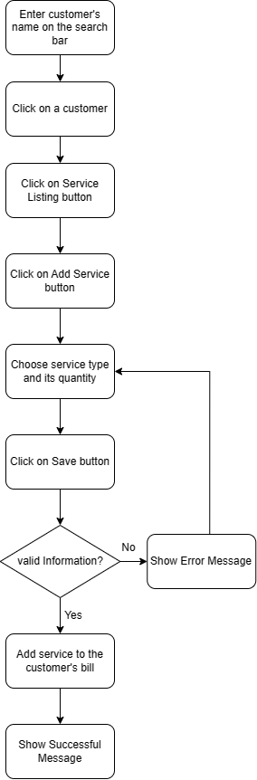

### Delete service

On the Receptionist Page, the receptionist enters a customer’s name into the search bar and clicks the search button. A list of matching customers is displayed, enabling the receptionist to select a specific customer. Upon selection, the receptionist is redirected to the Reservation Details Page.

The Reservation Details Page presents details about the customer’s reservation. At the bottom of the page, a "Services Listing" button is available. Clicking this button navigates the receptionist to the Services Page, where all services previously ordered by the customer are displayed. To remove a service, the receptionist selects the service and clicks the "Delete Service" button. A confirmation box appears, and upon confirmation, the service is deleted from the customer’s reservation and bill.

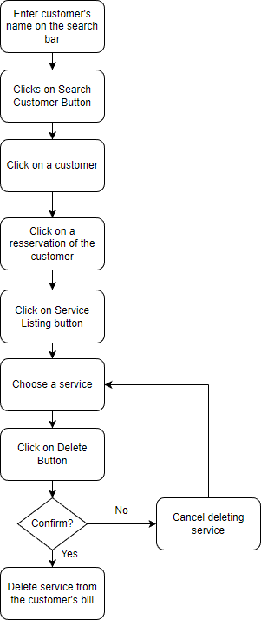

## Alternative Flows

None.

# Special Requirements

None.

# Preconditions

The user has successfully logged in with the role of receptionist. The customer has reserved at least one room.

# Postconditions

The customer’s reservation and bill are updated.

# Extension Points

NA.

# Prototype

On the Receptionist Page, functional buttons like Home Page, Manage Services, Report, Manage Rooms, and Manage Facility are situated on the left side. The remaining section provides an overview of the hotel's room status. Rooms marked with the darkest blue color and labeled "Vacant Ready" indicate their availability for customers. Grey-colored rooms are currently undergoing cleaning, while the lightest blue color signifies occupied rooms. The other two types of blue color either means the room already expecting customers or it’s being stayed over.

To initiate a search for a customer, the receptionist begins by entering the customer's name in the search bar and subsequently clicking the Search Button. This action prompts the display of a list containing customers whose names match the entered criteria:

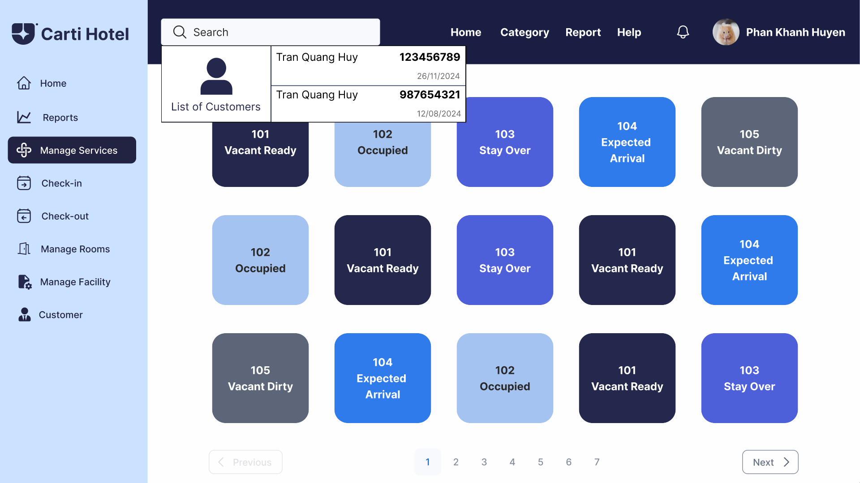

The receptionist clicks on a customer, then the reservation details of that customer will be shown. The details include check-in, check-out date, total length of stay, room type, total price as well as the customer’s name, phone number, and email. Below on the bottom left corner of the screen is the Service Listing button.

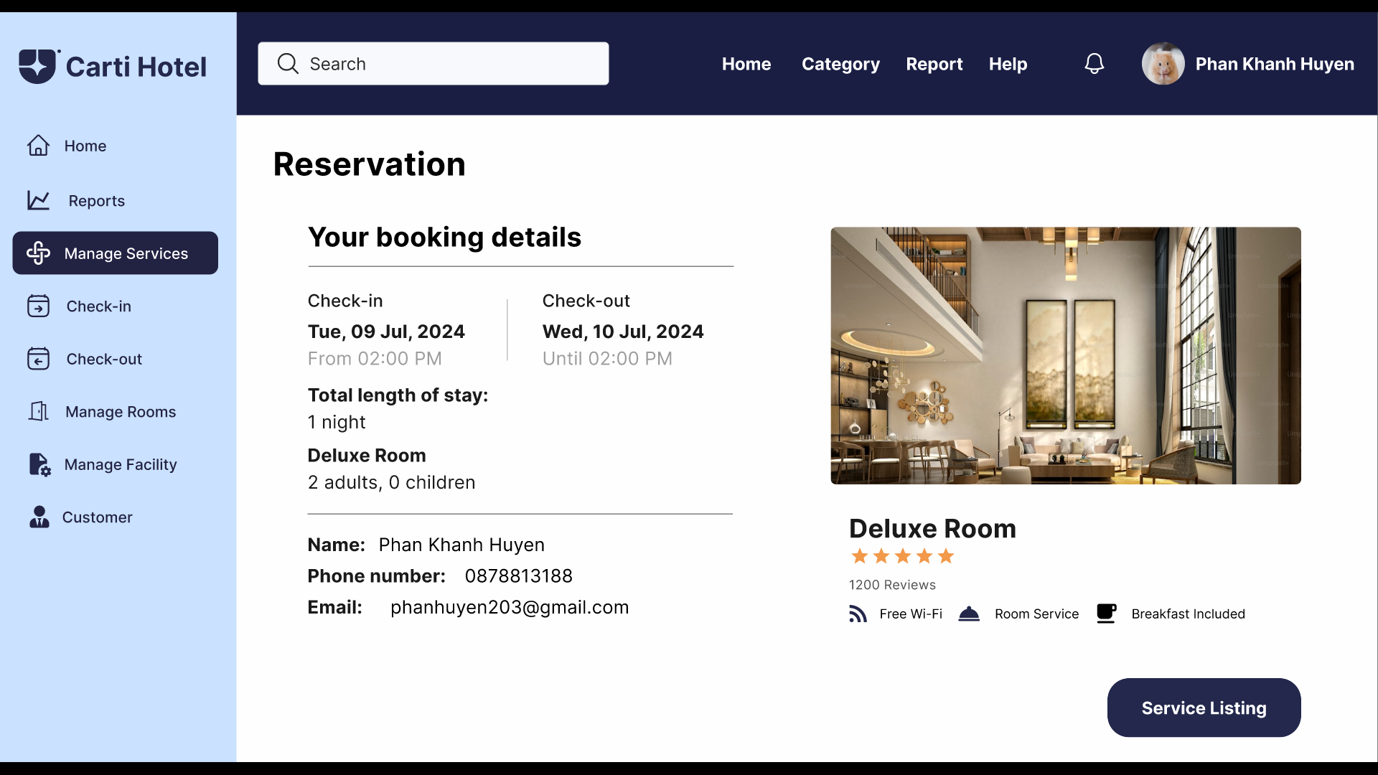

By selecting the Service Listing Button, the receptionist gains access to a table displaying the services that the customer has ordered for the reservation. This table includes three columns: service name, quantity, and price. Adjacent to this table, there is a Services block containing a comprehensive list of all services provided by the hotel. At the bottom right of the page, the Add Service button is prominently featured.

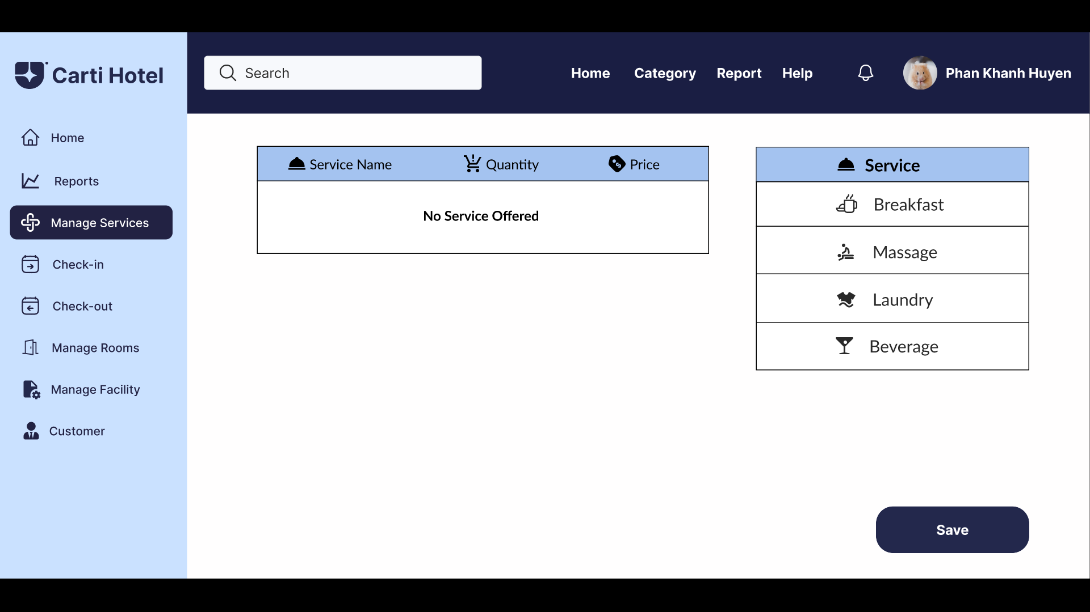

The receptionist has the option to select the type and quantity of services that the customer has ordered. The cumulative price of all selected services is displayed in the Total block, situated just below the Add Service table.

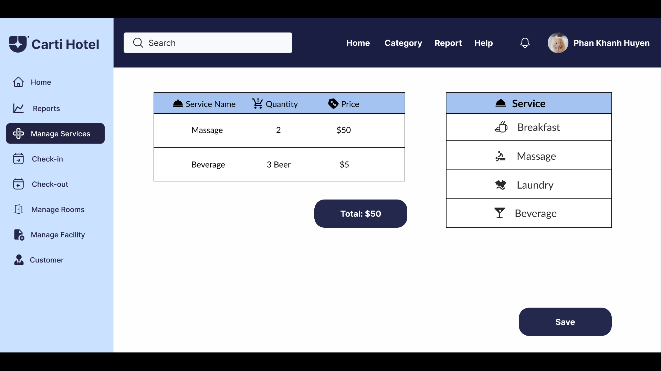

After the receptionist has finished choosing services, click on the Save Button, and a success message will be shown if nothing goes wrong:

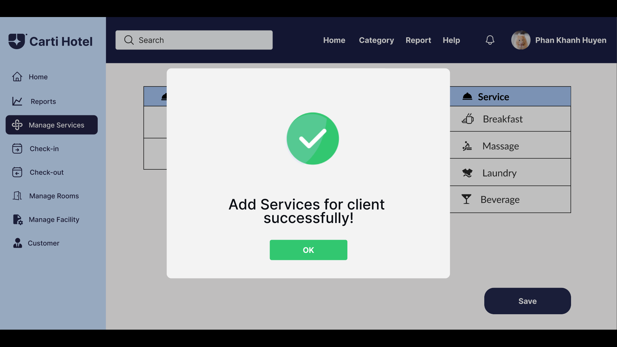

Otherwise, an error message will be shown:

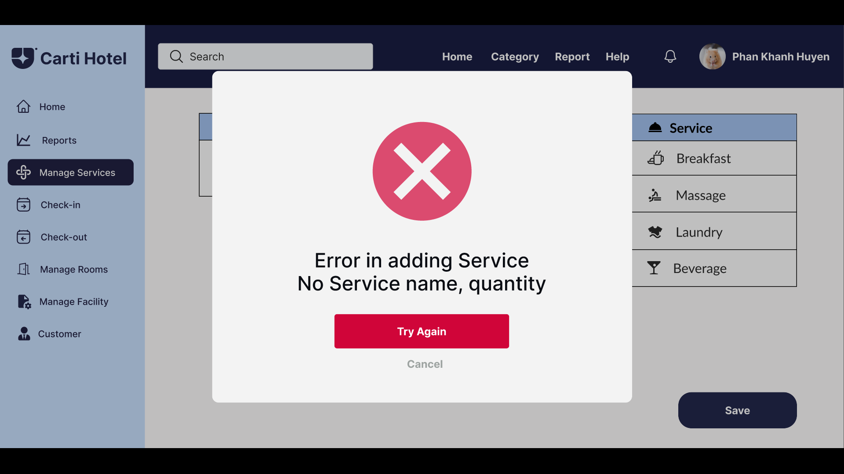

To remove a service from the customer's bill, the receptionist double-clicks on a service that the customer has ordered, causing that row to appear in front and a Delete Service Button to appear.

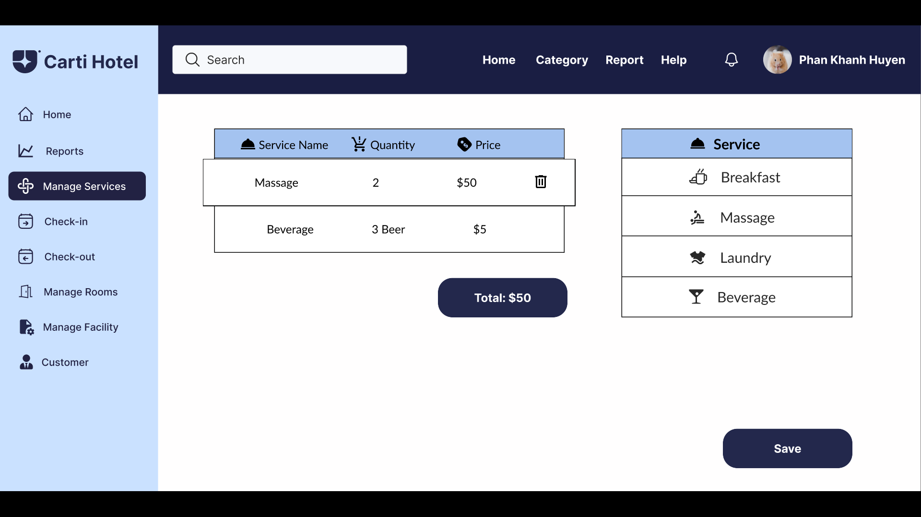

The receptionist clicks on the Delete Service Button. A confirmation box will show up:

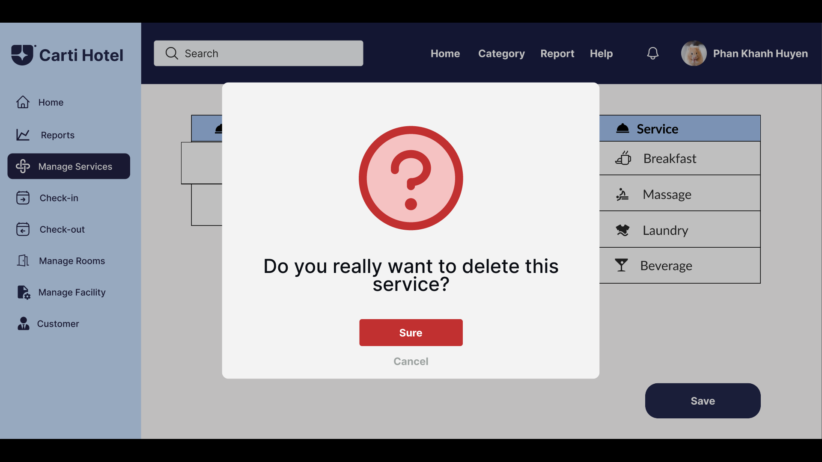

If the receptionist accepts to delete the service, click the “Yes” button. A message box will appear notifying successful deletion:

