PROJECT

Tutor: Do Quoc Binh

Student: Vu Dang bao khanh

HEALTH CARE F0 AT HOME

# Abstract

In this report, I will talk about the development of the “Health care F0 at home” system. First in the report I will go over the system and the technologies I use for development. Then I will review the system and its development process as possible technologies and finally the reason why I choose which technology to develop the system. As well as Review about methods and why I choose which method to apply for system development. Next I will talk about the similar systems I have developed in the past, present, and future. Next I will show the design of the system and the technologies I use to design. I will talk about the database and the link to my website. Next I will talk about my developed system and the development process, the tests during the development and the results of the tests. Next I will evaluate my system and present its Pros and Cons. The lessons I learned after completing the system and the difficulties in the development process, what needs to be developed of the system in the future. And finally I will present the system and the pictures of the system.

# Introduction

As mentioned above, my project is the "Health care F0 at home" system, this is a system that will support patients and doctors to interact with each other and doctors can take care of patients remotely. With users only need to access the website and then have a very easy to use interface. For example, when accessing a website, immediately appearing on the screen is the home interface with the words "Welcome to F0 at home" to help users know what website they are accessing.

The website has 3 main objects that are Admin, Doctor, Patient with each object will have a separate function.

For Admin, there will be functions such as Login, Manage Doctor, Manage Patient, Add patient for doctor, Manage Post.

For Doctor, there will be functions such as Login, Update personal information, Show list Patient, Confirm patient support, Receive notification of assigned patient, Receive notification of patient's condition in danger. drama, Communicating with patients.

For Patient, there will be functions such as Register, Login, Update personal information, Update health status, Communicate with doctors.

This project aims to reduce the large number of patients for the hospital and also partly develop information technology for the country.

# Literature Review

## What is Corona Virus?

Before going into the study of the system for F0 patient, we will find out what Covid-19 is like?

Corona virus is a new strain of virus that has never appeared in humans, whose name comes from Latin origin. Corona virus is a virus that is surrounded by spikes on the outside, interacting with receptors on cells, following a mechanism similar to keys and locks, thereby allowing the virus to enter inside.

The first time this virus appeared was at the end of December 2019, originating from a seafood market in Hunan, Wuhan, central China, the Corona virus was initially confirmed as a type of "strange pneumonia" disease. or “pneumonia of unknown cause”. After only 100 days of appearance, the acute respiratory infection caused by Corona virus quickly affected the economic and social fields, the financial market wobbled, the global economy fell into a recession with a high rate of inflation. Unemployment and poverty rates are unprecedented in history.

The name Corona virus is derived from Latin, where "corona" means "crown" or "halo". This virus has spikes on the outside, which interact with receptors on cells, in a similar way to keys and locks, thereby allowing the virus to enter inside. (VNVC, 2020)

**So how does Corona virus cause disease?**

Most coronaviruses have the same route of transmission as other cold viruses, which are:

* An infected person coughs and sneezes without covering their mouth, leading to the release of droplets into the air, spreading the virus to healthy people.
* A healthy person touches or shakes hands with someone who has the Corona virus, causing the virus to pass from person to person.
* A healthy person comes into contact with a surface or object that has the virus on it, and then touches his or her nose, eyes, or mouth.
* In rare cases, coronavirus can be spread through contact with feces.

A person infected with the Corona virus may show the first symptoms after an incubation period of about 2-14 days, with an average of 5 days. During the incubation period, the virus can still be transmitted causing infection. VNVC has prepared an article about the incubation period of Corona virus for your reference.

**Symptoms of Corona Virus day by day:**

Depending on the body and resistance, the symptoms of corona infection from day to day are different for each individual, but these symptoms are evident from 2-14 days. Therefore, as soon as there are suspicious signs, the patient should immediately go to the nearest medical facility for timely diagnosis.

Day 1 to Day 3:

* Symptoms are similar to those of a common cold.
* Mild sore throat, no fever, no fatigue.
* Eat and drink normally.

Day 4:

* Throat begins to ache slightly, the person is lethargic.
* Start hoarse.
* Body temperature increases slightly.
* Mild headache, mild diarrhea.
* Begins to lose appetite.

Day 5:

* More sore throat, more hoarseness.
* Slight increase in body temperature
* Tired body, aching joints.

Day 6:

* The symptom of the 2019 Corona virus is the onset of a low-grade fever.
* Cough with phlegm or dry cough without phlegm.
* More sore throat, pain when swallowing, when eating or speaking.
* Fatigue, nausea.
* Diarrhea, possibly vomiting.
* Back or fingers aching.

Day 7:

* Fever less than 38 degrees.
* More cough, more phlegm.
* Whole body aching.
* Shortness of breath.
* More diarrhea and vomiting.

Day 8:

* Fever around 38 degrees.
* Shortness of breath, wheezing, heaviness in the chest.
* Cough continuously, talk a lot, mute.
* Joint pain, headache, back pain.

Day 9:

* Conditions such as fever, cough, shortness of breath, heaviness in the chest… become more severe. (VNVC, 2020)

## What disease is Covid-19?

The World Health Organization (WHO) said that the official name of acute respiratory infection caused by a new strain of corona virus (nCoV) is Covid 19. This new name stands for coronavirus disease 2019, according to the keywords "corona", "virus", "disease" and 2019 is the year that this pandemic virus appeared.

In February 2020, the International Committee on Taxonomy of Viruses (ICTV) officially named the new strain of corona virus Sars-CoV-2. This is a different name from the name Covid 19 that WHO previously assigned.

Scientists have conducted research and isolated a new strain of corona virus, temporarily called 2019-nCoV by the World Health Organization (WHO) with the same gene sequence as the previous Sars-CoV, with a similarity up to 79.5%. (VNVC, 2020)

## Research of Health care F0 At Home

With the number of F0 infections in Vietnam increasing day by day, the number of Covid patients is also increasing day by day. The fact that patient F0 had to be hospitalized for treatment and isolation to prevent the disease from spreading to the community made hospitals overloaded because the number of patients was increasing, but the facilities and accommodation had run out. Since then, the hospital has come up with a solution that the patient F0 but not life-threatening will be isolated at home.

For patients isolated at home, the Ministry of Health has set up websites to support patients isolated at home, such as supporting self-isolation methods, guiding how to take care of themselves when infected with F0.

### Rules and steps for patient F0

When isolation steps have been taken for F0 subjects, the Ministry of Health also has regulations on home isolation as follows:

* The conditions for medical isolation at home, COVID-19 prevention and control comply with the issued Guidelines. Local authorities are responsible for closely monitoring and supervising, taking samples for testing for quarantined people according to regulations.
* The Ministry of Health proposed that the People's Committees of cities and the People's Committees of communes and wards only allow home isolation after a positive result has been obtained, isolation conditions are guaranteed and confirmed according to the regulations guide.
* The Center for Disease Control of the province, city or designated unit organizes testing for SARS-COV-2 for isolated people.

Regarding the requirements for facilities for the place where the patient self-isolates at home, there will be requirements:

* The place of isolation must be an individual residence.
* In front of the house, there is a warning sign on a red background, with yellow letters: "MEDICAL Isolation LOCATION FOR PREVENTION, FIGHTING COVID-19" or many other isolation words.
* There must be a separate isolation room, closed and separate from the family's common living area. If the house has many floors, use a separate floor to implement medical isolation.
* Next to the medical isolation room, there must be a separate room for medical staff to conduct medical examination, take samples and monitor health (arrange tables, chairs, hand sanitizer containing at least 60% alcohol, containers for substances). infectious waste, domestic waste container).
* The isolation room must meet the following requirements: Must be self-contained, have a separate toilet and bathroom, have enough personal hygiene tools, hand soap, clean water, and hand sanitizer containing less at least 60% alcohol. There are personal thermometers in the room.

Regarding the requirements for patients isolated at home, there will be the following requirements:

* Separate meals provided.
* Always implement the 5K Message and the epidemic prevention and control measures as prescribed.
* Install, enable and do daily medical declaration on VHD or Bluezone app during the quarantine period.
* Do not share personal items such as bowls, chopsticks, spoons, cups, toothbrushes, face towels with others.
* Self-implement daily hygiene and disinfection measures according to the instructions: Daily put masks, towels, nose and mouth wipes in a waste bag, then spray 70 degrees of alcohol to disinfect and fasten the mouth bags, then put them in the infectious waste container in the quarantined person's room… (Tế, 2021)

Before going into the F0 management system at home, I will talk about the handling of people with F0 in the community:

* Step 1: When a subject has a positive result for F0, the first thing to do is to isolate the subject at a local isolation area or at home.
* Step 2: The doctor will assess the patient's health status. There are 2 cases here:
* Case 1: The patient is a person with an underlying medical condition, a pregnant woman, a person over 65 years old or showing signs of respiratory failure. At this time, the patient must be given oxygen immediately and contact the medical center in the ward. the patient is alive or must rush the patient to the nearest hospital as soon as possible.
* Case 2: A patient with no symptoms or mild symptoms may allow the patient to self-isolate at home if the patient is eligible. Otherwise, the ward health station must report to the district health center to transfer the patient to a hospital with conditions for treatment.
* Step 3: Take care of F0
* In case F0 patient is isolated and treated at home: provide care according to the guidance in Decision No. 4038/QD-BYT dated August 21, 2021 of the Ministry of Health on the issuance of temporary guidance on management people infected with Covid-19 at home.
* In case F0 patients are isolated at concentrated isolation facilities, facilities should be encouraged to implement measures to improve their condition or apply combined Eastern - Western medicine, traditional medicine remedies. according to the instructions of the Ministry of Health.
* Case F0 is isolated for treatment at a field hospital or a hospital for Covid-19 treatment: care and treatment according to the guidance of the Ministry of Health in Decision No. 4689/QD-BYT dated October 6, 2021 of the Ministry of Health. Health on the issuance of guidelines for the diagnosis and treatment of Covid-19.
* Step 4: Epidemiological investigation, handling outbreaks according to regulations.

Each enterprise must set up its own health department and arrange a temporary isolation area. Carry out periodic testing and screening for employees. Enterprises must pay for testing costs for employees. Local health authorities always uphold the viewpoint and principles of coordination and create favorable conditions to help enterprises stabilize production and business activities. (HỢP, 2021)

The above is the process when there is F0 in the community, and if the case is F0 in the enterprise, what is the process? In an enterprise, when a person gives F0 test results, the following steps must be followed:

* Step 1: Temporarily isolate F0 in the isolation area. Notify local health authorities for assistance.
* Step 2: Temporarily suspend the operation of the area where F0 occurs to clean and disinfect, test for all F1.
* Step 3: Determine the scale of isolation: lines, parts, workshops, ...
* Step 4: Correctly identify F1 who was "in close contact" with that person F0 in the previous period.
* Step 5: In case the production facility has more than 80% of its employees fully vaccinated, all F1s are allowed to continue working, re-test on the 3rd, 7th and continue every 7 days until there are no more infections. show F0. Minimize communication with the outside until the end of the monitoring period. (VN, 2021)

### Applications used

About the application that requires patients to turn on notifications and report regularly as Bluezone and VHD. Bluezone application is a mandatory application for all people to use according to the regulations of the Ministry of Health. So what function does this Bluezone application have that the Ministry of Health requires people to use? Here I will talk through what Bluezone is and the features that Bluezone application brings to the community:

Bluezone close contact detection application is an application deployed by the Ministry of Information and Communications and the Ministry of Health under the direction of the Prime Minister with the aim of protecting the community against the Covid-19 pandemic, minimizing the risk of infection. risk of contagion, helping people return to normal life.

Bluezone is an application that uses Bluetooth low energy (Bluetooth Low Energy) technology to record close contacts between smart mobile phones that install and use Bluezone. The application will warn if the user has been in close contact with an infected case, a suspected case or a person who has been in close contact with a suspected case or case.

Contacts of Bluezone users with other Bluezone users are recorded in the contact history. Contact history data is stored on the user's phone. Contact history data will only be used to serve health authorities with the consent of the user or in case the user is an infected or suspected case.

Bluezone only saves contact history without saving location, does not use or access other information on the user's mobile phone such as contacts, photos, etc.

The more people install Bluezone, the more effective the protection is. Together we challenge the spread of the virus with the strength of the community. The Ministry of Information and Communications and the Ministry of Health recommend that everyone install Bluezone for themselves and for 3 other people. (Bluezone, 2021)

The features that the app has are:

* The application will first record the process of close contact including information such as When and How long.
* Next, if there is a case of F0, the competent health authority will enter patient data F0 into the system.
* Once there is information that patient F0 is nearby, the system will send F0 data to all machines in the Bluezone community.
* Next, the Bluezone application on the device will compare the exposure history with the F0 data.
* After the comparison is complete, if the F0 data matches the contact history, the application will warn the user at risk of COVID-19 infection.
* The screen will then display instructions to contact the competent health agency for help.
* Finally, the app can help alert people in the F2 category (F1 exposure). (Bluezone, Hệ thống Bluezone hoạt động như nào?, 2021)

We have an example in Singapore, their model of home treatment of F0 for subjects with mild symptoms or no symptoms. This is the default care management model for COVID-19 patients eligible for regulatory home isolation. These patients will be allowed to self-isolate and take necessary medical precautions at home with the support of remote health monitoring from the health authority. This model will accommodate hospitals for those who really need medical care, so that we can continue to provide essential medical services to all even if the number of infections increases. increase even higher.

Eligible F0 subjects to be allowed to be isolated at home in Singapore are: According to MOH regulations, patients who are eligible for home treatment in Singapore must meet the following conditions:

* Fully vaccinated
* From 12 to 50years old
* Mild symptoms or no symptoms
* No serious comorbidities or comorbidities
* No one in the household is over the age of 80 or in a vulnerable group - including those who are pregnant and those with weakened immune systems or underlying medical conditions.

Next are the steps for F0 to self-treat at home, which will include the following steps:

* Patient F0 does not need to go to the hospital. On the first day of self-healing at home, the patient will undergo an initial assessment conducted remotely by a designated healthcare provider, to ensure that the patient is doing well. clinically strong.
* Patient F0 will then be quarantined for 10 days and possibly fitted with electronic monitoring equipment to ensure they stay at home. Patient F0's room should have a private bathroom with a window for air circulation, ensuring ventilation.
* As a side note, children with COVID-19 aged 5 years and older with no underlying medical conditions are also encouraged to be cared for at home after undergoing an examination and evaluation at the hospital.

Followed by supportive measures from the hospital:

* In Singapore, a health worker, known as a home care companion, will be in charge of communicating with the patient during home treatment to provide necessary information.
* If the patient needs it, they will be provided with a medical care package that includes a thermometer, oxygen meter, medical mask and hand sanitizer.
* "COVID-19 patients should monitor, measure, and record health metrics such as body temperature, heart rate, and blood oxygen saturation (SpO2) at least once daily, using a care log. made available".

Finally, the time to finish the treatment at home:

* On the 6th day of the home treatment session, the patient can contact the health authority to arrange for a home PCR sample collection. If a patient's test results meet the criteria - a negative PCR result or a low viral load - they can be terminated on day 7.
* If the test results do not meet the criteria, patient F0's home recovery period will end on day 10 without any further testing, as long as the patient is healthy.
* After finishing home treatment, COVID-19 patients will no longer be subject to any movement restrictions, but it is still recommended to minimize social interactions for the next 7 days.

Currently, Vietnam has prevented the epidemic and has almost prevented the spread to the community. But there are still some issues that are not so good and here are the ones that I find not so good:

The first is that this epidemic came suddenly, so we still do not have an effective prevention plan in the first days of the epidemic. This shows that our reaction is still not fast. This is called a health crisis not only in Vietnam but also in all countries around the world.

Next is the economic problem, the outbreak of Covid has caused the world economy to be severely affected. Companies have to give employees a break to avoid the epidemic, production and processing factories have to stop working, resulting in the supply of essentials and food being affected, thereby indirectly causing the economy to be significantly reduced. tell. In Vietnam alone, the ban on exporting food to foreign countries has caused businesses to suffer extremely heavy economic damage. Our country's economy relies heavily on food exports to foreign countries, so this has caused our country's economy to suffer heavy damage and is considered the heaviest damage ever.

When businesses have to shut down, many people are unemployed. Most of our country's laborers are workers and the shutdown of factories has left these workers without jobs and resulting in no money to cover their lives.

Finally, directly affecting people, the Covid epidemic has caused many people to die and leave their loved ones behind. As a result, many families have fallen into the situation where their family members who are the breadwinners have died during this Covid pandemic, affecting that family's living expenses. And also from that cause many people no longer know what to do, leading to many tragic suicides.

Security is essential for any system. Information security is one of the mandatory requirements for every system if it wants to be licensed to operate. So what information needs to be kept confidential?

The first is the user's personal information. The fact that personal information is something extremely valuable to a user on a system is what system developers always have to be most concerned about. Confidentiality of user information is the responsibility of a community application. User information is extremely important and valuable because it is their secret and not something that can be made public. This also has many reasons, but the main reason is because a person's personal information can be sold for bad purposes by many objects.

Next is about the patient's infection information in my system. Confidentiality of the patient's medical history is the responsibility of the hospital and its website system. There are many reasons for this problem such as the fact that the patient's medical records are not allowed to be transmitted.

Next, it is also advisable to protect the personal information of the medical staff performing the duties. Sometimes the personal information of the medical staff is sometimes more important than the patient's because often if a patient is unfortunate enough to die while the doctor has tried his best to cure but cannot survive. However, for the family of the recently deceased patient, it doesn't matter if they do their best, they will often put all the blame on the doctors and nurses and if they have personal information of the doctors. That will have a very serious effect on that doctor.

### A few healthcare websites for F0 patients

Some websites for F0 patients should be self-made at home such as “chamsocsuckhoe.hanoi.gov.vn, chamsocsuckhoe.yte360.com, f0.phutho.vn”. These websites are the ones that were created during the nationwide outbreak and are known and trusted by many people. However, most of the above websites only advise patients about methods and symptoms, but do not have the necessary functions such as allowing patients to update their current health status daily for doctors to follow. monitor, monitor and guide care remotely.

In the past, when the epidemic broke out, F0 patients often had to be taken to the hospital for isolation and treatment. This leads to overcrowding of hospitals, nurses and doctors who cannot take care of all patients and sometimes leads to the death of some patients who do not receive good care. Since then, the Ministry of Health decided to let patient F0 but not life-threatening to self-treat and isolate at home. The ministry has proposed setting up websites for F0 patients at home such as “chamsocsuckhoe.hanoi.gov.vn, F0.Phutho.vn” to support patients isolated at home. At first, these websites only supported patients and self-treatment at home, and the above websites after updating their health status had to wait for people in the clinic or community for advice and support, so it took a long time. Sometimes with someone to help, the patient has become seriously ill and has to be hospitalized, so this does not help much and makes the patient worse and worse. (Thọ, 2020)

After the above unfortunate events, now websites such as “chamsocsuckhoe.hanoi.gov.vn, f0.phutho.vn” have been developed to support F0 patients at home with many necessary functions to Patients can update their health status on the website. These websites are mostly for patients to update their health status and the respondents are ward or community health stations. Daily, through the management software F0, the health station will review the patient's illness; Patients self-test negative, just send photos or videos via Zalo group. After that, the People's Committee of the ward will have a document confirming the end of the isolation period and transfer it to the residential group to send to the people. In case of loss, people go to the medical station of the ward to be re-issued in no more than 10 minutes. (Nội, 2020)

However, with the current functions, the patient takes a lot of time because when updating the health status of the patient, it takes a while to receive the answer. Therefore, there are many shortcomings in monitoring health and ensuring good treatment for patients.

From the above inadequacies, the Ministry of Health has requested to upgrade the system and must be functional such as "Contact the doctor for the patient, the doctor will have a patient management list to take care of". The development of the system is very necessary because in order to ensure the health of the patients, the first thing must ensure that they are always monitored and always consulted for timely handling when the situation is critical. danger. The system after development will be a system worth looking forward to and using when the necessary functions are added, the prestige of the site is also greater.

From here, I came up with the idea that I would make a "Health care F0 At Home" system with all the important features of the old websites such as Update health status,... and add features. New features are much needed for users for example: The doctor will manage a list of patients and the doctor must always be on duty to support the patient at all times to avoid the situation like the old websites when the patient always have to wait for support. And also patients can communicate with doctors using a chat screen available on my web.

From here, I came up with the idea that I would make a "Health care F0 At Home" system with all the important features of the old websites such as Update health status,... and add features. New features are much needed for users for example: The doctor will manage a list of patients and the doctor must always be on duty to support the patient at all times to avoid the situation like the old websites when the patient always have to wait for support.

## Review of Technologies

Before starting the project, I researched the existing “F0 At Home” websites and I have found that these are often hastily created and the technology they use is not. very optimized. Since then, I have researched and found the right technologies for me to apply to the project. Below I will talk about the technologies I researched, the pros and cons of each, and I will choose the most suitable technology to apply to my project.

### In terms of Front-End I would have:

When we enter a website, what is the first thing we see? That is the interface of that website. A website is used by many people not only because of its functionality, but largely because of the look and feel of that website. We don't want to use a website that although it has many good functions, the interface is ugly and unattractive, right? Since then, I have also found the interface technologies that I find the most stable to use in the project. Here are the Front-Ends that I found out. (Thịnh, 2021)

#### React

* The first is React. So what is React?

The most widely used JavaScript library for creating user interfaces is React (UIs). Utilizing a novel approach of producing web pages, it provides excellent reaction time to user interaction. (Hostinger, 2020)

* Next are the Advantages-Disadvantages of React:

Advantages:

* Easy to use, create lightweight components
* Elegant API
* Large community support
* Popular in the StartUp world
* Lots of open source utilities

Disadvantages:

* Adjustment for JSX
* Complete solutions require third-party libraries
* Availability of options can be confusing (NIIT, 2017)

#### Angular

* The next Front-End technology that I learned about was Angular. So what is Angular?

Google created Angular, a JavaScript framework for creating web interfaces (Front-end). Developers may create HTML and TypeScript single-page applications more quickly with the aid of Angular. (Viec, 2020)

* Next are the Advantages-Disadvantages of Angular:

Advantages:

* Custom Components: Angular allows users to build their own components and can encapsulate functionality along with rendering logic into reusable parts. It also works well with web components.
* Data Binding: Angular allows users to easily move data from JavaScript code to views and respond to user events without having to write any code manually.
* Dependency Injection: Angular allows users to write modular services and include them wherever they need to be. This improves the testability and reusability of the same services.
* Testing: You can easily Unit test every part of your application.
* Comprehensive: Angular is a full-fledged Framework and can provide convenient solutions for server communication, routing in your application, and more.
* Browser Compatibility: Angular provides cross-platform and cross-browser compatibility. An Angular app can typically run on all browsers (Example: Chrome, Firefox) and operating systems, such as Windows, macOS, and Linux.

Disadvantages:

* Insecure: Usually, the nature of Angular is one of Front End Frameworks, which Front end often cannot be secured by Back-end. Therefore, when using the API, you need to build a system to check the data so that it returns the best.
* With some browsers possessing the Disable JavaScript feature, it means that the website will not be completely usable based on those browsers anymore.
* You should code Angular apps using TypeScript, so you have to learn TypeScript. (Nguyễn A. , 2021)

#### JQuery

* The next very good Front-End is JQuery. So what makes this language stand out?

A JavaScript library called jQuery makes it simpler, quicker, and more feature-rich to create JavaScript functions. JavaScript and jQuery are both programming languages, not a different one. With jQuery, more can be accomplished with less work. JQuery offers APIs that simplify AJAX manipulation, event handling, animation, and viewing HTML documents. jQuery functions nicely in a wide range of browsers. The JS Framework is one of jQuery's powerhouses. (Bao, 2021)

* Next are the Advantages-Disadvantages of JQuery:

Advantages:

* Ease of use: This is the main advantage of using jquery, it is easier than many other standard javascript libraries because of its simple syntax and you only have to write less lines of code to create the same functionality. With only 10 lines of JQuery command, you can replace all 20 lines of DOM JavaScript commands, saving programmers' time.
* Is a large library of javascript: Executing more functions than other javascript libraries.
* Strong open source community (several jquery plugins available): JQuery is relatively new, there is a community that dedicates their time to developing JQuery plugins. As such, there are hundreds of pre-written plugins available for immediate download to speed up your coding process. Another advantage behind this is the efficiency and safety of the scripts.
* Lots of detailed documentation and tutorials: JQuery websites has a whole bunch of documentation and tutorials so that even a beginner in programming can roll the ball with this jquery library.
* Ajax support: JQuery allows you to develop Ajax templates easily. Ajax allows for a sleek interface on the website, functions can be performed on the pages without requiring the entire page to be reloaded.

Disadvantages:

* Make the client slow: The client not only has to display it, but it also has to handle many functions made up of jquery. Overusing jquery will make the client slow, especially weak clients. That's why programmers have to use more cache
* Functionality may not be available: JQuery already has a lot of functionality, depending on your site requirements. But many functions are still undeveloped, so you still have to use pure javascript to build this functionality. (Nghĩa, 2015)

### In terms of Back-End I will have:

After making the interface, the next thing we need to care about is the functionality of the website. To make it functional, I needed Back-End technology, and I explored many different technologies. Here I will talk about those technologies as well as their pros and cons. (IT, 2021)

#### Java

* The first is the programming language that everyone knows and is very popular with, which is Java. So what is Java?

Java is a powerful, contemporary, object-oriented, high-level, secure programming language is a Platform, Java SE, Java EE, and Java ME are the new names for the J2 versions. The java motto is "Write Once, Run Anywhere." This means that you just need to write once on Windows, for example, and then the same software can run on Linux, Android, and devices that use J2ME... (VietTuts, 2017)

* Next are the Advantages-Disadvantages of Java:

Advantages:

* Java is platform independent because we can run Java code on any machine without installing any special software, JVM does that.
* Java is object-oriented because of its classes and objects.
* The main reason Java is secure is pointers, Java doesn't use pointers.
* In Java we can execute multiple programs concurrently, so multithreading can be achieved.

Disadvantages:

* As a high-level language, it has to handle the compilation and abstraction levels of a virtual machine. Java exhibits poor performance, which is mainly caused by garbage collectors, invalid caching configurations, and deadlocks between processes.
* Java has very few GUI builders – Swing, SWT, JSF, and JavaFX among the more popular ones.
* To write code to perform a simple set of operations, you may have to write long and complex pieces of code. This can affect readability but ensures that programmers enter exactly what needs to be done. When we compared Java to Python, we noticed that Python doesn't need semicolons, parentheses or curly braces and has noticeably shorter code. (Funix, 2021)

#### PHP

* Next is the language that appeared for a long time, which is PHP. This is one of the much used languages back in the day, so what is PHP?

An all-purpose scripting language is PHP. For the creation of server-side web applications, PHP is frequently utilized. Thus, the PHP programming language can handle server-side tasks like gathering form data, updating the database, managing files on the server, or other actions to generate HTML code on the client. (Agile, 2019)

* Next are the Advantages-Disadvantages of PHP:

Advantages:

* The most important advantage of PHP is that it is free and open source. It can be downloaded anywhere. Ready to use for developing web applications.
* It is platform independent. PHP based applications can run on any operating system like UNIX, Linux and Windows etc.
* PHP-based applications can easily be loaded and connected to the database. It is mainly used because of faster loading speed on slow Internet and in many cases PHP has higher speed with many other programming languages.
* PHP is easy to learn for beginners, it's also simple and easy to use. If one knows basic C programming, it is easy to learn and work with PHP.

Disadvantages:

* PHP itself is not as secure as many other languages.
* PHP is not suitable for web applications that need to process large content
* PHP is a Weak type, so it can lead to incorrect data and information for users.
* Using PHP Frameworks requires learning more Built-in Function (PHP built-in functions) to avoid rewriting the function for the second time.
* Using many features of PHP frameworks can degrade the performance of the website. (Đỗ, 2020)

#### Python

* One of the most popular languages for applying AI technology is Python. Here I will talk about Python to see why it is used to do AI.

A robust, high-level, object-oriented programming language is Python. It is simple to learn and is quickly becoming one of the best programming languages to learn for beginners. Python employs automatic memory allocation and has entirely dynamic typing. Python provides robust high-level data structures and a straightforward but efficient method for writing object-oriented programs. Python's command syntax is a big bonus because it quickly becomes the best language for scripting and application development in a wide range of fields, in most sectors, due to its clarity, readability, and flexible typing every platform. (Nguyễn, 2020)

* Next are the Advantages-Disadvantages of Python:

Advantages:

* It is a language with clear forms, clear structure, and concise syntax.
* Available on all operating system platforms from UNIX, MS – DOS, Mac OS, Windows and Linix and other OSs in the Unix family.
* Strong compatibility with Unix, hardware, thirst-party software with a huge number of libraries (400 million users).
* With Python's extremely fast processing speed, python can create programs from micro-scripts to extremely large software like Biender 3D.

Disadvantages:

* Python has no properties like: protected, private or public, no do…while and switch…case loops.
* Although the processing speed of Python is faster than PHP, it is not equal to JAVA and C++. (Plus, 2017)

#### Spring boot

* When we don't want to have to code from start to finish a large project, then we will use Framework. And Spring boot will help us create a project quickly and easily, we just need to customize it to our liking. So what is Spring boot?

JAV (the Java programming language) created the Spring framework ecosystem project known as Spring Boot. It aids in streamlining the process of constructing an application with Spring so that programmers can concentrate solely on creating the application's business model. (Dũng, 2020)

* Next are the Advantages-Disadvantages of Spring Boot:

Advantages:

* Develop Spring-based applications in a time-saving and easy way.
* Automatically configure all components for a production-grade Spring application.
* Pre-built embedded servers (Tomcat, Jetty and Undertow), resulting in accelerated and more efficient application deployment.
* HTTP endpoint, allowing import of features inside the application such as metrics, health status, etc.
* There is no XML configuration.
* Wide selection of plugins, helping developers work with embedded and in-memory databases.
* Easily access database and queue services such as MySQL, Oracle, MongoDB, Redis, ActiveMQ and others.
* Smooth integration with Spring ecosystem.
* Large community and a lot of tutorials, facilitating the familiarization phase.

Disadvantages:

* Lack of control. Due to the fixed style, Spring Boot creates many unused dependencies resulting in large deployment file size.
* The process of converting old or existing Spring projects into Spring Boot applications is difficult and time consuming.
* Not suitable for large scale projects. Working seamlessly with microservices, according to many developers, Spring Boot is not suitable for building monolithic applications. (Mẫn, 2021)

#### JHipster

* A great project support tool is Jhipster. Here, I will talk about Jhipster so that everyone can understand this technology.

With Spring technologies and Angular/React, JHipster (short for Java Hipster) gives us a quick approach to build a project on the most popular technologies. (HoangManh, 2019)

* Next are the Advantages-Disadvantages of JHipster:

Advantages:

* Create a fast project
* The Manage user is available
* DISTRIBUTION
* Grafting for yourself Fe and be

Disadvantages:

* Because it gave birth to my own code, I was forced to understand its code

### About Database I will have:

A website always has the content in that website, the technologies that support creating websites like Java or angular help us create websites, but that's just the interface and functionality, not the storage support of our content. that website. Since then I have learned about the technologies that support data storage and hereafter I will present the technologies I have learned to store data for the website.

#### Oracle

* One of the largest suppliers in the current technology sector is Oracle. The term Oracle is an acronym for its main offering, an RDBMS formally known as Oracle Database, a relational database management system. In a company's IT, database software frequently plays a key role in a number of operations, including transaction processing, business intelligence (BI), and analytical applications. (Phạm, 2018)
* Next are the Advantages-Disadvantages of Oracle:

Advantages:

* Automatic object recognition: the accuracy of modes and triggers are built-in. That helps to limit the risk of software problems when using the software and easy to adjust when encountering categories.
* Structure of diverse solution design capabilities: Oracle not only contributes to diverse SQL, but also supports PL/SQL, using good command line tools to help manage changes smoothly and bring efficiency. high fruit.
* Powerful data-storage: stable running with background and cloud-reservable, automatic control-view admin role distribution, table sequence, information types, and function-based SQL Windowing.
* Security stability: one of the most popular features in the field of choosing Oracle databases is the security functionality it provides, which can protect the identity of the recognized oracle more than the competition

Disadvantages:

* There are not many sentence structures applied in PL/SQL, easy to modify the law of the land when in other languages.
* Training classes are not appreciated for effectiveness, the instructions are contrary to the needs of customers.
* Expenses are becoming an issue as competitors compete to work in the business area at a cheaper price point.
* Counseling and support services are often super slow, often unwilling to answer questions without intermediaries to resolve the issue. (Võ, 2022)

#### MySQL

* MySQL, or Relational Database Management System, is an open source database management system that uses a client-server architecture. MySQL is a program or service used to build and maintain databases by controlling the connections between them. (G, 2019)
* Next are the Advantages-Disadvantages of MySQL:

Advantages:

* Ease of use: MySQL is a high-speed, stable, easy-to-use and cross-operating database that provides a large set of very powerful utility functions.
* High security: MySQL is very suitable for applications that access databases on the Internet when it has many security features even at high level.
* Multi-feature: MySQL supports many of the SQL functions expected from a relational database management system both directly and indirectly.
* Scalable and powerful: MySQL can handle a lot of data and moreover it can be extended if needed.
* Fast: The introduction of several standards allows MySQL to work very efficiently and cost-effectively, thus increasing execution speed.

Disadvantages:

* Limitations: By design, MySQL is not intended to do it all and it comes with limitations on the functionality an application might need.
* Reliability: The way specific functions are handled with MySQL (e.g. references, transactions, audits, etc.) makes it less reliable than some DBMSs. other relationship.
* Limited capacity: If your number of records is growing, it is quite difficult to access your data, then we will have to apply many measures to speed up data retrieval such as load sharing this database to many servers, or create a MySQL cache. (Trắng, 2019)

### Compare:

|  |  |  |  |
| --- | --- | --- | --- |
| **Technologies** | **Advantages** | **Disadvantages** | **Suitable for project** |
| React | Easy to use and has many open utilities | Requires the support of a third-party library | React has a large support network, which demonstrates how well-liked it is. The popularity of React has fueled the expansion of companies. You have a lot of possibilities for creating comprehensive solutions thanks to the abundance of open source, community-developed React extensions. |
| Angular | Easily Unit test every part of the system.  Angular is compatible with many browsers and operating systems other than windows | Not secured.  Can be blocked on browsers with Disable JavaScript | As mentioned above, Angular is very powerful and suitable for large projects that need to code fast. However If you have a small or medium scale project without any complex user interface and interaction, you should use pure JavaScript. |
| JQuery | Easy to use  There are many JQuery Plugins available  There are many manuals | Client can be slow  Not many necessary functions yet | jQuery is a quick, compact, and feature-rich library that makes it easier to script HTML on the client side. Previously, utilizing JavaScript to interact with HMLT elements required writing a lot of tricky code. The interaction is considerably simpler and takes much less time now that jQuery is used. |
| Java | Java is platform independent, so we can run java on any machine platform without tools.  Java supports multithreading.  Java is a high-level language and is fairly easy to understand for everyone. | Since java is a high-level language, java always has to handle the compilation and abstraction of the virtual machine.  Java has few tools to create GUI - Swing | Java is arguably the most powerful programming language out there. Java has held the top spot in the TIOBE ranking for many years, as is evident. Java is highly helpful for developing applications, but it can also be used for Big Data, networking, Data Science, and other things. |
| PHP | PHP has a flexible syntax.  PHP is pretty easy to learn  PHP has a large user community  There are quite a lot of Frameworks and libraries | Although PHP reduces the memory load, it is because of that that PHP cannot be shared with others  PHP is too dependent on Extensions | For these tasks, PHP is appropriate:  In terms of computational processing, not too difficult  Although there are several hits—either few, many, or many—the logic is not very complex.  Ideal for issues with the Web interface in particular  Developer caliber is above average (Low dev quality is difficult to work) |
| Python | Python is a fairly simple and easy language to learn  Python is a simple language so the maintenance will reduce the cost a lot  Python can be widely used | Since python is an interpreted language, the speed is quite slow  Python uses a lot of memory so it is quite expensive in terms of memory  Because python is quite easy and simple, python users often find it difficult to use other languages | Simple to understand, not overly complicated in declaration. You can program more quickly and effectively using concise code.  This programming language is used by a lot of big websites, like YouTube, Facebook, and Google.  Lay a strong foundation before stepping into the realm of programming. |
| Spring boot | Since Spring boot is a framework, developing the system with spring boot saves a lot of time  The servers are pre-built so it's faster to deploy the app  The community of Spring boot users is very large, so it supports a lot of use | Since it is a framework, the storage capacity is quite large | An essential component of the Java ecosystem, Spring Boot offers a flexible and effective toolbox for creating Spring applications with a microservices architecture. It enables developers to benefit from speedier development and deployment thanks to the default setup for unit and integration tests. Additionally, Spring Boot enables developers to create strong apps with clear and safe configuration without having to invest a lot of time and energy in learning more about Spring. |
| Oracle | Oracle has pretty powerful data storage capabilities  Oracle security is very stable | The cost of using Oracle is not very good  Oracle services are usually very slow | Only when a huge database is required is Oracle beneficial. It is not the best option for small to medium-sized businesses that require simple databases. |
| MySQL | MySQL is fast and easy to use  MySQL has high security  MySQL supports a lot of functions  MySQL has strong extensibility | MySQL has quite a limited capacity  MySQL has quite a few limitations in terms of functionality | Is the fastest and most reliable database currently available. - Rich information security: Despite its high feature set, MySQL is easy to use and less complex. - Entirely free due to the open source nature of the code. However, you will still be required to pay if you require MySQL assistance.  Community backing due to large membership  Works across a variety of OS systems |

Table Technologies choose

## Review of Methodologies

The process of developing a system requires many steps from having to think of ideas and planning, choosing technology or personnel, etc. This job requires knowledge of project development. But there are also a few methods of supporting project management to help you plan the steps to develop a system. I have researched many different methods and here I will talk about the project management methods that I have found effective and preferred by many people and then I will talk about the method that I choose to apply into my project.

### Methods include

The first is the project management methods and the advantages and disadvantages of each method.

#### Agile

* Agile is a flexible software development methodology that is used in the software development process to hasten the delivery of goods to users. (base, 2022)
* Next are the Advantages-Disadvantages of Agile:

Advantages:

* Due to the project's separation into manageable, autonomous, small-scale components, changes can be made quickly and easily at any step of the process.
* You don't need to have all the information right away: suitable for initiatives without a definite end goal because it is not necessary in the initial stages.
* Faster deliverables: By breaking projects down into smaller pieces, the team is better equipped to test the components and identify and fix issues faster, resulting in more dependable and successful handovers.
* Pay attention to user and customer feedback: Both groups have the opportunity to provide suggestions and feedback, which can significantly and favorably influence the finished product.
* Agile fosters feedback from consumers and team members so that various stages of the finished product can be tested and improved as frequently as necessary.

Disadvantages:

* Because the project is broken up into multiple components, each of which has a specific delivery date, project planning is difficult.
* Comprehensive instruction and training are required: Agile approaches are far more complex than traditional ones. They need instruction and guidance in order to be able to comprehend the procedure clearly, especially at first.
* Less paperwork is needed since Agile methodologies vary so widely and because expectations and deliverables aren't outlined up front. Documents are required even though they are not the most important part.
* Collaboration is essential to a project's success, but it also involves a time commitment from both parties that other project management models might not necessarily require. For it to be successful, users must continue to collaborate and participate.
* High Price: Agile implementation costs are frequently a little higher than those associated with conventional development approaches.

#### Waterfall

* One of the current project management methods that is the simplest to comprehend and administer is the waterfall model. A project management approach called the waterfall model is based on a sequential and sequential design process.

The project's phases are carried out sequentially according to the waterfall model, and the next phase only begins once the one before it is finished.

The waterfall technique, which was initially developed as a software development life cycle model, is also employed in smaller projects when all the standards are established from the beginning. (Vietnambiz, 2019)

* Next are the Advantages-Disadvantages of Waterfall:

Advantages:

* Ideal for small or easy tasks
* The project team is well-aware of the requirements.
* Simple to grasp Simple to control
* There is no need to define implementation milestones.
* There are numerous documents that offer details to clients.

Disadvantages:

* Changes to the project's scope are prohibited.
* Do not permit the project's requirements to be changed.
* Up till the project is practically finished, no working product.
* It is difficult to manage unforeseen hazards.

#### Lean

* LEAN is a management approach that companies use to concentrate on adding value for consumers and getting rid of waste during the production and service providing processes. Agile project management technique Through a continuous improvement process, LEAN also assists firms in reducing time and improving their capacity to utilise resources. (Fastdo, 2022)
* Next are the Advantages-Disadvantages of Lean:

Advantages:

* Reduce the cost of inventory: Businesses will pay less to rent storage facilities and employ managers.
* Reduce production time and increase flexibility: Using this approach, organizations may more quickly meet consumer demands and increase productivity.
* Eliminate waste: LEAN will assist you in eliminating extra production time, defective goods, inventory, and more.
* Improved product quality will result from LEAN's use of the work cell model to run the production process. Workers will be able to see faulty components before mass production by moving the line to each component.
* Boost morale among employees by involving them in helping to raise product quality.
* Enhance customer relationship by keeping in regular contact with them and showing interest in how they are finding the product.

Disadvantages:

* Supply issues: Since there isn't much inventory, LEAN will be heavily dependent on suppliers. The production process will be significantly impacted if suppliers experience issues because the production line must stop.
* High running costs for businesses: When LEAN is applied to your company, the outdated machinery systems will be entirely disassembled. You will have to reset everything as a result, which will cost you a lot in operating expenses.
* Lack of employee consent: Many workers won't appreciate this approach and will obstruct others' efforts.
* Customers who are not happy will be impacted by any supply chain disruption, particularly if there are delivery problems.

#### Risk management

* Businesses utilize risk management techniques to minimize risks that could arise during project execution. The mechanisms for identifying and measuring risks, as well as countermeasures, will be part of the risk management approach. (Fastdo, 2022)
* Next are the Advantages-Disadvantages of Risk management:

Advantages:

* Reduce the project's potential loss as much as possible.
* Managers are given complete knowledge regarding risks as well as steps to reduce risks that may arise during task performance.

Disadvantages:

* Businesses still aren't able to account for every risk.
* It is impossible to totally restrict the losses brought on by the risk.

### Compare

|  |  |  |  |
| --- | --- | --- | --- |
| **Method** | **Advantages** | **Disadvantages** | **Suitable for project** |
| Agile | Can easily change plans  Agile allows us to not have to know too much about the plan  Agile helps us deliver projects faster  Agile can continuously improve the product | Agile is quite difficult to plan  Agile adopters must be trained in detail before adopting  Agile has very little documentation  Applying Agile, the cost of the project is quite high | Agile is only appropriate for projects that require a high degree of flexibility or have an unclear end objective. The following conditions must be completed by businesses in order to properly implement this project management methodology:  + Coordination and effective communication between organization members are essential. An effective team will be able to grasp the needs of the clients, work well together, and complete tasks quickly.  + Project teams need autonomy to function effectively on their own.  + The modularization of activities is done by cross-functional teams. These teams will focus on the needs of the customer while producing high-quality work quickly. |
| Waterfall | Very suitable for projects that have a specific plan from the beginning  Waterfall is one of the easiest methods to understand and use  Waterfall has a specific workflow, so it's easy to know what to do next when deploying | Waterfall is only suitable for projects that have a specific plan from the beginning  Because the plan must be followed, testing can only be done after completing the plan, leading to errors, you will have to start from the beginning. | The waterfall technique is appropriate for use in large projects with constrained implementation timelines or in projects that have been carried out several times with few implementation issues. Additionally, this approach works particularly well for managing production and producing goods that precisely meet instructions. |
| Lean | Speed up progress, respond to customer needs quickly  Can remove unnecessary things during implementation  Employees are allowed to contribute ideas during implementation | Operating costs for businesses are very high  Sometimes employees do not like to apply this method, leading to demoralization | LEAN is frequently used in traditional manufacturing industries, service industries, and non-profit organizations due to its focus on reducing waste and increasing value for consumers. profit… |
| Risk management | Minimize project risk  Managers are provided with sufficient information and ways to limit risks in the implementation process | Sometimes it's still not possible to anticipate the risks  Loss caused by risk cannot be absolutely limited | The majority of other areas, including those involving construction investment, can use the risk management approach for their projects. This approach must be used in every project since risk management is crucial to the outcome. This approach will make projects run more efficiently and produce the best results. |

Table Methodologies choose

## Choosing solutions

After researching and researching about the right technologies and methods, I considered and finally decided to use the right technology and method for the project I was developing. Here I will list the technologies and methods I choose and why I choose:

### Discussion of your chosen technologies

The first is about technology. As above, I have also listed a lot of different technologies for each different array such as Front-End, Back-End or Database. However, I will only use a few of those technologies for the project and here are the ones I chose:

About FE:

I use Angular, the reason I use Angular is because it is an extremely good FE support technology. Angular is also a language that can be used for a long time without fear of obsolescence. When coding with Angular, we do not have to reload the page when using the code, so it is very convenient to use. And the most special feature of the Angular language is that the user community is very large, so if there is a problem that cannot be solved by yourself, you can ask easily.

About BE:

I will use Jhipster, in Jhipster including Spring boot and Java. Jhipster is a way for us to create projects using very good technologies like Spring technologies or Angular. Jhipster also provides a lot of Server side like Spring boot, Oracle, … along with many other powerful front-end frameworks like Angular, React and with jhipster we can Deploy project easily. With Jhipster, we will easily have a powerful project and full of basic functions like CRUD to start the project quickly.

About Database:

I will use MySQL for the following reasons: First, MySQL is a high-speed database, works on many operating systems, so it is easy to use. Next, MySQL is suitable for applications that have access to databases on the internet when there are many high-level security features. Next, MySQL is multi-featured when it can support many SQL functions for a database management system. MySQL is also highly scalable with being able to handle a lot of data and can be extended if needed. Finally, MySQL's quickness in delivering a number of standards allows MySQL to work efficiently and cost-effectively.

### Discussion of your chosen methodologies

Next is the method, to develop a successful project must follow the steps of a method. I also learned a lot of different methods and after learning the method and based on the reality of the project, I decided to choose the Agile method. So what does Agile have that I choose? Here I will explain why I chose this method:

The first thing that made me want to use the Agile method is because it is easy to change at every stage of project development. This gives the flexibility to change the structure of the project when something needs to change suddenly. Next is when using the Agile method to develop a project when it is not clear what the end goal of this project is. This gives me more flexibility when changing project plans during development. The last thing is that Agile cares about feedback and quality so continuous improvement is one of the strengths of this Agile method. This is what I like most about Agile and this is what makes me choose Agile as the method to develop my system.

# Requirement Analysis

## Similar application 1

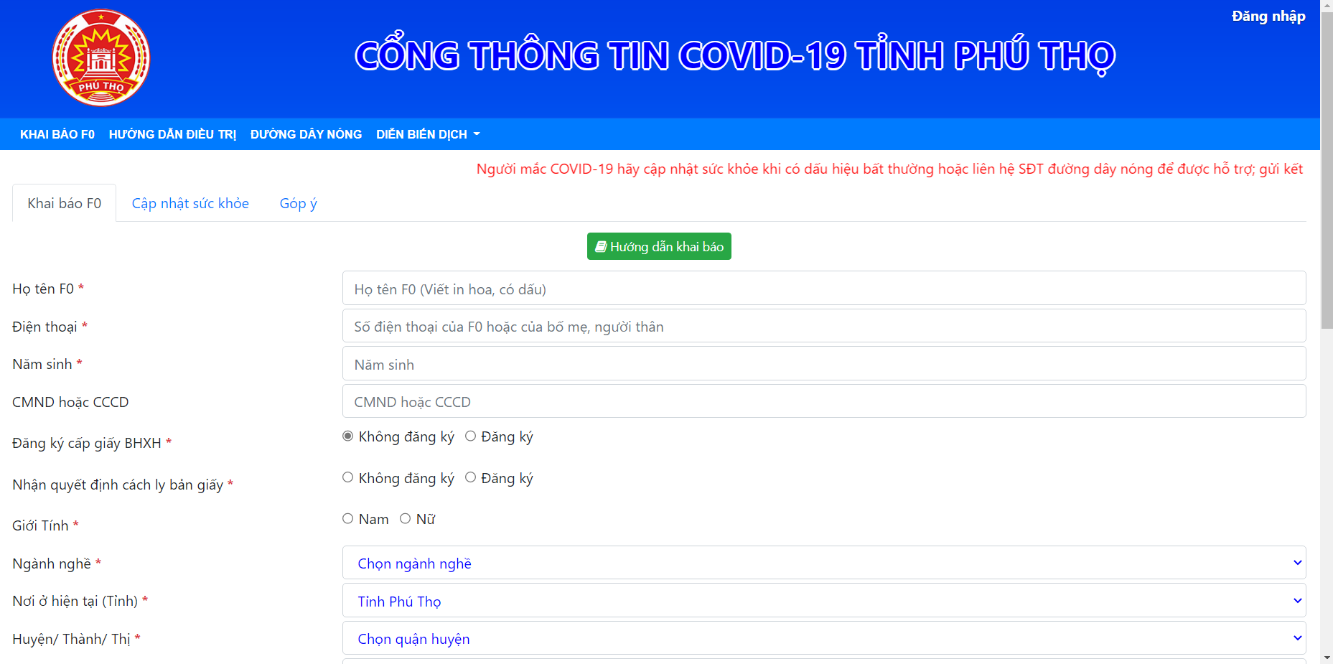

Figure : f0.phutho.vn Website

Link website: <https://f0.phutho.vn/dhcd/khaibaof0dieutritainha>

As seen in the image above, this website has a very simple interface when there are not many functions as well as only one task that is for patients to declare their health status. When the patient completes the declaration here, they will have to wait for the information to reach the ward health station and have to wait for the counselor or the community to support counseling.

The not very good point about this website is that the Login function is only for medical staff or the People's Committee. There is no Login function for patients so this is a bad point. A website usually has to have a Login function for objects to be able to manage information in the best way. But on this website, there is no Login function for patients, so this can be said to be a somewhat confusing way of handling. For example, when a patient wants to be updated with daily information and be able to manage their medical condition, they are required to have an account and login to the website to perform those operations. But in this website, there is no Login function for patients, so many people may not want to use this website very much. The proof is that although this website was created during the outbreak of the disease and the number of Covid cases increased more and more, the number of users of this website was not much with only more than 10,000,000 users reflect the functional deficiencies of this website.

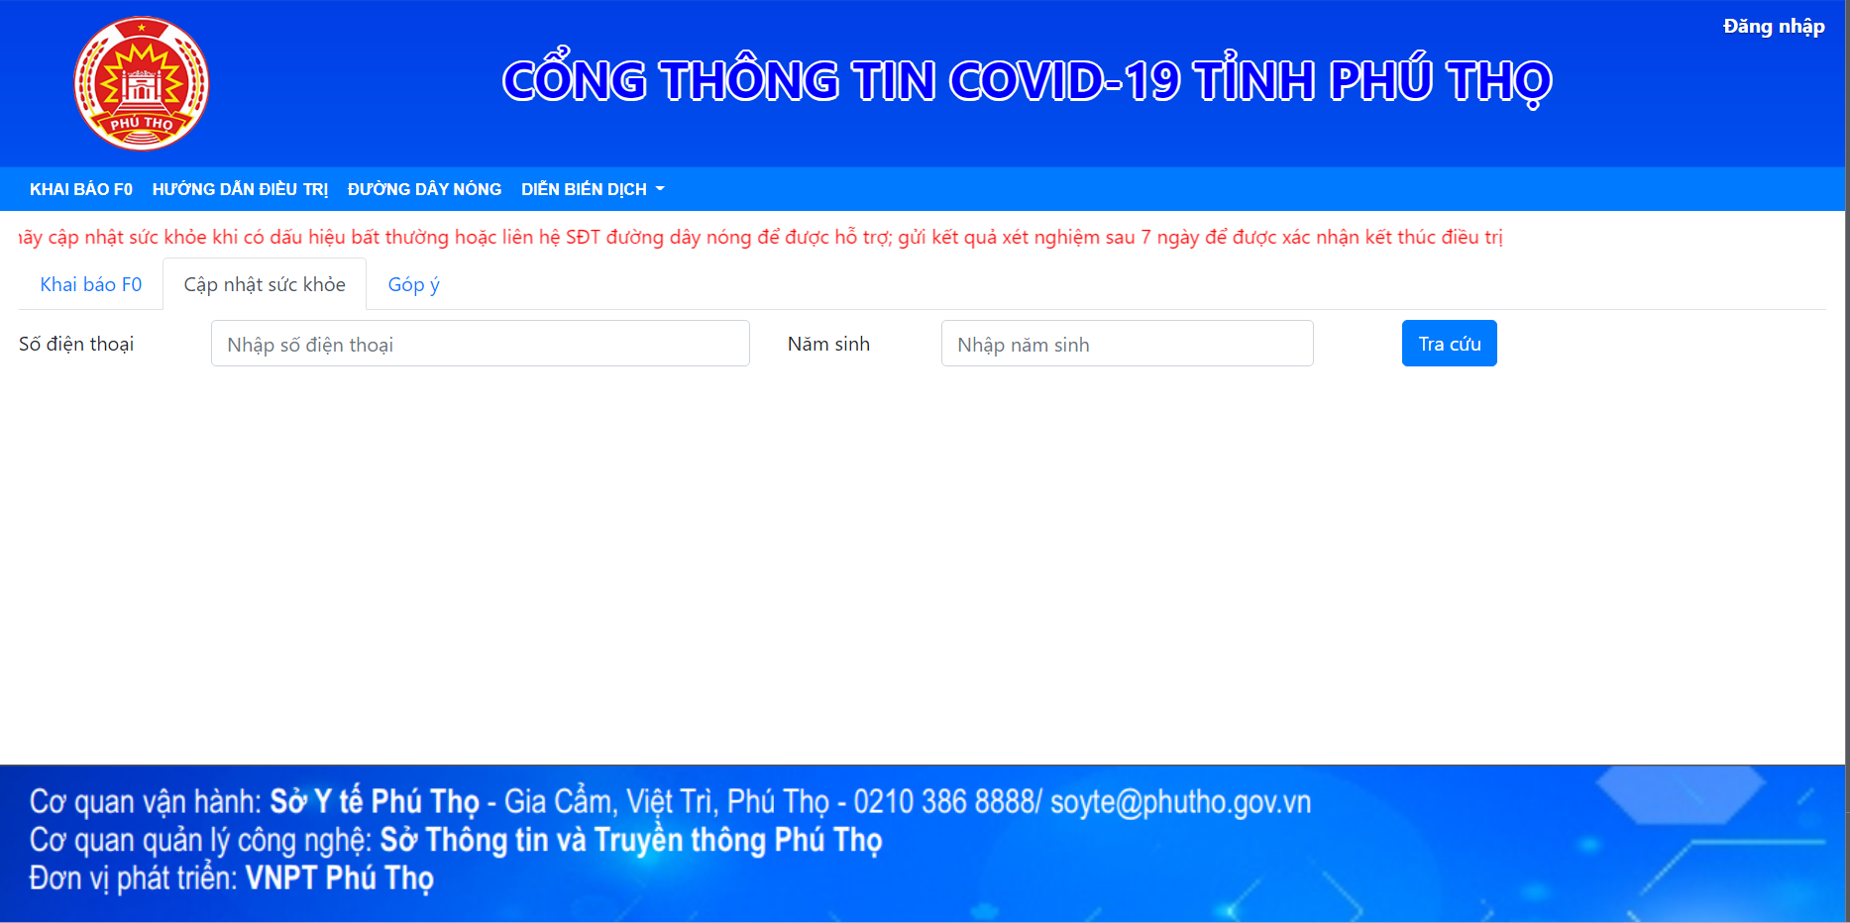

Figure : Patient lookup

The above is the declaration for patient F0 that still has many shortcomings, but this website still has some other functions such as the Patient Lookup function as shown in the picture. This is a function that helps users look up patient information declared on this website by entering Phone number and Date of Birth to search. When declaring, the user has also filled in this information and has been saved in the data of this system. After entering the other two information and then clicking the "Lookup" button, the information of the user with the same Phone number and Date of Birth will appear in the website's data.

However, this is also a minus point of the system, because when looking up like this, it will reveal all of the user's information while it is unlikely that the user wants this information to be known by too many people. This is an issue related to information security, one of the top priorities of every website. But this website does not meet the guarantee of information security. This is a huge minus point of this website and is also one of the reasons that this website is not trusted while the number of infections is increasing.

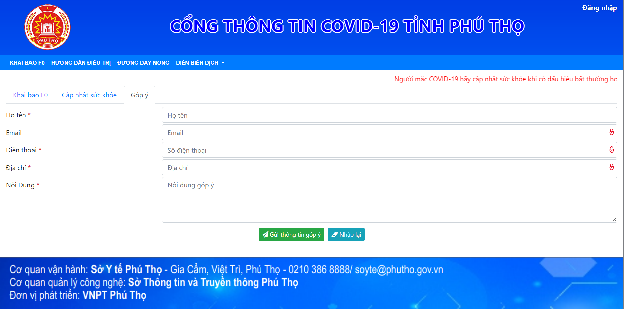

Figure : Community comments

This website also has another function for users, which is community feedback. When a patient updates his or her health status on the website, then the community as well as the Ministry of Health, doctors will also read it and will give advice to that patient through the comment function of the website this.

However, this function is also not very secure because the commenter must specify the address, phone number and email here, so personal information can be seen by outsiders and is not safe for users.

## Similar application 2

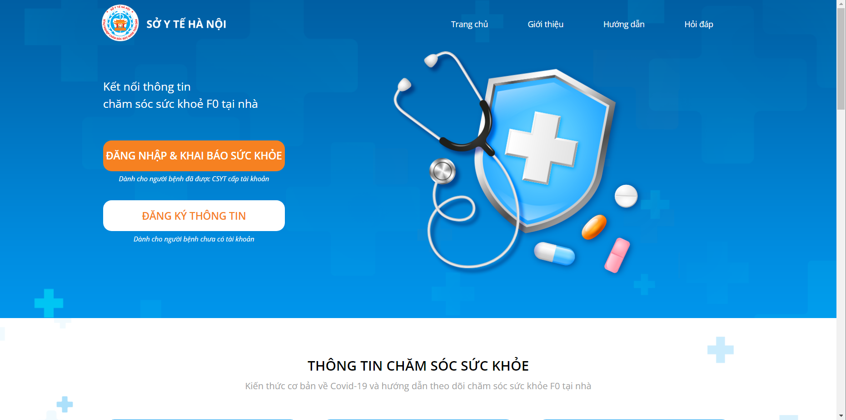

Figure : Chamsocsuckhoe.hanoi.gov.vn Website

Link website: <https://chamsocsuckhoe.hanoi.gov.vn/landingpage>

Another website about home care F0 similar to mine is the website of the Hanoi Department of Health. As in the picture we can see that as soon as we enter the website, we can immediately see the two functions that are Login and Register. This website is better than the previous website in that it is here that patients must log in to be able to update their health and receive support from others, especially doctors.

To register for an account on this website, you must fill in the information as shown in the image below:

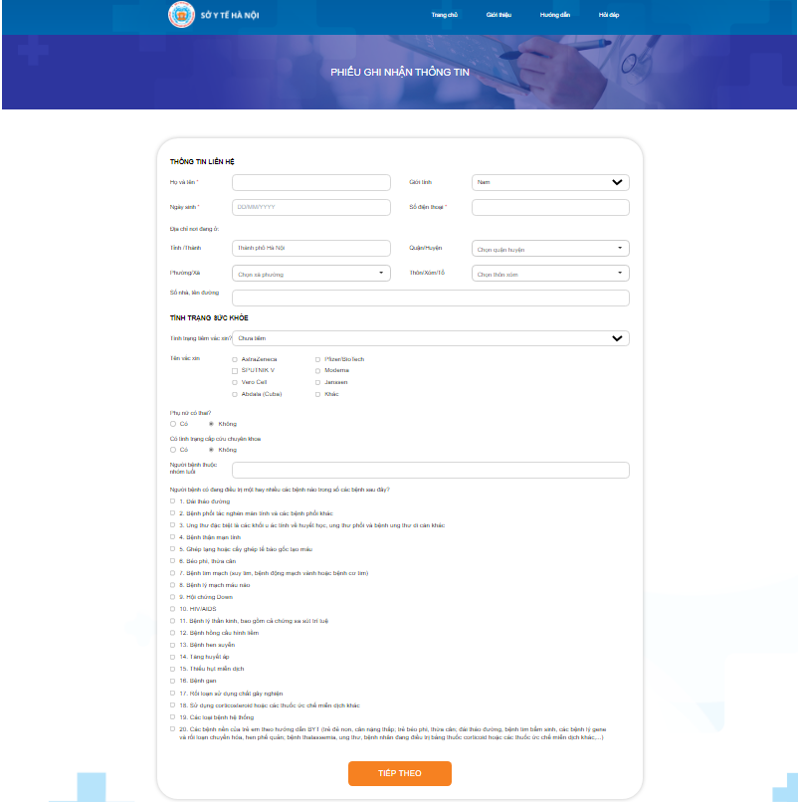

Figure : Register

However, the registration step on this website is a bit complicated and takes a lot of time. Because when we complete the information and click on the "Next" button as shown above, the website will go to another page as shown below:

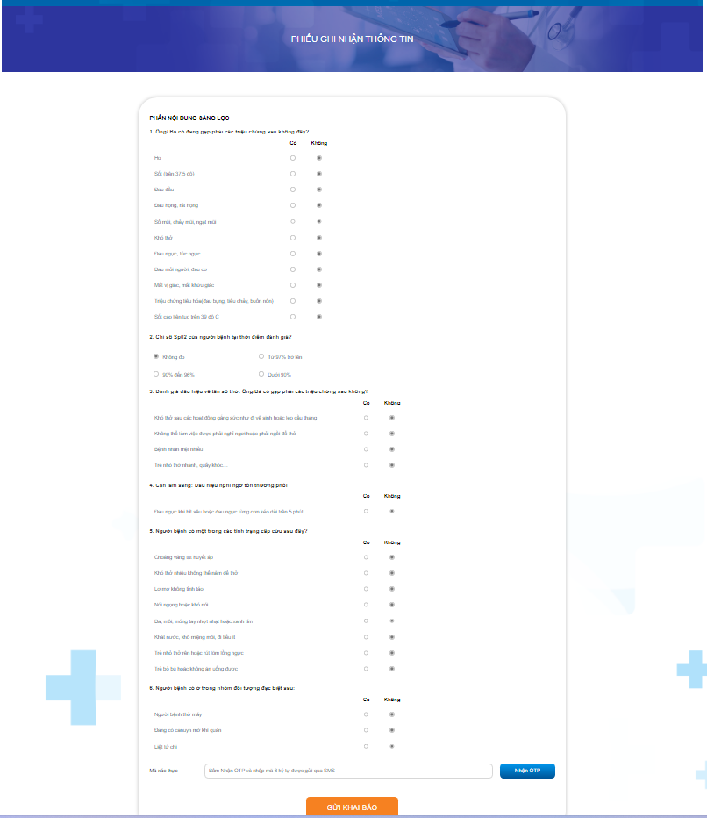

Figure : Form to fill in medical information

When the user completes the above information, there is another step before completing the account registration, which is "Verify OTP code". This may be considered confidential, but for patients they are very tired because they are sick, but when registering an account on this Website, it takes too much time. This can make the patient feel uncomfortable. I also tried to create an account on this Website and I find it very annoying that when I want to enter the OTP, the code is sent long after we click the "Send declaration" button. I created a test account and this OTP took more than 1 minute to be sent to my phone. This can be said to be the most annoying thing for users at this Website.

However, the features of this website are quite complete and almost perfect. Only one place is that this website does not have the function of assigning doctors to manage a number of patients, but here the person supporting the patients is still the community and the doctors. This also only makes patients have to wait a long time for someone to advise and support them after they fill in their medical information in the form.

This is what I find not very good about this website.

## Conclusion

### Operation of the system F0AtHome

* Admin access the system and create an account for Doctor, create a post to post on the system.
* Then the email will be sent to the Doctor and the Doctor will reset the password and then access the system with that account.
* Patient Register an account on sys
* After registration, the system will send an email to Patient to activate the account
* The system also sends a notification to the Admin so that the Admin knows which User has just created an account
* After accessing the account, Patient will fill in personal information (Including full name, SDT, emergency contact SDT, injected vaccine, type of vaccine, date of injection, ...)
* Declare disease symptoms on the system
* Then the system will send a notification to the Admin and the Admin will receive a notification to add that Patient to a Doctor
* After successfully adding Patient, Doctor will receive a notification about Patient received by that Doctor and displayed on that Doctor's Patient List (1 Doctor is only allowed to manage up to 10 Patients).
* After the Doctor receives the Patient, that Patient will receive a notification that the Doctor has received it.
* Then Patient will update his health status daily and update to the system.
* Then the system will send a notification about Patient's health status to Doctor and Doctor will assess Patient's health status, prescribe medicine and give Patient advice (Doctor and Patient will communicate with each other on chat. of the system).
* If the Patient is seriously ill, the Doctor will go to the Patient's house and treat the Patient (In this case, the Doctor will look at the Patient's home address and SDT on that Patient's personal information on the system or the Doctor will contact Patient's family by SDT for emergency contact).
* After a period of medical examination and treatment, Patient will update the normal status and Doctor also confirms that Patient is cured, Patient will receive a notification that Doctor has confirmed you are cured and that Patient will be certified as cured from disease. Doctor and get a certificate of cure on the system.
* After the Patient is cured, the Patient's Medical History will be saved in the History section in the system and also the Patient's operation on the system during the treatment period. (Including daily status updates) and this history can be reviewed from time to time
* Admins can view statistics on the prevalence of F0 of each age through a chart in the system's own statistics section that only Admins have access to.

### Confirm your application features

From the above, I have created the website “f0AtHome” which has the necessary functions for the patient and the doctor to be able to assist the patient in their care and if the condition worsens the doctor can know in advance and timely. treatment to save the patient's life.

This website is for 2 main objects: Doctor and Patient and has more Admin to manage the website. When accessing the website, each object will have a different interface and function. The account registration for Patient only by Doctor has been created by Admin and will send the account to Doctor so that Admin can easily manage Doctor. As for the interface, for Admin, it is mainly the interface to manage Post, Doctor and Patient posts. With Doctor, there will be an interface to manage personal information and see the list of patients and take care of patients. As for Patient, there will be an interface and function to manage personal information and update the health status for the Doctor to monitor and take care of.

With the development of this website system, my purpose is to help doctors and patients can interact and can help Covid patients receive the care of doctors while staying at home. reduce the load on hospitals. With self-isolation at home, not only helps the hospital to reduce overload, but also helps patients to monitor their own health but also be cared for by doctors, as well as helping to apply technology to health rapidly developing.

After the website is developed and applied, I will develop the website to add the necessary functions for the care of Covid patients at home, develop the web to increasingly suit the needs of users.

# Software design

## Architecture

### Jhipster (Spring boot - Angular)

Vẽ hình xem có mấy model

Cấu trúc của pack project như nào

### MySQL Workbench

MySQL workbench is a software that helps programmers can communicate with the MySQL database system instead of having to use complicated and time consuming Command-line commands. MySQL Workbench has many versions for different operating systems: Windows, Linux, Mac OS X, Unix, FreeBSD, NetBSD, Novell NetWare, SGI Irix, Solaris, SunOS, etc. (VanB, 2021)

* MySQL workbench supports creating multiple models in the same environment. Support users to create multiple modeling in the same environment as well as support other objects such as viewers, tables, triggers, storage methods, etc. to create a database.
* It is possible to run multiple queries and then the results will be automatically displayed in different tabs. In addition, the query is saved in the query history for easy retrieval and running later.
* Backup and restore data: intuitive tool for exporting/importing dump files in MySQL. Dumb files in MySQL contain SQL scripts to create databases, tables, viewers, methods for storing and inserting data.
* Allows migration to be configured, edited, copied, and executed and scheduled with projects.

### Websocket

WebSoket is a technology that supports two-way communication between client and server by using a TCP socket to create an efficient and inexpensive connection. Although designed specifically for use with web applications, programmers can still include them in any type of application. (Dat, 2017)

Pros:

* WebSockets provide powerful, low-latency, and error-prone bidirectional communication. It doesn't need as many connections as the Comet long-polling method, and it doesn't have the downsides of Comet streaming.
* The API is also very easy to use directly without any additional layers, compared to Comet, which usually requires a good library to handle reconnects, timeouts, Ajax requests (Ajax requests), acknowledgments and various optional transports (Ajax long-polling and jsonp polling).

Cons:

* It is a new specification of HTML5, so it is not yet supported by all browsers.
* There is no request scope. Since WebSocket is a TCP socket and not an HTTP request, it is not easy to use request-scoped services, like Hibernate's SessionInViewFilter. Hibernate is a classic framework that provides a filter around an HTTP request. When initiating a request, it sets up a contest (containing transactions and JDBC associations) that is bound to the request stream. When that request ends, the filter cancels the contest.

### Liquibase

## GUI

### Admin

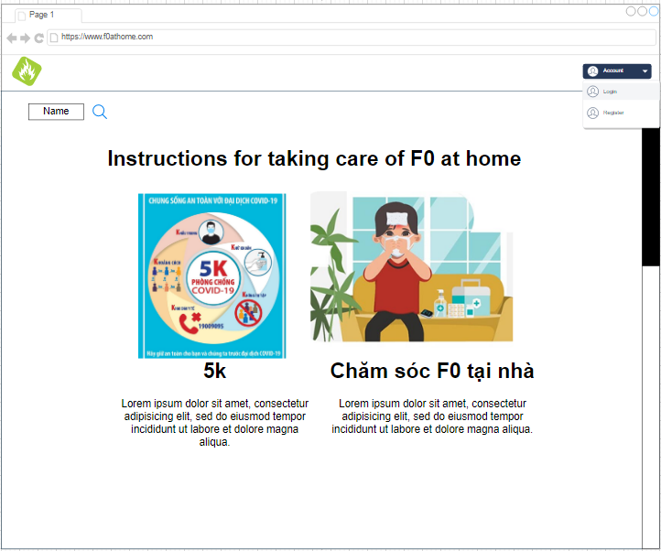 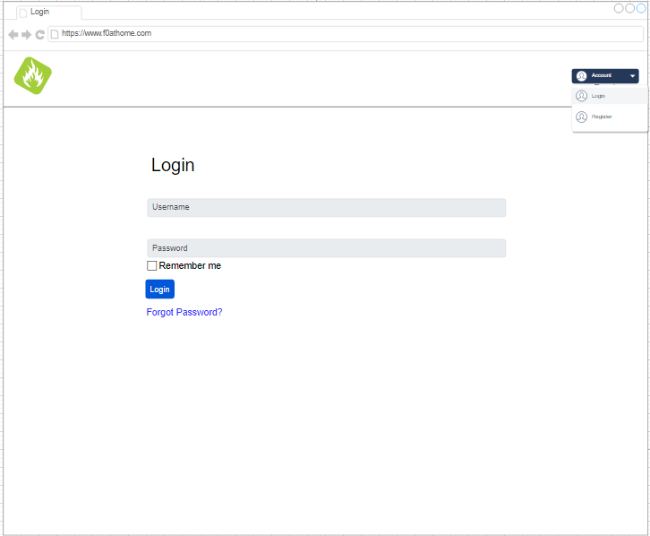

Figure : Admin Home page Figure : Login page

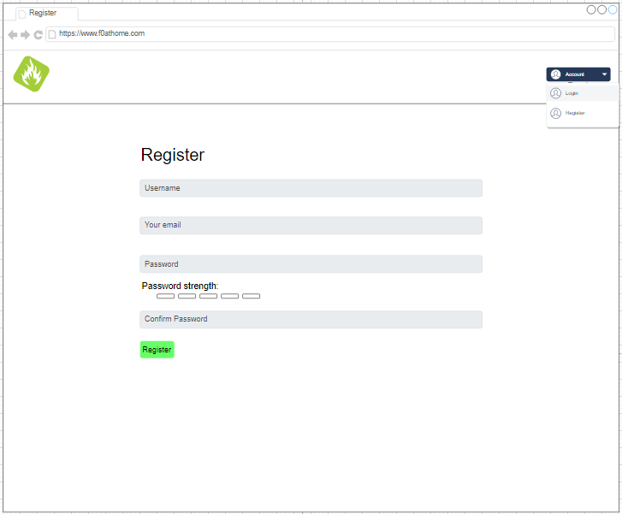 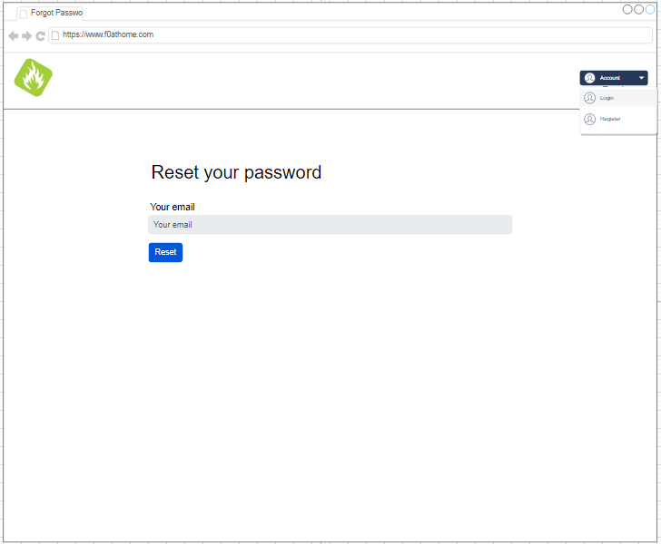

Figure : Register page Figure : Reset password page

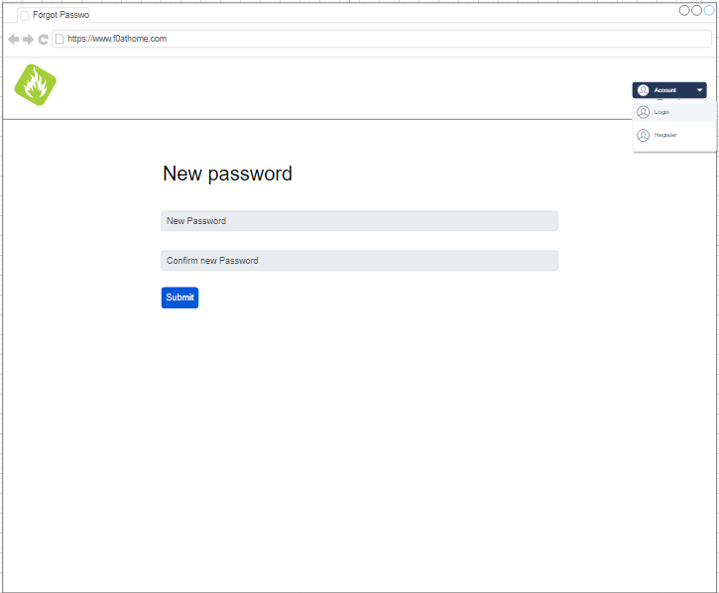 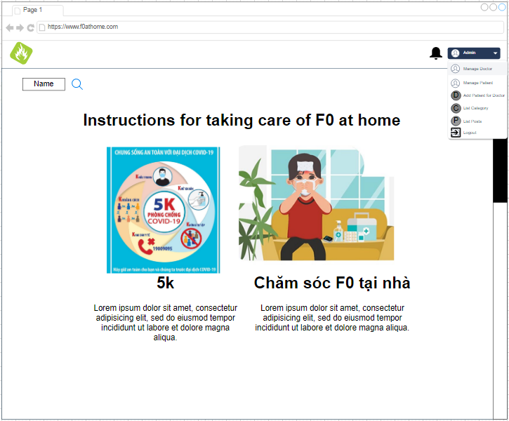

Figure : New password Figure : Home Page Admin

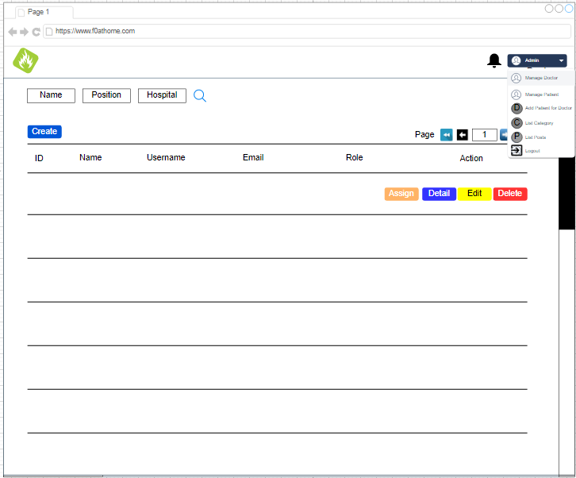 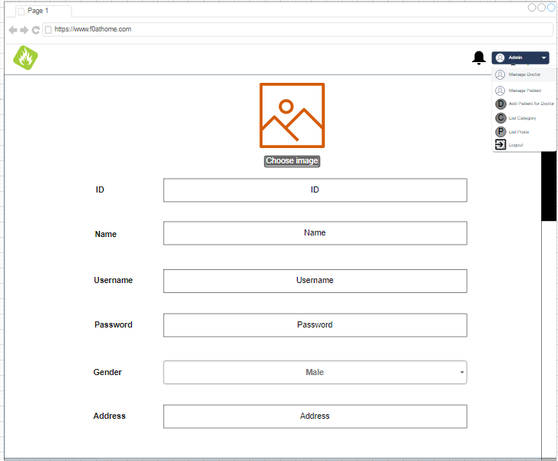

Figure : List user page Figure : Create Doctor 1

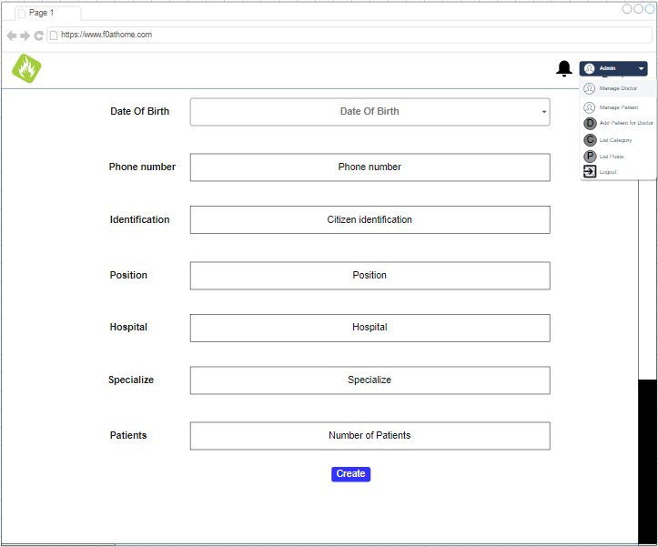 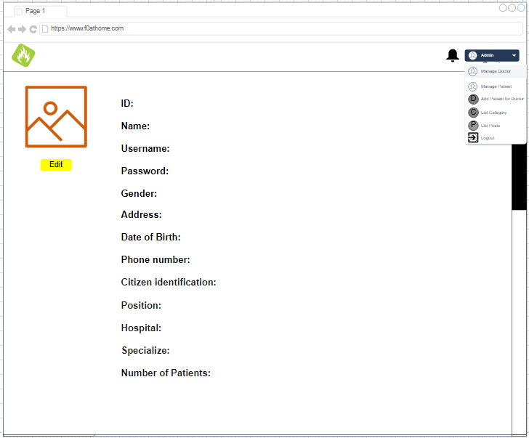

Figure : Create Doctor 2 Figure : Detail Doctor

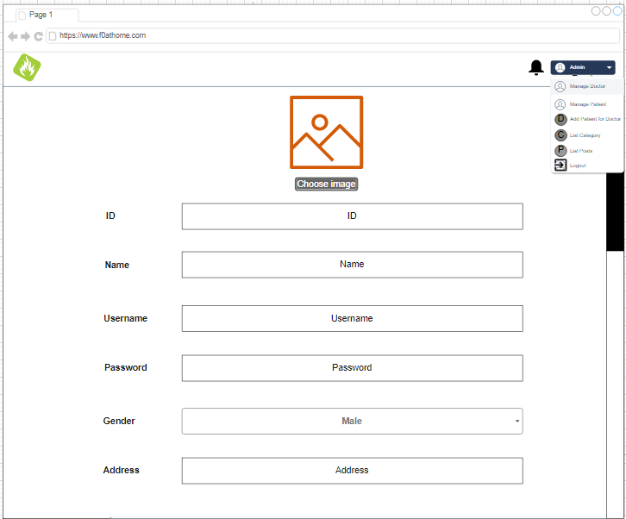 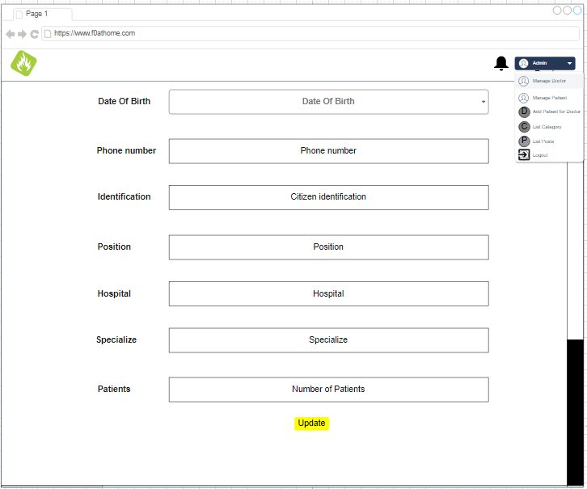

Figure : Edit Doctor 1 Figure : Edit Doctor 2

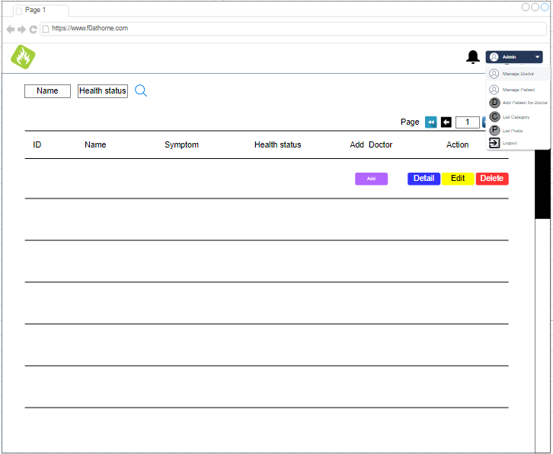 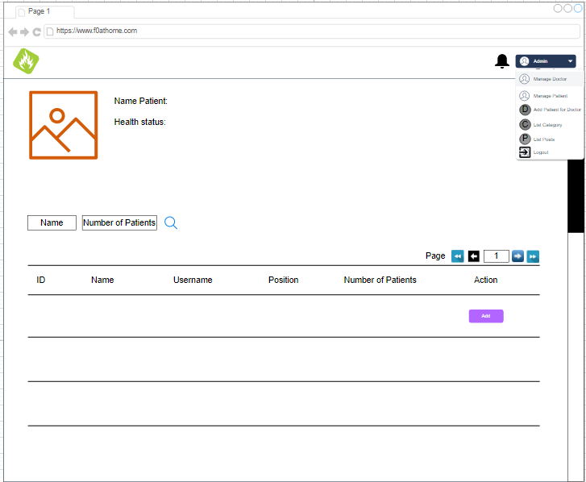

Figure : List Patient Figure : Add Patient for Doctor

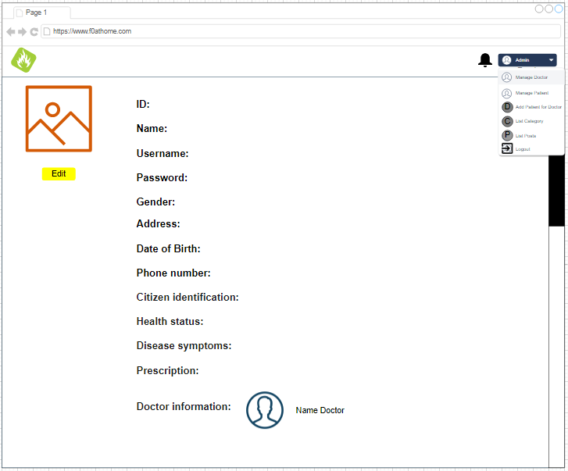 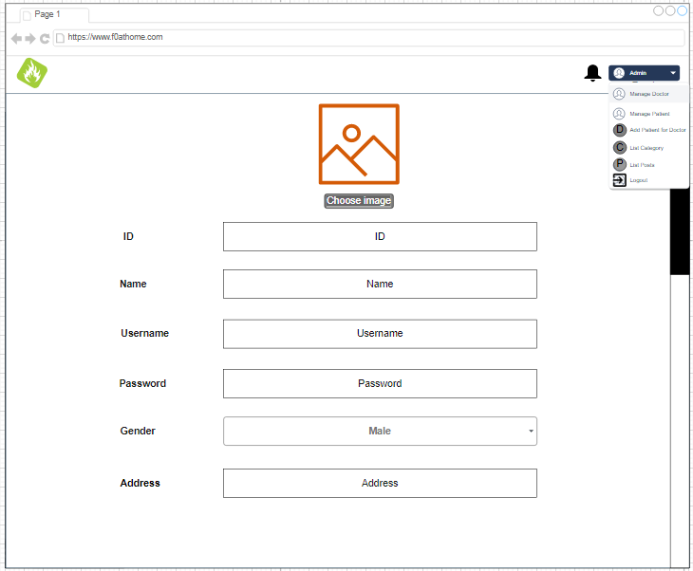

Figure : Detail Patient Figure : Edit Patient 1

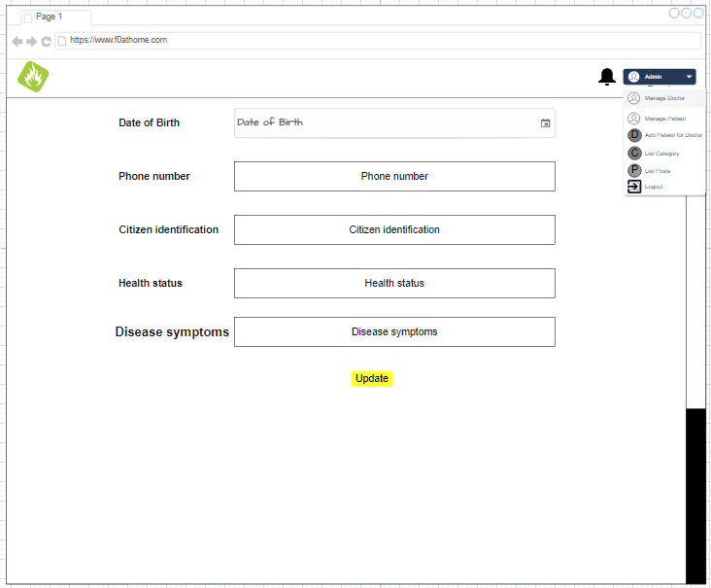 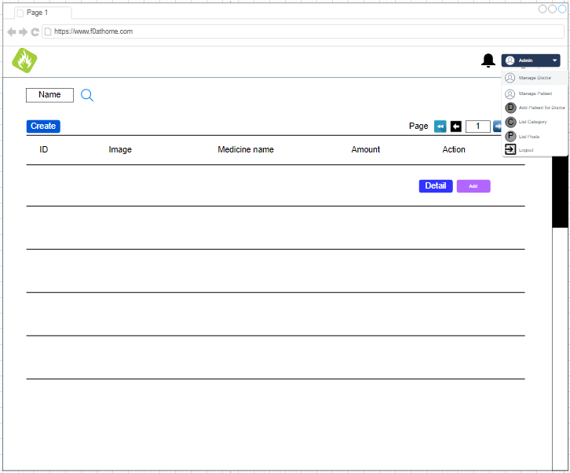

Figure : Edit Patient 2 Figure : Add Prescription

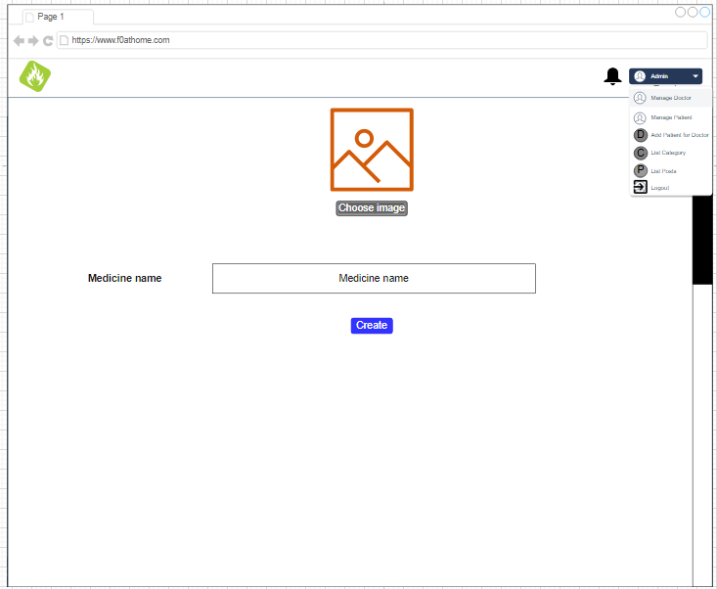 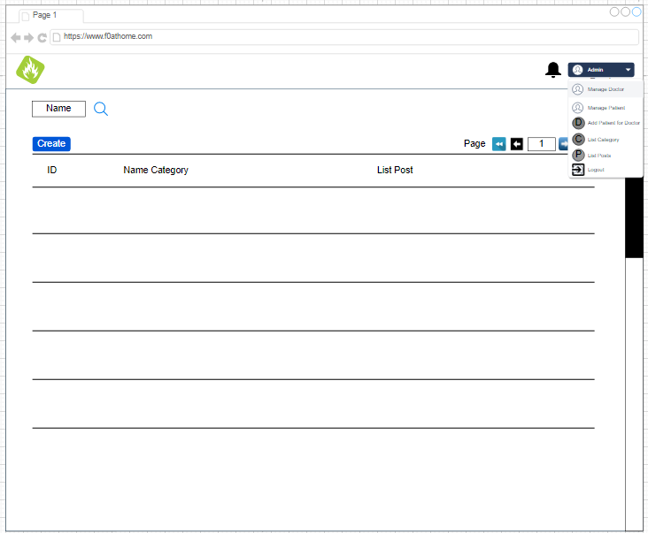

Figure : Add Medicine Figure : Manage Category

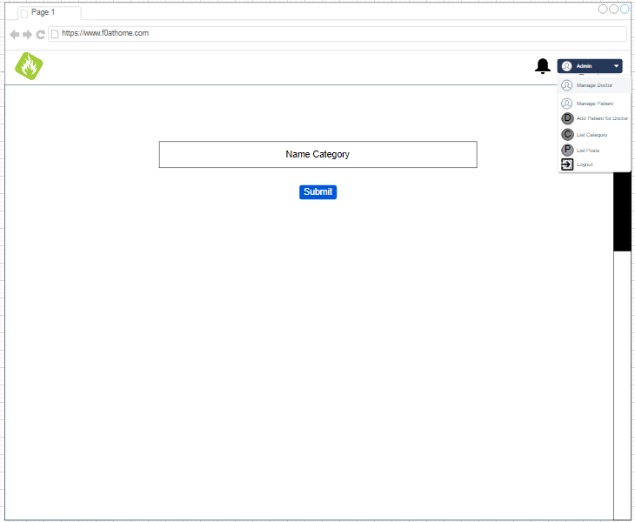 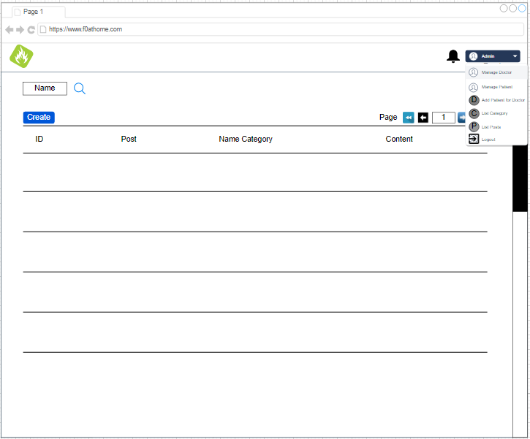

Figure : Add Category Figure : List Post

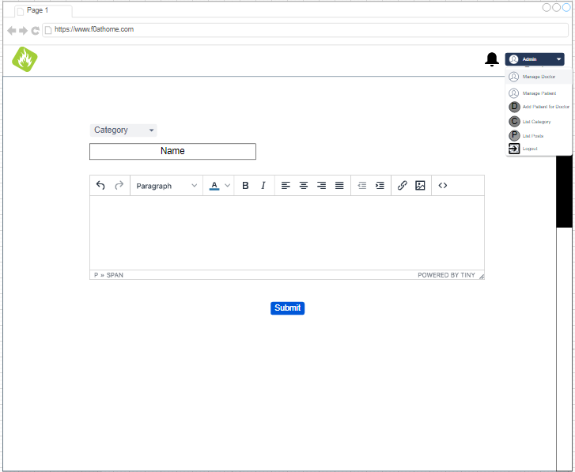

Figure : Add Post

### Doctor

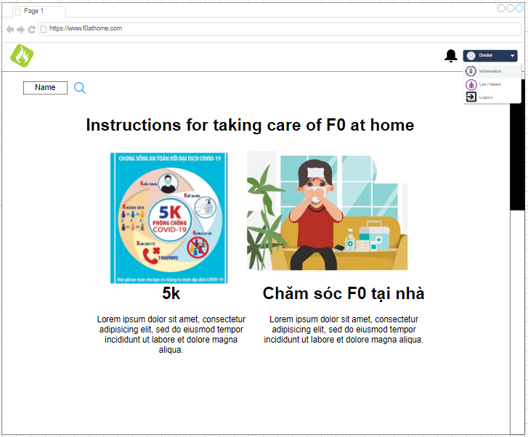 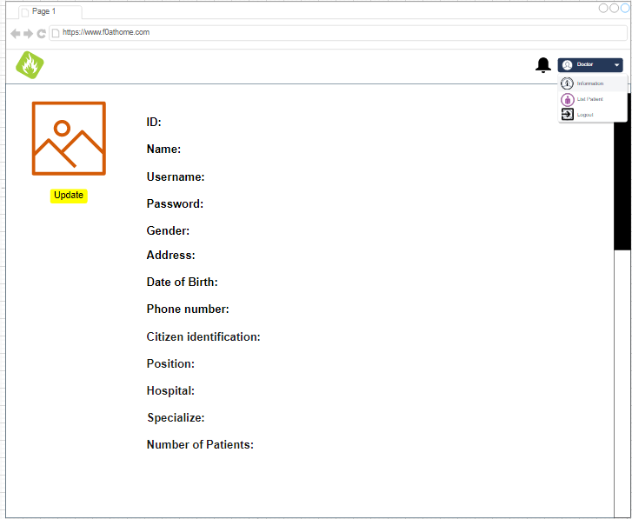

Figure : Doctor Home Page Figure : Detail

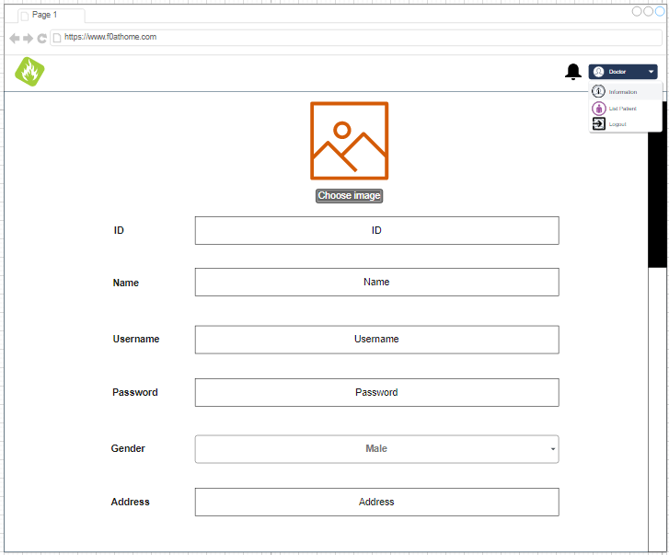 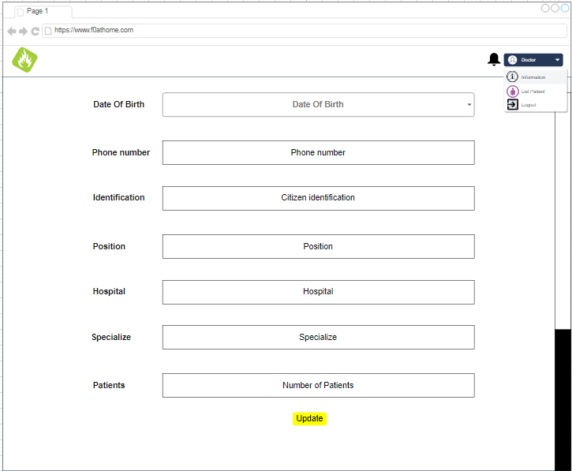

Figure : Edit information 1 Figure : Edit information 2

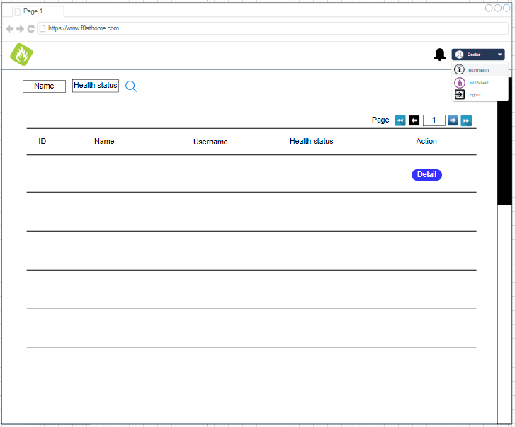 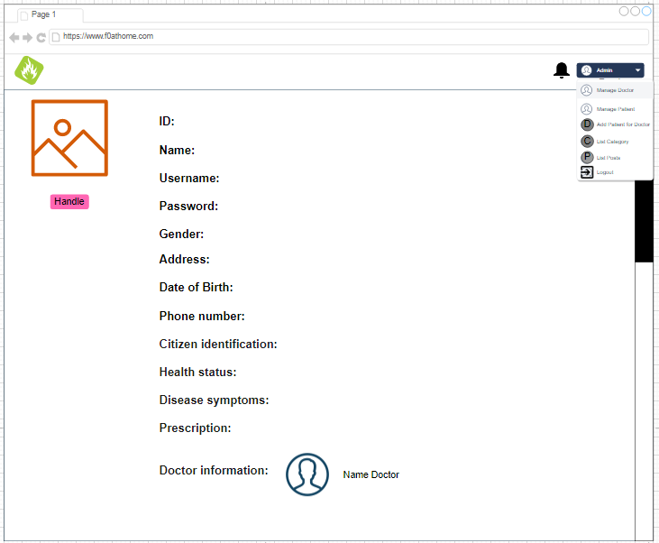

Figure : List Patient Figure : Detail Patient

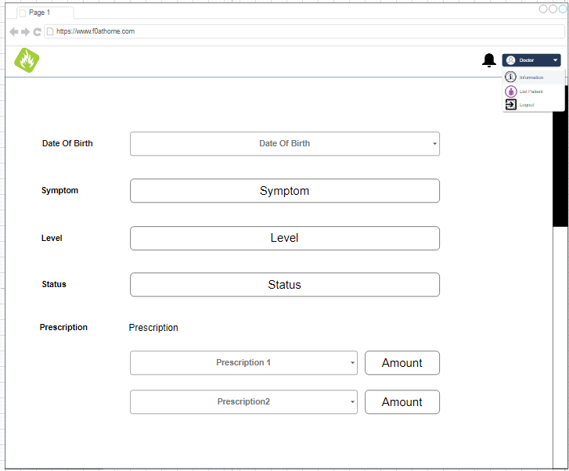 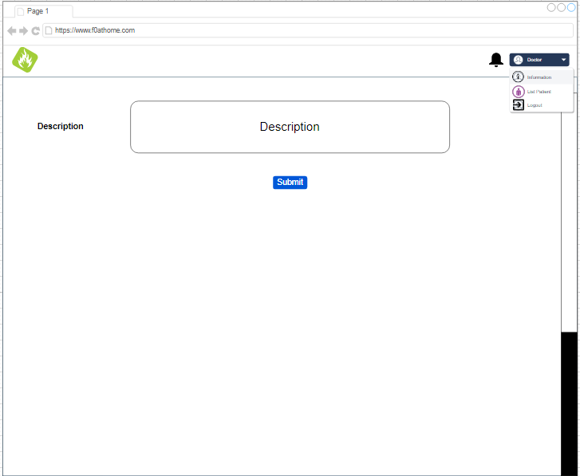 Figure : Handling the patient's condition 1 Figure : Handling the patient's condition 2

### Patient

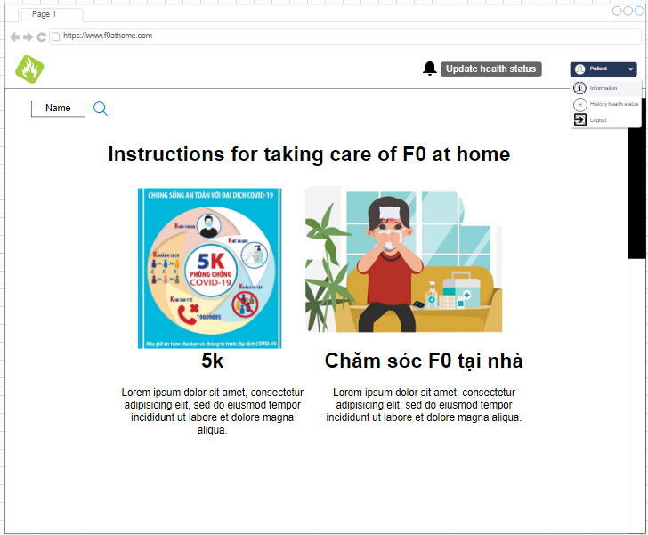 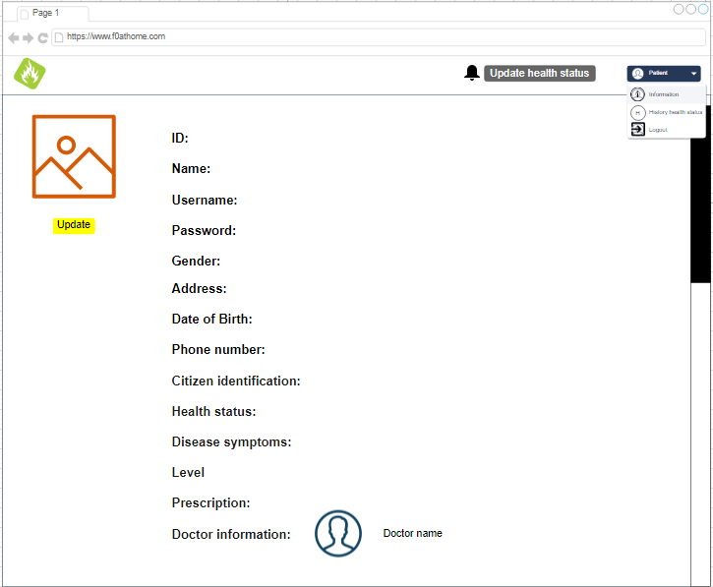

Figure : Patient Home Page Figure : Detail

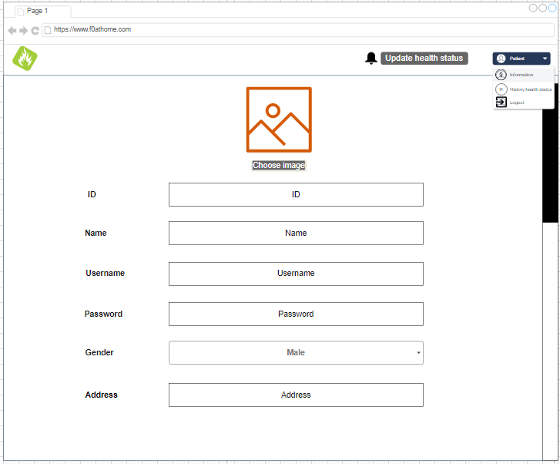 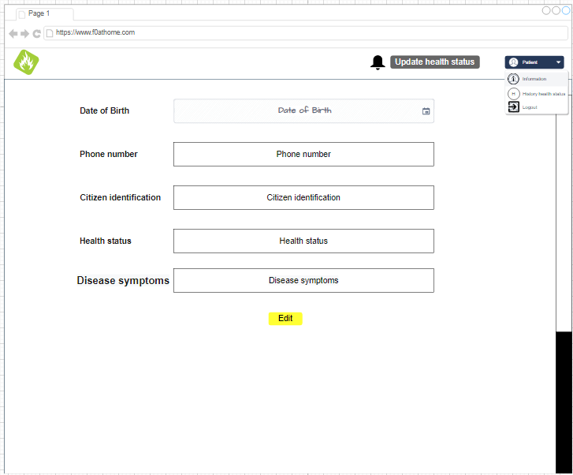

Figure : Edit information 1 Figure : Edit information 2

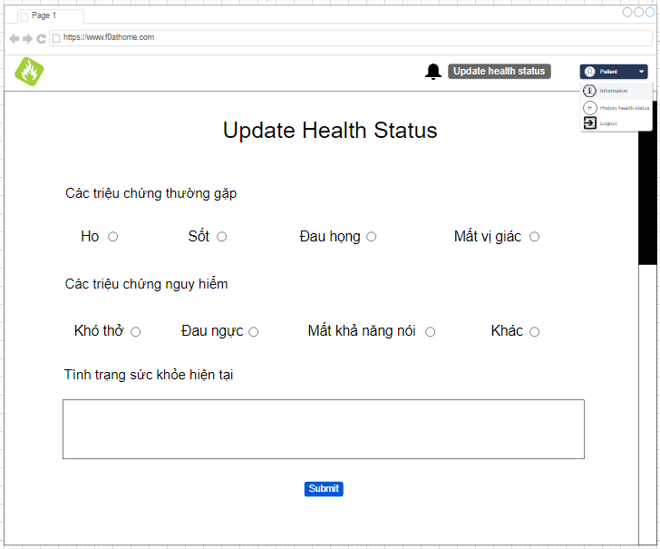 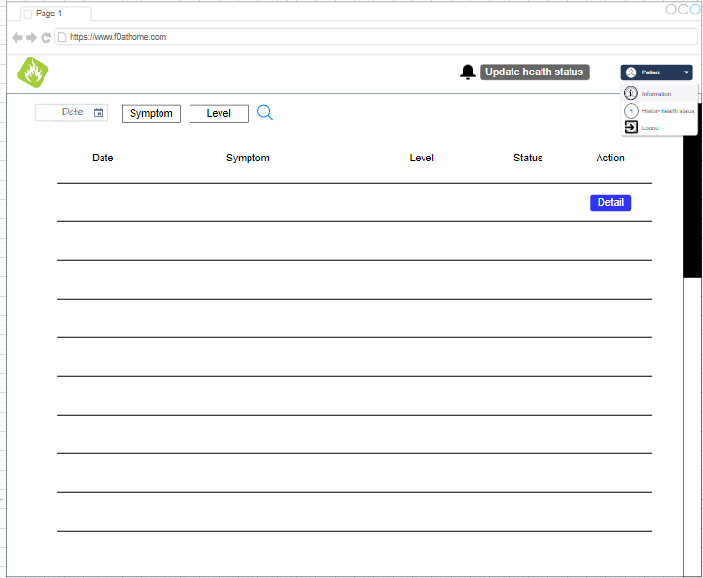

Figure : Update health status Figure : History health status

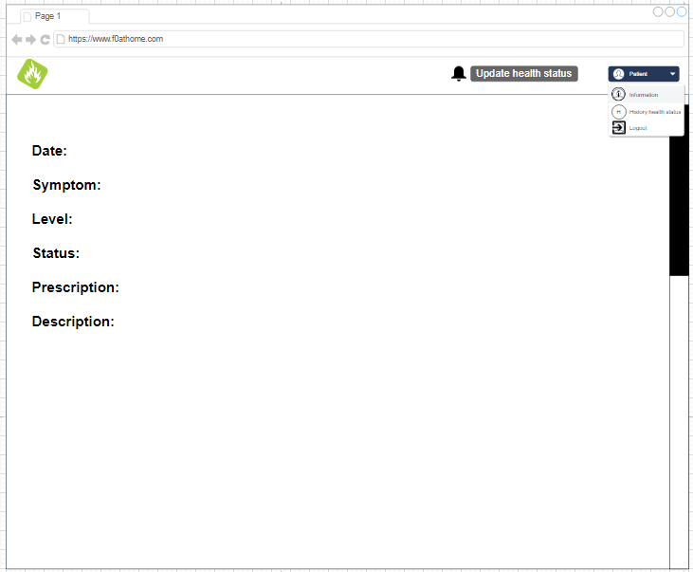

Figure : Health detail

## DB

### ERD

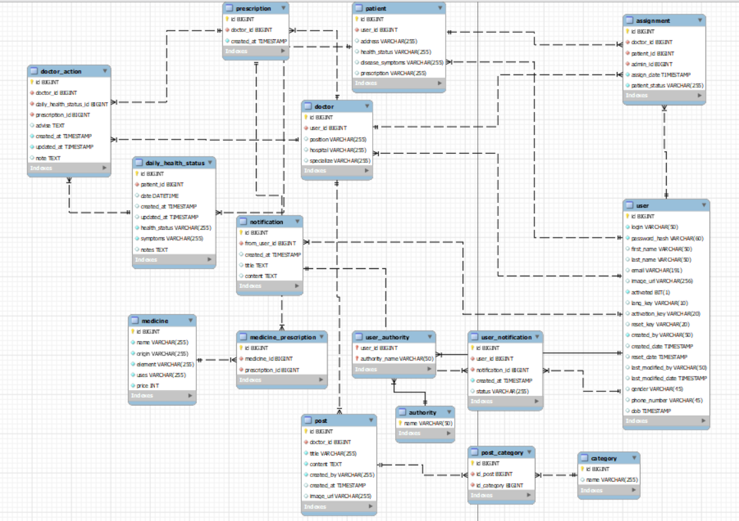

Figure : ERD

## UML

### Class Diagram

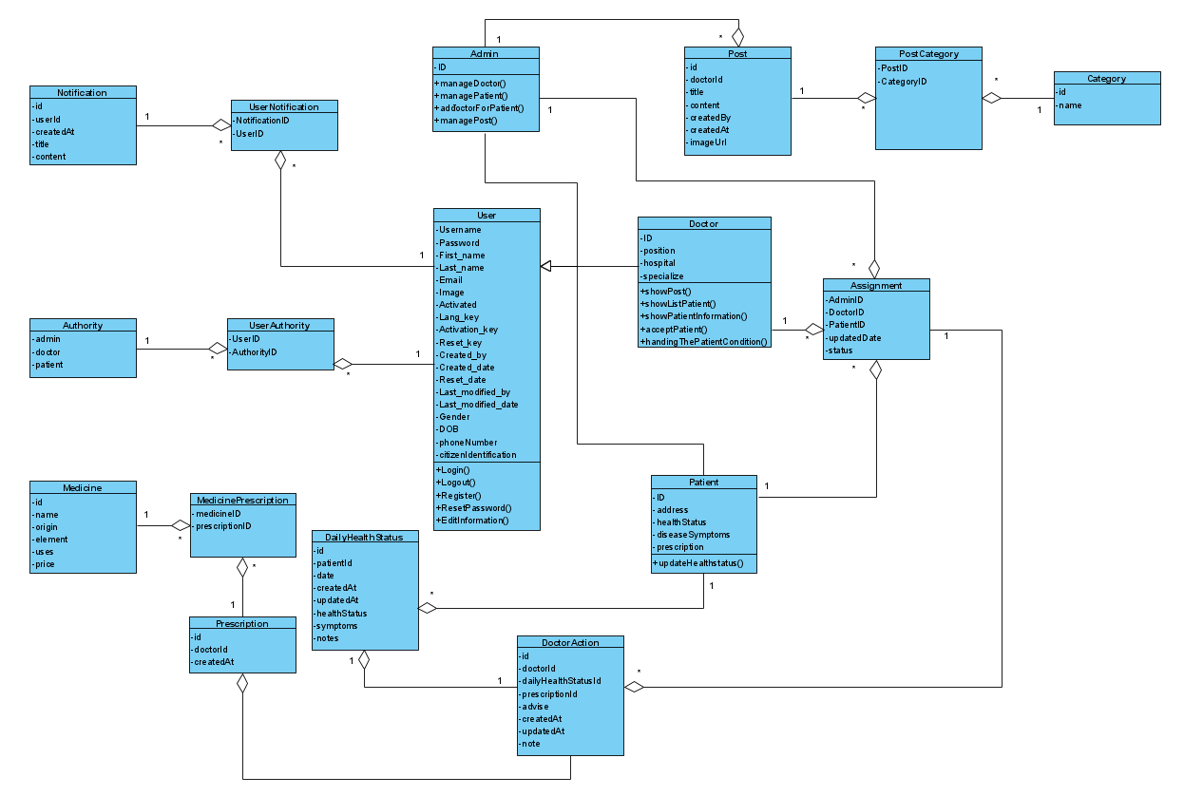

Figure : Class Diagram

### Use Case Diagram

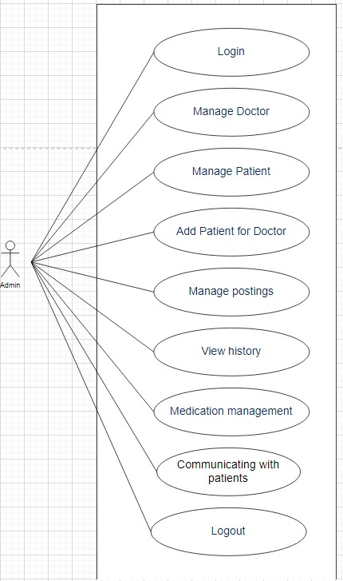 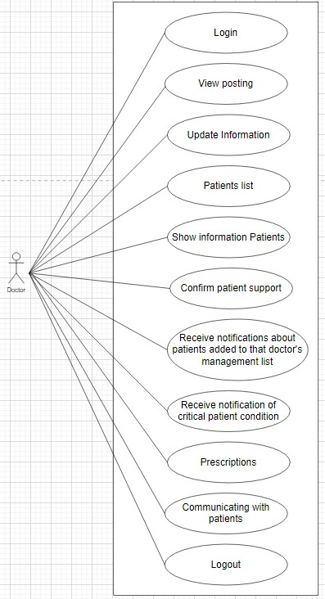 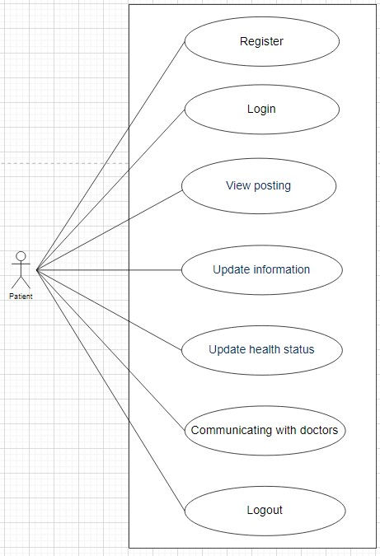

Figure : Use case Admin Figure : Use case Doctor Figure : Use case Patient

# Software implementation

## Development environment

### Jhipster

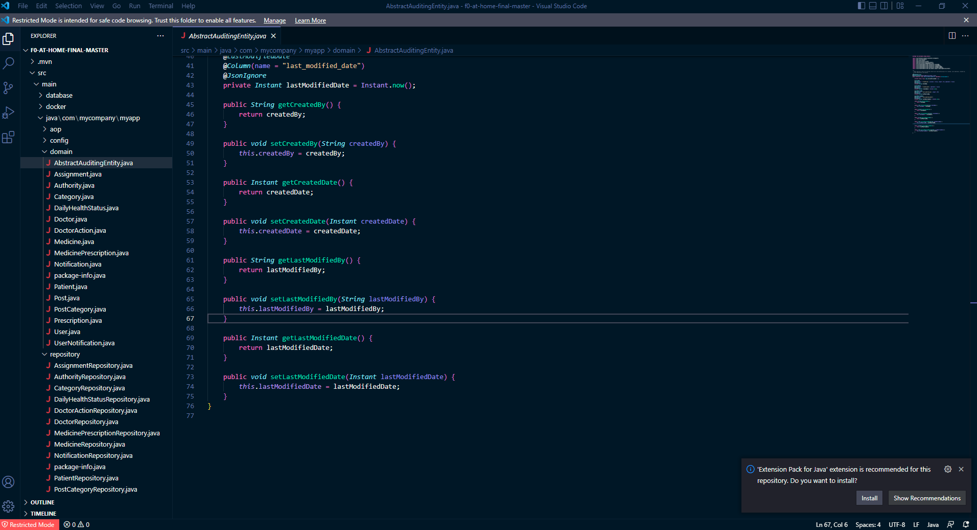

Figure : Visual Studio code

As for the tool code, I choose Visual Studio code. I choose this tool because it is a very good code support tool, although Visual Studio code is not as good as other tools like IntelliJ, Visual Studio, etc. However, Visual Studio code supports all languages, moreover this tool is very good. Lightweight, the interface is quite easy to use and supports running multiple Terminals at the same time. Suitable for many people who need to run many Terminals at the same time.

Sau khi implement

### MySQL Workbench

Ở đây tôi sử dụng Java 8 vì những lý do sau:

* Đầu tiên vì Java 8 ra mắt rất lâu rồi nên tính ổn định của Java 8 rất tốt.
* Tiếp theo là Java 8 có đầy đủ những tính năng mà tôi cần trong dự án ví dụ như: Lambda Expression (Giúp rút gọn các dòng code lại), Functional Interfaces. Tuy các phiên bản Java về sau cũng đều có những tính năng này và thậm chí có nhiều tính năng mới hơn tuy nhiên ở Java 8 là phiên bản đầu tiên có những tính năng này mà Java 8 cũng là phiên bản ổn định nhất và cũng đủ các tính năng tôi cần cho dự án nên tôi chọn Java 8 làm công nghệ phát triển dự án của mình.

### Websocket

Đối với Angular 10, tôi sẽ có được những tính năng sau:

### Liquibase

## Important technical problems & solutions

### Xây dựng chức năng chat (Dùng Websocket)

Websocket là công nghệ hỗ trợ giao tiếp hai chiều giữa Client và Server có thể tạo một kết nối hiệu quả và ít tốn kém. Ở đây tôi sử dụng Websocket để xây dựng được chức năng Chat trong trang web của tôi, chức năng Chat này được sử dụng cho mọi đối tượng.

### Vấn đề bảo mật, xác thực và phân quyền (Dùng của Spring security và JWT)

Bảo mật luôn là một trong những ưu tiên hàng đầu của mọi hệ thống trên thế giới. Hệ thống của tôi cũng vậy, tôi sử dụng tính năng bảo mật Spring Security của Spring boot vì tôi hiện sử dụng Jhipster có tích hợp Spring boot và khi sử dụng Spring boot sẽ giúp tôi tiết kiệm thời gian tích hợp tính năng bảo mật của công nghệ khác.

Spring security có các tính năng như Authentication, Authorization, Bộ lọc Servlet. Authentication là phần xác thực xem User đó có phải User của trang web đó hay không. Khi có chức năng này tôi sẽ biết được một User có phải là người dùng của hệ thống của tôi hay không.

Tiếp đến là Authorization, đây là tính năng phần quyền giúp hệ thống biết được User đó có quyền gì ở trong hệ thống đó. Tính năng này giúp tôi phân biệt được một User đó có quyền hạn gì trong hệ thống của tôi. Điều này giúp tôi biết User nào là Admin, Doctor hay Patient.

### Vấn đề Deploy code lên web bằng Heroku được tích hợp sẵn trong Jhipster

## Test

### Test case

|  |  |  |  |  |
| --- | --- | --- | --- | --- |
| **Number** | **Test Case Field** | **Description** | **Actual results** | **Result** |
| 1 | Truy cập vào trang web | Gõ đường dẫn lên google sẽ dẫn đến trang web | Đã đến trang web và hiện rat rang chủ trang web | Pass |
| 2 | Admin đăng nhập |  |  |  |
| 3 |  |  |  |  |
| 4 |  |  |  |  |
| 5 |  |  |  |  |
|  |  |  |  |  |
|  |  |  |  |  |
|  |  |  |  |  |
|  |  |  |  |  |
|  | Đăng kí và phân quyền |  |  |  |
|  | Quản lý danh sách bác sĩ, bệnh nhân |  |  |  |
|  | Chỉ định điều trị, bác sĩ điều trị |  |  |  |
|  | Bệnh nhân cập nhật status hàng ngày |  |  |  |
|  | Bác sĩ kê đơn thuốc ??? hay thông báo ? kênh chat? bài viết, quản lý thuốc, ... |  |  |  |
|  |  |  |  |  |
|  |  |  |  |  |
|  |  |  |  |  |
|  |  |  |  |  |
|  |  |  |  |  |
|  |  |  |  |  |
|  |  |  |  |  |
|  |  |  |  |  |
|  |  |  |  |  |
|  |  |  |  |  |
|  |  |  |  |  |
|  |  |  |  |  |
|  |  |  |  |  |
|  |  |  |  |  |
|  |  |  |  |  |
|  |  |  |  |  |
|  |  |  |  |  |
|  |  |  |  |  |
|  |  |  |  |  |
|  |  |  |  |  |
|  |  |  |  |  |
|  |  |  |  |  |
|  |  |  |  |  |
|  |  |  |  |  |
|  |  |  |  |  |
|  |  |  |  |  |
|  |  |  |  |  |
|  |  |  |  |  |
|  |  |  |  |  |
|  |  |  |  |  |
|  |  |  |  |  |
|  |  |  |  |  |
|  |  |  |  |  |
|  |  |  |  |  |
|  |  |  |  |  |
|  |  |  |  |  |
|  |  |  |  |  |
|  |  |  |  |  |
|  |  |  |  |  |
|  |  |  |  |  |
|  |  |  |  |  |
|  |  |  |  |  |
|  |  |  |  |  |
|  |  |  |  |  |
|  |  |  |  |  |
|  |  |  |  |  |
|  |  |  |  |  |
|  |  |  |  |  |
|  |  |  |  |  |

Table : Test case

## Results

# Evaluation and conclusion

## Evaluation of results

### Pros

Since this project of mine is about F0, a disease that is happening very complicatedly around the world, it is quite easy to find documentation for this issue. This system was also developed during the time of the complicated epidemic, so I was also easily approved by the teacher and also supported by him very enthusiastically.

Another advantage is that I built this system with a framework, so building the project is also quite fast. Just having to customize the system interface and write a few more pages also helps to develop the system quite quickly.

### Cons

When building this system, I also encountered some difficulties such as:

* When building the project, I have to learn a few more technologies like Jhipster, Angular, React. I have not learned these technologies before, so when I build, I also have to learn more about these technologies.
* Next is about the issue of setting up the environment to run on the Laptop. This is something that took me a lot of time because the above technologies use the environment on a lot of things. Having to learn and install this environment was a difficult experience for me.
* Finally, in terms of time. It took me a lot of time to build this system because in parallel with doing this project I also have to do Coursework of 4 other subjects, so in terms of time I have quite a bit so this makes it difficult for me a lot.

## Conclusion

### Lessons learnt

After completing this project, I also gained quite a bit of experience in developing a large system. Because the system I built can also be considered a large system, I also learned some lessons. I have gained some experience such as:

* To come up with an idea for a project, we have to consult a lot of documents, consult with people before deciding on a topic. Because this is the deciding factor to your progress.
* Next, the interface design must choose the right support tool, must design so that the interface must be suitable for the right user object, the purpose of the system before coding the project.
* The next lesson is that choosing the technology to develop the project is a key factor for the progress of the project fast or slow. The choice of technology will affect the progress of our work as well as our time, choosing the technology we already know and grasp will definitely help the progress of the project to be completed quickly. If we choose technology that we have never been exposed to, it will take time to learn the technology and will reduce the completion of the project.
* Another lesson is to know clearly what you are doing in the system development process and determine the right purpose of your system for what purpose, what function it needs, for which user object. Must determine the right purpose or we will easily get off topic and deviate from the original purpose planned.

### Problems / difficulties

During the implementation of this project, I also encountered some difficulties in many issues such as ideas or design, support tools. Here are the details of those difficulties:

* In terms of ideas: This is the first step when developing a system, before choosing this topic of F0 I also had a lot of other ideas such as: Website reading stories, Web sales, Web games. However, after thinking and also consulting a few acquaintances, I realized that the idea for other websites has many difficulties, for example, a website to read stories, I must have a source of stories and hire an author to write stories. to post on your website. Or like the sales website, it's too popular and I also think the teachers don't like this idea very much, so I consulted and made a decision to choose a topic about the F0 epidemic that is happening around the world.
* In terms of interface design before coding: I also had a hard time designing the interface for my website. I had to find the right interface for my system and design the interface accordingly.

### Future improvements

After completing this project, I also realized that my system needs further improvement in many aspects in the future. If I want the system to be widely used across the country, I need to improve the following:

* The first is about the interface: I consider my system interface is still rudimentary and not very beautiful. One of the first criteria for a website to be used a lot is the interface. The interface is the first thing users see when accessing our website, so the interface must definitely make users feel like they want to visit our website because the interface is an element in it.
* Next is in terms of user functionality: My system still lacks some functions such as allowing the patient to choose a doctor, the doctor can post their own patient news, or it is still lacking. community feedback function for patients.

The above are the things that I feel my system needs further improvement. However, still need to receive comments from the community and I will summarize and develop gradually to make the system more and more perfect.

# Appendix

## Final plan

Gantt Chart đánh giá

## Screenshots

# References

Agile, H. V. (2019). *PHP là gì?* Retrieved from PHP là gì? Lập trình viên PHP làm công việc gì?: https://hocvienagile.com/php-la-gi-lap-trinh-vien-php-lam-cong-viec-gi/

Bao, M. (2021, 10 16). *JQuery là gì*. Retrieved from jQuery là gì? Tổng quan và hướng dẫn sử dụng jQuery: https://wiki.matbao.net/jquery-la-gi-tong-quan-ve-jquery-va-huong-dan-su-dung-jquery/

Bão, M. (2021, 12 27). *MySQL là gì? Hướng dẫn toàn tập về MySQL*. Retrieved from https://wiki.matbao.net/mysql-la-gi-huong-dan-toan-tap-ve-mysql/

base, R. (2022). *QUẢN TRỊ NĂNG SUẤT*. Retrieved from Tổng quan về nguyên tắc Agile và cách áp dụng Agile trong quản lý dự án: https://resources.base.vn/productivity/tong-quan-ve-phuong-phap-agile-trong-quan-ly-cong-viec-va-du-an-200?campaignid=1621925214&adgroupid=111123497407&adid=459233238444&gclid=EAIaIQobChMIue2yobfe-AIVT1tgCh08xQFbEAAYASAAEgIv6_D_BwE

Bluezone. (2021). Retrieved from Hệ thống Bluezone hoạt động như nào?: https://bluezone.gov.vn/

Bluezone. (2021). *Ứng dụng Bluezone là gì?* Retrieved from https://bluezone.gov.vn/cac-cau-hoi-thuong-gap

BVDKXP. (2021). *CẦN BIẾT CÁC TRIỆU CHỨNG COVID-19 NHẸ VÀ TRUNG BÌNH*. Retrieved from http://bvxanhpon.vn/y-hoc-thuong-thuc/can-biet-cac-trieu-chung-covid-19-nhe-va-trung-binh/144-676-1349.aspx

Dat, T. Q. (2017, 10 29). Retrieved from Websocket là gì ?: https://viblo.asia/p/websocket-la-gi-Ljy5VxkbZra

Đỗ, H. (2020). *PHP là gì?* Retrieved from PHP là gì? Ưu và nhược điểm khi sử dụng PHP: https://lafactoriaweb.com/php-la-gi

động, L. (2021, 9 19). *Mục sở thị mô hình điều trị F0 tại nhà ở Singapore*. Retrieved from https://laodong.vn/the-gioi/muc-so-thi-mo-hinh-dieu-tri-f0-tai-nha-o-singapore-955115.ldo

Dũng, L. C. (2020). *Spring Boot là gì?* Retrieved from Giới thiệu về Spring Boot. Spring Boot là gì?: https://topdev.vn/blog/gioi-thieu-ve-spring-boot-spring-boot-la-gi/#:~:text=Spring%20Boot%20l%C3%A0%20m%E1%BB%99t%20d%E1%BB%B1,tri%E1%BB%83n%20business%20cho%20%E1%BB%A9ng%20d%E1%BB%A5ng.

Fastdo. (2022). *KIẾN THỨC QUẢN TRỊ*. Retrieved from 7 phương pháp quản lý dự án phổ biến, hiệu quả nhất hiện nay: https://fastdo.vn/phuong-phap-quan-ly-du-an/