Bài thục hành tuần 5

Lập trình hướng đối tượng (IT3103)

**Giảng Viên hướng dẫn:** Đàm Quang Tuấn

**Sinh viên thực hiện:** Vi Dương Khanh

**Mã số sinh viên:** 20225864

**Lớp:** Việt Nhật 02-K67

**Mã lớp học:** 744520

1. Swing components
   1. AWTAccumulator

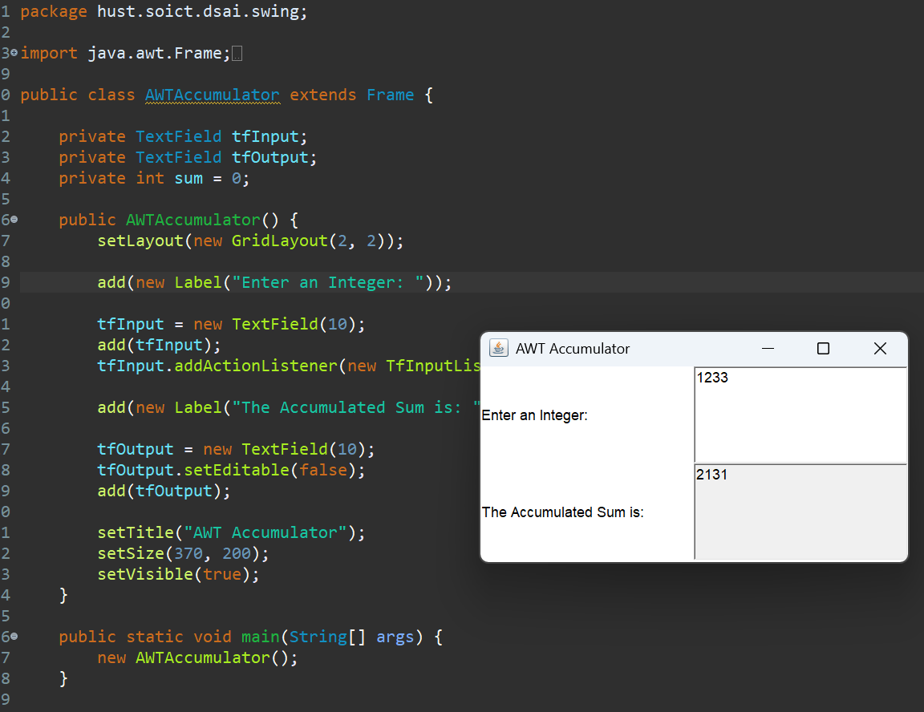

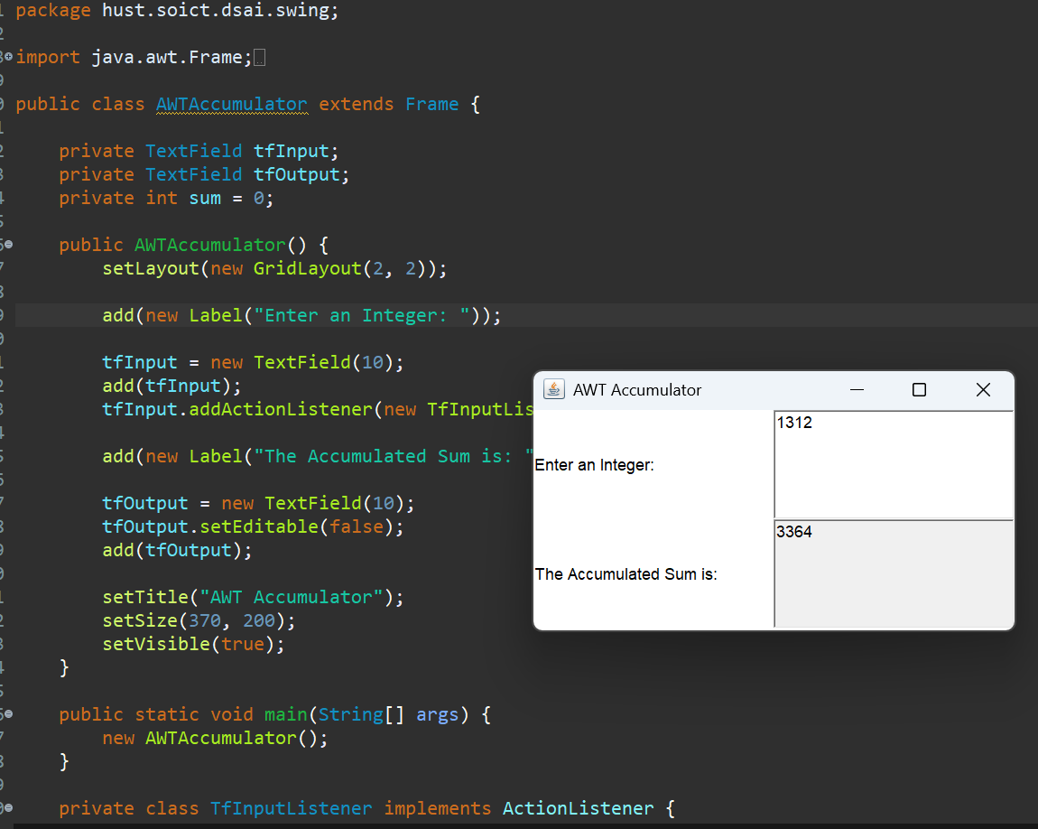

* 1. SwingAccumulator

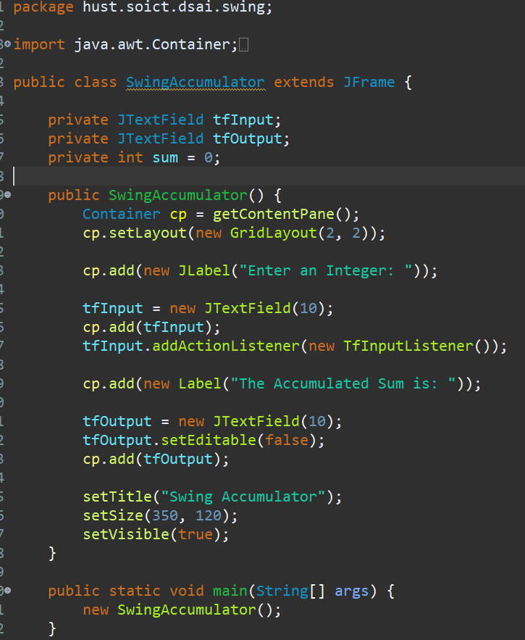

1. Organizing Swing components with Layout Managers
   1. *Using JPanel as secondary-level container to organize components*
      1. Create class NumberGrid

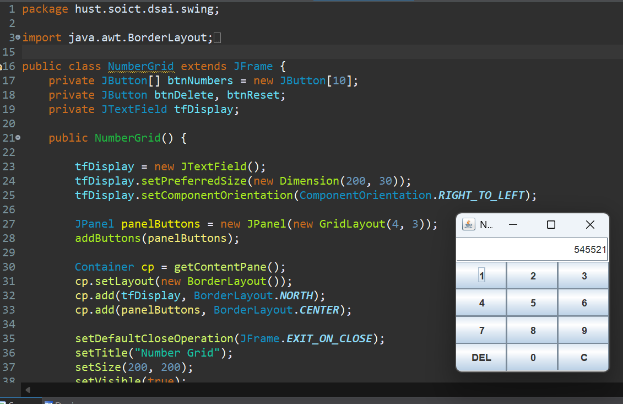

* + 1. Adding buttons

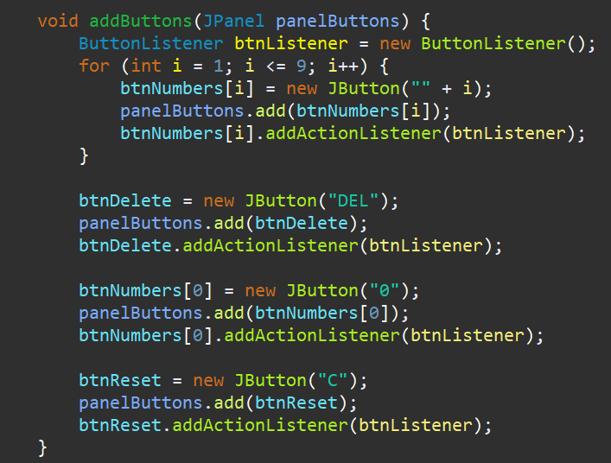

* + 1. Complete inner class ButtonListener

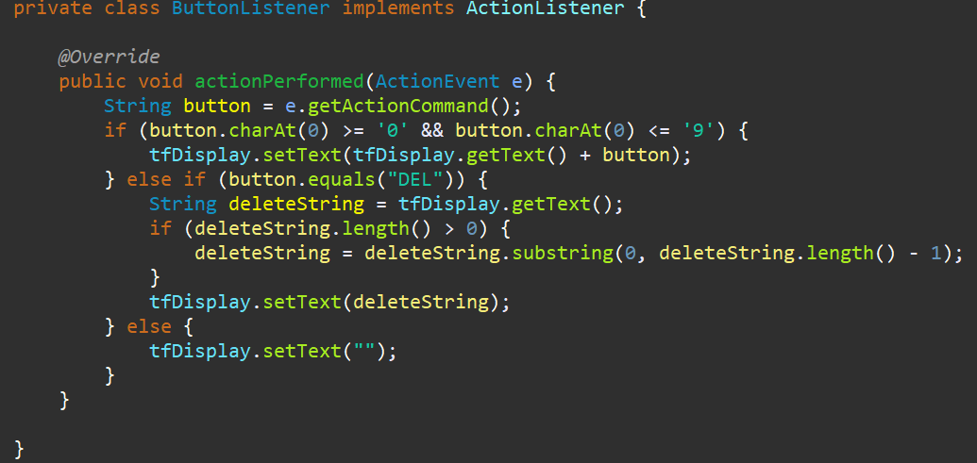

1. Create a graphical user interface for AIMS with Swing
   1. View Store Screen

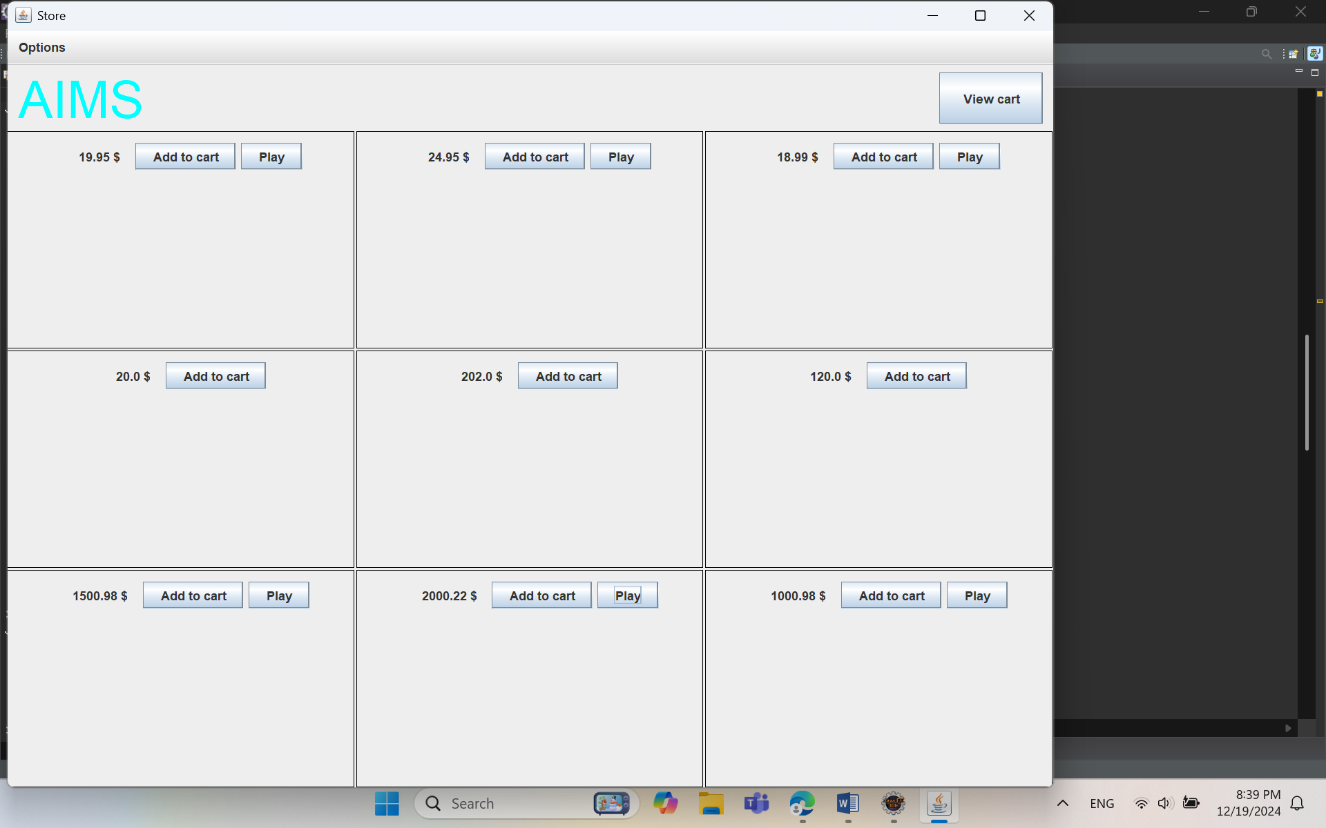

* + 1. Create the StoreScreen class

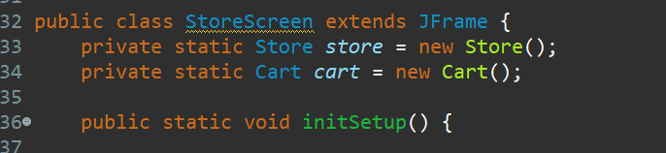

* + 1. The NORTH component

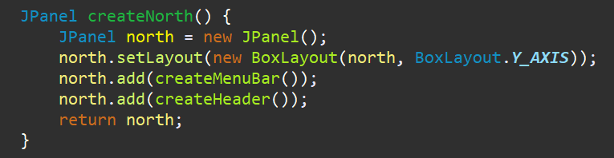

* Create the method createHeader():

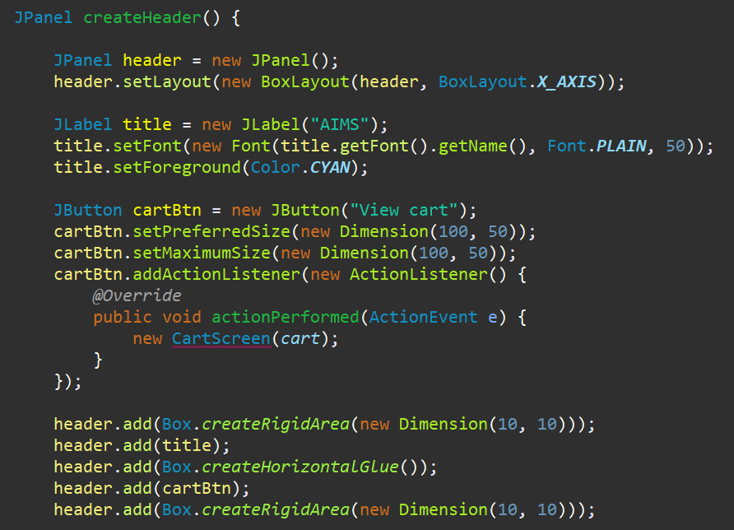

* Create the method createMenuBar():

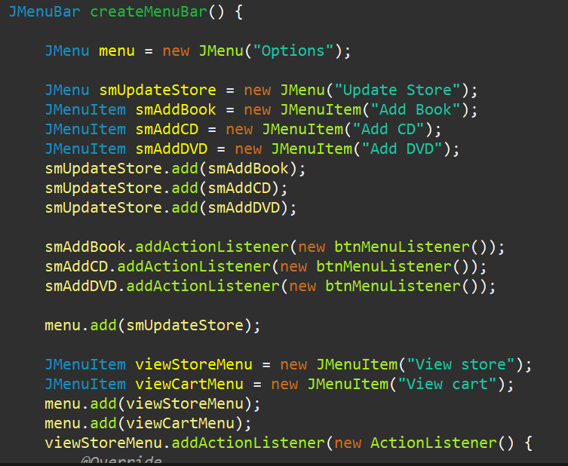

* + 1. The CENTER component

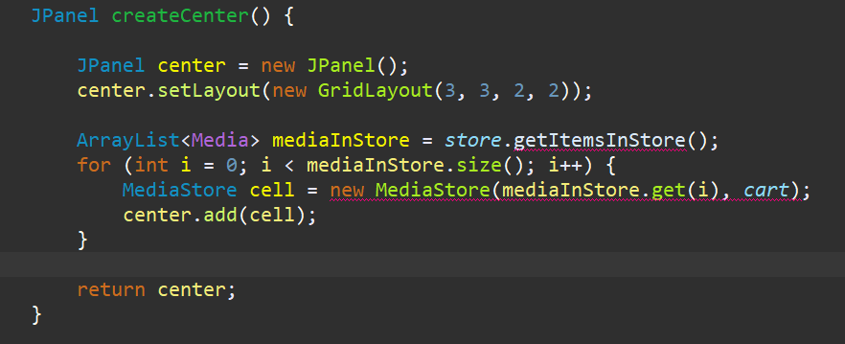

* + 1. The MediaStore class

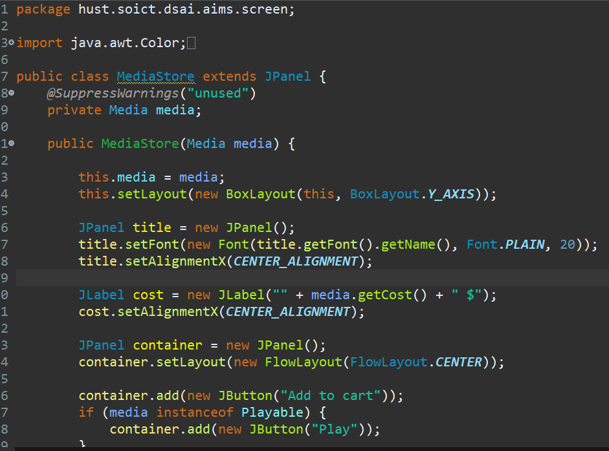

* + 1. Putting it all together

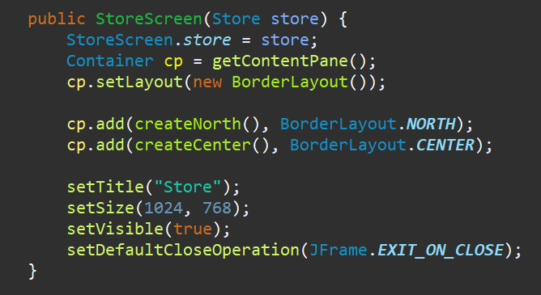

* 1. Adding more user interaction

1. JavaFX API
   1. Create the FXML file
      1. Create and open the FXML file in Scene Builder from Eclipse

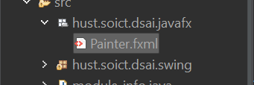

* + 1. Building the GUI
  1. Create the controller class

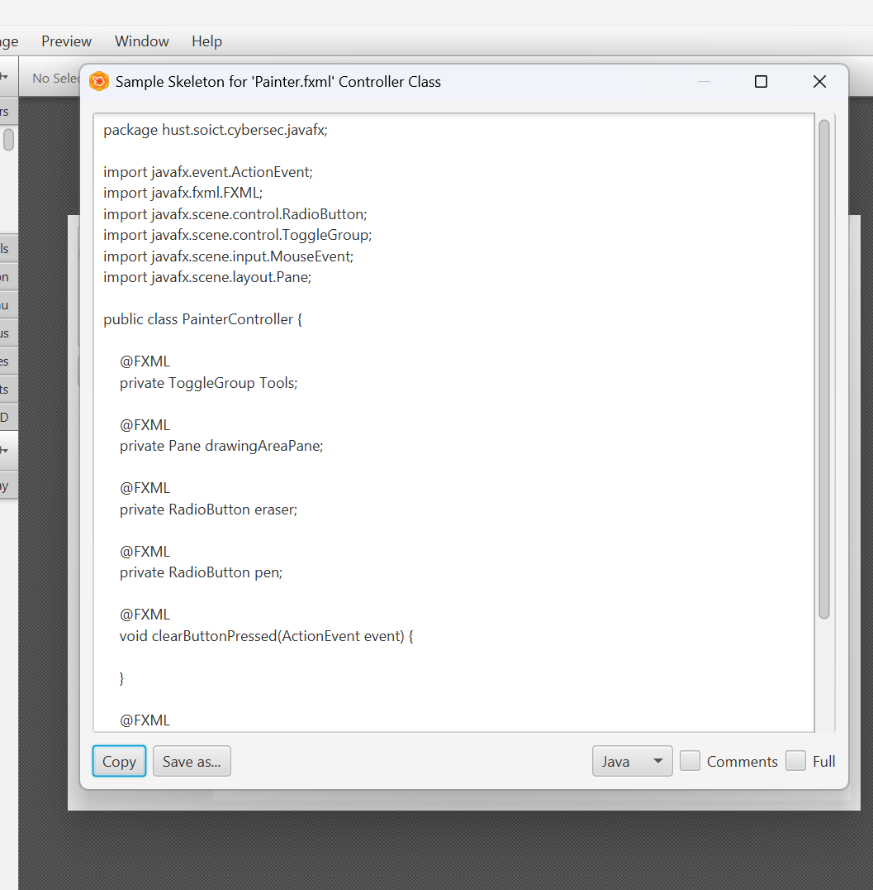  
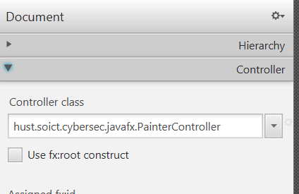

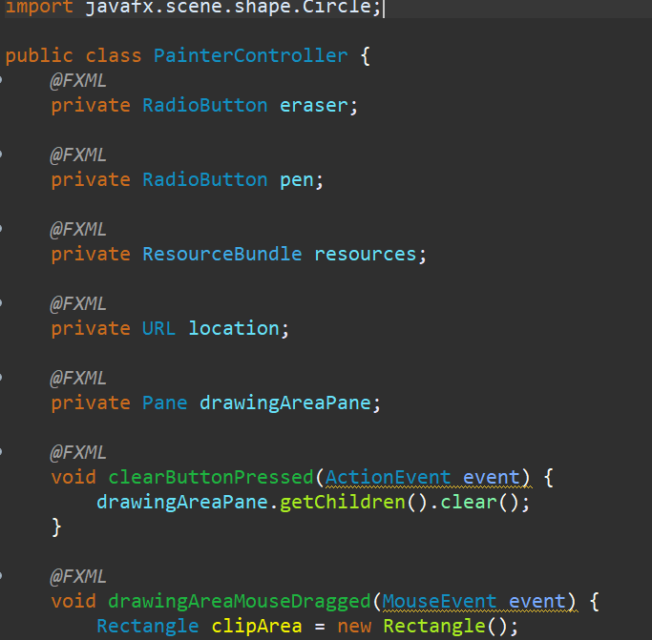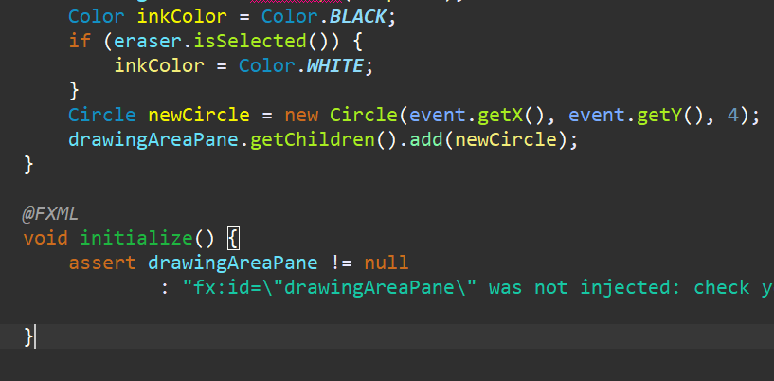

* 1. Create the application

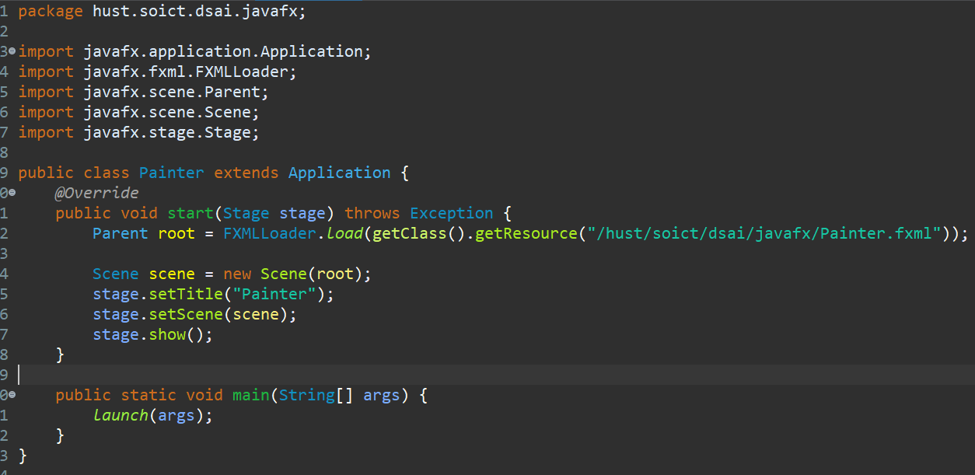

* 1. Practice exercise

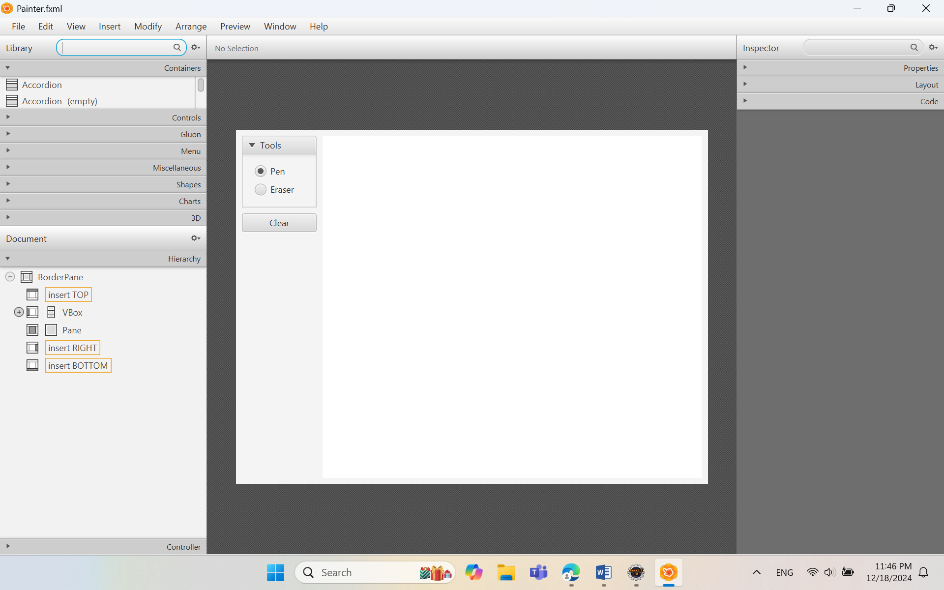

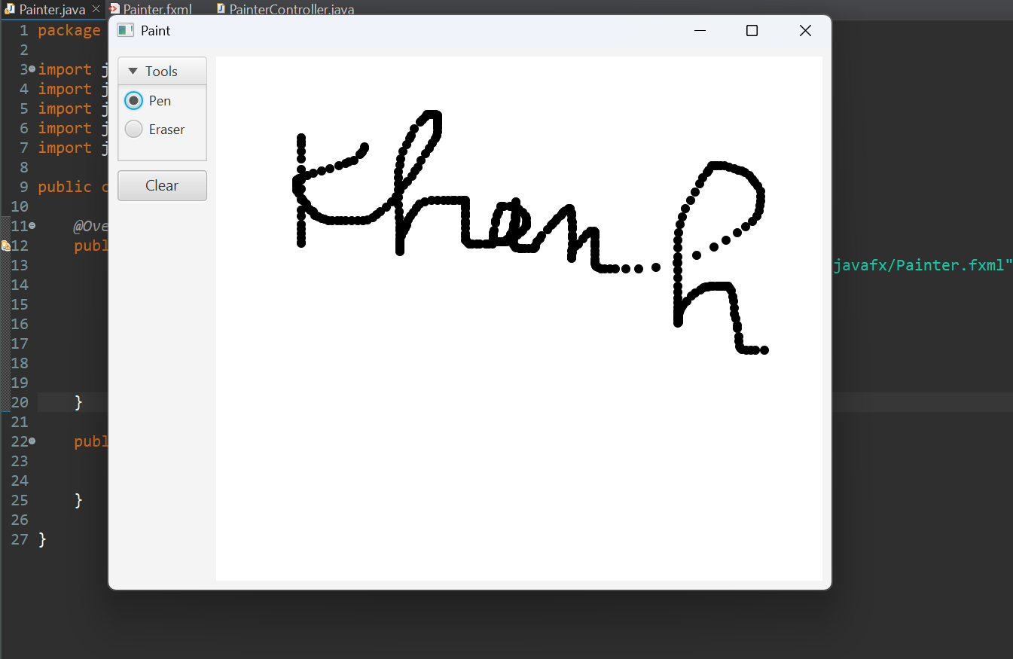

1. Setting up the View Cart Screen with ScreenBuilder
   1. Setting up the BorderPane

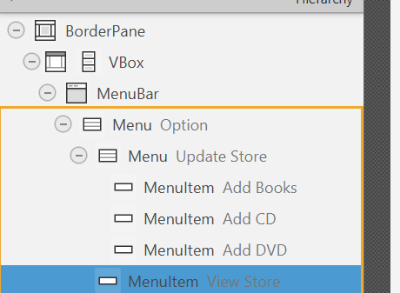

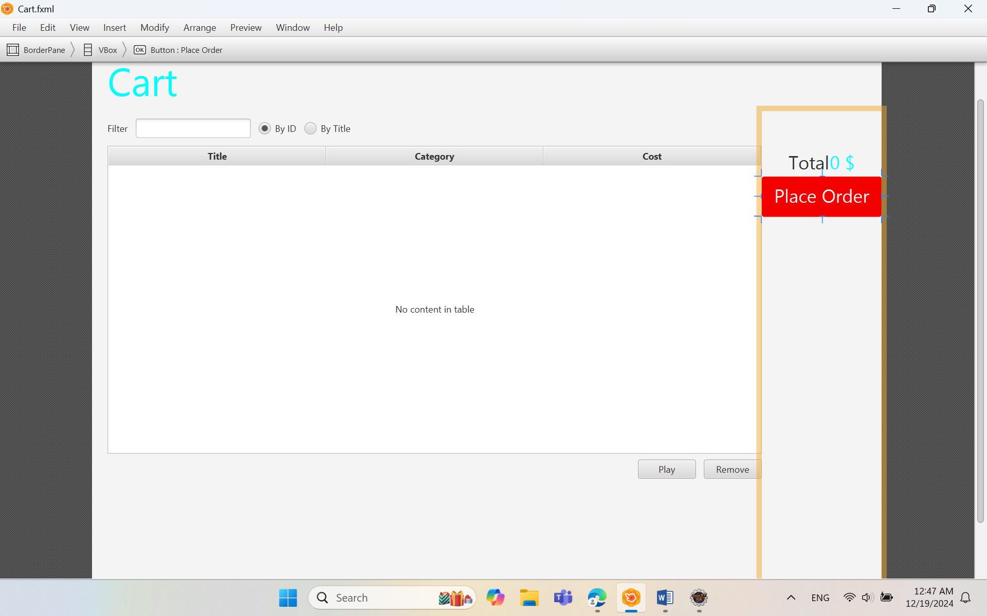

1. Integrating JavaFX into Swing application – The **JFXPanel** class

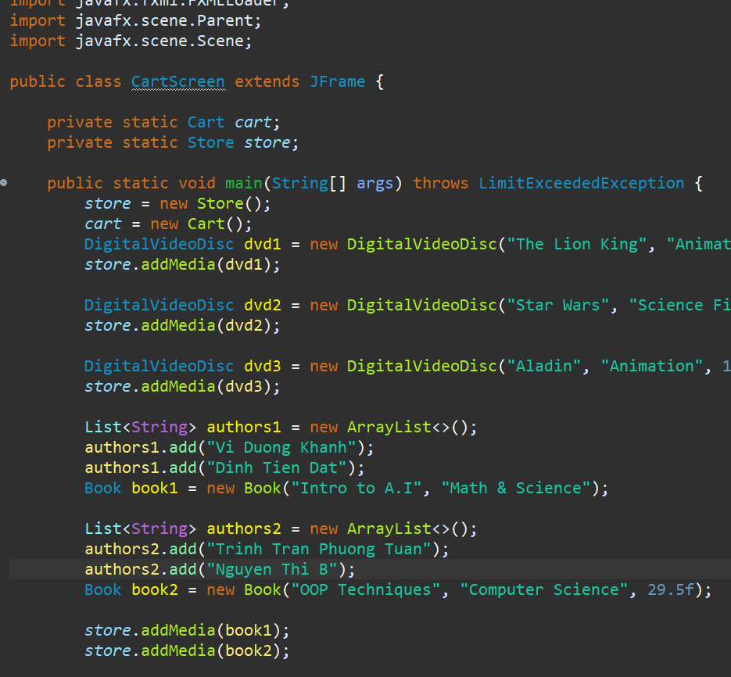

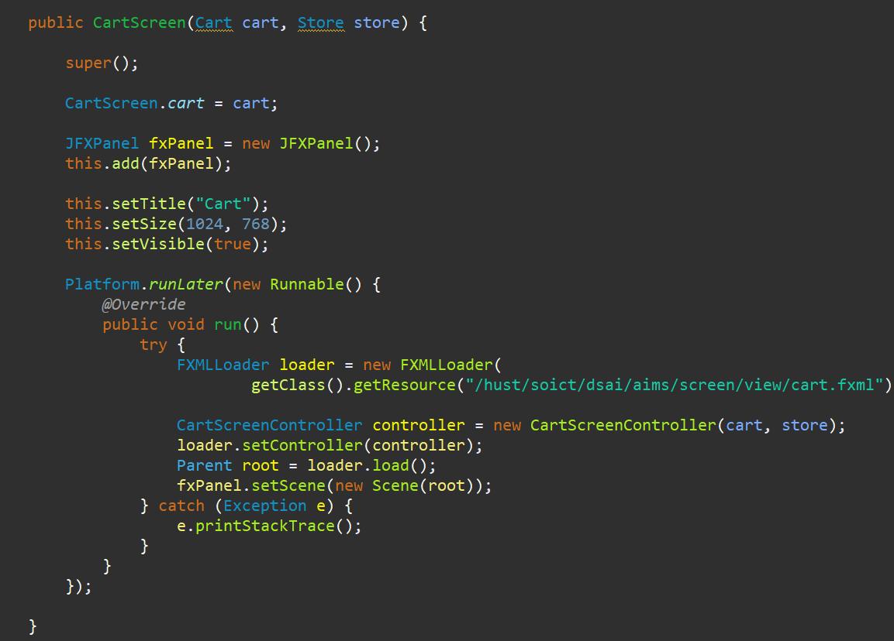

1. View the items in cart – JavaFX’s data-driven UI

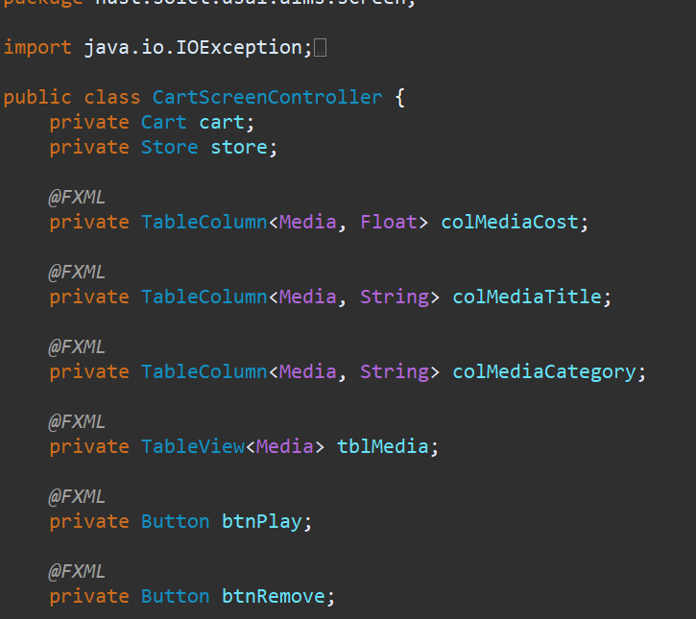

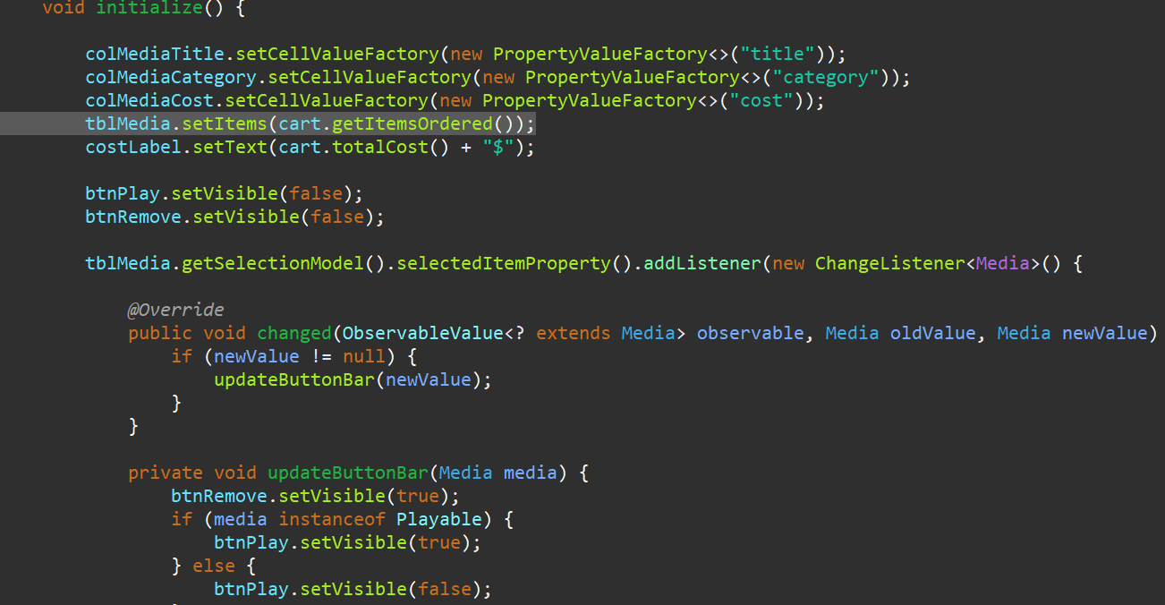

1. Updating buttons based on selected item in **TableView** – **ChangeListener**

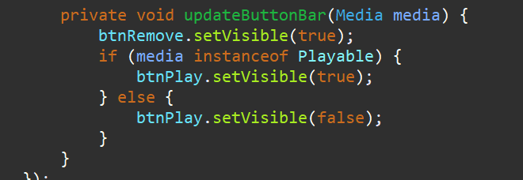

1. Deleting a media

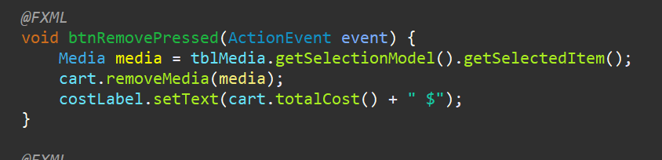

1. Filter items in cart – **FilteredList**

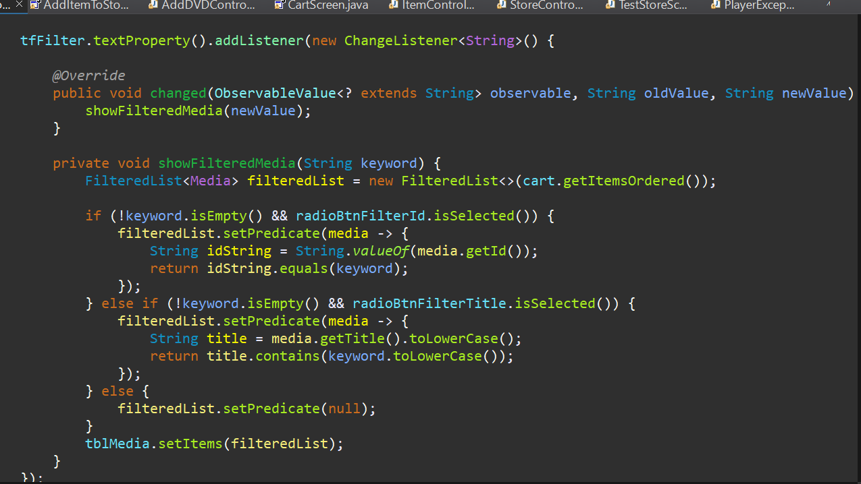

1. Complete the Aims GUI application

* When user clicks on one of the items of the “Update Store” menu on the menu bar (such as “Add Book”, “Add CD”, or “Add DVD”):

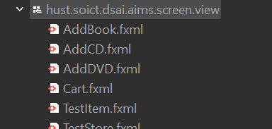

* AddDigitalVideoDiscToStoreScreen

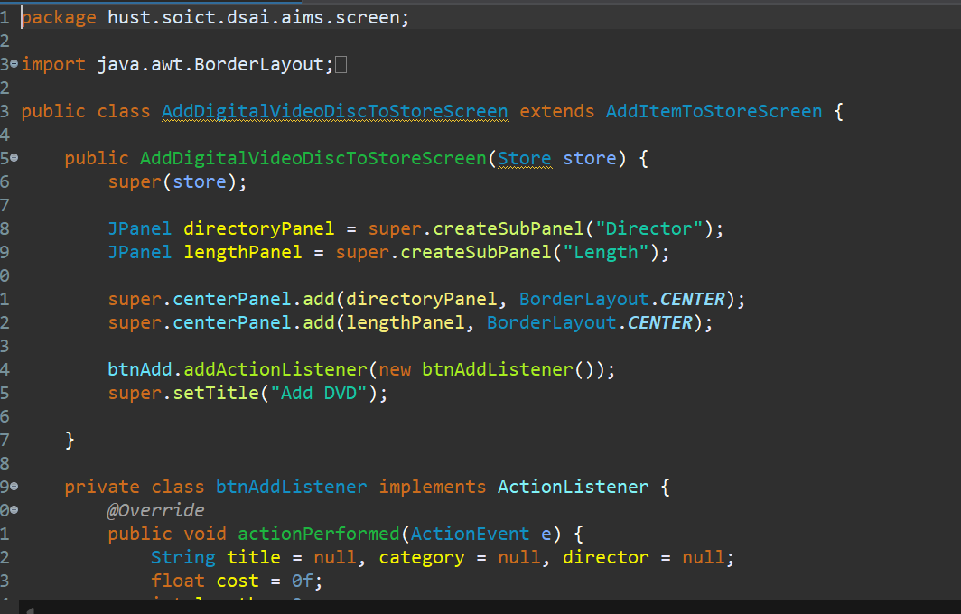

* AddCompactDiscToStoreScreen

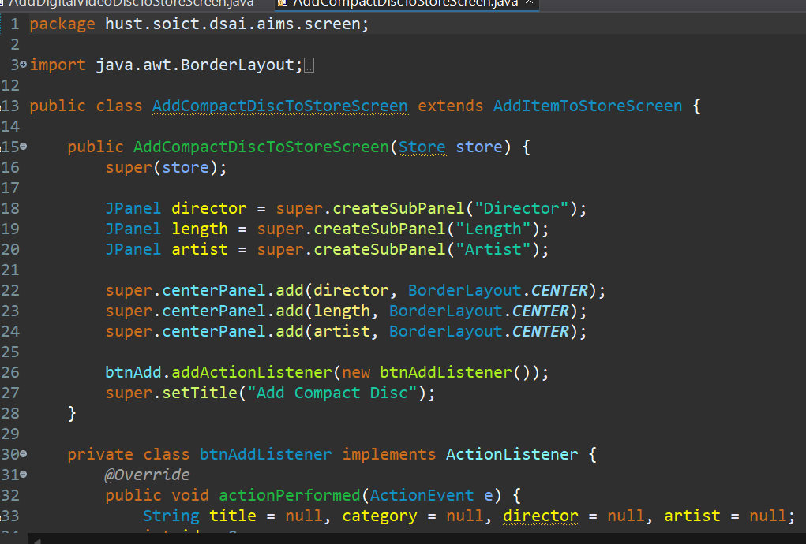

* AddBookToStoreScreen

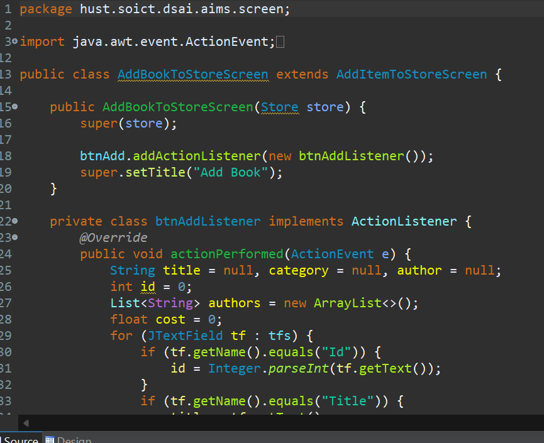

* AddItemToStoreScreen

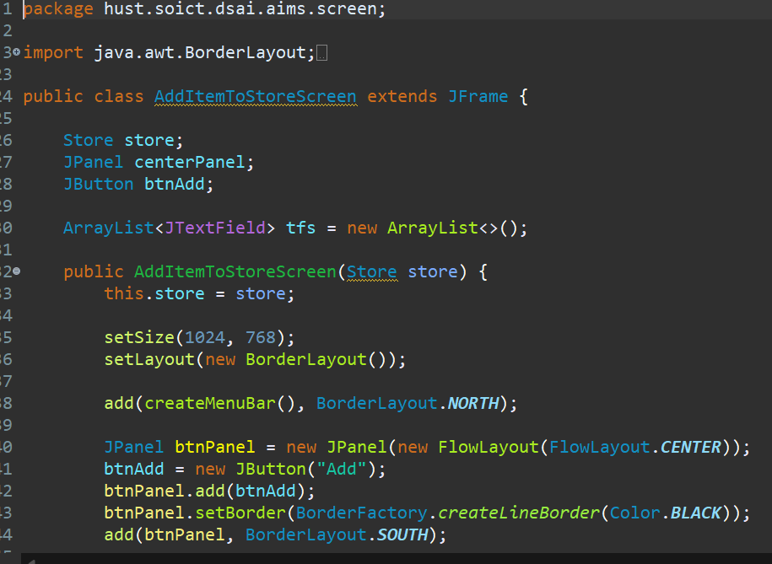

1. Check all the previous source codes to catch/handle/delegate runtime exceptions

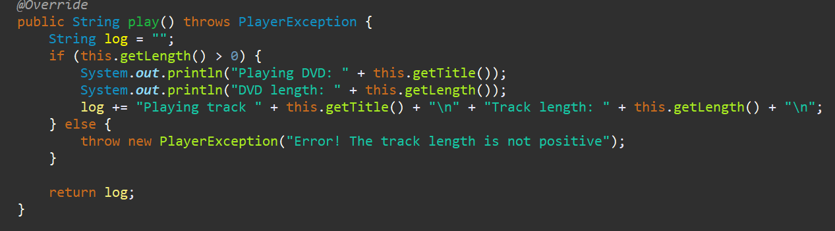

1. Create a class which inherits from **Exception**

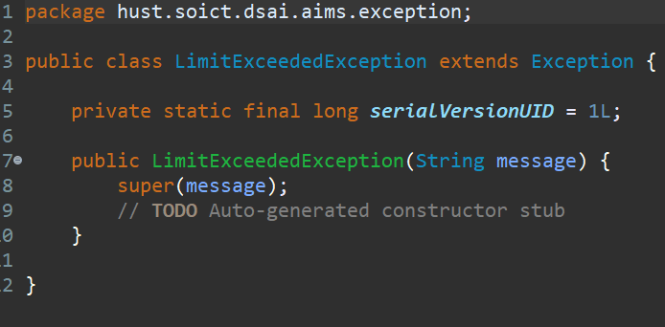

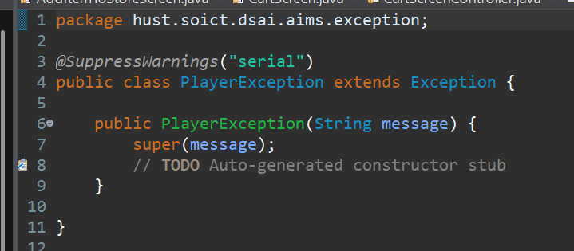

1. Update the **Aims** class