This is a set of multiple choice question.

For each of the following questions choose only one correct answer.

1. The goal of the testing process for new functionality is:
   1. Making sure there are no bugs
   2. Finding as many bugs as possible
   3. Providing reliable information about new functionality
   4. Finding all existing bugs
2. A good bug report has to contain:
   1. A bug reproduction information
   2. A suggested resolution method
   3. The name of the engineer assigned to fix the bug
   4. All of the above
3. According to the page object pattern, which of the methods below should not be placed in the LoginPage object:

Fill_Username()

Fill_Password()

Click_login()

Login_as_admin()

1. During testing of new functionality, a bug was found. After it was reported by the tester, the development team proposed a solution to the problem. However, fixing the bug will be very time-consuming. According to Scrum methodology, who can make the decision to release the functionality without fixing the bug:
   1. Product owner
   2. Scrum master
   3. Tester
   4. You should never release to production containing know bugs
2. In the attached code, what is the biggest problem, considered as bad practice in test automation:

 def click_and_wait_for_popup();

button = driver.find_element(By.XPATH, ‘//button’)

button.click()

time.sleep(100)

popup = driver.find_element_by_name(‘modal’)

a. Usage of time.sleep()

b. Locating element by path

c. Locating element by name

d. Sleep wait is too long

1. What is the name of the design technique presented in the attached image:

|  |  |  |  |  |
| --- | --- | --- | --- | --- |
|  | 9:00 – 10:00 | 10:00 – 11:00 | 11:00-12:00 | 13:00-14:00 |
| Blue | Y | N | N | N |
| Red | Y | N | N | N |
| Yellow | N | N | N | N |

* 1. XY table
  2. Decision table
  3. Boudary value analysis
  4. Decision tree

1. What kind of test is presented in the attached code:

def test_add_floats (self)

result = mymath.add (5, 5.5)

self.asertEqual(result, 10.5)

* 1. Integration test
  2. System test
  3. E2e test
  4. Unit test

1. What is the key factor to be considered while designing a test plan:
   1. Human resources availability
   2. Complexity of the functionality
   3. Risk of functionality not working properly in production
   4. Important of the stakeholders
2. Functionality is given: For a fiven file, the number of processing worker is calculated and enabled with the following rule:

< 1MB – 1 running worker

1MB to 5MB – 2 running workers

5MB to 100MB – 3 running workers

>100MB – 4 running workers

Which test design technique will be best suited to testing this functionality?

* 1. Decision table
  2. Boundary value analysis
  3. State transition diagram
  4. Cause-effect graphing

1. What is the name of document containning the scope, approach, resources and schedule of the testing activities?
   1. Test plan
   2. Test case
   3. Test design
   4. Test procedure
2. Selenium RC and Selenium WebDriver are consolidated in a single tool in which of Selenium’s version?
   1. 1.0
   2. 2.0
   3. 3.0
   4. 4.0
3. Which one of the following options is a properly declared relative Xpath?
   1. Ref:*[@class=’feature-box’]//*[text()=’Testing’]
   2. //*[@class=’feature-box’]//*[text()=’Testing’]
   3. Relative:”[@class=’feature-box’]//*[text()=’Testing’]
   4. *[@class=’feature-box’]//*[text()=’Testing’]
4. Which of the following can be tested automatically using Selenium?
   1. Iframes
   2. Desktop applications
   3. Mobile applications
   4. CAPTCHA
5. Selenium cannot be used effectively for automating:
   1. Functional testing
   2. Regression testing
   3. Performance testing
   4. It can be used effective for all of the above
6. What does the following code do?

new Action(webDriver).sendKey(“some_text”).perform();

* 1. It redirects to a page from the text in the quotation marks, which should be an URL
  2. It sends the cookie to the browser. Text in quotation marks should be replaced by an HTTP Cookie
  3. It sends the text in quotation markws to a focused element.
  4. It provides the password to the password-protected web page

1. In Selenium we can distiguish three types of waits:
   1. Implicit, Fluent and Explicit
   2. Absolute, Explicit and Implicit
   3. Implicit, Exact and Fluent
   4. Explicit, Implicit and Smooth
2. If the code in unable to initialize the WebDriver, it raises an exception:
   1. InitException
   2. InitializationException
   3. WebDriverException
   4. UnableToInitException
3. Is it possible to verify color in tests using selenium?
   1. Yes, using getColorValue(‘rgb”), though “rgb” is the only supported color model.
   2. Yes, using the getCssValue() method.
   3. Yes, using getColorValue(“rgb”), where “rgb” can be replaced by any color model.

Exam 1: (60 mins)

Given a login page to an online service. Your task is write automation test scripts to validate whether the form works correctly.

Write a list of test cases that should check whether the given page works correctly.

You can use the following credentials to check the login process:

* Url: workforces-stg.hubble.sg
* Valid credentials: email: [abc@hubble.sg](mailto:abc@hubble.sg), password: password
* Invalid credentials: email: [unknown@hubble.sg](mailto:unknown@hubble.sg), password: password

Hint:

* Check if the email and password fields are on the main screen of the application:
* Check if the given valid credentials work:
* Check if the given wrong credentials work
* Check if the email validation is working
* Check for empty credentials

Exam 2: (60 mins)

Given that login sucessful, redirect to Monthly Salary Page. Write automation test scripts to validate whether search form work correctly and the total labour cost in the month will based on the total workers’ salary in search result.

(You redirect to Monthly Salary Page by access in menu: Manpower > Salary > Monthly Salary)

For example:

Input keyword “vijay” into search box, search result will be automatically display all employee that containing searched keywork “vijay”.

Check if sum(each total workers’ salary in search result) = total labour cost

($2989.13 + $1321.38 + $1045.27 + $891.15 + $1060.49 + $698.18 + $518.64) = $8524.24

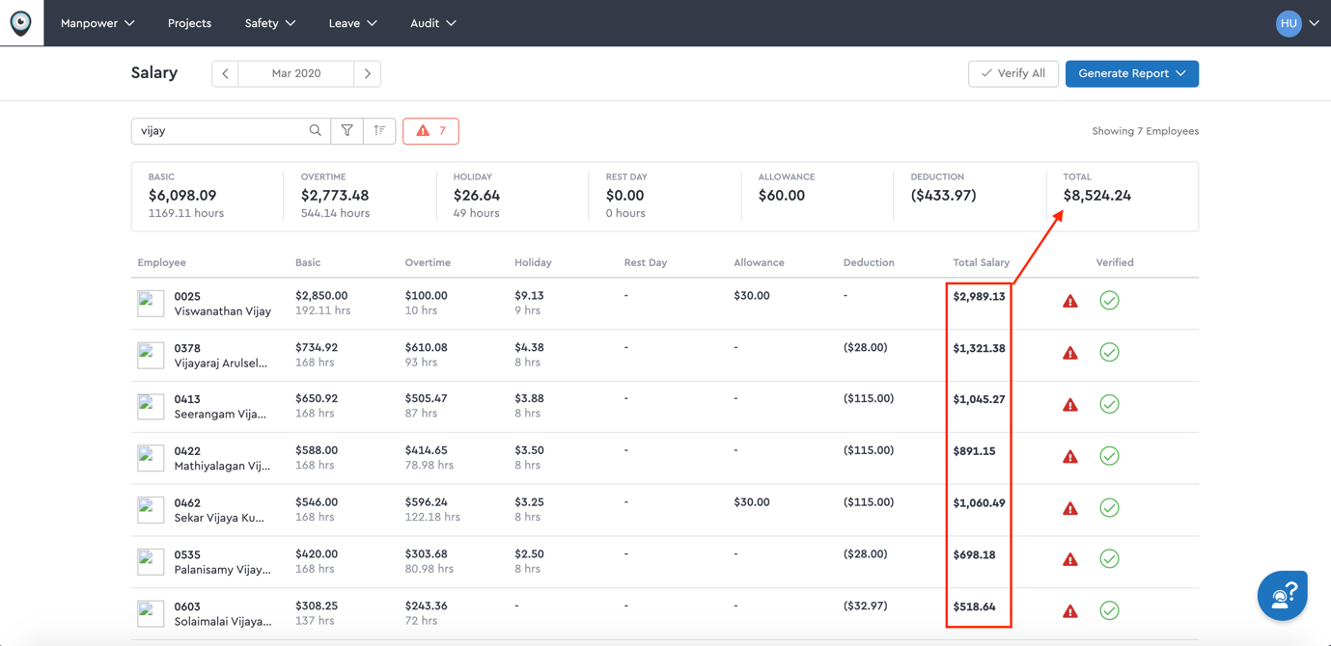

Exam 3: (120mins)

Follow use case bellow:

1. Write a list of test cases that should check whether the use case works correctly.
2. Write automation test script based on list of test case defined above.

(After complete the exam, you can upload your source code to source control (gitlab, bitbucket… @luu))

Write the function

class Solution {public int[] solution(int N);}

that, given an integer N (1<=N<=100), returns an array containing N unique integers that sum up to 0. The function can return any such array.

For example, given N = 4, the function could return [-1, 0, -3, 2] or [-2, 1, -4, 5].

The answer [1, -1, 1, 3] would be incorrect (because value 1 occurs twice). For N=3 one of the possible answers is [-1, 0, 1] (but there are many more correct answers).