PHENIKAA UNIVERSITY
PHENIKAA SCHOOL OF INFORMATION TECHNOLOGY



COURSE TITLE : SOFTWARE ARCHITECTURE

PROJECT TITLE : ANALYSIS AND SYSTEM DESIGN
FOR A LIBRARY MANAGEMENT APPLICATION
Instructor : Vũ Quang Dũng
Students : Trần Phương Nam (23010220)
Tiêu Hải Nam (23010214)
Cohort : K17
Class code : N02
Group: 04
Program : Information Technology

Ha Noi, February 5th, 2026
Contents
1. Cover Page & Info 4
2. Executive Summary 4
3. Project Requirements & Goals 5
3.1 Business Requirements 5
3.2 Core Functional Requirements 7
3.2.1 User Requirements Analysis 8
3.2.2 Administrator Requirements Analysis 8
3.3 Key Quality Attributes (Architectural Goals – Non-functional Requirements) 9
3.3.1 Security 9
3.3.2 Performance 9
3.3.3 Data Consistency 9
3.3.4 Scalability 10
3.3.5 Usability & Learnability 10
3.3.6 Maintainability & Reliability 10
3.4 Proposed ASR Model 11
3.4.1 Security and Access Control 11
3.4.2 Performance and Responsiveness 11
3.4.3 Data Consistency and Integrity 12
3.4.4 Scalability and Extensibility 12
3.4.5 Usability and Learnability 13
3.4.6 Maintainability and Reliability 13
3.5 Use case Modeling 14
3.5.1 Use Case Diagram 15
3.5.2 Detailed use case model 17
4. Architectural Design & Implementation 22
4.1.Architectural Pattern 22
4.1.1. C4 Model 23
4.1.2. Architectural Model 30
4.2. Technical Stack and Data Model 30
4.2.1. Technical Stack 30
4.2.2. Data Model 31
4.3. Implementation: Server Side Logic 32
4.3.1. Authentication Logic 32
4.3.2. Business Logic and Firestore 34
4.3.3 External API Intergration 37
4.4. Implementation: Client Side Logic 39
4.4.1. UI and Navigation 39
4.4.2. State Management 40
4.4.3. Role-based UI Rendering 40
4.4.4. Error Handling and UX 41
5. Testing and Verification 41
5.1. Testing Strategy Overview 41
5.2 Unit Testing 41
5.2.1. Definition 41
5.2.2. Unit Test Scope 42
5.2.3 Unit Test Code Example 42
5.2.4. Unit Test Case Table 43
5.3 API Testing 43
5.3.1. Purpose 43
5.3.2. API Request Example 43
5.3.3. API Response Handling Code 43
5.3.4. API Test Case Table 44
5.4 Integration Testing 44
5.4.1 Definition 44
5.4.2 Integration Test Scenario 44
5.5 Real-time Broadcast Testing 45
5.5.1 Definition 45
5.5.2 Real-time Mechanism Used 45
5.5.3 Test Execution with Two Devices 45
5.5.4. Real-time Test Case Table 46
5.6. Test Results and Verification 46
5.7 Conclusion 47
6. Conclusion & Reflection 47
6.1 Lessons Learned 47
6.2 Future Improvements 48

1. Cover Page & Info
• Project Title: Analysis and System Design For A Library Management Application
• Course Name: Software Architecture
• Student Info: Tiêu Hải Nam - 23010214
Trần Phương Nam - 23010220
• Date: February 5th, 2026

2. Executive Summary
The objective of this project is to design and develop a Library Management System that effectively supports book management, borrowing and returning operations, and user management in a multi-user environment. The system serves two primary actors: Users and the Administrator.
The system is implemented as a monolithic application with a clearly layered architecture, in which all core functionalities are deployed and executed within a single application. Despite being monolithic, the system is structured into well-defined layers, including the presentation layer (UI), business logic layer (Service), and data model layer (Model). This design approach helps reduce complexity, improve maintainability, and ensure clear separation of responsibilities among system components.
The system is designed to satisfy key quality attributes such as security, performance, data consistency, and reliability. Role-based authentication and authorization mechanisms ensure secure access control for different user roles. Real-time data updates and transactional operations are applied to maintain data integrity during concurrent borrowing and returning activities, preventing inconsistencies and race conditions.
Overall, the project delivers a stable and well-structured monolithic library management system that is suitable for the system’s scale and functional requirements. The chosen architecture effectively fulfills the architectural and non-functional requirements identified during the requirements elicitation and analysis phase, while remaining easy to deploy, maintain, and extend in the future.

3. Project Requirements & Goals
This section describes the core functionalities that the Library Management System must provide
for each group of actors in the system. The functional requirements are categorized by the roles
of User and Admin to ensure clear authorization boundaries and responsibilities.

3.1 Business Requirements
The Library Management System (LMS) is designed to address limitations commonly found in traditional or manual library management processes, such as inefficient book tracking, lack of transparency in borrowing and returning activities, and limited support for reporting and statistics.
The system aims to support both end users (library members) and administrators by automating core library operations, improving data accuracy, and enabling effective monitoring and management of library resources.
The main business requirements of the system are defined as follows:
BR-01. Support Efficient Book Discovery
The system must provide users with the ability to search for books using multiple criteria, including book title, author, and category. This requirement ensures that users can quickly and efficiently locate relevant learning and reference materials within the library collection.
BR-02. Manage the Book Borrowing and Returning Lifecycle
The system must support the complete lifecycle of book borrowing, including submitting borrowing requests, approving requests, returning books, and confirming returns. This process must be strictly controlled to prevent users from borrowing books beyond the available quantity and to minimize the risk of resource loss.
BR-03. Ensure Transparency and Traceability of Borrowing Activities
The system must maintain a clear and accurate record of all borrowing and returning activities. Users should be able to view their personal borrowing history, while administrators should be able to monitor and audit library usage to ensure policy compliance.
BR-04. Support Administrative Management of Library Resources
The system must enable administrators to manage the library’s book inventory by adding new books, updating existing book information, deleting outdated records, and maintaining accurate availability status for each book.
BR-05. Provide Reporting and Decision-Support Information
The system must provide statistical data and reports related to book inventory, borrowing frequency, and overall library activity. These insights support administrators in decision-making processes, such as identifying popular books, evaluating library usage, and planning future resource allocation.

3.2 Core Functional Requirements
ID | Description
PR-01 | The system must allow users to search for books by title, author, or category.
PR-02 | The system must allow users to view detailed information about a book, including the author, publication year, and availability status.
PR-03 | The system must allow users to submit book borrowing requests and return borrowed books.
PR-04 | The system must notify users about the status of their borrowing and returning activities, including overdue notifications.
PR-05 | The system must allow users to view their personal borrowing history.
PR-06 | The system must allow the Admin to add, update, delete, and manage the status of books in the library.
PR-07 | The system must allow the Admin to approve book borrowing requests and confirm book returns.
PR-08 | The system must allow the Admin to view statistics related to books, borrowing activities, and overall library status.

3.2.1 User Requirements Analysis
Users need to search for books quickly using multiple criteria such as title, author, and category in order to save time and improve access to library resources.

Users need to view detailed book information (e.g., description, author, availability status) so they can decide whether the book is suitable before borrowing.

Users need to submit book borrowing requests online instead of borrowing directly, which helps the system control the number of borrowed books and prevent duplicate or conflicting borrowings.

Users need to view their borrowing and returning history to track personal responsibilities and monitor the current status of borrowed books.

3.2.2 Administrator Requirements Analysis
Administrators need to manage the book lifecycle, including adding, updating, and deleting book records, to ensure that the library collection is accurate and up to date.

Administrators need to review and approve borrowing requests in order to control shared resources and enforce library policies.

Administrators need to view statistical reports (such as borrowing frequency and popular books) to evaluate library usage and support decision-making.

3.3 Key Quality Attributes (Architectural Goals – Non-functional Requirements)

3.3.1 Security
The system must ensure data security and access control through clear authentication and authorization mechanisms. User authentication is implemented using Firebase Authentication, while authorization is enforced based on user roles:
- Admin: authorized to add, update, delete, import books, and approve borrowing requests.
- User: authorized only to search for books, submit borrowing requests, and view personal borrowing history.
User data is isolated by unique identifiers (UIDs), and critical data such as book availability (available) and borrowing count (borrowCount) can only be updated through transactional mechanisms to prevent inconsistencies and fraudulent actions. The system must ensure that users cannot borrow books beyond the allowed quantity.

3.3.2 Performance
The system is required to provide a fast and smooth response experience for users. Firestore real-time streams are utilized to ensure that data is updated instantly without requiring interface reloads.
To optimize performance and reduce query costs:
- Only essential data is retrieved, such as the Top 3 most borrowed books or book lists filtered by category.
- Query limiting mechanisms are applied, and data sorting and filtering are performed on the client side to minimize redundant database queries.

3.3.3 Data Consistency
The system must ensure data integrity and consistency in a concurrent multi-user environment. Firestore transactions are applied to critical operations such as:
- Approving book borrowing requests
- Returning books
- Updating book availability
- Incrementing the borrowing count
The following data constraints must always be enforced:
- The available value must not be negative
- The available value must not exceed the total book quantity
- The borrowCount must only be incremented when a borrowing request is approved
This approach helps prevent race conditions when multiple users perform operations simultaneously.

3.3.4 Scalability
The system is designed using a clearly layered architecture (UI – Service – Model), enabling easy scalability and extensibility in the future. This architecture supports:
- The addition of new roles (e.g., librarian, teacher)
- The extension of statistical features (e.g., monthly statistics, category-based statistics)
- Changes to the user interface without impacting core business logic

3.3.5 Usability & Learnability
The system interface is designed clearly according to user roles (Admin / User), enabling ease of use and quick user onboarding. The user flow is simple and intuitive, covering registration, login, and book borrowing and returning operations.
Visual elements such as icons, consistent color schemes, animations, and top-book rankings are applied to enhance user experience and improve system accessibility.

3.3.6 Maintainability & Reliability
The source code is well-organized into dedicated services such as BookService, BorrowService, and AuthService, clearly separating business logic from the user interface. Data models support mapping and cloning methods, enabling easier system extension and maintenance.
The system validates data before performing updates and does not allow:
- Borrowing books when no copies are available
- Returning books in quantities exceeding those borrowed
A clear borrowing state management mechanism (Pending – Approved – Returned) is implemented to ensure reliability and transparency throughout the entire borrowing process.

3.4 Proposed ASR Model

3.4.1 Security and Access Control
ASR Type: Security (Non-Functional Requirement)
Statement:
The system must ensure secure authentication, strict authorization, and data protection mechanisms to prevent unauthorized access and invalid user operations.
Architectural Impact:
This ASR drives the adoption of Firebase Authentication as a centralized and secure identity management mechanism. Authentication is separated from application logic, improving security and scalability.
Authorization is enforced using role-based access control (RBAC) at the service layer, distinguishing between Admin and User permissions.
User data is isolated using unique identifiers (UIDs), ensuring that users can only access their own data.
Critical operations such as borrowing approval and book availability updates are protected using Firestore transactions, preventing data tampering and fraudulent actions.
This requirement strongly influences the layered architecture (UI – Service – Model), where security checks are centralized in the Service layer rather than scattered across the UI.

3.4.2 Performance and Responsiveness
ASR Type: Performance
Statement:
The system must provide fast response times and real-time data updates to ensure a smooth user experience.
Architectural Impact:
This ASR motivates the use of Firestore real-time streams, enabling instant data synchronization without requiring manual page reloads.
To reduce latency and database costs, the architecture limits database queries by retrieving only essential data (e.g., Top 3 borrowed books) and applying query limits.
Client-side filtering and sorting are used where appropriate, reducing unnecessary backend processing.
These decisions influence both data access patterns and UI design, ensuring responsiveness even as the dataset grows.

3.4.3 Data Consistency and Integrity
ASR Type: Data Consistency
Statement:
The system must maintain consistent and correct data in a concurrent multi-user environment.
Architectural Impact:
This ASR leads to the use of Firestore transactional mechanisms for all critical state-changing operations, including borrowing approval, book returns, availability updates, and borrowing count increments.
Explicit data constraints are enforced at the service layer to prevent invalid system states, such as negative availability or borrowing beyond allowed limits.
By centralizing consistency logic within services, the system avoids race conditions and ensures reliable behavior even when multiple users perform operations simultaneously.

3.4.4 Scalability and Extensibility
ASR Type: Scalability
Statement:
The system must be easily scalable and extensible to support future functional growth without major architectural changes.
Architectural Impact:
This ASR directly justifies the use of a layered architecture (UI – Service – Model), enabling independent evolution of each layer.
New user roles (e.g., librarian, teacher) can be added by extending the authorization logic without modifying core system components.
Additional features such as advanced statistics or reporting modules can be integrated by adding new services, ensuring long-term scalability.

3.4.5 Usability and Learnability
ASR Type: Usability
Statement:
The system must be easy to learn and use for both Admin and User roles.
Architectural Impact:
This ASR influences the separation of user flows based on roles, ensuring that each role interacts only with relevant functions.
Clear navigation structures, consistent UI elements, and real-time feedback are integrated into the UI layer while keeping business logic isolated.
This separation allows UI changes to be made independently, improving usability without risking system stability.

3.4.6 Maintainability and Reliability
ASR Type: Maintainability & Reliability
Statement:
The system must be easy to maintain, reliable, and resilient to invalid operations.
Architectural Impact:
This ASR results in a service-oriented internal structure, with clearly defined services such as BookService, BorrowService, and AuthService.
Business rules and validations are centralized in the Service layer, preventing invalid operations such as borrowing unavailable books or returning excessive quantities.
A well-defined borrowing lifecycle (Pending – Approved – Returned) improves system transparency and reliability.
The modular design enhances testability, simplifies debugging, and reduces long-term maintenance costs.

3.5 Use case Modeling
Use Case | Actor | Flow Description
Search Books | User | 1. The user opens the library application.  2. The user enters a search keyword (book title, author)  3. The system queries the database and displays a list of matching books.
View Book Details | User | 1. The user selects a book from the search results.  2. The system displays detailed information about the book, including author, publication year, and availability status.
Request Book Borrowing | User | 1. The user selects a book to borrow.  2. The user submits a borrowing request.  3. The system records the request and sets its status to Pending Approval.
Return Book | User | 1. The user selects a borrowed book.  2. The user initiates the return process.  3. The system updates the return status and waits for Admin confirmation.
Receive Notifications | User | 1. The system monitors the user’s borrowing and returning status.  2. The system sends notifications when a request is approved, a book is returned, or a book becomes overdue.
View Borrowing History | User | 1. The user accesses the borrowing history feature.  2. The system displays a list of previously borrowed and currently borrowed books along with their statuses.
Approve Borrow Request | Admin | 1. The admin accesses the list of borrowing requests.  2. The admin reviews request details.  3. The admin approves or rejects the request.  4. The system updates the request status and book availability.
Confirm Book Return | Admin | 1. The admin receives a book return notification from a user.  2. The admin confirms the return.  3. The system updates the book status and inventory quantity.
Manage Books | Admin | 1. The admin adds, updates, or deletes books in the system.  2. The system saves the changes and updates book data for users.
View Statistics and Reports | Admin | 1. The admin accesses the statistics feature.  2. The system displays reports related to book inventory, borrowing activities, and overall library status.

3.5.1 Use Case Diagram
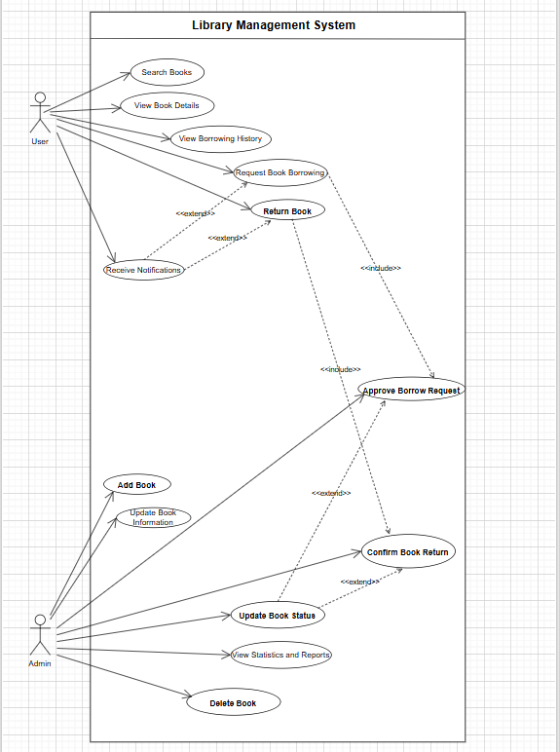

3.5.2 Detailed use case model
- Search Book
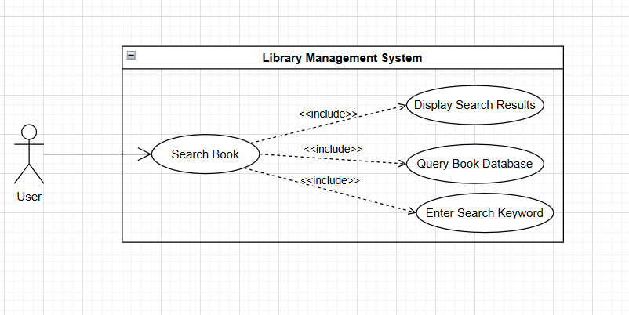
This use case allows users to search for books in the library system based on criteria such as book title or author. The user enters a search keyword, and the system queries the database to display a list of matching books. This function helps users quickly find the materials they need in the library.
- View Book Details
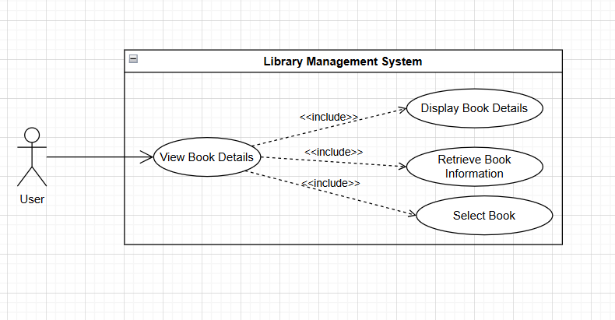
This use case allows users to view detailed information about a specific book in the system. After selecting a book from the search results, the system displays information such as the book title, author, publication year, and availability status. This function helps users make informed decisions before borrowing a book.
- Request Book Borrowing
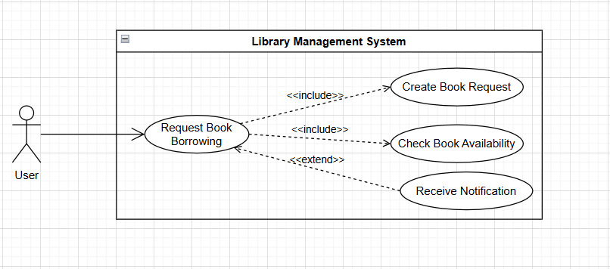
This use case allows users to submit a request to borrow a book from the library. The user selects a desired book and sends a borrowing request, which is then recorded by the system and set to a pending approval status. This function ensures that the borrowing process is properly managed and controlled.
- Return Book
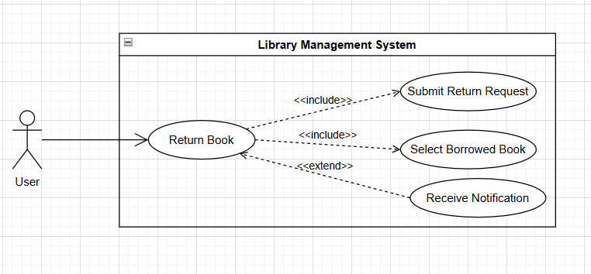
This use case allows users to return a borrowed book to the library. The user selects the book to be returned and initiates the return process, after which the system updates the return status and waits for confirmation from the administrator. This function helps maintain an accurate borrowing lifecycle.
- Receive Notifications
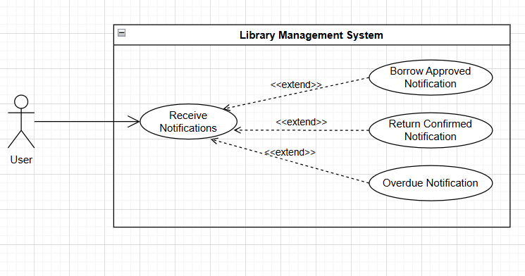
This use case allows the system to send notifications to users regarding borrowing and returning activities. Notifications may include borrowing approval, return confirmation, or overdue reminders. This function helps users stay informed about the status of their borrowed books.
- View Borrowing History
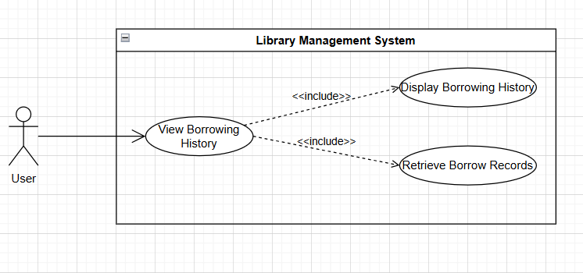
This use case allows users to view their borrowing history in the system. The system displays a list of previously borrowed and currently borrowed books along with their respective statuses. This function helps users track and manage their library usage effectively.
- Approve Borrow Request
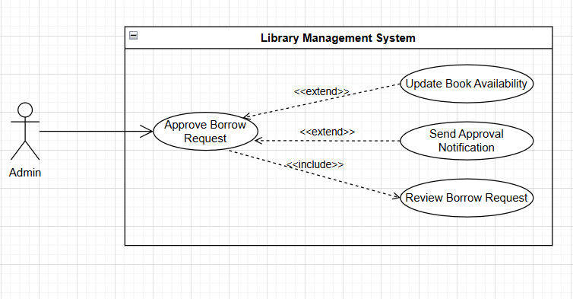
This use case allows administrators to review and process borrowing requests submitted by users. The administrator can approve or reject requests, after which the system updates the request status and book availability accordingly. This function ensures controlled and efficient book lending management.
- Confirm Book Return
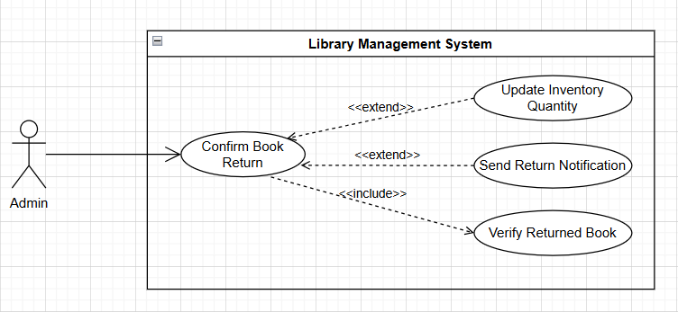
This use case allows administrators to confirm the return of books from users. After verifying the returned book, the system updates the book status and inventory quantity. This function helps maintain accurate inventory records within the library system.
- Manage Books
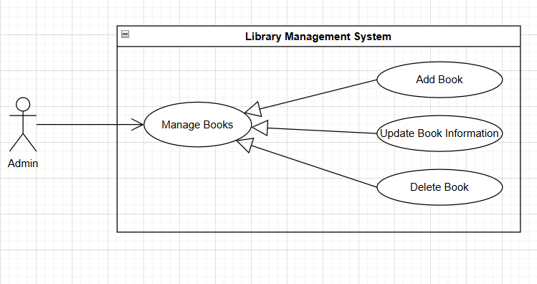
This use case allows administrators to manage books in the library system, including adding new books, updating book information, and deleting books that are no longer needed. This function ensures that book data remains accurate and up to date for users.
- View Statistics and Reports
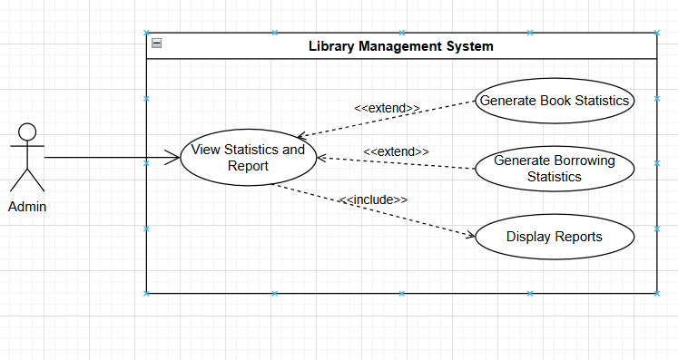
This use case allows administrators to view statistics and reports related to library operations. The system provides information on book inventory, borrowing activities, and overall library performance. This function supports administrators in monitoring and making informed management decisions.

4. Architectural Design & Implementation

4.1.Architectural Pattern
The project is designed using a layered architecture combined with the MVC (Model – View – Controller) pattern, which is suitable for a Flutter application using Firebase Backend-as-a-Service.
- Applied in the project:
• Model (represents data and business structure):
Book, AppUser, Borrow
• View (Flutter user interface):
AdminHomeScreen, ImportBookScreen, ProfileScreen, AdminStatisticScreen, ManageBorrowScreen, LoginScreen, RegisterScreen, HistoryScreen, StudentHomeScreen
• Controller / Service Layer (handles business logic and communicates with Firebase):
AuthService, BookService, BookApiService, BorrowService
- Reasons for choosing this architecture:
• Clear separation between UI, logic, and data
• Easy to extend (adding roles, adding new features)
• Easy to maintain and test
• Suitable for Flutter + Firebase (client-heavy architecture)

4.1.1. C4 Model
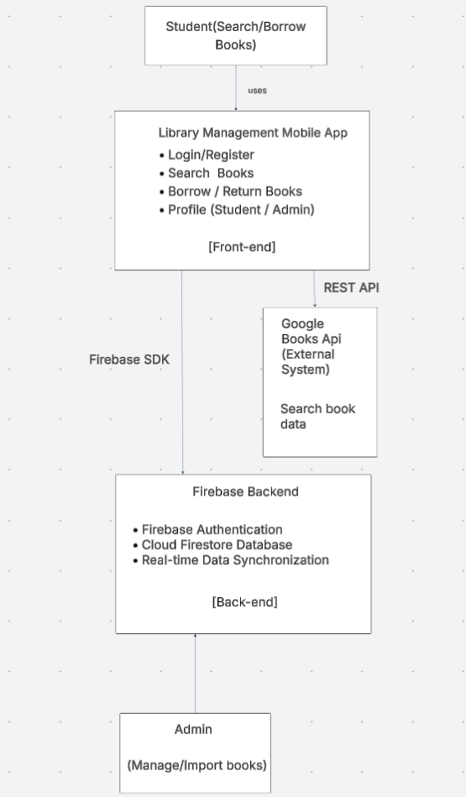
1.1.1.1. Level 1: System Context 1
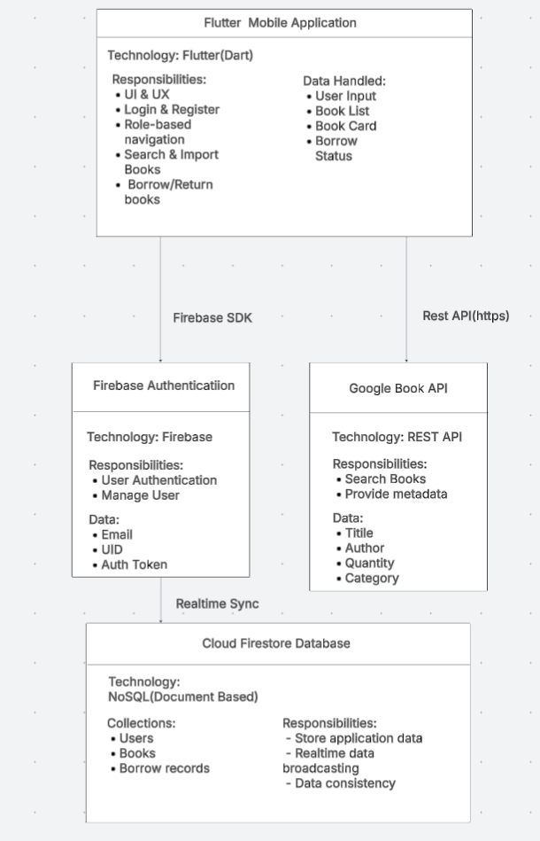
1.1.1.2. Level 2: Container
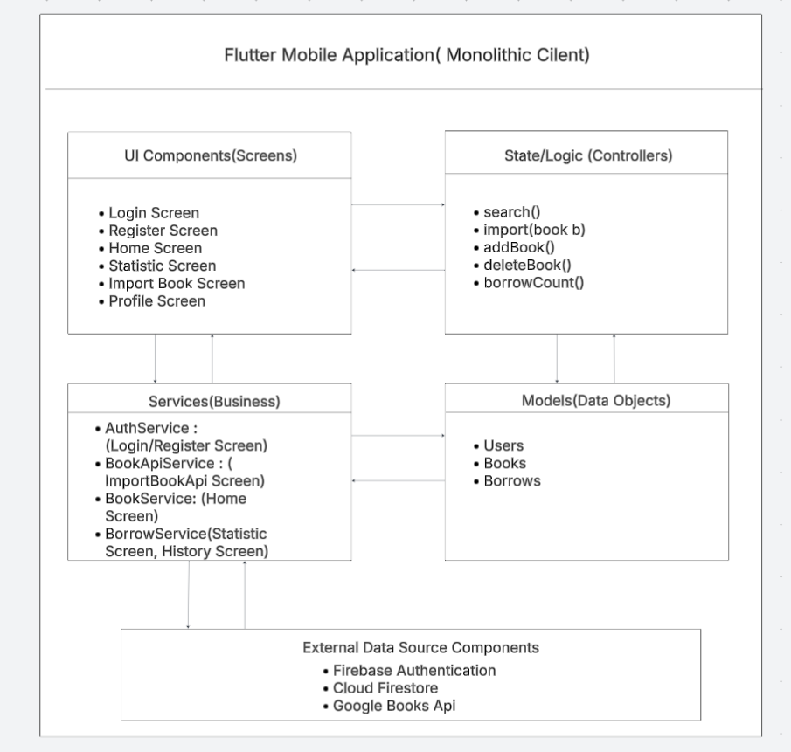

1.1.1.3. Level 3: Components

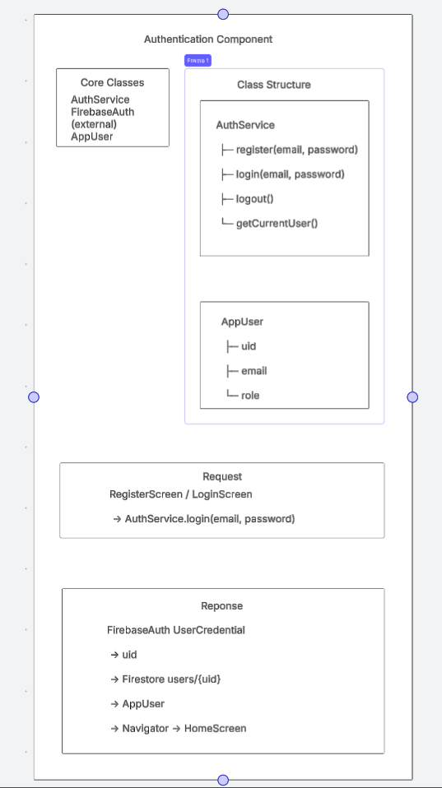
1.1.1.4. Level 4: Authentication
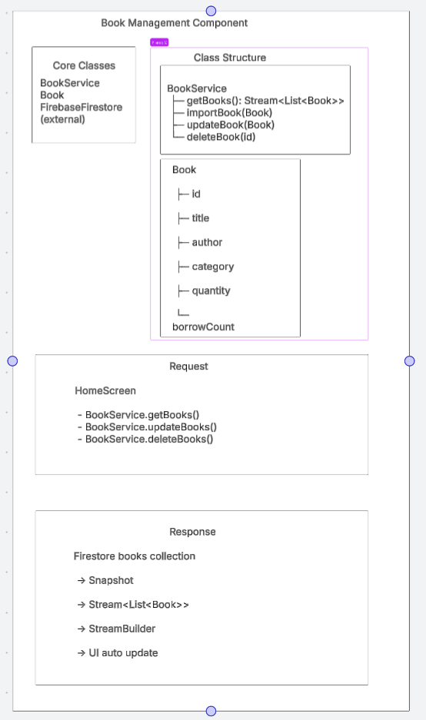

1.1.1.5. Level 4: Book Management
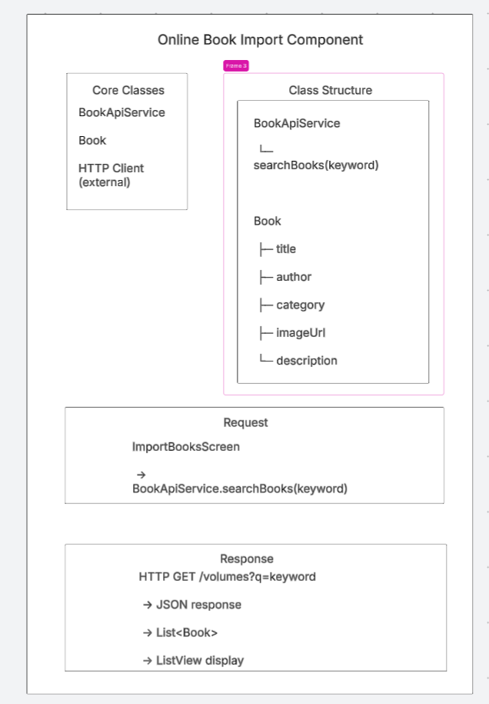

1.1.1.6. Level 4: Import Book Online
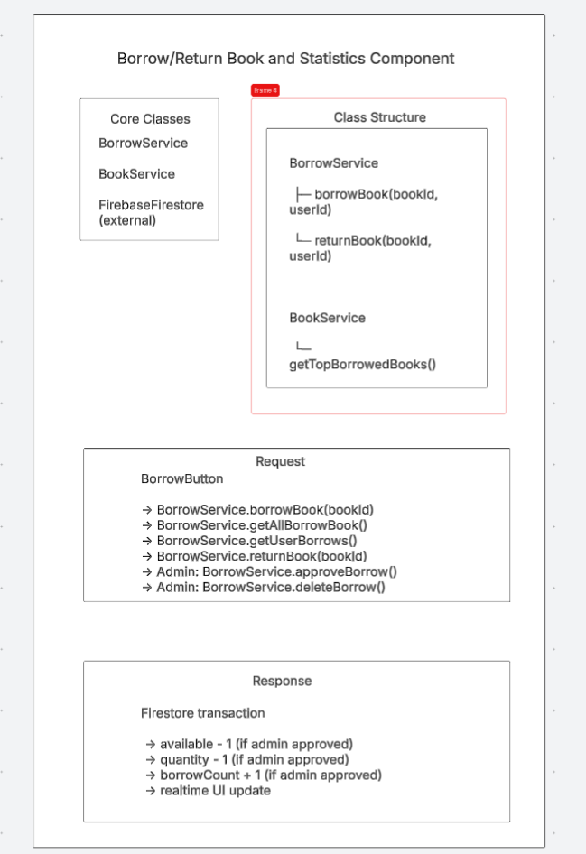

1.1.1.7. Level 4: Borrow/Return, Statis
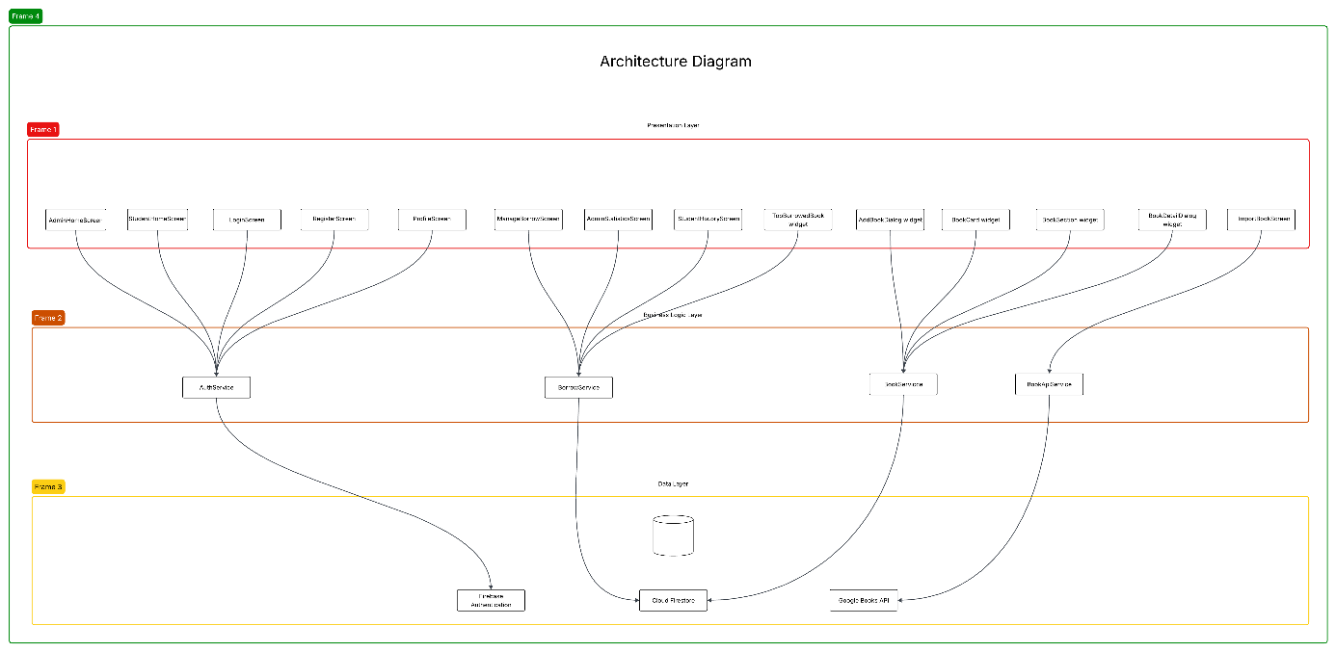

4.1.2. Architectural Model

4.2. Technical Stack and Data Model

4.2.1. Technical Stack
Components | Stack
Frontend | Flutter(Dart)
Backend | Firebase
Authentication | Firebase Authentication
Database | Cloud Firestore
External API | Google Books API
Platform | Android/IOS/Web

4.2.2. Data Model
- Collection:Users
{
“createdAt”: “Timestamp”
"uid": "string",
"email": "string",
"name": "string",
"studentId": "string",
"role": "admin | student"
}
- Collection: Borrows
{
“approved” : “bool”
“bookId”: “string”
“bookTitle”: “string”
“borrowDate”: “string”
“categoryName”: “string”
“createdAt”: “Timestamp”
“returnDate”: “Timestamp”
“returned”: “bool”
“userId”: “string”
}

- Collection: Books
{
“author” : “string”
“available”: “int”
“borrowCount”: “int”
“category”: “string”
“description”: “string”
“imageUrl”: “string”
“quantity”: “int”
“title”: “string”
}
- The data model is designed using a NoSQL approach, optimized for:
• Real-time queries
• Flexible data scalability
• Compatibility with Firestore

4.3. Implementation: Server Side Logic
- In the project, Firebase acts as the server side, handling authentication and data storage.

4.3.1. Authentication Logic
• Register / log in using Firebase Authentication
• After registration, user information is stored in Firestore
• Role-based authorization (admin, student)

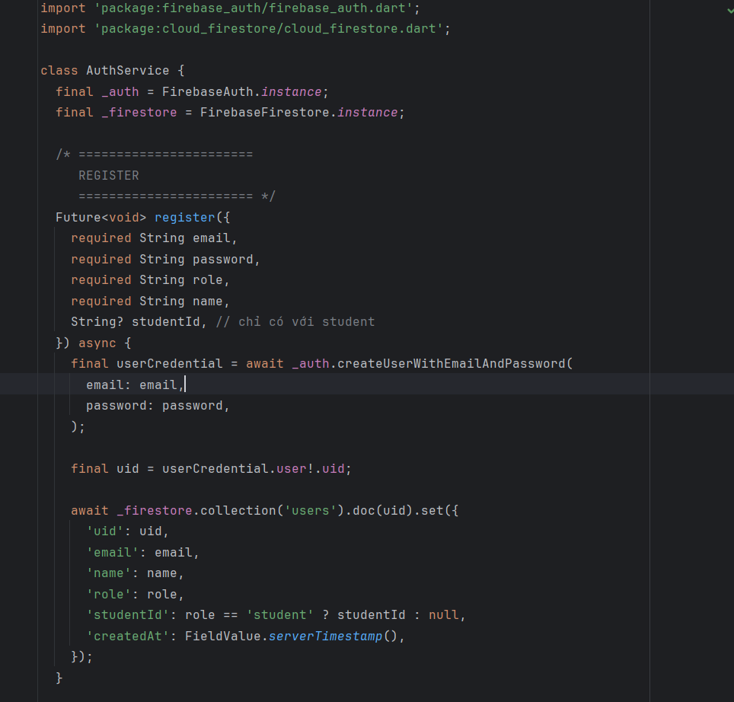

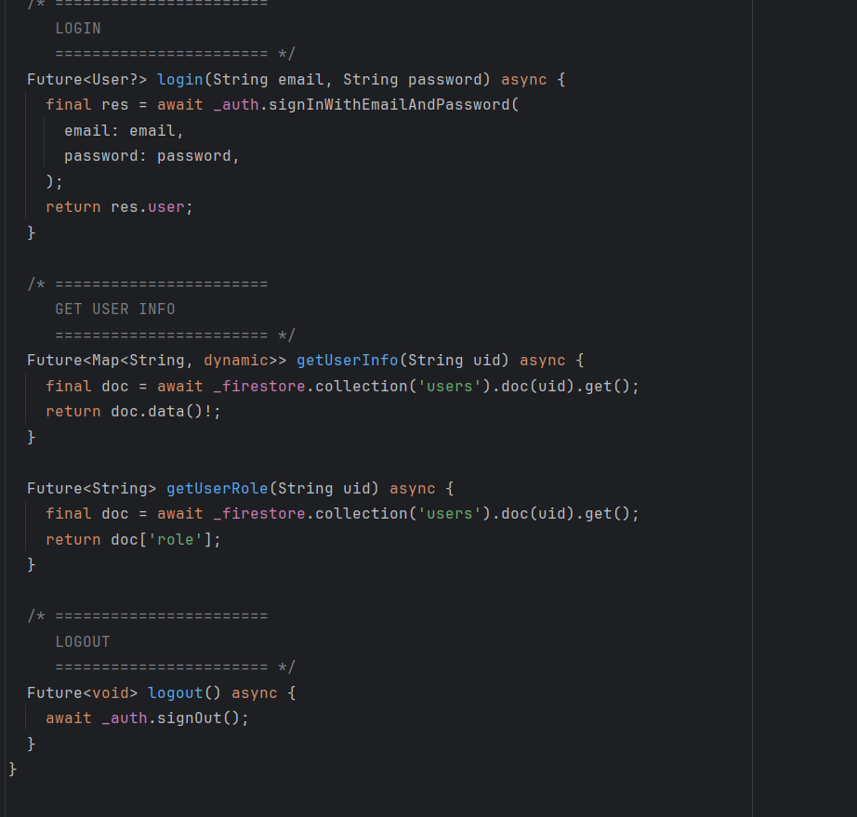

4.3.2. Business Logic and Firestore
• Add / edit / delete books (Admin)
• Borrow / return books (Student)
• Statistics for most borrowed books
• Use Firestore Transactions to ensure data integrity
Example:
• When borrowing a book:
– Decrease available
– Increase borrowCount
• When returning a book:
– Increase available (not exceeding quantity)

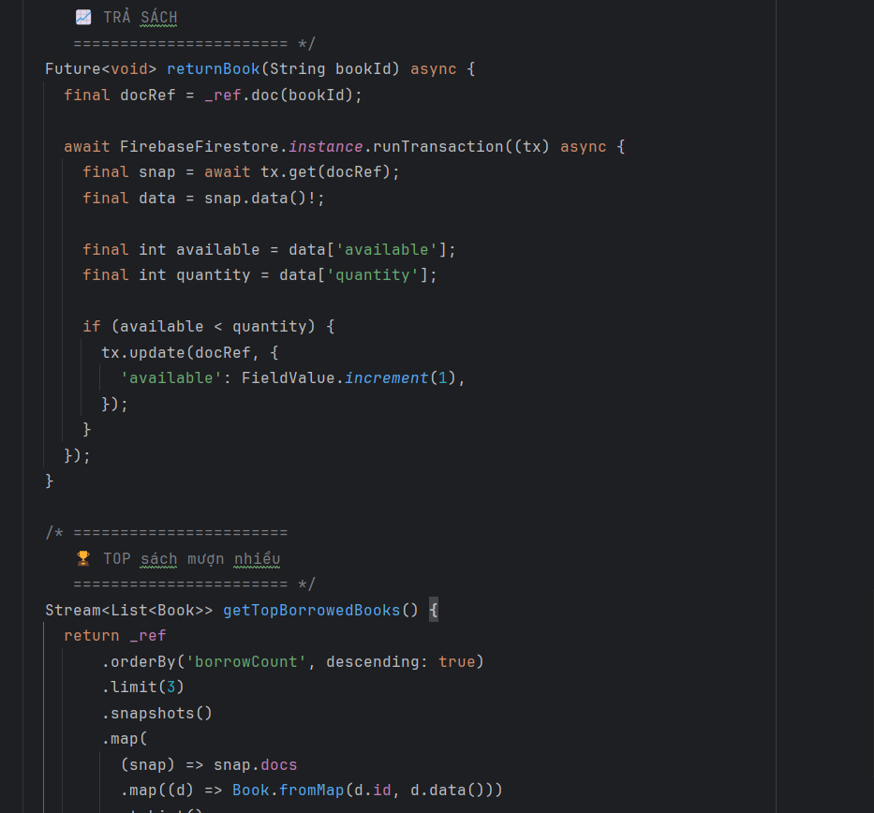

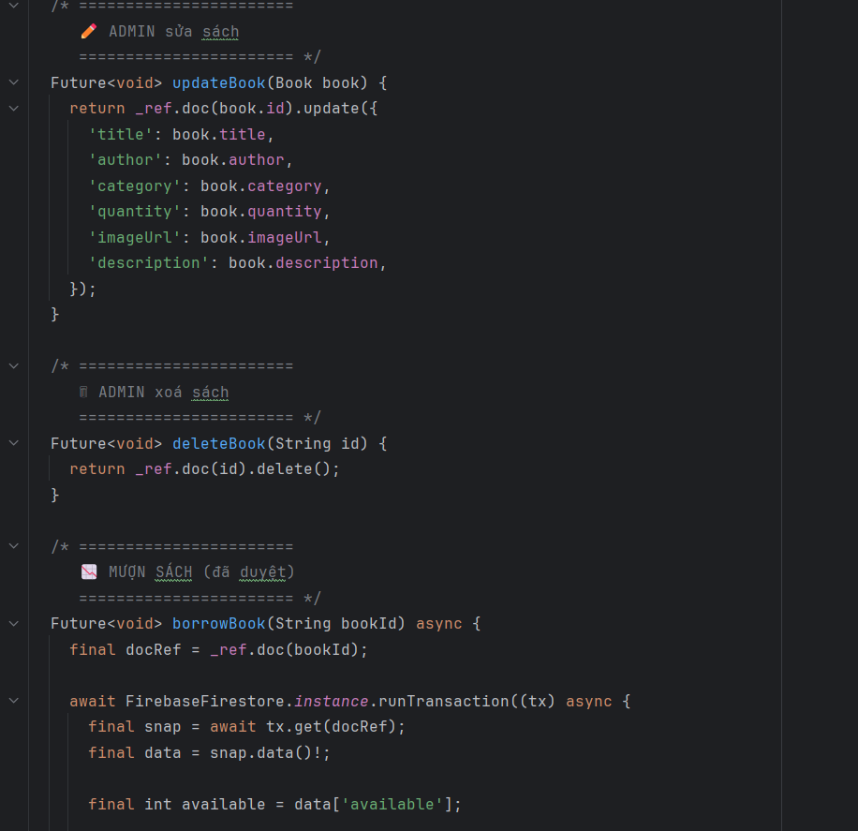

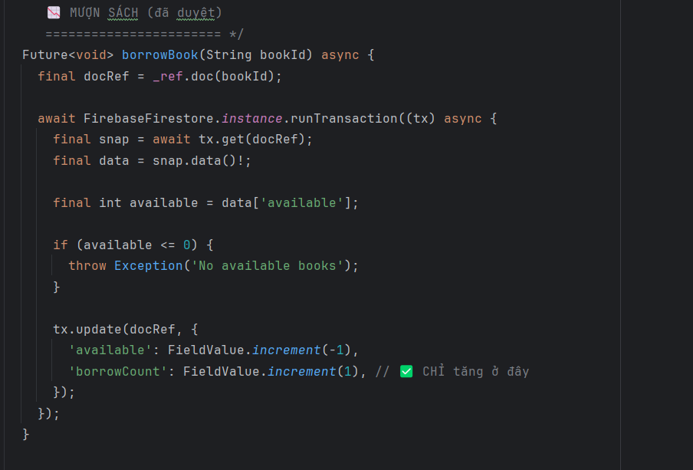

4.3.3 External API Intergration
- Integrate the Google Books API
- Search books online
- Import books directly into the system
- Error handling:
• Timeout
• Rate limit (HTTP 429)
• Empty API responses

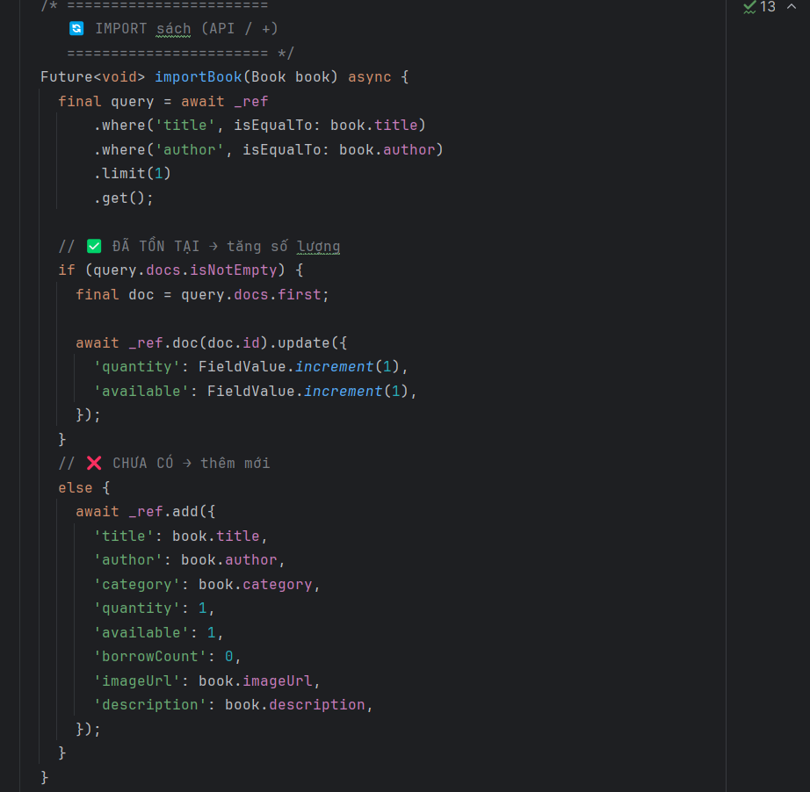

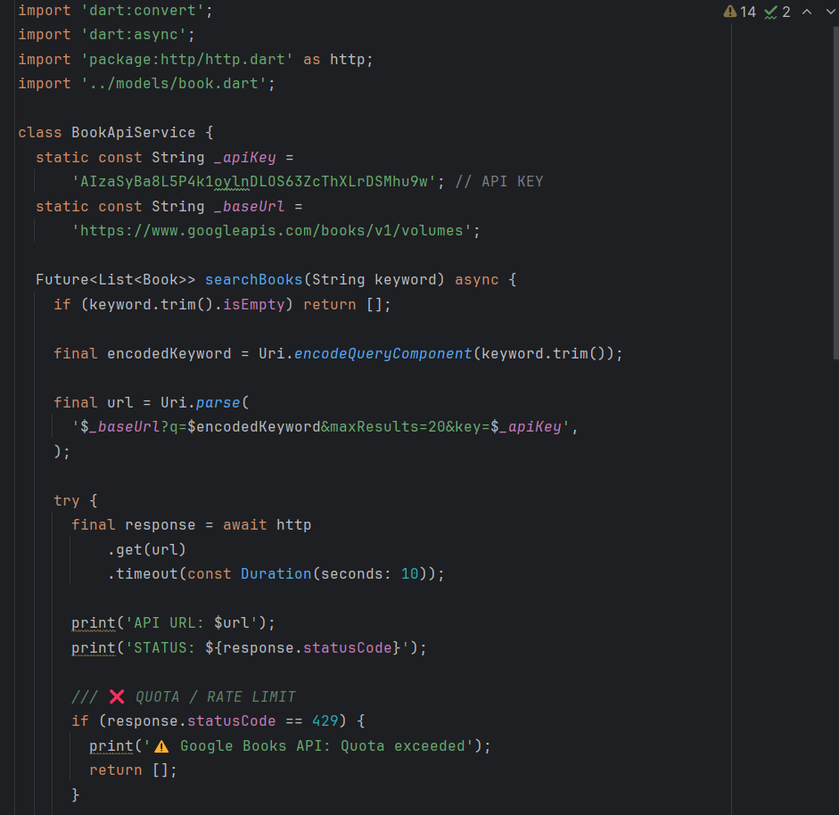

4.4. Implementation: Client Side Logic

4.4.1. UI and Navigation
- The interface is built using Flutter widgets
- Navigation is handled using Navigator
- The UI changes based on user roles:
- Admin: import, add, manage books
- Student: borrow, view books
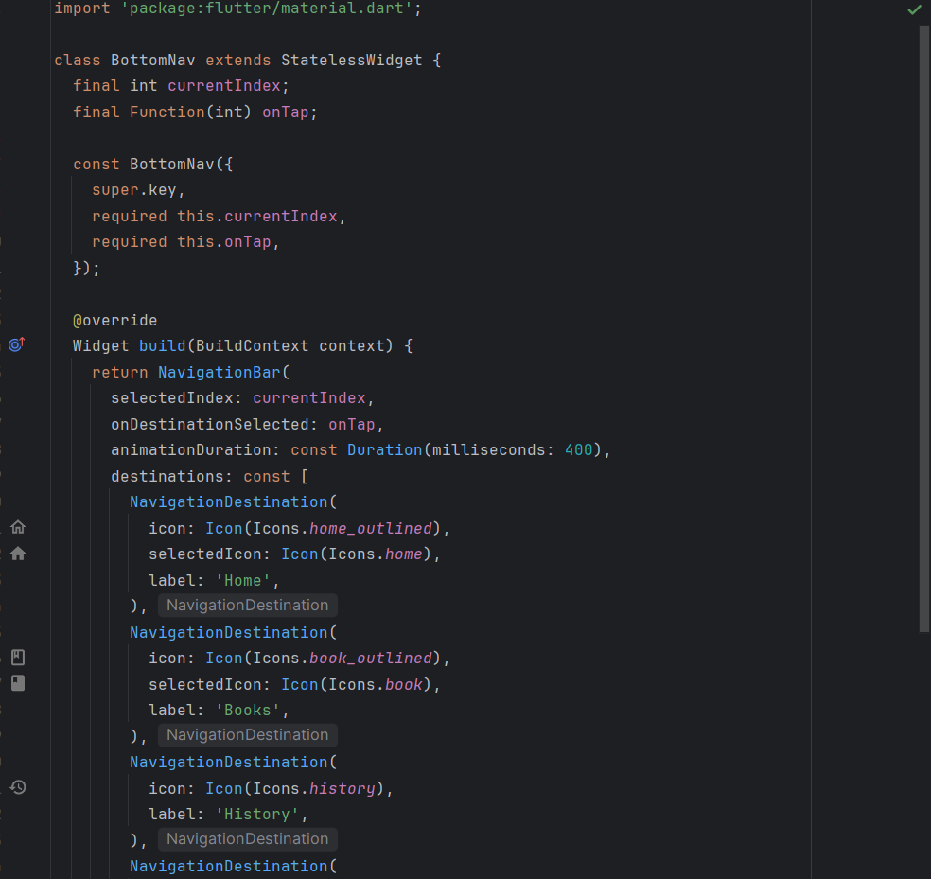

4.4.2. State Management
- Use StatefulWidget with setState
- Use StreamBuilder to:
• Display real-time data from Firestore
• Update the UI when data changes

4.4.3. Role-based UI Rendering
- After login:
• Check the user role from Firestore
• Navigate to the appropriate screen
- The profile displays:
• Email
• Name
• Student ID
• Role (Student / Admin)

4.4.4. Error Handling and UX
• Loading indicator when calling the API
• SnackBar to display status (successful import, errors)
• Prevent invalid actions (borrowing a book when unavailable)

5. Testing and Verification

5.1. Testing Strategy Overview
The testing strategy of the project focuses on ensuring correctness, reliability, and real-time consistency of the Library Management Application.
Due to the project scope and timeline, testing is conducted at three main levels:
- Unit Testing: Verify individual functions and core logic
- API Testing: Validate communication with external services
- Integration Testing: Verify interactions between multiple system components
- Real-time Broadcast Testing: Validate Firebase real-time data synchronization
This layered testing approach helps detect errors early and ensures system stability.

5.2 Unit Testing

5.2.1. Definition
Unit testing focuses on testing the smallest testable parts of the application (functions, methods, or classes) in isolation, without involving external systems such as Firebase or third-party APIs.
In this project, unit tests mainly target:
- Data models
- Data parsing logic
- Validation logic
- Business rules inside services

5.2.2. Unit Test Scope
Component | Description
Book model | Parsing and mapping data
User model | Role and UID validation
API service logic | Keyword validation
Helper functions | Null and edge-case handling

Unit Test Code Example
- Testing Book Model Parsing:
import ‘package:flutter_test/flutter_test.dart’;
import ‘../lib/models/book.dart’;

void main() {
test(‘Book.fromMap parses data correctly’, () {
final map = {
‘title’: ‘Flutter Basics’,
‘author’: ‘Google’,
‘category’: ‘Programming’,
‘quantity’: 5,
‘available’: 5,
};

final book = Book.fromMap(‘1’, map);

expect(book.title, ‘Flutter Basics’);
expect(book.author, ‘Google’);
expect(book.category, ‘Programming’);
expect(book.quantity, 5);
expect(book.available, 5);
});
}

5.2.4. Unit Test Case Table
Test ID | Description | Input | Expected Output
UT-01 | Parse book from map | Valid map data | Book object created
UT-02 | Missing author field | Author = null | Default value used
UT-03 | Empty keyword search | “” | Return empty list
UT-04 | Quantity validation | Quantity < 0 | Rejected

5.3 API Testing

5.3.1. Purpose
API testing verifies communication between the application and external services.
In this project, the main external API is Google Books API used for importing book data.

5.3.2. API Request Example
GET https://www.googleapis.com/books/v1/volumes?q=flutter&maxResults=20&key=API_KEY

5.3.3. API Response Handling Code
if (response.statusCode == 429) {
print('Quota exceeded');
return [];
}
if (response.statusCode != 200) {
return [];
}

5.3.4. API Test Case Table
Test ID | Senario | Input | Expected Result
API-01 | Valid Keyword | “flutter” | Book List returned
API-02 | Empty keyword | “” | Empty list
API-03 | Rate limit exceeded | 429 | Graceful fallback
API-04 | Timeout | No response | Timeout handled

5.4 Integration Testing

5.4.1 Definition
Integration testing verifies that different components work correctly together, including:
- UI → Service
- Service → Firebase Firestore
- Firebase → UI update

5.4.2 Integration Test Scenario
Scenario: Import a book and verify it appears in the book list
Steps:
- Admin searches book using Google Books API
- Admin clicks “Import”
- Book is stored in Firestore
- Book list UI updates automatically

5.4.3. Integration Test Case Table
Test ID | Scenario | Steps | Expected Result
IT-01 | Import Book | Search -> Import | Book stored in Firestore
It-02 | Borrow book | Click Borrow | Available, quantity decreases
IT-03 | Return book | Click Return | Available,quantity increases
IT-04 | Role-based access | Student login | Admin features hidden

5.5 Real-time Broadcast Testing

5.5.1 Definition
Real-time broadcast testing verifies that data updates in one client are automatically synchronized and reflected in other clients without manual refresh.
This application uses Firebase Firestore real-time listeners.

5.5.2 Real-time Mechanism Used
Stream<List<Book>> getBooks() {
return FirebaseFirestore.instance
.collection('books')
.snapshots()
.map((snap) =>
snap.docs.map((d) => Book.fromMap(d.id, d.data())).toList());
}

5.5.3 Test Execution with Two Devices
Test Environment
- Emulator 1: Admin account
- Emulator 2: Student account
Test Flow
- Admin imports a new book
- Student device updates automatically
- Student borrows the book
- Admin device sees updated availability

5.5.4. Real-time Test Case Table
Test ID | Action | Device A | Device B | Result
RT-01 | Import Book | Admin | Student | Sync Success
RT-02 | Borrow Book | Student | Admin | Quanity updated
RT-03 | Delete Book | Admin | Student | Book removed
RT-04 | Network delay | Any | Any | No crash

5.6. Test Results and Verification
Test Type | Status
Unit Testing | Passed
Api Testing | Passed
Intergration | Passed
Real-time Broadcast | Passed

The testing results demonstrate that the system meets both functional and non-functional requirements, including correctness, reliability, and real-time responsiveness.

5.7 Conclusion
Through systematic unit testing, API validation, integration testing, and real-time broadcast verification, the application ensures:
- Correct data handling
- Stable external API usage
- Consistent multi-user synchronization
- Reliable system behavior under normal conditions

6. Conclusion & Reflection
This project successfully analyzed and designed a comprehensive Library Management System that supports core library operations for both users and administrators.
The primary system goals-efficient book search, borrowing/return management, request approval, and notification handling-were clearly identified and addressed through well-defined functional workflows and system components.
The system design ensures data consistency, role-based access (User/Admin), and scalability, while improving the overall user experience by digitizing manual library processes such as borrowing approval, return confirmation, and inventory tracking.

6.1 Lessons Learned
• Clear Requirement Analysis:
Conducting a detailed analysis of user and admin requirements helped define accurate system functionalities, reducing ambiguity in later design stages.
• Separation of Responsibilities:
Dividing system roles between User and Admin simplified permission management and improved system security and maintainability.
• Process-Oriented Design:
Modeling key workflows such as searching, borrowing, returning, approval, and notification highlighted dependencies between system components and ensured smooth process execution.
• Data-Centered Thinking:
Designing around core entities (Book, User, Borrow Request, Loan History) emphasized the importance of structured data management for reporting and tracking purposes.

6.2 Future Improvements
- Enhanced Security:
Implement authentication and authorization mechanisms (e.g., JWT, role-based access control) to secure user sessions and admin operations.
- Automation & Notifications:
Integrate automated reminders for due dates and overdue books via email or mobile notifications to improve user compliance.
- System Scalability:
Deploy the application using a cloud-based infrastructure and adopt a microservices architecture to support larger libraries and higher concurrent users.
- Data Analytics & Reporting:
Extend the statistics module to provide advanced analytics such as popular books, borrowing trends, and user behavior insights.
- Persistence & Backup:
Integrate a robust database with regular backup mechanisms to ensure data reliability and recovery.

