Cross-platform Java mobile map viewer
JVNMobileGIS supports fetching map data from remote server to view on mobile devices. Focus on OGC (Open Geospatial Consortium - http://www.opengeospatial.org/) and JCP (The Java Community Process - http://jcp.org/) standards.

Features
- Run on any mobile devices with JavaME MIDP 2.0, CLDC 1.0
- Get map data from any OGC WMS compliant server on Internet.
- HTTPS, SSL3 support ing for secured data transfer
- Automatically scale bounding box and image to best fit on the device screen.
- Interactive actions on map view: Zoom in, zoom out, recenter map to the cursor point, drag.
- Support GetFeatureInfo of OGC WMS specification.
- Search Feature in current map view
- Fullscreen display ing
- Support touch screen devices (e.g. Pocket PC, UIQ,...).
- Multi-langues: English and Vietnamese

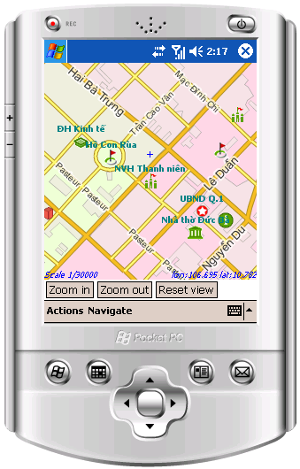
JVNMobileGIS
Java Mobile Map
JavaVietnam - 460 Nguyen Kiem St. Phu Nhuan Dist. – HCMC – Vietnam
info@javavietnam.org
http://jvnmobilegis.googlecode.com

Screenshots
Splash screen  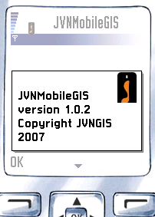 | Main menu  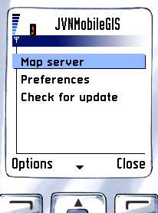

Sample maps
Ho Chi Minh city  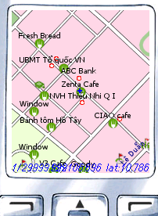 | Demis World map  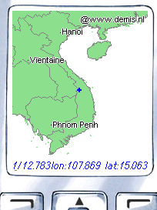

Screenshots
Layer selection  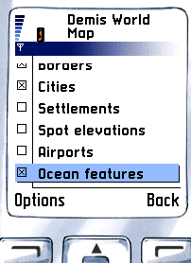 | Feature Search results  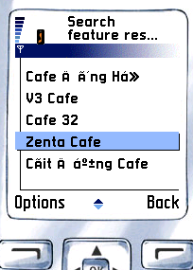

GetFeatureInfo
Feature Info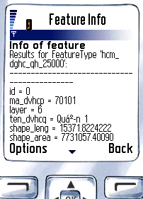 | Preferences  