JVNMOBILEGIS USERGUIDE

Introduction:
JVNMobileGIS:
A mobile map viewer which is developed with Java ME technology. Support fetching map data from remote server to view on mobile device. Focus on OGC (Open Geospatial Consortium - http://www.opengeospatial.org/) and JCP (The Java Community Process - http://jcp.org/) specifications.
To run this application you need a Java supported mobile device (MIDP 2.0).
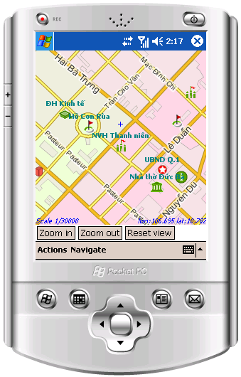
Figure 1. JVNMobileGIS on Windows Mobile
You can get all files and information about JVNMobileGIS at project homepage: http://code.google.com/p/jvnmobilegis/
Features:
- Support CLDC 1.0 for low-end Java phones.
- Get data from any OGC WMS compliant server on the Internet.
- Support HTTP, SSL to interact with secured map servers.
- Support GZIP transmission
- Simple caching of map data
- Interactive actions on map view: Zoom in, zoom out, re-center map to the cursor point, drag.
- Support GetFeatureInfo of OGC WMS specification.
- Support multi-languages
- Support touch-screen devices (e.g. Pocket PC, UIQ, etc.). You can drag map on the screen.
Installation
On real mobile devices (mobile phone, pocket PC, PDA)
The installation step depends on your phone model and manufacturer. Please refer to your device specifications and manual for detail information.
Basically, you have 2 ways to install application on mobile devices:
- Over the Air installation:
You can enter this URL http://jvnmobilegis.googlecode.com/svn/JVNMobileGIS.jad to your phone browser and follow all instructions given.
- Install by connecting to PC: Connect your phone to your computer through cable, bluetooth, IR or Wifi. Copy the JVNMobileGIS.jar file to your phone, open it and install. Some phones need you to copy the JVNMobileGIS.jad file too.
PC Emulation
You can emulate JVNMobileGIS application in your PC by:
- Executable version: download executable package from Download (http://code.google.com/p/jvnmobilegis/downloads/list) page, extract and run JVNMobileGIS.exe
- Live Demo: You can run JVNMobileGIS on your PC using Java Webstart of mpowerplayer. Please make sure you have Java Runtime Environment installed. User this URL to launch live demo of JVNMobileGIS, please accept any warnings:
http://webstart.mpowerplayer.com/jvnmobilegis.googlecode.com/svn/JVNMobileGIS.jad
- Build from source: using Sun Java Wireless Toolkit or IDE. Java ME should already know about this.
Application Using
Main menu

