

Mobile Internet Speed Prediction for Hanoi
COS40007 Artificial Intelligence Engineering
Group Task 1: System Blueprint & Project Planning

- Group Agreement and Project Plan
- Studio Session No.: Wendnesday 1h-5h
- Group No. (given by tutor only): 5
- Github repo : https://github.com/khanhnedu2006-byte/COS40007
- Name and Students' Numbers of Group Members:

Student Name | Student ID
Hoàng Minh Đức | 105541452
Phạm Quang Minh | 104999568
Nguyễn Nam Khánh | 105706565

Group style and roles
Who does what, and how will you work together? Who will be responsible for the submitted deliverables? Who will ask questions on behalf of their group? Who is the Scrum Master for each Sprint or all sprints?
Our project builds a web map of Hanoi where a user clicks any point and receives an estimated mobile internet speed (4G and 5G together). The estimate comes from a machine learning model trained on Ookla Open Data speed tests and the distance from each point to 4G/5G cell towers in OpenCelliD.
Working style. We work as a small Scrum team with two-week sprints. Each sprint starts with sprint planning and ends with a sprint review and retrospective, all held in our Tuesday Google Meet meeting. Each member owns one part of the pipeline from start to finish (data, model, application) and DevOps duties are shared, so every member writes code, tests their own work and contributes to the report.
Member | Role | Responsibilities | Deliverables owned
Nguyễn Nam Khánh | Team Leader, Scrum Master  Data Processing, Tester, DevOps | Download and clean Ookla tiles and OpenCelliD towers for Hanoi; exploratory data analysis  Feature engineering (distance to towers, tower density, 5G share) and the training dataset  Test plan, unit tests for data and features, end-to-end testing and bug log  GitHub repository, branch protection, pull-request reviews and data versioning  Runs meetings, keeps the Trello board up to date, final submission | hanoi_train.csv and data contract  Test reports  Group agreement and final report
Hoàng Minh Đức | Model Training and Testing, MLOps | 3GPP physics module (theoretical speed from tower distances)  KNN and Random Forest baselines and the hybrid model (3GPP + XGBoost) with an 80% range  Spatial block cross-validation, model comparison and figures  Model registry, monitoring, drift detection and the retraining workflow | Saved model bundle  Evaluation results  MLOps design
Phạm Quang Minh | Frontend, Backend, DevOps | React + Leaflet map with tower nodes and click-to-predict  FastAPI backend (/api/predict, /api/towers) and the prediction service that loads the saved model  GitHub Actions CI/CD, Docker images and deployment of the demo | Web application  CI/CD pipeline  API contract

Answers to the questions above
- Who does what: each member owns the area in the table above. Work that crosses areas (data columns, model inputs, API format) is agreed in the Tuesday meeting and written in the data and API contracts.
- Responsible for submitted deliverables: Nguyễn Nam Khánh combines all parts and submits every deliverable; each member is responsible for the quality of their own section and checks the full report before submission.
- Asks questions on behalf of the group: Nguyễn Nam Khánh contacts the tutor; Hoàng Minh Đức is the backup contact when Nguyễn Nam Khánh is not available.
- Scrum Master: Nguyễn Nam Khánh is the Scrum Master for all sprints: he runs the meetings, tracks the Trello board and removes blockers.
- Decision making: technical decisions inside one area are made by the owner; decisions that affect other members are made together in the Tuesday meeting and recorded in the minutes.

Timeline (Follow Sprint here)
By when do you need to make decisions? When do tasks need to be completed by to ensure you submit on time? (Aim to submit BEFORE the deadline to allow for unforeseen circumstances).
The project runs from Week 4 to Week 12 in five sprints. Each deliverable has an internal deadline two days before the official due date, so there is time for review and for unforeseen problems.
Sprint | Weeks | Goal | Key deliverables | Lead | Decision point
Sprint 0 | Week 4 | Plan the project | Group agreement and roles  System blueprint and MLOps/DevOps design  GitHub repository, Trello board, code skeleton | All | Approve scope, roles and tools
Sprint 1 | Weeks 5–6 | Reliable Hanoi dataset | Ookla tiles for Hanoi (6+ quarters)  Hanoi 4G/5G tower table from OpenCelliD  EDA notebook  hanoi_train.csv and data contract  3GPP physics module with tests (Đức)  Map skeleton with mock data (Minh) | Nguyễn Nam Khánh | End of Week 5: enough towers in Hanoi? If not, add OpenStreetMap features and use a coarser grid
Sprint 2 | Weeks 7–8 | Trained and evaluated models | KNN and Random Forest baselines  Hybrid model with 80% range  Spatial CV comparison and figures  Saved model bundle (v1)  API with mock predictor (Minh) | Hoàng Minh Đức | End of Week 8: choose the final model (target: MAE at least 10% lower than the best baseline)
Sprint 3 | Weeks 9–10 | Working demo | Backend using the saved model  Map with tower nodes, click-to-predict and result panel  GitHub Actions CI  Monitoring and drift scripts (Đức)  End-to-end tests (Khánh) | Phạm Quang Minh | End of Week 10: feature freeze, only bug fixes after this
Sprint 4 | Weeks 11–12 | Release and report | Retraining workflow  Deployment and demo video  Final report and presentation | Nguyễn Nam Khánh | Final review two days before submission

Key dates
- Week 5: decide whether the tower data is good enough; this is the main risk of the project.
- Week 6: data freeze: hanoi_train.csv is fixed so model training can start on the same data.
- Week 8: model selection: the best model is chosen with spatial cross-validation and saved for the backend.
- Week 10: feature freeze: no new features, only testing and bug fixes.
- Week 12: all deliverables finished two days before the deadline; the final check is done in the Tuesday meeting.

Communication Plan
Decide and document how your group will communicate and collaborate regularly throughout the project. This could include meeting via Zoom, communicating via a Teams group or Canvas, and using cloud services for shared documents, etc. How often and how will you communicate? What are your expectations of others responding to your communications?
The group uses two communication channels only: a Zalo group chat and a weekly Google Meet meeting.
- Zalo group chat: used for all day-to-day communication: progress updates, quick questions, blockers, links to pull requests and meeting minutes. Each member posts a short progress update at least twice a week.
- Response time: members reply to Zalo messages within 24 hours. Urgent messages are marked “URGENT” and answered the same day. Blockers are reported within 48 hours instead of waiting for the meeting.
- Weekly Google Meet meeting: every Tuesday from 9:00 pm to 10:30 pm. Agenda: (1) each member’s progress on the Trello board, (2) blockers and help needed, (3) decisions, (4) tasks for the next week. In the first meeting of a sprint we do sprint planning; in the last meeting we do the sprint review and retrospective.
- Minutes: a note-taker (rotating each week) writes the decisions and action items and posts them in the Zalo group on the same night.
- Extra meetings: if a problem cannot wait until Tuesday, a short extra Google Meet call is arranged in the Zalo group.
- Absence: a member who cannot attend tells the group at least 24 hours before, posts a written update in Zalo and reads the minutes afterwards.
- Shared work (tools, not communication channels): tasks are tracked on the Trello board; code, notebooks and documents are shared in the GitHub repository; large data files are kept in a shared cloud folder because they are too large for Git.

On-track behaviours
What behaviours will result in great group outcomes?
- Attending every Tuesday meeting on time and coming prepared with an update.
- Finishing assigned tasks by the sprint deadline and moving Trello cards as work progresses.
- Raising blockers early on Zalo (within 48 hours) and offering help to other members.
- Reviewing each other’s pull requests constructively and within two days.
- Following the shared data and API contracts, and announcing any change before making it.
- Writing clear commit messages, clean notebooks and short documentation for each part.

Off-track behaviours
What behaviours would result in group outcomes that are not great?
- Missing meetings or deadlines without notice.
- Not replying on Zalo for more than 24 hours during a sprint.
- Pushing directly to the main branch or merging code that has not been tested.
- Changing shared settings (feature list, model inputs, API format) without telling the team.
- Leaving work until the last day, so others cannot review or build on it.
- Doing another member’s task without agreement, or criticising people instead of the work.

Resolving tensions
How will we resolve tensions or off-track behaviour as a group?
We resolve problems early and step by step, so small issues do not grow:
- Step 1 – talk directly: the members involved discuss the issue privately (Zalo or a short call) within two days.
- Step 2 – team meeting: if it is not solved, the issue is raised in the next Tuesday meeting. The team agrees on a fix, for example re-assigning tasks, adjusting a deadline or pairing two members on a task.
- Step 3 – decision rule: technical disagreements are settled with evidence where possible (a quick test or a comparison on the data); otherwise by majority vote, with the Team Leader deciding a tie.
- Step 4 – tutor: if a member repeatedly does not contribute after Steps 1–3, the Team Leader informs the tutor with evidence from Trello and GitHub.

Team Expectations:
1. | Every member completes their Trello tasks by the sprint deadline and reports blockers on Zalo within 48 hours.
2. | Every member attends the Tuesday 9:00–10:30 pm Google Meet meeting, or gives 24 hours’ notice and a written update.
3. | All code reaches the main branch only through a reviewed pull request that passes the automated tests.

- System Blueprint Diagram: A diagram showing system components, data flow, and ML model integration with an explanation relevant to your applied project.
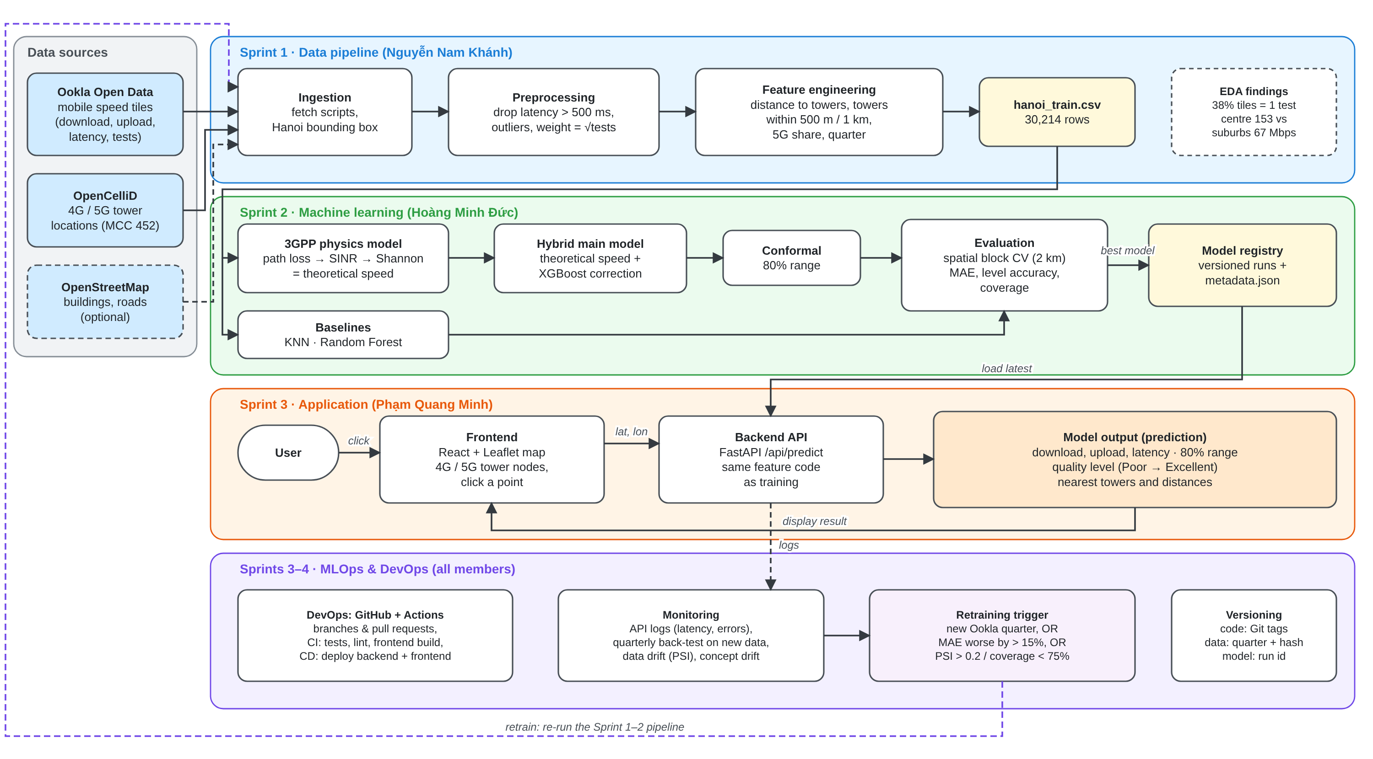
Figure 1. System blueprint. Lanes show the sprint and owner of each stage; solid arrows show data flow, dashed arrows show feedback and optional flows.
System components
- Data sources: Ookla Open Data mobile speed-test tiles (about 610 m × 610 m, released every quarter) with download, upload, latency and number of tests; OpenCelliD cell tower locations for Vietnam (MCC 452), filtered to LTE (4G) and NR (5G) towers in Hanoi; OpenStreetMap building data is optional.
- Ingestion: scripts download the tiles inside the Hanoi bounding box (latitude 20.53–21.40, longitude 105.28–106.03) and the tower file. The current dataset has 30,214 rows covering 10,459 tiles over six quarters (Q4 2024 to Q1 2026).
- Preprocessing: removes invalid rows and extreme values (latency above 500 ms) and adds a sample weight of √tests, because our EDA showed that 38% of tiles contain only one speed test and are noisy.
- Feature engineering: for every tile: distance to the nearest tower and the nearest 5G tower, number of towers within 500 m and 1 km, share of 5G towers, the theoretical speed from the physics model and a time index. The same feature code is used for training and by the backend, so both see identical inputs.
- ML component: the 3GPP TR 38.901 urban macro model turns tower distances into a theoretical speed (path loss → SINR → Shannon capacity). The hybrid model uses XGBoost to learn the correction between this theoretical speed and the real Ookla speed. KNN (location only) and Random Forest (same features) are baselines. Conformal prediction adds an 80% range to each estimate.
- Evaluation and model registry: models are compared with 5-fold spatial block cross-validation (2 km blocks). The best model is saved with its metadata in a versioned model registry, and the backend always loads the latest approved version.
- Backend (FastAPI): /api/towers returns the towers to draw on the map; /api/predict receives a latitude and longitude, builds the features, runs the saved model and returns the prediction. Points outside Hanoi are rejected with a clear message.
- Frontend (React + Leaflet): shows a map of Hanoi with 4G and 5G towers as coloured nodes. After a click it shows the estimated download, upload and latency, the 80% range, a quality level (Poor below 15 Mbps, Fair 15–100, Good 100–200, Excellent 200 and above) and lines to the three nearest towers.
- MLOps and DevOps: request logs and quarterly back-tests feed monitoring; a retraining trigger re-runs the data and training pipeline. GitHub and GitHub Actions provide version control, automated tests and deployment for every stage (Section 3).
Data flow when a user clicks the map
- 1: the frontend sends the clicked latitude and longitude to /api/predict.
- 2: the backend checks that the point is inside Hanoi and finds the nearby towers.
- 3: the shared feature code computes the tower features and the 3GPP theoretical speed.
- 4: the hybrid model predicts the correction, giving the final estimate and its 80% range.
- 5: the backend returns the estimate, quality level and nearest towers as JSON; the map shows them and the request is logged for monitoring.
Why this design fits our project. Download speed in Hanoi is spatially clustered (median 153 Mbps within 5 km of Hoan Kiem versus 67 Mbps beyond 20 km), so the model must use location and tower information, and evaluation must use spatial blocks. Speeds also rise over time (median 70.7 Mbps in Q4 2024 to 79.8 Mbps in Q1 2026), so the design includes regular retraining. Ookla tiles are sparse in the suburbs, so the physics part keeps estimates sensible where there is little data.

- MLOps & DevOps Integration (High-Level Design): How MLOps (retraining, monitoring) and DevOps (CI/CD, version control) will fit into your project.
MLOps
Data and training strategy
- Unit of data: one row is one Ookla tile in one quarter (30,214 rows, 10,459 tiles, six quarters).
- Split: tiles are grouped into 2 km × 2 km blocks. About 20% of the blocks are held out as the test set and never used for training or tuning. The remaining blocks are used for 5-fold spatial block cross-validation, and 20% of them calibrate the 80% range (about 64% training, 16% calibration/validation, 20% test). We also report results on the newest quarter alone.
- Why spatial blocks: neighbouring tiles have very similar speeds; a random split would put near-duplicates in both sets and overstate accuracy.
- Evaluation targets: MAE at least 10% lower than the best baseline, at least 60% of quality levels correct, and 75–85% coverage for the 80% range. Metrics use tiles with at least 3 tests; training weights tiles by √tests.
Retraining strategy
Trigger | Rule | Reason
Time-based | Every new Ookla quarter (every 3 months); tower features refreshed monthly | Mobile speeds in Hanoi rise quickly as 5G expands, so the model ages even without errors
Performance-based | The current model is tested on the new quarter first. Retrain if MAE is more than 15% worse than the recorded test MAE, or if 80%-range coverage is outside 75–85% | Detects when predictions become unreliable
Drift-based | Retrain and investigate if PSI > 0.2 for download speed or a key feature | Detects changes in the data before errors become visible

- Retraining pipeline: download the new quarter → rebuild features → retrain all models with the same settings → evaluate on the held-out blocks → save as a new version.
- Champion and challenger: the retrained model (challenger) replaces the current model (champion) only if it scores better on the same test blocks; otherwise the current model stays in use and the result is logged. This means about four retraining runs per year, plus extra runs from the other triggers.
Monitoring
- Service monitoring: the backend logs every request (time, location, prediction, response time, errors). We track response time (target under 1 second), error rate, number of requests and the share of clicks outside Hanoi.
- Model performance: users do not report their real speed, so performance is measured with a quarterly back-test: when a new Ookla quarter is released, predictions for those tiles are compared with the measured values (MAE, level accuracy, range coverage) and stored in a metrics history.
- Data drift: the new data is compared with the training data using the Population Stability Index (PSI) and the Kolmogorov–Smirnov test for download speed and the main features (tower distance, towers within 1 km, 5G share). PSI above 0.2 is treated as significant drift.
- Concept drift: the relationship between features and speed can change, for example when towers are upgraded to 5G. We detect this by tracking the residuals (prediction minus actual) by distance band and quality level, the gap between theoretical and real speed, and changes in XGBoost feature importance.
- Model versioning: each trained model is saved in its own folder (artifacts/models/<name>/<run id>) with metadata recording the Git commit, data version, parameters and metrics. A LATEST pointer marks the model used by the backend, so any version can be reproduced or rolled back.
DevOps
- Version control: one GitHub repository for code, notebooks and documentation. The main branch is protected; work happens on feature branches (e.g. feature/data-tower-features) and is merged through a pull request reviewed by at least one other member. Commit messages reference the Trello card (e.g. “T-04: add tower features”) and each sprint ends with a release tag (v0.1-sprint1, …).
- CI pipeline (GitHub Actions): on every pull request: install dependencies, run the linter, run the unit tests (physics worked example, feature columns, model save/load), check that notebooks have no stored outputs and build the frontend. A pull request cannot be merged if any check fails.
- CD pipeline: on merge to main: build Docker images for the backend and frontend and deploy the demo. A scheduled workflow each quarter downloads the new Ookla data, runs the back-test and drift checks, and starts the retraining pipeline if a trigger fires.
- Data versioning: data files are kept outside Git in a shared cloud folder and identified by quarter and a SHA-256 hash, which is stored in the model metadata.
- Ownership: Hoàng Minh Đức owns retraining, monitoring and the model registry; Phạm Quang Minh owns CI/CD, Docker and deployment; Nguyễn Nam Khánh owns the repository, branch rules, pull-request reviews and tests.

- Project Management Setup (Agile Tools): A Jira (or Trello or others) board with key user stories and a Confluence/Notion/Word page for project documentation.
Tool: Trello – https://trello.com/b/Cb1sJZPX/cos40007-hanoi-mobile-speed-prediction
- Lists: Backlog (all user stories and future tasks) → Sprint To Do (tasks of the current sprint) → In Progress → In Review (pull request open) → Done (merged and tested).
- Cards: each user story (US1–US6) is a card with its acceptance criteria and a checklist linking to its tasks. Each task card (T-01 to T-23) has the story points in its title and the user story, owner, priority, sprint and a “done when” condition in its description.
- Labels: green = Sprint 1, yellow = Sprint 2, orange = Sprint 3, purple = Sprint 4, red = highest-priority tasks on the critical path (T-02, T-11, T-14), blue = user story.
- Workflow: in sprint planning, tasks move from Backlog to Sprint To Do and are assigned to members. A member moves a card to In Progress when starting, to In Review when the pull request is opened, and to Done after the review and tests pass.
Key user stories
ID | User story | Acceptance criteria | Priority | Sprint | Owner
US1 | As a mobile user in Hanoi, I want to click any point on a map and see the estimated download speed, so that I can choose where to work or study with good internet. | A click inside Hanoi returns download, upload and latency estimates in under 1 second; a click outside Hanoi shows a clear warning. | High | 3 | Phạm Quang Minh
US2 | As a mobile user, I want each estimate to show a confidence range and a quality level, so that I know how much I can trust it. | Every estimate has an 80% range with 75–85% coverage on test data; the level is shown as Poor, Fair, Good or Excellent. | High | 2–3 | Hoàng Minh Đức, Phạm Quang Minh
US3 | As a mobile user, I want to see the nearest 4G/5G towers and their distances, so that I understand why an area is fast or slow. | 4G and 5G towers are shown in different colours; after a click, lines to the three nearest towers show their distances. | Medium | 3 | Phạm Quang Minh
US4 | As a data engineer, I want a clean, reproducible Hanoi dataset with tower features, so that every model trains on the same inputs. | hanoi_train.csv follows the data contract, can be rebuilt from raw data with one notebook, and the feature tests pass. | High | 1 | Nguyễn Nam Khánh
US5 | As an ML engineer, I want to compare the baselines with the hybrid model using spatial cross-validation, so that we can show the improvement honestly. | 5-fold spatial block CV for all three models; hybrid MAE at least 10% lower than the best baseline (or the gap is explained); comparison table saved. | High | 2 | Hoàng Minh Đức
US6 | As the maintenance team, I want automated tests, versioned models and a retraining check for each new data quarter, so that the system stays accurate. | CI runs on every pull request; every saved model has metadata; the quarterly back-test and drift check decide whether to retrain. | Medium | 3–4 | All

Task breakdown
Card | Story | Task | Assignee | Priority | Sprint | Points
T-01 | US4 | Download Ookla tiles for Hanoi, including newest quarters | Nguyễn Nam Khánh | High | 1 | 2
T-02 | US4 | Download OpenCelliD (MCC 452), filter Hanoi 4G/5G towers | Nguyễn Nam Khánh | Highest | 1 | 3
T-03 | US4 | EDA notebook: distributions, map, tests per tile | Nguyễn Nam Khánh | High | 1 | 3
T-04 | US4 | Cleaning module and tower-distance features | Nguyễn Nam Khánh | High | 1 | 5
T-05 | US4 | Build hanoi_train.csv and data contract; feature tests | Nguyễn Nam Khánh | High | 1 | 3
T-06 | US5 | 3GPP physics module with worked-example tests | Hoàng Minh Đức | High | 1 | 5
T-07 | US6 | GitHub repo, branch protection, PR template, README | Nguyễn Nam Khánh | High | 1 | 2
T-08 | US1 | Frontend map skeleton with mock JSON | Phạm Quang Minh | Medium | 1 | 3
T-09 | US5 | Spatial block CV and metrics | Hoàng Minh Đức | High | 2 | 3
T-10 | US5 | Train KNN and Random Forest baselines | Hoàng Minh Đức | High | 2 | 3
T-11 | US2 | Hybrid model (3GPP + XGBoost) and conformal 80% range | Hoàng Minh Đức | Highest | 2 | 5
T-12 | US6 | Model registry: versioned runs with metadata | Hoàng Minh Đức | Medium | 2 | 2
T-13 | US1 | FastAPI endpoints with mock predictor | Phạm Quang Minh | High | 2 | 3
T-23 | US1 | API contract and backend integration tests | Phạm Quang Minh | Medium | 2 | 3
T-14 | US1 | Predictor that loads the saved model and shared features | Phạm Quang Minh | Highest | 3 | 3
T-15 | US3 | Tower layer and lines to nearest towers | Phạm Quang Minh | Medium | 3 | 3
T-16 | US2 | Result panel: estimate, range, quality level | Phạm Quang Minh | High | 3 | 2
T-17 | US6 | GitHub Actions CI: lint, tests, frontend build | Phạm Quang Minh | Medium | 3 | 3
T-18 | US6 | Monitoring: request logs, PSI drift, quarterly back-test | Hoàng Minh Đức | Medium | 3 | 3
T-19 | US1 | End-to-end test plan and bug log | Nguyễn Nam Khánh | High | 3 | 3
T-20 | US6 | Scheduled retraining with champion/challenger | Hoàng Minh Đức | Medium | 4 | 3
T-21 | US1 | Docker images, deployment and demo video | Phạm Quang Minh | Medium | 4 | 3
T-22 | — | Final report, presentation and submission | Nguyễn Nam Khánh | High | 4 | 5
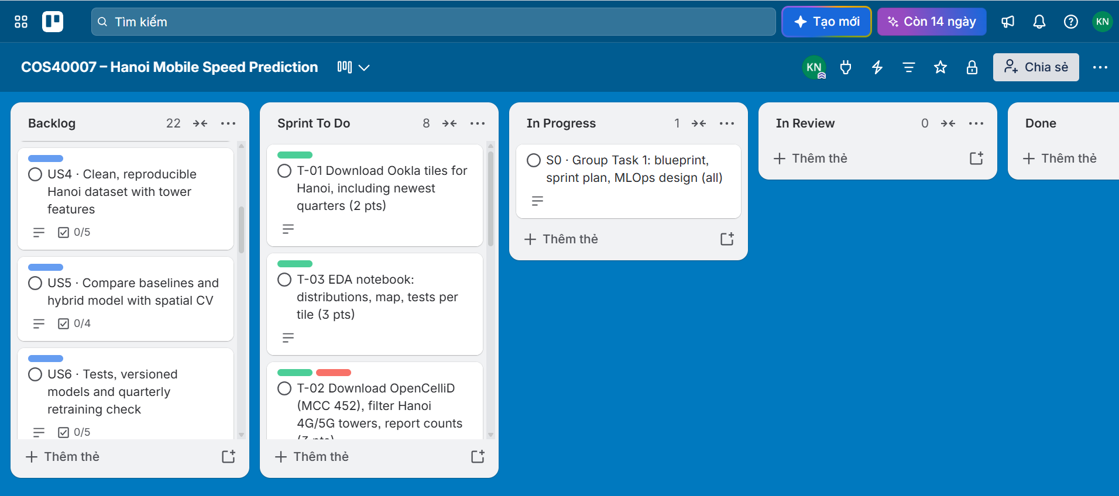Project documentation
Location: [Notion / Word page link]. The same content is kept in the GitHub repository (README.md and docs/).
- Project description: goal, scope (mobile internet in Hanoi, 4G and 5G together), users and success criteria.
- System overview: the blueprint in Figure 1 and how to run the pipeline, backend and frontend.
- Data contract: the columns of hanoi_train.csv, their units and meaning, shared between data and model work.
- API contract: the request and response JSON of /api/predict and /api/towers, shared between backend and frontend.
- Design decisions: data sources, choice of the hybrid model and baselines, spatial cross-validation, the 80% range and the retraining policy, each with its reason.
- Meeting minutes: decisions and action items from every Tuesday meeting.
- Contribution Statement
Each member contributed to Group Task 1 in their own area, and the work was shared equally. All members reviewed the full report before submission.
Member | Role | Contribution to Group Task 1 | Share | Signature
Nguyễn Nam Khánh | Team Leader, Data Processing, Tester, DevOps | Wrote the group agreement, roles, sprint plan and communication plan  Exploratory data analysis of the Hanoi Ookla data used in the blueprint and design decisions  Set up the GitHub repository and the Trello board; wrote the data and testing user stories and tasks  Combined, formatted and submitted the report | 33.3%
Hoàng Minh Đức | Model Training and Testing, MLOps | Designed the ML component of the blueprint (3GPP physics, hybrid model, baselines, 80% range)  Wrote the MLOps design: data split, retraining triggers, monitoring, data and concept drift, model versioning  Wrote the model-related user stories and tasks | 33.3%
Phạm Quang Minh | Frontend, Backend, DevOps | Designed the application part of the blueprint (FastAPI backend, React + Leaflet map)  Wrote the DevOps design: version control workflow, CI/CD pipeline, Docker and deployment  Wrote the application user stories and tasks | 33.3%

We confirm that the contribution shares above are accurate and agreed by all members.
- Generative AI Declaration
Our group used generative AI in preparing this submission, as allowed by the unit. We used Claude (Anthropic) for brainstorming ideas, researching information relevant to the project, assisting in the development of the project structure, and creating plans and schedules tailored to each individual's capabilities.. All AI output was reviewed, edited and checked by the group against our own data analysis and design decisions, and the group takes full responsibility for the final submission. All numbers from our dataset (row counts, median speeds) were computed by the group from the Ookla data.

