COS40007 Design Project · Theme 5
5G Network Performance: Zone Clustering and Forecasting
Work plan and system architecture design

1. Project summary
The system takes geo-tagged 5G measurements collected by trucks in the Brimbank area and answers two questions from the brief:
- How many groups of zones exist by network performance, and what are the key properties of each group?
- What is the predicted network performance for the next hour?

Item | Description
Input | 5G performance values: latency, upload, download, location (latitude/longitude or square_id), time
Output | The group and zone the data belongs to; the next-hour forecast with a prediction interval; an uncertainty map of zones; a written analysis report generated by an LLM
Demonstrator | A web application: React frontend (map, input form, charts, report) calling a FastAPI backend that serves the models

2. Scope

In scope
- Data preprocessing and feature engineering
- Clustering of zones, with meaningful labels for each cluster
- A classifier that assigns new data to a cluster
- Next-hour forecasting of latency and throughput, including zero-shot time-series foundation models
- Prediction intervals and a per-zone uncertainty map using conformal prediction
- Model evaluation and comparison of several algorithms
- A FastAPI backend that serves the models through a REST API
- A React frontend with a zone map, prediction form, forecast charts and report panel
- An LLM layer in the backend that writes the analysis report

Out of scope
- Training deep networks from scratch (the foundation models are used pretrained, without training)
- Real-time streaming, user accounts and cloud deployment (the app runs locally for the demo)
- Root-cause analysis of network infrastructure

3. What the group needs to do
The phases follow the marking weights in the brief. Preprocessing carries the most marks, so it gets the most time.
Phase | Stage | Tasks | Weight
1 | Data preparation | Merge the daily per-truck CSVs; parse date and truck from the filename; remove invalid GPS rows (99,999); normalise units; handle missing values and outliers; explore the data; build latency, throughput and time features | 40%
2 | Model development | Scale features; train K-Means, GMM and DBSCAN; label clusters from centroid profiles; train the zone classifier (Random Forest, TabPFN); build lag and rolling features; train XGBoost and run Chronos or TimesFM zero-shot; calibrate conformal intervals | 20%
3 | Results | Produce the cluster assignments, cluster profiles, zone map, next-hour forecasts with intervals and the uncertainty map | 15%
4 | Evaluation | Compare algorithms with silhouette, Davies-Bouldin, accuracy/F1, MAE, RMSE, interval coverage and width; use a time-based split and a naive baseline for forecasting | 15%
5 | Backend, frontend and LLM | Build the FastAPI endpoints around the saved models; build the React pages; add the LLM report service last, with a fallback when the call fails | 10%
6 | Deliverables | Project brief, presentation and final report | Own rubric

Checklist per phase
- Phase 1: ingestion script, cleaning script, EDA notebook, zone table and time series table saved as parquet.
- Phase 2: saved scaler, clustering model, classifier and forecaster; cluster names and centroid profile table.
- Phase 3: map of zones coloured by cluster; forecast plots against actual values.
- Phase 4: metrics table for every candidate model; justification of the chosen number of clusters and the chosen models.
- Phase 5: running backend with documented endpoints; React app where input values go in and group, zone, forecast and written report come out.

4. System architecture
The system has four parts. The offline ML pipeline turns raw CSVs into trained models and result tables. Storage holds those artefacts. The FastAPI backend loads them and exposes a REST API. The React frontend calls that API and never touches the models or data files directly.
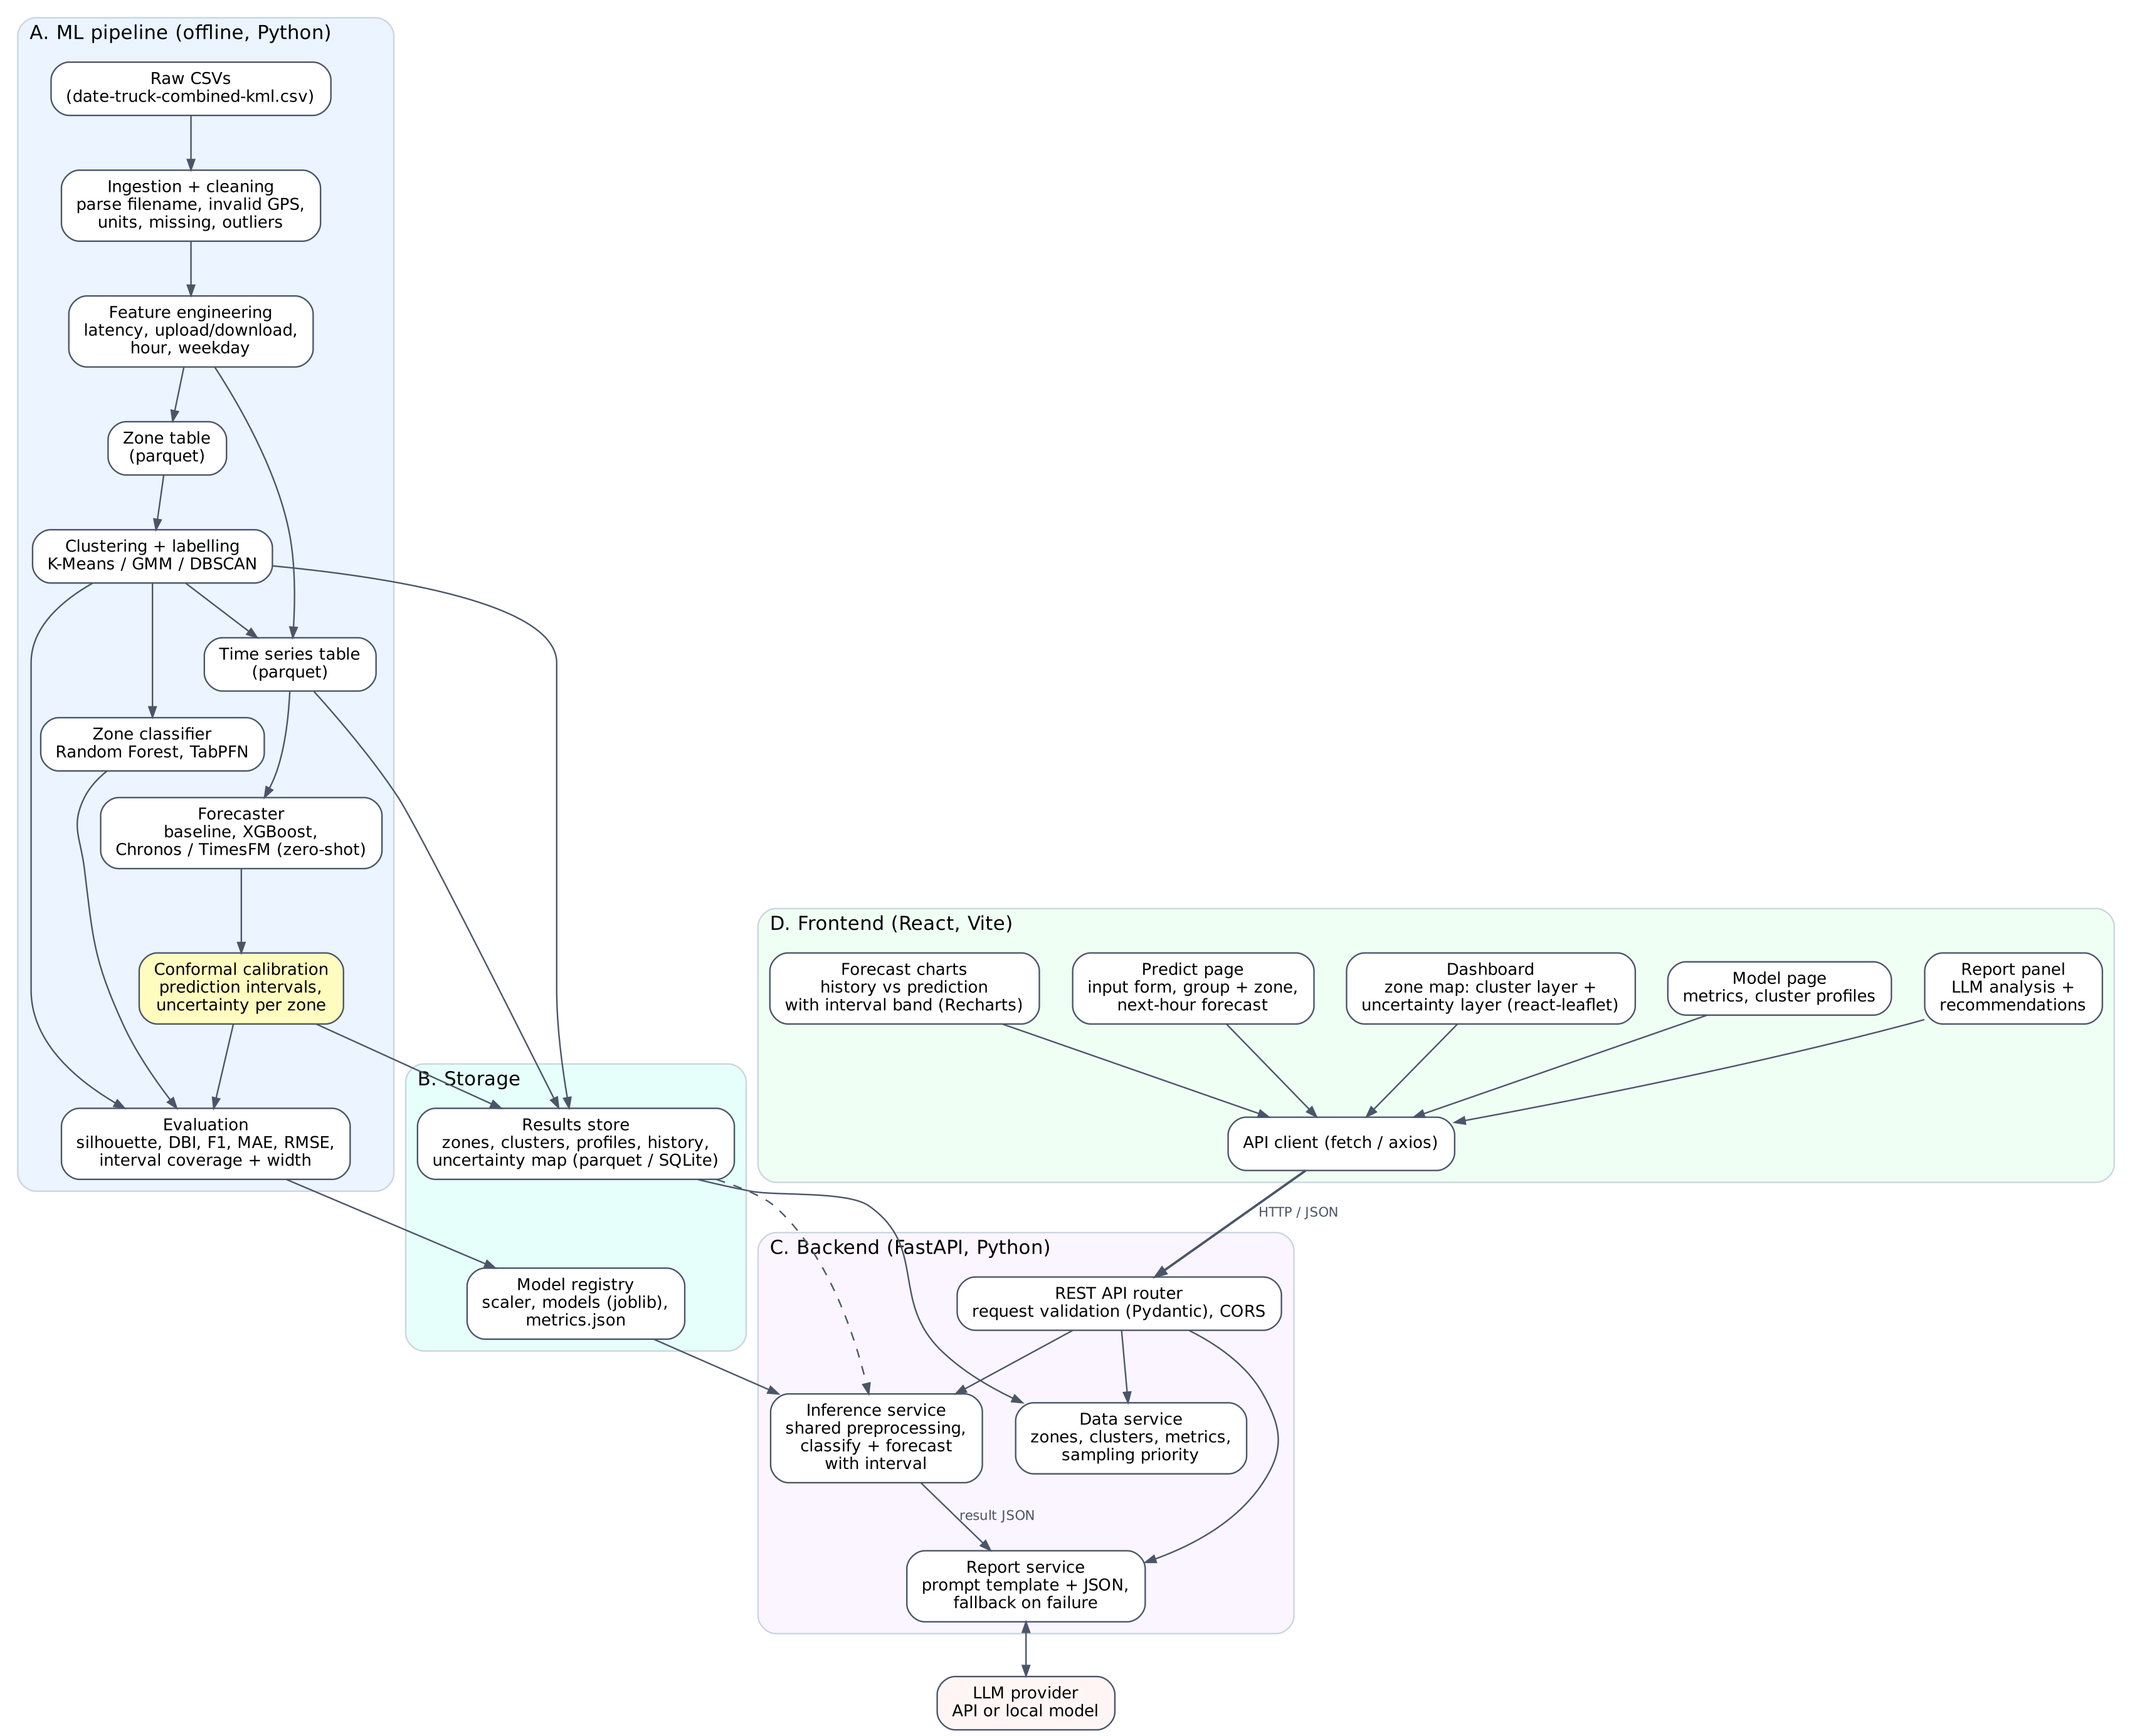
Figure 1. Full-stack system architecture. The dashed line is the recent history the forecaster needs at request time.

Components
Part | Responsibility | Technology
A. ML pipeline | Ingest, clean, build features, train clustering, classifier and forecaster, evaluate. Run from the command line, not by the web app | pandas, scikit-learn, XGBoost
B. Storage | Model registry (scaler, models, metrics) and results store (zones, clusters, profiles, hourly history) | joblib, JSON, parquet or SQLite
C. Backend | Load models once at startup; validate requests; run inference; serve zone and metric data; call the LLM | FastAPI, Pydantic, Uvicorn
D. Frontend | Single-page app with map, prediction form, charts, report panel and model page | React, Vite, react-leaflet, Recharts
LLM provider | Turns the result JSON into a written explanation and recommendations | LLM API or local model

Backend API
Endpoint | Purpose | Used by
GET /api/zones | All zones with coordinates, cluster and summary statistics | Dashboard map
GET /api/clusters | Cluster names and centroid profiles | Dashboard, Model page
POST /api/predict | Input values in; group, zone and next-hour forecast with interval out | Predict page
GET /api/uncertainty | Interval width per zone and the ranked list of zones to measure next | Dashboard map
GET /api/forecast/{zone_id} | Recent history and next-hour prediction for a zone or cluster | Forecast charts
POST /api/report | Result JSON in; LLM analysis text out | Report panel
GET /api/metrics | Evaluation metrics for every candidate model | Model page
GET /api/health | Confirms the backend and models are loaded | Frontend startup

Frontend pages
- Dashboard: map of Brimbank with a cluster layer and an uncertainty layer; clicking a zone shows its profile.
- Predict: form for latency, upload, download, location and time; shows the group, zone and next-hour forecast.
- Forecast: line chart of historical values against the prediction, with the interval drawn as a band.
- Report: the LLM analysis for the current result, with the numbers still shown if the LLM is unavailable.
- Model: metrics table and cluster profiles, useful for the presentation.

Request flow for a prediction
- The user submits the form on the Predict page.
- The API client sends POST /api/predict with the values as JSON.
- The backend validates the input, applies the saved preprocessing, classifies the group and forecasts the next hour.
- The backend returns the result JSON and the page shows the numbers immediately.
- The page then calls POST /api/report, and the report panel fills in when the LLM answers.

Key design decisions
- Unit of clustering: aggregate measurements to square_id and cluster zones, not raw rows. This is less noisy and answers the brief directly.
- Location features: cluster on performance features only, then plot on the map. Compare with a version that includes latitude and longitude in the report.
- Training stays offline: the web app only loads saved models. Retraining is a separate command, so a request can never trigger slow training.
- One preprocessing path: training and the backend import the same preprocessing function and the same saved scaler; otherwise predictions on new input are wrong.
- Separate classifier: DBSCAN cannot assign new points, so a supervised classifier handles unseen input and adds accuracy and a confusion matrix to the evaluation.
- LLM is called from the backend only: the LLM key stays in the backend environment and is never sent to the browser.
- Report is decoupled: the report is a separate request, so the numeric result shows first and the demo still works if the LLM fails.
- Python backend: FastAPI is chosen because the models are Python; a Node backend would need a second service to run them.
- Intervals are precomputed: conformal calibration runs offline and stores one interval width per zone or cluster, so the backend only adds it to the forecast.

5. AI models
Each job has classical baselines, which cover the course rubric, and one newer method, which is the material for the paper.
Job | Baselines (course) | New method (paper) | Selected by
Clustering | K-Means, GMM, DBSCAN | None; clustering stays classical | Silhouette, Davies-Bouldin, elbow
Zone classification | Random Forest, Logistic Regression or KNN | TabPFN, a pretrained tabular foundation model | Accuracy, F1, confusion matrix
Forecasting | Naive last value, XGBoost on lag features | Chronos or TimesFM, time-series foundation models used zero-shot | MAE, RMSE on a time-based split
Uncertainty | None | Conformal prediction around the best forecaster | Interval coverage against the target, interval width
Report generation | None | Pre-trained LLM through an API or a local model | Report matches the numbers given

Supporting steps: StandardScaler before clustering, and optionally PCA to plot clusters in two dimensions.

Why these new methods
- Foundation models: trucks pass each zone only occasionally, so the series are short and sparse. Foundation models are pretrained on many other time series and forecast without training, which suits this case better than XGBoost or an LSTM.
- Conformal prediction: a forecast for a zone with three measurements should not be trusted like one with three hundred. Conformal prediction turns every forecast into a range with a stated coverage level, for example 80%.
- Uncertainty map: zones with the widest intervals are where data is missing. Ranking them gives a principled answer to where a UAV should measure next.

Rules for the LLM layer
- The LLM reads only the JSON result. It never reads the raw CSVs and never calculates.
- The report follows a fixed template: summary, cluster profiles, forecast, recommendations.
- A fallback shows the numeric results when the API call fails.
- It is built last, after the ML models and evaluation are finished.

6. Repository structure
project/
├── data/raw/ original CSVs
├── data/processed/ zone_table.parquet, timeseries.parquet
├── ml/ offline pipeline
│ ├── ingestion.py
│ ├── cleaning.py
│ ├── features.py shared with the backend
│ ├── clustering.py
│ ├── classifier.py
│ ├── forecasting.py XGBoost and foundation models
│ ├── uncertainty.py conformal intervals
│ ├── evaluation.py
│ └── train.py runs the whole pipeline
├── models/ saved artefacts and metrics.json
├── backend/
│ ├── main.py FastAPI app, CORS, startup model loading
│ ├── routers/ zones, predict, forecast, uncertainty, report
│ ├── services/ inference.py, data.py, report_generator.py
│ └── schemas.py Pydantic request and response models
├── frontend/
│ ├── src/pages/ Dashboard, Predict, Forecast, Model
│ ├── src/components/ ZoneMap, PredictForm, ForecastChart, ...
│ ├── src/api/client.js all calls to the backend
│ └── package.json
└── notebooks/ EDA and experiments

7. Team roles (3 people)
The work is split into three tracks of similar size. Each person owns one track end to end, including its part of the evaluation and the report, so nobody is left with only writing or only cleaning.
 | Person 1: Data and clustering | Person 2: Forecasting and uncertainty | Person 3: Application
Builds | Ingestion, cleaning, unit normalisation, zone table; K-Means, GMM, DBSCAN; cluster labelling and profiles | Time series table, lag features; zone classifier (Random Forest, TabPFN); XGBoost and Chronos or TimesFM; conformal intervals and uncertainty map | FastAPI backend and endpoints; React pages, map and charts; LLM report service; integration of the saved models
Evaluates | Data quality checks; silhouette, Davies-Bouldin, elbow; algorithm comparison | Accuracy and F1; MAE and RMSE against the baseline; interval coverage and width | API tests; end-to-end demo test; LLM report checked against the numbers
Writes | Data, preprocessing and clustering sections | Classification, forecasting and uncertainty sections | System design, implementation and demo sections
Presents | Data and clusters | Predictions and uncertainty | Architecture and live demo

Shared work
- First week: all three explore the raw data together, because every track depends on understanding it.
- Interfaces: Person 1 and Person 2 agree the column names of the two feature tables; Person 2 and Person 3 agree the JSON returned by each endpoint. Fix these early so the tracks can run in parallel.
- Parallel start: Person 3 can build the frontend against mock JSON while the models are still being trained.
- Joint deliverables: introduction, conclusion, project brief and slides are written together.

8. Paper track and UAV extension
Working title: uncertainty-aware 5G performance forecasting from sparse vehicle measurements using time-series foundation models, with uncertainty-guided UAV sampling.

Experiments
- Zero-shot foundation models against XGBoost and the naive baseline, as a function of how much history a zone has.
- Conformal intervals: is the measured coverage close to the target, and how wide are the intervals?
- Uncertainty-guided sampling: does measuring the most uncertain zones first reduce error faster than random sampling? Simulated first by holding zones out, later with real UAV flights.

UAV phase
- The pipeline is vehicle-agnostic: it works on any geo-tagged 5G measurements.
- Add altitude as a feature, so a zone becomes a square plus a height band.
- Retrain or recalibrate on UAV data. A truck-trained model cannot predict performance at height, because towers aim their antennas at the ground.
- Real UAV measurements are needed, from the group’s own flights or a public dataset, before any claim about aerial prediction.

Related work to read first
- Jiang et al. (2024), conformal prediction for cellular connection quality on Ookla speed-test grids.
- Computer Networks (2025), time-series foundation models applied to network monitoring tasks.
- Tarhuni et al. (2023), predicting ground-level coverage from UAV measurements.
- Ansari et al., Chronos; Hollmann et al. (Nature, 2025), TabPFN.
This list comes from a quick search. A full literature review is needed before claiming novelty.

9. To confirm before starting
- With the tutor: the brief says clustering or forecasting, but the required outputs list both. This plan does both.
- With the tutor: the unit’s rules on using an LLM in the product and in the submitted report.
- In the data: whether per-zone hourly series are dense enough; if not, forecast per cluster.
- Hardware: Chronos, TimesFM and TabPFN run on a laptop CPU for small data, but check speed early; a GPU or Colab may be needed.
- In the data: whether stationary trucks over-represent some locations (use the speed column).
- LLM choice: API (needs a key and has a cost) or a local model.
- Effort check: the UI is worth 10%, and a React app with a backend takes more time than a Streamlit page. Finish phases 1 to 4 before starting it.

The number of clusters, the cluster names and the preferred algorithms in this document are starting assumptions. The evaluation on the real data decides the final choices.

