Exploratory Data Analysis Report
Student Name: Nguyen Nam Khanh
Student ID: 105706565
Class Number: COS40007
Date: 01/10/2026
Dataset: Seoul Bike Sharing Demand – UCI Machine Learning Repository https://archive.ics.uci.edu/dataset/560/seoul+bike+sharing+demand

1. Dataset Overview
- Description and engineering relevance: The dataset records hourly public bike rentals in Seoul from 1 December 2017 to 30 November 2018, together with weather measurements (temperature, humidity, wind speed, visibility, dew point, solar radiation, rainfall, snowfall) and calendar information (season, public holiday, functioning day). Rentals are logged automatically by the station system and weather comes from meteorological stations (Sathishkumar V. E. et al., 2020). In transportation engineering, forecasting hourly demand lets operators rebalance bikes between stations before peak periods, schedule maintenance in low-demand hours, and plan fleet size and station capacity.
- Number of rows: 8,760 (365 days × 24 hours); 8,448 after cleaning.
- Number of columns: 14 (13 after dropping the constant functioning_day column).
- Target variable: rented_bike_count (number of bikes rented per hour).
- Problem type: Regression – the target is a continuous count (0 to 3,556).
- Class conversion: Yes. The target was converted into three demand classes (Low / Medium / High) using equal-frequency binning (pd.qcut). Because the target is right-skewed (skewness = 1.14), equal-width binning (pd.cut) left only 161 hours (1.9%) in the High class, whereas pd.qcut gives perfectly balanced classes of 2,816 hours each: Low = 2-285, Medium = 286-896, High = 897-3,556 bikes/hour.
- Summary statistics: the target has mean ≈ 705, std ≈ 645, min = 0 and max = 3,556 on the raw data. The mean is well above the median (504.5), confirming a right-skewed distribution. Full statistics are given in Table 1.
Required Evidence
Dataset shape (df.shape): (8760, 14) before cleaning; (8448, 13) after cleaning.
Table 1. Data types (df.dtypes) and summary statistics (df.describe()) of the raw dataset
Column | Data type | Mean | Std | Min | Max
rented_bike_count | int64 | 704.60 | 645.00 | 0.00 | 3,556.00
hour | int64 | 11.50 | 6.92 | 0.00 | 23.00
temperature | float64 | 12.88 | 11.94 | -17.80 | 39.40
humidity | int64 | 58.23 | 20.36 | 0.00 | 98.00
wind_speed | float64 | 1.72 | 1.04 | 0.00 | 7.40
visibility | int64 | 1,436.83 | 608.30 | 27.00 | 2,000.00
dew_point_temperature | float64 | 4.07 | 13.06 | -30.60 | 27.20
solar_radiation | float64 | 0.57 | 0.87 | 0.00 | 3.52
rainfall | float64 | 0.15 | 1.13 | 0.00 | 35.00
snowfall | float64 | 0.08 | 0.44 | 0.00 | 8.80
date | datetime64 | – | – | 2017-12-01 | 2018-11-30
seasons | object (4 categories) | – | – | – | –
holiday | object (2 categories) | – | – | – | –
functioning_day | object (2 categories) | – | – | – | –

The dataset contains 1 datetime column, 10 numeric columns (4 integer, 6 float, including the target) and 3 categorical columns. Most frequent categories: Spring (2,208 hours), No Holiday (8,328), Functioning Day = Yes (8,465).
2. Data Quality Assessment
- Missing values: None - every column has 0 missing values (0.0%), confirmed by df.isnull().sum() and a missing-value heatmap. However, some values are present but not meaningful (see below).
- Duplicates found and handled: 0 duplicated rows, so no action was needed.
- Hidden invalid records: 295 hours with functioning_day = "No" (system closed; the target is always 0) were removed because they do not represent real demand, and the now-constant functioning_day column was dropped. 17 rows with humidity = 0% were removed as sensor errors, since 0% relative humidity is not physically realistic in Seoul.
- Outliers detected and handled: Boxplots (Figure 1) show many outliers in rainfall, snowfall, wind speed, solar radiation and the target. These were kept, because heavy rain, snow and rush-hour peaks are real events that a model must learn rather than measurement errors.
- Data types after cleaning: date (datetime64); rented_bike_count, hour, humidity, visibility (int64); temperature, wind_speed, dew_point_temperature, solar_radiation, rainfall, snowfall (float64); seasons, holiday (categorical/string). Final shape: 8,448 rows × 13 columns.
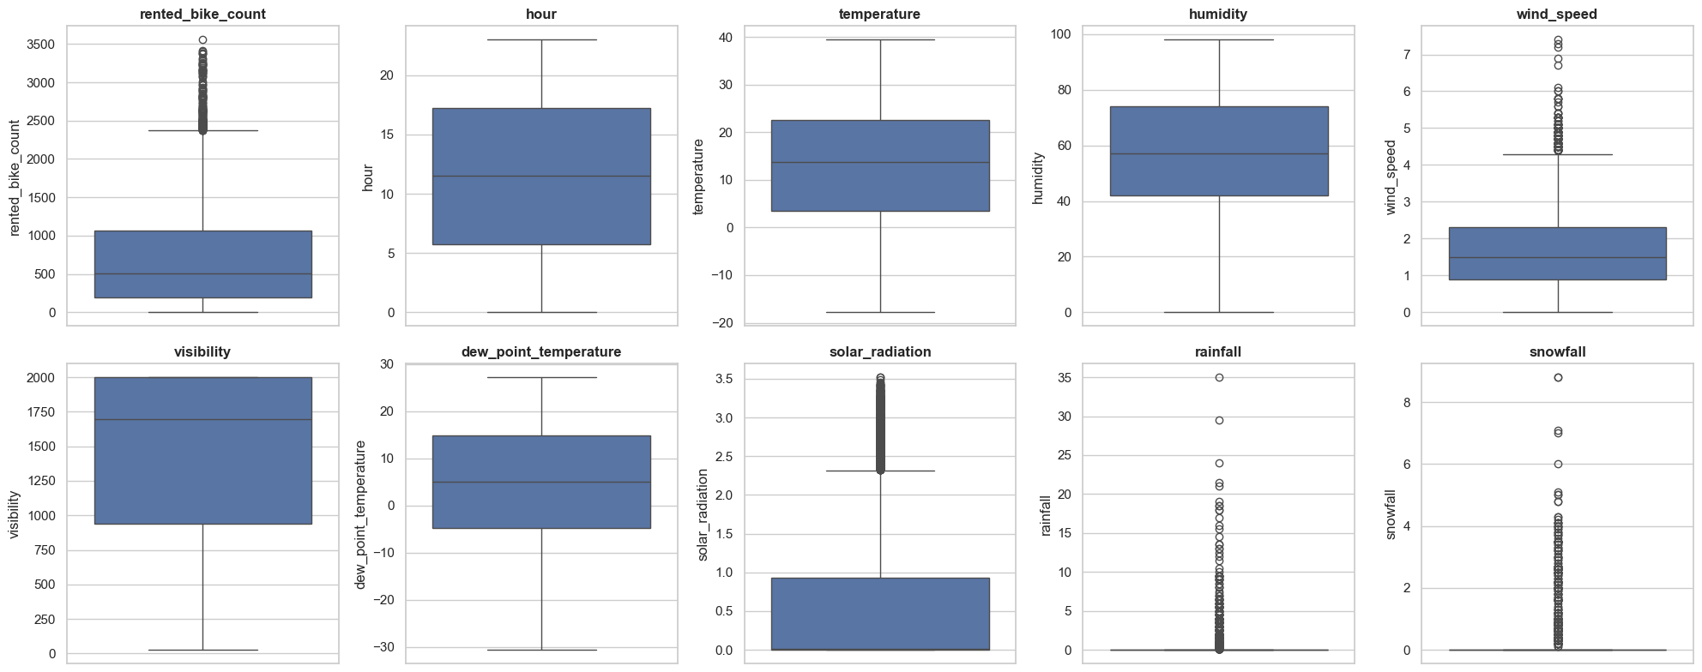
Figure 1. Boxplots of all numerical variables (outlier detection)
3. Key Findings from Univariate Analysis
Target variable. rented_bike_count (after cleaning: mean = 729.8, median = 544.5, max = 3,556) is right-skewed with skewness = 1.14: most hours have low to moderate demand and only a few hours reach very high demand (Figure 2). This motivated the equal-frequency binning described in Section 1 (Figure 3 shows the resulting balanced classes).
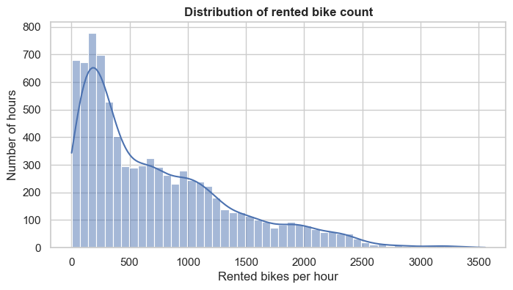
Figure 2. Distribution of rented bike count (histogram with KDE)
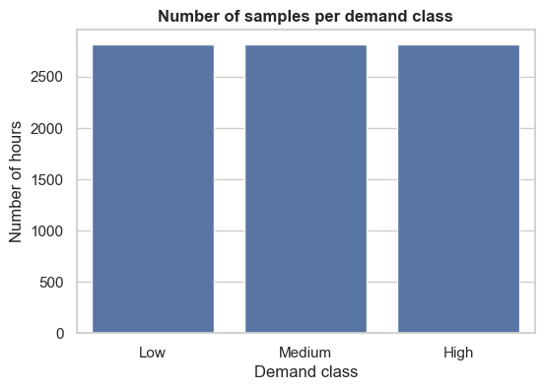
Figure 3. Demand classes after equal-frequency binning (2,816 hours each)
Numerical predictors (Figure 4, Table 2):
- Approximately symmetric: temperature (skew = -0.17), humidity (0.10) and dew point (-0.34). Hour is uniformly distributed, as each hour appears once per day.
- Moderately skewed: wind speed is right-skewed (0.89); visibility is left-skewed (-0.69) because it is capped at 2,000 (20 km).
- Highly skewed and zero-inflated: rainfall (skew = 14.60, kurtosis = 289) and snowfall (8.28, 90) - about 94% of hours have no rain and 95% have no snow. Solar radiation (1.51) is zero in 49% of hours because of night-time.
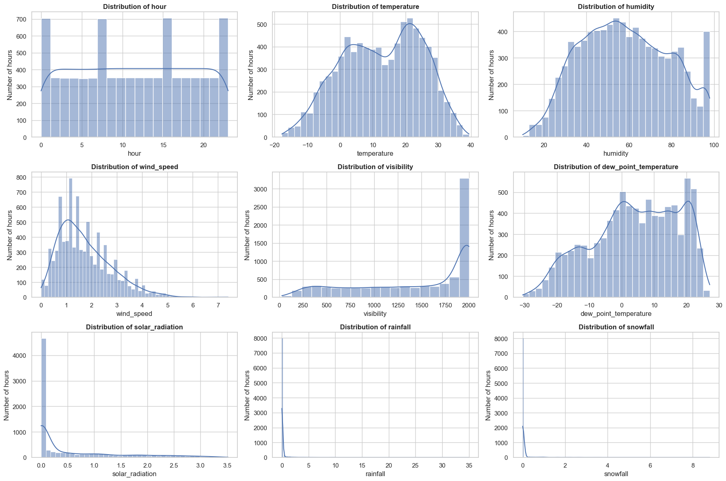
Figure 4. Distributions of the numerical predictors
Table 2. Summary statistics of numerical predictors after cleaning (incl. skewness and kurtosis)
Feature | Mean | Std | Min | Max | Skewness | Kurtosis
hour | 11.52 | 6.92 | 0.0 | 23.0 | 0.00 | -1.20
temperature | 12.77 | 12.12 | -17.8 | 39.4 | -0.17 | -0.89
humidity | 58.26 | 20.34 | 10.0 | 98.0 | 0.10 | -0.88
wind_speed | 1.73 | 1.03 | 0.0 | 7.4 | 0.89 | 0.75
visibility | 1,433.36 | 609.42 | 27.0 | 2,000.0 | -0.69 | -0.97
dew_point_temperature | 3.94 | 13.25 | -30.6 | 27.2 | -0.34 | -0.82
solar_radiation | 0.57 | 0.87 | 0.0 | 3.52 | 1.51 | 1.14
rainfall | 0.15 | 1.13 | 0.0 | 35.0 | 14.60 | 289.38
snowfall | 0.08 | 0.44 | 0.0 | 8.8 | 8.28 | 90.35

Categorical predictors: seasons are roughly balanced (about 2,100-2,200 hours each), while holiday is highly imbalanced (most hours are non-holidays). Skewed and zero-heavy features may need log transforms or binary indicators before modelling.
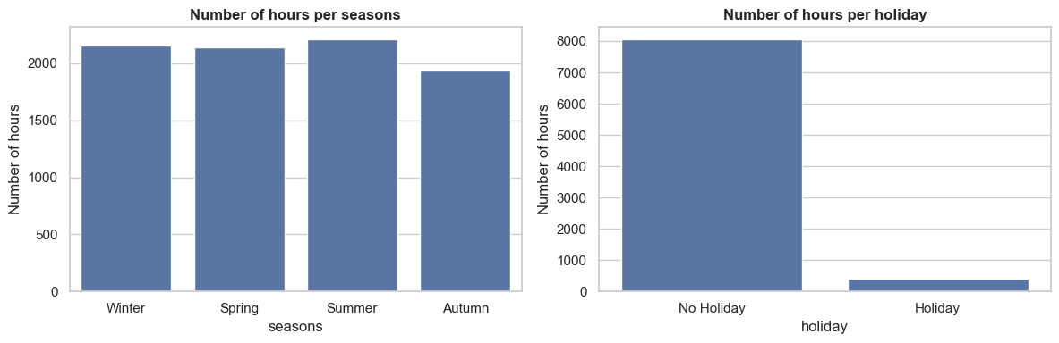
Figure 5. Number of hours per season and per holiday category
4. Key Findings from Multivariate Analysis
Top 3 features correlated with the target (Pearson r, sorted by absolute value):
- temperature - 0.563
- hour - 0.425
- dew_point_temperature - 0.401
Other correlations with the target: solar_radiation 0.273, visibility 0.213, humidity -0.207, snowfall -0.152, rainfall -0.129, wind_speed 0.124.
Correlation Heatmap
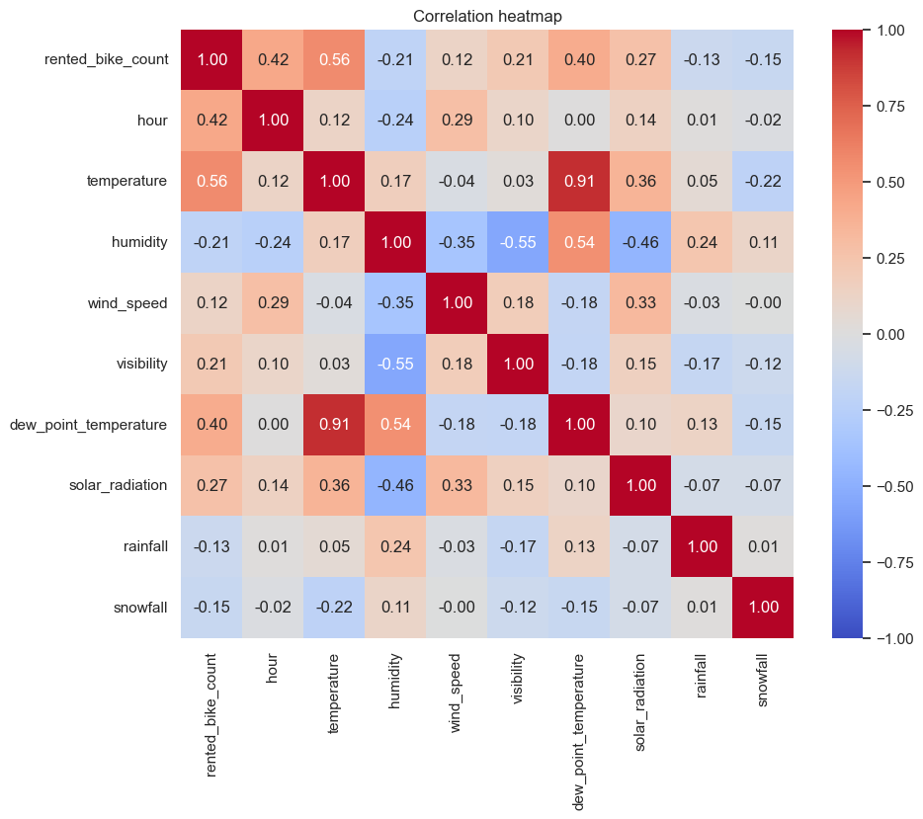
Figure 6. Correlation matrix heatmap of the target and numerical predictors
- The heatmap (Figure 6) shows the full Pearson correlation matrix of the target and all nine numerical predictors.
- Multicollinearity: only one predictor pair exceeds |r| > 0.7 - temperature and dew_point_temperature (r = 0.915). This is physically expected, since dew point is derived from temperature and humidity. Dew point therefore adds little new information and can be dropped while keeping temperature. All other predictor pairs are below 0.6 in absolute value.
Predictor Relationships
- Important relationships between predictors: humidity is negatively related to visibility (r = -0.55, fog and haze) and to solar radiation (r = −0.46, cloud cover); temperature and dew point move together (r = 0.915).
- Patterns: demand shows clear non-linear daily and seasonal patterns - two commuting peaks per day (08:00 ≈ 1,050 and 18:00 ≈ 1,554 bikes/hour) and a roughly fivefold seasonal swing (winter ≈ 226 vs summer ≈ 1,034). Rain and holidays are associated with lower demand. In the pairplot (Figure 7) the demand classes overlap heavily, so no single feature cleanly separates Low, Medium and High demand; demand classes form clusters only in combinations such as warm temperature × commuting hour. This suggests non-linear models will be more suitable.
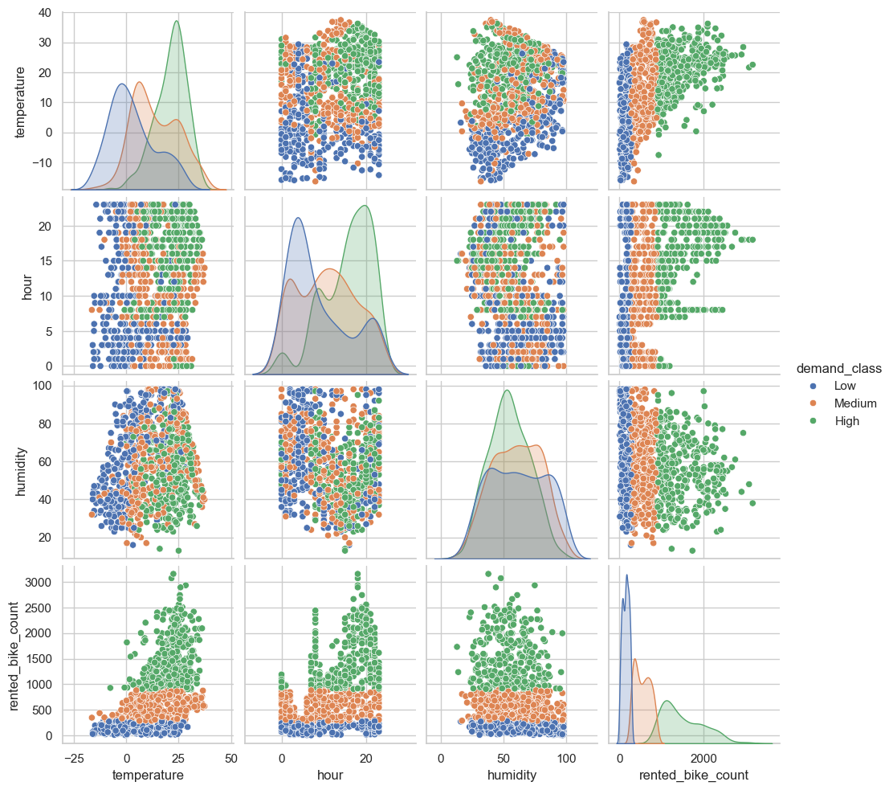
Figure 7. Pairplot of temperature, hour, humidity and the target, coloured by demand class (1,000-row sample)
5. Initial Insights for Modelling
- Most promising features: temperature, hour, seasons, rainfall (as a rain/no-rain flag) and humidity.
Preprocessing that might be needed:
- Scaling: StandardScaler on numerical features for scale-sensitive models (KNN, SVM, Logistic Regression); not required for tree-based models.
- Encoding: one-hot encode seasons; convert holiday to a binary 0/1 feature.
- Feature selection: drop dew_point_temperature (r = 0.915 with temperature) and the raw date column (after extracting useful parts such as day of week); consider binary flags or log transforms for the zero-inflated rainfall and snowfall.
- Modelling approaches that might work well: tree-based models (Decision Tree, Random Forest, Gradient Boosting) to capture non-linear and interaction effects, with Logistic Regression as a simple, interpretable baseline. Since the classes are balanced, accuracy and F1-score are suitable evaluation metrics.
6. Engineering Interpretation
What do the results mean in transportation engineering?
- Temperature (r = 0.563) is the strongest driver - people cycle more in comfortable weather - while hour (r = 0.425) reflects commuting behaviour. Humidity, rainfall and snowfall reduce demand. Weather and time of day are therefore the main inputs for planning bike supply and rebalancing.
- Unexpected pattern: rainfall has only a weak correlation (r = -0.13), yet average demand falls from 766 to 167 bikes/hour when it rains at all. Whether it rains matters more than how much, so correlation alone understates its effect.
- The evening peak (18:00, ≈ 1,554) is much higher than the morning peak (08:00, ≈ 1,050), suggesting evening trips combine commuting with leisure use.
- Physical/process relationships reflected: atmospheric physics (dew point derived from temperature and humidity; humidity lowers visibility and solar radiation; solar radiation is zero at night in 49% of hours); human behaviour (commuting peaks, holidays lower demand 532 vs 740, seasons change demand ≈ 5×); sensor behaviour (visibility capped at 2,000; humidity = 0 readings are faults).
- Missing features that would matter: day of week / weekend flag, station location and bike availability, air quality (PM2.5), and public-transport disruptions or special events.
What type of model might suit this dataset?
- Random Forest and Gradient Boosting suit this data because they handle non-linear relationships, mixed numeric/categorical features and skewed variables without scaling, and their feature importances help operators understand the drivers of demand. Logistic Regression serves as the baseline.
7. Challenges Encountered
- File encoding: the CSV could not be read as UTF-8 because of the "°" symbol in column names, so it was loaded with latin-1 and the columns were renamed to snake_case.
- Hidden data problems: although there were no missing values or duplicates, further checks revealed 295 closed hours (target always 0) and 17 rows with humidity = 0 (sensor errors); both were removed.
- Outliers: rather than removing extreme values automatically (e.g. by IQR), they were kept because heavy rain, snow and rush-hour peaks are genuine events.
- Target binning: equal-width binning left only 161 samples in the High class; comparing it with equal-frequency binning led to balanced classes (2,816 each).
- Feature analysis: correlation was misleading for rainfall (r = -0.13), so group averages (766 vs 167 bikes/hour) were needed alongside correlation.
- Visualisation: the original pairplot was too cluttered, so it was reduced to the key features and a 1,000-row sample, removing dew point which duplicates temperature.
8. Reflection Questions
How might poor data quality affect model reliability?
- Sensor errors: faulty readings such as humidity = 0% teach the model false relationships, so new data must also be validated before prediction.
- Few extreme-weather examples: rainfall and snowfall are about 94% zeros, so the model may perform poorly in heavy rain or snow – exactly when operators need accurate forecasts.
- Outdated data: the data covers only one year (2017–2018); changes in stations, prices or travel habits will reduce accuracy over time unless the model is retrained.
What ethical or bias issues might exist in this dataset?
- Unmet demand is not recorded: when a station is empty nobody can rent a bike, so the data underestimates real demand and a model could keep under-supplying busy areas.
- No location data: demand is aggregated city-wide, so decisions may favour busy central areas and neglect outer or lower-income neighbourhoods.
- Only current users are represented: people who do not or cannot use the service (e.g. older people or people with disabilities) are invisible in the data, so their needs may be ignored.
9. Next Steps
- Add a weekday/weekend feature: extract the day of week from date to test whether the morning and evening peaks are driven by working-day commuting.
- Explore feature interactions: e.g. temperature × hour, and whether rain has a stronger effect during peak hours.
- Transform skewed features: compare rain/snow indicator flags with log transforms for rainfall and snowfall.
- Build baseline models: train Logistic Regression and Random Forest to validate the EDA insights and measure the effect of dropping features such as dew point.
- Collect more data: station-level information, air quality (PM2.5) and additional years to reduce the limitations identified in Section 8.
10. GenAI Declaration
I used Claude Code to assist with debugging code, supporting design ideas and suggesting feature combinations. All final code, interpretations and conclusions are my own work after verification.

