
COS40007 Artificial Intelligence Engineering
Portfolio Assessment 2
Advanced Data Preprocessing, Feature Engineering & Model Development Report
Student Name: Nguyen Nam Khanh
Student ID: 105706565
Lecturer: Mr. Mai Duc Tho
Date: 12/10/2026
Dataset: Seoul Bike Sharing Demand – UCI Machine Learning Repository (https://archive.ics.uci.edu/dataset/560/seoul+bike+sharing+demand )
Github link: https://github.com/khanhnedu2006-byte/portfolio-for-COS40007

Acknowledgement of Country
This report continues from Portfolio 1. It reuses the cleaned dataset (8,448 hours after removing 295 non-functioning hours and 17 rows with humidity = 0) and the balanced three-class target demand_class created with pd.qcut. All results below were produced by the accompanying notebook (random_state = 42, 70/30 stratified train-test split, 5-fold cross-validation).
1. Target Variable Preparation
- Target: rented_bike_count (bikes rented per hour), converted from a continuous count into a three-class problem: demand_class.
- EDA evidence: the target is right-skewed, with skewness = 1.14 and mean 729.8 well above the median 544.5 after cleaning (P1 §3, Fig. 2). Most hours have low to moderate demand and only a few reach very high demand.
- Method: equal-frequency binning (pd.qcut, q = 3). Thresholds: 2.0 / 285.7 / 896.3 / 3,556 bikes/hour, giving Low (2–285), Medium (286–896) and High (897–3,556).
- Class balance: each class contains exactly 33.3% of the data (2,816 hours), so accuracy is a fair metric and no resampling is needed (P1 Fig. 3).
- Justification: because of the skew, equal-width bins (pd.cut) would place about 79% of hours in Low and only 1.9% (161 hours) in High (P1 §1). A model could then reach high accuracy while ignoring the peak-demand hours that matter most to operators. Three classes also map to operational actions: off-peak maintenance, normal service, and pre-emptive rebalancing.
2. Feature Normalisation & Transformation
2.1 Scaling choice for each feature, justified by the EDA
Instead of applying one scaler to every column, each numerical feature was profiled using the distribution statistics from the EDA (P1 §3, Table 2 and Fig. 4) plus IQR-outlier % and zero %. A scaler was then chosen by a documented rule: heavily zero-inflated and skewed features get log1p + MinMaxScaler; features with more than 1% outliers get RobustScaler; flat or bounded distributions get MinMaxScaler; near-symmetric features get StandardScaler.
Table 1. Distribution profile, chosen scaler and EDA justification for each numerical feature
Feature | Skew | Kurt. | Outl. % | Zeros % | Scaler | EDA justification
hour | 0.00 | −1.20 | 0.00 | 4.17 | MinMax | Uniform 0–23, bounded (P1 §3)
temperature | −0.17 | −0.89 | 0.00 | 0.25 | Standard | Near-symmetric, no outliers
humidity | 0.10 | −0.88 | 0.00 | 0.00 | Standard | Near-symmetric after removing 0% sensor errors (P1 §2)
wind_speed | 0.89 | 0.75 | 1.82 | 0.84 | Robust | Right-skewed with outliers (P1 Fig. 1)
visibility | −0.69 | −0.97 | 0.00 | 0.00 | MinMax | Left-skewed, capped at 2,000 (P1 §3)
dew_point_temperature | −0.34 | −0.82 | 0.00 | 0.71 | Standard | Near-symmetric
solar_radiation | 1.51 | 1.14 | 7.34 | 49.02 | Robust | Zero at night (49%), many outliers
rainfall | 14.60 | 289.38 | 6.11 | 93.89 | log1p + MinMax | ~94% zeros, extreme tail; IQR = 0
snowfall | 8.28 | 90.35 | 5.24 | 94.76 | log1p + MinMax | ~95% zeros, extreme tail; IQR = 0

2.2 Before/after comparison
Table 2. Summary statistics before and after scaling
Feature | Before: mean | Before: std | Before: min–max | After: mean | After: std | After: min–max
hour | 11.52 | 6.92 | 0 – 23 | 0.50 | 0.30 | 0 – 1
temperature | 12.77 | 12.12 | −17.8 – 39.4 | 0.00 | 1.00 | −2.52 – 2.20
humidity | 58.26 | 20.34 | 10 – 98 | 0.00 | 1.00 | −2.37 – 1.95
wind_speed | 1.73 | 1.03 | 0 – 7.4 | 0.16 | 0.74 | −1.07 – 4.21
visibility | 1,433.36 | 609.42 | 27 – 2,000 | 0.71 | 0.31 | 0 – 1
dew_point_temperature | 3.94 | 13.25 | −30.6 – 27.2 | 0.00 | 1.00 | −2.61 – 1.75
solar_radiation | 0.57 | 0.87 | 0 – 3.52 | 0.60 | 0.93 | −0.01 – 3.77
rainfall | 0.15 | 1.13 | 0 – 35 | 0.02 | 0.08 | 0 – 1
snowfall | 0.08 | 0.44 | 0 – 8.8 | 0.02 | 0.09 | 0 – 1

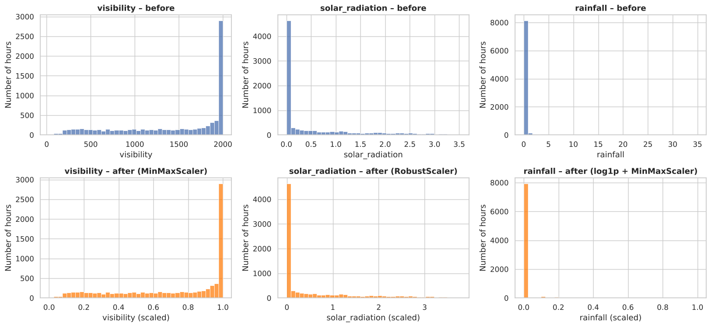
Figure 1. Histograms before (top) and after (bottom) scaling for one feature of each scaler type
- Impact on range: before scaling, visibility (max 2,000) was about 270 times larger than wind speed (max 7.4). After scaling, every feature lies on a comparable range, so no feature dominates by magnitude.
- Shape is preserved for linear scalers: visibility and solar_radiation keep exactly the same histogram shape; only the axis changes (Figure 1).
- log1p changes the shape for rainfall: the extreme tail (max 35 mm) is compressed, so the rare heavy-rain hours no longer dominate. The zero spike remains, which is why the binary is_raining flag was added in Section 3.
2.3 Encoding categorical features
- holiday → binary 0/1 (two categories; highly imbalanced, P1 §3).
- seasons → one-hot encoding (season_Autumn, season_Spring, season_Summer, season_Winter). Seasons are nominal and roughly balanced (P1 Fig. 5), and label encoding would impose a false order.
- Excluded: functioning_day (constant after cleaning, P1 §2) and rented_bike_count (it defines the target, so including it would be target leakage).
- Result: feature matrix X with 8,448 rows × 14 columns (9 scaled numerical + 1 binary + 4 one-hot).
Expected impact: distance- and margin-based models (SVM, KNN) and PCA depend on feature scale, while Decision Trees are scale-invariant. This was confirmed in Section 5, where raw and normalised features gave almost identical tree accuracy (78.93% vs 79.05%).
3. Feature Engineering
Seven features were engineered, each motivated by a specific EDA finding:
Table 3. Engineered features, EDA motivation, engineering meaning and correlation (r) with the target
Feature | Definition | EDA finding (reference) | Engineering meaning | r
temp_x_hour | temperature × hour | Temperature (0.563) and hour (0.425) are the top 2 correlated features (P1 §4, Fig. 6) | Warm weather boosts demand most during active hours | 0.700
hour_sin | sin(2π·hour/24) | Non-linear daily cycle of demand (P1 §4, Fig. 7) | Cyclic time: 23:00 is placed next to 00:00 | −0.448
hour_cos | cos(2π·hour/24) | Same daily cycle (P1 §4) | Second coordinate of the daily cycle | −0.102
is_weekend | day of week ≥ 5 | Weekday/weekend flag identified as a missing feature (P1 §6, §9) | Separates commuting days from leisure days | −0.047
rush_workday | hour ∈ {7–9, 17–19}, working, non-holiday day | Peaks at 08:00 (≈1,050) and 18:00 (≈1,554); holidays lower demand (P1 §6) | Commuting-peak flag for fleet rebalancing | 0.329
is_raining | rainfall > 0 | ~94% of rainfall values are 0 (P1 §3); demand drops 766 → 167 when raining (P1 §6) | Any rain deters cycling, regardless of amount | −0.223
daily_rainfall | sum of rainfall over the day | Rain lowers demand; rain effect proposed for further study (P1 §6, §9) | Wet roads for the whole day, not just the current hour | −0.152

- Scaling of new features: temp_x_hour → StandardScaler; daily_rainfall → log1p + MinMaxScaler; the others are already bounded (sin/cos in [−1, 1], flags in {0, 1}). The engineered matrix X_eng has 8,448 × 21 columns.
- Validation – correlation: temp_x_hour (0.700) is now the strongest single predictor, ahead of temperature (0.563). hour_sin (−0.448) captures the daily cycle better than raw hour (0.425), and is_raining (−0.223) is stronger than rainfall amount (−0.129), confirming the P1 finding that whether it rains matters more than how much.
- Validation – model: adding these features raised Decision Tree accuracy by 4.34 points (Section 5), and three of the five most important tree features are engineered (Figure 3).
- Multicollinearity: four pairs exceed |r| > 0.7: temperature–dew_point (0.915), temperature–temp_x_hour (0.798), hour–hour_sin (−0.776) and solar_radiation–hour_cos (−0.705). Some engineered features are therefore partly alternatives to the originals. This matters for correlation-based selection (Sections 5 and 8) but much less for trees and RBF-SVM.
4. Decision Tree Modelling
Five DecisionTreeClassifier models (default hyperparameters, random_state = 42) were trained, one per feature set, on the same stratified 70/30 split (5,913 training / 2,535 test hours):
- Set 1 – Original (raw): 9 unscaled numerical features + holiday + 4 season dummies (14 features).
- Set 2 – Original (normalised): the same 14 features after Section 2 scaling.
- Set 3 – Normalised + engineered: Set 2 + 7 engineered features (21 features).
- Set 4 – Top 5 correlated (normalised): temp_x_hour, temperature, hour_sin, hour, dew_point_temperature.
- Set 5 – PCA (5 components): first 5 principal components of the 21-feature normalised set.
5. Decision Tree Results & Findings
Table 4. First summary table: Decision Tree accuracy for each feature set
Feature set | No. of features | Test accuracy (%)
Set 1: Original (raw) | 14 | 78.93
Set 2: Original (normalised) | 14 | 79.05
Set 3: Normalised + engineered | 21 | 83.39
Set 4: Top 5 correlated (normalised) | 5 | 74.67
Set 5: PCA (5 components) | 5 | 74.20

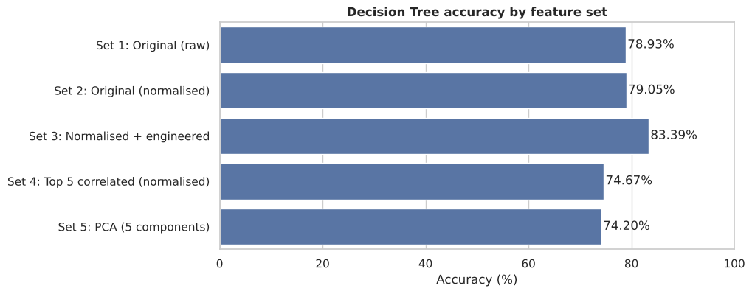
Figure 2. Decision Tree accuracy by feature set
Which feature set performed best and why?
- Set 3 (normalised + engineered) is best at 83.39%, +4.34 points over the original features. temp_x_hour, hour_sin/cos and rush_workday encode the weather × time interaction and the commuting peaks directly, so the tree needs fewer, cleaner splits to separate the classes.
- Normalisation has almost no effect on trees (78.93% → 79.05%, +0.12 points). Trees choose split thresholds per feature, so rescaling does not change which splits are possible; the tiny difference comes from floating-point tie-breaking.
- Top-5 correlated features lose about 4.4 points. The five features are redundant with each other (two temperature-like, two hour-like, plus dew point), while useful signals such as season, rain and holiday are dropped. Ranking features one at a time by correlation ignores this redundancy.
- PCA with 5 components is worst (74.20%). Components maximise variance, not class separation, and rotated axes suit axis-aligned tree splits poorly; they are also no longer interpretable for operators.
Feature importance of the best model (Set 3):
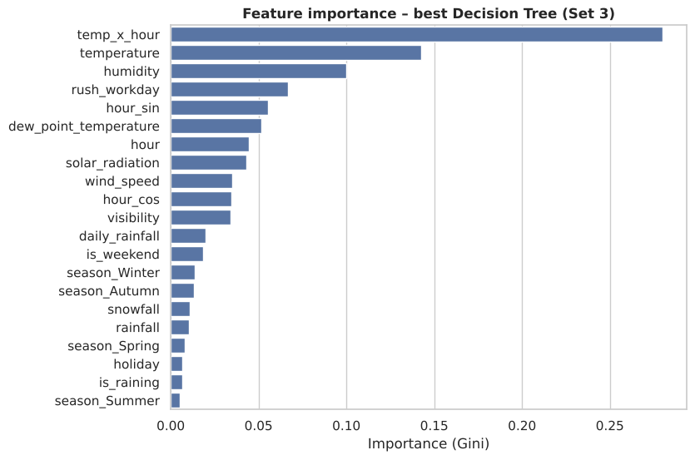
Figure 3. Gini feature importance of the best Decision Tree (Set 3)
- temp_x_hour dominates with importance 0.280, about twice that of temperature (0.142), followed by humidity (0.100), rush_workday (0.067) and hour_sin (0.056). Three of the top five features are engineered, which validates the feature engineering of Section 3.
- Humidity ranks third even though its correlation with the target is weak (−0.207). The tree most likely uses it to separate rainy and foggy hours, an effect that a linear correlation does not capture.
- Season dummies, holiday and snowfall have almost no importance, because their information is already contained in temperature and the time features.
- Overfitting: the unpruned tree reaches 100% training accuracy (depth 24, 718 leaves) against 83.39% on the test set. This 16.6-point gap motivates a model with built-in regularisation (SVM, Section 6).
6. Model Improvement with SVM
Because the target is categorical, an SVM classifier (SVC) was used rather than SVR. The 21-feature normalised + engineered set (Set 3) was shuffled (random_state = 42), saved as shuffled_seoulbike.csv and used for all SVM experiments. Each model was evaluated in two ways: the same stratified 70/30 split and 5-fold cross-validation (CV).
- Baseline SVM (RBF kernel, C = 1, gamma = 'scale'): 85.21% on the test split and 85.18% with 5-fold CV.
- This is already +1.82 points above the best Decision Tree (83.39%). The RBF kernel draws smooth, non-linear boundaries in the scaled feature space, which suits gradual effects such as temperature, while the margin-based C parameter regularises the model. The tree, by contrast, memorised the training data.
- The near-identical split and CV scores (difference 0.03 points) show the result does not depend on one lucky split.
7. Hyperparameter Tuning
Table 5. SVM kernel comparison
Kernel (default C and gamma) | 5-fold CV accuracy (%)
linear | 78.30
poly | 85.23
rbf | 85.18
sigmoid | 54.66

- Kernel comparison: the linear kernel is about 7 points below RBF and polynomial, confirming that the demand classes are not linearly separable. This is consistent with the non-linear daily and seasonal patterns in P1 §4. The sigmoid kernel performs poorly (54.66%) because it is not positive semi-definite for most parameter values and is rarely suited to tabular data. RBF and poly are equivalent (≈ 85.2%).
- Grid search: GridSearchCV (5-fold) over C ∈ {0.1, 1, 10, 100} and gamma ∈ {'scale', 0.01, 0.1, 1} with the RBF kernel (16 combinations, 80 fits). C controls regularisation and gamma controls how local each support vector's influence is, so these are the two parameters that matter most for RBF-SVM.
- Best parameters: C = 100, gamma = 'scale' (scale = 1 / (n_features × variance of X)).
- Tuned SVM: 88.13% test split and 87.52% 5-fold CV, an improvement of +2.92 and +2.34 points over the baseline SVM.
- Interpretation: a large C means weak regularisation, allowing a more complex boundary. With 8,448 samples and 21 features the data supports this; the small gap between split and CV accuracy (0.61 points) suggests the model is not heavily overfitting.
8. Feature Selection
- Method: SelectKBest with the ANOVA F-test (f_classif), placed inside a pipeline with the tuned SVM, so selection is re-fitted within each training fold and does not leak test information.
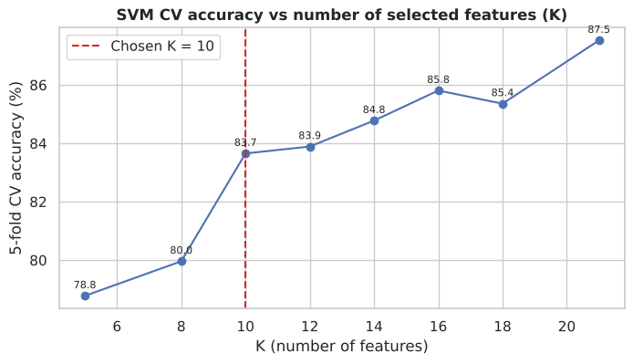
Figure 4. 5-fold CV accuracy of the tuned SVM for different numbers of selected features K
- Choice of K: K was swept from 5 to 21 (Figure 4). Accuracy jumps by 3.7 points from K = 8 (79.96%) to K = 10 (83.65%); after that the gains are smaller and uneven (−0.5 to +2.2 points per step). K = 10 is the elbow of the curve: it halves the number of inputs while keeping most of the gain, and it matches the 10 PCA components in Section 9, making the two reduction methods directly comparable.
- Selected features (K = 10): hour, temperature, dew_point_temperature, solar_radiation, season_Summer, season_Winter, temp_x_hour, hour_sin, rush_workday, is_raining.
- Dropped: humidity, wind_speed, visibility, rainfall, snowfall, holiday, season_Autumn, season_Spring, hour_cos, is_weekend, daily_rainfall.
- Result: 83.83% split and 83.65% CV, which is 4.30 points lower than the tuned SVM with all 21 features.
- Why it got worse: the F-test scores each feature on its own. It keeps redundant features (temperature, dew point and temp_x_hour all describe warmth) and drops features that are weak alone but useful in combination. Humidity, for example, was dropped although it was the third most important feature for the Decision Tree (Figure 3). The sweep shows accuracy keeps rising up to all 21 features, so every feature adds some information for the RBF-SVM.
9. Dimensionality Reduction with PCA
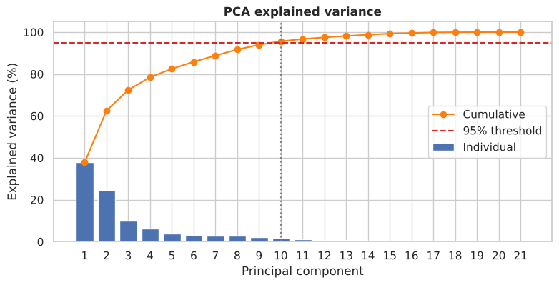
Figure 5. Individual and cumulative explained variance of the principal components
- Explained variance: PC1 explains 37.8% and PC2 24.7% of the variance (62.5% together); the curve then flattens, with each component after PC5 adding less than 4%.
- Number of components: the smallest number reaching the 95% threshold was selected automatically: 10 components (95.6% of the variance). Components 11–21 add only 4.4% in total and mostly carry noise and redundant information from correlated pairs such as temperature–dew point.
- Result: PCA (10 components) + tuned SVM gives 86.71% split and 86.40% CV, only 1.42 points below the tuned SVM while using half as many inputs.
- Comparison with feature selection: PCA (86.71%) clearly beats SelectKBest (83.83%) at the same dimensionality of 10. PCA combines information from every original feature instead of discarding features outright.
- Trade-off: PCA components are linear mixtures of features, so they lose the physical meaning that operators need to explain a prediction. With only 21 features, the full feature set is preferred here.
10. Final Summary & Recommendations
Table 6. Final summary of the four SVM variations (stratified 70/30 split and 5-fold CV)
SVM configuration | Train-test split (%) | Cross-validation (%)
Baseline SVM (all 21 features) | 85.21 | 85.18
With hyperparameter tuning (C = 100, gamma = 'scale') | 88.13 | 87.52
With feature selection + tuning (K-Best, K = 10) | 83.83 | 83.65
With PCA + tuning (10 components, 95.6% variance) | 86.71 | 86.40

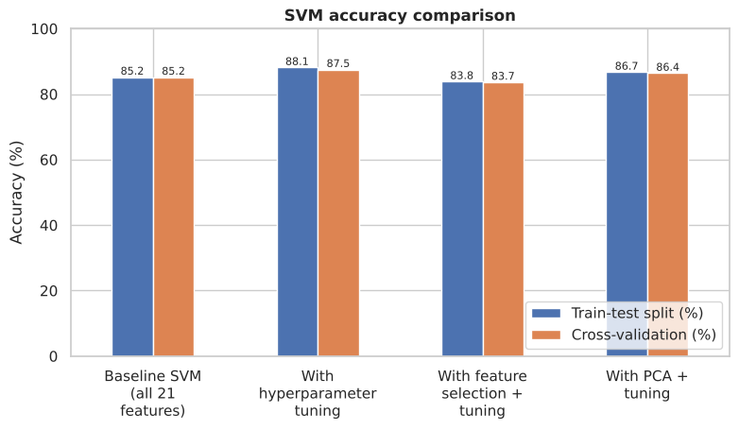
Figure 6. SVM accuracy comparison: train-test split vs 5-fold cross-validation
- Best model: RBF-SVM with C = 100 and gamma = 'scale' on all 21 normalised + engineered features: 88.13% (split) / 87.52% (CV). This is 4.74 points above the best Decision Tree and 9.08 points above a tree on the original features.
- What drove the improvement: (1) feature engineering (+4.34 points for trees), (2) switching to a regularised, non-linear SVM (+1.82), (3) hyperparameter tuning (+2.92). Reducing the inputs, by selection or PCA, lowered accuracy in every case.
- Consistency: split and CV accuracies differ by less than 0.7 points for every model, so the ranking of the methods is reliable.
- Engineering interpretation: the model assigns the correct demand class in about 7 of every 8 hours, using only weather and calendar inputs that are known or forecastable in advance.
Recommendations:
- Deploy the tuned RBF-SVM with all 21 features as the demand-class predictor. Use a predicted High class to dispatch rebalancing trucks before the 08:00 and 18:00 commuting peaks, and Low periods (night, winter, rainy hours) to schedule maintenance.
- Keep the engineered features (especially temp_x_hour, rush_workday and is_raining) in any future model; they gave the largest single improvement.
- Use PCA (10 components) only if prediction speed or memory becomes a constraint, accepting about 1.4 points lower accuracy and less interpretability. Do not use univariate K-Best selection for this dataset.
- Before operational use, re-validate with a chronological split and fix the limitations listed in Section 12.
11. Challenges Encountered
- Choosing scalers: one scaler did not fit all features (uniform hour, normal temperature, zero-inflated rainfall). I wrote a rule-based selector driven by skewness, kurtosis, outlier % and zero % so that each choice is documented and reproducible.
- Zero-inflated features: rainfall and snowfall have an IQR of 0, so RobustScaler would divide by zero; log1p + MinMaxScaler was used instead, and the binary is_raining flag captures the presence of rain.
- Redundant engineered features: temp_x_hour and hour_sin are strongly correlated with their source features, which made the correlation-based "top 5" set worse than expected and had to be explained rather than assumed to help.
- Computation time: the SVM grid search (16 combinations × 5 folds) is much slower than trees, so the grid was limited to the RBF kernel after the kernel comparison.
- Interpreting negative results: feature selection and PCA both reduced accuracy; analysing why (univariate scoring, redundancy, loss of interactions) was more informative than the scores alone.
12. Reflection & Limitations
Methodological limitations (risk of optimistic accuracy):
- Random split on time-series data: neighbouring hours of the same day can appear in both training and test sets, so the model partly sees the conditions it is tested on. A chronological split (e.g. train on the first 10 months, test on the last 2) would better reflect real forecasting.
- Pre-split scaling: scalers and the engineered-feature scalers were fitted on the full dataset before splitting. The leakage is minor for distribution statistics, but fitting them inside a Pipeline would be more rigorous.
- daily_rainfall uses future information: it sums rainfall over the whole day, including hours after the prediction time. In a real-time system it should be replaced by forecast rainfall or rainfall up to the current hour.
- Tuning and evaluation on the same folds: the best hyperparameters were selected and then scored with CV on the same data. Nested cross-validation would give an unbiased estimate.
Ethical and practical considerations:
- The target records rentals, not true demand. When a station is empty, demand goes unrecorded, so a model trained on this data may keep under-serving areas that are already under-supplied.
- Demand is city-wide, so the model cannot guarantee fair service across neighbourhoods; station-level data would be needed before using it for allocation decisions.
- The SVM is less interpretable than a tree. For operational trust, its predictions should be explained (e.g. with permutation importance) and monitored for drift as travel habits change.
13. Next Steps
- Re-evaluate the best model with a chronological train-test split and a full scikit-learn Pipeline (scaling + engineering + model) to remove the leakage risks above.
- Report a confusion matrix and per-class precision/recall, to check that errors are mainly between adjacent classes (Low↔Medium, Medium↔High) rather than Low↔High.
- Compare with ensemble models (Random Forest, Gradient Boosting), which often match SVM accuracy on tabular data while remaining more interpretable through feature importance.
- Replace daily_rainfall with lagged or forecast weather features (e.g. rainfall in the previous 3 hours).
14. GenAI Declaration
I used Claude (Anthropic) to assist with debugging code, suggesting feature-engineering ideas, and drafting and formatting this report from my notebook results. All code was run by me, and all results, interpretations and conclusions were checked against my notebook outputs and are my own work.
[Insert screenshots of my interactions with Claude here as proof.]

