1.

- What are var and const in JavaScript?

used for variable declaration

- What are different between let and var?

|  |  |
| --- | --- |
| var | let |
| - var declarations are globally scoped or function scoped  - can be re-declared and update  - hoisted to the top of its scope but initialized with a value of undefined | - let declarations are block scoped  - can be update but can’t be  re-declaration  - hoisted to the top of its scope but will get a reference error |

- What are different between let and const?

Const is almost exactly the same as let. But const variable can neither be updated nor re-declared. And while var and let can be declared without being initialized, const must be initialized during declaration.

- What to use in what case?

+ use const when the variable will not change

+ use let when need to change the variable value in future

+ var slightly the same as let but var should not be used

2.

1. What is Boolean?

Boolean is a primitive data type commonly used in computer programming languages. Boolean has two possible values: true or false

2. What results in Boolean? value of either true or false

10.

a.

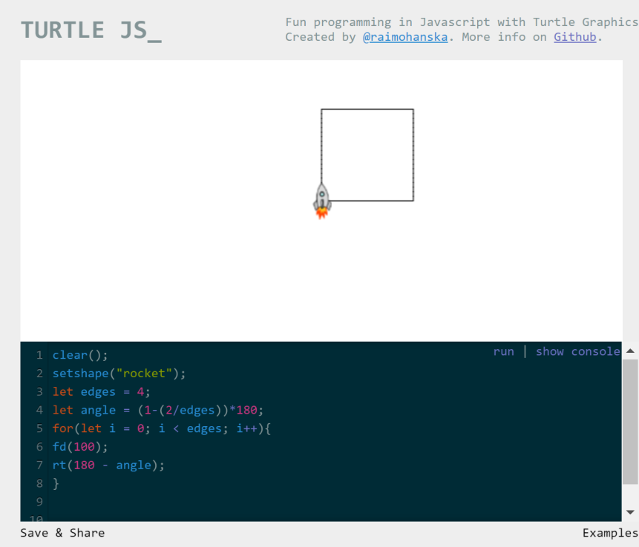

b.

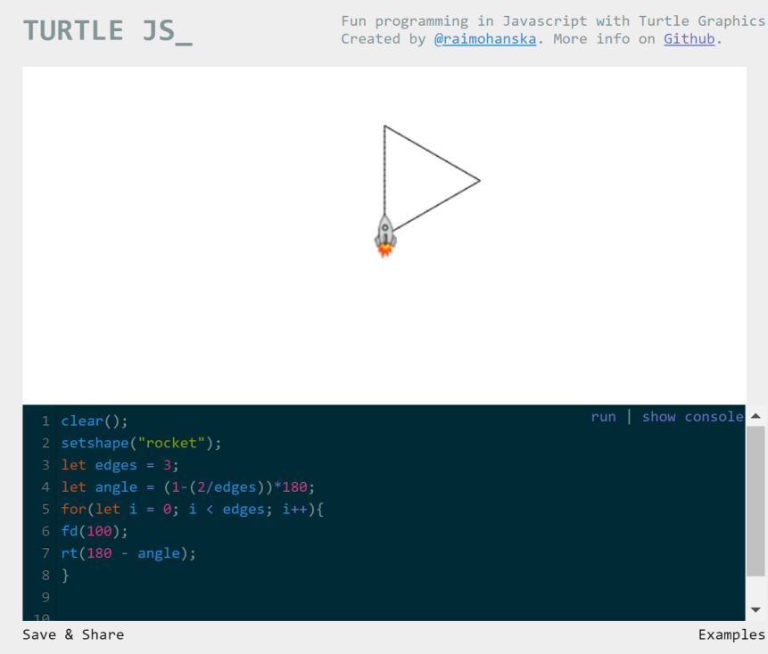

c.

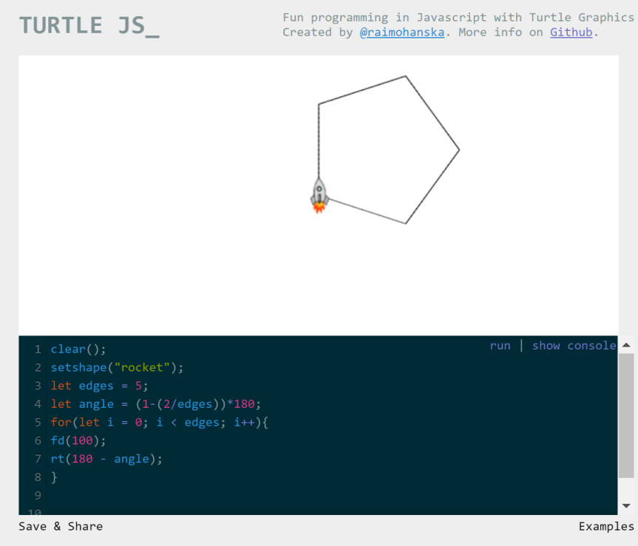

d.

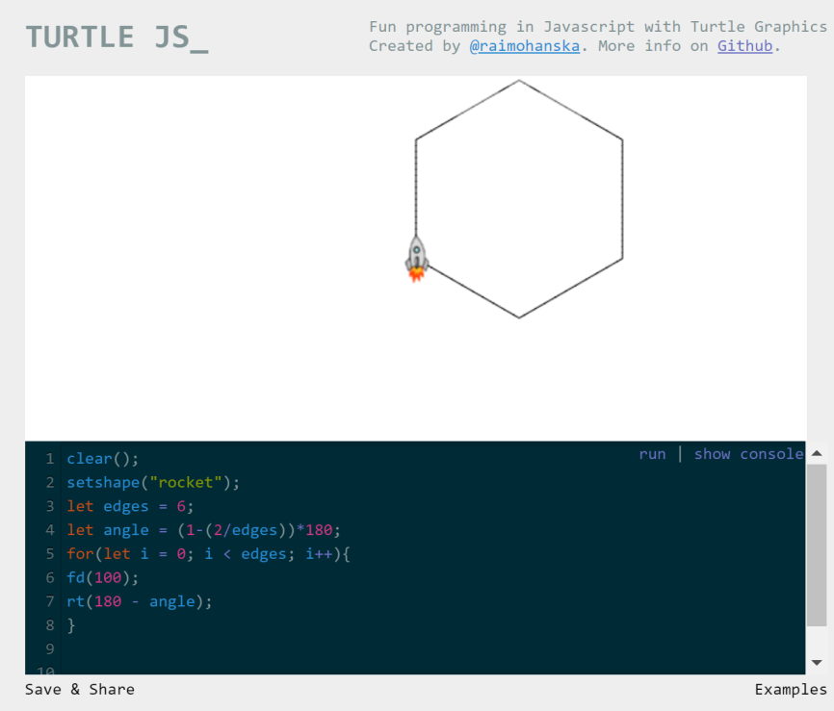

11.

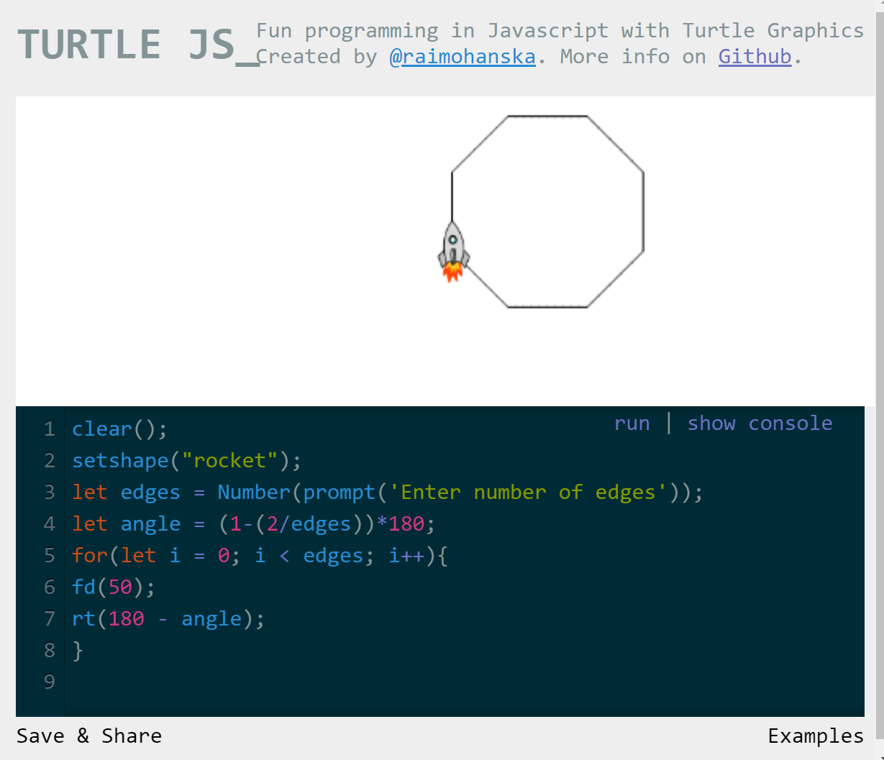

12.

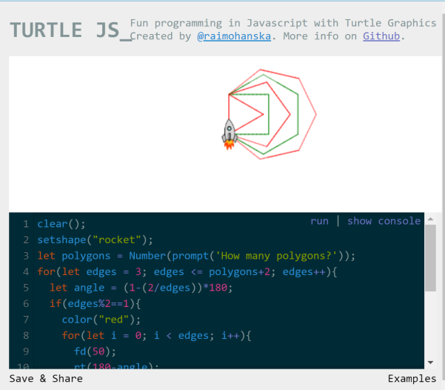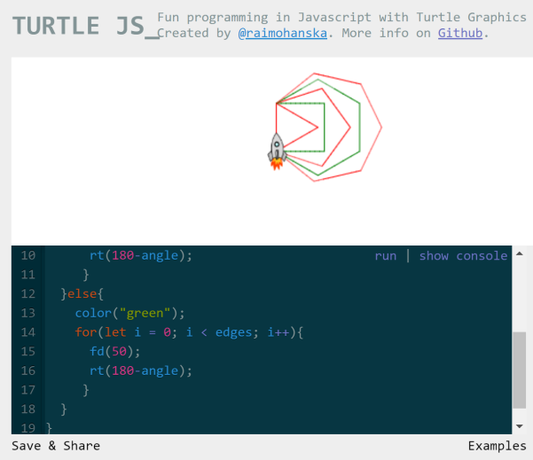

clear();

setshape("rocket");

let polygons = Number(prompt('How many polygons?'));

for(let edges = 3; edges <= polygons+2; edges++){

let angle = (1-(2/edges))*180;

if(edges%2==1){

color("red");

for(let i = 0; i < edges; i++){

fd(50);

rt(180-angle);

}

}else{

color("green");

for(let i = 0; i < edges; i++){

fd(50);

rt(180-angle);

}

}

}