1.

Example 1: 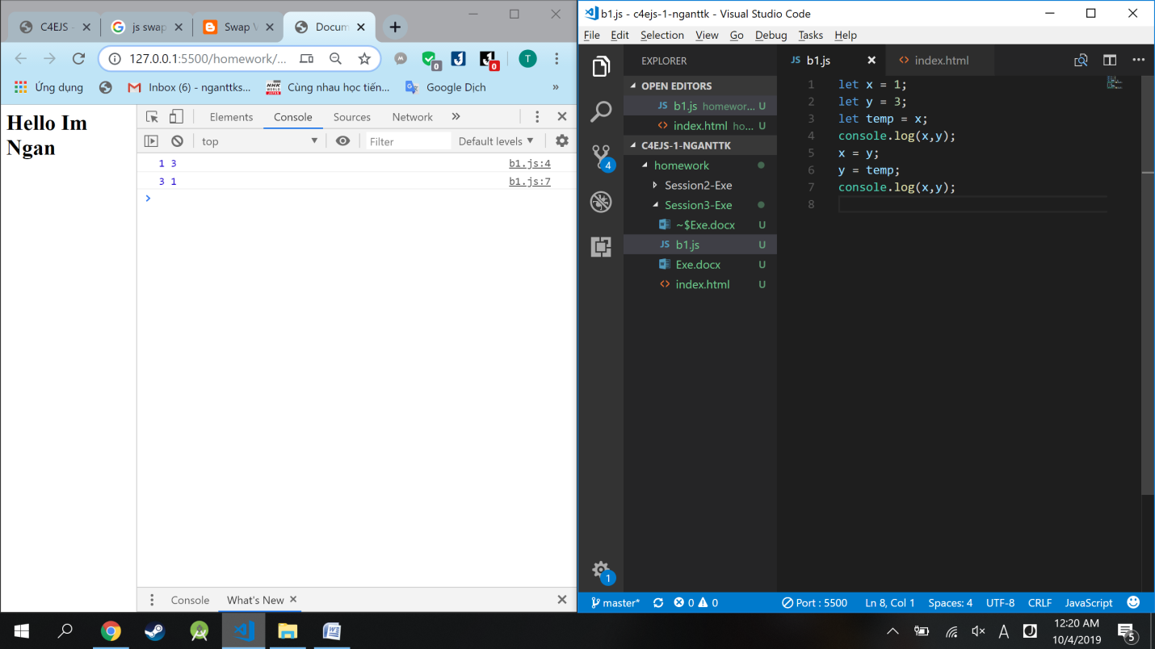

Example 2:

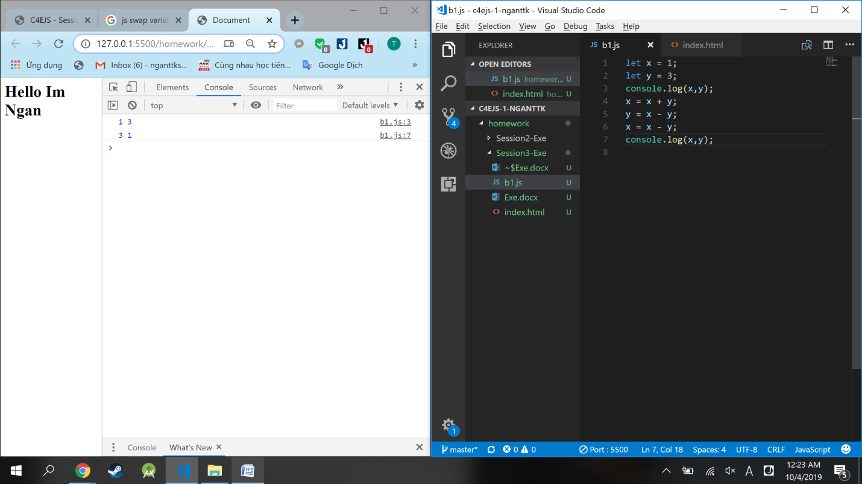

Example 3:

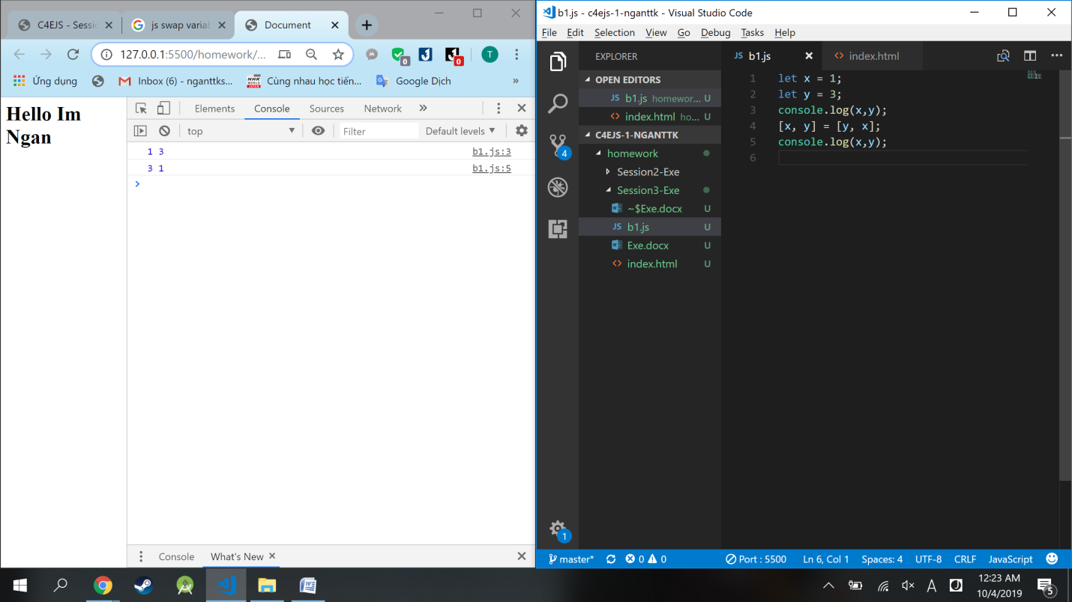

2.

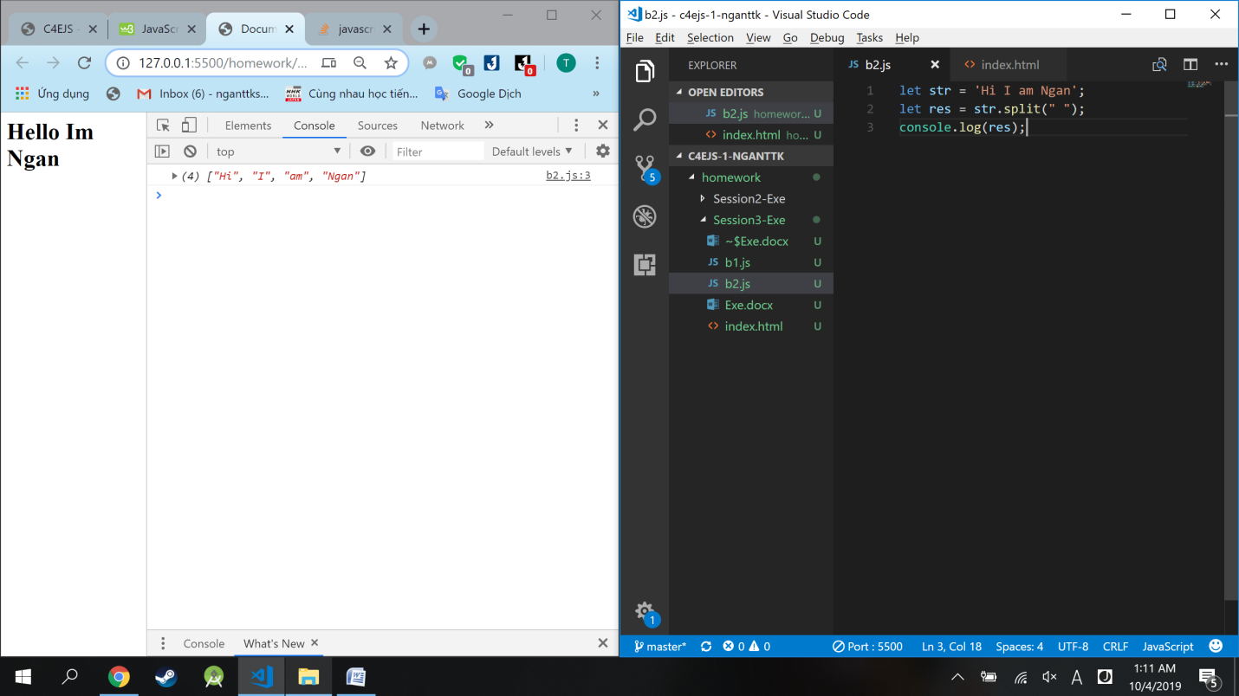

3.

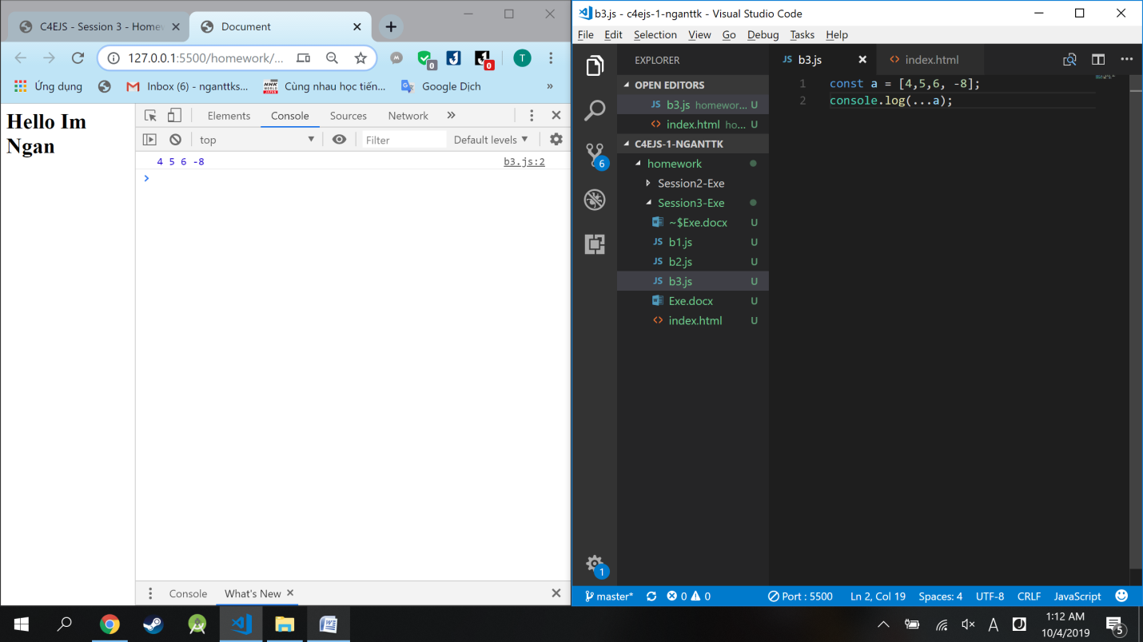

10.

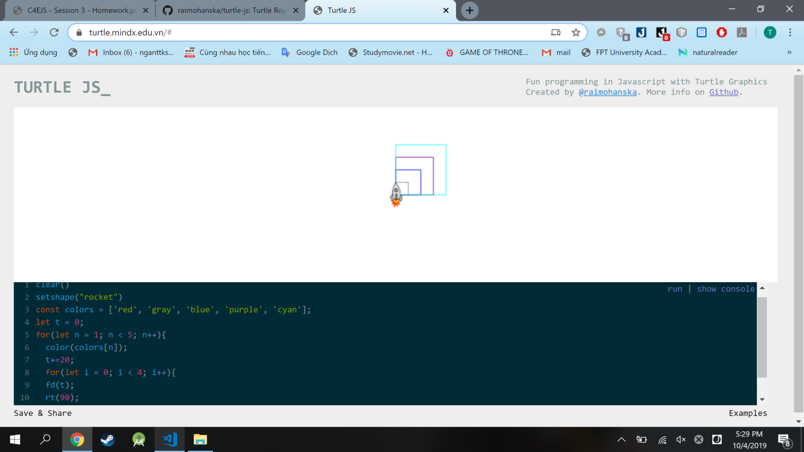

clear()

setshape("rocket")

const colors = ['red', 'gray', 'blue', 'purple', 'cyan'];

let t = 0;

for(let n = 1; n < 5; n++){

color(colors[n]);

t+=20;

for(let i = 0; i < 4; i++){

fd(t);

rt(90);

}

}